**The Spinsolve-Expert Experiment Menu**

Contents

Run experiment 1

Edit current protocol 1

Open pulse program editor 1

Visualize sequence 1

Save parameters to run later 1

Estimate experiment time 1

Edit parameter visibility 1

Show minimum parameter entries 1

Show user defined parameter entries 1

Show all parameter entries 1

Check for duplicate names 1

List parameters 1

This menu has options for running experiments, opening the pulse program editor and compiler, for designing scripts and building customizable user interfaces and modifying what parameters are visible in the user interface.

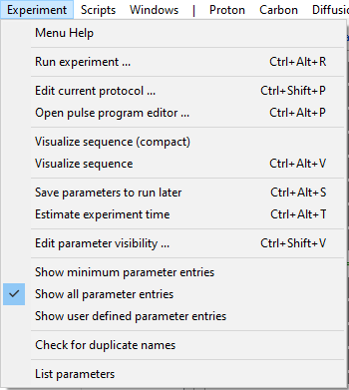

# Run experiment

This command performs the same function as the Run button – i.e. it starts an experiment. This works in history or batch mode.

# Edit current protocol

This option will open the appropriate pulse program editor for the currently loaded pulse program or protocol (i.e. the one displayed in the parameter list). There are 3 possible editors which can be displayed depending on the type of experiment. The pulse program editor and compiler for standard experiment (like Proton, COSY etc), the protocol editor for experiments which use multiple pulse programs (like QuickShim) and which have a large number of parameters, and the simple text editor for script based experiments which have a very simple parameter list.

Please refer to the help for these different types of experiment in the pulse programming guide (see Help menu).

# Open pulse program editor

This opens the pulse program editor and compiler without loading any particular experiment. This is useful when you need to recompile older experiments which won’t load directly into the current Expert interface. In this case you will need to select the pulse sequence from within the pulse program editor interface.

# Visualize sequence (compact)

For experiments which are based on a single pulse sequence, you can view the pulse sequence visually using this tool. Note that this does not include scripts or complex protocols like QuickShim. Each pulse sequence command is represented graphically by a symbol in a special 1D plot. Blocks of commands like WALTZ-16 can also be represented by alternative symbols to simplify the sequence.

An example of the interface for the COSY sequence is shown below

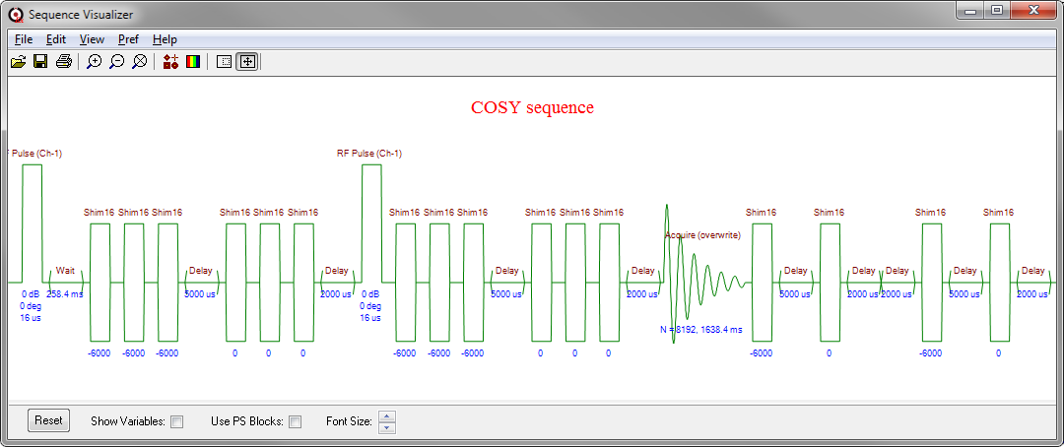

In this case the Spoiler blocks can be replaced by a simpler symbol by selecting the ‘Use PS block’ check box.

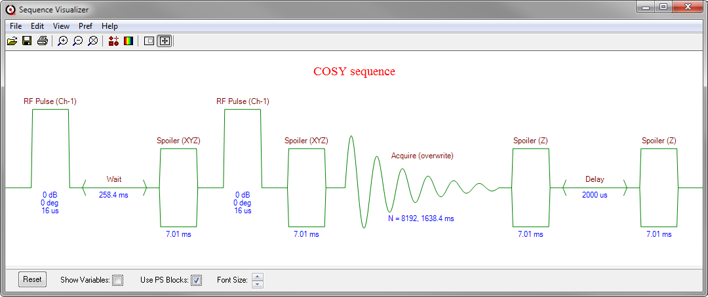

Labels on each of the graphic symbols can be toggled between variable names and constants and the font size can be varied as required. The normal plot functions like zooming and panning still function.

# Visualize sequence

For complex sequences a more readable visualizer can be selected with the RF channels and shims on separate lines

# Save parameters to run later

Occasionally it is useful to be able to save the parameters for an experiment without actually running it. This option will add an experiment to the history list with a comment of ‘Saved’. Later you can return to this experiment – click on it and either continue modifying the parameters or just run the experiment. Effectively this is like running an experiment and then immediately aborting it.

# Estimate experiment time

Sometimes it is useful to know how long an experiment will take without running if first. This option will print out the estimated run time into the command line interface. This will work in both the history and batch modes.

# Edit parameter visibility

You can control which pulse sequence parameters are visible by applying this option. It will add a checkbox next to each experiment parameter. You can then select which parameters to hide by unchecking their boxes. For example, in the Proton experiment we choose to hide the ‘Pulse amplitude’ and ‘Pulse length’ parameters as these are normally taken from the factory parameters Likewise the ‘Number of points to shift’ parameter rarely needs to be set to anything else than 1.

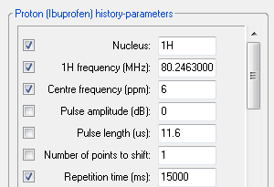

Once you have made your selection, reselect the Edit parameter visibility option in the menu and the hidden parameters will disappear. You can restore the selected configuration at any time by choosing the ‘Show user defined parameter entries option’ in the Experiment menu. The choices you have made here are stored in the preferences folder in the following location:

<prospa_preferences>\SpinsolveParameters\Experiments\<experiment_name>\parameter_visibility.mac

# Show minimum parameter entries

In the pulse sequence folder for an experiment a file can be defined called *parameterVisibility.mac*. This macro controls which parameters will be visible when the ‘Show minimum parameter entries’ option is selected. It has a simple format – For example the proton experiment it looks like this

procedure(parameterVisibility)

showList = ["nucleus",

"b1Freq1H",

"centerFreqPPM",

"repTime",

"acquDiv",

"nrPnts",

"dwellTime",

"nrScans",

"bandwidth",

"acqTime",

"procDiv",

"zf",

"filter",

"dispDiv",

"dispRangeMinPPM",

"dispRangeMaxPPM"]

endproc(showList)

# Show user defined parameter entries

If the parameter visibility is defined using the ‘Edit parameter visibility’ option in the edit menu then the *parameterVisibility.mac* will be stored in the user preferences and will be applied with the ‘Show user defined parameters option’ is selected.

# Show all parameter entries

This will show all the parameter and will ignore both of the *parameterVisibility.mac* files should they exist.

# Check for duplicate names

If is possible to have two or more experiments in the menus with the same name. This can cause confusion if reference is made to an experiment without the path being defined. This happens because Expert will use the first experiment found with this name while searching for it. For this reason, you should avoid duplicates, and this option will help you find any duplicates currently present.

# List parameters

This lists all the parameters (visible or otherwise) and their values in the command line interface.