**The Spinsolve-Expert File Menu**

Contents

Select experiment folders or base path 2

Search History 4

Rename experiment folders 6

Open current data folder 6

Open notes editor 7

Import SpinsolveExpert data folders 7

Open application folder 8

Open user preferences folder 8

Save current parameters to pulse program defaults file 9

Copy ‘user’ parameter visibility to ‘minimum’ 9

Open SpinsolveExpert preferences 9

Open Spinsolve firmware dialog 15

Open Spinsolve parameter dialog 15

Save all plots 16

Make a desktop shortcut 17

Quit application 17

This menu controls the loading and saving of files related to the Spinsolve-Expert application

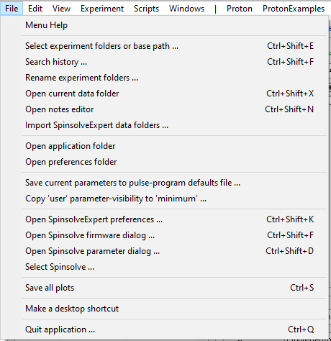

# Select experiment folders or base path

This option, which has the same function as the button labelled ‘...’ in the Experiment control region of the user interface, allows the selection of a base folder under which all data will be stored. There are two options here, which are determined by the choice made in the first window which appears:

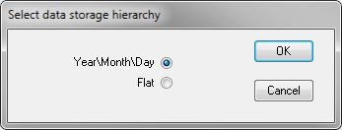

If you choose the “Year\Month\Day” option, then data will be stored in a date-based hierarchy with 3 levels of folders automatically created beneath the base path. These will the year, month, and the day (all as numbers). When an experiment is performed, it will be stored in the current day folder. If you choose the flat option (not recommended in most cases), the data will all be stored directly within the base path.

The next window allows you to select the base path. In the case of an existing date hierarchy you can either choose the base path (C:\Data\SpinsolveExpert in this case) or an individual experiment folder:

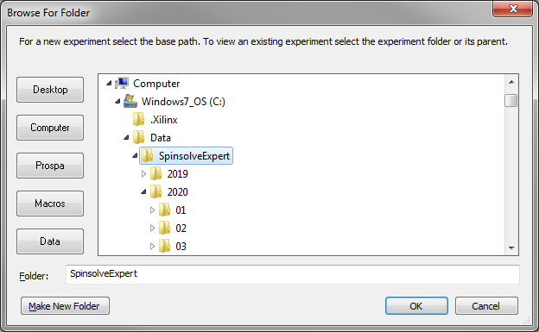

*Selecting the experiment base folder*

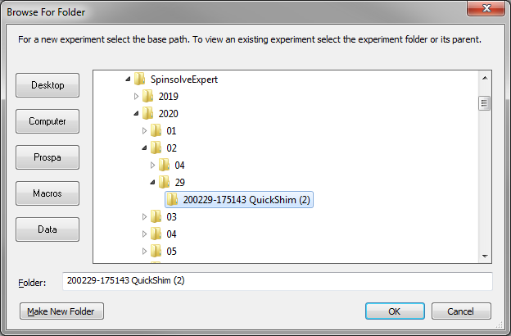

*Selecting an experiment folder*

The first option will reset the experiment history list to the current day, while the second will display a list of all experiments collected on the same day as the selected experiment and display the data collected in the selected experiment. Note that you can also select the day folder (24 in this case) to get the same functionality. In this case the experimental results will not be displayed until a particular file is selected from the history list.

If you select any folder between the base folder and a day folder (i.e. a year or month folder) you will see this error message

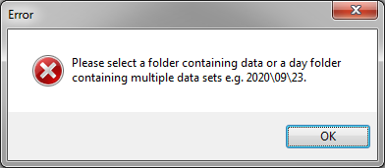

The distinction between the base folder and an experiment folder is that the latter should include an acqu.par file. If you select a folder which has a nonnumeric name and which doesn’t contain an acqu.par file it will become the base folder and a date folder hierarchy will be built below it.

# Search History

This option will generate an interface allowing the current history hierarchy to be searched:

e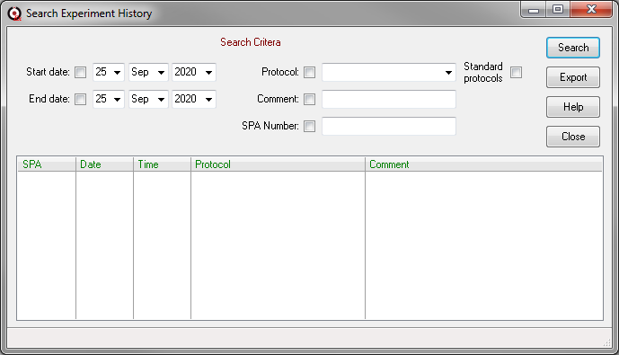

To use this interface, modify the filters at the top to restrict the search. For example, to search for COSY protocols performed on Ethanol samples, enter COSY into the Protocol field and Ethanol into the comment field, remembering to add the check marks. Then press *Search*. The time required to search the history will depend on its size and the number of entries, but it may take many seconds if there are a large number of folders to search. Note that the Protocol option is selected by default when the window is opened.

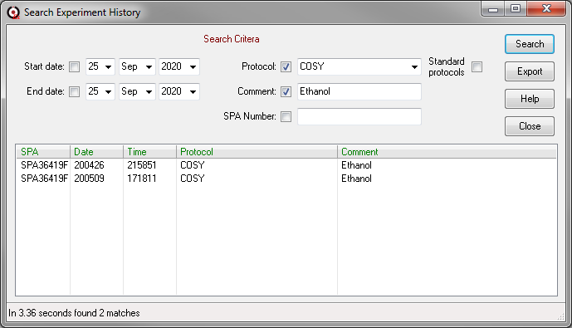

Once the search has finished it will list the found data sets and you can select an individual experiment by clicking on them. This will load the experiments for the selected date into the history list and display the selected data set.

It is also possible to search and view experimental data collected with the standard software. A list of the supported protocols can be viewed in the Protocol dropdown menu by selecting the Standard Protocols checkbox.

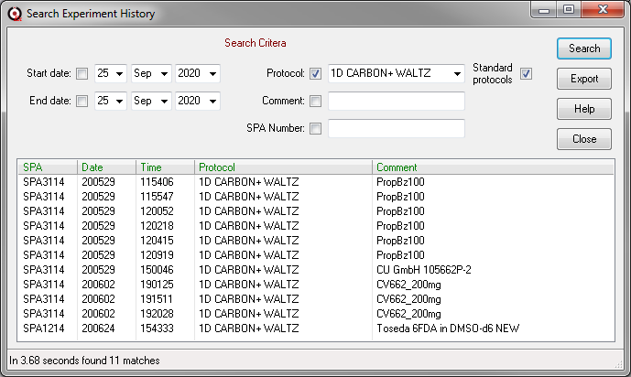

The Export button will copy the found experiment folders into a new location e.g.

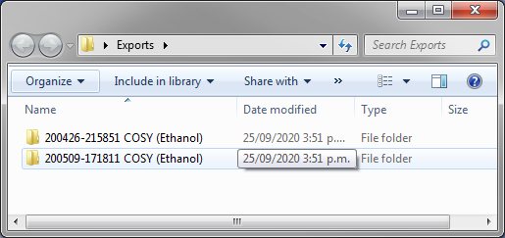

These can be viewed by selecting ‘Select experiment folders or base path’ option from the file menu, choosing the flat-file hierarchy option and then (in this case) selecting the Exports folder.

# Rename experiment folders

If an experiment protocol name has changed, then you will be unable to load the previously collected experimental data. With this command you can rename old experimental data folder to the new name so they can be reloaded.

In this example, all experiment data collected using the 1Pulse protocol name will be renames Proton.

# Open current data folder

This option will open the current data folder (the selected data folder in the history list), in a Windows Explorer dialog:

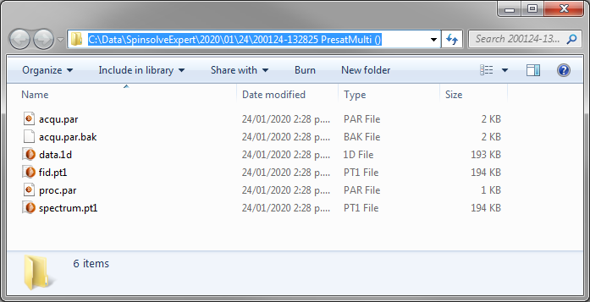

# Open notes editor

With each experiment you can save a text file with some description of the experiment. This option opens a Prospa editor into which you can add the notes. When finished simply select the save note (Ctrl+S) option from the file menu to the save the note to the experimental folder.

# Import SpinsolveExpert data folders

Versions of SpinsolveExpert before 1.40 didn’t use the date-time hierarchy and cannot be loaded directly into this version of the software. However you can import these files into an existing or new date-time hierarchy using this command. Simply choose your Experiment base-path and then select this command. Next select either a single experiment folder (which may also contain numbered sub-experiments), or a parent folder which contains a number of experiment folders. The time stamp of the acqu.par file(s) will be used to determine the location and partial folder name for the imported experimental result(s). If you wish to keep a group of related experiments together then it is recommended that you choose a new experiment base folder when performing the import, otherwise they might be ‘lost’ amongst the current hierarchy. Currently you cannot import into a flat folder.

The location of each import will be listed in the command line interface. Note that the original experimental files are not affected by this process.

# Open application folder

This command opens the Prospa installation folder in a Windows Explorer dialog (Prospa is SpinsolveExpert’s underlying application). Please refer to the Prospa manual for details of the various files and folders.

# Open user preferences folder

This command opens the Prospa user preferences folder in a Windows Explorer dialog (Prospa is SpinsolveExpert’s underlying application). This is a folder which is created in the current user’s AppData folder – normally this is hidden. The typically location is

C:\Users\<user_name>\AppData\Roaming\Prospa\Preferences V3.4\

Normally the user has write permission in this folder, so it is used to store a variety of preferences such as window positions, current data directories, shim and common parameter values. Those files relevant to the SpinsolveExpert application are stored in the SpinsolveParameters folder.

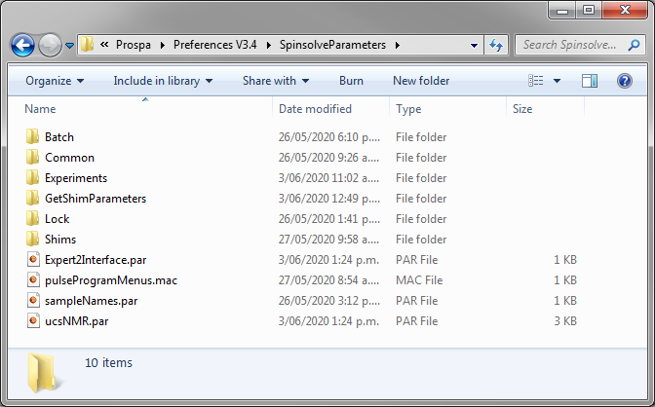

Occasionally you may find that SpinsolveExpert is not starting up. In this case the first thing to check is whether one of these files (especially Expert2Interface.par) has been corrupted. You can do this by closing Prospa (possibly from the task manager if it is not visible), renaming Expert2Interface.par and then starting Expert again. If this doesn’t work then rename the whole SpinsolveParameters or Prospa parent folders in preferences and repeat the process.

# Save current parameters to pulse program defaults file

If you have selected this option in the preferences dialog box (general button)



Then you will see this menu option in the file menu. This option will copy the current experimental parameters as seen in the UI into the pulse program defaults file. You can use this option when you are developing a new experiment. However, be aware that the new defaults file will probably require some manual editing afterwards as several parameters in the parameter list are automatically generated and don’t need to be in the defaults file.

# Copy ‘user’ parameter visibility to ‘minimum’

If you have selected this option in the preferences dialog box (general button)



Then you will see this menu option in the file menu. This option will write or update the file parameterVisibility.par normally stored in the preferences folder:

<preferences>\SpinsolveParameters\Experiments\protocol

to the protocol pulse program folder. This will define the ‘Show minimum parameter entries’ option in the experiment menu.

# Open SpinsolveExpert preferences

The preferences relating to the SpinsolveExpert application can be accessed using this option.

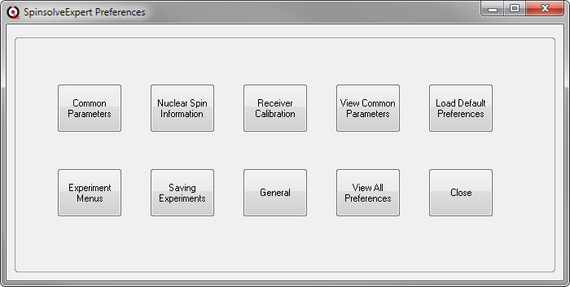

From this control panel you can access different options. These will be described below. If you make any changes to one of the pages press the Save button on the top right. To return to the main selection page (shown above) press the back arrow on the top left.

*Common Parameters*

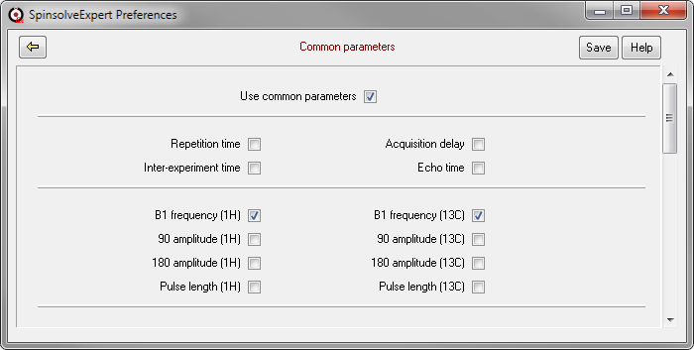

This page defines the common parameters which will be used by SpinsolveExpert. Generally you should always have the ‘Use common parameters’ option checked, otherwise many experiments which rely on this functionality will not work. Apart from this you should normally have all the B1 frequencies selected as common parameters as these will change with time and magnet temperature. The other parameters may only need to be selected if you are running legacy experiments which don’t read the factory settings for these parameters.

*Experiment menus*

In the main menu the items between the vertical lines (to the right of the Windows menu and to the left of Batch) are user definable.

A simple way to add items to this menu is to drag a folder onto the menu bar. A popup window appears allowing the new menu to be given a name and then any Prospa/Expert macros (*.mac) in the folder or folders containing pulse program files, will be visible in the menu list. Alternatively, you can view the Experiment menus page in the preferences. This displays a dialog into which the user-defined menus are listed and can be modified.

On the left-hand side, the dialog contains a list of predefined experiments folders. Of course only those experiments which are valid for your type of Spinsolve can be run successfully.

Experiments can be copied from the Default Pulse Program list to the menu list using the button labelled with an arrow: . Other user-defined menus can be added using the  button or by dragging and dropping the experiment folder onto the dialog. The  button will delete the entry from the list while the modify button  will allow the menu name to be modified. You can also double click on the menu name to modify it.

When you are finished modifying the menu list press the Save button to copy this to the main menu.

*Nuclear spin parameters*

This lists the NMR frequencies for each NMR active nucleus which the Spinsolve has been designed to detect (depending on your model). These frequencies are relative to 1H and are not adjustable.

The zero offsets on the right allow you to define the frequency which will appear in the centre of the spectrum. This is user adjustable. 4.74 ppm is the offset for water.

*Saving Experiments*

Here we can select the data folder hierarchy. This option is described in this manual in the ‘Select experiment folders or base path’ command.

When an experiment is run it will normally save the data in a proprietary Prospa plot format (.pt1 or .pt2). If MNova is supported it will also save a simple binary file data.1d or data.2d. Using the options on this page you can force the saving of this latter format and also save the data as a picture (png) file or as a comma delimited text file. This latter format can take up a lot of disk space. Even if these options are not selected, you can always choose to export the data in one of these formats using the post processing button labelled ‘Export’.

*Receiver calibration*

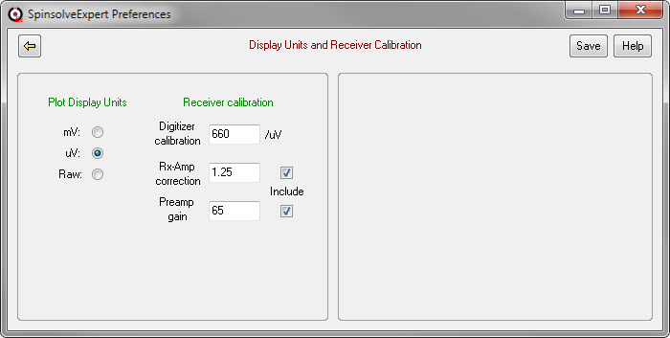

By default Expert will display the time domain data with units of microvolts (millivolts are also possible). This is the calculated signal level from the probe. It does this by using the 3 scaling factors shown here and also takes into account the receiver amplifier gain. This means that changing the receiver gain in an experiment will generally not change the FID amplitude - only the SNR. (Although extreme values of receiver gain will result in either very bad SNR or overloading). If you choose the Raw plot unit option, then this compensation will not be applied and the data amplitude is determined by the product of the incoming signal level, the total receiver gain and the digitisation process.

*General*

This page contains two regions. One to control the permissions to access various items in the software and the other to modify how the user interface looks.

The permissions options are really about limiting the possibility of causing damage to the software, spectrometer or your data. They are entirely voluntary, but like the super-user password in Linux should be used with care. Here are the options:

*Permissions*

* Allow script editing – if this is checked, then holding down the shift key when selecting a post processing button or protected script will display this in an editor. Be aware that changing these files may cause the script to fail!
* Show test protocols – there are several experiments in the monitor menu which are normally hidden. These are used mainly for system diagnostics and would only clutter the interface if always present. (Changing this option requires a restart of the program to see any effect).
* Allow to overwrite default parameter files – there are two options in the File menu which are normally hidden. One allows the default parameter file to be updated for the current experiment using the parameters in the parameter list. This should only be used on your own experiments and will still require some manual editing of the defaults file. The second allows the currently visible parameters to define the minimum visible parameter list. Again this will typically only be used for your own pulse sequences. Note that if you accidentally overwrite the provided files you will need to recover them from a backup. (Changing this option requires a restart of the program to see any effect).
* Allow to trash complete data sets - normally you probably don’t want to do this. However if you are developing a new pulse program and producing a lot of bad data then this might be useful.
* Allow to overwrite the spectrometer parameters - this should only be done under the supervision of Magritek staff, as this can cause experiments or even the Spinsolve itself to fail!
* Allow to update the spectrometer firmware - again this should only be done under the supervision of Magritek staff, as this can cause experiments or even the Spinsolve itself to fail!
* Allow off-line sequence development. This option will use a saved copy of the Spinsolve parameters to allow pulse program development even without a spectrometer.
* Allow importer editing/viewing. This option will display an extra tab in the compiler editor enabling development of scripts to import experiments collected using the standard software.

*User interface*

This provides the option to display the buttons in Expert installed on a Windows 10/11 computer using a Window 7 style. This is obviously a personal preference.



*The default Windows 10 view*



*The Windows 7 option*

The remaining 3 options just list or modify parameters:

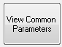

This displays the contents of the common parameters file stored in

<prospa_preferences>\SpinsolveParameters\Common\SPAXXX.par

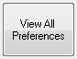

This displays the contents of the preferences file store in

<prospa_preferences>\SpinsolveParameters\ucsPreferences.par

(UCS was an early name for the Spinsolve and stands for Ultra Compact Spectrometer).



This will overwrite the preferences with factory settings – only do this if you having problems with the system.

# Open Spinsolve firmware dialog

Allows the checking, and if required, updating of the firmware used within the Spectrometer. (Note that updating should only be done by Magritek staff).

# Open Spinsolve parameter dialog

This allows the checking, and if required, updating of the spectrometer (factory) parameters used by the pulse programs. (Note that updating should only be done by Magritek staff)

To use this dialog, press the ‘Read DSP/FX3 Parameters’ button at the top right of the window. This will load the various factory settings from the spectrometer’s computer.

This window will have several tabs – the number will depend on how many X-channels are supported.

The first page has some generic parameters like the spectrometer ID, its capabilities and firmware information, as well as parameters used to keep the system thermally stable.

From the end-user perspective the most important parameters are the expected frequencies and pulse lengths and amplitudes. Some parameters are specific to certain experiments.

*The Spinsolve Parameter Updater interface*

|  |  |
| --- | --- |
|  |  |

On the second page the factory shims are listed, while on the final pages (if present) we have the X-channel nuclei information.

Most pulse programs will use the some of the values from this list to define default values for certain parameters that rarely change (like the 90 degree pulse-length and amplitude for a nucleus). This is normally performed in the pulse program file procedure getFactoryBasedParameters that uses calls the function gData->getXChannelParameters() to get this information.

The shim and calibration protocols will also use some of these values as starting points, when performing shim or frequency searches.

# Save all plots

This option will save the current plots to file unless they are not tagged with the “fid” type (this can be set in the user interface file procedure plot_load_layout). It will also save the plot layout – in this way you can hide the FID using the View buttons in the top right of the main user interface, and then just view the spectrum the next time the experiment is selected from the history list.

# Make a desktop shortcut

If the desktop shortcut added during installation is lost for some reason, this option will make a new shortcut. Note that it is still possible to start Expert without this shortcut. Simply start the Prospa application (prospa.exe in the Prospa install folder) and then select SpinsolveExpert from the Layout menu.

# Quit application

Closes the SpinsolveExpert application after checking for confirmation.