**The Spinsolve-Expert Monitor Menu**

Contents

Monitor lock and temperatures 1

Monitor lock signal 2

Check lock and temperature 3

Test scripts 4

Display monitor history 4

This menu has options which allow the monitoring of various Spinsolve functions such as, locking and temperature monitoring. Most of these are diagnostic tools which you will only use occasionally when you believe there are issues with the system.

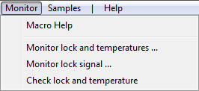

# Monitor lock and temperatures

This plots the temperature of various parts of the Spinsolve spectrometer; the air inlet or room temperature, the interior of the Spinsolve box and the magnet. All of these should be within the specified dashed lines for reliable operation. If you are concerned about the stability of the spectrometer this option can be run for a long period to check this. The Monitor temperature output also includes a couple of important voltages which control the heating and cooling in the spectrometer. Note that the temperature limits for the magnet and box will depend on the type of spectrometer you have.

Finally this command also plots the lock offset – this is the amplitude of the lock correction (in Hz) being applied to the shim offset coil. Monitoring this is useful when you have lock issues. (For example distorted lineshapes on long FIDs can be caused by a rapidly drifting lock.)

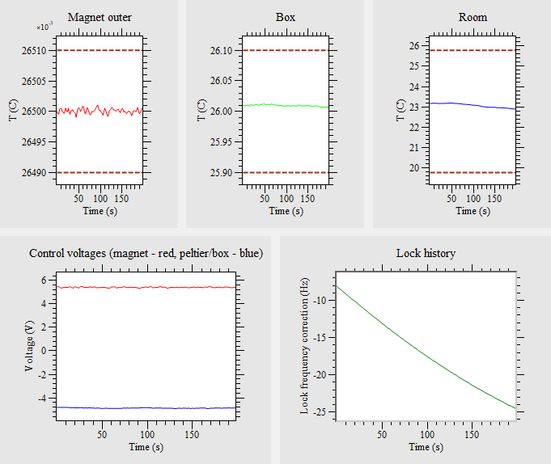

# Monitor lock signal

This checks the stability of the lock by measuring the lock FID for a certain number of scans (which you can define) and tracking the lock frequency and the B0 correction over this time. First the lock frequency is found – starting with the factory setting stored in the spectrometer. Once the frequency has been found the phase is adjusted to 90 degrees and the lock is engaged. It is then monitored for the specified number of steps

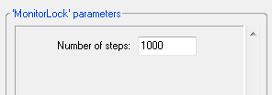

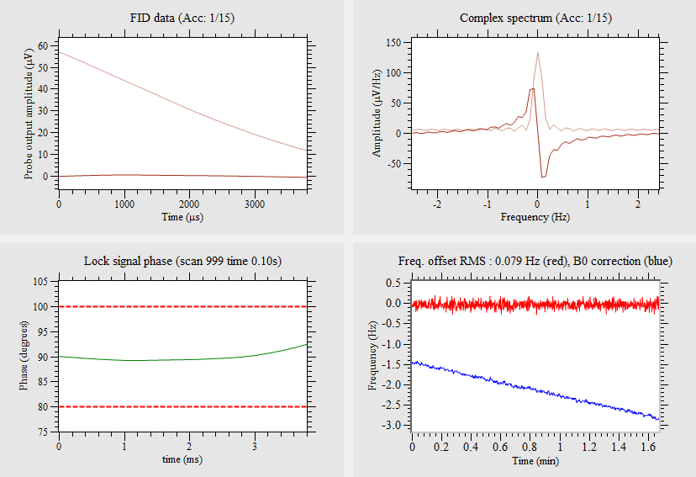

If the lock is good you should see the lock frequency sitting close to zero with a low noise level (typically < 0.1 Hz RMS), while there might be a small drift on the B0 correction due to temperature changes. If run directly after selecting a Lock and Calibrate protocol, the offset level should start close to zero Hz.

# Check lock and temperature

This does a fast measurement of the temperature and the state of the lock. It will either return a pass or fail. This test is performed before and after each experiment is run and used to update the colored monitors in the Status region of the user interface.

>

--- Spectrometer temperature check ---

Magnet temperature = 26.50 °C (ideal 26.5 °C)

Box temperature = 26.00 °C (ideal 26 °C)

Room temperature = 23.52 °C (limits 19.5 to 25.5 °C)

--- Spectrometer lock check ---

Lock deviation = 0.0176435

Locked

Note that this experiment is performed immediately and you don’t have to press the run button. The result is *not* recorded in the history list.

The lock deviation is the standard deviation noise level (in Hz) of the lock frequency after offset correction. Occasionally this command returns a larger value and will cause the lock display to go red. Just try repeating the command in that case.

# Test scripts

This part of the menu checks the tuning and matching of each probe. They only need to be run if you are having problems with the signal from that probe (e.g. low or no signal).

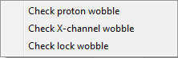

These options will only be visible if you choose the ‘Show test scripts’ options in the SpinsolvePreferences/General page and then restart the software.

An example is given below for the proton channel. Do not be concerned if the dip in the curve is not exactly on the resonant frequency, our experience is that this is not too critical. However the maximum amplitude is important and should be in the 100-400 range.

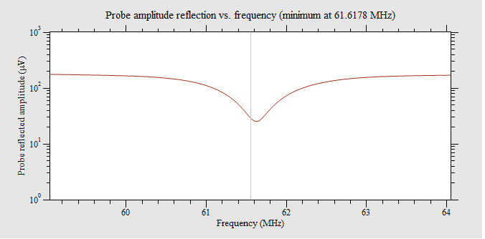

Similar results should be seen with the X-channel and lock wobble experiments. Note that after running the *Check lock wobble* experiment you will need to relock the system.

# Display monitor history

This option will be displayed if the Record history option is selected in the Preferences dialog. (General page).

With this option selected Expert will, from startup, begin to periodically record the lock and temperatures in the Spinsolve. This option should normally only be run if you are experiencing temperature or lock issues with your Spinsolve and want to track down the cause. When selected, the software will record the lock and temperature each second an experiment is not running and also, if enough time is available, between scans.

To view the recorded data, select this option from the Monitor menu and then press the Run button. The recorded data will be displayed. Note that temperature and lock data can only be recorded when the spectrometer is idle. If you choose the option ‘Save history data’ before pressing ‘Run’ then the result will be saved to the current data folder. Press the reset button at any time to erase the recorded history within application (any saved file will not be affected).

Note that when recording history do not change spectrometers in the File menu as this is currently not supported and may result in errors.