**The Spinsolve-Expert Program Menu**

Contents

Edit current pulse-program 1

Open pulse program editor 1

Window Designer 1

Edit script template 1

This menu has options for opening the pulse program editor and compiler, for designing scripts and also building customizable user interfaces.

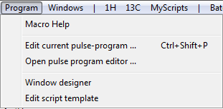

# Edit current pulse-program

This option will open the appropriate pulse program editor for the currently loaded pulse program (i.e. the one displayed in the parameter list). There are 3 possible editors which can be displayed depending on the type of experiment. The pulse program editor and compiler for standard experiment (like Proton, COSY etc), the protocol editor for experiments which use multiple pulse programs (like QuickShim) and which have a large number of parameters, and the simple text editor for script based experiments which have a very simple parameter list.

Please refer to the help for these different types of experiment in the pulse programming guide (see Help menu).

# Open pulse program editor

This opens the pulse program editor and compiler without loading any particular experiment. This is useful when you need to recompile older experiments which won’t load directly into the current Expert interface. In this case you will need to select the pulse sequence from within the pulse program editor interface.

# Window Designer

This displays an interactive window designer which can be used to design your own user interface (this was used, for example, to design the Samples user interface). Please refer to the Help file accessible from this window for more details.

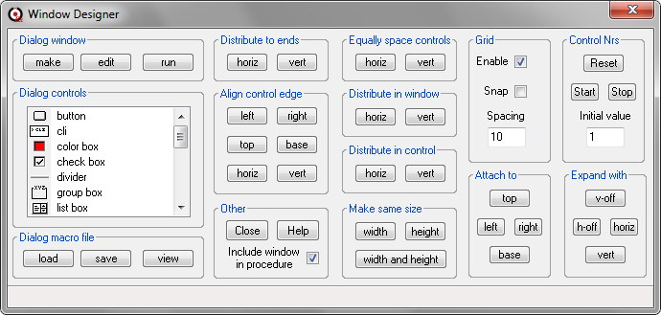

# Edit script template

This opens a script template in a Prospa editor which, if saved to an accessible menu folder, will allow a 1-Pulse pulse duration sweep experiment to be performed. This experiment is written using simple script commands such as RunExpt.

