**The Spinsolve-Expert Samples Menu**

This menu controls has a single option



This opens the following interface

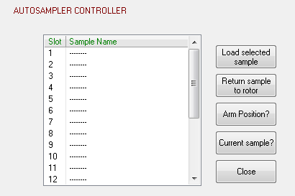

This allows the definition of sample names or comments and the selection of samples if a sample changer is connected to the spectrometer.

First the sample names can be defined by double clicking on the Sample Name entries (1-20). Alternatively right clock to see a contextual menu.

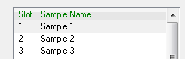

These names will appear in the file comment controls

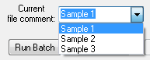

If a sample changer is connected to the spectrometer the buttons down the right side of the interface can be used to change the sample, return it to the sample changer rotor and interrogate the positon of the sample changer. Note that changing the sample takes about 30 seconds.