**The Spinsolve-Expert Scripts Menu**

Contents

Edit script template 1

Window Designer 2

This menu has options for designing experiment scripts plus a list of example scripts (which may be different from that shown below)

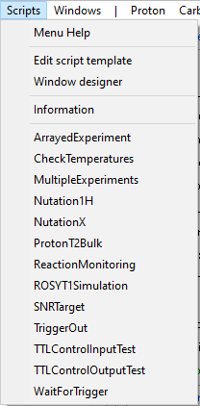

# Edit script template

This opens a script template in a Prospa editor which, if saved to an accessible menu folder, will allow a 1-Pulse pulse duration sweep experiment to be performed. This experiment is written using simple script commands such as RunExpt.

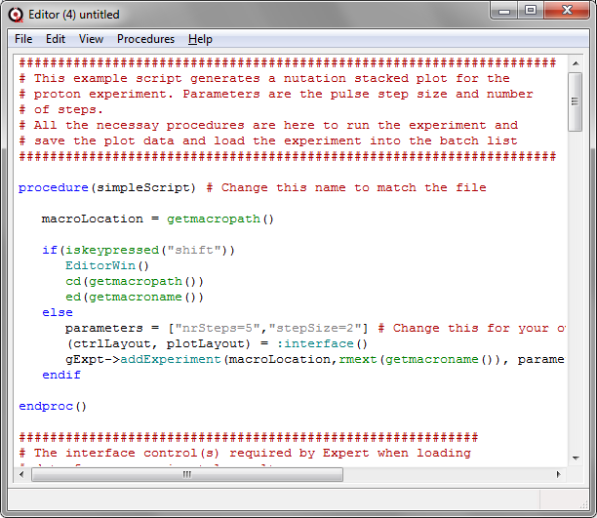

The format of the script experiment is simpler than a normal experiment. All necessary procedures are in the same file, and it calls existing experiments rather than generating a new pulse program. However, because the parameters used in the called experiments can be modified manually or programmatically this provides a powerful way to generated complex experiments from simple ones. For example, you can step a pulse duration in the Proton experiment to generate a nutation experiment or a take the output of one experiment to influence the operation of another. Please refer to the SpinsolveExpert User manual for more details on how to write a script.

# Window Designer

This displays an interactive window designer which can be used to design your own user interface (this was used, for example, to design the Samples user interface). Please refer to the Help file accessible from this window for more details.

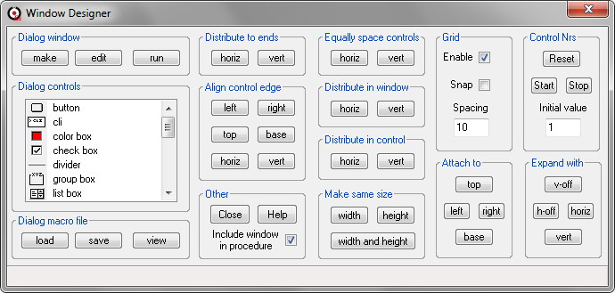

# Information

This prints a short description of each of the scripts present in this menu to the command line interface. Here we will just describe the ArrayedExperiment script as this is likely to be the most useful.

# ArrayedExperiment

This script can call any experiment and modify a parameter within that experiment. The parameter will take the values passed in the parameter array. For 1D experiments the result will be a stacked plot while for 2D experiment a series of 2D plots will be displayed.

The user interface consists of 4 parameters:

* The protocol to call repeatedly.
* The parameter within the protocol which should be modified
* An array specifying the values the parameter should take
* Which saved file to present in the final plots

In addition to these parameters, you can also view and adjust all the usual parameters for the protocol you have chosen.

In the following examples the Proton protocol has been chosen and the pulse length parameter is adjusted from 1 to 20 us – this will result in a nutation experiment.

The second example runs the INEPT experiment which will vary the evolution delay from 1 to 4 ms in 0.2 ms steps.

|  |  |  |
| --- | --- | --- |
| *Proton as the arrayed experiment with pulseLength1H as the array parameter*s |  | *INEPT as the arrayed experiment with dEvolution as the array parameter* |

This result can be loaded into the 1D Data Analyser and integrated to give a nutation curve.

Similarly, the INEPT experiment produces the following set of curves which can also be integrated, from which the optimum evolution time can be determined (~2.5 ms)

