**The Spinsolve-Expert Setup Menu**

Contents

Shimming 2

CheckShim 2

Standby Shim 2

Quick Shim 3

Power Shim 5

The Shim File 6

Finishing the shim 7

Miscellaneous setup experiments 7

Import Standard Shim and Calibrate from Standard Software 7

Export Shim and Calibrate to Standard Software 7

Load Expert or User Shim 8

Lock and Calibrate 8

This menu controls the setup of the Spinsolve spectrometer; shimming, locking, and calibration.

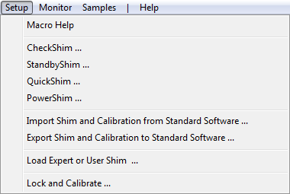

For a Spinsolve which has not been used for a while, or with a new computer, the PowerShim option allows shims to found when the only reference is the factory settings. Once a good shim file has been generated, regular adjustments can be performed using the QuickShim or StandbyShim options. The shimming options also perform a lock and calibration, so no other steps are required before a new experiment can be run.

Here is a brief summary of the items in this menu

# Shimming

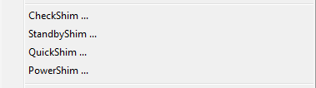

Shimming is the process of improving the magnetic field uniformity in the probe to minimize the spectral linewidth.

This menu contains an option to check the shim, a Quick Shim option, a Power Shim and a StandbyShim. All experiments must be added to the user interface first by selecting the menu option and then the Run button pressed. This allows the shim to be recorded in the history list. A calibration offset and, in some cases, a method is also available as a parameter. If using the reference water sample then the default value of 4.74 ppm is correct, otherwise enter the offset of the largest peak in the spectrum which will be used as the shimming reference.

## CheckShim

Check shim runs a Proton pulse and collect experiment and measures the linewidth reporting this to the command line interface. This should be done using the reference sample. It also saves this data internally to be used for reference deconvolution when post processing 1D data.

There are two parameters. The Long acquire time check toggles the number of points collected between 32 and 64k while the dwell time selects the sampling interval. This defaults to 200 us since this is the default for the Proton experiment and if these match it can be used for deconvolution when post processing.

The output is the linewidth at 50 % and 0.55 % of the peak height.

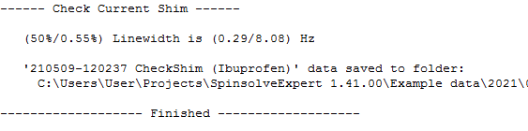

Be aware that running CheckShim on a non-reference sample may lead to a larger linewidth than expected, because of overlapping peaks and short T1s.

## Standby Shim

Because the Spinsolve magnet is temperature sensitive, the shim and resonant frequency will drift with time. To avoid having to perform a time-consuming Power shim when returning to the spectrometer after some time, you can instead run the standby shim when you are not using the instrument. To do this, insert a suitable water reference sample and select StandbyShim. Then press Run. The program will perform a continuous series of 1st and 2nd (and optionally 3rd) order Quick Shims interleaved with a calibration step. When you are ready to use the instrument again, press the complete button to end the shimming process. This involves relocking and calibrating the spectrometer. If the collect reference option is selected, then a high resolution spectrum will be collected and saved for post processing deconvolution. Note that this adds another minute to the time it takes to complete the exit process.

The Spinsolve will now be freshly shimmed, calibrated and ready for normal use.

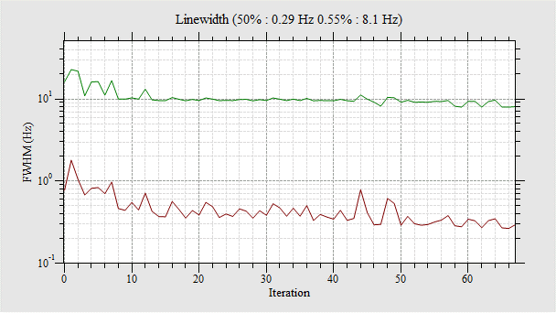

A short standby shim showing the rapid improvement in linewidth

## Quick Shim

The Quick Shim options should be used when you have a reasonably good shim – better than 5 Hz. Start by entering whether you want to perform a lock and calibration step and then the peak position in the latter case.

You can choose from three different shim speeds – typically Fast shim will work fine. If the sample has a very long T1 you might want to use the medium or slow.

The Shim start-mode defines which shims to start from. The last Expert Shim is the shim found after performing a Quick, Power Shim or after importing a shim from the Standard software or from a file.

The ‘Last Standard Shim’ takes the shim from the Standard software data-base.

‘Loaded Shims’ takes the shim from the values displayed in the lower part of the parameter list. These will only be visible if you select ‘Show all parameter entries’ in the ‘Experiment’ menu. Here you have the option to load a shim from a parameter file or enter the shims manually.

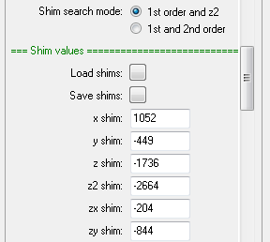

These entries are also modified during the shim process.

Finally you can select the shim order to correct. Most of the time the first order (x, y and z) and z2 will be sufficient to restore a shim. Shimming all second order or third order shims as well will take longer.

The fast first order shim takes about 40 seconds depending on how close you are to the perfect shim. If the shim improves, but is still not ideal, try the high order options. These take from 1.5 to 4 minutes. Note that the estimated time shown in the progress bar will be on the low side since it assumes a good starting point. Sometimes it can take up to twice as long. The Quick Shim uses a parabolic search; for each shim, three measurements are made of the shim quality with a middle, low, and high shim value centred on the starting value. If the middle value is not the lowest, a search is done sideways until it is. Then a parabolic fit is performed to find the shim value corresponding to the best linewidth. This process is then repeating for all shims in the list.

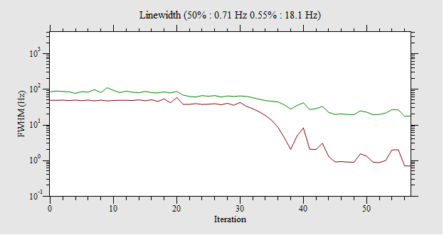

*An example of Quickshim output using the first order shim option*

If you are far from a good shim the shim step size might be increased before the parabolic search is started.

## Power Shim

|  |  |
| --- | --- |
| If the shim refuses to improve you will need to run the Power Shim.  This takes around 25 minutes depending on the number of steps chosen, but should find a good shim regardless of the starting point. The Power Shim uses a simplex search to try and find the global minimum in the multidimensional shim space.  Again, you can choose your starting shim value. Normally this will be the last Expert shim, but it can also import the Standard shim, or if it has been a while since you shimmed, the Factory settings. You can even set the start values to zero, although this may not always converge to the best shim.  The power shim is divided into different phases. Phase 1 uses relatively large steps and adjusts the first order shims and z2 and has a short acquisition time (41 ms). |  |

This is followed by Phase 2 which adjusts all first and second order shims with smaller steps and has a longer acquisition time (160 ms).

Phase 3 repeats phase 2 but with smaller steps and an even longer acquisition time (655 ms), while phase 4 optimises all the shims using the smallest steps and a 2.5 s acquisition time.

*An example of PowerShim output showing the 4 phases (32 minutes)*

Often you can shorten the whole power shim process by changing the number of steps in each phase. An example of this is given in the script FastPowerShim which sets the number of phase 4 steps to zero and replaces this with a 3rd-order fast Quickshim. In this case the complete Power+Quick shim process takes about 12 minutes.

*The FastPowerShim output with the PowerShim result at the bottom*

*and the QuickShim result at the top.*

## The Shim File

At the end of the shimming process a shim file is saved in the following location in the Prospa preferences folder (which you can access from the main File menu):

<prospa-preferences>\SpinsolveParameters\Shims

The shim file will have the name

SPAXXXShims.par

where SPAXXX is the identification number of your Spinsolve. If contains a list of shim values along with the linewidths found. For example:

xshim = -1020

yshim = 2858

zshim = 4070

z2shim = -3176

zxshim = 1099

zyshim = 785

xyshim = 1754

x2y2shim = 1238

z3shim = -1993

z2xshim = -993

z2yshim = -415

zxyshim = -86

zx2y2shim = -135

x3shim = -494

y3shim = 1576

If you choose ‘Last Expert Shim’ as the start mode then shimming will use this file as a starting point.

## Finishing the shim

When the shim is compete, or if you press the ‘Complete’ button, the lock will be reengaged and the system will be recalibrated. The shims will then be saved.

Pressing the Abort button will stop the shimming process without saving the shim values or calibrating. Locking and calibrating can also be done using the ‘Lock and Calibrate’ option in this menu.

# Miscellaneous setup experiments

If you are happy with an existing shim set, then it may be quicker just to load this shim and then lock and calibrate rather than search for a new optimal shim. The options in the lower part of the Setup menu will allow you to do this.

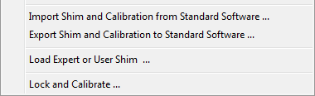

Note that there are no parameters for some of these protocols, but you still need to press the Run button to initiate them.

## Import Standard Shim and Calibrate from Standard Software

This imports the shim and calibration from the Standard Spinsolve software database and updates the shims and B1 frequencies on the Spinsolve. After importing the shim it will run a CheckShim. Relocking and calibration is optional

## Export Shim and Calibrate to Standard Software

This is the reverse of the previous command. The Shim and Calibration found by Expert are exported to the standard software data-base. By combining these commands it should be possible to move between the two software packages without having to reshim or calibrate on both sides. Note that you will need to restart the Standard software to see these new settings.

## Load Expert or User Shim

This provides the opportunity to load the shims from a file, from the factory settings or even zero the shims (press the appropriate button in the parameter list). It also allows the shims displayed in the parameter list to be saved to a parameter file. You can also make manual modifications to the shim settings.

By default it will first load the last set of shims saved by SpinsolveExpert. These are stored in the following location in the Prospa preferences folder

<preferences_folder>\SpinsolveParameters\Shims\SPAxxxShim.par

Once you have imported or modified the shims press the Run button to send them to the spectrometer. You can also optionally execute a check-shim by selecting the ‘Measure linewidth’ checkbox.

## Lock and Calibrate

If the Spinsolve has lost the lock then this option will refind the it and calibrate the PPM axes to the largest peak. Again you can enter the peak offset (which defaults to 4.74 ppm) before running the experiment

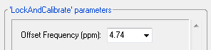

As a final step the experiment also measures the linewidth.