**The Spinsolve-Expert View Menu**

Contents

Display data value under cursor 2

Select a rectangular region 3

Move a plot 3

Select row data 3

Select column data 4

Select a region and zoom 4

Zoom a region 5

Show last region 5

Display all data 5

Show legend 5

Toggle single/multiple view 6

Next plot in single plot view 6

Show real part 6

Show imaginary part 6

Move & scale 6

This menu has options for modifying the view in the current plot or image as well as in the parameter list. The menu entries will differ depending on whether a 1D plot or 2D image has been selected.

|  |  |
| --- | --- |
| *The 1D plot view menu* | *The 2D image view menu* |

 A description of the different options is given below

## Display data value under cursor

When this option is selected a cross-hair cursor will be available in the currently selected 1D window. This cursor can be used to determine the value of data points in the window. First select the plot window to be viewed. Next press the left mouse button somewhere on the data-set of interest. A new dashed cursor will then appear (see below). By dragging the mouse the cursor will track the data and the (x,y) data values will be reported in the status region at the bottom of the 1D window.

If the right button is clicked while the cursor is visible, then an offset is applied to the x-value in the status window so that it is zeroed at this point. This allows distances along the x-axis to be measured. Click the right mouse button again to remove the offset.

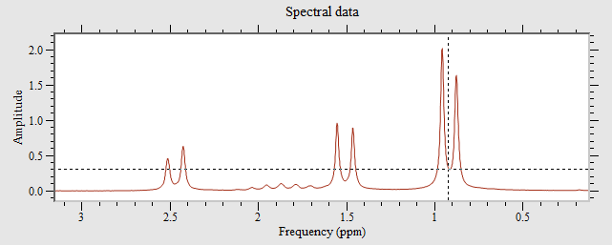

*The data under the cursor is reported in the status window as shown below and is updated in real time as the cursor is moved.*



The values here are the array index (13713), the x-axis ppm value (0.92) and the real and imaginary data amplitude. (In this case the imaginary part is not visible).

In the case of 2D plots the status bar shows the x, y coordinates in the current units and the intensity of the point under the cursor:

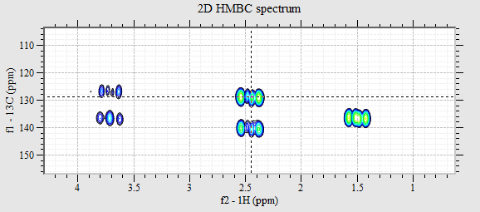



When in offset mode an 'O' will be displayed in the right corner of the status window 

## Select a rectangular region

This option allows the user to select a rectangular region in the current 1D or 2D plot using the mouse and cursor. This rectangle may be used to specify a region for enlargement, or for other purposes by using the Prospa getrect() command.

## Move a plot

This command allows the current 1D plot to be interactively moved or dragged using the mouse, or zoomed using the mouse scroll-wheel. To move, select the point to “grab” and then drag the mouse with the left button help down. The 1D plot will follow you during this operation. To zoom, just rotate the mouse scroll wheel. In one direction it zooms in and the other is zooms out.

## Select row data

(2D only). This allows rows from the current 2D plot to be viewed in the current 1D plot. This only works if an additional 1D plot is visible in the user interface or if you open a new 1D window from the Windows menu.

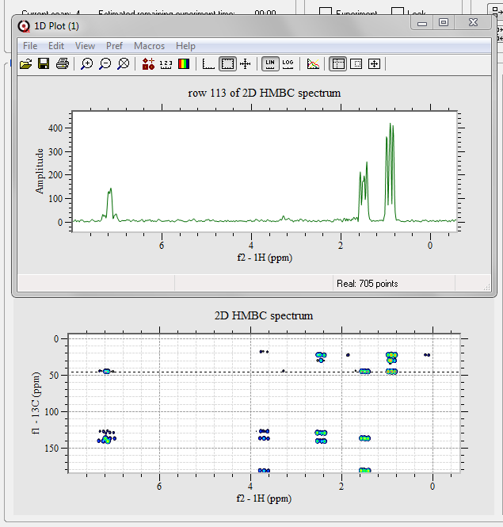

*An example of a row from a 2D plot being displayed in a new 1D window*

## Select column data

(2D only). This allows columns from the current 2D plot to be viewed in the current 1D plot. This only works if an additional 1D plot is visible in the user interface or if you open a new 1D window from the Windows menu. An alternate version of the row and column data viewer may be found in the 2D plot viewer, a post processing tool for 2D plots.

## Select a region and zoom

This combines ‘Select a rectangular region’ and ‘Zoom a region’ into one action. To use this option hold down the control key while dragging the mouse with the left mouse key depressed. A coloured translucent rectangle will follow the mouse cursor and when you release the left mouse button the zoom will be performed.

|  |  |
| --- | --- |
|  |  |

## Zoom a region

This command allows you to zoom in on a region of interest. To do this, first choose the "Select a rectangular region" option in the menu and then select a rectangular region in the plot window using the mouse; click the left mouse button to define one corner and then drag the mouse, with the button held down, until the rectangle is the right size. Then release the left button. If you don’t like the region you have selected you can select another region.

When you are satisfied with the selected region, select this option. The chosen region will then be expanded to fill the plot window. This process can be repeated any number of times.

When in the zoom mode a 'Z' will be displayed in the right corner of the status window: 

## Show last region

To move back to previously selected regions, click the history button or type “Ctrl-L”.

## Display all data

Displays the complete data set following a zoom.

## 

## Show legend

If you wish to add a legend to the plot select this option. You can change the name of the trace appearing in the legend using the ‘Edit trace settings’ option in the Edit menu or by double clicking on the trace. If you are using the 1D plot window from the Windows menu you can also overlay multiple traces:

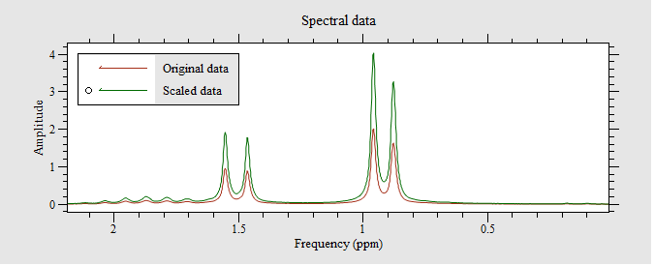

Note that this option is only available for 1D plots.

## Set plot layout

Here you can manually modify the plot layout to hide plots or reorganise them. They can then be saved to using the Ctrl+S shortcut so when reloaded they will retain this layout. Note that you should use standard plot layout syntax when defining the new layout. See section 7 of the Spinsolve-Expert user manual for details.

## Toggle single/multiple view

This option provides the same functionality as the button in the View region of the user-interface  , replacing a multiple plot view with a single plot view or vice-versa

Next plot in single plot view

 This selects the single plot view if it is not already selected and then cycles through the available plots each time this option is chosen. This is the same functionality as provided by the button in the View region of the user-interface.

## Show real part

When a complex 1D data set is displayed this will toggle the visibility of the real part.

## Show imaginary part

When a complex 1D data set is displayed this will toggle the visibility of the imaginary part.

|  |  |
| --- | --- |
| Move & scale  The next two options are pull-right menus that allow keyboard control of the currently viewed region. The Move options use the arrow keys to shift the currently viewed region left, right, up or down by 1%. Holding down an arrow key will cause the contents to move continuously.  Likewise the Scale options do the same except that the shortcut keys include the shift button. (Here the scaling factor is 10% larger or smaller). | *Move submenu*    *Scale submenu* |