**The Spinsolve-Expert Windows Menu**

Contents

Open new editor 1

Open new 1D Plot 2

Open new 2D Plot 3

Open new 3D Plot 3

Show/hide temporary windows 4

Show next window 4

Show last window 4

This menu has options for creating new floating windows and selecting and moving between these windows.

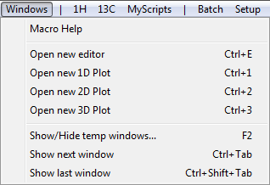

At the bottom of this menu will also be listed all any floating windows which have be created (some of which might be minimised). You can select and show these here.

# Open new editor

The editor supplied with Prospa/SpinsolveExpert is designed to work with the Prospa scripting language. It provides syntax help, syntax highlighting and simple ways to navigate around the Prospa scripting environment.

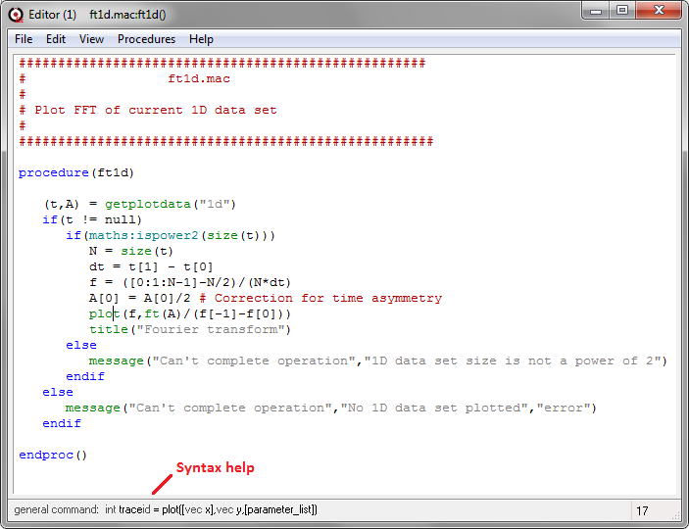

*A new editor window with the 1D plot menu script ft1d.mac loaded*

Many of the scripts accessible via the main menu can be viewed in an editor by holding down the shift key when selecting the menu item. The scripts underlying dialogs and window can also be viewed by shift-double clicking on the window or dialog while the text editor is open. Note that the complete SpinsolveExpert interface is built from user-modifiable Prospa scripts.

# Open new 1D Plot

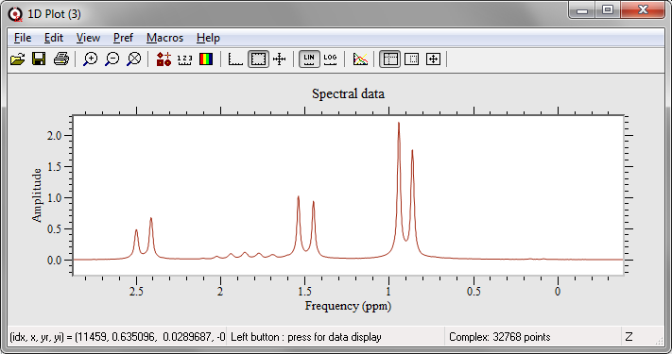

In addition to the 1D plots in the main user interface you can also define floating 1D plot windows. These provide their own menu and a variety of tools with which to manipulate the data. You can copy a 1D plot from a main plot window to the floating window using usual the Ctrl-C Ctrl-V combination. Multiple traces can be overlaid by holding down the shift key when pasting. This allows comparison of different traces.

# Open new 2D Plot

In addition to the 2D plots in the main user interface you can also define floating 2D plot windows. These provide their own menu and a variety of tools with which to manipulate the data. You can copy a 2D plot from a main plot window to the floating window using usual the Ctrl-C Ctrl-V combination.

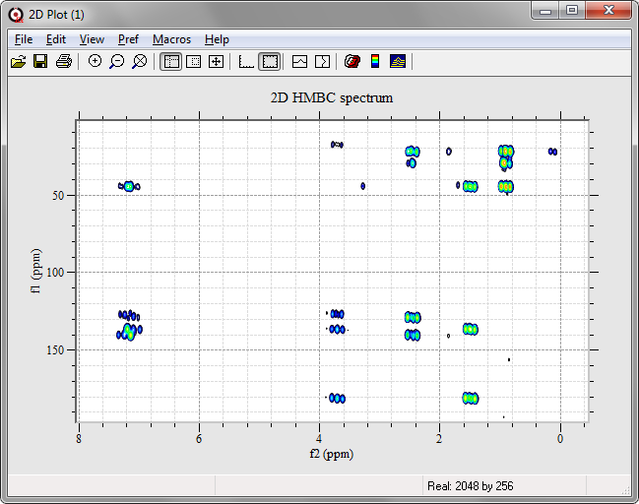

*The 2D contour plot copied into a new 2D plot window*

# Open new 3D Plot

This allows 3D plots of different kinds to be displayed. There is limited need in Spinsolve-Expert to show 3D plots, however there is a demonstration in the Macros\demos folder which shows the evolution of several magnetisation vectors due to the magnetic fields produced during a CPMG pulse train.

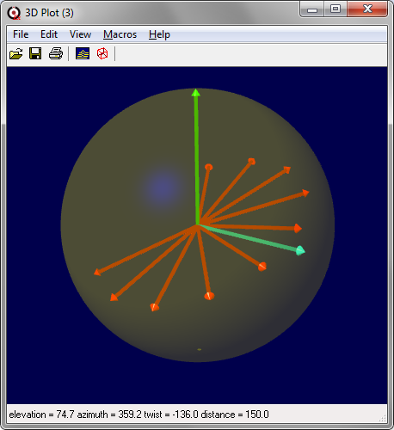

# Show/hide temporary windows

This will hide or show all windows which are not part of the main user interface (i.e. temporary or floating windows).

# Show next window

This will make the next window get the keyboard focus.

# Show last window

This will make the previous window get the keyboard focus.