Report on Invertebrates on Dutch Coast

Stu Dent

7/17/2017

# R Markdown Introduction

This is an R Markdown document. Markdown is a simple formatting syntax for authoring HTML, PDF, and MS Word documents. For more details on using R Markdown see <http://rmarkdown.rstudio.com>.

The formating for this manuscript is controlled by the template "word-styles-reference-01.docx." If you would like to change the formatting to match a journal's preferences, for example, you can follow the instructions in this article: <http://rmarkdown.rstudio.com/articles_docx.html>.

When you click the **Knit** button a document will be generated that includes both content as well as the output of any embedded R code chunks within the document. You can **Knit** to PDF or to Microsoft word, just chose the appropriate dropdown from the **Knit** button.

## Style notes:

* You can make words **bold** with two asterisks, *italicized* with one.
* Hashtags denote a header, and the hierarchy is defined by the number of hashtags.

## How to set up references

You can cite references using the **citr** add-in. With **citr** you can cite papers in line like Fieberg and Guidice (2008) is fond of doing, or parenthetically (R Development Core Team 2014). You can also cite multiple sources at once (Zuur et al. 2007, Fieberg and Guidice 2008, Plummer 2013). References can be added into the myrefs.bib file directly, or created with BibTeX through LaTeX.

# Methods

## Data

The data has been collected by week from several areas along the Dutch coast (Fig. 1).

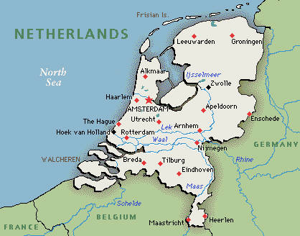

1. Data collection sites (Zuur et al. 2007).

## Statistical Analysis

We used simple linear regression to relate invertebrate richness ($y$) to NAP ($x$):

$$y=β_{0}+β_{1}x.$$

# Results

The results of the regression analysis demonstrate a significant, negative relationship between richness and NAP (Fig. 2).

lm.out <- lm(Richness~NAP, data = rikz.data)  
summary(lm.out)

##   
## Call:  
## lm(formula = Richness ~ NAP, data = rikz.data)  
##   
## Residuals:  
## Min 1Q Median 3Q Max   
## -5.0675 -2.7607 -0.8029 1.3534 13.8723   
##   
## Coefficients:  
## Estimate Std. Error t value Pr(>|t|)   
## (Intercept) 6.6857 0.6578 10.164 5.25e-13 ***  
## NAP -2.8669 0.6307 -4.545 4.42e-05 ***  
## ---  
## Signif. codes: 0 '***' 0.001 '**' 0.01 '*' 0.05 '.' 0.1 ' ' 1  
##   
## Residual standard error: 4.16 on 43 degrees of freedom  
## Multiple R-squared: 0.3245, Adjusted R-squared: 0.3088   
## F-statistic: 20.66 on 1 and 43 DF, p-value: 4.418e-05

The fitted relationship was 6.69 + -2.87x.

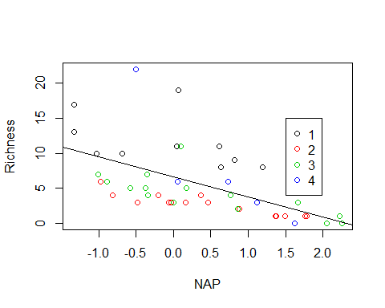

2. The relationship between richness (y) and NAP (x): y = 6.69 + -2.87x (Zuur et al. 2007).

# References

Fieberg, J. R., and J. H. Guidice. 2008. Variance of stratified survey estimators with probability of detection estimates. The Journal of Wildlife Management 72:837–844.

Plummer, M. 2013. JAGS Version 3.4.0 user manual.

R Development Core Team. 2014. R: A Language and Environment for Statistical Computing. R Foundation for Statistical Computing, Vienna, Austria.

Zuur, A., E. Ieno, and G. Smith. 2007. Analysing Ecological Data. Springer, New York.