Chapter 2

This chapter was written to conform to the submission requirements of the *Journal of Ecological Restoration*, where I intend to publish. I wrote it in collaboration with my academic advisor Dr. Todd Arnold and Dr. Althea ArchMiller, both of whom will be co-authors on that publication. The use of plural pronouns throughout the thesis is reflective of this collaboration.

Hierarchical Abundance Modeling to Inform oak savanna Habitat Restoration within the Anoka Sand Plain of Minnesota

Abstract

Oak savanna is imperiled across its entire global range, including the Midwestern United States. Sand Dunes State Forest in central Minnesota contains some of the last high-quality remnants of oak savanna in the state, and in 2013 the Minnesota Department of Natural Resources initiated a comprehensive effort to restore additional areas of the state forest to pre-settlements habitat types. To inform restoration and management within Sand Dunes, we surveyed for six habitat specialist wildlife species between 2014 and 2016 and used hierarchical abundance models to describe relationships between abundance and occupancy and habitat characteristics related to management. For gophersnakes (*Pituophis catenifer)* andplains hog-nosed snakes (*Heterodon nasicus)* we obtained insufficient data for statistical analysis, but for remaining species we found that predicted abundances and occupancy probabilities were affected by habitat features and management disturbances. Eastern towhees (*Pipilo erythrophthalmus)* and lark sparrows *(Chondestes grammacus)* both declined in abundance with increasing canopy closure, indicating the importance of open partly forested habitats for both species. In addition, lark sparrow abundance increased with management disturbance and declined with number of woody stems. Leonard’s skippers (*Hesperia leonardus leonardus)* increased in occurrence and abundance with increased abundance of blazing star (*Liatris* spp.), a preferred food source, and declined in abundance following management disturbance. Finally, norther barrens tiger beetle (*Cicindela patruela patruela)* responded positive to canopy closure and topographical relief. It was noteworthy that some of the same habitat variables (e.g. canopy closure, recent disturbance) affected different species in different directions. These results highlight the importance of careful planning when undertaking habitat restoration projects. Plans should consider the habitat nee4ds of individual species as well as their responses to active habitat management to achieve balance between maintenance of local populations and habitat restoration on a landscape scale.

Introduction

Oak savanna and upland prairie are some of the most imperiled habitat types in North America (Noss 1995). These fire-dependent ecosystems once covered vast areas of the continent, but their distribution has been significantly reduced since European settlement (Nuzzo 1986). Once a dominant land cover, oak savanna has been reduced to less than 0.02% of its pre-settlement extent (~12,000,000 ha) in the Midwest (Nuzzo 1986) and is ranked as globally imperiled (Faber-Langendoen et al. 2001). In the United States, the Midwestern oak savanna once extended in a contiguous band from central Minnesota and Wisconsin to southeastern Texas, with spatially isolated outlying areas as far west as central North Dakota and as far east as central Ohio (Nuzzo 1986, McPherson 1997). Oak savanna was an integral part of the transition zone between the mixed deciduous forests of the eastern part of the continent and the Great Plains to the west. In Minnesota, oak savanna and other upland habitats including mixed oak woodland and brushland once blended with areas of wetland in a broad swath that stretched across the state from the northwest to the southeast, forming a mosaicked transition zone between the mixed-hardwood, conifer, and peatland areas in the northern part of the state and the tallgrass prairie systems to the west and southwest, (Marschner 1974, Coffin 1988). The high biodiversity associated with these habitat types is largely due to their function as an ecological transition between broad, disparate biomes (Dey and Kabrick 2015). The original distribution of these habitats in Minnesota was largely determined by substrate and precipitation patterns and maintained partly by cyclic fire (Nuzzo 1986, Minnesota Department of Natural Resources (hereafter, MN DNR) 2005). In the years since European settlement of the continent, human intervention in the form of fire suppression and elimination of non-agricultural grazing have allowed the natural succession of oak savanna and prairie habitats into mixed deciduous woodland and brushland, while land conversion for agriculture, urban expansion, and timber production have eliminated native habitat and altered the landscape. Of an estimated 2,200,000 hectares of mixed savanna and prairie in Minnesota at the time of the original public land survey (1848-1907) (Nuzzo 1986), only 4842 hectares remained when the Minnesota Biological Survey (hereafter, MBS) mapped native prairie and savanna habitat in the state between 1991 and 2009 (Minnesota Biological Survey 2017). The loss has continued, with an estimated 309 ha of oak savanna destroyed by urban expansion, conversion to agriculture, and mining between the original MBS mapping efforts and the most recent assessment in 2017 (MN DNR 2017).

The Anoka Sand Plain ecological subsection of Minnesota contains some of the last remnants of these rare habitats. The Anoka Sand Plain covers approximately 485,600 hectares in east-central Minnesota and encompasses all or portions of Anoka, Benton, Chisago, Crow Wing, Isanti, Hennepin, Mille Lacs, Morrison, Ramsey, Sherburne, Stearns, and Wright counties, including the northern edge of the Twin Cities metropolitan area. It is largely characterized by a broad, flat plain of glacial outwash sands and is bordered on the southwestern edge by the Mississippi river. The generally flat topography and sand substrate of the subsection are the result of meltwater from the Grantsburg sublobe during the last glaciation (MN DNR 2005), and dunes were formed by prevailing winds during periods of extreme drought during the mid-Holocene, between 8000-4000 years before present (Keen 1985). The substrate and topography resulted in a landscape with few impediments to fire and subsequent development of unique fire-adapted ecosystems. At the time of the public land survey, the predominant vegetation of the Anoka Sand Plain was oak savanna and upland prairie, surrounded by varied wetland complexes (Marschner 1974, MN DNR 2006). The subsection contains some of the highest quality examples of dry oak savanna in Minnesota, but destruction continues to threaten its persistence. Of the 309 ha of oak savanna documented as converted or destroyed since the counties were originally mapped by MBS between 1991 and 2009, 252 ha (82%) was located within the Anoka Sand Plain (MN DNR 2017). When the 2006 State Wildlife Action Plan (MN DNR 2006) was published, population growth in the Anoka Sand Plain was the fastest of any subsection in the state, and more than 90% of the land was in private ownership. The 2006 MN DNR subsection profile for the Anoka Sand Plain (MN DNR 2006) identified 97 Species in Greatest Conservation Need that were known or predicted to occur within the Anoka Sand Plain, including 39 species that were federally or state Endangered, Threatened, or Special Concern (MN DNR 2006). The Wildlife Action Plan and subsection profile identified continued habitat loss, fragmentation, and degradation as key challenges facing Minnesota Species in Greatest Conservation Need in the Anoka Sand Plain (MN DNR 2006), but the amount of native habitat in this area has continued to decline (MN DNR 2017), to the detriment of rare native animal species that depend on it for survival

Sand Dunes State Forest and Sherburne National Wildlife Refuge (hereafter, Sand Dunes and Sherburne, respectively) are spatially adjacent natural areas within the Anoka Sand Plain that have been managed under different strategies since the mid-20th century. Both contain areas of native upland habitat and provide an opportunity for conservation of rare plant and animal communities. Recognizing an opportunity to preserve and restore rare and important habitat features, the MN DNR Divisions of Forestry, Ecological and Water Resources, and Fish and Wildlife reached a joint agreement in 2013 to restore some areas within Sand Dunes to an approximation of pre-settlement vegetation and to permanently manage these areas for rare plant and animal species and the unique habitats on which they depend (MN DNR 2013b). We designed this project to function in conjunction with the 2013 operational plan for Sand Dunes (MN DNR 2013b) and to inform a process of ongoing management designed to protect and restore Anoka Sand Plain habitats for rare native species, specifically MN Species in Greatest Conservation Need.

Focal Species

When the operational plan was written, very little was known about the specific requirements of habitat specialist fauna within the Anoka Sand Plain. To better inform habitat restoration, the MN DNR selected a suite of six species identified by previous research (MN DNR 2009, Harper 2010, Hoaglund 2012) as sensitive habitat specialists likely to provide sufficient sample sizes to allow rigorous statistical analyses. Our focal species were: lark sparrow, (*Chondestes grammacus),* eastern towhee (*Pipilo erythrophthalmus),* Leonard’s skipper (*Hesperia leonardus leonardus)*, northern barrens tiger beetle (*Cicindela patruela patruela)*, plains hog-nosed snake (*Heterodon nasicus)*, and gophersnake (*Pituophis catenifer)*. All are MN Species in Greatest Conservation Need with the exception of the eastern towhee, which was chosen as an early-successional habitat specialist likely to produce sufficient data for analysis (MN DNR 2013a). Results from this project were intended to inform restoration of native habitats within the Sand Dunes State Forest and to provide guidance on future adaptive management strategies.

The lark sparrow (Special Concern) prefers edge habitats and ecotones between open and forested areas, and most frequently associated with oak savannas, dry grasslands, or pastures scattered with small trees or shrubs (Martin and Parrish 2000; Pfannmuller et al. 2017). Long-term population declines have been attributed to a loss of their preferred open, shrubby and/or agricultural nesting habitat due to natural succession, urban expansion, or conversion to more intensive agricultural practices (Hunter et al. 2001), although no studies have presented definitive conclusions and population decline has not been ubiquitous across the species’ entire range (Sauer et al. 2015). The eastern towhee is a relatively common habitat generalist in many areas of North America, but in Minnesota is mainly associated with edge habitat between forested and non-forested areas (Greenlaw 2015). Hagen (1993) hypothesized that eastern towhee populations are dependent on shrubby, early-successional habitat and that they decline as habitat succeeds into mature forest.

The Leonard’s skipper (Special Concern) prefers dry, sandy prairie and savanna dominated by native plant species (MN DNR 2008). No studies have been conducted regarding the specific habitat needs of Leonard’s skippers, but their requirements are likely comparable to similar native prairie skippers of the same genus that have been studied more extensively, including *H. l. pawnee*, which occurs on mesic prairie further to the west and hybridizes with Leonard’s skipper (Robert Dana, MN DNR, pers. comm.). The northern barrens tiger beetle (Special Concern) prefers sandy openings and roads in areas with low to moderate canopy cover (MN DNR 2008). This species requires open sand for larval and adult burrows, and open sand with sparse, scattered vegetation for hunting.

The plains hog-nosed snake (Special Concern) prefers open, sandy, sparsely-vegetated habitat such as prairie and oak savanna. According to the MN DNR rare species guide, grassland management practices that limit the encroachment of brush can enhance habitat for this species, and increasing habitat connectivity may enhance the viability of known populations (MN DNR 2008). The gophersnake (Special Concern) is widely distributed throughout western and central North America, though in Minnesota most records are from counties along the Minnesota, Mississippi, and St. Croix rivers (MN DNR 2008). The gophersnake prefers areas of well-drained, loose, sandy soil. In Minnesota, dry sand prairies and bluff prairies are considered prime habitat.

Our main study objective was to examine habitat abundance relationships for rare, upland Anoka Sand Plain species. Specifically, we attempted to describe the habitat needs of the lark sparrow, eastern towhee, Leonard’s skipper, northern barrens tiger beetle, plains hog-nosed snake, and gophersnake as they relate to current and ongoing habitat management and restoration. Our intent was to provide baseline information about species’ habitat needs and responses to management related disturbances in order to inform current management and future, more focused studies about long-term persistence of these species within the Anoka Sand Plain.

**Methods**

Study Area

Our study was conducted at Sand Dunes State Forest (45.405° N; -93.665° W) and Sherburne National Wildlife Refuge (45.494° N; -93.695° W), two managed areas in Sherburne County within the Anoka Sand Plain ecological subsection in central Minnesota. The mean (30-year-average; 1981-2010) annual temperature in the area was 6.9°C and mean precipitation was 787 mm (Station ID: GHCND:USC00217502; 45.546° N; -93.7572° W; National Climatic Data Center 2017). Although spatially adjacent, the two areas exhibit significant ecological disparities due to differing topography, historical land use, and management regimes.

Sand Dunes State Forest was acquired by the Minnesota Department of Natural Resources in 1946 and covers approximately 4,468 hectares. It has been managed primarily for timber production and recreation. Dominant land cover types include mixed oak savanna, oak woodland, sand prairie, dunes, wetlands, and pine plantations. Sand Dunes contains rare geologically and ecologically significant features, as well as diverse native plant communities and rare plant and animal species (MN DNR 2009). Previous DNR studies have recorded four globally ranked native plant communities, five sites ranked by the Minnesota Biological Survey as outstanding biodiversity significance and six sites ranked as having high biodiversity significance. Five state-listed (Endangered, Threatened, or Special Concern) rare plant species and nine state-listed rare animal species that require dry oak savanna habitats have also been documented at Sand Dunes (MN DNR 2009).

Sherburne National Wildlife Refuge (12,424 ha) is directly north of Sand Dunes and has been managed for wildlife since the 1960s. The refuge was established to preserve the Saint Francis River watershed, wetlands, and associated wildlife; especially waterfowl. Diverse wetland habitats within Sherburne include wet meadows, emergent marshes, lakes, and a meandering stretch of the St. Francis River. Upland habitat includes a mix of prairie, savanna, and forest. Upland habitat management includes selective timber harvest, conservation grazing, and prescribed burning. For the purposes of this study, Sherburne is considered to be a relatively restored and intact landscape that partly serves as a model of desired future conditions and can contribute to our understanding and evaluation of management and restoration at Sand Dunes.

Study Design

We used ArcGIS (ESRI 2011. ArcGIS Desktop: Release 10. Redlands, CA: Environmental Systems Research Institute) to select 60 40-acre (~16.2 ha) survey plots within the combined study area. Twenty plots were allocated within Sherburne and 40 plots were allocated within Sand Dunes. A higher proportion of plots were allocated within Sand Dunes because informing the DNR’s changing management strategy for the state forest was an important goal of the project. Nine plots were non-randomly placed in Sand Dunes Immediate Conversion Areas, which were designed to undergo restoration beginning in 2014. These areas were intended to provide baseline information to inform the restoration and management of Eventual Conversion Areas, which would be restored based on a longer timeframe after timber had been harvested (MN DNR 2013b). Remaining plots were randomly selected, except selections that were dominated by wetland habitats were discarded and a new primarily terrestrial plot was randomly selected. We determined our initial sample size by using Program MARK (White and Burnham 1999) to conduct Monte Carlo-based simulations designed to maximize survey power and cost-effectiveness, given anticipated patterns of abundance and detection probability based on preliminary research and expert opinion (Harper 2010). One plot within Sand Dunes was lost mid-way through the study due to a change in ownership and subsequent loss of access permission, so final analysis was performed with data from 59 plots. We designed our surveys to maximize opportunities for detection and generate replicate observations at each site for use in estimating abundance and detection parameters using N-mixture models (Royle 2004). Although all surveys followed the same general strategy, specific survey techniques were based on established methods for each taxon and differed between some focal species based on their specific ecology.

Surveys – Lark Sparrow and Eastern Towhee

We conducted concurrent point count surveys for lark sparrows and eastern towhees from a single survey point within each plot (Hutto et al. 1986). Each plot’s survey point was placed in oak savanna or the habitat most resembling oak savanna based on our interpretation of aerial photography in ArcGIS. If no suitable habitat was available, the point was placed in the center of the plot. All survey points were at least 100 m away from the plot edges. We surveyed each plot twice during the breeding season (May 20 – June 30) in two consecutive years of the study (2015-2016). Each survey was a 9 minutes long and was conducted between 30 minutes before sunrise and 10:00 h when wind was below 16 kph and precipitation not more than a light drizzle. Point counts were divided into 3 consecutive 3-minute intervals, which resulted in a total of 12 detection opportunities per plot over the entire study period. During each survey interval we recorded the number of individuals of each target species that were detected by sight or sound. Individuals that were detected during multiple intervals were counted during each interval in which they were detected. We assumed population closure during and between surveys conducted within the same year, but not between years.

Surveys –Insects and Snakes

We conducted plot-level wandering transects for Leonard’s skippers, northern barrens tiger beetles, and both snake species. We traversed as much appropriate habitat as possible while searching for target species for a fixed amount of time (30 or 60 min). Searches were divided into 3 equal time intervals (e.g., 3x10 min or 3 x 20 min), and were considered to be concurrent for all non-avian target species unless the search was conducted outside of the appropriate timeframe for any species, in which case it was omitted as a target of that search. Searches specifically targeting our invertebrate species were conducted as follows.

Surveys – Leonard’s skippers

Surveys for Leonard’s skippers were conducted in 2015 and 2016 between August 1 and September 30 to coincide with the annual flight period. Searches were conducted in sunny or partly sunny conditions, and not during rain events. Surveyors targeted blooming blazing star (*Liatris* spp.) or other nectar sources and counted the number of adult Leonard’s skippers encountered during each interval of the search.

Surveys – Northern barrens tiger beetles

Surveys for northern barrens tiger beetles were conducted in 2014, 2015 and 2016 between May 1 and June 30 to coincide with their primary flight period. There is a second, smaller flight as new adults emerge during the late summer. Observations were also recorded during that time period, but surveys during late summer were focused primarily on Leonard’s skippers. We conducted searches in ambient air temperatures of at least 10°C under sunny or partly sunny conditions with no rain. We targeted sandy roads and trails and other open sand patches, and counted or estimated the number of tiger beetles encountered during each period of the search. Because tiger beetles have more than one generation present per season (adults that overwinter and larvae that develop into adults and emerge during the summer), we did not assume population closure between surveys or years.

Surveys – Snakes

We surveyed for gophersnakes and plains hog-nosed snakes in a similar manner to our target invertebrates. We conducted plot-level wandering transects in 2015 and 2016 between April 1 and June 30, and Aug 15 and Sept 15 to coincide with periods of highest activity. Spring searches were not conducted before the ground was thawed, and all searches were conducted when it was not raining and ambient air temperature was at least 10°C.

Habitat Characteristics

We measured habitat characteristics during the summer and fall of 2016. We measured vegetation cover in at least three to five 1-meter radius subplots within each plot. One subplot was located in the center of each plot, with four more located half way to each of the four plot corners. Subplots that were located within lakes or wetlands were not surveyed. Understory vegetation was evaluated at each subplot, including: percent cover of bunchgrass, non-bunchgrass, and little bluestem (*Schizachyrium scoparium*); number of stems of woody vegetation (i.e. shrubby species < 0.5 m tall), blazing star (*Liatris* spp.), and milkweed (*Asclepias* spp.); number of pocket gopher (*Geomys bursarius*) mounds; and litter depth. We averaged all subplot variables over the entire plot. Several additional variables (e.g., habitat type, percent canopy, number of open-grown oaks, and number of sand blowouts) were evaluated at larger scales. Habitat type was categorically generalized as the dominant habitat type of the area immediately surrounding the subplot. Percent canopy cover was evaluated based on the effective area visible from each subplot center with a densitometer. All open-grown oaks and sand blowouts visible from each subplot were counted, and values were averaged over the entire plot. Open-grown oaks were defined by spreading, symmetrical and well-developed canopies that had grown without the apparent interference of nearby trees. Sand blowouts were classified as areas of open sand at least 1 meter in diameter.

**Statistical Analysis**

We identified *a priori* habitat covariates likely to affect occupancy, abundance, and detection probability based on the natural history of each target species and our knowledge of the study system. Lark sparrows often inhabit disturbed sites with exposed soils, grazing, or recent fire and prefer areas with canopy cover of less than 25% (Martin and Parrish 2000). Dechant et al. (2002) reported that lark sparrow abundance was negatively correlated with ground litter and cover density. We therefore hypothesized that lark sparrow abundance would be negatively related to litter depth and canopy cover and positively related to sites with shrubby habitat and management-related disturbances. The eastern towhee exhibits a preference for shrubby, early-successional habitats, so we predicted that their abundance would be inversely related with canopy cover and positively related to management activities that retain open savanna conditions (e.g., burning, grazing, or forest management). For both bird species, we hypothesized that detection probability would be affected by date and minutes from sunrise. Leonard’s skippers seem to favor areas of mesic prairie that have open sand or other bare ground between clumps of bunchgrass. Larvae feed on grasses, build refugia in the base of bunchgrasses, and likely overwinter in the tangle of vegetation at the base of bunchgrasses or on the ground under the overhanging grass (Robert Dana, MN DNR, pers. comm.), which may make them susceptible to destruction during prescribed burning (Dana, R. 1991). Leonard’s skippers were frequently observed nectaring on blazing star (*Liatris* spp.) during previous studies within the Anoka Sand Plain, and *Liatris* is believed to be a preferred nectar source (MN DNR 2009). We therefore hypothesized that Leonard’s skipper abundance would be positively related to graminoid cover and *Liatris* abundance and negatively related to canopy cover, litter depth, and management disturbances, and that detection would be positively affected by *Liatris* and negatively affected by wind speed. Northern barrens tiger beetles are chase and ambush predators known to inhabit oak savanna, pine barrens, and light to medium density forest or forest edges with available open sandy areas. Anecdotally, observers have noted that tiger beetles seem to be found most frequently in areas of Sand Dunes and Sherburne that have rolling topography (Christopher Smith, MN Department of Transportation, pers. comm.). We therefore hypothesized that tiger beetle abundance would be positively related to variation in elevation and negatively related to canopy cover and litter depth, and that detection would be positively affected by date and temperature. Both the plains hog-nosed snake and gophersnake prefer sparsely-vegetated areas of sandy, well drained soils. We hypothesized that both snake species would be negatively related to canopy cover, percent grass, and litter depth, and that detection would be affected by date and temperature.

Our general modeling approach used state-space abundance models (also known as N-mixture models; Royle 2004), which are particularly useful for modeling field data from unmarked animals because they allow for concurrent modeling of abundance and detection probability (Royle 2004). Hostetler and Chandler (2015) further modified these models to account for excess zeroes that often result from field surveys of rare species by incorporating the flexibility to model data with negative binomial or zero-inflated Poisson distributions, in addition to the default Poisson distribution typically employed in N-mixture models (Royle 2004, Hostetler and Chandler 2015). State-space abundance models rely on repeated observations from the same location to evaluate local while accounting for individuals that go undetected. Although the evaluation of factors that influence a species’ detection probability may not be a primary goal of many studies, its inclusion in the process allows for inference about the proportion of null observations (i.e., failures to detect the species of interest when it was actually present during the survey), as well as systematic undercounting that occurs when surveyed organisms are mobile or cryptic.

Models developed by Dail and Madsen (2011) and Hostetler and Chandler (2015) build on the N-mixture abundance models originally proposed by Royle (2004) by allowing population size to change between primary survey periods (e.g., years). In addition to the conditionally related elements of initial abundance and detection probability that are evaluated in Royle’s original class of N-mixture models, open population N-mixture models also allow for the evaluation of abundance during subsequent time periods. Colonization (population establishment at a previously unoccupied site), extinction (loss of all individuals at a previously occupied site), recruitment (gain of individuals at a previously occupied site), and survival (loss of some individuals from an occupied site) can all be described by this class of model. Although a two-year study is insufficient to examine factors affecting recruitment and survival, we included these parameters in our models to avoid assuming that surveyed populations were closed to demographic changes across seasons, an important assumption of the original N-mixture model described by Royle (2004).

In addition to population closure, state-space abundance models also include other important assumptions that warrant further explanation. N-mixture models assume constant detection probability among individuals across all sites and survey occasions, unless such variation explicitly modeled by covariates, and this assumption is likely to be violated during field surveys (Barker et al. 2018, Link et al. 2018). N-mixture models also assume that counts are binomial random variables, an assumption that could easily be violated if some individuals are counted more than once during a survey (Link et al. 2018). We structured our field survey techniques with these assumptions in mind, and for species whose specific ecology introduced potential violations of these assumptions (e.g., both species of invertebrates), we developed Bayesian hierarchical models to relax these assumptions.

Assuming that *Nh,t* is the true abundance in plot *h* in survey year *t*, we can account for among-plot variation in *Nh,1* (i.e., initial plot-level abundance) with a Poisson process (eq 1), a negative binomial (NB) process (eq 2), or a zero-inflated Poisson process (eq 3):

$N_{h,1}\sim \text{Pois}\left(λ_{h}\right)$ (eq1)

$N_{h,1}\sim \text{NB}\left(λ_{h},α\right)$ (eq2)

$N_{h,1}\sim \text{0 with probability} ψ \text{or }N_{h,1}\text{\sim Pois}\left(λ_{h}\right)\text{ with probability} 1-ψ$ (eq3)

where $λ_{h}$ is plot level mean abundance, $α$ is the spread of the negative binomial distribution and $ψ$ is the additional proportion of unoccupied plots (i.e., the inflated zeros). Plot-level mean abundance is typically modeled with log-linear regression of plot-level covariates (e.g., habitat characteristics):

$\log\left(λ_{h}\right)=β_{k}X_{h,k}$ (eq4)

where $β_{k}$ is a vector of k + 1 regression coefficients (i.e., $β_{0},β_{1}$… $β_{k}$) and $X_{h,k}$ is a matrix of plot-level habitat covariates including intercepts (i.e., $1,x_{1}$… $x_{k}$). Subsequent year abundance is then a combination of the surviving individuals from each plot (*Sh,t*) and recruitment of new individuals into each plot (*Gh,t*):

(eq5)

$S_{h,t}|N_{h,t-1}\sim \text{Bin}(N_{h,t-1},ω)$ (eq6)

$G_{h,t}|N_{h,t-1}\sim \text{Pois}(γN_{h,t-1})$ (eq7)

where $ω$ is probability of survival (including both mortality and emigration) and $γ$ is per-capita recruitment (including fecundity and immigration). Given sufficient data, both $ω$ and $γ$ can be functions of plot or occasion-specific covariates, but for our study we treated them as simple constants. Detection is a binomial process based on plot-and occasion-level abundance, *Nh,t*, and the probability of detecting individuals (*ph,i,t*) in each plot *h*, survey replicate *i*, and survey occasion *t*. The detection probability was assumed to be affected by survey-specific covariates (*xh,i,t*), which gave us our observed counts (*nh,i,t*):

(eq8)

$\text{logit}\left(p_{h,i,t}\right)=β_{k}X_{h,i,t}$ (eq9)

where equation 9 is a logistic regression that allowed us to predict the survey-specific detection probabilities based on plot-, survey-, and occasion- specific covariates ($X_{h,i,t}$**).**

For all target species that we analyzed, we used package unmarked (Fiske and Chandler 2011) in Program R (R Core Team, 2013) to construct hypothesis-based models of initial abundance (*Nh,1*) with individual site covariates (*xh*) chosen based on *a priori* knowledge of the species of interest and the study system. We followed a degree of freedom spending approach and limited the number of explanatory covariates to between 3 and 6 variables per species, based on our original sample size m = 60 plots and guidelines given in Giudice et al. (2012) of *m*/10 or *m*/20 total variables, depending on whether m was continuous of binary, respectively. As a first step, we estimated initial abundance using either Poisson, negative binomial, or zero-inflated Poisson distributions to determine which baseline model provided the best fit for our data, where “best” was determined based on minimum values of the Akaike information criterion (AIC). Next, we used the best-ranked initial abundance model to determine covariates that influenced detection probability ( $p_{h,i,t})$ following the variable selection process provided in the supplementary material of Hostetler and Chandler (2015). Finally, we considered a priori habitat variables hypothesized to affect abundance by modeling one habitat covariate at a time (Fondell et al. 2008), and in the event that >1 habitat variable was explanatory (i.e., led to a reduction in AIC), we built a final model including all explanatory habitat covariates.

Although we followed the same general strategy described above for all of our analyses, our specific methodology differed for both of our invertebrate species (Leonard’s skipper and northern barrens tiger beetle). To account for assumption violations given species ecology and our survey techniques (e.g., constancy of detection probability among all survey replicates), we conducted all subsequent modeling for invertebrates using a Bayesian hierarchical modeling approach that provided greater flexibility in modeling structure. Briefly, we modified the model structure to relax model restrictions including the closure assumption and the assumption that detection probability was invariant across the three replicate survey intervals. The closure assumption was violated given that invertebrate abundance varies across survey occasions within years due to hatching and mortality cycles, and detection probability needed to vary among replicates given the meandering search process that was followed for replicate surveys (i.e., replicates were spatial rather than temporal). In the model-based approach, we assumed that plot abundance in each year and survey period (*Nh,i*) was a function of whether the plot was occupied (*zh*) and plot-level habitat covariates (*xh*) that potentially influenced plot-level occupancy and plot level abundance given occupancy:

$N_{h,i}=z_{h}*{\hat{λ}}_{h,i}$ (eq10)

$z_{h}\sim \text{Bern}(ψ_{h})$ (eq11)

${logit\left(ψ_{h}\right)= β}_{k}X_{h,k}$ (eq12)

${\hat{λ}}_{h,i}\sim \text{Pois}(N_{h,i}^{*})$ (eq13)

$\log\left(N_{h,i}^{*}\right)=λ_{h}+δ_{h,i}$ (eq14)

$\log\left(λ_{h}\right)=β_{k}X_{h,k}$ (eq15)

where $ψ_{h}$ and $λ_{h}$ were the predicted probability of occupancy and abundance for each plot, based on plot-specific covariates $X_{h,k}$ that we identified during preliminary analyses using R package unmarked (Fiske and Chandler 2011). Because abundance was highly variable from survey to survey, we allowed predicted abundance per survey $\log\left(N_{h,i}^{*}\right)$ to exhibit additional spatio-temporal variation by incorporating a random error ($δ_{h,i}$) drawn from a normal distribution with a variance term ($σ$):

$$δ_{h,i}\sim N(0,σ)$$

$$σ\sim Unif(0.1,5)$$

The probability of detection $p_{h,i,j}$ potentially varied by plot (*h*), survey occasion (*i*), and survey replicate (*j*) by using a Beta-binomial relationship:

$$n_{h,i,j}\sim \text{Bin}(N_{h,i},p_{h,i,j})$$

$$p_{h,i,j}\sim \text{Beta}(α^{p},β^{p})$$

We used vague priors throughout:

$$α^{p}\sim β^{p}\sim gamma(0.01,0.01)$$

$${log(β}_{0}^{λ})\sim \text{gamma}(0.1,0.01)$$

$$β_{1}^{λ}\sim β_{2}^{λ}\sim β_{0}^{ψ}\sim β_{1}^{ψ}\sim β_{2}^{ψ}\sim \text{N}(0,0.25)$$

Based on preliminary analyses, we did not fit covariates to detection probability because observations were insufficient for robust modeling. The Bayesian model-based approach was implemented using Markov chain Monte Carlo (MCMC) methods in JAGS (Plummer 2003), accessed using jagsUI (Kelner, K., 2018) in Program R. We ran the models using 3 chains with 250,000 total iterations, including 100 adaptation iterations and 50,000 burn-in iterations, with a thinning rate of 10, yielding 60,000 estimates of each retained variable in the posterior distribution. We assessed model fit by examining traceplots of posterior distributions and verifying that $\hat{R}$ statistics were < 1.1 for all parameters.

**Results**

Lark Sparrow

Lark sparrows were detected in 18 of 59 plots. Mean predicted abundance was 1.29 (85% CI 0.69, 2.39) individuals per plot based on the null (intercept only) model. Predicted lark sparrow abundance was positively affected by pre-survey disturbance (logging, grazing, or burning before 2015) and negatively affected by canopy cover and number of woody stems (Fig. 1, Table 1). In the multi-variate model including all 3 of these habitat predictors, disturbance and woody steams were still significant, but the effect of canopy on abundance became weaker and was no longer significant (Table 1). Detection probability was positively affected by date (days after May 1) and time (minutes from sunrise) in all models (Table 1).

Table 1. Lark Sparrow abundance models ranked by Akaike information criterion (AIC). Abundance was modeled with a negative binomial distribution in all models. The last column includes a multi-variate model with all covariates that were informative in single-variable models. Parameter estimates are given with 85% confidence intervals. Bolded non-intercept parameter estimates are significant at p < 0.15.

|  |  |  |  |  |  |  |
| --- | --- | --- | --- | --- | --- | --- |
| **Single Abundance Models** | | | | | | **Multiple  Abundance  Model** |
| Variable | Model 1 | Model 2 | Model 3 | Model 4 | Model 5 |
| Intercept | -2.97 | -0.07 | 0.13 | 0.26 | 0.26 | -2.94 |
|  | (-4.48,-1.46) | (-0.70,0.56) | (-0.45,0.71) | (-0.36,0.87) | (-0.36,0.87) | (-4.45,-1.43) |
| Disturbance | **4.13** | -- | -- | -- | -- | **3.72** |
|  | **(2.58,5.68)** |  |  |  |  | **(2.15,5.29)** |
| Canopy | -- | **-0.85** | -- | -- | -- | -0.37 |
|  |  | **(-1.42,-0.28)** |  |  |  | (-0.89,0.15) |
| Woody Stems | -- | -- | **-0.58** | -- | -- | **-0.61** |
|  |  |  | **(-1.11,-0.05)** |  |  | **(-1.07,-0.15)** |
| Litter | -- | -- | -- | -- | -0.01 | -- |
|  |  |  |  |  | (-0.43,0.41) |  |
| **Detection Models** | | | | | | |
| Intercept | -1.85 | -1.7 | -1.78 | -1.74 | -1.74 | -1.89 |
|  | (-2.29,-1.41) | (-2.18,-1.23) | (-2.22,-1.35) | (-2.18,-1.30) | (-2.19,-1.30) | (-2.30,-1.47) |
| Date | **0.26** | **0.29** | **0.29** | **0.29** | **0.29** | **0.25** |
|  | **(0.08,0.43)** | **(0.11,0.47)** | **(0.11,0.47)** | **(0.11,0.47)** | **(0.11,0.47)** | **(0.08,0.43)** |
| Time | **0.33** | **0.36** | **0.37** | **0.37** | **0.37** | **0.34** |
|  | **(0.15,0.52)** | **(0.18,0.55)** | **(0.18,0.55)** | **(0.18,0.55)** | **(0.18,0.55)** | **(0.16,0.52)** |
| **Dynamics** |  |  |  |  |  |  |
| Survival | 0.25 | 0.27 | 0.07 | 0.03 | 0.03 | 0.28 |
|  | (-0.55,1.04) | (-0.71,0.76) | (-0.68,0.82) | (-0.70,0.76) | (-0.70,0.76) | (-0.52,1.09) |
| Recruitment | -2.25 | -2.16 | -2.12 | -2.09 | -2.09 | -2.29 |
|  | (-3.33,-1.17) | (-3.20,-1.11) | (-3.14,-1.10) | (-3.06,-1.12) | (-3.06,-1.12) | (-3.44,-1.15) |
| **AIC** | 442.73 | 461.61 | 463.78 | 464.09 | 466.09 | 442.79 |

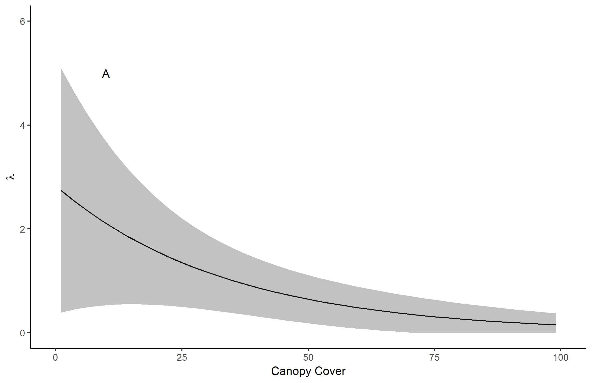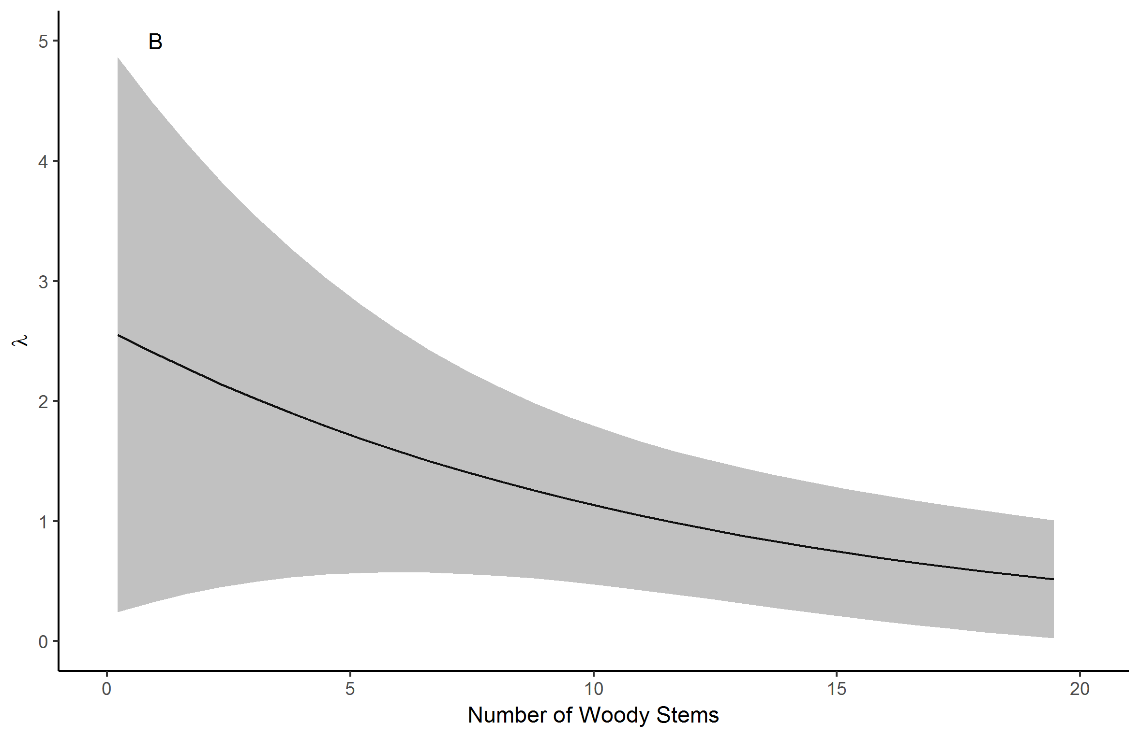

Figure 1. Lark sparrow predicted mean abundance versus canopy cover (A) and number of woody stems (B). Grey bands are 85% prediction intervals. Note that the effect of canopy cover became insignificant when disturbance and woody stems were also included in the model.

Eastern Towhee

Eastern towhees were detected in 58 of 59 plots. Mean predicted abundance under the null model was 2.73 (85% CI 2.34 - 3.20). Predicted eastern towhee abundance was negatively affected by canopy cover, but unaffected by disturbance (Fig. 2, Table 2). Detection probability was positively affected by date (days after May 1) in all models (Table 2).

Table 2. Eastern towhee abundance models ranked by Akaike information criterion (AIC). Abundance was modeled with a Poisson distributed in all models. Parameter estimates are given with 85% confidence intervals. Bolded non-intercept parameter estimates are significant at p < 0.15.

|  |  |  |  |
| --- | --- | --- | --- |
| **Single Abundance Models** | | | |
| Variable | Model 1 | Model 2 | Model 3 |
| Intercept | 1.01 (0.85,1.17) | 1.01 (0.85,1.16) | 0.99 (0.80,1.18) |
| Canopy | **-0.13 (-0.25,0.00)** | -- | -- |
| Disturbance | -- | -- | 0.04 (-0.21,0.29) |
| **Detection Models** | | | |
| Intercept | -0.41 (-0.60,-0.23) | -0.40 (-0.58,-0.22) | -0.40 (-0.58,-0.22) |
| Date | **0.12 (0.05,0.19)** | **0.12 (0.05,0.19)** | **0.12 (0.05,0.19)** |
| **Dynamics** | | | |
| Survival | 0.54 (-0.22,1.29) | 0.58 (-0.17,1.33) | 0.59 (-0.17,1.33) |
| Recruitment | 0.04 (-0.45,0.53) | 0.01 (-0.48,0.5) | 0.01 (-0.48,0.50) |
| AIC | 1723.19 | 1723.26 | 1725.21 |

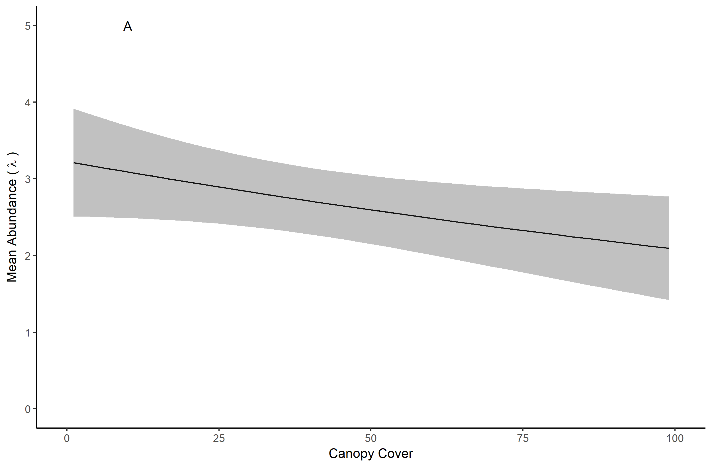

Figure 2. Eastern towhee predicted mean abundance versus canopy cover. Grey bands are 85% prediction intervals.

Leonard’s skipper

Leonard’s skippers were observed in 10 of 59 plots. In plots where they were observed, mean counts were 1.4 +/- 0.22 SE individuals. Based on preliminary modeling in unmarked (Table 3, Table 4), we identified mean number of *Liatris* stems and pre-survey disturbance (logging, grazing, or burning before 2015) as covariates affecting abundance and *Liatris* as a covariate affecting occupancy. Based on our hierarchical model, predicted Leonard’s skipper occupancy and abundance were positively affected by number of *Liatris* stems and mean predicted abundance was negatively affected by pre-survey disturbance (Table 5) (Fig. 3).

Table 3. Leonard’s skipper occupancy models ranked by Akaike information criterion (AIC). Occupancy was modeled using program unmarked in R. Parameter estimates are given with 85% confidence intervals. Bolded non-intercept parameter estimates are significant at p < 0.15.

|  |  |  |  |  |  |  |  |
| --- | --- | --- | --- | --- | --- | --- | --- |
| **Single Occupancy Models** | | | | | | | |
| Variable | Model 1 | Model 2 | Model 3 | Model 4 | Model 5 | Model 6 | Model 7 |
| Intercept | -1.62 | -1.47 | -1.51 | -1.47 | -1.47 | -1.47 | -1.5 |
|  | (-2.25,-0.99) | (-2.03,-0.90) | (-2.10,-0.92) | (-2.03,-0.90) | (-2.03,-0.90) | (-2.03,-0.90) | (-2.24,-0.75) |
| *Liatris* | **0.75** | -- | -- | -- | -- | -- | -- |
|  | **(0.16,1.34)** |  |  |  |  |  |  |
| Non-bunchgrass | -- | **--** | -0.39 | -- | -- | -- | -- |
|  |  |  | (-1.14,0.35) |  |  |  |  |
| Litter | -- | -- | -- | -0.13 | -- | -- | -- |
|  |  |  |  | (-0.70,0.44) |  |  |  |
| Bunchgrass | -- | -- | -- | -- | 0.09 | -- | -- |
|  |  |  |  |  | (-0.45,0.63) |  |  |
| Canopy | -- | -- | -- | -- | -- | 0.04 | -- |
|  |  |  |  |  |  | (-0.51,0.59) |  |
| Disturbance | -- | -- | -- | -- | -- | -- | 0.07 |
|  |  |  |  |  |  |  | (-1.03,1.16) |
| **Detection Model** | | | | | | | |
| Intercept | -1.03 | -1.01 | -1.01 | -1.01 | -1.01 | -1.01 | -1.01 |
|  | (-1.45,-0.60) | (-1.42,-0.60) | (-1.43,-0.60) | (-1.43,-0.60) | (-1.42,-0.60) | (-1.43,-0.60) | (-1.42,-0.60) |
| **Dynamics** | | | | | | | |
| Extinction | 0.27 | 0.26 | 0.25 | 0.26 | 0.26 | 0.26 | 0.26 |
|  | (-0.81,1.36) | (-0.83,1.34) | (-0.83,1.34) | (-0.82,1.34) | (-0.82,1.34) | (-0.83,1.34) | (-0.83,1.34) |
| Colonization | -10.43 | -9.72 | -10.41 | -9.95 | -10.36 | -10.37 | -10.41 |
|  | (-53.49,32.64) | (-39.83,20.40) | (-52.00,32.17) | (-43.77,23.87) | (-51.82,31.10) | (-52.15,31.40) | (-52.87,32.05) |
| AIC | 160.73 | 162.87 | 164.18 | 164.76 | 164.81 | 164.86 | 164.86 |

Table 4. Leonard’s skipper abundance models ranked by Akaike information criterion (AIC). Abundance was modeled with a negative binomial distribution in all models. Parameter estimates are given with 85% confidence intervals. Bolded non-intercept parameter estimates are significant at p < 0.15.

|  |  |  |  |  |  |  |  |
| --- | --- | --- | --- | --- | --- | --- | --- |
| **Single Abundance Models** | | | | | | | |
| Variable | Model 1 | Model 2 | Model 3 | Model 4 | Model 5 | Model 6 | Model 7 |
| Intercept | -1.12 | 0.34 | -0.06 | -0.22 | -0.15 | -0.92 | -0.62 |
|  | (-1.94,-0.31) | (-0.47,1.15) | (-0.75,0.64) | (-0.93,0.49) | (-0.85,0.55) | (-0.80,0.61) | (-0.76,0.63) |
| *Liatris* | **1.84** | -- | -- | -- | -- | -- | -- |
|  | **(0.94,2.73)** |  |  |  |  |  |  |
| Disturbance | -- | **-1.50** | -- | -- | -- | -- | -- |
|  |  | **(-2.86,-0.14)** |  |  |  |  |  |
| Non-bunchgrass | -- | -- | -- | -0.75 | -- | -- | -- |
|  |  |  |  | (-1.75,0.24) |  |  |  |
| Bunchgrass | -- | -- | -- | -- | 0.25 | -- | -- |
|  |  |  |  |  | (-0.20,0.71) |  |  |
| Litter | -- | -- | -- | -- | -- | -0.35 | -- |
|  |  |  |  |  |  | (-1.32,0.63) |  |
| Canopy | -- | -- | -- | -- | -- | -- | 0.19 |
|  |  |  |  |  |  |  | (-0.57,0.96) |
| **Detection Model** | | | | | | | |
| Intercept | -1.98 | -2.00 | -2.00 | -2.00 | -1.98 | -1.99 | -2.01 |
|  | (-2.34-1.62) | (-2.36,-1.63) | (-2.37,-1.63) | (-2.36,-1.62) | (-2.35,-1.61) | (-2.37,-1.62) | (-2.38,-1.64) |
| **Dynamics** | | | | | | | |
| Survival | -1.47 | -1.48 | -1.48 | -1.48 | -1.47 | -1.48 | -1.49 |
|  | (-2.24,-0.70) | (-2.26,-0.71) | (-2.26,-0.71) | (-2.26,-0.71) | (-2.25,-0.70) | (-2.25,-0.71) | (-2.26,-0.71) |
| Recruitment | -11.2 | -11.0 | -10.4 | -12.1 | -14.2 | -11.4 | -11.6 |
|  | (-92.1,69.7) | (-84.2,62.1) | (-64.5,43.6) | (-137.2,113.0) | (-371.6,343.2) | (-100.8,78.0) | (-109.7,86.5) |
| AIC | 207.71 | 216.62 | 216.84 | 217.56 | 218.13 | 218.59 | 218.71 |

Table 5. Parameter estimates, including mean, SD, 95% credible intervals, and R-hat statistics from hierarchical JAGS model of Leonard’s skipper occupancy, abundance, and detection probability.

|  |  |  |  |  |  |
| --- | --- | --- | --- | --- | --- |
|  | Mean | sd | 0.025 | 0.975 | R-hat |
| **Occupancy** |  |  |  |  |  |
| Intercept | -0.687 | 0.842 | -2.083 | 1.219 | 1.032 |
| *Liatris* | 2.502 | 1.554 | -0.267 | 5.782 | 1.017 |
| **Abundance** |  |  |  |  |  |
| Intercept | 11.114 | 24.602 | 0.025 | 103.898 | 1.423 |
| Disturbance | -3.789 | 1.273 | -6.493 | -1.403 | 1.042 |
| *Liatris* | 0.917 | 0.764 | -0.371 | 2.546 | 1.053 |
| Random Effect | 1.611 | 0.879 | 0.311 | 4.021 | 1.159 |
| **Detection** |  |  |  |  |  |
| alpha | 1.042 | 0.822 | 0.205 | 3.294 | 1.014 |
| beta | 52.309 | 61.841 | 3.960 | 248.743 | 1.333 |
| p(derived) | 0.033 | 0.023 | 0.003 | 0.092 | 1.080 |

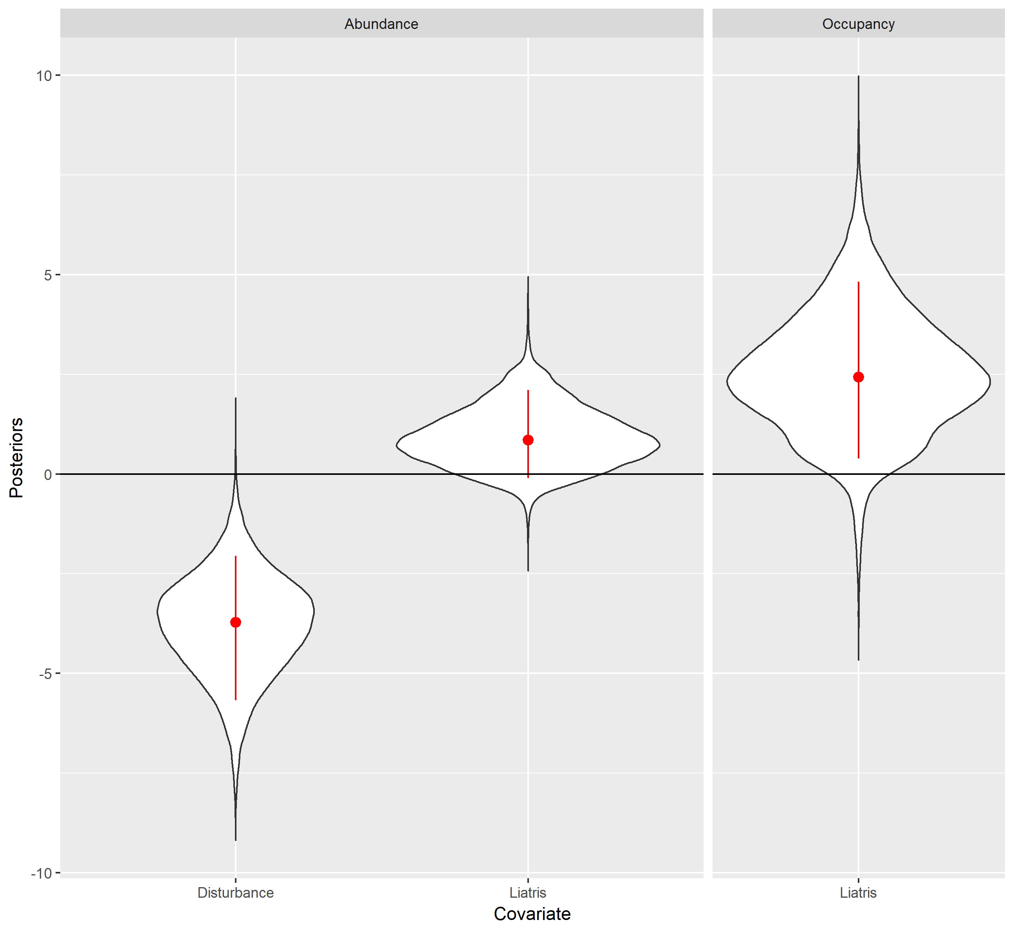

Figure 3. Posteriors of abundance and occupancy effect sizes for disturbance and *Liatris* (abundance) and *Liatris* (occupancy) for Leonard’s skipper. Red circles represent the mean and red lines represent the 85% credible intervals.

Northern Barrens Tiger Beetle

Northern barrens tiger beetles were observed in 27 of 59 plots. Mean counts in plots where tiger beetles were detected was 3.18 +/- 0.38 SE. Initial plot occupancy for tiger beetles was positively affected by both elevation CV and canopy cover (Table 6) with 85% credible intervals that did not include zero (Fig. 4). Mean tiger beetle abundance was positively affected by elevation CV and canopy cover (Table 7). Based on our hierarchical model, northern barrens tiger beetle occupancy and abundance were positively affected by canopy closure and elevation CV (Table 8) (Fig. 4).

Table 6. Tiger beetle occupancy models ranked by Akaike information criterion (AIC). Parameter estimates are given with 85% confidence intervals. Bolded non-intercept parameter estimates are significant at p < 0.15.

|  |  |  |  |  |
| --- | --- | --- | --- | --- |
| **Single Occupancy Models** | | | | |
| Variable | Model 1 | Model 2 | Model 3 | Model 4 |
| Intercept | -0.98 (-1.49,-0.48) | -0.93 (-1.41,-0.45) | -0.82 (-1.24,-0.39) | -0.82 (-1.26,-0.39) |
| Elevation CV | **1.16 (0.57,1.76)** | -- | -- | -- |
| Canopy | -- | **0.87 (0.38,1.36)** | -- | -- |
| Litter | -- | -- | -- | 0.30 (-0.13,0.73) |
| **Detection Model** | | | | |
| Intercept | -0.22 (-0.46,0.02) | -0.22 (-0.46,0.01) | -0.21 (-0.45,0.02) | -0.22 (-0.46,0.02) |
| **Dynamics** | | | | |
| Survival | -1.29 (-1.89,-0.70) | -1.32 (-1.92,-0.72) | -1.29 (-1.87,-0.70) | -1.31 (-1.90,-0.71) |
| Recruitment | -2.66 (-3.12,-2.20) | -2.68 (-3.15,-2.21) | -2.66 (-3.11,-2.20) | -2.67 (-3.14,-2.20) |
| AIC | 707.91 | 712.26 | 717.86 | 718.86 |

Table 7. Northern barrens tiger beetle abundance models ranked by Akaike information criterion (AIC). Abundance was modeled with a negative binomial distribution in all models. Parameter estimates are given with 85% confidence intervals. Bolded non-intercept parameter estimates are significant at p < 0.15.

|  |  |  |  |  |
| --- | --- | --- | --- | --- |
| **Single Abundance Models** | | | | |
| Variable | Model 1 | Model 2 | Model 3 | Model 4 |
| Intercept | 1.65 (1.16,2.13) | 1.88 (1.37,2.38) | 2.08 (1.55,2.61) | 2.07 (1.54,2.61) |
| Elevation CV | **1.24 (0.54,1.94)** | -- | -- | -- |
| Canopy | -- | **0.68 (0.14,1.22)** | -- | -- |
| Litter | -- | -- | -- | 0.12 (-0.57,0.81) |
| **Detection Model** | | | | |
| Intercept | -2.54 (-2.66,-2.41) | -2.54 (-2.66,-2.41) | -2.53 (-2.66,-2.41) | -2.53 (-2.66,-2.41) |
| **Dynamics** | | | | |
| Survival | 2.66 (2.24,3.07) | 2.64 (2.24,3.05) | 2.63 (2.23,3.03) | 2.63 (2.23,3.03) |
| Recruitment | -2.51 (-3.24,-1.79) | -2.49 (-3.21,-1.77) | -2.44 (-3.11,-1.77) | -2.44 (-3.11,-1.77) |
| AIC | 2473.34 | 2477.55 | 2478.72 | 2480.65 |

Table 8. Parameter estimates including mean, SD, 95% credible intervals, and R-hat statistics from hierarchical JAGS model of northern barrens tiger beetle occupancy, abundance, and detection probability.

|  |  |  |  |  |  |
| --- | --- | --- | --- | --- | --- |
|  | Mean | sd | 0.025 | 0.975 | R-hat |
| **Occupancy** |  |  |  |  |  |
| Intercept | -0.123 | 0.313 | -0.736 | 0.494 | 1.000 |
| Elevation CV | 0.671 | 0.323 | 0.060 | 1.336 | 1.000 |
| Canopy | 0.753 | 0.340 | 0.120 | 1.456 | 1.000 |
| **Abundance** |  |  |  |  |  |
| Intercept | 13.238 | 11.172 | 1.730 | 42.447 | 1.219 |
| Elevation CV | 0.671 | 0.323 | 0.060 | 1.336 | 1.000 |
| Canopy | 0.753 | 0.340 | 0.120 | 1.456 | 1.001 |
| Random Effect | 2.040 | 0.291 | 1.556 | 2.732 | 1.086 |
| **Detection** |  |  |  |  |  |
| alpha | 0.571 | 0.113 | 0.379 | 0.818 | 1.004 |
| beta | 50.819 | 40.262 | 8.884 | 179.910 | 1.282 |
| p(derived) | 0.017 | 0.012 | 0.003 | 0.050 | 1.324 |

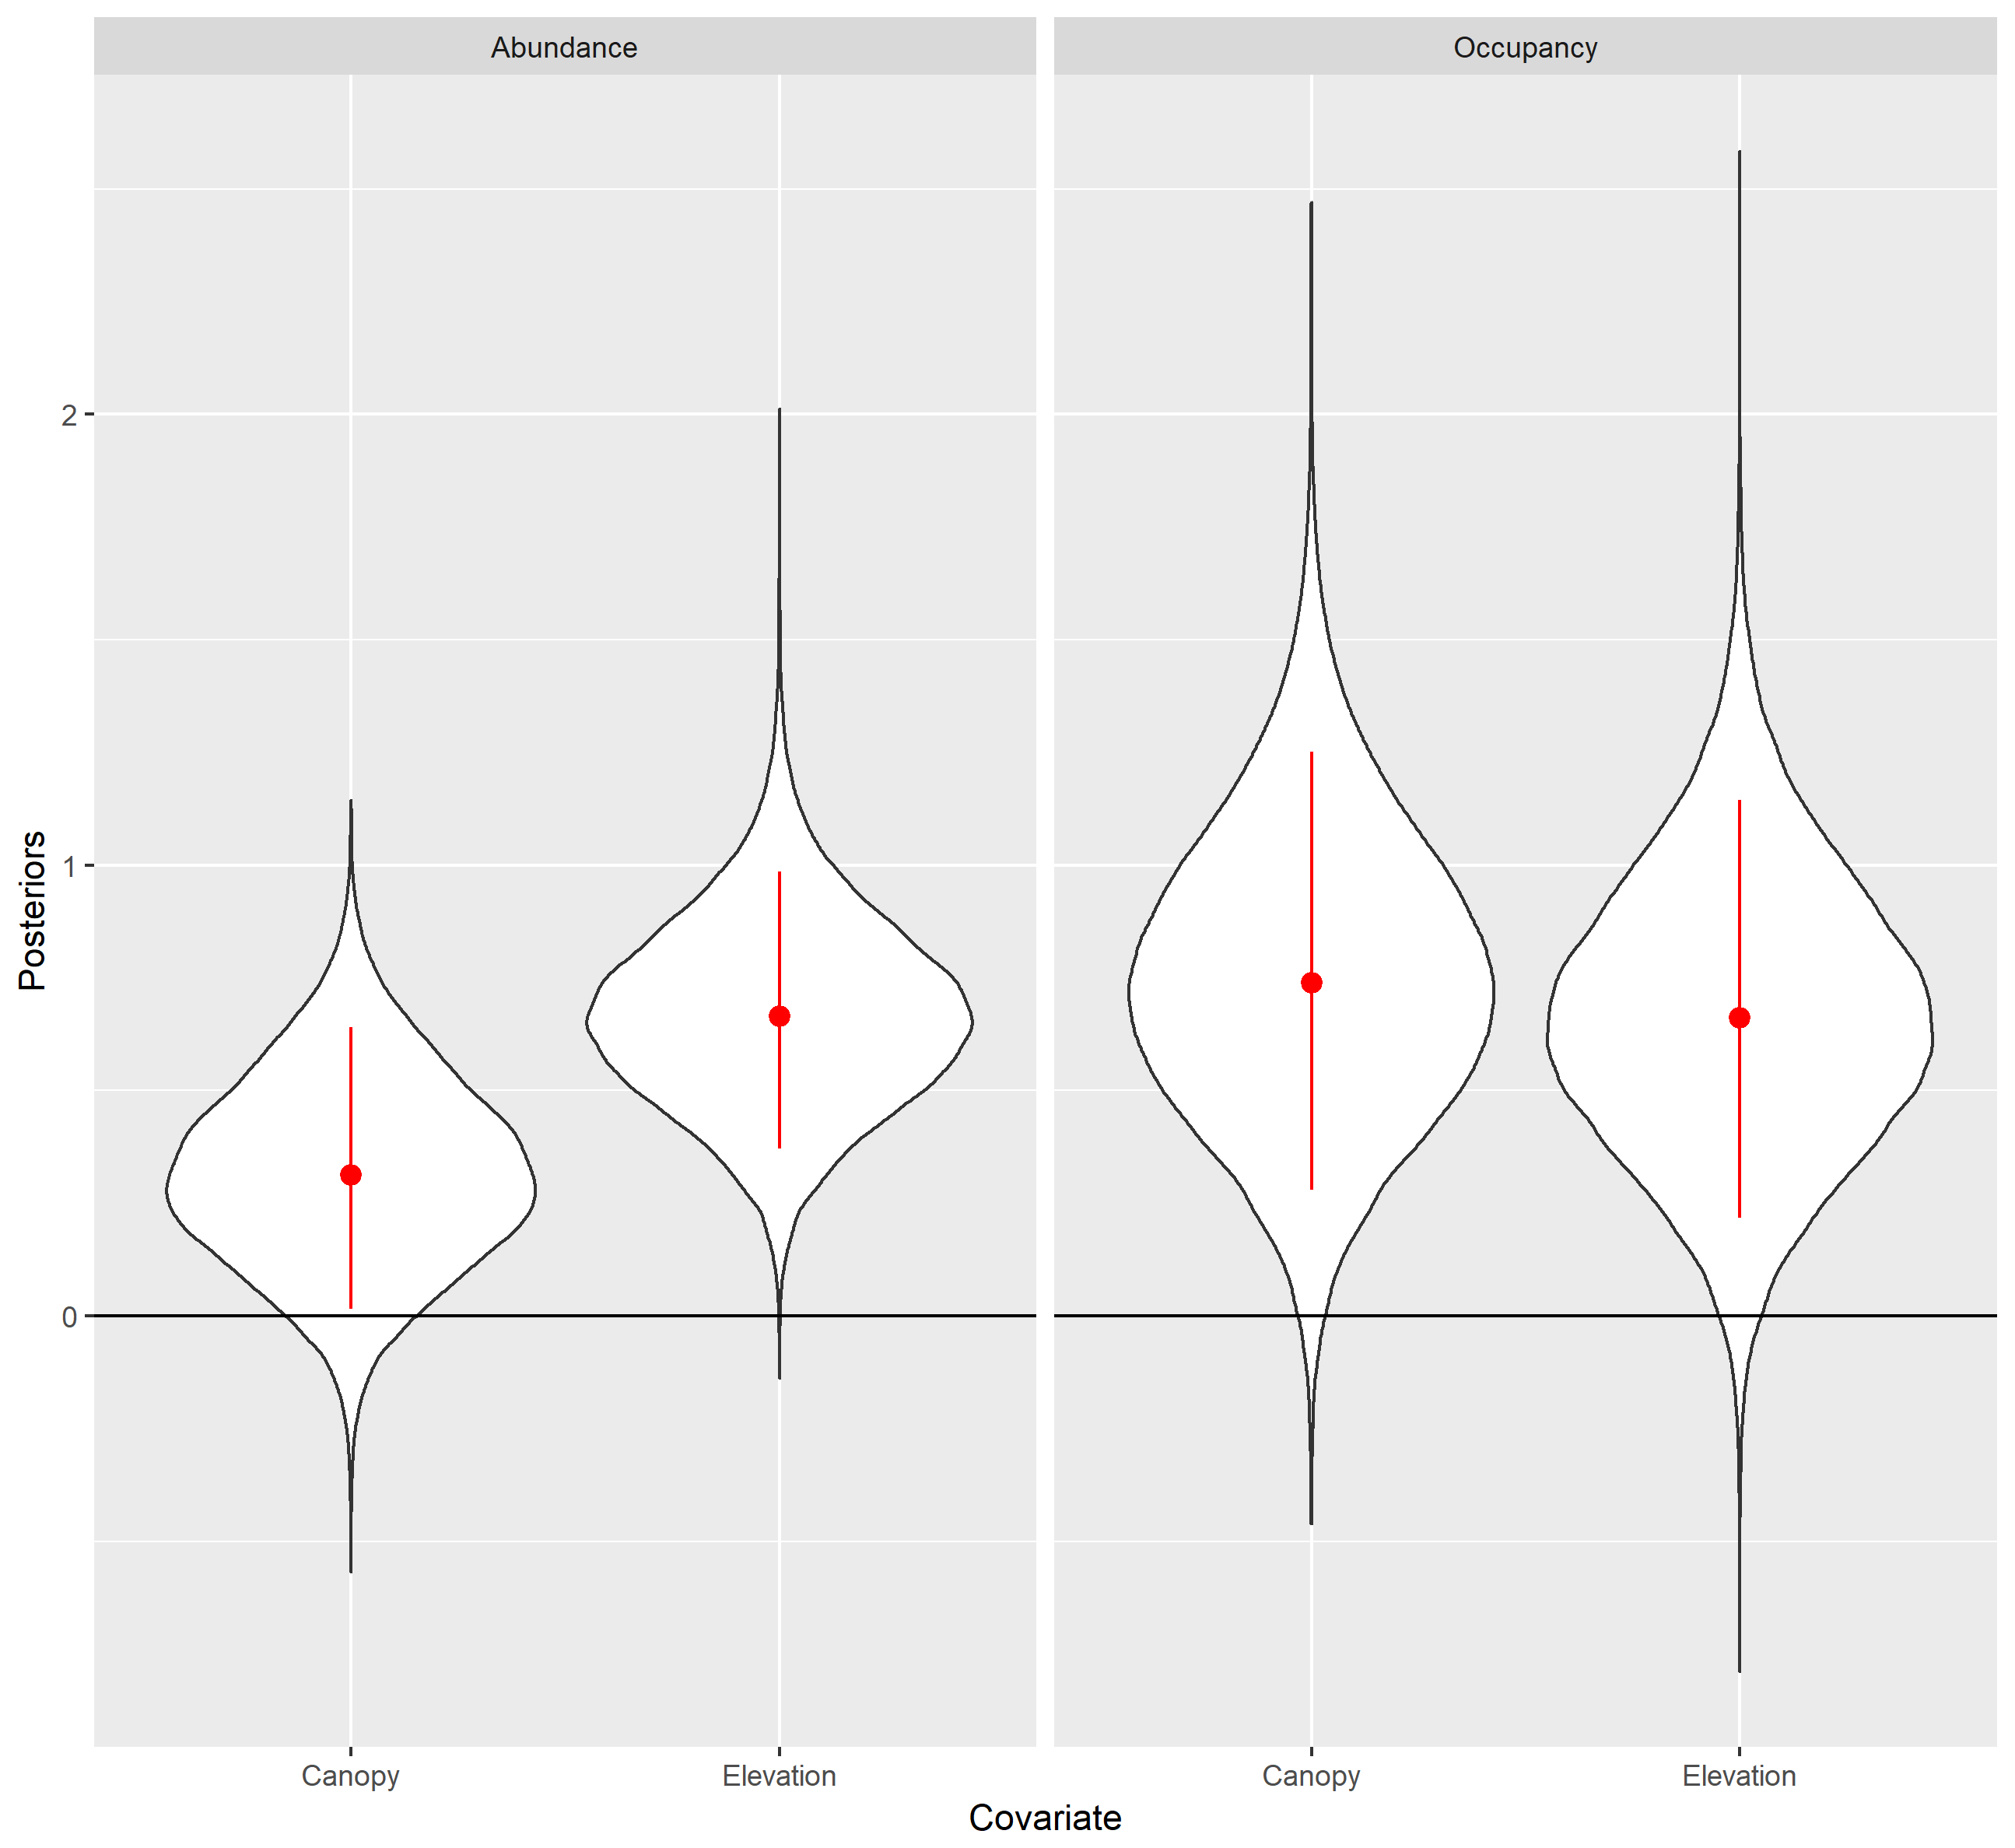

Figure 4. Posteriors of abundance and occupancy effect sizes for canopy and elevation for CIPA. Red circles represent the mean and red lines represent the 85% credible intervals.

Gophersnake and plains hog-nosed snake

Gophersnakes were encountered during 16 surveys in 11 of 59 plots. The mean observed abundance in plots where gophersnakes were detected was 1.54 (85% CI 1.23-1.85). Plains hog-nosed snakes were observed in 3 of 59 plots during 4 individual survey replicates. The mean observed abundance in plots where hog-nosed snakes were detected was 1.67 (85% CI 1.0-2.34). Given the near absence of detection evens during replicate surveys, data for both species of snakes were insufficient for occupancy and abundance analysis (Guillera-Arroita et al., 2010).

Discussion

With the exception of snakes, which had too little data for analysis, we found that species’ predicted abundance and occupancy probability were affected by habitat features and management disturbances, with at least one variable per species receiving statistical support. Specifically, we found support for our hypotheses that lark sparrow abundance would be negatively related to canopy cover and positively related to sites with shrubby habitat and management-related disturbances. We also found support for our hypothesis that eastern towhee would be negatively correlated with canopy cover. We similarly found support for our invertebrate models; Leonard’s skipper abundance was negatively correlated with pre-survey disturbance and occupancy was positively correlated with mean plot-level *Liatris*. Tiger beetle abundance and occupancy were positively correlated with elevation CV and canopy.

Our results illuminate the complicated nature of wildlife habitat interactions and highlight the difficulty encountered when designing projects to restore and manage habitat for the benefit of the multiple species. Although the benefits of fire and grazing as tools to restore and maintain prairie, savanna, and other upland habitats for native fauna are well-documented (Swengel 1998, Vander Yacht et al. 2016, Davis et al. 2000, Peterson and Reich 2001), the relative costs and benefits in terms of abundance, persistence, and survival vary across taxa and species (Bendel et al. 2018, Davis et al. 2000, Swengel 1998). For example, within our study system lark sparrow and Leonard’s skipper had disparate associations with management disturbance (logging, burning, and grazing), with lark sparrows responding positively to these activities, but Leonard’s skipper responding negatively. This may have been because lark sparrows are highly mobile and able to respond directly to habitat changes within a relatively short timeframe. Open soil created as a result of burning or grazing may provide foraging opportunities almost immediately, and canopy openings created by logging could be available the same or the next year, depending on when they were logged. Lark sparrows may also avoid negative effects of prescribed burning because they often establish territories after early spring burns. Conversely, burning and grazing both have the potential to significantly disrupt the life cycle of the Leonard’s skipper (Dana, 1991, Swengel 1996, Bendel et al. 2018). On an invertebrate metapopulation level, balance between local establishment or re-establishment and local extinction may be disrupted by fragmentation (Dana 1991) and protected tracts must be intentionally managed to minimize the chance of local extinctions (Goodman 1987). Habitat management must be carefully and thoughtfully planned to avoid unintended negative consequences for habitat specialist native invertebrate species, which are at increased risk of lasting negative effects on populations (Swengel 1996, Vogel et al. 2010). Within our study system, the Leonard’s skipper was negatively impacted by management disturbance. Unlike the lark sparrow, their life cycle is very likely to be interrupted by commonly used management techniques. Prairie skippers like the Leonard’s are bound to the same location over multiple seasons and development phases. They are vulnerable to spring fire as overwintering pupae (Dana 1991), and grazing cows consume the grass upon which larvae are dependent. Skippers also inhabit different habitat components at different periods of their life cycle such that females may lay eggs in a desirable habitat in the fall only to have the larvae consumed by grazers or fires in the spring of the following year. In addition, we noticed that areas with potentially ideal skipper habitat (i.e., understories with bunchgrass, *Liatris*, and other nectar sources interspersed by bare ground) that had been previously occupied were devoid of skippers after intensive management activities (burning and grazing). Conversely, areas that provided seemingly marginal habitat (thickly grown grass, limited nectar resources, and limited bare ground) but had not been recently altered by management yielded some scattered individuals.

Canopy cover also demonstrated contrasting effects on abundance of our target species within this system. Lark sparrow abundance was negatively related to canopy cover, whereas Northern barrens tiger beetle abundance was positively related. This is likely reflective of the natural history of each species and is one more example of the difficulty associated with managing habitat for multiple species. Manipulation of canopy cover can be relatively straightforward from a management perspective, but the effects on wildlife are not as easy to define and can be dependent on the individual species and condition of the surrounding landscape (Vander Yacht et al. 2016).

Our results and observations indicate that management and restoration should be planned at large spatial and temporal scales to benefit the multitude of species that depend on rare oak savanna, oak woodland, and prairie habitats, rather than benefitting a select few at the cost of the rest. Historically, disturbance was an integral part of the Anoka Sand Plain landscape and many native plant and animal communities are well adapted to it (Henderson et al. 2017, Vander Yacht et al. 2016), but the function of this large-scale system has been compromised by habitat loss and fragmentation. One pressing concern is to better understand how to manage for disturbance-sensitive species within disturbance-dependent ecosystems (Moranz et al. 2014) on a reduced scale. Although restoration planning should be at a large scale to provide a variety of related habitat types on the landscape and should be planned over as long a term as is possible, actual restoration activities may need to be conducted at relatively small scales to provide refugia from which populations can recolonize and rebound and to protect relatively isolated populations from accidental extirpation. When possible, a variety of techniques should be considered in the overall management plan to account for species’ differential responses to management (Davis et al. 2000, Swengel 1996).

Recommendations for future research

Our study generated a number of potential recommendations for the focus and design of future research. Due to low rates of detection for some species, our analyses had relatively low power for identifying habitat relationships. Unfortunately, this is part of the challenge in working with rare and cryptic species, even when sampling units are well-matched to the spatial ecology of the target species and surveys are conducted using protocols that maximize detection (Guillera-Arroita et al., 2010; Mackenzie & Royle, 2005). An alternative might be the conditional occupancy method described by Specht et al. (2017), which is potentially more effective at low levels of occupancy and detection, although it would have required many more potential sample sites than used in our study. It is also possible that the study design could be further refined to match the ecology of the study system and target species. We recommend conducting preliminary research into the specific home range sizes for target species before or during the process of experimental design and potentially focusing surveys on species-specific home range sizes rather than one primary plot size. We found that habitat types varied significantly over the 40 acres of a plot, yet the presence of target organisms in a small portion of suitable habitat could have confounded the relationships between occupancy, abundance, and plot-level habitat covariates. Especially for extremely rare species such as the Leonard’s skipper, a more spatially focused strategy could produce a more precise picture of specific habitat use.

We also recommend conducting additional future surveys for target species. Repeating surveys may be especially useful for the study of rare species in restoration systems which may not respond to restoration efforts right away. The goal of this and other restoration projects is long-term habitat improvement, rather than instantaneous change. Measurable effects may take longer, particularly if species are very rare, are ineffective dispersers, or have low fecundity. Further, it may take a period of years for important habitat changes to take effect after management activities are conducted. A longer time period is likely more appropriate for detecting the types of metapopulation change that are often goals of habitat restoration efforts. In addition to providing a more reasonable timeframe for detecting and describing metapopulation dynamics (e.g., colonization, extinction, recruitment, survival), repeating this type of study with a period of years between surveys (or clusters of surveys) may provide a more reasonable study framework from a cost perspective. The cost of field surveys for rare species in terms of effort can be prohibitively high, and it is generally beneficial to allocate effort in a cost-effective manner (MacKenzie and Royle 2005). For studies with multiple target species, it may be practical to conduct surveys on a staggered timeframe based on the management strategies being used and the ecology of each target species. This study provides a baseline upon which further investigation of rare Anoka Sand Plain species population dynamics can be founded, and we hope the information provided here will be useful in further management and restoration efforts

References

Arnold, T. W. 2010. Uninformative parameters and model selection using Akaike's Information Criterion. The Journal of Wildlife Management, 74: 1175–1178. doi:10.1111/j.1937-2817.2010.tb01236.x

Bendel, C.R., Hovick, T.J., Limb, R.F., and J.P. Harmon. 2018. Variation in grazing management practices supports diverse butterfly communities across grassland landscapes. Journal of Insect Conservation 22: 99-111. <https://doi-org.ezp2.lib.umn.edu/10.1007/s10841-017-0041-9>

Coffin, B.J. 1988. The natural vegetation of Minnesota at the time of the public land survey: 1847-1907. Adapted from the Original Vegetation of Minnesota by F. J. Marschner. Minnesota Natural Heritage and Nongame Research Program, Minnesota Department of Natural Resources.

Dana, R. (1991). Conservation management of the prairie skippers, *Hesperia dacotae* and *Hesperia ottoe*: Basic biology and threat of mortality during prescribed burning in spring (Station bulletin (University of Minnesota. Agricultural Experiment Station); 594). St. Paul, Minn.: Minnesota Agricultural Experiment Station, University of Minnesota.

Davis, M. A., Peterson, D. W., Reich, P. B., Crozier, M., Query, T., Mitchell, E., Huntington, J. and Bazakas, P. (2000), Restoring Savanna Using Fire: Impact on the Breeding Bird Community. Restoration Ecology, 8: 30-40. doi:10.1046/j.1526-100x.2000.80005.x

Fiske, I. and R. Chandler. 2011. unmarked: An R Package for Fitting Hierarchical Models of Wildlife Occurrence and Abundance. Journal of Statistical Software, 43(10), 1-23. URL http://www.jstatsoft.org/v43/i10/.

Fondell, T. F., D. A. Miller, J. B. Grand, and R. M. Anthony. 2008. Survival of dusky Canada goose goslings in relation to weather and annual nest success. Journal of Wildlife Management 72:1614-1621.

Giudice, J. H., J. R. Fieberg, and M. S. Lenarz. 2012. Spending degrees of freedom in a poor economy: A case study of building a sightability model for moose in northeastern Minnesota. The Journal of Wildlife Management, 76: 75–87. doi:10.1002/jwmg.213

Greenlaw, Jon S. 2015. Eastern towhee (Pipilo erythrophthalmus), version 2.0. *In* The Birds of North America (P. G. Rodewald, editor). Cornell Lab of Ornithology, Ithaca, New York, USA. https://doi.org/10.2173/bna.262

Guillera‐Arroita, G., Ridout, M.S. & Morgan, B.J.T. 2010. Design of occupancy studies with imperfect detection. Methods in Ecology and Evolution, 1, 131–139. DOI: 10.1111/j.2041-210X.2010.00017.x

Goodman, Daniel. 1987. How do any species persist? Lessons for conservation biology. Conservation Biology, 1:59-62. http://www.jstor.org.ezp1.lib.umn.edu/stable/2386127.

Harper, L., E.P. Hoaglund, C. E. Smith, and H. Texler. 2010. Rare wildlife and habitat surveys in oak savannas of the Anoka Sand Plain subsection. Final report submitted to the State Wildlife Grants Program. 135 pp.

Hoaglund, E. P., C. E. Smith, and H. Texler. 2012. Microhabitat components of key habitat types in the Anoka Sand Plain that influence habitat selection among Species in Greatest Conservation Need. Final report submitted to the State Wildlife Grants Program. 93 pp.

Mackenzie, D. I., and J.A. Royle. 2005. Designing occupancy studies: General advice and allocating survey effort. Journal of Applied Ecology, 42, 1105–1114

Martin, J. W. and J. R. Parrish. 2000. Lark Sparrow (Chondestes grammacus), version 2.0. *In* The Birds of North America (P. G. Rodewald, editor). Cornell Lab of Ornithology, Ithaca, New York, USA. https://doi.org/10.2173/bna.488

Marshner, F. J. 1974. The original vegetation of Minnesota (map scale 1:500,000). USDA Forest Service, North Central Forest Experiment Station, St. Paul, Minnesota (redraft of the original 1930 edition)

Minnesota Department of Natural Resources, 2006. Tomorrow’s Habitat for the Wild and Rare: An Action Plan for Minnesota Wildlife, Comprehensive Wildlife Conservation Strategy. Division of Ecological Services, Minnesota Department of Natural Resources.

Minnesota Department of Natural Resources, Division of Ecological Resources. 2008. Rare Species Guide: An online encyclopedia of Minnesota's rare native plants and animals [Web Application]. Minnesota Department of Natural Resources, St. Paul, Minnesota. www.dnr.state.mn.us/rsg. Accessed [Mar 2018].

Minnesota Department of Natural Resources. 2009. An Evaluation of the Ecological Significance of the Sand Dunes State Forest. Division of Ecological Resources, Minnesota Department of Natural Resources.

Minnesota Department of Natural Resources, 2013. Operational Plan for Management of Sand Dunes State Forest, Sherburne County, MN. Divisions of Forestry, Ecological and Water Resources & Fish and Wildlife.

Minnesota Department of Natural Resources. 2017. The conversion of documented prairie native plant communities in Minnesota until 2015: an analysis of the MNDNR Native Prairie Communities layer [polygon geospatial data]. St. Paul, MN: Minnesota Biological Survey, Minnesota Department of Natural Resources. [February 2017, compiled by Dustin Graham].

Noss, R., & Peters, R. 1995. Endangered ecosystems : A status report on America's vanishing habitat and wildlife. Washington, D.C.: Defenders of Wildlife.

Nuzzo, V. A. 1986. Extent and status of Midwest oak savanna: presettlement and 1985. Natural Areas Journal 6(2):6-36

Pfannmuller, L., G. Niemi, J. Green, B. Sample, N. Walton, E. Zlonis, T. Brown, A. Bracey, G. Host, J. Reed, K. Rewinkel, and N. Will. 2017. The First Minnesota Breeding Bird Atlas (2009-2013). Accessed November 2017.

Plummer, M. 2003. JAGS: A program for analysis of Bayesian graphical models using Gibbs sampling

R development Core Team. R: A Language and Environment for Statistical Computing; 2014. R Foundation for Statistical Computing, Vienna, Austria.

Specht, H.M., H.T Reich, F. Iannarilli, et al. 2017. Occupancy surveys with conditional replicates: An alternative sampling design for rare species. Methods in Ecology and Evolution. 8:1725–1734. https://doi-org.ezp1.lib.umn.edu/10.1111/2041-210X.12842

Swengel, A. 1996. Effects of fire and hay management on abundance of prairie butterflies. Biological Conservation, 76(1), 73-85.

Swengel, A. 1998. Effects of management on butterfly abundance in tallgrass prairie and pine barrens. Biological Conservation, 83(1), 77-89.

Vander Yacht, A., Keyser, P., Buehler, D., Harper, C., Buckley, D., & Applegate, R. 2016. Avian occupancy response to oak woodland and savanna restoration. Journal of Wildlife Management, 80(6), 1091-1105.