Abstract

Introduction

Oak savanna and upland prairie are some of the most imperiled habitat types in North America (Noss et al. 1995). These fire-dependent ecosystems once covered vast areas of the continent, but their distribution has been significantly reduced in the years since European settlement (Nuzzo 1986). Once a dominant land cover, oak savanna has been reduced to less than 0.02% of its pre-settlement extent in the Midwest (Nuzzo 1986) and is ranked as globally imperiled. In the United States, oak savanna once stretched from the Upper Midwest south to eastern Texas (Nuzzo 1986, XX that one map) and was an integral part of the transition zone between the mixed deciduous forests of the eastern part of the continent and the Great Plains to the west. In Minnesota, oak savanna and other upland habitats including mixed oak woodland and brushland once blended with areas of wetland in a broad swath that stretched across the state from the northwest to the southeast, forming a mosaicked transition zone between the mixed-hardwood, conifer, and peatland areas in the northern part of the state and the tallgrass prairie systems to the west and southwest (XX Marshner 1974, Coffin 1988). The high biodiversity (XX BIRDS, SGCN) associated with these habitat types is largely due to their function as an ecological transition between broad, disparate biomes (XX citation). The original distribution of these habitats in Minnesota was largely determined by substrate and precipitation patterns and maintained partly by cyclic fire (XX Keen 1986). In the years since European settlement of the continent, human intervention in the form of fire suppression and elimination of non-agricultural grazing have allowed the natural succession of oak savanna and prairie habitats into mixed deciduous woodland and brushland, while land conversion for agriculture, urban expansion, and timber production have eliminated native habitat and altered the landscape. Of an estimated XX hectares of mixed savanna and prairie at the time of the 18XX public land survey, only XX hectares remained when the state was surveyed by the Minnesota Biological Survey (MBS) between YYYY-YYYY.

The Anoka Sand Plain ecological subsection (ASP) of Minnesota contains some of the last remnants of these rare habitats. The ASP covers approximately 485,600 hectares in east-central Minnesota and encompasses all or portions of Anoka, Benton, Chisago, Crow Wing, Isanti, Hennepin, Mille Lacs, Morrison, Ramsey, Sherburne, Stearns, and Wright counties, including the northern edge of the Twin Cities metropolitan area. It is largely characterized by a broad, flat plain of glacial outwash sands and is bordered on the southwestern edge by the Mississippi river. Though mostly flat, the ASP also harbors sand dunes formed during periods of extreme drought in the mid-Holocene, between 8000-4000 years before present (XX Keen 1985). At the time of the public land survey (mid-1800’s), the predominant vegetation of the ASP was oak savanna and upland prairie, surrounded by varied wetland complexes (XXMN DNR 2006 subsection profile, MN DNR 2010 MN T-13-R-1 final report.) The ASP contains some of the highest quality examples of dry oak savanna in Minnesota, but urban development is occurring at a rapid rate. As of 2006, population growth in the ASP was the fastest of any subsection in the state, and more than 90% of the land was in private ownership. The amount of native habitat in this area is rapidly declining, as are many rare native animal species that depend on it for survival. The 2006 Minnesota Department of Natural Resources (DNR) subsection profile for the Anoka Sand Plain identified 97 Species in Greatest Conservation Need (SGCN) that are known or predicted to occur within the ASP, including 39 species that were federally or state Endangered, Threatened, or Special Concern (XX ESA, MN List). Continued habitat loss, fragmentation, and degradation are key challenges facing Minnesota SGCN in the ASP (XX2006 SWAP).

Study overview and hypotheses

The purpose of this project was to inform habitat restoration by examining the relationships between habitat characteristics and the occupancy and abundance patterns of ASP specialist animal species within Sand Dunes State Forest and Sherburne National Wildlife Refuge in Sherburne County, MN. Sand Dunes State Forest (hereafter, Sand Dunes or SDSF) and Sherburne National Wildlife Refuge (hereafter, Sherburne or SNWR) are spatially adjacent natural areas that have been managed under different strategies since the mid-20th century. Both contain areas of native upland habitat and provide an opportunity for conservation of rare ASP plant and animal communities. Recognizing an opportunity to preserve and restore rare and important habitat features, the MN DNR Divisions of Forestry, Ecological and Water Resources, and Fish and Wildlife reached a joint agreement to restore some areas within Sand Dunes to an approximation of pre-settlement vegetation, and to permanently manage for rare plant and animal species and the unique habitats on which they depend (XX2013 OP). This project was intended to function in conjunction with the 2013 operational plan for SDSF (XX appendix x) and to inform a process of ongoing management designed to protect and restore ASP habitats for rare native species, specifically MN SGCN.

When the operational plan was written, very little was known about the specific requirements of habitat specialist fauna within the ASP. To better inform habitat restoration for rare upland ASP fauna, we selected a suite of six species identified by previous research (XX Harper at al. 2010 and Hoaglund et al. 2012, SWG T-24-R1, 2009 SDSF Ecological Significance Doc) as sensitive habitat specialists likely to provide sufficient sample sizes to allow rigorous statistical analyses. Our focal species were: *Heterodon nasicus* (plains hog-nosed snake), *Pituophis catenifer* (gophersnake), *Cicindela patruela* (northern barrens tiger beetle), *Hesperia leonardus leonardus* (Leonard’s skipper), *Chondestes grammacus* (lark sparrow), and *Pipilo erythrophthalmus* (eastern towhee). All of the species are MN SGCN with the exception of the eastern towhee, which was chosen as an early-successional habitat specialist (XX MN Birds) likely to produce observational data sufficient for robust analysis (SWG Grant proposal). Results from this project will be used to inform restoration of native habitats within the Sand Dunes State Forest and to provide guidance on future adaptive management strategies. Our biological hypotheses were formed based on our understanding of the ecology and habitat requirements of each individual species.

Focal Species

The lark sparrow (Special Concern) shows a preference for edge habitats and ecotones between open and forested areas. Its primary range encompasses most of the western United States, where its preferred habitats include shrub-steppe, pinon-juniper edges, roadsides, and fields. In Minnesota, it is an uncommon, edge-dependent species with a relatively narrow habitat niche, most frequently associated with oak savannas, dry grasslands, or pastures scattered with small trees or shrubs (XX Pfannmuller et al. 2017). Lark sparrows often inhabit disturbed sites with exposed soils, grazing, or recent fire and prefer areas with canopy cover of less than 24% (XX Martin, J. W. and J. R. Parrish 2000). Dechant et al. (XX[1999], 2002) reported that lark sparrow abundance was negatively correlated with ground litter and cover density. It is a ground-foraging omnivore that builds its nests in a small depression at the base of a forb or woody plant, or occasionally in small trees or shrubs (XX Pfannmuller et al. 2017). Multiple sources have attributed observed long-term population decline to a loss of their preferred open, shrubby and/or agricultural nesting habitat due to natural succession, urban expansion, or conversion to more intensive agricultural practices (Hunter et al. 2001, XX more?), although no studies have presented definitive conclusions and population decline has not been ubiquitous across the species’ entire range (XXMN Breeding Bird Atlas). Based on this information, we hypothesized that lark sparrow abundance would be negatively related to litter depth and canopy cover and positively related to sites with shrubby habitat and management-related disturbances.

The eastern towhee (*Pipilo erythrophthalmus*) is a relatively common habitat generalist in many areas of North America, but in Minnesota is mainly associated with edge habitat between forested and non-forested areas (XX Greenlaw, 2015). Hagen (XX YYYY)) hypothesized that eastern towhee populations are dependent on shrubby, early-successional habitat and that they decline as habitat succeeds into mature forest. Thus, we hypothesized that eastern towhee abundance would be inversely related with canopy cover, but also positively related to management activities that retain open savanna conditions (e.g., burning, grazing, or forest management).

The plains hog-nosed snake (*Heterodon nasicus*), (Special Concern) prefers open, sandy, sparsely-vegetated habitat such as prairie and oak savanna (cite XX). This species overwinters beneath the frost line in mammal tunnels or self-dug burrows. This species is extremely cryptic and can be difficult to locate because of its habit of lying near the entrance to a burrow and quickly retreating when disturbed. Habitat fragmentation and loss are threats to this species, which has a relatively small home range and may have trouble dispersing (cite XX Ernst and Barbour in MN Rare species guide) (cite XX MN Rare species guide). According to the MN DNR rare species guide, grassland management practices that limit the encroachment of brush can enhance habitat for this species, and increasing habitat connectivity may enhance the viability of known populations. (cite XX Rare Species Guide)

The gophersnake (*Pituophis catenifer*), (Special Concern), is widely distributed throughout western and central North America, though in Minnesota most records are from counties along the Minnesota, Mississippi, and St. Croix rivers (cite XX). The gophersnake prefers areas of well-drained, loose, sandy soil. In Minnesota, dry sand prairies and bluff prairies are considered prime habitat. Primary threats include habitat loss, degradation, and fragmentation. We hypothesized that open sand, percent grass, number of gopher mounds, and canopy cover would most affect initial snake abundance, and that temperature at the start of the survey would most affect detection.

The Leonard’s skipper (*Hesperia leonardus leonardus)*, (Special Concern) prefers dry, sandy prairie and savanna dominated by native plant species (XX source, prob rare species guide). No studies have been conducted regarding the specific habitat needs of Leonard’s skippers in Minnesota, but their requirements are likely comparable to similar native prairie skippers of the same genus that have been studied more extensively, including *H. l. pawnee*, which occurs on mesic prairie further west and hybridizes with Leonard’s skipper (XX Robert Dana, Pers. Communication). Adults emerge in August, feed on varying nectar sources, and lay eggs shortly thereafter. Eggs hatch in approximately 10 days, after which the larvae build refugium in the base of bunchgrasses from which they forage until entering diapause for the winter. Definitive information is not available, but larvae likely overwinter in the tangle of vegetation at the base of bunchgrasses or on the ground under the overhanging grass (XX Robert Dana, pers. communication). The Leonard’s skipper seems to favor areas of mesic prairie that have open sand or other bare ground between clumps of bunchgrass. Leonard’s skippers were frequently observed nectaring on blazing star (*Liatris* spp.) during previous studies within the ASP, and this genus is believed to be a preferred nectar source for adult skippers (XX source, maybe invert surveys of SDSF). We hypothesized that Leonard’s skipper abundance would be positively related to graminoid cover and blazing star abundance and negatively related to canopy cover, litter depth, and management disturbances. We hypothesized that detection would relate to survey date and wind speed.

The northern barrens tiger beetle (*Cicindela patruela patruela*), (Special Concern), is a chase-and-ambush predator that prefers sandy openings and roads in areas with low to moderate canopy cover (XX source, prob mn dnr). Adults emerge from the larval stage in the fall and overwinter in ground burrows after a period of active foraging. They re-emerge in spring, mate, lay eggs, and die off as summer progresses. This species requires open sand for larval and adult burrows, and open sand with sparse, scattered vegetation for hunting. Steffens (2005XX) noted that probable threats to tiger beetle populations include development, clear-cutting, off-road vehicle use, and other activities that significantly disturb sandy soil. Anecdotally, observers have noted that tiger beetles seem to be found most frequently in areas of Sand Dunes and Sherburne that are relatively “hilly,” rather than flat. We hypothesized that tiger beetle abundance would be positively related to terrain roughness and negatively related with canopy cover and litter depth.

The main objective of this study was to examine the relationships between rare, upland ASP species and their habitat requirements. Specifically, we attempted to describe the needs of *H. nasicus*, *P. catenifer*, *C. p. patruela*, *H. l. leonardus*, *C. grammacus*, and *P. erythrophthalmus* as they relate to current and ongoing habitat management and restoration. Our intent was to provide baseline information about species’ habitat needs and responses to management related disturbances to inform current management and future, more focused studies about populations’ long-term persistence on the Anoka Sand Plain.

**Methods**

Study Area

This study was conducted at Sand Dunes State Forest (45.405° N; -93.665° W) and Sherburne National Wildlife Refuge (45.494° N; -93.695° W), two managed areas in Sherburne County within the Anoka Sand Plain ecological subsection in central Minnesota. The mean (30-year-average; 1981-2010) annual temperature in the area was 6.9°C and mean precipitation was 787 mm (Station ID: GHCND:USC00217502; 45.546° N; -93.7572° W; XX National Climatic Data Center 2017). Although spatially adjacent, the two areas exhibit significant ecological disparities due to differing topography, historical land use, and management regimes.

Sand Dunes State Forest was acquired by the Minnesota Department of Natural Resources in 1946 and covers approximately 4,468 hectares. It has been managed primarily for timber production and recreation. Dominant land cover types include mixed oak savanna, oak woodland, sand prairie, dunes, wetlands, and pine plantation. Sand Dunes contains rare geologically and ecologically significant features, as well as diverse native plant communities and rare plant and animal species (XX). Previous DNR studies have recorded four globally ranked native plant communities, five sites ranked by the Minnesota Biological Survey as outstanding biodiversity significance, six sites ranked as having high biodiversity significance (reword). Five state-listed (Endangered, Threatened, or Special Concern) rare plant species and nine state-listed rare animal species that require dry oak savanna habitats have also been documented (XX MN DNR 2009).

Sherburne National Wildlife Refuge (12,424 ha) is directly north of Sand Dunes. In contrast to Sand Dunes, Sherburne has been managed for wildlife since the 1960s. The refuge was established to preserve the Saint Francis River watershed, wetlands, and associated wildlife; especially waterfowl. Diverse wetland habitats within Sherburne include wet meadows, emergent marshes, lakes, and a meandering stretch of the St. Francis River. Upland habitat includes a mix of prairie, savanna, and forest. Upland habitat management includes selective timber harvest, conservation grazing, and prescribed burning. For the purposes of this study, Sherburne is considered to be a relatively restored and intact landscape that partly serves as a model of desired future conditions and can contribute to our understanding and evaluation of management and restoration at Sand Dunes.

Study Design

Survey Area

This study was designed to gather information about our focal species and their use of available habitat. We established plots within Sand Dunes and Sherburne and conducted surveys of our target organisms within those plots. We used ArcGIS (XXESRI 2011. ArcGIS Desktop: Release 10. Redlands, CA: Environmental Systems Research Institute) to randomly select 60 40-acre (~16.2 ha) survey plots within the study area. Plots that were dominated by wetland habitats were excluded from consideration. Twenty plots were randomly located within Sherburne and 40 plots were located within Sand Dunes. More plots were placed within Sand Dunes because informing the DNR’s changing management strategy for the state forest was an important goal of the project. We determined our sample size by using Program R (XXR Core Team, 2013) to conduct Monte Carlo-based simulations designed to maximize survey power and cost-effectiveness. We developed the simulation scenarios to reflect estimates of each species’ detection probability based on preliminary research and expert opinion (Harper et al., 2010). One plot within Sand Dunes was lost mid-way through the study due to a change in ownership and subsequent loss of access permission, so final analysis was performed with data from 59 plots. Our survey strategies were designed to maximize opportunities for detection and generate replicate observations at each site for use in estimating abundance and detection parameters (XX citation needed? Royle, DM, or HC?). Although all surveys followed the same general plot-level detection strategy, specific survey techniques were based on established methods for each taxon and differed between some focal species based on their ecology.

Surveys – Lark Sparrow and Eastern Towhee

We conducted concurrent point count surveys for both the lark sparrow and eastern towhee from a single survey point within each plot. Each plot’s survey point was placed in oak savanna or the habitat most resembling oak savanna based on our interpretation of aerial photography in ArcGIS. If no suitable habitat was available, the point was placed in the center of the plot. All survey points were at least 100 m away from the plot edges. We surveyed each plot twice during the breeding season (May 20 – June 30) in two consecutive years of the study (2015-2016). Each survey was a 9-minute point count conducted between 30 minutes before sunrise and 10:00 h when wind was below 16 kph and precipitation not more than a light drizzle. Point counts were divided into 3 consecutive 3-minute intervals, which resulted in a total of 12 detection opportunities per plot over the entire study period. During each survey interval we recorded the number of individuals of each target species that were detected by sight or sound. Individuals that were detected during multiple intervals were counted during each interval in which they were detected. We assumed population closure during and between surveys conducted within the same year, but not between years.

Surveys – Leonard’s Skipper and Northern Barrens Tiger Beetle

We conducted plot-level wandering transects for both Leonard’s skippers and northern barrens tiger beetles. Surveyors traversed as much appropriate habitat as possible while searching for target species for a set amount of time. Searches were divided into 3 equal time intervals, and were considered to be concurrent for all non-avian target species unless the search was conducted outside of the appropriate timeframe for any species, in which case it was omitted as a target of that search. Searches specifically targeting our invertebrate species were conducted as follows.

Surveys – Leonard’s skippers

Surveys for Leonard’s skippers were conducted in 2015 and 2016 between August 1 and September 30 to coincide with the annual flight period. Searches were conducted in sunny or partly sunny conditions, and not during rain events. Surveyors targeted blooming blazing star (*Liatris* spp.) or other nectar sources and counted the number of skippers encountered during each period of the search.

Surveys – Northern barrens tiger beetles

Surveys for northern barrens tiger beetles were conducted in 2014, 2015 and 2016 between May 1 and June 30 to coincide with their primary flight period. There is a second, smaller flight of tiger beetles as new adults emerge during the late summer. Observations were also recorded during that time period, although they were not being specifically targeted. Searches were conducted in ambient air temperatures of at least 10°C under sunny or partly sunny conditions with no rain. Surveyors targeted sandy roads and trails and other open sand patches, and counted or estimated the number of tiger beetles encountered during each period of the search. Because tiger beetles have more than one generation present per season (adults that overwinter and larvae that develop into adults and emerge during the summer), we only assumed population closure within each survey and not between surveys or years.

Surveys – Snakes

The gophersnake and plains hog-nosed snake were surveyed in a similar manner to invertebrates. Surveys for snakes were conducted in 2015 and 2016 between April 1 and June 30, and Aug 15 and Sept 15 to coincide with periods of highest activity. Searches were conducted when ambient air temperature was at least 10°C, and not during rain events. Spring searches were not conducted before the ground was thawed.

Habitat Characteristics

We surveyed habitat characteristics within each plot during the summer and fall of 2016 (August 22 to November 4). We measured vegetation cover at three to five subplots within each plot. One subplot was located in the center of each plot, with four more located half way to each of the four plot corners. Subplots that were located within lakes or wetlands were not surveyed.

Habitat covariates were measured at different scales. Understory vegetation was evaluated at the one-meter subplot-level by category. The categories included: number of woody stems (i.e., shrubby species < 0.5 m tall), graminoid cover, (sub-classified based by growth form as bunchgrass or non-bunchgrass) and the number of blazing star stems. Litter depth was defined as the depth from the top of the leaf litter to the beginning of the mineral soil.

We classified overstory habitat by canopy cover and number of open-grown oaks. We evaluated canopy cover based on the effective area visible from each subplot center with a densitometer, and counted all open-grown oaks visible from each survey point. Open oaks were defined by spreading, symmetrical and well-developed canopies that had grown without the apparent interference of nearby trees. Habitat values were averaged over the entire plot.

**Statistical Analysis**

Our general modeling approach used state-space abundance models (also known as N-mixture models; Royle 2004), which are particularly useful for modeling field data on rare or cryptic species because they allow for modeling both the parameter of interest (in this case, abundance) and the observation error that is often inherent in field surveys (Dail and Madsen 2011, Hostetler and Chandler 2015). Though very similar to its predecessor, the Hostetler variant specifically addresses the excess-zeroes that often result from field surveys of rare species by incorporating the flexibility to model data with negative binomial and zero-inflated Poisson distributions in addition to the default Poisson distribution typically employed in N-mixture models (Royle 2004). State-space abundance models rely on repeated observations from the same location to evaluate three conditionally related elements; initial abundance, abundance at subsequent time periods, and the detection process. Although the evaluation of factors that influence a species’ detection probability may not be a primary goal of many studies, its inclusion in the process allows for inference about the proportion of null observations (i.e., failures to detect the species of interest when it was actually present during the survey), as well as systematic undercounting that occurs when surveyed organisms are mobile or cryptic.

The models developed by Dail and Madsen (2011) and Hostetler and Chandler (2015) build on the N-mixture abundance models originally proposed by Royle (2004 XX) by allowing population size to change between primary survey periods (e.g., years), specifically for metapopulation dynamics such as recruitment and survival. We included these dynamics without covariates, because while a two-year study is not sufficient to examine factors that are driving recruitment and survival directly, it would have been erroneous to assume closure across seasons. In addition to population closure within primary survey periods, other important assumptions of this class of models include constant detection probability across the study system (unless explained by observation variables), and equal abundance across the study system (unless explained by state variables).

Assuming that *Nh,t* is the true abundance in plot *h* in survey year *t*, we can account for *Nh,1* (initial plot-level abundance) with a Poisson process, a negative binomial (NB) process, or a zero-inflated process:

$N_{h,1}\sim \text{Pois}\left(λ_{h}\right)$ (eq1)

$$N_{h,1}\sim \text{NB}\left(λ_{h},α\right)$$

$$N_{h,1}\sim \text{Pois}\left(0\right) \text{with probability} ψ \text{or }N_{h,1}\text{\sim Pois}\left(λ_{h}\right)\text{ with probability} 1-ψ$$

Where $λ_{h}$ is plot level mean abundance, $α$ is the spread of the negative binomial distribution and $ψ$ is the proportion of unoccupied plots (i.e., the inflated zeros). Plot-level mean abundance is modeled with log-linear regression of plot-level covariates (*xh*) (e.g., habitat characteristics):



where [define β0 and β1 too]. Subsequent year abundance is then a combination of the surviving individuals from each plot (*Sh,t*) and recruitment of new individuals into each plot (*Gh,t*):

[]. The detection process is a Binomial process based on plot-level abundance, *Nh,t*, and the probability of detecting each individual (*ph,i,t*), which is assumed to be affected by plot (h), survey (i), and year-specific (t) covariates (*xh,i,t*), and which gives us our counts (*nh,i,t*):

[].

For all target species that we analyzed, we used package unmarked (XX Fiske and Chandler 2011) in Program R (Cite XX) to construct hypothesis-based models of initial abundance (*Ni,1*) with individual site covariates (*xh*) chosen based on *a priori* knowledge of the species of interest and the study system. Following the degree of freedom spending approach described by Giudice et al. (2012XX), we chose not to include covariate interactions in our abundance models because of the small sample size of our data. We replicated each initial abundance model using Poisson, negative binomial, and zero-inflated Poisson distributions to determine the best fit for our data. Models were subsequently ranked based on Akaike information criterion (AIC) and ΔAIC values and only the best-ranked model was included in subsequent steps (Fondell et al. 2008 in Arnold 2010). For both of our avian target species (lark sparrow and eastern towhee), we then used the best-ranked initial abundance model to rank detection covariate models ($x_{h,i,t}$). This variable selection process followed the example given in the supplementary material of Hostetler and Chandler (2015).

Although we conducted the same initial modeling step and followed the same general strategy described above for all of our analyses, our specific methodology differed slightly for both of our invertebrate species (Leonard’s skipper and northern barrens tiger beetle). To account for violations of the models’ assumptions given species ecology and our survey techniques, we conducted all subsequent modeling for invertebrates using a Bayesian hierarchical modeling approach. Briefly, we modified the model structure to relax model restrictions including the closure assumption and the assumption that detection probability was invariant across the three replications within each survey period. The closure assumption was violated given that invertebrate abundance varies within one growing season due to hatching and mortality cycles, and detection probability needed to vary among replicates given the meandering search process that was followed for replicate surveys. (For both invertebrate species, surveyors had conducted targeted wandering transects focused on appropriate patches of habitat and made an effort to not repeatedly traverse the same ground.) In the model-based approach, we assumed that plot abundance in each year and survey period (*Nh,i*) was a function of whether the plot was occupied (*zh*) and plot-level habitat covariates (*xh*):

where $ψ$ was the probability of occupancy and ${\hat{N}}_{h,i}$ was the predicted survey and plot-level abundance, which was based on a Poisson-distributed variable ($N_{h,i}^{*}$) that was a function of mean plot-level abundance ($λ_{h}$) and random error ($δ_{h,i}$). The random error was drawn from a normal distribution with a variance term ($σ$):

$$δ_{h,i}\sim N(0,σ)$$

$$σ\sim Unif(0.1,5)$$

We used plot-level covariates to account for occupancy:

$$\operatorname{logit}\left(ψ_{h}\right)=β_{0}^{ψ}+β_{1}^{ψ}x_{h,1}+β_{2}^{ψ}x_{h,2}$$

Where the covariates were chosen based on occupancy model ranking in unmarked following similar protocols to those described above for abundance modeling. The probability of detection potentially varied by plot (*h*), survey occasion (*i*), and survey replicate (*j*) by using a Beta-binomial relationship:

$$n_{h,i,j}\sim \text{Bin}(N_{h,i},p_{h,i,j})$$

$$p_{h,i,j}\sim \text{Beta}(α^{p},β^{p})$$

We used vague priors throughout:

$$α^{p}\sim β^{p}\sim gamma(0.01,0.01)$$

$${log(β}_{0}^{λ})\sim \text{gamma}(0.1,0.01)$$

$$β_{1}^{λ}\sim β_{2}^{λ}\sim β_{0}^{ψ}\sim β_{1}^{ψ}\sim β_{2}^{ψ}\sim \text{N}(0,0.25)$$

Based on preliminary analyses, we did not fit covariates to detection probability because observations were insufficient for robust modeling (results not shown; see XX at doiXX). The Bayesian model-based approach was implemented using Markov chain Monte Carlo (MCMC) methods in JAGS (), accessed using jagsUI (CITE XX) in Program R. We ran the models with 250,000 total iterations, 100 adaptation iterations, 50,000 burn-in iterations, a thinning rate of 10, and 3 chains, for a total of 60,000 estimates of each retained variable in the posterior distribution.

**Results**

Lark Sparrow

Predicted lark sparrow abundance was positively affected by pre-survey disturbance (logging, grazing, or burning before 2015) and negatively affected by canopy cover and number of woody stems (Fig. XX, Table XX). Detection probability was positively affected by Julian date (days after May 1) and time (minutes from sunrise) in all models (Table XX).

Table 1XX. Lark Sparrow abundance models ranked by Akaike information criterion (AIC). Abundance was modeled with a negative binomial distributed in all models. Parameter estimates are given with 85% confidence intervals. Bolded non-intercept parameter estimates are significant at p < 0.15.

|  |  |  |  |  |  |  |  |  |
| --- | --- | --- | --- | --- | --- | --- | --- | --- |
| Model | Abundance Model | | Detection Model | |  | Dynamics | | AIC |
|  | B0lambda | B1lambda | B0p | B1p | B2p | Survival | Recruitment |  |
| Disturbance | -2.97  (-4.48,-1.46) | **4.13**  **(2.58,5.68)** | -1.85  (-2.29,-1.41) | **0.26**  **(0.08,0.43)** | **0.33**  **(0.15,0.52)** | 0.25  (-0.55,1.04) | -2.25  (-3.33,-1.17) | 442.73 |
| Canopy | -0.07  (-0.70,0.56) | **-0.85**  **(-1.42,-0.28)** | -1.70  (-2.18,-1.23) | **0.29**  **(0.11,0.47)** | **0.36**  **(0.18,0.55)** | 0.27  (-0.71,0.76) | -2.16  (-3.20,-1.11) | 461.61 |
| Woody Stems | 0.13  (-0.45,0.71) | **-0.58**  **(-1.11,-0.05)** | -1.78  (-2.22,-1.35) | **0.29**  **(0.11,0.47)** | **0.37**  **(0.18,0.55)** | 0.07  (-0.68,0.82) | -2.12  (-3.14,-1.10) | 463.78 |
| Null | 0.26  (-0.36,0.87) | --  -- | -1.74  (-2.18,-1.30) | **0.29**  **(0.11,0.47)** | **0.37**  **(0.18,0.55)** | 0.03  (-0.70,0.76) | -2.09  (-3.06,-1.12) | 464.09 |
| Litter | 0.26  (-0.36,0.87) | -0.01  (-0.43,0.41) | -1.74  (-2.19,-1.30) | **0.29**  **(0.11,0.47)** | **0.37**  **(0.18,0.55)** | 0.03  (-0.70,0.76) | -2.09  (-3.06,-1.12) | 466.09 |

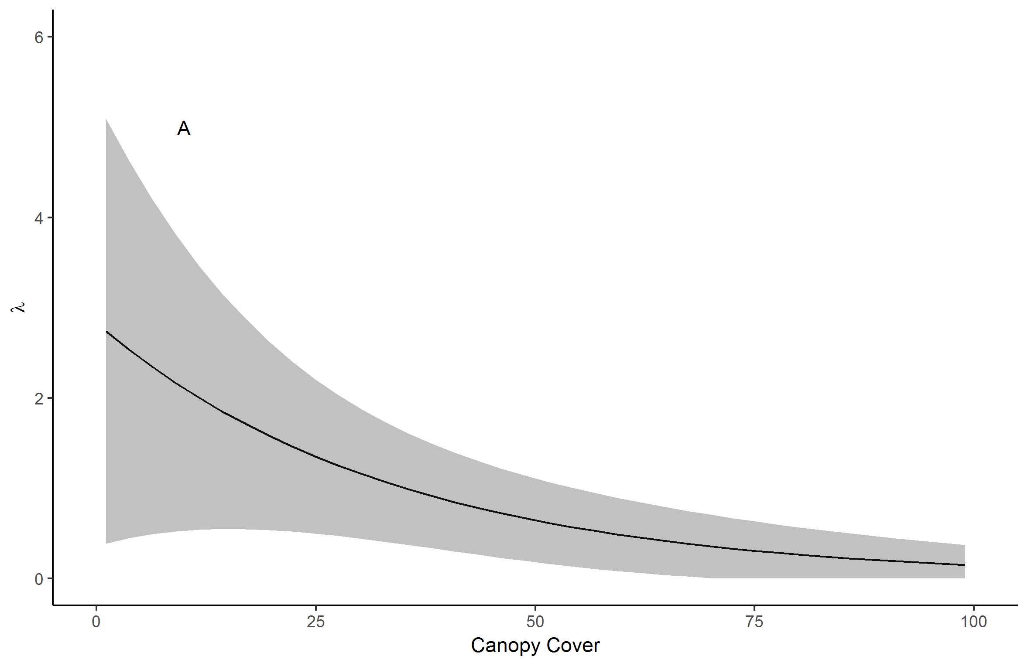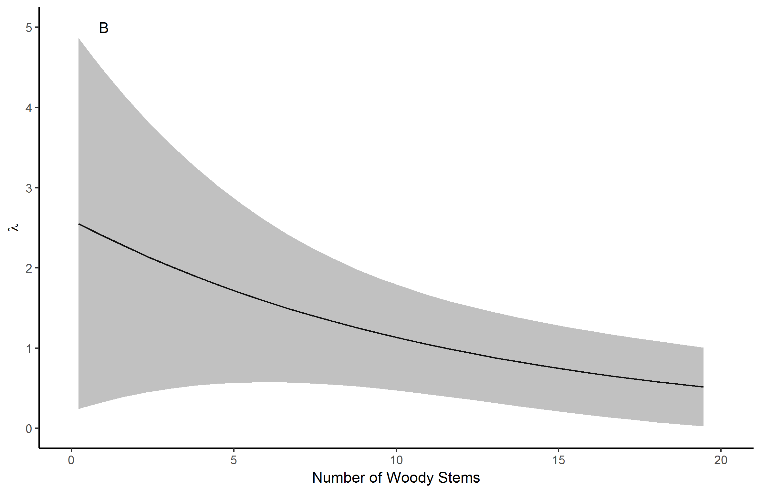

Figure 1XX. Lark sparrow predicted mean abundance versus canopy cover (A) and number of woody stems (B). Grey bands are 85% confidence intervals.

Eastern Towhee

Predicted eastern towhee abundance was negatively affected by canopy cover, but unaffected by disturbance (Fig. XX, Table XX). Detection probability was positively affected by Julian date (days after May 1) (Table XX).

Table 2XX. Eastern towhee abundance models ranked by Akaike information criterion (AIC). Abundance was modeled with a Poisson distributed in all models. Parameter estimates are given with 85% confidence intervals. Bolded parameter estimates are significant at p < 0.15.

|  |  |  |  |  |  |  |  |
| --- | --- | --- | --- | --- | --- | --- | --- |
| Model | Abundance Model | | Detection Model | | Dynamics | | AIC |
|  | B0lambda | B1lambda | B0p | B1p | Survival | Recruitment |  |
| Canopy | 1.01  (0.85,1.17) | **-0.13**  **(-0.25,0.00)** | -0.41  (-0.60,-0.23) | **0.12**  **(0.05,0.19)** | 0.54  (-0.22,1.29) | 0.04  (-0.45,0.53) | 1723.19 |
| Null | 1.01  (0.85,1.16) | --  -- | -0.40  (-0.58,-0.22) | **0.12**  **(0.05,0.19)** | 0.58  (-0.17,1.33) | 0.01  (-0.48,0.5) | 1723.26 |
| Disturbance | 0.99  (0.80,1.18) | 0.04  (-0.21,0.29) | -0.40  (-0.58,-0.22) | **0.12**  **(0.05,0.19)** | 0.59  (-0.17,1.33) | 0.01  (-0.48,0.50) | 1725.21 |

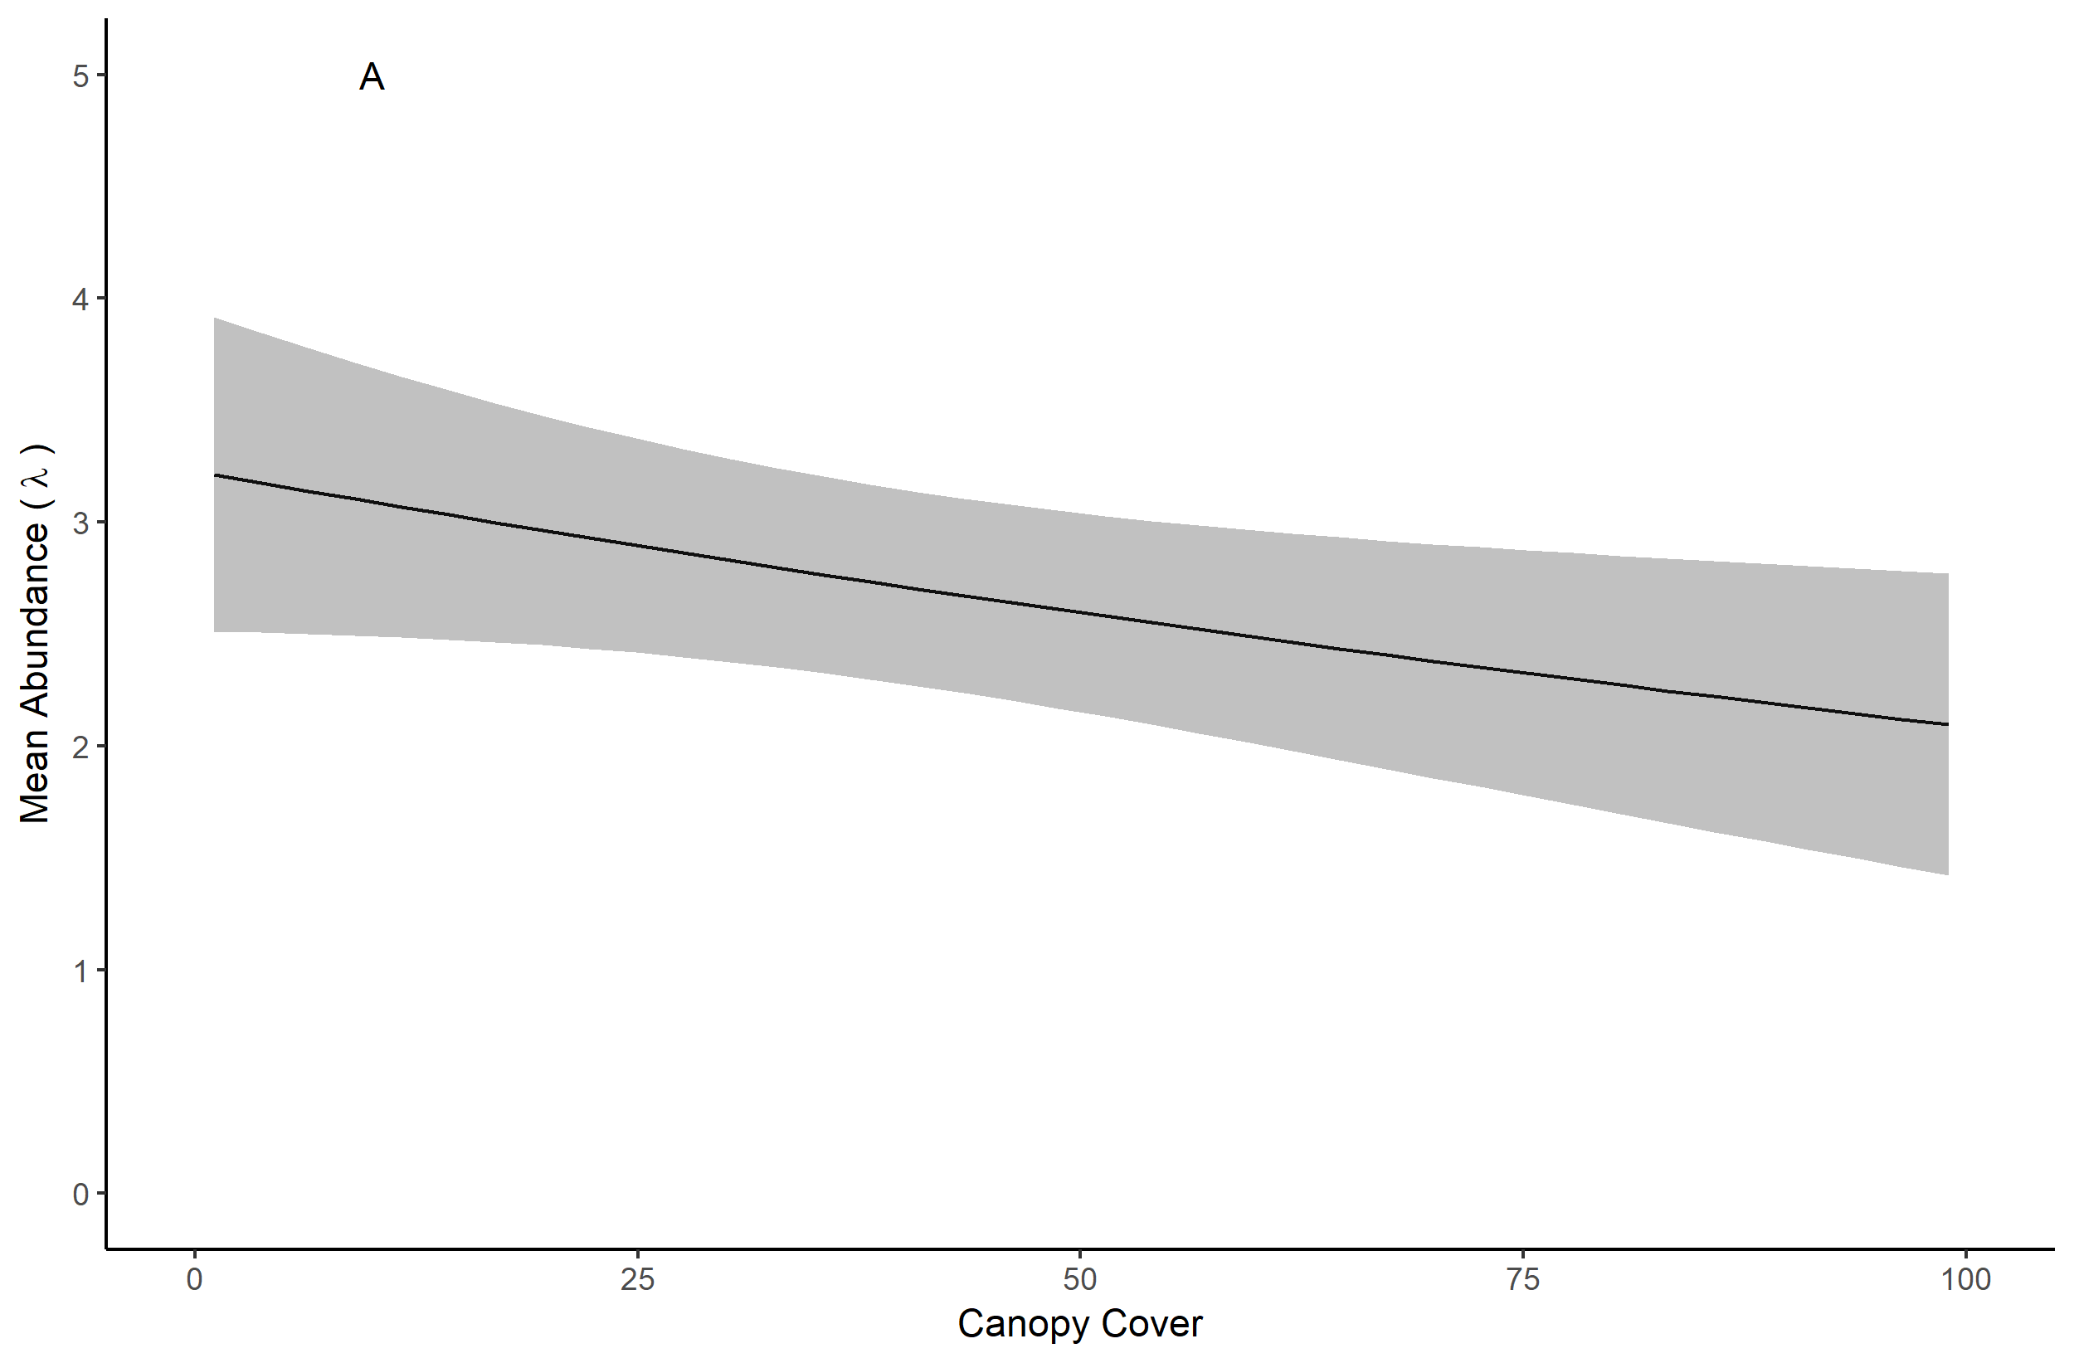

Figure 2XX. Eastern towhee mean abundance versus canopy cover (A) and probability of detection versus date (B). Grey bands are 85% confidence intervals.

Leonard’s skipper

Based on preliminary modeling in unmarked (table XX), we identified mean number of *Liatris* stems and pre-survey disturbance (logging, grazing, or burning before 2015) as the two most important abundance covariates and *Liatris* and bunchgrass as the two most important occupancy covariates for our JAGS model. Mean Leonard’s skipper abundance was negatively affected by pre-survey disturbance (-3.9, 1.4 SD) (Fig. XX) and occupancy was positively affected by number of *Liatris* stems.

Table 3XX. Leonard’s skipper abundance models ranked by Akaike information criterion (AIC). Abundance was modeled with a XX distribution in all models. Parameter estimates are given with 85% confidence intervals. Bolded regression coefficients are significant at p < 0.15.

|  |  |  |  |  |  |  |  |
| --- | --- | --- | --- | --- | --- | --- | --- |
| Model | Abundance Model | | Detection Model | | Dynamics | | AIC |
|  | B0lambda | B1lambda | B0p |  | Survival | Recruitment |  |
| *Liatris* | -1.12  (-1.94,-0.31) | **1.84**  **(0.94,2.73)** | -1.98  (-2.34-1.62) |  | -1.47  (-2.24,-0.70) | -11.23  (-92.19,69.73) | 207.71 |
| Disturbance | 0.34  (-0.47,1.15) | **-1.50**  **(-2.86,-0.14)** | -2.00  (-2.36,-1.63) |  | -1.48  (-2.26,-0.71) | -11.04  (-84.22,62.14) | 216.62 |
| Null | -0.06  (-0.75,0.64) | --  -- | -2.00  (-2.37,-1.63) |  | -1.48  (-2.26,-0.71) | -10.42  (-64.50,43.64) | 216.84 |
| Non-bunchgrass | -0.22  (-0.93,0.49) | -0.75  (-1.75,0.24) | -2.00  (-2.36,-1.62) |  | -1.48  (-2.26,-0.71) | -12.10  (-137.18,112.97) | 217.56 |
| Bunchgrass | -0.15  (-0.85,0.55) | 0.25  (-0.20,0.71) | -1.98  (-2.35,-1.61) |  | -1.47  (-2.25,-0.70) | -14.22  (-371.63,343.20) | 218.13 |
| Litter | -0.92  (-0.80,0.61) | -0.35  (-1.32,0.63) | -1.99  (-2.37,-1.62) |  | -1.48  (-2.25,-0.71) | -11.44  (-100.82,77.95) | 218.59 |
| Canopy | -0.62  (-0.76,0.63) | 0.19  (-0.57,0.96) | -2.01  (-2.38,-1.64) |  | -1.49  (-2.26,-0.71) | -11.61  (-109.67,86.45) | 218.71 |

Table 4XX. Leonard’s skipper occupancy models ranked by Akaike information criterion (AIC). Occupancy was modeled with a negative binomial distribution in all models. Parameter estimates are given with 85% confidence intervals. Bolded parameter estimates are significant at p < 0.15.

|  |  |  |  |  |  |  |  |
| --- | --- | --- | --- | --- | --- | --- | --- |
| Model | Occupancy Model | | Detection Model | | Dynamics | | AIC |
|  | B0psi | B1psi | B0p |  | Extinction | Colonization |  |
| *Liatris* | **-1.62**  **(-2.25,-0.99)** | **0.75**  **(0.16,1.34)** | **-1.03**  **(-1.45,-0.60)** |  | 0.27  (-0.81,1.36) | -10.43  (-53.49,32.64) | 160.73 |
| Null | **-1.47**  **(-2.03,-0.90)** | **--**  **--** | **-1.01**  **(-1.42,-0.60)** |  | 0.26  (-0.83,1.34) | -9.72  (-39.83,20.40) | 162.87 |
| Non-bunchgrass | **-1.51**  **(-2.10,-0.92)** | -0.39  (-1.14,0.35) | **-1.01**  **(-1.43,-0.60)** |  | 0.25  (-0.83,1.34) | -10.41  (-52.00,32.17) | 164.18 |
| Litter | **-1.47**  **(-2.03,-0.90)** | -0.13  (-0.70,0.44) | **-1.01**  **(-1.43,-0.60)** |  | 0.26  (-0.82,1.34) | -9.95  (-43.77,23.87) | 164.76 |
| Bunchgrass | **-1.47**  **(-2.03,-0.90)** | 0.09  (-0.45,0.63) | **-1.01**  **(-1.42,-0.60)** |  | 0.26  (-0.82,1.34) | -10.36  (-51.82,31.10) | 164.81 |
| Canopy | **-1.47**  **(-2.03,-0.90)** | 0.04  (-0.51,0.59) | **-1.01**  **(-1.43,-0.60)** |  | 0.26  (-0.83,1.34) | -10.37  (-52.15,31.40) | 164.86 |
| Disturbance | **-1.50**  **(-2.24,-0.75)** | 0.07  (-1.03,1.16) | **-1.01**  **(-1.42,-0.60)** |  | 0.26  (-0.83,1.34) | -10.41  (-52.87,32.05) | 164.86 |

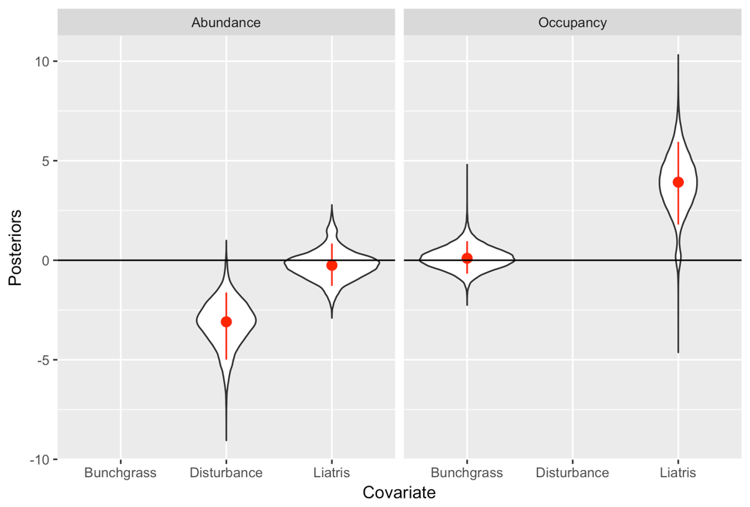

Figure 3XX. Posterior distributions of abundance and occupancy effect sizes for canopy and elevation for HELE. Red circles represent the mean and red lines represent the 85% credible intervals.

Northern Barrens Tiger Beetle

Based on preliminary modeling in unmarked (table 4XX), we selected coefficient of variation of elevation (elevation CV) and canopy cover as the two most important covariates for both abundance and occupancy. Mean tiger beetle abundance was positively affected by elevation CV (0.7, 0.2 SD) and canopy cover (0.3, 0.2 SD) (Fig. XX). Initial plot occupancy for tiger beetles was positively affected by both elevation (0.7, 0.3 SD) and canopy cover (0.8, 0.3 SD), with 85% credible intervals that did not include zero (0.2 to 1.1 and 0.3 to 1.3, respectively) (Fig. XX).

Table 5XX. Tiger beetle abundance models ranked by Akaike information criterion (AIC). Abundance was modeled with a negative binomial distribution in all models. Parameter estimates are given with 85% confidence intervals. Bolded parameter estimates are significant at p < 0.15.

|  |  |  |  |  |  |  |  |
| --- | --- | --- | --- | --- | --- | --- | --- |
| Model | Abundance Model | | Detection Model | | Dynamics | | AIC |
|  | B0lambda | B1lambda | B0p |  | Survival | Recruitment |  |
| Elevation CV | **1.65**  **(1.16,2.13)** | **1.24**  **(0.54,1.94)** | **-2.54**  **(-2.66,-2.41)** |  | **2.66**  **(2.24,3.07)** | **-2.51**  **(-3.24,-1.79)** | 2473.34 |
| Canopy | **1.88**  **(1.37,2.38)** | **0.68**  **(0.14,1.22)** | **-2.54**  **(-2.66,-2.41)** |  | **2.64**  **(2.24,3.05)** | **-2.49**  **(-3.21,-1.77)** | 2477.55 |
| Null | **2.08**  **(1.55,2.61)** | --  -- | **-2.53**  **(-2.66,-2.41)** |  | **2.63**  **(2.23,3.03)** | **-2.44**  **(-3.11,-1.77)** | 2478.72 |
| Litter | **2.07**  **(1.54,2.61)** | **0.12**  **(-0.57,0.81)** | **-2.53**  **(-2.66,-2.41)** |  | **2.63**  **(2.23,3.03)** | **-2.44**  **(-3.11,-1.77)** | 2480.65 |

Table 6XX. Tiger beetle occupancy models ranked by Akaike information criterion (AIC). Occupancy was modeled with a negative binomial distribution in all models. Parameter estimates are given with 85% confidence intervals. Bolded parameter estimates are significant at p < 0.15.

|  |  |  |  |  |  |  |  |
| --- | --- | --- | --- | --- | --- | --- | --- |
| Model | Occupancy Model | | Detection Model | | Dynamics | | AIC |
|  | B0psi | B1psi | B0p |  | Extinction | Colonization |  |
| Elevation CV | **-0.98**  **(-1.49,-0.48)** | **1.16**  **(0.57,1.76)** | -0.22  (-0.46,0.02) |  | -1.29,  (-1.89,-0.70) | -2.66  (-3.12,-2.20) | 707.91 |
| Canopy | **-0.93**  **(-1.41,-0.45)** | **0.87**  **(0.38,1.36)** | -0.22  (-0.46,0.01) |  | -1.32  (-1.92,-0.72) | -2.68  (-3.15,-2.21) | 712.26 |
| Null | **-0.82**  **(-1.24,-0.39)** | -- | -0.21  (-0.45,0.02) |  | -1.29  (-1.87,-0.70) | -2.66  (-3.11,-2.20) | 717.86 |
| Litter | **-0.82**  **(-1.26,-0.39)** | 0.30  (-0.13,0.73) | -0.22  (-0.46,0.02) |  | -1.31  (-1.90,-0.71) | -2.67  (-3.14,-2.20) | 718.86 |

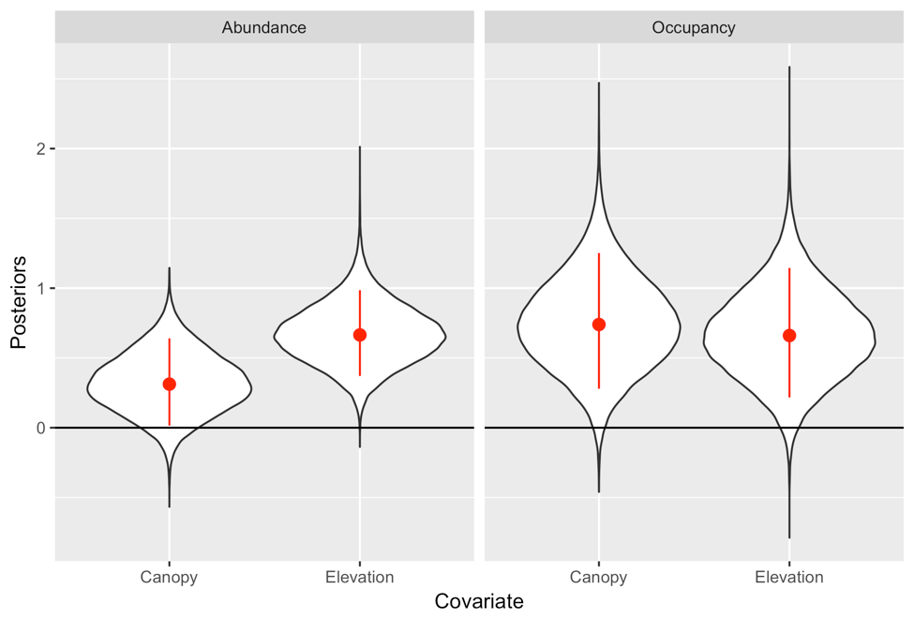

Figure 4XX. Posteriors of abundance and occupancy effect sizes for canopy and elevation for CIPA. Red circles represent the mean and red lines represent the 85% credible intervals.

Discussion

We found that species’ predicted abundance and occupancy probability were affected by habitat features and management disturbances, with at least one variable per species receiving statistical support. Specifically, we found support for our hypotheses that lark sparrow abundance would be negatively related to canopy cover and positively related to sites with shrubby habitat and management-related disturbances. We also found support for our hypothesis that eastern towhee would be negatively correlated with canopy cover. We similarly found support for our invertebrate models; Leonard’s skipper abundance was negatively correlated with pre-survey disturbance and occupancy was weakly positively correlated with mean plot-level *Liatris*. Tiger beetle abundance and occupancy were positively correlated with elevation CV and canopy.

Our results illuminate the complicated nature of wildlife habitat interactions and highlight the difficulty encountered when designing projects to restore and manage habitat for the benefit of the native fauna as a whole. Although the benefits of fire and grazing as tools to restore and maintain prairie, savanna, and other upland habitats for native fauna are well-documented (Swengel 1998, Vander Yacht et al. 2016, Davis et al. 2001, Peterson and Reich 2001), the relative costs and benefits in terms of abundance, persistence, and survival vary across taxa and species (Bendel et al. 2018, Davis et al. 200, Swengel 1998). For example, within our study system lark sparrow and Leonard’s skipper had disparate associations with management disturbance (logging, burning, and grazing.) Lark sparrow responded positively to these management activities. This may have been because lark sparrows are mobile, may have many individuals searching for territory each breeding season, and may be able to directly benefit from multiple management techniques within a relatively short timeframe. Open soil created as a result of burning or grazing may provide foraging opportunities almost immediately, and canopy openings created by logging could be considered to be available the same or the next year, depending on when they were logged. Lark sparrows may also avoid negative effects of prescribed burning because they often territorialize ASP habitat after early spring burns. Conversely, burning and grazing both have the potential to significantly disrupt the life cycle of our target invertebrate species (Dana, 1991, Swengel 1996, Bendel et al. 2018). On an invertebrate metapopulation level, balance between local establishment or re-establishment and local extinction may be disrupted by fragmentation (Dana 1991) and careful management of protected tracts to minimize local extinctions is of critical importance (Goodman 1987 in Dana 1991). Habitat management must be carefully and thoughtfully planned to avoid unintended negative consequences for habitat specialist native invertebrate species, which are at increased risk of lasting negative effects on populations (Swengel 1996, Vogel et al. 2010). Within our study system, the Leonard’s skipper was negatively impacted by management disturbance. Unlike the lark sparrow, their life cycle is very likely to be interrupted by commonly used management techniques. Prairie skippers like the Leonard’s are bound to the same location over multiple seasons and development phases. They are vulnerable to spring fire as overwintering pupae (Dana 1991), and grazing cows consume the grass upon which larvae are dependent. Skippers also inhabit different habitat components at different periods of their life cycle such that females may lay eggs in a desirable habitat in the fall only to have the larvae consumed by grazers or fires in the spring of the following year. In addition, observers noticed that areas with potentially ideal skipper habitat (i.e., understories with bunchgrass, *Liatris*, and other nectar sources interspersed by bare ground) that had been previously occupied were devoid of skippers after intensive management activities (burning and grazing). Conversely, areas that provided seemingly marginal habitat (thickly grown grass, limited nectar resources, and limited bare ground) but had not been recently altered by management yielded some scattered individuals.

Canopy cover also demonstrated contrasting effects on abundance of our target species within this system. Lark sparrow abundance was negatively related to canopy cover, whereas Northern barrens tiger beetle abundance was positively related. This is likely reflective of the natural of each species and is one more example of the difficulty associated with managing habitat for multiple species. Manipulation of canopy cover can be relatively straightforward from a management perspective, but the effects on wildlife are not as easy to define and can be dependent on the individual species and condition of the surrounding landscape (Vander Yacht et al. 2016).

Our results and observations indicate that management and restoration should be planned at large spatial and temporal scales to benefit the multitude of species that depend on rare oak savanna, oak woodland, and prairie habitats, rather than benefitting a select few at the cost of the rest. Historically, disturbance was an integral part of the ASP landscape and many native plant and animal communities are well adapted to it (Henderson et al. 2017, Vander Yacht et al. 2016), but the function of this large-scale system has been compromised by habitat loss and fragmentation. One pressing concern is to better understand how to manage for disturbance-sensitive species within disturbance-dependent ecosystems (Moranz et al. 2014) on a reduced scale. Although restoration planning should be at a large scale to provide a variety of related habitat types on the landscape and should be planned over as long a term as is possible, actual restoration activities may need to be conducted at relatively small scales to provide refugium from which populations can recolonize and rebound and to protect relatively isolated populations from accidental extirpation. When possible, a variety of techniques should be considered in the overall management plan to account for species’ differential responses to management (Davis et al. 2000, Swengel 1996).

Recommendations for future research

This study generated a number of potentially beneficial recommendations for the focus and design of future research. Due to low rates of detection for some species, the subsequent analyses had relatively low power for identifying strong wildlife-habitat relationships. Unfortunately, this is part of the challenge in working with rare and cryptic species, even when sampling units are well-matched to the spatial ecology of the target species and surveys are conducted using protocols that maximize detection (Guillera-Arroita, Ridout, & Morgan, 2010; Mackenzie & Royle, 2005 in Specht 2017). An alternative might be the conditional occupancy method described by Specht et al. (2017), which is potentially more effective at low levels of occupancy and detection, although it would have required many more potential samples sites than used in our study. It is also possible that the study design could be further refined to match the ecology of the study system and target species. We recommend conducting preliminary research into the specific home range sizes for target species before or during the process of experimental design and potentially focusing surveys on species-specific home range sizes rather than one primary plot size. We found that habitat types varied significantly over the 40 acres of a plot, yet the presence of target organisms in a small portion of suitable habitat could have confounded the relationships between occupancy, abundance, and plot-level habitat covariates. Especially for extremely rare species such as the Leonard’s skipper, a more spatially focused strategy could produce a more precise picture of specific habitat use.

We also suggest conducting additional future surveys for target species. Repeating surveys may be especially useful for the study of rare species in restoration systems which may not respond to restoration efforts right away. The goal of this and other restoration projects is long-term habitat improvement, rather than instantaneous change. Measurable effects may take longer, particularly if species are very rare, are ineffective dispersers, or have low fecundity. Further, it may take a period of years for important habitat changes to take effect after management activities are conducted. A longer time period is likely more appropriate for detecting the types of metapopulation change that are often goals of habitat restoration efforts. In addition to providing a more reasonable timeframe for detecting and describing metapopulation dynamics (e.g., colonization, extinction, recruitment, survival, etc.), repeating this type of study with a period of years between surveys (or clusters of surveys) may provide a more reasonable study framework from a cost perspective. The cost of field surveys for rare species in terms of effort can be prohibitively high, and it is generally beneficial to allocate effort in a cost-effective manner (MacKenzie and Royle 2005). For studies with multiple target species, it may be practical to conduct surveys on a staggered timeframe based on the management strategies being used and the ecology of each target species. This study provides a baseline upon which further investigation of rare Anoka Sand Plain species population dynamics can be founded, and we hope the information provided here will be useful in further management and restoration efforts in the future.