Computational prediction of acoustic emissions from collapsing bubbles using interface capturing multiphase flow simulations

R&D Project Proposal to
Naval Research Board

Submitted by

Ratnesh K. Shukla

Department of Mechanical Engineering
Indian Institute of Science
Bangalore-560012
India

- Title of research/development proposal: Computational prediction of acoustic emissions from collapsing bubbles using interface capturing multiphase flow simulations

- (a) Specific aim of the project

Prediction of the noise produced from ship and submarine propellers is of considerable practical interest to the naval labs. Underwater sound waves generated from propellers experience negligible damping as they are transmitted over long distances that are much larger than their wavelength. The noise produced from an underwater submarine propeller wake could therefore be used towards its accurate detection from locations that are significantly afar. From a stealth point of view suppression or alteration of the sound spectrum generated from underwater propellers is necessary to avoid detection, For these reasons, an understanding of the sound wave generation from propeller wakes and accurate prediction of wake noise is of significant importance.

The noise produced from propeller wakes is strongly influenced by cavitation. The high speed rotary motion of submerged propeller blades invariably results in cavitation inception. These cavitation bubbles interact strongly with the unsteady pressure variations induced by the propeller motion. While interacting with the pressure variations, cavitation bubbles undergo large shape variations and collapse violently. Strong blast waves are emitted during cavitation bubble collapse process (Brennen (1995)). The jetting and blast wave emission associated with collapsing bubbles are two principal sources of sound wave emission. Thus, besides interacting with sound waves, cavitation bubbles generate sound as well.

The aim of the project is to develop an accurate and efficient computational technique to reliably predict noise due to cavitation. Specifically we aim to study the acoustic and shock wave emission from underwater cavitation bubble clusters. For the aforementioned reasons, accurate prediction of the sound radiated from interacting cavitation bubbles in terms of the intensity of the bubble cluster collapse is of significant importance in marine hydrodynamics. The primary objective of the proposed study is to investigate how bubble clusters in a model propeller wake interact with and produce sound. In particular we will develop a novel algorithm for simulation of high-speed multiphase flows that is built upon state-of-the-art low-dissipation shock and interface capturing spatiotemporal discretization techniques. This computational technique will be used to conduct detailed numerical simulations of cloud cavitation collapse. A detailed understanding of the acoustic emission mechanisms (sound radiated) from the clouds of cavitation bubbles will be obtained by utilization of an efficient technique for identification of sources of sound and quantification of sound waves radiated from interacting cavitation bubbles. The ultimate goal of this proposed work will be to develop a computational framework that can be used for reliable prediction of sound generated from interacting underwater bubble clusters in a propeller wake and utilization of this framework to study sound wave interaction and generation from a bubble cluster in a model propeller wake.

Summary of proposed research/facilities and objectives (Brief statement about the proposed investigation, its conduct, and the anticipated results in not more than 200 words)

The primary objective of the proposed study is to understand detailed flow physics associated with cloud cavitation collapse. This includes sound wave propagation and generation during the process of single and multiple cavitation bubble collapse events. The specific deliverables are:

i) A novel algorithm for simulation of high-speed multiphase flows that is built upon state-of-the-art low-dissipation shock and interface capturing spatiotemporal discretization techniques. This will be necessary for reliable prediction of sound wave emission and its interaction with multiple collapsing cavitation bubbles.

ii) Implementation of a high fidelity efficient three-dimensional computational method that could be used to conduct fully parallel detailed numerical simulations of cloud cavitation collapse in free space and in a model propeller wake.

iii) An efficient technique for quantification of sound waves radiated from distributions of interacting cavitation bubbles.

The key outcomes of this proposed work will be

i) Development of a high-order fully parallel shock and interface capturing technique for simulation of unsteady high-speed multiphase flows in multiple dimensions.

ii) Detailed understanding of the acoustic emissions (sound radiated) from clusters of cavitation bubbles. This understanding should result in effective strategies for discriminating between the acoustic signatures of marine propeller wakes with and without cavitation bubbles.

- Key words: Cavitation bubble collapse, acoustic emission, noise prediction.

- Classification of the project: Applied research and exploratory investigation.

- Background and justification (Basis for the proposal with brief review of the state of the art in the subject, followed by an outline of the relevance and importance of the project in particular towards research/development/design related to Naval Research Board).

Prediction of the noise produced from ship and submarine propellers is of considerable interest to the naval labs. Underwater sound waves propagate to distances that are significantly larger than their wavelength without experiencing significant damping. as they are transmitted over long distances that are much larger than their wavelength. As such the noise produced from an underwater submarine propeller wake can be detected from locations that are significantly afar. From a stealth point of view, suppression or alteration of the sound spectrum generated from underwater propellers is necessary to avoid detection. For these reasons, an understanding of the sound wave generation from propeller wakes and accurate prediction of wake noise is of significant importance to naval labs.

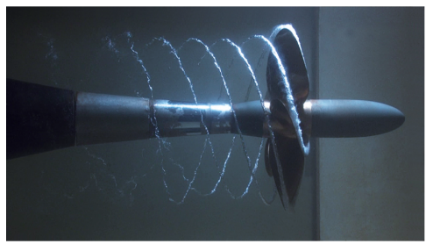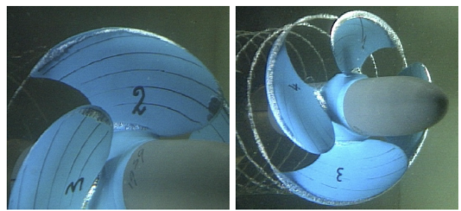
Fig. 1 (Left) Cavitating helical tip vortices from a propeller. (Center) Cavitation tip vortex pattern and (Right) sheet cavitation on a propeller (source: Bosschers, 2018),

The noise produced from propeller wakes is strongly influenced by cavitation (Brennen, 1995). The high speed rotary motion of submerged propeller blades invariably results in cavitation inception. For example, figure 1 shows a typical distribution of cavitating helical vortices that are generated from a propeller tip. These cavitation bubbles interact strongly with the unsteady pressure variations induced by the propeller motion. While interacting with the pressure variations, cavitation bubbles undergo large shape variations and collapse violently. Strong blast waves are emitted during cavitation bubble collapse process (Brennen (1995), Leighton (1994)). The jetting and blast wave emission associated with collapsing bubbles are two principal sources of sound wave emission. Thus, besides interacting with sound waves, cavitation bubbles generate sound as well.

The sound waves generated from cavitation bubbles formed in a propeller wake alter the spectrum of the sound emitted from it. This alteration hinders accurate detection of the propelling body (submarine for instance). For reliable underwater detection of a distant self-propelling body, an understanding of the influence of cavitation bubbles on the radiated sound spectrum is of critical importance. Developing such an understanding and predictive capability for the sound radiated from cavitation bubbles in terms of the intensity of their collective collapse is the principal motivation behind this proposed investigation. An understanding and predictive capability of cavitation noise is crucial for discriminating between flow generated noise and the sound spectrum associated with distant sources. This understanding would be useful in development of effective strategies for sonar detection of underwater vessels. An understanding of how bubbles collectively produce and interact with sound waves could be useful in design of acoustic cloaks that effectively shield underwater self-propelling bodies. Thus, both from sound detection/prediction and sound suppression/shielding perspectives the prediction of sound generated from cavitation bubbles would be of interest to the naval labs.

In this proposed work, we will focus on predicting the sound generated by cavitation bubbles in model propeller wakes using advanced simulation tools that will be developed specifically to accurately capture shock and sound wave propagation through bubbly medium. Despite its importance in naval applications, the unique computational challenges involved in estimation of sound emitted from cavitation bubbles have hindered investigations in this area. Early investigations on quantification of sound radiated from oscillating bubbles have relied on theoretical analysis of the simplified radial dynamics (Rayleigh (1977); Plesset & Prosperetti (1997); Prosperetti (1982)). The asymmetric deformations are important as they eventually lead to formation of a strong jet and sound wave emission due to water-hammer-like impact of the strong jet onto the deforming water-air interface (Johnsen & Colonius (2009); Lauterborn & Kurtz (2010)).

Recent advancements in computational power, hardware and especially simulation methodologies (Shukla et al (2010) ; Shukla (2014) ; Saurel & Pantano (2018)) have enabled detailed simulation-based investigations of the aspherical collapse process (Freund et al (2009) ; Jamaluddin et al. (2011)). However, prediction of sound from a distribution of bubbles remains a challenge that is yet to be overcome. Simulations of single bubble cavitation collapse tend to be computationally intensive and as expected multi-bubble calculations are significantly more complex, challenging and expensive. Moreover, for reliable noise prediction, simulations must accurately propagate sound waves throughout a relatively large computational domain that encapsulates the major sources of sound. This requirement augments the computational burden of an inherently expensive simulation.

Our plan in this proposed work is to overcome the challenges outline above by first developing high-resolution low dissipation approximation methods that can accurately capture propagation of underwater sound waves over long distances. Second, to overcome the excessive cost of simulating bubble-bubble interactions we will pursue development of efficient parallelization strategies that will allow calculations to be performed on several thousand cores of a high performance computing cluster. Parallel simulations will also facilitate realistic simulations that include numerous cavitation bubbles in a model propeller wake.

Next, using the fully parallel computational tool, we plan on performing detailed simulations to establish the dependency of radiated sound waves on the bubble cluster collapse dynamics. An understanding of the bubble-bubble interaction process in a cluster collapse scenario will enable detailed characterization of the acoustic emission associated with clouds of cavitation bubbles in a model propeller wake. The proposed modelling effort will be an important first step towards developing a comprehensive understanding of generation and interaction of sound waves with bubby wakes formed behind propelling bodies.

The proposed work falls under the broad area of Cavitation Study that is listed as a thrust area under the CFD multiphase flow program of NSTL Vishakhapatnam. The computational tools developed as part of this research work would be useful in prediction of noise radiated from cavitating flows. Since our simulation methodology would accurately account for sound and shock wave propagation and their interaction with deforming interfaces, our modeling and simulation technique would also be valuable in investigations concerned with sound wave propagation through bubbly flows. The understanding gained through the proposed work will be useful for discriminating between flow generated noise and the sound spectrum associated with distant self-propelling bodies. This could lead to development of effective strategies for sonar detection of underwater vessels. An understanding of how bubbles collectively produce and interact with sound waves could be useful in design of acoustic cloaks that effectively shield underwater self-propelling bodies. The modeling and simulation techniques developed during the proposed study could also be effectively utilized to obtain improved propeller noise estimations for ships and submarines. Thus, as argued earlier, both from sound detection/prediction and sound suppression/shielding perspectives the proposed work would be of interest to the naval labs.

References:

[1] Bosschers, J. (2018) “Propeller tip vortex cavitation and its broad band noise” Ph.D. dissertation.

[2] Brennen, C. E.(1995) “Cavitation and bubble dynamics," Oxford University Press.

[3] Freund, J.B. Shukla, R.K., and Evan, A. (2009) “Shock-induced bubble jetting into a viscous fluid with application to tissue injury in shock-wave lithotripsy,” The Journal of the Acoustical Society of America, 126, 2746-2756.

[4] Jamaluddin, A. R., Ball, G. J., Turangan, C. K. and Leighton., T. G. (2011) “The collapse of single bubbles and approximation of the far-field acoustic emissions for cavitation induced by shock wave lithotripsy,” Journal of Fluid Mechanics, 677, 305-341.

[5] Johnsen, E. and Colonius, T. (2009) “Numerical simulations of non-spherical bubble collapse,” Journal of Fluid Mechanics, 629, 231-262.

[6] Lauterborn, W. and Kurz, T. (2010) " Physics of bubble oscillations,'' Reports on progress in Physics, 73, 106501.

[7] Leighton, T. G. (1994) “The acoustic bubble,” London : Academic.

[8] Plesset, M. S. and Prosperetti, A. (1977) “Bubble dynamics and cavitation,” Annual Review of Fluid Mechanics, 9, 145-185.

[9] Prosperetti, A, (1982) “A generalization of the Rayleigh–Plesset equation of bubble dynamics,” Physics of Fluids, 25(3), 409-410.

[10] Rayleigh, L. (1917) “On the pressure developed in a liquid during the collapse of a spherical cavity,” Philosophical Magazine, 34, 94-98.

[11] Saurel, R., Pantano, C. (2018) "Diffuse-interface capturing methods for compressible two-phase flows," Annual review of fluid mechanics, 50, 105-130.

[12] Shukla, R. K., Pantano, C. and Freund, J. B. (2010) “An interface capturing method for the simulation of multi-phase compressible flows” Journal of Computational Physics, 229, 7411-7439.

[13] Shukla, R. K. (2014) “Nonlinear preconditioning for efficient and accurate interface capturing in simulation of multicomponent compressible flows” Journal of Computational Physics, 276, 508-540.

- (a) Approach (details of the actual approach intended to be adopted in the execution of the project/facilities indicating how each of the objectives listed in item 6(a) will be achieved).

To begin with the interface capturing framework developed by the principal investigator will be used to develop a computational model of cavitation bubble cluster collapse. The computational modeling approach will account for the compressibility effects and also the orders of magnitude difference between the acoustic impedance of bubble medium and surrounding water. This important step would involve generalization of the state of the art interface and shock capturing techniques that we have developed over the last few years. In particular, we plan on extending our current state-of-the-art ADER- WENO (Arbitrary Derivative- Weighted Essentially Non-Oscillatory) based single phase compressible flow simulation technique to unsteady compressible multiphase flows consisting of numerous air/vapor bubbles in a water-like medium in three dimensions. Our ADER-WENO based conservative discretization technique will combine low-dissipation spatiotemporal discretization with oscillation free shock and interface capturing in order to minimize the numerical dissipation. The numerical dissipation necessary for oscillation free shock and interface capturing is particularly detrimental in simulations of bubble collapse as it prevents accurate resolution of bubble contents at its minimum volume on relatively coarse grids. The low dissipation discretization we plan on developing would reduce the resolution necessary for accurate resolution of intricate flow features. The use of low-dissipation approximation techniques will also facilitate accurate resolution of sound waves that are generated from interacting bubbles. In simulations, accurate resolution of sound waves over distances that are much larger than their wavelengths is important for reliable prediction of sound propagation and generation from cavitation bubbles.

We will thoroughly validate our technique using detailed comparisons with the existing theoretical results for an isolated single bubble undergoing nonlinear oscillations in an externally applied pressure field. For validation purposes, preliminary tests will therefore be conducted on a simple configuration consisting of a single bubble oscillating in free space. For this setup comparisons will be made against the well-known spherically symmetric bubble shape oscillations predicted using the solution of the Rayleigh-Plesset equation. Both the nonlinear regime and the giant response regime in which the bubble resonates at its natural frequency (Lauterborn & Kunz, 2010) will be considered to validate the compressible flow solver and to establish its accuracy and convergence characteristics.

Next, practically important cases of swarms of bubbles that oscillate collectively will be simulated. Bubble clusters in free space and in a model propeller wake will be considered and our focus will be on performing high-resolution detailed simulations that capture the most important flow features accurately and identify the sources of sound, The identified sources will further be utilized to establish the dependency of the radiated sound waves on the bubble cluster collapse characteristics. Our acoustic emission analysis

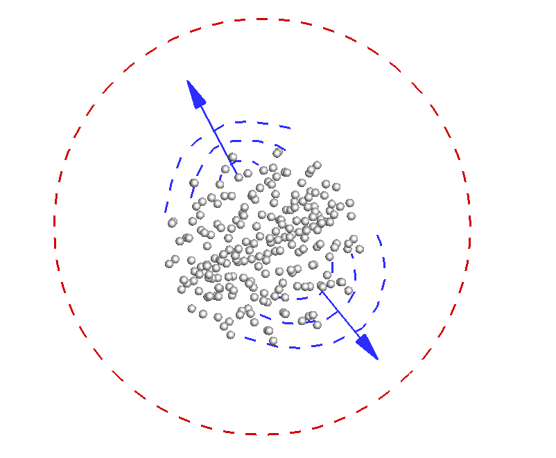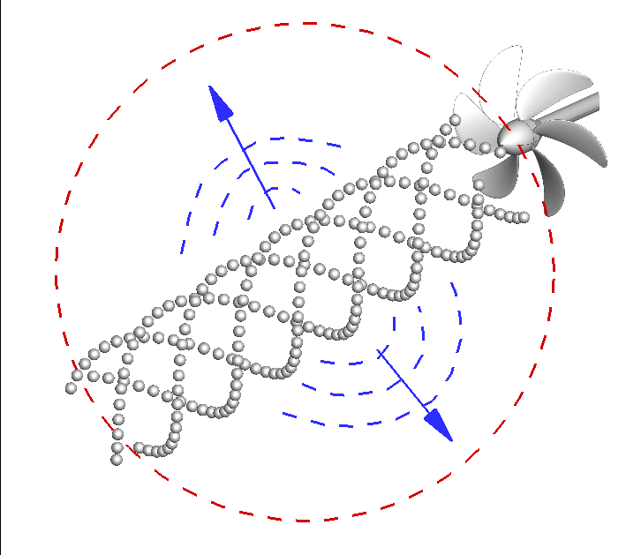
Fig. 2 Schematic showing our proposed simulation configuration consisting of (left) a spherical bubble cluster and (right) a helical distribution of bubbles that deform and collapse in a model propeller wake. The bubbles are shown in grey and the aim is to predict the emitted sound waves (shown in blue) in a relatively large computational domain (shown using red dotted lines).

will rely on the Kirchoff and Ffowcs William-Hawkings formulations for identification of sources of sound within a specified region of interest.

Figure 2 shows a schematic of the two configurations we will target though our simulations. The one on the left shows a spherical distribution of cavitation bubbles in free space, whereas the one of the right depicts a helical distribution of bubbles in a model propeller wake. In both these target simulations we will account for the deformation of bubbles both due to mutual interactions with surrounding bubbles and also due to variations in the pressure field. The bubble distribution in these target simulations will be chosen such that it mimics the distribution typically observed in controlled experiments. An attempt will be made to match the characteristics of the cavitating propeller wake in as much details as possible. Thus in our simulations of cavitating propeller wake, we will attempt inclusion of inception events leading to formation of a helical distribution of bubbles in a model thrust- generating wake. A principal aim will be to make predictive calculations of the sound radiated from the bubble distributions with the hope that these techniques would aid in discriminating between acoustic signature from propeller wakes with and without cavitation bubbles.

Both our target simulations will involve a reasonably large collection of bubbles. Consideration of a sufficiently large cluster consisting of numerous bubbles will be necessary for realistic modeling of a helical cavitating propeller wake. As such we will also develop efficient parallelization and domain decomposition strategies that facilitate implementation of our simulation technique on several thousand cores that are available on the CRAY XC-40 high performance computing cluster housed in the Supercomputing Education and Research Center at Indian Institute of Science. This important step will ensure that the relatively expensive simulations involving numerous bubbles and hydroacoustic calculations are completed in a reasonable time. Use of several thousand cores will also lead to over an order of magnitude increase in the spatial and temporal resolution employed in our calculations. Increased resolution will naturally improve the quality of our predictions. This is because sound wave propagation and generation, and also the flow features that influence sound wave emission and propagation (such as flow turbulence, interactions with bubbles, vortical features etc.) are captured accurately only on a sufficiently refined mesh.

