Front Page Certificate

**Practical 1-Creating tables and inserting records**

**1. Create table employee based on the following instance chart and populate the table.**

|  |  |  |
| --- | --- | --- |
| **Column Name** | **Data Type** | **Constraints** |
| Emp_no | Integer | Primary Key |
| Emp_name | Varchar(30) | Not Null |
| Salary | Float |  |
| Zone | Varchar(15) |  |
| Age | Integer | Greater than 20 |
| Grade | Char(1) |  |
| Dept | Integer | Foreign Key(Department table) |

**Source Code:**

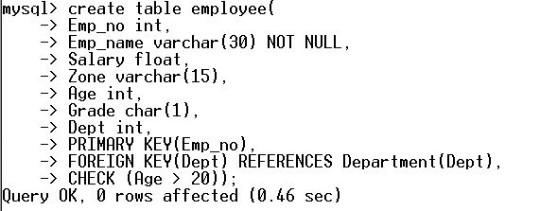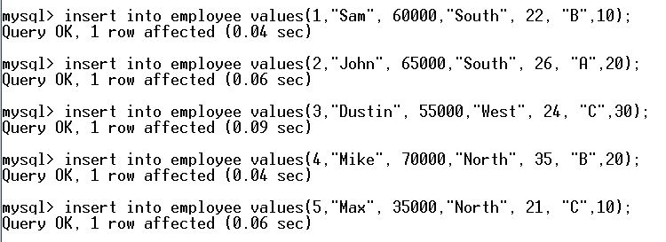

**Output:**

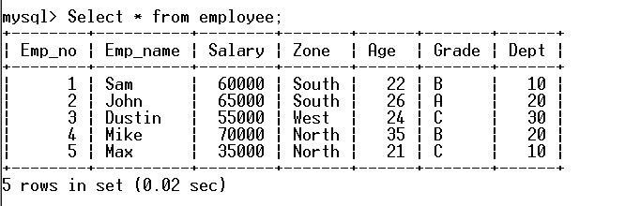

**2.Create table Department based on the following instance chart and populate the table**

|  |  |  |
| --- | --- | --- |
| **Column Name** | **Data Type** | **Constraints** |
| Dept | Integer | Primary Key |
| D_name | Varchar(20) | Not Null |
| HOD | Integer | Default-5 |

**Source Code:**

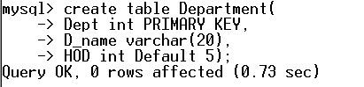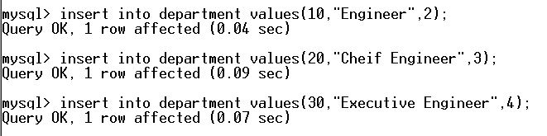

**Output:**

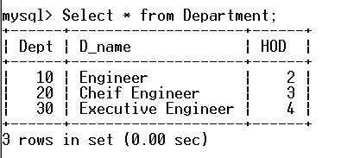

**Practical 2- To add tables and update table**

**Source Code:** 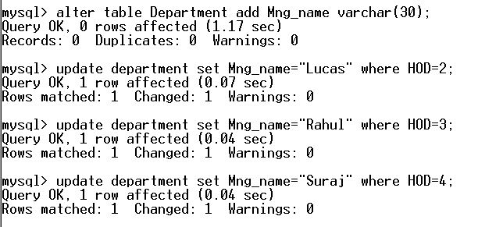

**Output:**

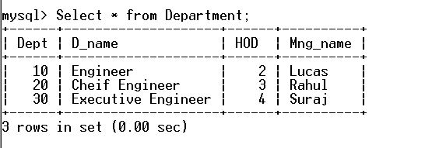

**Practical 3-To delete records based on criteria**

**1.Delete all the records from Employee table belonging to Central Zone and having grade A**

**Source code:**

**C:\Users\user\Desktop\CS Project\Images\PL-3.1.JPG**

**Output:**

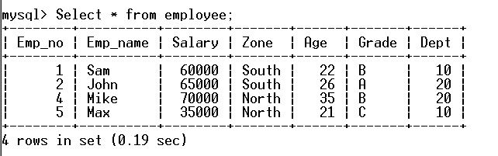

**2.Delete column Mng_Name from department table**

**Source Code:**

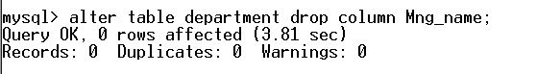

**Output:**



**Practical 4 – Extracting Data**

**1.Display Emp_no, Emp_name, Salary and corresponding D_name of all the employees whose age is between 25 and 35(both values inclusive).**

**Source Code:**



**Output:**

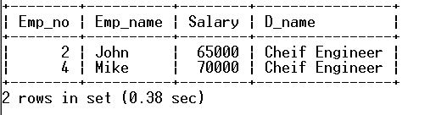

**2.Display D_name and corresponding Emp_name from tables department and employee.**

**Source code:**



**Output**

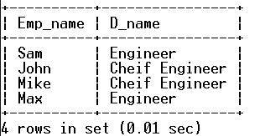

**3.Display Emp_name, Salary, Zone and income Tax of all the employees with appropriate column headings. (Income Tax to be calculated 30% of the salary)**

**Source Code:**

**C:\Users\user\Desktop\CS Project\Images\PL-4.3.3.JPG**

**Output:**

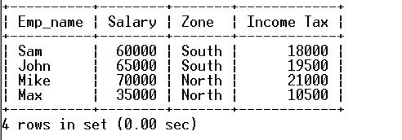

**4.Display all details of employees of south zone whose salary is greater than 50,000.**

**Source Code:**

**C:\Users\user\Desktop\CS Project\Images\PL-4.4.1.JPG**

**Output:**

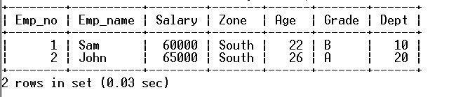

**5.Display Emp_Name, Age, grade of employees whose name started with the character ‘M’.**

**Source Code:**

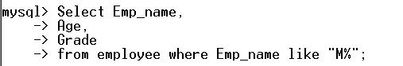

**Output:**

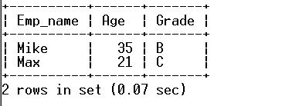

**Practical 5-Using Functions**

**1.Display maximum salary and minimum salary from table employee under appropriate column headings.**

**Source Code:**

**C:\Users\user\Desktop\CS Project\Images\PL-5.1.2.JPG**

**Output:**

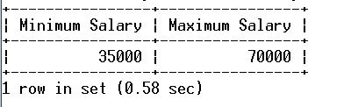

**2.Display the average and total salary from table employee.**

**Source Code:**

**C:\Users\user\Desktop\CS Project\Images\PL-5.2.2.JPG**

**Output:**

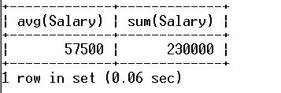

**3.Count the number if employees in the table employees.**

**Source Code:**

**C:\Users\user\Desktop\CS Project\Images\PL-5.3.1.JPG**

**Output:**

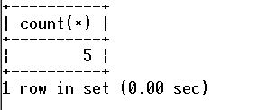

**4.Count the number of distinct zones from table employee.**

**Source Code:**

**C:\Users\user\Desktop\CS Project\Images\28.JPG**

**Output:**

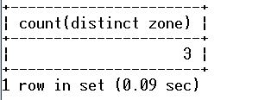

**Practical 6-Using Functions**

**1.Display D_name of the table department in uppercase.**

**Source Code:**

**C:\Users\user\Desktop\CS Project\Images\30.JPG**

**Output:**

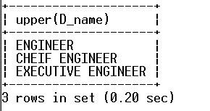

**2.Removing leading and trailing spaces from D_name field of department table.**

**Source Code:**

**C:\Users\user\Desktop\CS Project\Images\32.JPG**

**Output:**

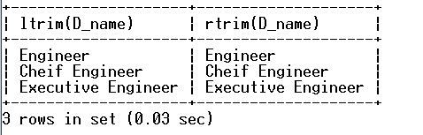

**3.Concatenate D_name and Dept of the table department having D_Name as ‘Engineer’.**

**Source Code:**

**C:\Users\user\Desktop\CS Project\Images\34.JPG**

**Output:**

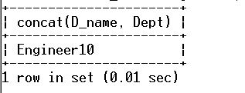

**4.Display first three characters extracted from D_name column of the table department whose Dept is not 30.**

**Source Code:**

**C:\Users\user\Desktop\CS Project\Images\36.JPG**

**Output:**

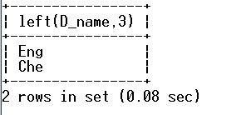

**5.Display the date/time queries to return current date, date only, month only, year only, current date and time at which the function executes.**

**Source Code:**

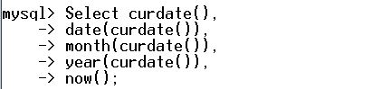

**Output:**

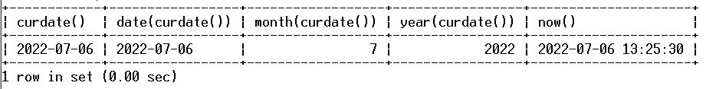

**Practical 7-Grouping Data**

**1.Display grade wise total salary**

**Source Code:**

**C:\Users\user\Desktop\CS Project\Images\40.JPG**

**Output:**

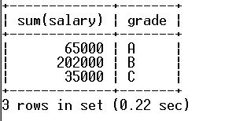

**2.Display maximum and minimum salary in each zone.**

**Source Code:**

**C:\Users\user\Desktop\CS Project\Images\42.JPG**

**Output:**

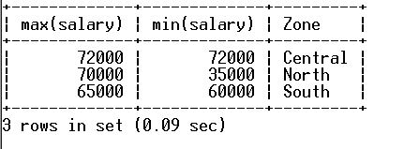

**3.Display department wise average salary having average salary less than 70000.**

**Source Code:**

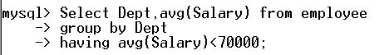

**Output:**

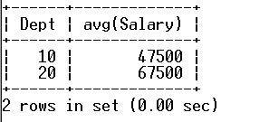

**4.Display department wise average salary having dept count less than or equal to 2.**

**Source Code:**

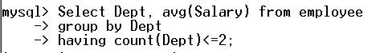

**Output:**

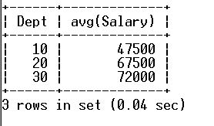

**Practical 8-Sorting Data**

**1.Display names from table employee in ascending order.**

**Source Code:**

**C:\Users\user\Desktop\CS Project\Images\48.JPG**

**Output:**

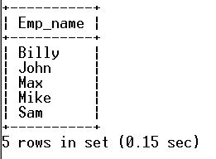

**2.Display all the details of employees in descending order of age from table employees.**

**Source Code:**

**C:\Users\user\Desktop\CS Project\Images\50.JPG**

**Output:**

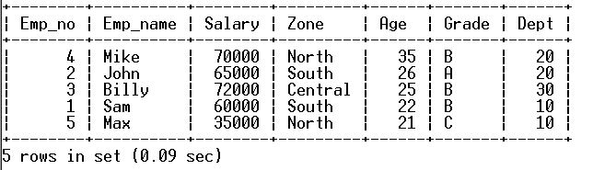

**3.Display all the details of employees in descending order of grade and then by descending order of age from table employee.**

**Source Code:**

**C:\Users\user\Desktop\CS Project\Images\52.JPG**

**Output:**

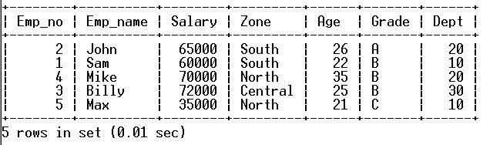

**4.Display name and age of employees in ascending order of names where age is between 20 and 40.**

**Source Code:**

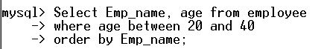

**Output:**

