**Program 1 – Area of various shapes using various functions**

**Aim: To easily calculate the area of different shapes and to reduce the program size and calculations by using functions.**

**def triangle(b,h):**

**area=0.5*b*h**

**return area**

**def square(a):**

**area=a*a**

**return area**

**def rectangl(l,b):**

**are=l*b**

**return area**

**def circle(r):**

**area=3.14*r*r**

**return area**

**y="yes"**

**while y=="yes":**

**print("MENU")**

**break;**

**print("Which area do you want to find?")**

**print("1.area of triangle")**

**print("2.area of square")**

**print("3.area of rectangle")**

**print("4.area of circle")**

**print(" ")**

**x=int(input("Enter your choice:"))**

**if x==1:**

**base=int(input("Enter the length of the base:"))**

**height=int(input("Enter the height of the triangle:"))**

**a=triangle(base,height)**

**print(a)**

**if x==2:**

**side=int(input("Enter the length of the square:"))**

**a=square(side)**

**print(a)**

**if x==3:**

**length=int(input("Enter the length of the rectangle:"))**

**breadth=int(input("Enter the breadthof the rectangle:"))**

**a=rectangle(length,breadth)**

**print(a)**

**if x==4:**

**radius=int(input("Enter the radius of the circle:"))**

**a=circle(radius)**

**print(a)**

**y=input("Do you want to continue?(yes or no)")**

**print("MENU")**

**Output:**

**Area of Triangle:**

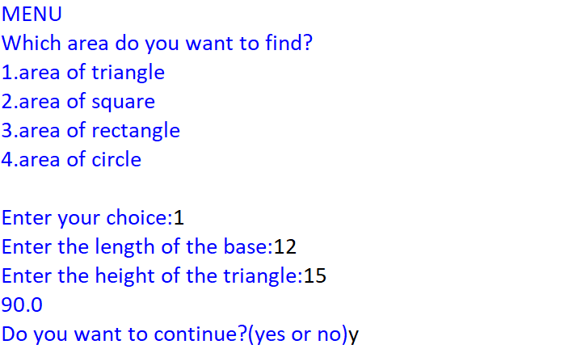

**Area of Square:**

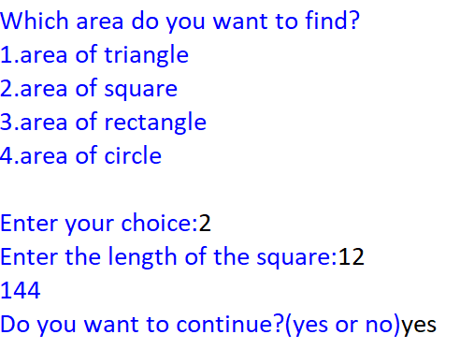

**Area of Rectangle:**

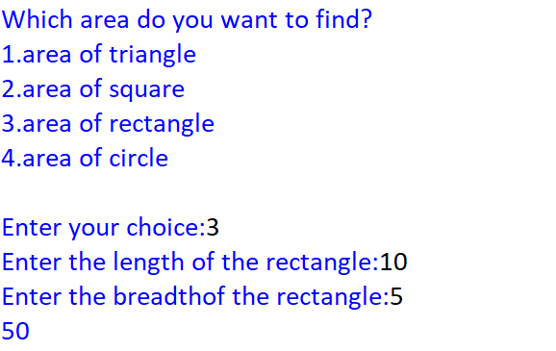

**Area of Circle:**

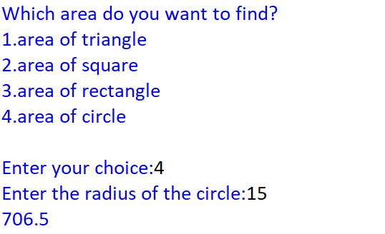

**Program 2-Library functions**

**Aim:** To enable us to various functions in the math and string module

**Source Code:**

import math

import string

y="yes"

while y=="yes":

print("1.Math module functions")

print("2.String module functions")

a=int(input("Enter function choice:"))

if a==1:

print("Choose functions:")

print("1.sqrt")

print("2.exp")

print("3.pow")

print("4.sin")

print("5.cos")

print("6.radians")

b=int(input("enter function:"))

if b==1:

x=int(input("Enter value to be calculated:"))

y=math.sqrt(x)

print(y)

elif b==2:

x=int(input("Enter value to be calculated:"))

y=math.exp(x)

print(y)

elif b==3:

x=int(input("Enter value to be calculated:"))

a=int(input("Enter power:"))

y=math.pow(x,a)

print(y)

elif b==4:

x=int(input("Enter value to be calculated:"))

y=math.sin(x)

print(y)

elif b==5:

x=int(input("Enter value to be calculated:"))

y=math.cos(x)

print(y)

elif b==6:

x=int(input("Enter value to be calculated:"))

y=math.radians(x)

print(y)

elif a==2:

print("Choose functions:")

print("1.lower")

print("2.upper")

print("3.title")

print("4.find")

print("5.replace")

b=int(input("Choose function:"))

if b==1:

x=input("Enter string:")

print(x.lower())

elif b==2:

x=input("Enter string:")

print(x.upper())

elif b==3:

x=input("Enter string:")

print(x.title())

elif b==4:

x=input("Enter string:")

y=input("Enter letter to be searched:")

print(x.find(y))

elif b==5:

x=input("Enter string:")

y=input("Enter word to be replaced:")

z=input("Enter new word:")

print(x.replace(y,z))

y=input("Continue?(y/n)")