# Document Contents

1. **Introduction**
2. **Target Audience**
3. **Platform & Genre**
4. **Unique Selling Points**
5. **Game play**
6. **Control Mechanics**
7. **Game Mechanics**
8. **Visual Style**
9. **Graphic User Interface Design**
10. **Level Design**
11. **Future Implement**
12. **Credits**

**Introduction**

CUBO is a fast pace platform game where player need to maneuver a ball on a platform of cubes, 6 by 6.

**Target Audience**

The game will be set for any age group.

**Platform & Genre**

CUBO is set to be for PC platform, with the intention of making a release for next gen consoles and iPhone. Ideally, CUBO is plan to be an iPhone game to fully utilize the motion detection function.

**Unique Selling Points**

* Simple Game play; for every age
* Fast Paced
* Challenging Levels
* Dynamic Environment
* High replay value

**Game play**

Player will play as a ball, and move the ball around the platform of cubes with each of them changing color constantly, when the ball and the cube are not of the same color, the cube will fall off from the game world, which will leave a gap in the platform, and so player will have lesser cubes to stand and maneuver the ball around causing the player to have more difficulty staying “alive” in the game.

**Control Mechanics**

The game can be played using the arrow keys on the keyboard. As for iPhone, control will be used based on the accelerometer function, to tilt left and right, top or down to maneuver the ball in the game.  
  
Keyboard:

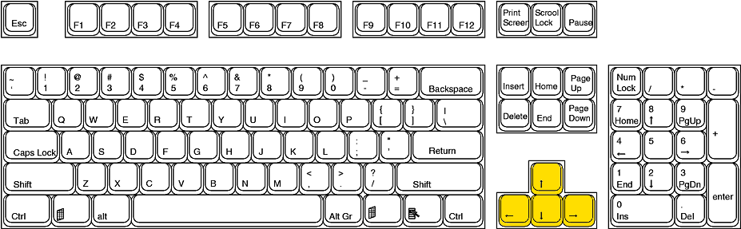

C:\Documents and Settings\tempstaff2010\Desktop\02a.png C:\Documents and Settings\tempstaff2010\Desktop\02b.png C:\Documents and Settings\tempstaff2010\Desktop\02c.png C:\Documents and Settings\tempstaff2010\Desktop\02d.png  
Move up Move down Move left Move Right

iPhone:

Pitch   
forward / backward

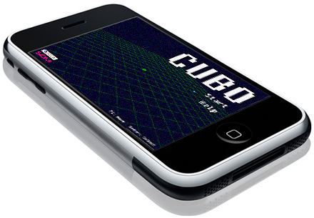

Roll left

Roll right

Pitch   
backward / forward

**Game Mechanics**CUBO has a simple game structure, to survive the game till the time has run out. Each game will last no longer than 2 minutes, set in a 6 by 6 cubes as the platform. The cube will change color randomly, and so do the ball too. Player needs to stay in the game by rolling the ball onto the matching color cube; else the cube will break off from the platform and leave a gap, which the ball will fall off and player will lose the game.

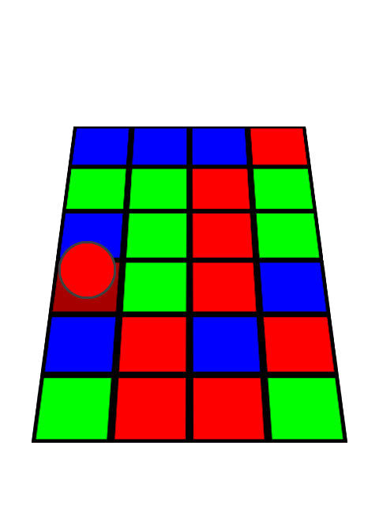 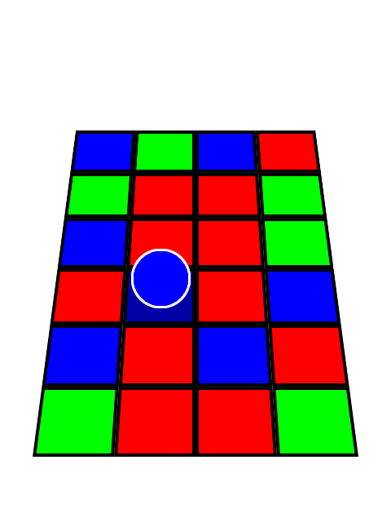

Blue Tile

Blue Ball





Red Tile

Red Ball

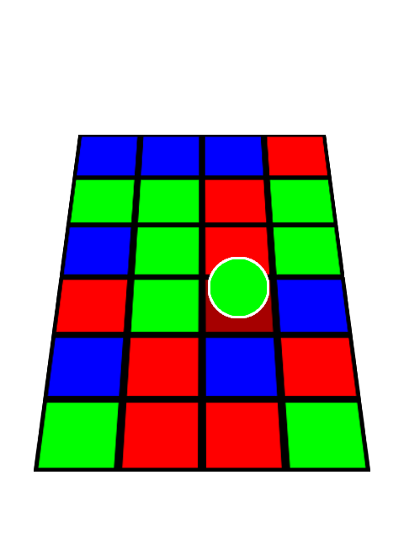 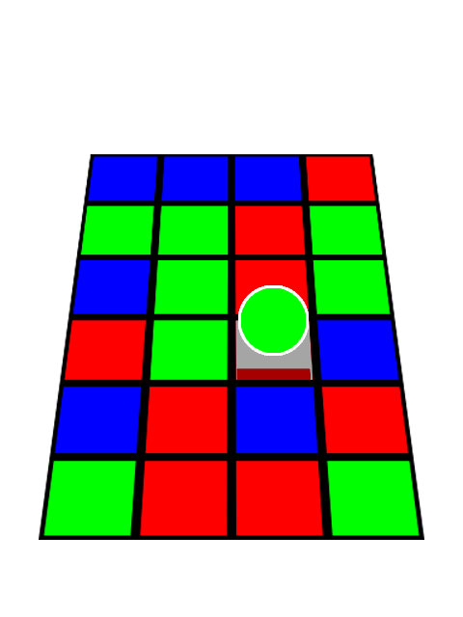

The tile will fall and causes the ball will fall as well and loses the game.



Red Tile

Green Ball

**Visual Style**

CUBO is inspired by disco dance floor, so the game style will be very “disco-like” and colorful.

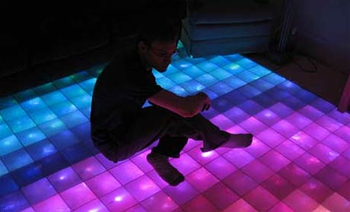

**The game is inspired by Disco Dance Floor.**

**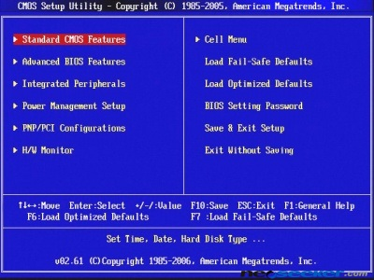  
  
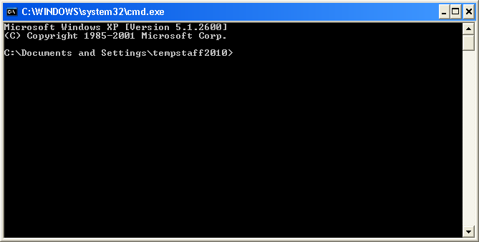  
The visuals are also strongly 8 bit graphic based.**

**Graphic User Interface**Game flow:

Splash  
Screen

Main Menu

Game  
Screen

Help  
Screen

Concluding Screen

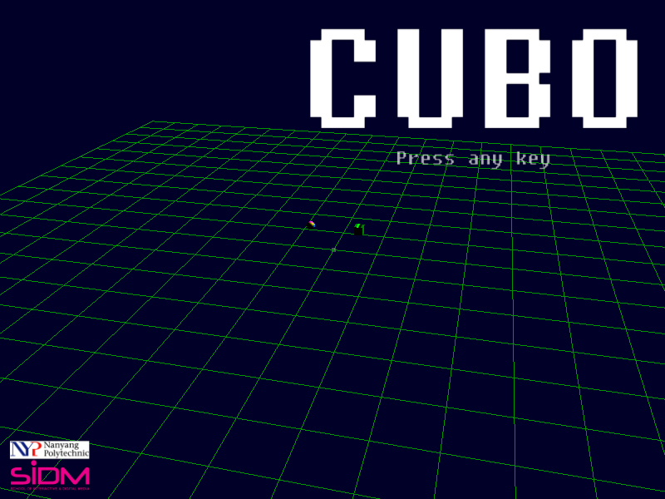 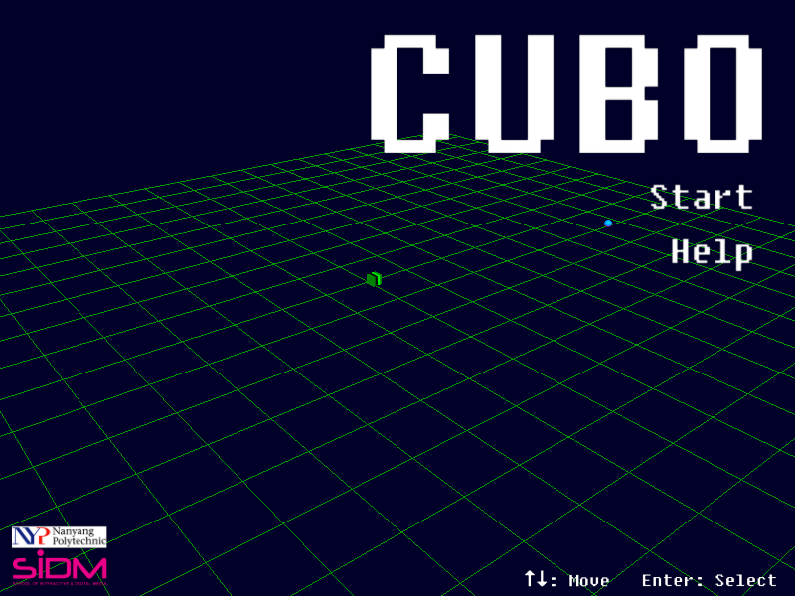  
Splash Screen Menu Screen  
  
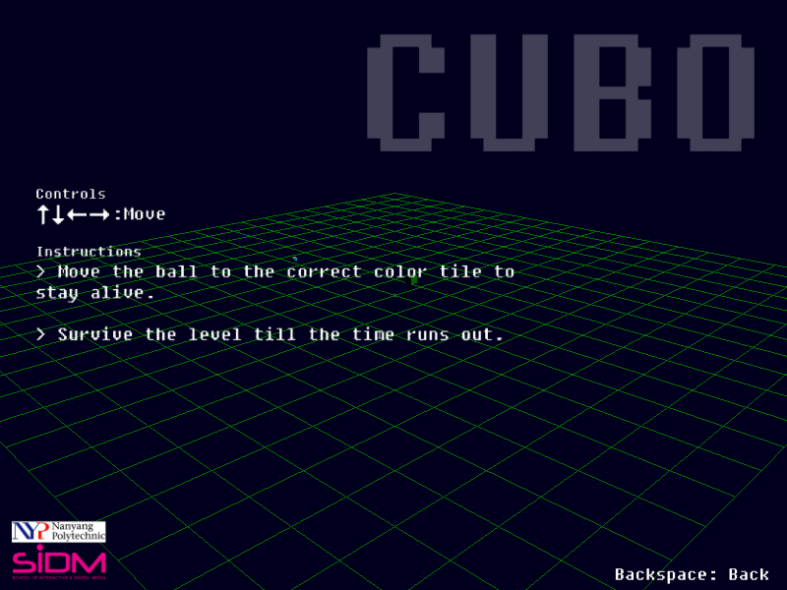 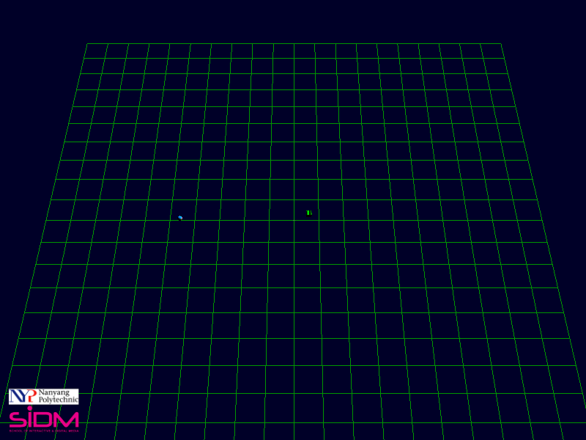  
Help Screen Game Screen

**Level Design**

The level will have a default 6 by 6 tiles layout.

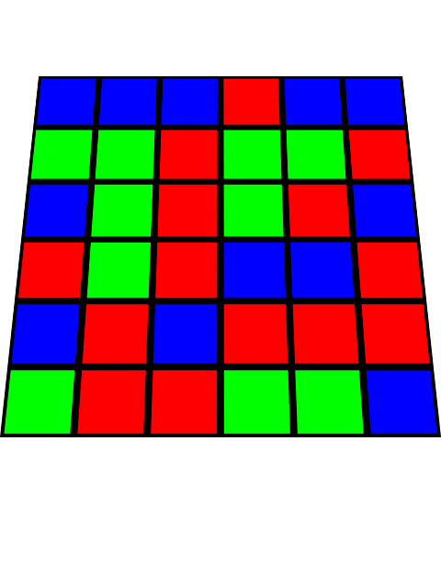

6

6

Other features:

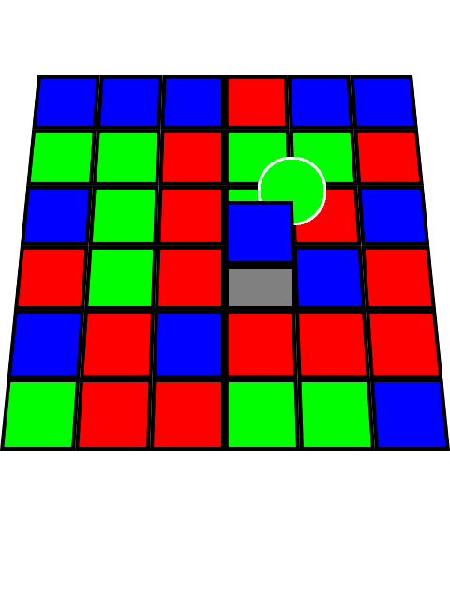  
 Trap tiles  
Randomly, tiles will rise up, rendering them inaccessible for the players.

Obstacles:

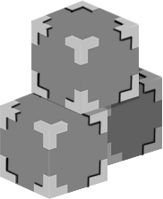 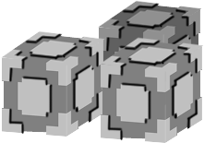

Light obstacles cubes Heavy obstacles cube

Obstacles will be randomly dropped down to the level to obstruct the player’s movement. Different weigh cubes will have different mass and be harder to push aside.

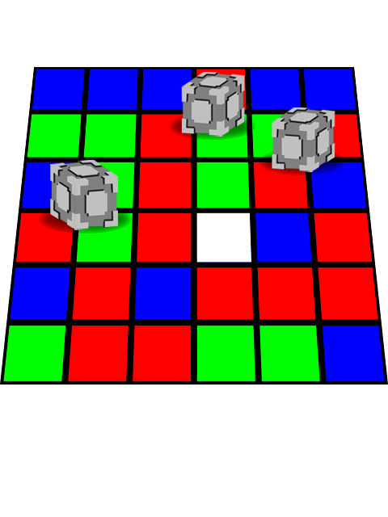

As the level increases, the dimension of the platform will change, by increase and/or decreasing the numbers of tiles, increase in the time to survive (not longer than 2 minute) and introducing more colors varieties. **Future Implement**

Creative level layout. Example: Mario Shaped level.

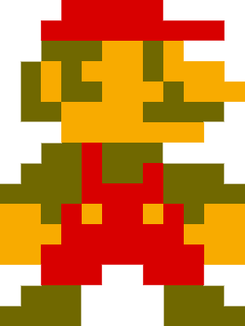 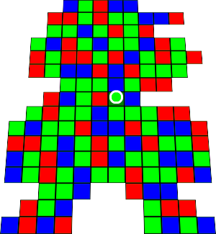

Introduce more colors varieties to increase the difficulty.

Pick random varieties of textures.

Level editor