Mohammad Abaeiani

810198432

DLD CA 6

­

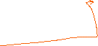

An alternative form of the design is like below (used in this project):

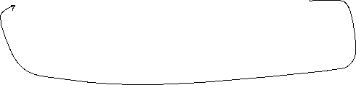

Sequential multiplier:



Wrapper:

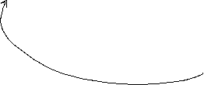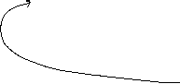

Code:

I used option d for this part

The plain FP multiplier with multiply operation instead of sequential.

Data path:

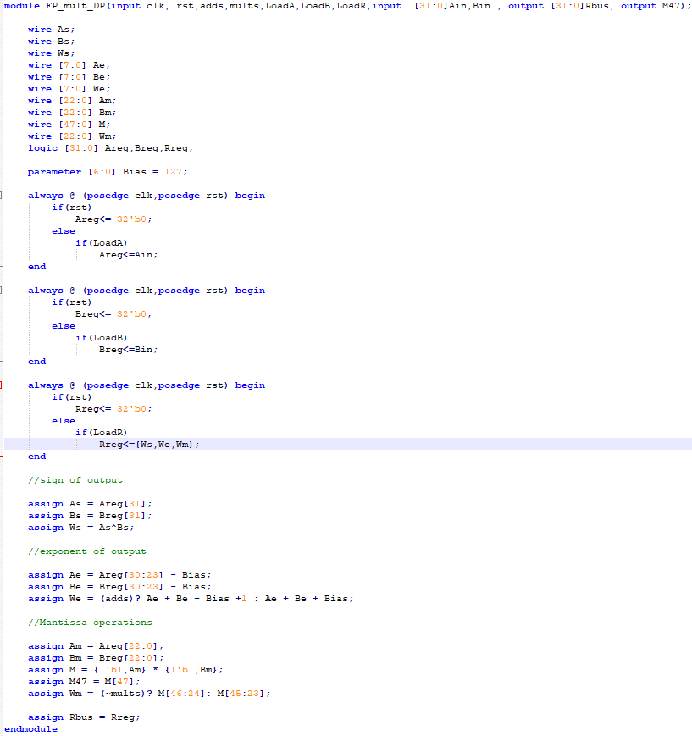

Controller:

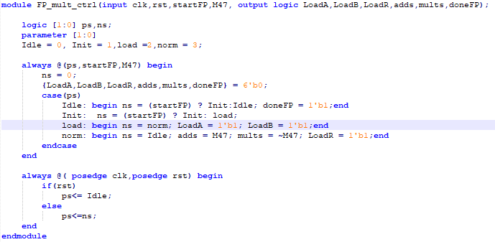

Top level:

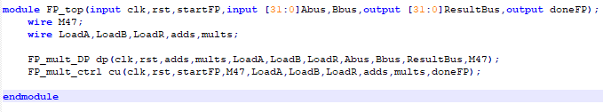

Output:

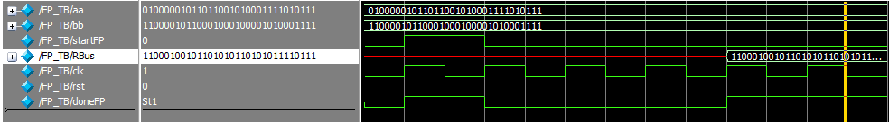

As an example I did

14.79 \* -98.13 = 1451.3427

The output is 11000100101101010110101011110111 which is -1451.342651 in decimal and its fairly close to the exact output.

Synthesis:

Report:

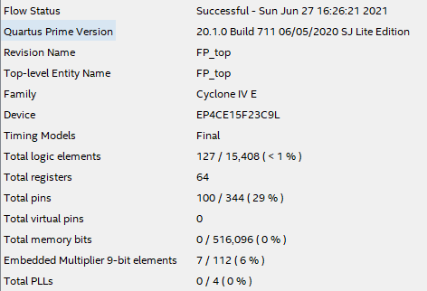

Symbols:

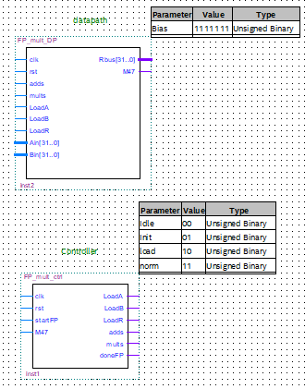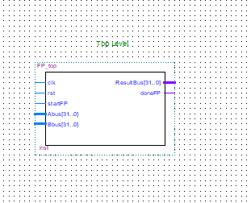

Test bench for pre and post simulation:

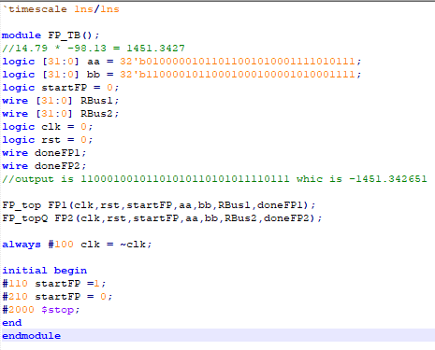

Wave Form:

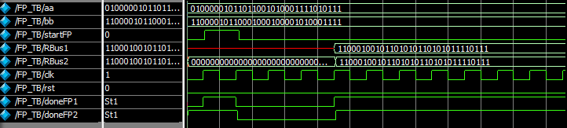

RBus1 and FP1 are for pre synthesis and RBus2 and FP2 are for post synthesis

If we zoom in we find that the post synthesis one triggers with a bit of delay and also it prepares the output in different steps.

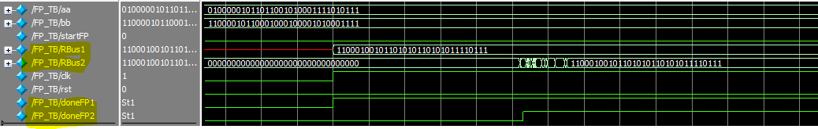

Sequential mult:

Datapath:

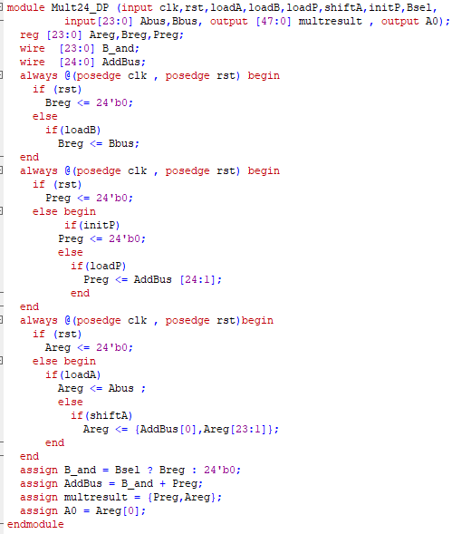

Controller and top level:

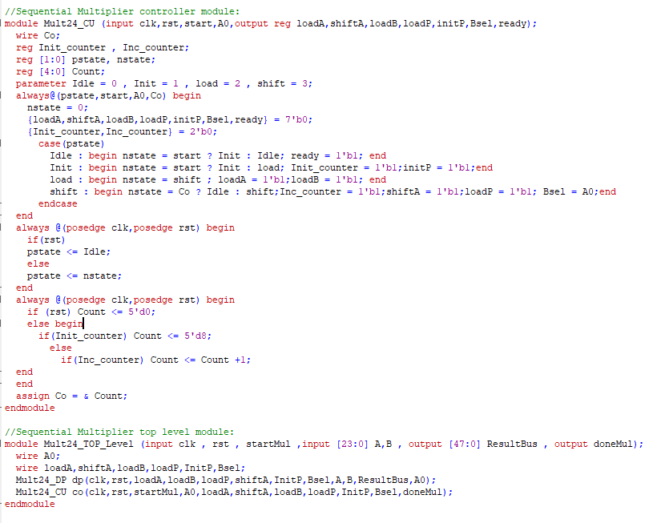

Synthesis report:

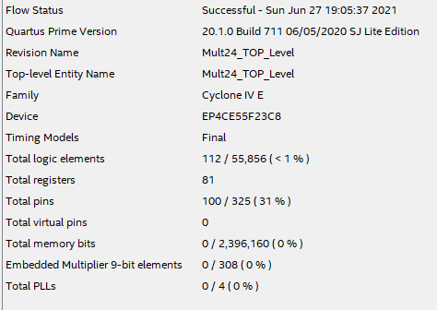

Symbols:

