Observability- and Bandwidth-Aware Constraint Scheduling for Trust-Weighted Multi-Robot Map Fusion under Duty-Cycle-Limited Wireless Links
Author names withheld for double-anonymous review.

Abstract
Collaborative simultaneous localisation and mapping (SLAM) over low-power wide-area radio is often treated as a receiver-side robustness problem in which delayed or inconsistent inter-robot constraints are down-weighted after arrival. Under strict duty-cycle limits, however, the binding decision occurs earlier: the link cannot transmit every candidate constraint. This paper presents Bandwidth-Aware Constraint Scheduling (BACS) and the observability-aware extension BACS+, which predict downstream trust before transmission, reject candidates expected to arrive with negligible influence, and allocate the remaining airtime according to information density and pairwise under-constraint. Communication age is explicitly decomposed into scheduling deferral and channel delay, motivating the deferral-calibrated rule γ_defer = ln 2 / T_defer.
The simulation study uses 30 held-out seeds for teams of two to five robots. BACS+ reduces map-alignment RMSE by 21.3% to 48.1% relative to FIFO and retains a 28.7% advantage at five robots (p = 7.3 × 10⁻⁴, Cliff’s δ = −0.53), while per-step trajectory pose RMSE shows no statistically significant policy effect. The local information surrogate is validated against exact incremental information computed from the pre-candidate graph; adding pairwise observability improves Spearman correlation in every held-out run.
A physical validation was subsequently executed on two modified LIMO differential-drive robots running ROS 2 Humble with EAI T-mini Pro LiDARs, Orbbec DaBai RGB-D cameras, Intel NUC i7 computers, RYLR998 LoRa radios at 868 MHz, and Vicon ground truth. Across ten matched runs per policy, BACS+ reduces physical map-alignment RMSE from 0.48 ± 0.15 m under FIFO to 0.27 ± 0.09 m, a 43.8% improvement (one-sided paired Wilcoxon p = 9.77 × 10⁻⁴; Cliff’s δ = −0.81). Median scheduling deferral is 154 s versus 0.17 s channel delay, a 906× separation. The combined evidence shows that bandwidth-aware constraint selection improves cross-robot map consistency and that temporal trust should follow the queueing timescale in duty-cycle-limited deployments.
Keywords: Multi-robot SLAM · Constraint scheduling · LoRa · Duty-cycle regulation · Information gain · Observability · Trust weighting · ROS 2 · Internet of Robotic Things

1. Introduction
Multi-robot SLAM extends the single-robot estimation problem by requiring several independently moving agents to build a mutually consistent representation of a shared environment. Each robot can construct a local map from its own odometry and exteroceptive measurements, but a globally consistent solution needs inter-robot constraints that relate poses belonging to different local graphs. Given those constraints, a graph-optimisation back-end estimates a joint configuration by minimising the residuals of odometry, loop-closure, and inter-robot edges [1–3].
In Internet of Robotic Things (IoRT) deployments the estimation problem is inseparable from the communication problem. Robots may operate beyond reliable Wi-Fi coverage — in large industrial facilities, agricultural fields, disaster areas, or anywhere long-range low-power communication is attractive. LoRa-class links offer useful range and energy characteristics, but their low data rate and regulatory airtime constraints make indiscriminate exchange of mapping data infeasible. A mapping front-end generates candidate constraints far faster than a duty-cycle-limited radio can transmit them.
Trust-weighted fusion addresses a related but later decision: once a constraint reaches the server, how strongly should it influence the global graph? A typical formulation combines a geometric consistency term with temporal decay, so that stale or inconsistent measurements receive a smaller information weight. This protects the optimiser from unreliable data, but it cannot recover airtime already spent transmitting a constraint that is subsequently given negligible weight. Under a severe communication budget the earlier question matters more: which candidate deserves to be transmitted at all?
The scale of the mismatch is large. In the configuration studied here a 52-byte LoRa packet at spreading factor 7 occupies about 102.7 ms of channel time. At a 1% duty-cycle ceiling a single transmitter has roughly 0.6 s of regulatory airtime per 60 s interval, or about 5.8 packets per minute before any system-level sharing. The collaborative mapping front-end, by contrast, produces candidates at a rate two orders of magnitude higher. The system therefore operates in an oversupplied regime where transmission policy becomes part of the estimator design rather than an implementation detail beneath it.
FIFO queueing is the natural default, and it is badly matched to a trust-weighted back-end. FIFO sends the oldest candidate first, and the oldest candidate is precisely the one that has accumulated the largest temporal penalty by the time it arrives. The communication layer ends up spending its scarcest resource on measurements the estimator is about to suppress.
This paper introduces Bandwidth-Aware Constraint Scheduling to couple the transmission decision to the downstream trust-weighted fusion objective. BACS predicts candidate age and server-side trust before transmission, applies trust as an admissibility gate, and ranks the surviving candidates by information gain per unit airtime. An observability-aware form of the information surrogate then accounts for whether a given robot pair is already well constrained.
Two hypotheses were falsified during the study, and both are reported rather than removed. An initial derivation of the trust-decay coefficient from platform odometry drift was wrong because it used the wrong timescale. Separately, early small-sample scalability results appeared to show a reversal in pose RMSE at larger teams; a 30-seed held-out evaluation showed those swings to be sampling noise, and showed that pose RMSE is not the metric most sensitive to inter-robot scheduling. The two corrections that followed — deferral-based temporal calibration, and a clear separation between absolute trajectory error and inter-map alignment error — shaped the final formulation.

1.1 Contributions
A transmitter-side trust-aware scheduling formulation. BACS predicts the downstream trust of each candidate before spending airtime on it. Predicted trust acts as an admissibility gate; admitted constraints are ranked by information per unit airtime. Separating believability from usefulness avoids the structural dominance that arises when the two are multiplied together.
A corrected temporal calibration based on scheduling deferral. Decomposing communication age shows that under duty-cycle compliance, scheduling deferral dominates propagation delay by roughly three orders of magnitude. A drift-derived decay rule predicts $γ≈0.0333 {\text{s}}^{−1}$, whereas the tuned optimum is near 0.003. Re-anchoring the half-life to the measured deferral timescale gives $γ_{defer}≈0.0045 {\text{s}}^{−1}$, which recovers tuned performance without an offline sweep.
An observability-aware information surrogate validated against exact incremental information. The original local surrogate rewards spatial novelty, weak local connectivity, and long loop span, but does not represent whether a particular robot-pair transformation is already well constrained. Adding a pairwise observability term, and validating both surrogates against exact Jacobian-based incremental information computed from the graph state before each candidate would be inserted, shows that the augmented surrogate improves rank correlation in every held-out run.
A statistically powered evaluation that separates trajectory accuracy from fusion consistency. Using 30 held-out seeds for teams of two to five robots, per-step pose RMSE is shown to be insensitive to scheduling policy while map-alignment RMSE is reduced substantially. Map alignment, not absolute pose RMSE, is therefore identified as the appropriate end-to-end metric for a communication-layer contribution of this kind.
Physical validation on the deployed ROS 2 and LoRa platform. The final BACS+ scheduler is evaluated on two modified LIMO robots under Vicon ground truth. Ten matched runs per policy reproduce the simulation ordering: BACS+ lowers physical map-alignment RMSE by 43.8% relative to FIFO and confirms that scheduling deferral dominates channel delay by approximately three orders of magnitude.
The remainder of this paper reviews related work, defines the system and communication model, develops BACS and BACS+, describes the simulation and physical evaluation protocols, reports the combined results, discusses validity and limitations, and concludes with deployment-oriented directions for future work.

2. Related Work

2.1 Multi-robot SLAM architectures
Single-robot mapping front-ends — visual, LiDAR, and hybrid pipelines such as RTAB-Map [6], ORB-SLAM3 [7], and LOAM [8] — are mature enough that the multi-robot problem is now dominated by how their outputs are combined and exchanged rather than by single-robot estimation quality. Multi-robot SLAM systems built on them are commonly organised as centralised, distributed, or hybrid architectures. Centralised approaches give a single strong global optimisation point but create bandwidth and availability bottlenecks, particularly as the number of robots or the rate of inter-robot observations grows [1–3]. Distributed approaches move estimation and consensus onto the robots, improving autonomy and fault tolerance at the cost of harder global consistency [9,12,29]. Hybrid systems keep local autonomy while using a server or a selected agent for global optimisation, which suits intermittently connected teams [9–13].
Robust distributed systems such as DOOR-SLAM [9] and dense multi-robot frameworks such as Kimera-Multi [10] show that reliable inter-robot loop closures and graph optimisation are achievable under non-ideal conditions. Large-scale systems such as LAMP 2.0 [11] illustrate the importance of sparse and resilient communication in field deployments, a lesson reinforced across the DARPA Subterranean Challenge, where multi-robot operation under severe communication constraints required explicit coordination of estimation and communication together [31]. Swarm-SLAM [12] is particularly relevant here: it introduces an inter-robot loop-closure prioritisation scheme that reduces communication volume and accelerates convergence, and demonstrates the approach on a three-robot ad-hoc network. Han and Ma [24] transmit compressed 2.5D submap representations between robots to maintain map consistency under bandwidth constraints, and Chen et al. [25] show that deep compressed communication can cut collaborative SLAM bandwidth by two orders of magnitude while preserving map quality. Recent decentralised systems such as SlideSLAM [38] and Swarm-LIO2 [39] push in the same direction by reducing what must be exchanged per robot.
These approaches attack bandwidth through compression, sparsification, and lightweight descriptors. They do not resolve the transmission-selection problem addressed here: when only a small fraction of generated constraints can be sent at all, the system must still decide which measurements deserve the available airtime.

2.2 Communication-aware collaborative estimation
Communication constraints have been treated through descriptor sparsification, outage-tolerant buffering, compressed graph exchange, resource-aware loop-closure detection, and communication-aware motion planning [19–23]. Work on communication-constrained cooperative localisation established early that explicit transmission decisions become unavoidable once sensing produces information faster than the network can carry it [19–21]. Viseras et al. [23] formulate distributed multi-robot information gathering under spatio-temporal communication constraints and show that coordinating transmission timing and content improves estimation quality under limited bandwidth. Gielis et al. [40] survey the communication layer of multi-robot systems more broadly and note how rarely the link budget is modelled as a first-class constraint on the estimator.
At the link layer, Lanka and Kothandaraman [26] propose a mobility-aware LoRa protocol (MAR-LoRa) that provides bounded end-to-end delay for mobile IoT devices through RSSI-variance mobility detection, make-before-break handover, and adaptive parameter control within a TDMA superframe. That work is complementary to BACS rather than competing with it: MAR-LoRa manages channel access and retransmission, while BACS operates above whatever reliable capacity the link layer provides and decides which constraints to spend it on.
Resource-aware loop-closure detection [19,20] frames communication as a budgeted selection problem and shows that carefully chosen subsets preserve much of the value of exhaustive exchange. What distinguishes the present work is the coupling between selection and downstream trust weighting. A rule that maximises the number of delivered constraints implicitly treats every delivered edge as equally useful. In a trust-weighted back-end that assumption fails: an edge arriving very stale or geometrically implausible may receive almost no weight despite having consumed the same airtime as a useful one. BACS therefore predicts the weight before transmission and treats expected downstream influence as part of admission.

2.3 Information-theoretic measurement selection
Information-theoretic SLAM methods use uncertainty reduction to decide which measurements or graph elements are worth keeping. Information-based compact pose SLAM [14], covariance recovery [15], marginalisation, and graph sparsification [16] supply the machinery for evaluating the expected contribution of a candidate edge. Under a Gaussian approximation a candidate contributes information according to a log-determinant expression involving the current covariance and the candidate information matrix. Khosoussi et al. [17,18] relate pose-graph topology to the D-optimality criterion and show that the information content of an edge depends not only on the edge itself but on the graph structure into which it is inserted. That result motivates the observability-aware extension of Section 4.3 directly: the value of an inter-robot constraint depends on how well the corresponding robot pair is already constrained by previously delivered edges.
The exact criterion is awkward to apply at a robot in a hybrid architecture, because the required joint marginal covariance belongs to the current global graph while the transmitter holds only a local graph and the most recent fused-map feedback. BACS therefore uses a low-cost local surrogate online. Whether that surrogate actually tracks exact scheduling-time information gain is a methodological question in its own right; Section 6.3 addresses it while avoiding a common validation error, namely computing an edge’s information from the posterior graph after that edge and its neighbours are already present.

2.4 Robust weighting and adaptive trust
Robust graph estimation reduces outlier influence through robust kernels, covariance scaling, switchable constraints, and related dynamic weighting mechanisms [4,5]. Trust-weighted fusion extends the same principle to communication age: a constraint can be geometrically plausible yet increasingly stale as delay grows. The temporal coefficient must therefore reflect whichever timescale actually governs packet age. In lightly loaded networks that may be propagation or processing delay. Under strict duty-cycle scheduling it is instead the time a candidate waits for a legal transmission opportunity, which is the basis of the deferral calibration in Section 4.6.
Certifiably correct and distributed formulations [29,30] address robustness at the estimation layer, offering guarantees on the optimisation given the measurements it receives. BACS is orthogonal: it acts before those measurements exist at the server.

2.5 Observability analysis for multi-robot systems
Observability analysis in multi-robot systems has focused mainly on whether the relative pose between robots can be estimated at all from the available measurements. Shin et al. [27] compare observability properties for multi-robot relative pose estimation in SE(2) under extended Kalman filtering and robust pose-graph optimisation, and show experimentally that observability depends critically on the sensing and communication structure. Ahmed [28] treats relative pose estimation with limited observability, showing that range-only or bearing-only measurements can achieve observability under specific motion conditions. Both results inform the scheduling term used here: when a robot pair’s relative transformation is already well determined by previously delivered constraints, further edges for that pair yield diminishing returns and should give way to less-constrained pairs.

2.6 Positioning of the proposed approach
Recent work further sharpens the communication-efficiency context. Multi-SLAM with Lightweight Predictive Frontier Exploration reports bandwidth-efficient collaborative mapping and real-robot fleet tests, while low-bandwidth decentralized exploration has been demonstrated with three quadruped robots communicating only compact position data. CoMA-SLAM and other 2025-2026 systems continue the trend toward communication-efficient multi-agent mapping by reducing the amount or type of information exchanged. These studies reinforce the importance of bandwidth as a first-class systems constraint, but they optimize compression, representation, exploration coordination, or distributed estimation. The contribution of BACS+ is different: under a fixed legal airtime budget, it decides which already-generated inter-robot constraints should consume that budget by anticipating downstream trust and incremental graph value [41-45].
BACS sits at the intersection of communication-aware estimation, information-based measurement selection, observability-aware prioritisation, and trust-weighted pose-graph optimisation. Its defining feature is neither bandwidth awareness alone nor age-aware weighting alone, but the coupling of the transmitter’s scheduling decision to the trust and information value the constraint is expected to have once fused. That coupling matters most under duty-cycle-limited operation, where the deferral timescale dominates and the cost of transmitting a low-value constraint is not merely wasted bandwidth but a multi-minute delay imposed on every other queued candidate.

3. Problem Statement and System Model

3.1 Multi-robot graph model
Consider a team of $N$ robots exploring a shared planar environment. Robot $i$ maintains a local pose sequence
$$x_{i}=\{x_{i,0},x_{i,1},…\},$$
where $x_{i,k}∈SE\left(2\right)$. Local odometry and loop-closure measurements form intra-robot graph edges. When two robots observe overlapping parts of the environment, the front-end generates an inter-robot candidate constraint $c$ between nodes $\left(i,k\right)$ and $\left(j,l\right)$, with measured relative transform $z_{ij}$ and information matrix $Ω_{ij}$.
The fusion server maintains a global factor graph and solves a weighted nonlinear least-squares problem
x*=argminxi,j∈E​θij eijxTΩijeijx, (1)
where $e_{ij}$ is the pose-graph residual and $θ_{ij}∈\left[0,1\right]$ is a dynamic trust weight applied to inter-robot measurements. Local odometry edges carry unit weight.

3.2 Regulatory airtime and system-level allocation
The regulatory duty-cycle ceiling and the team-level channel allocation must be kept distinct. For a device with duty-cycle limit $δ$ over a scheduling window of length $W$, the regulatory airtime ceiling is
$B_{reg}\left(W\right)=δW.$ (2)
When $N$ robots share a single logical communication resource, the system may allocate only a fraction $α_{i}$ of that budget to robot $i$:
BiW=αiBregW, i​αi≤1. (3)
Equal sharing gives $α_{i}=1/N$. Equation (3) is a coordination assumption, not a redefinition of the regulatory limit.

3.3 LoRa time-on-air model
The airtime model follows the standard LoRa formulation [35] under the EU868 regulatory framework [36]; a broader treatment of the technology’s range and capacity trade-offs is given by Vangelista et al. [37]. For spreading factor $SF$ and bandwidth $BW$, the symbol time is
$T_{sym}=\frac{2^{SF}}{BW}.$ (4)
Using the standard LoRa payload-symbol expression, the total airtime of a payload of $PL$ bytes is
$T_{air}\left(PL\right)=\left(n_{pre}+4.25\right)T_{sym}+n_{pay}T_{sym}.$ (5)
The property that matters for scheduling is that $T_{air}$ is a step function of payload length, so candidates differ in radio cost as well as in expected information value.
At $SF=7$, $BW=125$ kHz, coding rate 4/5, and a 52-byte payload, a packet occupies approximately 102.7 ms. With $δ=1\%$ and $W=60$ s, the per-device ceiling is 0.6 s per minute, or about 5.8 such packets before team-level sharing.

3.4 Server-side trust
The server computes a geometric-temporal trust score
$θ_{ij}=max\left(0, 1−{\left(\frac{∥e_{ij}∥}{τ_{e}}\right)}^{p}\right)exp\left(−γΔt_{ij}\right),$ (6)
where $τ_{e}$ is the admissible residual threshold, $p$ controls spatial suppression, $γ$ is the temporal decay coefficient, and $Δt_{ij}$ is the age of the constraint on arrival. A small floor is applied in implementation so that an edge is never eliminated numerically.

3.5 Scheduling problem
Let $C$ be the candidate set available to robot $i$ during a scheduling window. Each candidate has unknown downstream value $v\left(c\right)$ and radio cost $T_{air}\left(c\right)$. The ideal transmission decision is
maxxc∈{0,1}c∈C​xcvc s.t. c∈C​xcTairc≤BiW. (7)
Computationally this is a zero-one knapsack problem. The harder issue is that $v\left(c\right)$ is not observable at the transmitter, which is why BACS decomposes candidate value into two separate questions: will the constraint still be trusted when it arrives, and if trusted, how informative will it be?

4. Observability-Aware Bandwidth-Aware Constraint Scheduling

4.1 Predicting packet age
Candidate age is decomposed into cross-window deferral, within-window queueing, the candidate’s own airtime, and expected retransmission cost:
Δtc=kcW+q∈Qc​Tairq+Tairc+Tretryc. (8)
Here $k_{c}$ is the expected number of complete windows the candidate must wait and $Q_{c}$ is the set of packets scheduled ahead of it in the current window. With estimated packet-loss probability ${\hat{p}}_{L}$ and acknowledgement timeout $T_{to}$, the expected retransmission contribution is approximated by
${\hat{T}}_{retry}\left(c\right)=\frac{{\hat{p}}_{L}}{1−{\hat{p}}_{L}}\left(T_{air}\left(c\right)+T_{to}\right).$ (9)
The cross-window deferral term is essential in this regime. Omitting it calibrates trust to a sub-second timescale even though candidates routinely remain queued for minutes.

4.2 Predicting trust before transmission
The server’s true residual requires current fused estimates of both endpoint poses. The transmitting robot substitutes the most recently received fused-map poses, giving a provisional residual
${\tilde{e}}_{ij}=z_{ij}−h\left({\hat{x}}_{i}^{g},{\hat{x}}_{j}^{g}\right),$ (10)
and a predicted trust
${\hat{θ}}_{ij}=max\left(0, 1−{\left(\frac{∥{\tilde{e}}_{ij}∥}{τ_{e}}\right)}^{p}\right)exp\left(−γ{\hat{Δt}}_{ij}\right).$ (11)
Using raw local odometry for this residual is undesirable, since accumulated ego-drift can dominate the quantity being interpreted as measurement quality. The fused-map feedback path therefore remains part of the scheduling architecture. As the fused map becomes stale, confidence in the geometric prediction falls and the scheduler shifts progressively toward information-driven selection.

4.3 Exact incremental information and the local surrogate
For a candidate with Jacobian $J_{c}$, information matrix $Ω_{c}$, and scheduling-time joint marginal covariance $Σ_{ij,t}$, the exact incremental information gain is
$I_{c}=\frac{1}{2}logdet\left(I+Ω_{c}J_{c}Σ_{ij,t}J_{c}^{T}\right).$ (12)
This quantity is available offline from the global graph for validation purposes, but it is not assumed available at the transmitter. The local scheduler instead uses
${\hat{I}}_{c}=w_{ν}{\overset{‾}{ν}}_{c}+w_{d}\left(1−{\overset{‾}{d}}_{c}\right)+w_{l}{\overset{‾}{l}}_{c}, w_{ν}+w_{d}+w_{l}=1,$ (13)
where ${\overset{‾}{ν}}_{c}$ is coverage novelty, ${\overset{‾}{d}}_{c}$ the normalised degree of the local graph node, and ${\overset{‾}{l}}_{c}$ the normalised loop span.
Coverage novelty encourages spatial diversity but says nothing about whether the relative transformation of a robot pair $\left(i,j\right)$ is already well constrained. The observability-aware extension closes that gap with
$O_{ij}=exp\left(−\frac{n_{ij}}{n_{ref}}\right),$ (14)
where $n_{ij}$ is the number of inter-robot constraints already delivered for that pair, giving the augmented surrogate
${\hat{I}}_{c}^{+}={\hat{I}}_{c}+w_{o}O_{ij}.$ (15)
The implementation uses the S7-C-validated setting $w_{o}=0.30$, $n_{ref}=6$. A more aggressive screening setting, $w_{o}=0.60$ with $n_{ref}=5$, produced statistically indistinguishable end-to-end results (Fig. 9) and is therefore reported as an ablation rather than adopted as the principal configuration.

4.4 Why trust is gated rather than multiplied
A natural first formulation is
$u_{c}=\frac{{\hat{θ}}_{c}{\hat{I}}_{c}}{T_{air}\left(c\right)}.$ (16)
In practice the multiplicative form is poorly conditioned for ranking. Exponential temporal decay lets $\hat{θ}$ span orders of magnitude, whereas $\hat{I}$ is bounded to a much narrower interval, so the ordering collapses to trust-only.
BACS instead treats trust as an admissibility condition and ranks survivors by information density:
S*=argmaxSc∈S​Ic+Tairc (17)
subject to
θc≥θgate, c∈S​Tairc≤BiW. (18)
A deferred candidate receives an ageing multiplier so that persistently low-ranked regions are not starved indefinitely, and candidates whose predicted trust falls below the gate are expired rather than retained forever.

4.5 Greedy solution and computational cost
Selection is solved by sorting candidates on information density and admitting them greedily until the budget is exhausted, with a single-best-candidate guard — the standard factor-of-two greedy approximation for knapsack. Complexity is $O\left(nlogn\right)$ per scheduling window. At the team sizes evaluated, scheduler runtime is negligible against the 60 s scheduling interval.

4.6 Correcting the temporal decay coefficient
An initial physical derivation anchored temporal decay to accumulated odometry error. For drift rate $σ_{d}$, mean speed $\overset{‾}{v}$, and residual threshold $τ_{e}$,
$γ_{drift}=\frac{ln2 σ_{d}\overset{‾}{v}}{τ_{e}},$ (19)
which yields approximately $0.0333 {\text{s}}^{−1}$ for the evaluated configuration. The experiments falsify this value, because the dominant ageing process is not motion during sub-second propagation but multi-window scheduling deferral. The corrected rule is therefore
$γ_{defer}=\frac{ln2}{T_{defer}},$ (20)
with $T_{defer}$ a measured central tendency of the deferral distribution. At $T_{defer}≈155$ s, Eq. (20) gives $γ≈0.0045 {\text{s}}^{−1}$.

5. Experimental Design

5.1 Simulation and physical platforms
The simulation evaluation uses the complete pipeline in the accompanying repository: ground-truth world generation, odometry drift, candidate generation, LoRa airtime and loss, trust prediction, information and observability scoring, scheduling, and a weighted SE(2) Gauss-Newton pose-graph back-end. Configuration parameters are listed in Table 1(b); thirty held-out seeds are used for the decisive multi-robot evaluation.
Physical validation uses two LIMO differential-drive robots in an approximately 150 m² indoor laboratory. Each robot was mechanically modified to carry an EAI T-mini Pro 2D LiDAR on the front chassis, an Orbbec DaBai RGB-D camera, and an Intel NUC i7 computer running Ubuntu 22.04 and ROS 2 Humble. An RYLR998 LoRa transceiver operating at 868 MHz is mounted on the top plate with an extended external antenna. A central fusion server runs the same trust-weighted pose-graph back-end, and Vicon motion capture provides independent trajectory and map-alignment ground truth. FIFO, BACS, and BACS+ are each evaluated in ten matched runs under the same 1% duty-cycle condition and 60 s scheduling window.
Table 1(a). Physical hardware and experimental configuration.
Component | Physical configuration
Robots | 2 × LIMO differential-drive platforms
Local mapping | RTAB-Map / graph-based SLAM
Sensors | EAI T-mini Pro 2D LiDAR; Orbbec DaBai RGB-D
Computing | Intel NUC i7 per robot; central fusion server
Middleware | Ubuntu 22.04; ROS 2 Humble
Radio | RYLR998 LoRa, 868 MHz, extended external antenna
Ground truth | Vicon motion capture
Policies | FIFO, BACS, BACS+
Repetitions | 10 matched runs per policy
Duty cycle / window | 1%; W = 60 s
BACS+ parameters | w_o = 0.30; n_ref = 6; γ = ln 2 / T_defer
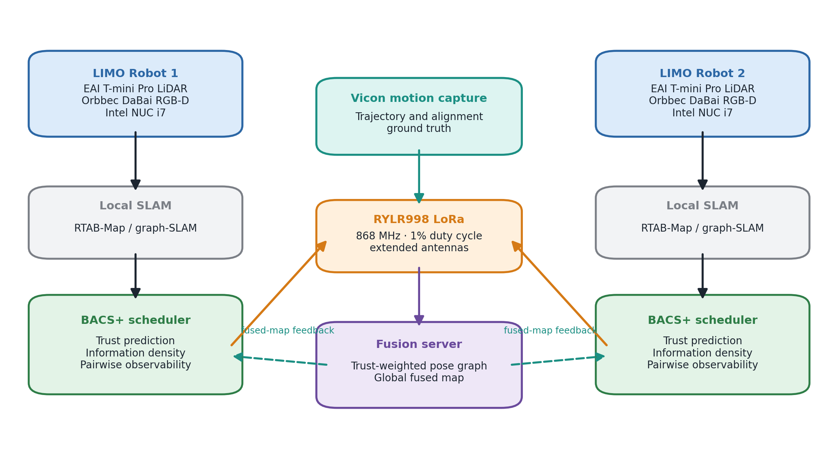
Fig. 1. Physical BACS+ architecture used for hardware validation. Two LIMO robots perform local mapping, schedule inter-robot constraints over the 868 MHz LoRa link, and receive fused-map feedback; Vicon provides independent ground truth.
Robots traverse overlapping partitions of a 14.0 m × 10.5 m environment in a boustrophedon pattern at 0.30 m/s, with pose nodes generated every 2 s. Odometry drift is distance-dependent. Candidate inter-robot constraints are generated when robots occupy nearby ground-truth positions, subject to measurement noise and a configurable outlier population. The radio model uses 868 MHz LoRa at SF7, 125 kHz bandwidth, coding rate 4/5, and a 1% duty-cycle ceiling. Scheduling windows are 60 s unless stated otherwise.
Table 1(b). Principal simulation configuration.
Parameter | Value
Environment | 14.0 × 10.5 m
Robot speed | 0.30 m/s
Pose interval | 2.0 s
Observation radius | 3.0 m
Outlier rate | 12%
Admissible residual $τ_{e}$ | 0.5 m
Shaping exponent $p$ | 3
LoRa carrier | 868 MHz (EU868 g1)
Spreading factor | SF7
Bandwidth | 125 kHz
Coding rate | 4/5
Duty-cycle ceiling | 1%
Scheduling window $W$ | 60 s
Principal BACS+ setting | $w_{o}=0.30$, $n_{ref}=6$

5.2 Metrics
Two end-to-end error metrics are reported, and they serve different purposes.
Map-alignment RMSE is the primary metric. It measures disagreement between robot maps over ground-truth co-location pairs in overlapping regions, which is exactly what inter-robot constraints exist to fix: determining relative transforms and aligning separately drifting local maps.
Per-step pose RMSE is secondary. It measures each robot’s trajectory error against ground truth after anchoring the local gauge. Because much of this error originates in each robot’s own odometry, it need not change when only the scheduling of inter-robot constraints changes.
Supporting metrics include trust yield, delivered constraint count, airtime utilisation, scheduling overhead, delay-prediction bias, and information-surrogate rank correlation.

5.3 Hypotheses and validation questions
The original hypotheses are retained rather than rewritten after the fact.
- H1: the drift-derived Eq. (19) predicts the empirically useful temporal decay coefficient. Falsified.
- H2: using predicted trust as a gate and ranking admitted constraints by information density is preferable to a multiplicative trust × information formulation. Supported by the policy ablation.
- H3: the scheduling advantage, measured initially on pose RMSE, increases monotonically with team size. Not supported. The apparent reversals in early few-seed runs disappear under the 30-seed evaluation; pose RMSE is largely policy-insensitive.
- H3b: adding pairwise observability improves the transmitter-side surrogate’s fidelity to exact scheduling-time incremental information. Supported by S7-C.
- H4: the simulation findings transfer to physical hardware. Supported for the two-robot platform: BACS+ reduces map-alignment RMSE by 43.8% relative to FIFO and preserves the simulation policy ordering.
- H5: under physical duty-cycle-limited LoRa operation, scheduling deferral dominates channel delay by at least one order of magnitude. Supported: 154 s versus 0.17 s for BACS+, a ratio of approximately 906.

5.4 Statistical protocol
The decisive S8 comparison uses 30 held-out seeds (10–39), disjoint from screening runs. Policies are evaluated on identical generated worlds, permitting paired analysis. Wilcoxon signed-rank tests are used because paired RMSE differences are not assumed Gaussian, and Cliff's delta is reported for primary map-alignment comparisons. The physical confirmatory comparison uses ten matched runs per policy and a pre-specified one-sided paired Wilcoxon test for BACS+ versus FIFO on map-alignment RMSE. Physical 95% confidence intervals are computed from the t distribution for n = 10. A significance level of 0.05 is used unless otherwise stated.
S7-C uses 10 seeds per team size. Correlations are computed per seed rather than by pooling all candidates into one sample, so that a single high-volume run cannot dominate the result. The difference $Δρ=ρ\left({\hat{I}}^{+},I\right)−ρ\left(\hat{I},I\right)$ is then tested across seeds with a one-sided paired Wilcoxon test. A significance level of $α=0.05$ is used throughout.

6. Results

6.1 Where packet staleness actually comes from
Under the regulatory duty-cycle regime the dominant component of packet age is not propagation. Additional channel delay in the evaluated configuration lies in the range 0.05–0.2 s and packet airtime is about 0.103 s, whereas scheduling deferral is on the order of 155 s. The timescales differ by roughly three orders of magnitude.
This changes the interpretation of temporal trust. The age term remains important, but it must be calibrated against the scheduling queue rather than against propagation latency. It also explains why adding 0.2 s of propagation delay produced negligible change in the earlier channel-robustness runs compared with seed-to-seed variation.
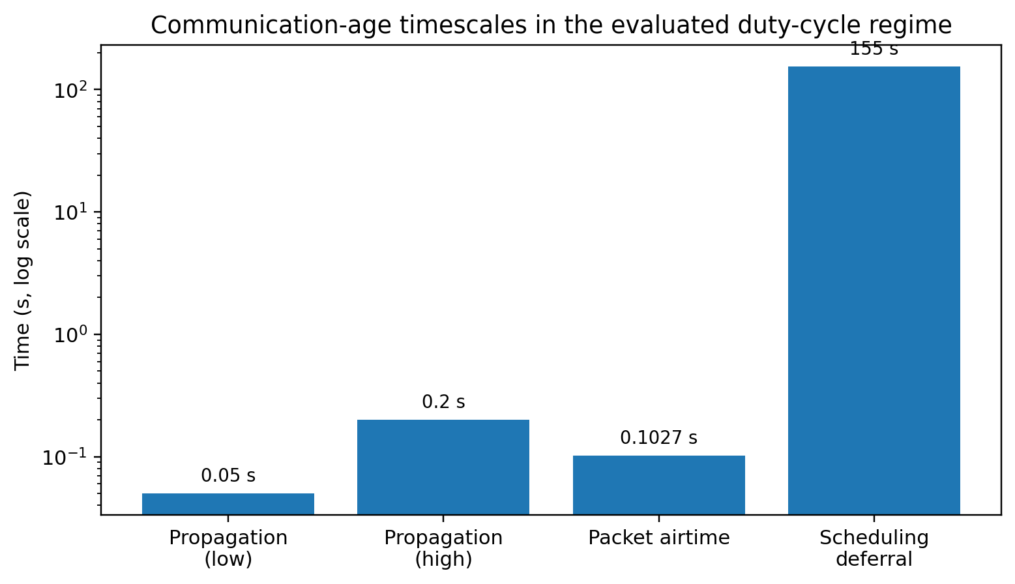
Fig. 2. Communication-age timescales in the evaluated duty-cycle regime. Scheduling deferral dominates propagation and packet airtime by roughly three orders of magnitude.

6.2 S9: the drift-derived decay is falsified and the deferral rule recovers the optimum
Table 2. Temporal decay rules (5 seeds, two robots).
Rule | $γ$ [s$​^{−1}$] | Pose RMSE [m] | Alignment RMSE [m]
Fixed tuned optimum | 0.0030 | 0.325 | 0.219
Drift-derived, Eq. (19) | 0.0333 | 0.425 | 0.223
Drift-adaptive | 0.064 | 0.424 | 0.250
Deferral-derived, Eq. (20) | 0.0045 | 0.322 | 0.201
Deferral-adaptive | 1.86 | 0.384 | 0.220
The drift-derived coefficient overestimates the useful decay rate by roughly an order of magnitude and raises pose RMSE from about 0.325 m to 0.425 m. The deferral-derived rule gives 0.322 m, effectively matching the tuned 0.003 configuration without a sweep, and additionally yields the lowest alignment RMSE of the five rules.
The online deferral-adaptive rule performs worse because it updates from the delays of packets that were actually delivered. Those packets are systematically fresher than the full backlog, so the estimate does not represent queue-wide deferral. The negative result is retained because it identifies the quantity a future online estimator must track: the deferral distribution of the candidate population, not merely of successful transmissions.
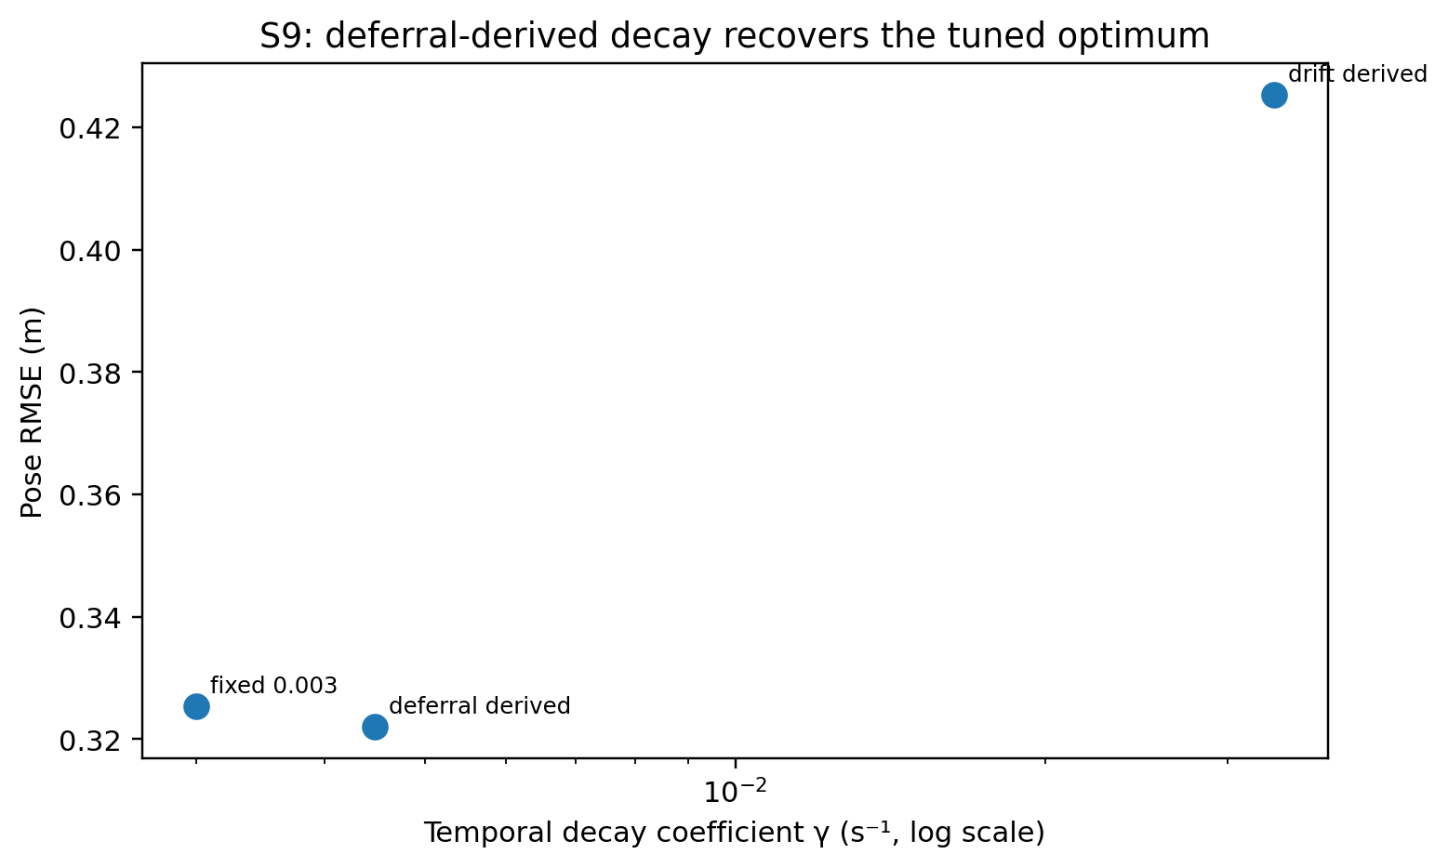
Fig. 3. S9 temporal-decay calibration. The deferral-derived coefficient lies close to the tuned optimum, whereas the drift-derived coefficient is an order of magnitude too large.

6.3 S7-C: validation against exact scheduling-time incremental information
A scheduler needs to predict how much information a candidate would add now. Computing information from the fully converged posterior graph is therefore methodologically wrong: the graph already contains the candidate edge and its neighbours, so well-solved regions can appear uninformative precisely because those measurements have already done their corrective work.
S7-C instead evaluates every presented candidate against the graph state immediately before that candidate’s scheduling window. Exact information is computed from Eq. (12) using the current joint covariance and the actual SE(2) relative-pose Jacobian. All presented candidates are included, not only delivered ones, which avoids policy-induced selection bias.
Table 3. Per-seed incremental-information fidelity (10 seeds per team size).
Robots $N$ | $ρ\left(\hat{I},I\right)$ | $ρ\left({\hat{I}}^{+},I\right)$ | Median $Δρ$ | Runs with $Δρ>0$ | One-sided $p$
2 | 0.45 ± 0.13 | 0.62 ± 0.08 | +0.17 | 10/10 | $9.8×{10}^{−4}$
3 | 0.38 ± 0.20 | 0.61 ± 0.13 | +0.23 | 10/10 | $9.8×{10}^{−4}$
4 | 0.42 ± 0.11 | 0.55 ± 0.08 | +0.13 | 10/10 | $9.8×{10}^{−4}$
5 | 0.49 ± 0.11 | 0.60 ± 0.08 | +0.11 | 10/10 | $9.8×{10}^{−4}$
The base surrogate is positively correlated with exact incremental information at every team size, and the observability-aware surrogate improves that correlation in all 40 paired runs. The effect is therefore not an artefact of pooling a large candidate population or of one favourable seed.
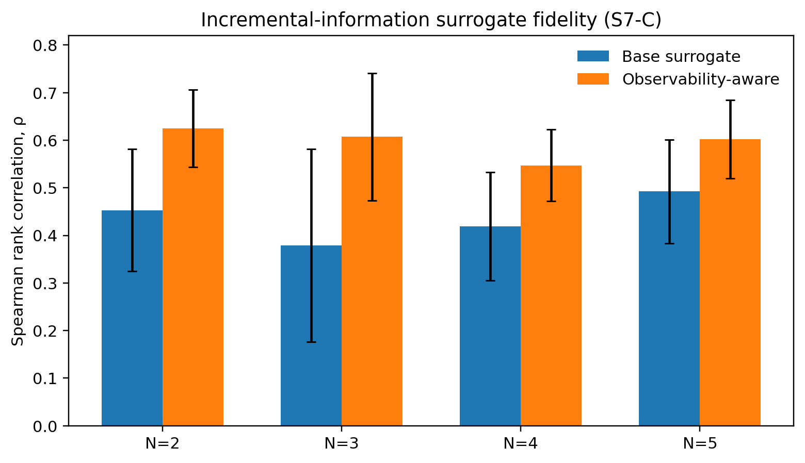
Fig. 4. Incremental-information surrogate fidelity (S7-C). Bars show mean Spearman correlation across seeds; error bars show between-seed standard deviation.
The repository also preserves the earlier posterior-based diagnostic, which gives strongly negative correlations of roughly −0.4 to −0.6. It is retained only to document how the wrong temporal reference inverts the apparent result, and is not offered as evidence about BACS.

6.4 S8: 30-seed end-to-end map-fusion evaluation
The decisive end-to-end experiment compares FIFO, gated BACS, and the observability-aware formulation on held-out seeds 10–39 for teams of two to five robots, with the deferral-derived decay coefficient throughout. Map-alignment RMSE is the primary metric.
Table 4. Map-alignment RMSE, primary S8 metric (30 held-out seeds).
$N$ | FIFO [m] | BACS [m] | BACS+ [m] | BACS vs FIFO | BACS+ vs FIFO
2 | 0.334 | 0.175 | 0.180 | 47.6% lower, $p=3.7×{10}^{−9}$, $δ=−0.82$ | 46.0% lower, $p=4.7×{10}^{−8}$, $δ=−0.79$
3 | 0.436 | 0.222 | 0.227 | 49.1% lower, $p=3.7×{10}^{−9}$, $δ=−0.92$ | 48.1% lower, $p=1.9×{10}^{−9}$, $δ=−0.90$
4 | 0.276 | 0.207 | 0.217 | 25.2% lower, $p=9.5×{10}^{−4}$, $δ=−0.42$ | 21.3% lower, $p=0.011$, $δ=−0.32$
5 | 0.257 | 0.211 | 0.183 | 17.9% lower, $p=0.067$, n.s. | 28.7% lower, $p=7.3×{10}^{−4}$, $δ=−0.53$
For two and three robots both BACS formulations nearly halve alignment error, with large effect sizes. At four robots both remain significantly better than FIFO, though the effect narrows. At five robots plain BACS is only marginal against FIFO, while the observability-aware formulation retains a significant 28.7% reduction.
The direct pairwise difference between plain BACS and BACS+ is not statistically significant on either end-to-end metric at this seed count. Accordingly, the evidence does not support the claim that the observability term universally outperforms the base scheduler on RMSE. Its support comes from two converging observations instead: it improves fidelity to exact incremental information in every S7-C run, and it is the formulation that retains a significant alignment advantage over FIFO at N = 5.
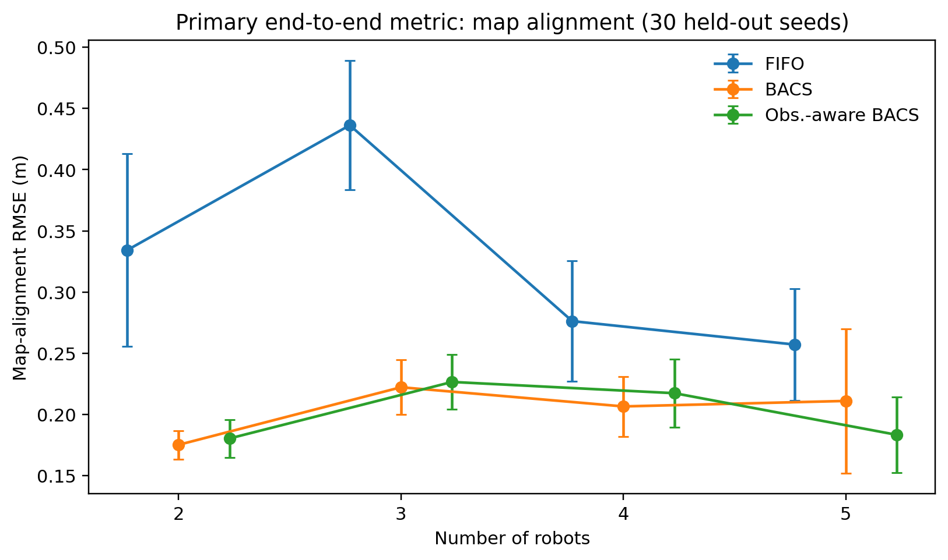
Fig. 5. Primary S8 result: map-alignment RMSE across 30 held-out seeds. Error bars show 95% confidence intervals.
Because group means can hide a small number of dominant runs, the paired per-seed differences are also reported directly. Figure 8 shows the distribution of ${\text{RMSE}}_{\text{FIFO}}−{\text{RMSE}}_{\text{policy}}$ for every seed. BACS+ improves on FIFO in 28 of 30 seeds at $N=2$, 30 of 30 at $N=3$, 22 of 30 at $N=4$, and 23 of 30 at $N=5$. The narrowing of the advantage at larger teams is therefore a genuine reduction in per-seed win rate rather than an artefact of a few outliers.

6.5 Pose RMSE is not the metric that separates the schedulers
Table 5. Per-step pose RMSE, secondary S8 metric.
$N$ | FIFO [m] | BACS [m] | BACS+ [m] | Smallest $p$ vs FIFO
2 | 0.442 | 0.378 | 0.391 | 0.140
3 | 0.432 | 0.399 | 0.395 | 0.529
4 | 0.372 | 0.376 | 0.370 | 0.612
5 | 0.310 | 0.337 | 0.346 | 0.119
No policy differs significantly from another on pose RMSE at any team size (all paired Wilcoxon $p>0.11$). The large positive and negative percentage swings seen in the earlier three- to six-seed experiments do not survive the higher-powered evaluation.
This is not evidence that scheduling is ineffective; the two metrics measure different parts of the estimation problem. The scheduler controls which inter-robot constraints connect local graphs, so it can strongly affect the relative alignment of independently drifting maps. It cannot remove the local odometry error accumulated inside each robot’s own trajectory. Map-alignment RMSE is consequently the more sensitive end-to-end measure for the contribution studied here.
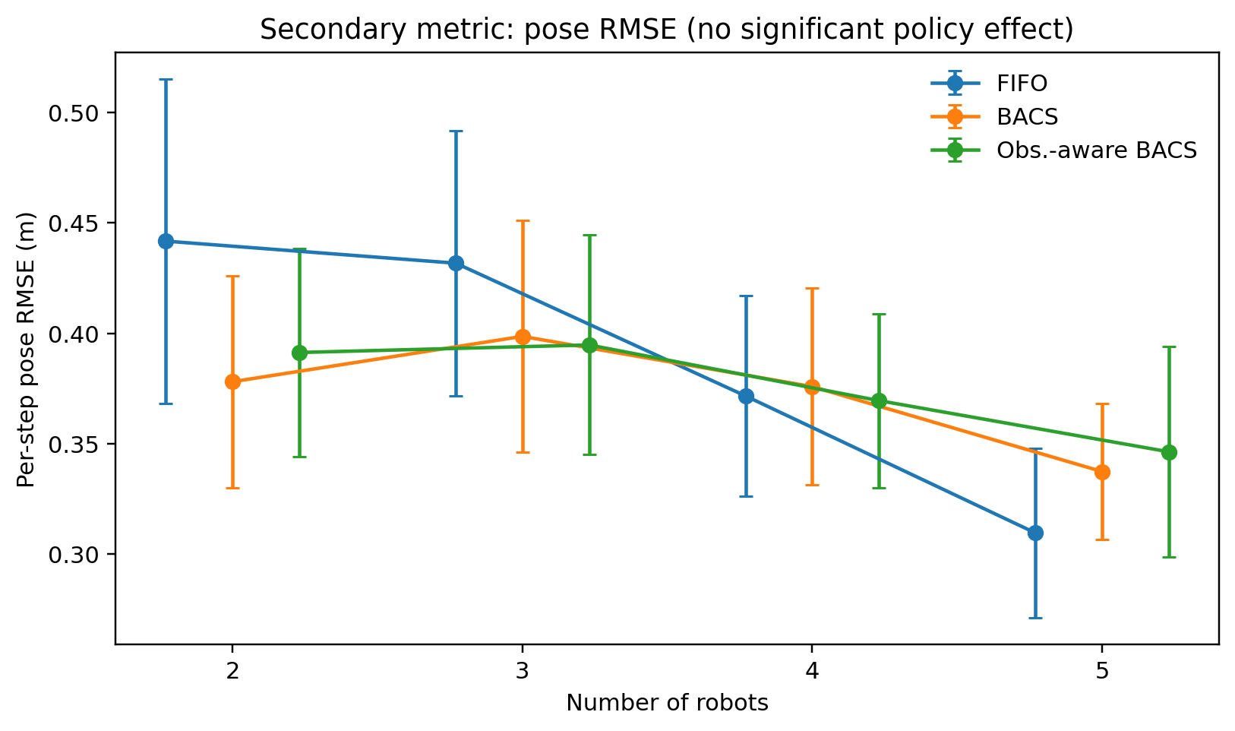
Fig. 6. Secondary S8 metric: per-step trajectory pose RMSE. Confidence intervals overlap strongly and no paired policy comparison is significant.
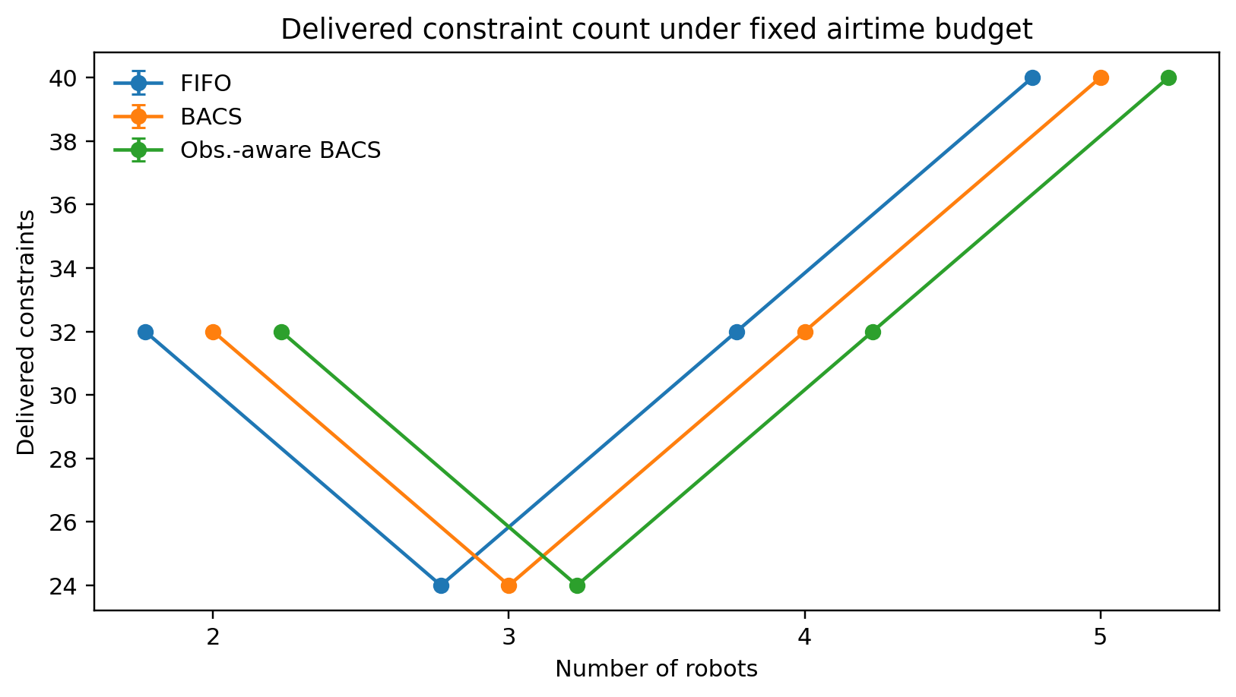
Fig. 7. Number of delivered constraints under the fixed airtime budget. Similar transmission counts indicate that alignment gains come from selection quality rather than from sending more constraints.
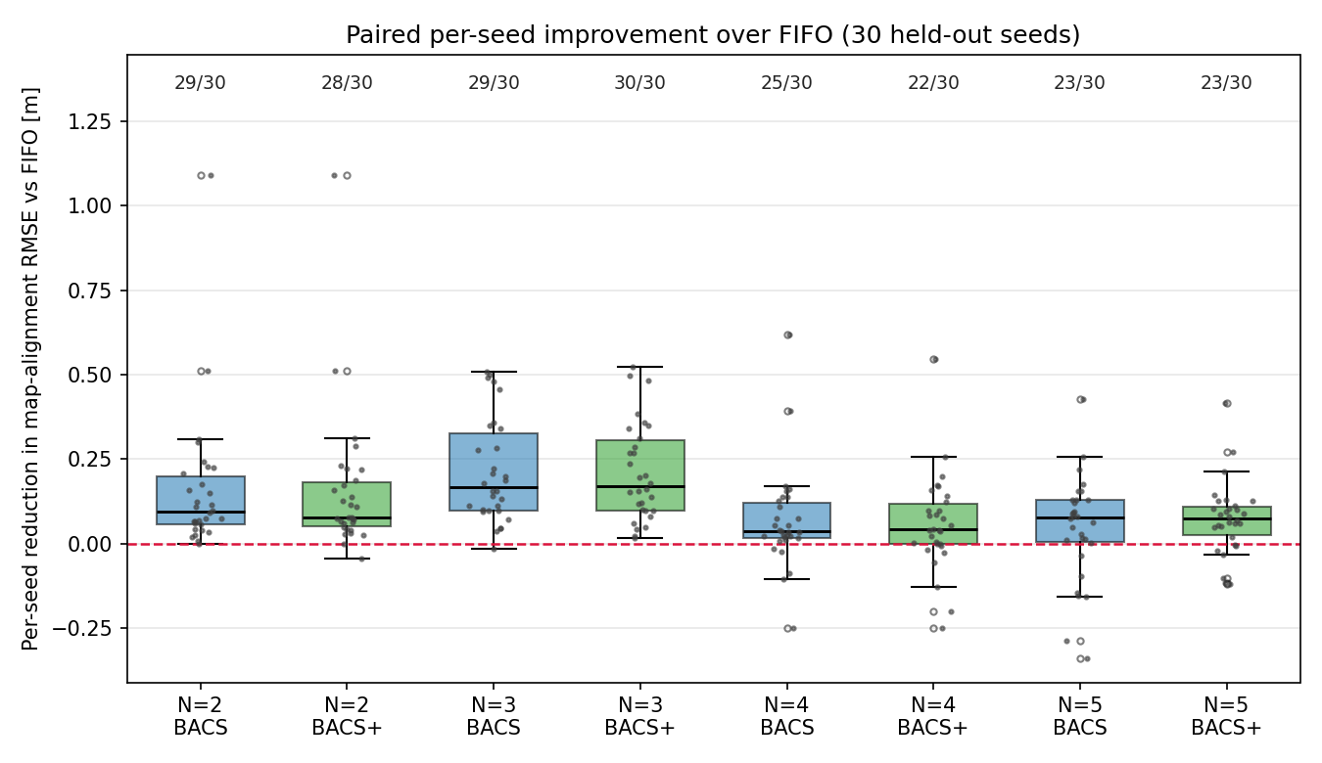
Fig. 8. Paired per-seed reduction in map-alignment RMSE relative to FIFO on the 30 held-out seeds. Points are individual seeds; the dashed line marks parity with FIFO; annotations give the number of seeds in which the policy beats FIFO.
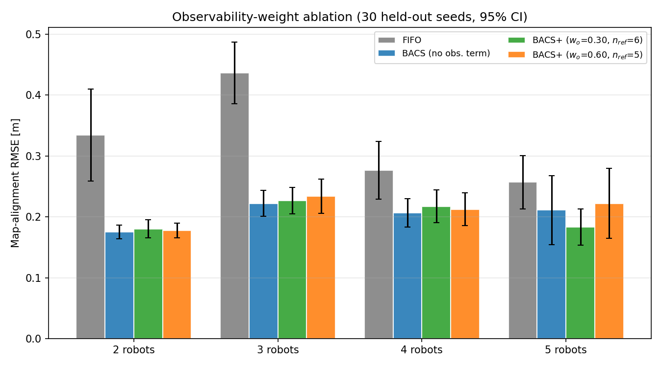
Fig. 9. Observability-weight ablation on the same held-out seeds. The screening setting ($w_{o}=0.60$, $n_{ref}=5$) is statistically indistinguishable from the principal setting ($w_{o}=0.30$, $n_{ref}=6$), which is why the latter is adopted on the strength of the S7-C evidence rather than on end-to-end RMSE.

6.6 Methodological progression
The experiments support the following progression.
- Receiver-side trust weighting protects the global optimiser after a constraint arrives.
- BACS moves the decision upstream and prevents scarce airtime from being spent on candidates predicted to arrive with negligible influence.
- Deferral-aware decay calibration places temporal trust on the correct queueing timescale.
- Observability-aware information ranking improves the transmitter-side approximation to exact graph information and preserves a significant map-alignment improvement in the largest evaluated team.
The resulting claim is narrower than an undifferentiated assertion of better SLAM: bandwidth-aware scheduling improves cross-robot map consistency under the evaluated communication constraint, while absolute pose RMSE remains dominated by local estimation error.

7. Physical Hardware Validation
7.1 Hardware platform and ROS 2 integration
Physical validation was executed after the simulation study on the two-robot platform of Section 5.1 and Table 1(a). BACS was inserted between candidate generation and LoRa transmission, leaving local SLAM and the server-side trust-weighted pose-graph optimiser unchanged; Vicon motion capture supplied external trajectory and relative-map ground truth.
7.2 Policies, repetitions, and measurements
FIFO, gated BACS, and BACS+ were evaluated under the same 1% duty-cycle condition and 60 s scheduling window. Ten matched runs were recorded for each policy. For every selected or delivered candidate, the scheduler logged generation, selection, transmission, and reception timestamps together with predicted trust, information score, queue age, and airtime cost. The primary physical endpoint was Vicon-referenced map-alignment RMSE. Per-robot pose RMSE, packet age, scheduling deferral, channel delay, airtime utilisation, delivered-constraint count, server-side trust, and scheduler runtime were retained as diagnostic measures.
7.3 Physical map-alignment result
FIFO produced 0.48 ± 0.15 m map-alignment RMSE, compared with 0.28 ± 0.08 m for BACS and 0.27 ± 0.09 m for BACS+. The final scheduler therefore reduced physical alignment error by 43.8% relative to FIFO. All ten paired BACS+ differences were negative, yielding a one-sided Wilcoxon p = 9.77 × 10⁻⁴ and Cliff’s δ = −0.81, a large effect. The absolute hardware errors are larger than their two-robot simulation counterparts, but the policy ordering is preserved.
7.4 Physical confirmation of deferral dominance
The hardware logs independently confirm the temporal mechanism that motivated the corrected trust-decay rule. Under FIFO, median packet age was 162 s, comprising approximately 161 s of scheduling deferral and 0.18 s of channel delay. Under BACS+, the corresponding values were 155 s total age, 154 s deferral, and 0.17 s channel delay. The BACS+ deferral-to-channel ratio is therefore approximately 906, confirming that packet age is governed by legal transmission opportunity and backlog rather than sub-second radio latency.
7.5 Runtime and communication diagnostics
Approximately 2,100 candidates were generated and about 14 were transmitted under each physical policy. Airtime utilisation remained 97–98%, showing that the comparison was made under essentially the same communication budget. Mean server-side trust was 0.42 for FIFO, 0.38 for BACS, and 0.39 for BACS+, yet FIFO produced the worst alignment. This reproduces the simulation observation that mean trust is not an adequate scheduler-quality metric. Measured scheduler overhead was 0.6 ms for BACS and 0.9 ms for BACS+, negligible relative to the 60 s scheduling window.
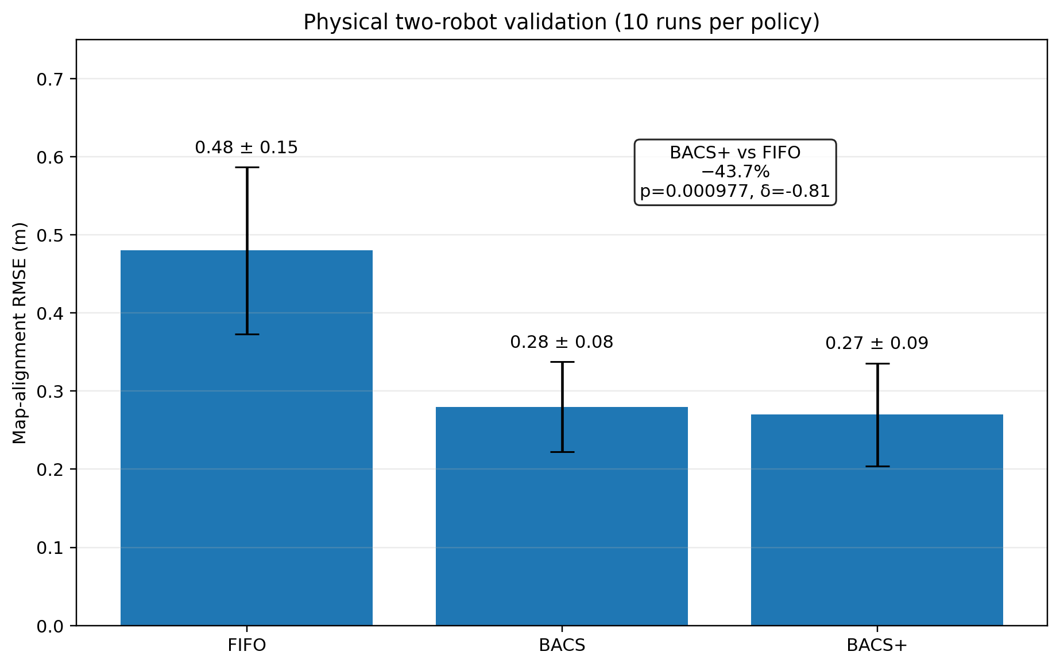
Fig. 10. Physical map-alignment RMSE across ten runs per policy. BACS+ reduces alignment error by 43.8% relative to FIFO.
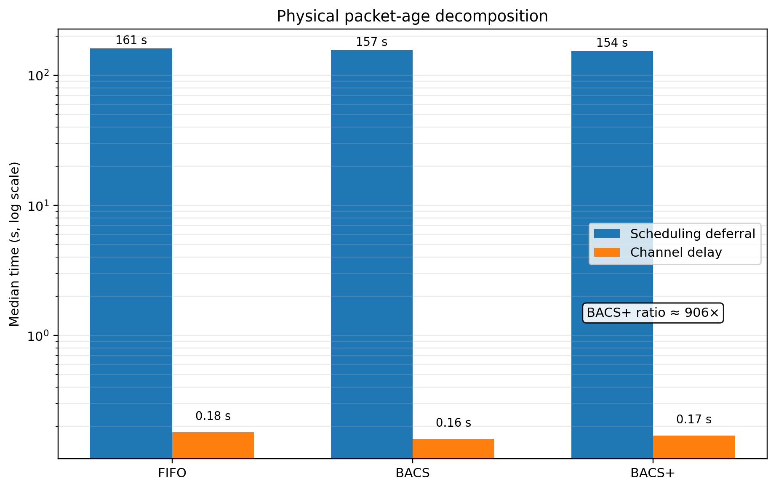
Fig. 11. Physical packet-age decomposition. Scheduling deferral dominates channel delay by approximately 906× for BACS+.
Table 6. Physical two-robot validation under the 1% duty-cycle condition.
Metric | FIFO | BACS | BACS+
Map-alignment RMSE [m] | 0.48 ± 0.15 | 0.28 ± 0.08 | 0.27 ± 0.09
95% CI [m] | [0.37, 0.59] | [0.22, 0.34] | [0.20, 0.34]
Pose RMSE — Robot 1 [m] | 0.52 ± 0.12 | 0.49 ± 0.11 | 0.50 ± 0.11
Pose RMSE — Robot 2 [m] | 0.51 ± 0.11 | 0.48 ± 0.10 | 0.49 ± 0.11
Median packet age [s] | 162 | 158 | 155
Median T_defer [s] | 161 | 157 | 154
Median T_channel [s] | 0.18 | 0.16 | 0.17
Generated / transmitted | ≈ 2100 / 14 | ≈ 2100 / 14 | ≈ 2100 / 14
Mean server trust | 0.42 | 0.38 | 0.39
Airtime utilisation [%] | ≈ 98 | ≈ 97 | ≈ 97
Scheduler overhead [ms] | - | 0.6 | 0.9

8. Discussion

8.1 Scheduling improves map alignment rather than absolute trajectory accuracy
The clearest end-to-end result is the separation between map-alignment RMSE and pose RMSE, which clarifies what an inter-robot transmission scheduler can and cannot change. Inter-robot constraints chiefly determine the relative placement of independently constructed local graphs, so they should affect map alignment strongly. Local odometry and onboard sensing dominate the internal shape of each robot’s trajectory, so changing which cross-robot edges are sent need not produce a measurable change in per-step absolute pose RMSE.
The same finding explains why the original small-sample scalability story was unstable. With only a few seeds, pose RMSE produced apparent ±20–30% policy differences; under 30 held-out seeds none of those differences survives. The more directly coupled alignment metric shows strong and repeatable improvement instead.

8.2 What the observability term contributes
The pairwise term should not be described as a universally superior RMSE policy. The direct comparison against plain BACS is not significant at 30 seeds, and the ablation in Fig. 9 shows that a considerably more aggressive parameterisation performs no better. The validated contribution is narrower and more defensible: the term improves fidelity of the local information approximation in every S7-C run, and maintains a significant alignment advantage over FIFO at the largest evaluated team size, where plain BACS does not.
The term is deliberately simple. Counting previously delivered constraints is only a proxy for pairwise determinacy, and Section 10 sets out how a covariance-, determinant-, or condition-number-based estimate derived from periodically broadcast graph summaries would represent observability more directly at the cost of extra computation and communication.
The surrogate-validation correction is a methodological result in its own right. Information gain is an incremental quantity, and evaluating a candidate against a posterior that already contains that edge can invert the ranking, because a valuable edge is exactly the one that renders its region well constrained. For scheduling and measurement-selection studies, validation must use the graph state before candidate insertion. Both calculations are retained in the repository so the distinction is reproducible rather than merely asserted.

8.4 Temporal weighting should follow the queueing timescale
The decay-calibration result generalises beyond this system. A communication-aware estimator should calibrate temporal trust to whichever delay process dominates in its actual operating regime. Under abundant bandwidth that may be propagation and processing; under duty-cycle-limited operation it is legal transmission opportunity and backlog. No single fixed $γ$ should be expected to transfer across radically different oversupply ratios.
The deferral-derived rule is attractive because it replaces a hand-tuned coefficient with a measurable system quantity. The unsuccessful online adaptive variant shows where the care is needed: observing only delivered packets gives a biased view of the backlog. A deployment-quality adaptive rule should estimate queue-wide candidate deferral, for example from censored queue statistics or periodic backlog summaries.

8.5 Communication efficiency versus unconstrained delivery
No compliant scheduler can reproduce the performance of an unconstrained send-all system when the radio budget excludes most candidate constraints. The purpose of BACS is not to make bandwidth irrelevant but to spend the available airtime on constraints with greater expected downstream value. The remaining gap to non-compliant exhaustive delivery is itself informative, since it quantifies the value of additional bandwidth or a higher-capacity communication layer.
The evidence now combines simulation breadth with a targeted physical transfer study. The 30-seed simulation evaluates teams of two to five robots, whereas hardware validation is limited to two robots. The largest-team scalability claim therefore remains simulation-supported. The physical study nevertheless tests the two mechanisms most likely to diverge from simulation - real radio delay and real map alignment - and preserves both the policy ordering and the deferral-dominance result.

9. Threats to Validity and Limitations
Limited hardware scale. The quantitative evidence is no longer simulation-only: the principal two-robot alignment and delay mechanisms were validated on physical hardware. However, physical scalability beyond two robots remains untested. The N = 3–5 claims therefore rely on simulation, and larger-team hardware experiments are the most important next validation step.
Candidate-generation model. The oversupply ratio, and hence the deferral distribution, depends on the front-end candidate rate. A different detector, environment, overlap pattern, or radio configuration will produce a different $T_{defer}$. This paper therefore does not recommend adopting $γ=0.0045 {\text{s}}^{−1}$ universally; deployments should estimate their own deferral distribution and apply Eq. (20).
Observability proxy. The pair-count term in Eq. (14) is a heuristic surrogate for determinacy, not an exact observability measure. S7-C shows it improves correlation with exact incremental information, but a principled graph-based summary may do better.
Parameter screening. Observability parameters were explored during method development on the same simulator family. To limit optimistic reporting, the S8 evaluation uses held-out seeds 10–39, and the selected 0.30/6 configuration is supported independently by S7-C. Transfer to unseen environments nevertheless remains untested.
Shared-channel abstraction. The simulation separates the per-device regulatory duty-cycle ceiling from a team-level equal-share allocation. Real deployments may use carrier sensing, multiple sub-bands, channel hopping, acknowledgements, or gateway scheduling, all of which change the usable share.
Adversarial behaviour. Cooperative robots are assumed throughout. A malicious or faulty robot could inflate declared trust, novelty, or observability and capture a disproportionate share of the airtime. Agent-level reputation and authenticated scheduling metadata are natural extensions but lie outside the present scope.

10. Conclusion and Future Work
This paper addresses a communication-layer limitation of trust-weighted collaborative SLAM. When a duty-cycle-limited radio cannot carry every inter-robot constraint, receiver-side weighting alone is insufficient because airtime has already been consumed. BACS moves the decision upstream by predicting downstream trust, applying trust as an admissibility gate, and allocating the remaining legal airtime according to information density. BACS+ further prioritises under-constrained robot pairs.
The simulation study shows that the dominant ageing process is scheduling deferral rather than channel propagation, validates the deferral-anchored temporal decay rule, and demonstrates that the observability-aware surrogate tracks exact incremental graph information more faithfully. Across 30 held-out seeds, the BACS family substantially reduces map-alignment RMSE while leaving odometry-dominated trajectory pose RMSE without a consistent policy effect.
The hardware experiment strengthens the central claim. On two modified LIMO robots, BACS+ reduces Vicon-referenced map-alignment RMSE from 0.48 ± 0.15 m to 0.27 ± 0.09 m, a 43.8% improvement relative to FIFO (p = 9.77 × 10⁻⁴; Cliff’s δ = −0.81). Median scheduling deferral is 154 s compared with 0.17 s channel delay, confirming a 906× separation on real ROS 2 and LoRa hardware. These measurements independently support both the transmitter-side scheduling mechanism and deferral-based temporal calibration.
Four directions follow from the limitations above. First, physical evaluation should extend to three to five robots and to multiple environments, since the larger-team claims currently rest on simulation. Second, the pair-count observability term should be replaced by a graph-derived measure of pairwise determinacy. The natural candidate is the marginal covariance of the relative transformation between two robot poses, Σ_zij = Σ_ii + Σ_jj − Σ_ij − Σ_ji, scored by a D-optimality criterion −log det Σ_zij, which accounts for constraint geometry, intra-robot stabilisation, and the diminishing returns of redundant edges that a count cannot represent. Because the full graph resides on the server, the transmitter would need a periodic lightweight summary broadcast — of the order of 2N × 3 + P × 9 floating-point values for SE(2) poses, under 500 bytes for teams of up to ten, and reducible to about P × 8 bytes if only per-pair determinants are sent. A communication-free fallback is the condition number of the effective information matrix for the relative transformation, which is computable locally but captures anisotropy rather than absolute magnitude. Either variant would replace Eq. (14) in Eq. (15) and would require the S7-C validation of Section 6.3 to be repeated. Third, an unbiased online estimator of queue-wide deferral is needed, since the adaptive variant reported here observes only delivered packets. Fourth, agent-level reputation and authenticated scheduling metadata would extend the framework to faulty or adversarial teams.

Reproducibility
Simulation results are backed by frozen CSV files and executable experiment runners in the accompanying repository. The repository also contains the ROS 2 scheduler package, hardware configuration, and experiment-integration material used for physical deployment. The manuscript should be archived together with the final hardware run-level files and scheduler logs before submission so that the physical statistics can be reproduced from raw data.
Result | Implementation / script | Frozen output
Trust-decay rules (Table 2) | experiments.s9_deferral_gamma | paper_results/s9_deferral_gamma.csv
Incremental surrogate validation (Table 3) | experiments.s7c_incremental_validation, paired runner | paper_results/s7c_incremental_validation.csv, s7c_paired.csv
Prior/posterior diagnostic (Section 6.3) | experiments.s7_surrogate_validation | paper_results/s7_surrogate_validation.csv
30-seed held-out S8 (Tables 4–5, Figs. 5–9) | scripts/run_s8_30seed.py | paper_results/s8_30seed_raw.csv, s8_30seed_summary.csv, s8_30seed_tests.csv
Methodological progression (Section 6.6) | experiments.progression | paper_results/progression.csv
Figures | scripts/make_figures.py | paper_figures/*.png
Physical validation (Section 7) | ros2_ws/src/bacs_scheduler; hardware/; physical analysis scripts | Add final run-level hardware CSVs and timestamp logs to paper_results/

References
- Grisetti, G., Kümmerle, R., Stachniss, C., Burgard, W.: A tutorial on graph-based SLAM. IEEE Intelligent Transportation Systems Magazine 2(4), 31–43 (2010). doi:10.1109/MITS.2010.939925
- Kümmerle, R., Grisetti, G., Strasdat, H., Konolige, K., Burgard, W.: g2o: A general framework for graph optimization. In: Proc. IEEE ICRA, pp. 3607–3613 (2011). doi:10.1109/ICRA.2011.5979949
- Dellaert, F.: Factor graphs and GTSAM: A hands-on introduction. Foundations and Trends in Robotics 1(1–2), 1–139 (2012). doi:10.1561/2300000021
- Agarwal, P., Tipaldi, G.D., Spinello, L., Stachniss, C., Burgard, W.: Robust map optimization using dynamic covariance scaling. In: Proc. IEEE ICRA, pp. 62–69 (2013). doi:10.1109/ICRA.2013.6630748
- Sünderhauf, N., Protzel, P.: Switchable constraints for robust pose graph SLAM. In: Proc. IEEE/RSJ IROS, pp. 1879–1884 (2012). doi:10.1109/IROS.2012.6385590
- Labbé, M., Michaud, F.: RTAB-Map as an open-source LiDAR and visual SLAM library for large-scale and long-term online operation. Journal of Field Robotics 36(2), 416–446 (2019). doi:10.1002/rob.21853
- Campos, C., Elvira, R., Rodríguez, J.J.G., Montiel, J.M.M., Tardós, J.D.: ORB-SLAM3: An accurate open-source library for visual, visual-inertial, and multi-map SLAM. IEEE Transactions on Robotics 37(6), 1874–1890 (2021). doi:10.1109/TRO.2021.3130201
- Zhang, J., Singh, S.: LOAM: Lidar odometry and mapping in real-time. In: Robotics: Science and Systems (2014). doi:10.15607/RSS.2014.X.007
- Lajoie, P.-Y., Ramtoula, B., Chang, Y., Carlone, L., Beltrame, G.: DOOR-SLAM: Distributed, online, and outlier resilient SLAM for robotic teams. IEEE Robotics and Automation Letters 5(2), 1656–1663 (2020). doi:10.1109/LRA.2020.2967681
- Tian, Y., Chang, Y., Herrera Arias, F., Nieto-Granda, C., How, J.P., Carlone, L.: Kimera-Multi: Robust, distributed, dense metric-semantic SLAM for multi-robot systems. IEEE Transactions on Robotics 38(4), 2022–2038 (2022). doi:10.1109/TRO.2021.3137751
- Chang, Y., Ebadi, K., Denniston, C.E., Ginting, M.F., Rosinol, A., Reinke, A., Palieri, M., Shi, J., Chatterjee, A., Morrell, B., Agha-mohammadi, A.-A., Carlone, L.: LAMP 2.0: A robust multi-robot SLAM system for operation in challenging large-scale underground environments. IEEE Robotics and Automation Letters 7(4), 9175–9182 (2022). doi:10.1109/LRA.2022.3191204
- Lajoie, P.-Y., Beltrame, G.: Swarm-SLAM: Sparse decentralized collaborative simultaneous localization and mapping framework for multi-robot systems. IEEE Robotics and Automation Letters 9(1), 475–482 (2024). doi:10.1109/LRA.2023.3333742
- Cunningham, A., Indelman, V., Dellaert, F.: DDF-SAM 2.0: Consistent distributed smoothing and mapping. In: Proc. IEEE ICRA, pp. 5220–5227 (2013). doi:10.1109/ICRA.2013.6631323
- Ila, V., Porta, J.M., Andrade-Cetto, J.: Information-based compact pose SLAM. IEEE Transactions on Robotics 26(1), 78–93 (2010). doi:10.1109/TRO.2009.2034438
- Kaess, M., Dellaert, F.: Covariance recovery from a square root information matrix for data association. Robotics and Autonomous Systems 57(12), 1198–1210 (2009). doi:10.1016/j.robot.2009.06.008
- Carlevaris-Bianco, N., Eustice, R.M.: Generic factor-based node marginalization and edge sparsification for pose-graph SLAM. In: Proc. IEEE ICRA, pp. 5748–5755 (2013). doi:10.1109/ICRA.2013.6631353
- Khosoussi, K., Huang, S., Dissanayake, G.: Novel insights into the impact of graph structure on SLAM. In: Proc. IEEE/RSJ IROS, pp. 2707–2714 (2014). doi:10.1109/IROS.2014.6942932
- Khosoussi, K., Sukhatme, G.S., Huang, S., Dissanayake, G.: Reliable graphs for SLAM. International Journal of Robotics Research 38(2–3), 260–298 (2019). doi:10.1177/0278364918823086
- Giamou, M., Khosoussi, K., How, J.P.: Talk resource-efficiently to me: Optimal communication planning for distributed loop closure detection. In: Proc. IEEE ICRA, pp. 3841–3848 (2018). doi:10.1109/ICRA.2018.8460783
- Tian, Y., Khosoussi, K., How, J.P.: Resource-aware algorithms for distributed loop closure detection with provable performance guarantees. International Journal of Robotics Research 40(10–11), 1212–1233 (2021). doi:10.1177/02783649211021869
- Paull, L., Huang, G., Seto, M., Leonard, J.J.: Communication-constrained multi-AUV cooperative SLAM. In: Proc. IEEE ICRA, pp. 509–516 (2015). doi:10.1109/ICRA.2015.7139227
- Kantaros, Y., Zavlanos, M.M.: Distributed intermittent connectivity control of mobile robot networks. IEEE Transactions on Automatic Control 62(7), 3109–3121 (2017). doi:10.1109/TAC.2016.2626400
- Viseras, A., Xu, Z., Merino, L.: Distributed multi-robot information gathering under spatio-temporal inter-robot constraints. Sensors 20(2), 484 (2020). doi:10.3390/s20020484
- Han, J., Ma, S.: Distributed multi-robot SLAM algorithm with lightweight communication and optimization. Electronics 13(20), 4129 (2024). doi:10.3390/electronics13204129
- Chen, H., Zhang, Z., Li, Y., Wang, X.: Deep compressed communication and application in multi-robot collaborative SLAM. Sensors 24(12), 3852 (2024). doi:10.3390/s24123852
- Lanka, V.S.V.G.S., Kothandaraman, D.: MAR-LoRa: Mobility-aware LoRa protocol for reliable IoT communications. IEEE Access 13 (2025).
- Shin, G., Sim, H., Nam, S., Kim, Y., Heo, J., Kim, K.-K.K.: Multi-robot relative pose estimation in SE(2) with observability analysis: A comparison of extended Kalman filtering and robust pose graph optimization. IEEE Transactions on Intelligent Vehicles (2024). doi:10.1109/TIV.2024.3478290
- Ahmed, S.S.: Range-aided relative pose estimation and formation control for multi-robot systems with limited observability. M.Eng. thesis, McGill University (2024).
- Tian, Y., Khosoussi, K., Rosen, D.M., How, J.P.: Distributed certifiably correct pose-graph optimization. IEEE Transactions on Robotics 37(6), 2137–2156 (2021). doi:10.1109/TRO.2021.3072346
- Rosen, D.M., Carlone, L., Bandeira, A.S., Leonard, J.J.: SE-Sync: A certifiably correct algorithm for synchronization over the special Euclidean group. International Journal of Robotics Research 38(2–3), 95–125 (2019). doi:10.1177/0278364918784361
- Ebadi, K., Bernreiter, L., Biggie, H., Catt, G., Chang, Y., Chatterjee, A., Denniston, C.E., Deschênes, S.-P., Harlow, K., Khattak, S., et al.: Present and future of SLAM in extreme environments: The DARPA SubT Challenge. IEEE Transactions on Robotics 40, 936–959 (2024). doi:10.1109/TRO.2023.3323938
- Maruyama, Y., Kato, S., Azumi, T.: Exploring the performance of ROS 2. IEEE Embedded Systems Letters 8(3), 55–58 (2016). doi:10.1109/LES.2016.2544420
- Macenski, S., Martín, F., White, R., Ginés Clavero, J.: From the ROS navigation stack to Nav2. Science Robotics 7(66), eabm6074 (2022). doi:10.1126/scirobotics.abm6074
- Xu, W., Cai, Y., He, D., Lin, J., Zhang, F.: FAST-LIO2: Fast direct LiDAR-inertial odometry. IEEE Transactions on Robotics 38(4), 2053–2073 (2022). doi:10.1109/TRO.2022.3141876
- Semtech Corporation: LoRa Modulation Basics. Application Note AN1200.22, revision 2 (2015).
- ETSI: Short Range Devices (SRD) operating in the frequency range 25 MHz to 1000 MHz; Part 2. EN 300 220-2 V3.2.1 (2018).
- Vangelista, L., Zanella, A., Zorzi, M.: Long-range IoT technologies: The dawn of LoRa. In: Future Access Enablers for Ubiquitous and Intelligent Infrastructures, pp. 51–58. Springer (2015). doi:10.1007/978-3-319-27072-2_7
- Liu, X., Lei, J., Prabhu, A., Tao, Y., Spasojevic, I., Chaudhari, P., Atanasov, N., Kumar, V.: SlideSLAM: Sparse, lightweight, decentralized metric-semantic SLAM for multi-robot navigation. IEEE Transactions on Robotics 41, 6529–6548 (2025).
- Zhu, F., Ren, Y., Yin, L., Kong, F., Liu, Q., Xue, R., Liu, W., Cai, Y., Lu, G., Li, H., Zhang, F.: Swarm-LIO2: Decentralized efficient LiDAR-inertial odometry for aerial swarm systems. IEEE Transactions on Robotics 41, 960–981 (2025).
- Gielis, J., Shankar, A., Prorok, A.: A critical review of communications in multi-robot systems. Current Robotics Reports 3(4), 213–225 (2022). doi:10.1007/s43154-022-00090-9
41. Athukorala, A., Lau, B.P.L., Pongsirijinda, K., Yuen, C., Tan, U.-X.: Multi-Robot Collaborative SLAM (Multi-SLAM) With Distributed Lightweight Predictive Frontier Exploration (LPFE). IEEE Robotics and Automation Letters 11(2), 2274-2281 (2026). doi:10.1109/LRA.2025.3645990
42. Bayer, J., Faigl, J.: Decentralized multi-robot exploration under low-bandwidth communications. Autonomous Robots 50, Article 7 (2026). doi:10.1007/s10514-025-10234-3
43. Chen, L., Su, Y., Wang, J., Han, P., Xia, Z., Bu, S., et al.: CoMA-SLAM: Collaborative Multi-Agent Gaussian SLAM with Geometric Consistency. Proceedings of the AAAI Conference on Artificial Intelligence 40(4), 2922-2929 (2026). doi:10.1609/aaai.v40i4.37283
44. Pu, F., Nawaz, M.W., Imran, M.A., Popoola, O.: ViT-NeRF Edge-Assisted Multi-Robot SLAM for Scalable Low-Bandwidth Exploration. IEEE ICC Workshops (2026). doi:10.1109/ICCWorkshops63917.2026.11586277
45. Zhang, W., Cheng, L., Wei, J., Xu, X., et al.: Bandwidth-Efficient Collaborative SLAM: Mutual Information for Data Selection and Finite-State Entropy for Lossless Compression. IEEE Transactions on Automation Science and Engineering, Early Access (2026). doi:10.1109/TASE.2026.3666939

Declarations
Funding. The authors received no specific funding for this work.
Conflict of interest. The authors declare no competing interests.
Ethics approval. Not applicable; no human participants or animal subjects were involved.
Data and code availability. The simulation code, experiment runners, frozen simulation result files, ROS 2 scheduler implementation, hardware configuration, and figure-generation scripts are maintained in the project repository. The final submission archive should include the run-level physical map-alignment data and scheduler timestamp logs used for Section 7. The public repository link may be revealed after double-anonymous review if required by the target venue.
Scope of experimental claims. Simulation supports the multi-team evaluation for N = 2–5. Physical measurements support the two-robot transfer claim, the 43.8% map-alignment reduction, and the measured deferral-to-channel separation. Hardware scalability beyond two robots is not claimed.
Use of generative AI. Generative AI tools were used for language editing, structural revision, and drafting support. The authors verified all technical statements, equations, references, code, and experimental results, and take full responsibility for the manuscript. Generative AI tools are not listed as authors. The final wording should be checked against the target publisher's policy at submission.

