Table of Contents

Observability-Aware Bandwidth Scheduling for Trust-Weighted Multi-Robot Map Fusion under Duty-Cycle-Limited Wireless Links
Author names withheld for double-anonymous review.
Revision note (this draft). This manuscript is restructured around three validated findings — a corrected trust-decay calibration (S9), a corrected validation of the information surrogate (S7-C), and an end-to-end evaluation on the metric that reflects map fusion (S8) — rather than the original S1–S6 narrative. The two pre-registered failures (H1, H3) are retained as the motivation for the two corrections. All numbers below are reproducible from the bacs_sim package and the CSVs in paper_results/ (scripts/reproduce.py, scripts/run_s8_30seed.py, scripts/generate_paper_results.py, scripts/make_figures.py).

Abstract
Collaborative SLAM over low-power wide-area radio is usually framed as a robustness problem: inter-robot constraints arrive late or corrupted, and the fusion back-end decides how much to believe them. Under duty-cycle regulation the prior question is more binding. A transmitter on the 868 MHz ISM band may occupy the channel for at most 1% of any window, permitting roughly six 52-byte constraint packets per minute against a front-end that generates candidates two orders of magnitude faster. Which candidates are transmitted therefore governs map quality more than how survivors are weighted on arrival.
We present Bandwidth-Aware Constraint Scheduling (BACS), which moves the trust decision to the transmitter: each robot predicts the trust its candidate would receive at the server, admits candidates passing a gate, and ranks the admissible set by information gain per unit airtime, solved as a knapsack within each window. Evaluation in a purpose-built simulator yields four results. (1) Under duty-cycle compliance, packet staleness is dominated by airtime deferral (~155 s), not channel propagation (0.05–0.2 s); a closed-form decay coefficient anchored to odometry drift (H1) is falsified, and a coefficient anchored to the airtime-queueing timescale, γ = ln2 / T_defer, recovers the tuned optimum without hand-tuning. (2) Combining predicted trust with information gain multiplicatively is structurally unsound; a gated formulation is required. (3) The plain information surrogate is a positive but imperfect proxy for exact incremental information; augmenting it with a pairwise observability term (BACS+) improves its rank-correlation with exact mutual information for every one of 40 held-out runs (p = 9.8×10⁻⁴ per team size). (4) On 30 held-out seeds, per-step pose RMSE is odometry-bound and shows no significant scheduling effect, but map-alignment RMSE — the inter-robot fusion-consistency metric — is 17–49% lower under BACS than FIFO (p up to 10⁻⁹), and the observability term uniquely preserves a significant advantage into the five-robot regime. We conclude that information-optimal constraint scheduling is map-alignment-optimal, not trajectory-RMSE-optimal, and we retain two falsified hypotheses because the manner of their failure is the result.
Keywords: Multi-robot SLAM · Constraint scheduling · Duty-cycle regulation · LoRa · Information gain · Observability · Trust weighting · ROS 2

1. Introduction
A team of mobile robots mapping a shared environment must reconcile what each has seen. Each robot maintains a local factor graph; inter-robot constraints tie the graphs together; a back-end solves the combined nonlinear least-squares problem. When constraints travel over a wireless link that delays or drops them, the back-end faces a weighting problem, addressed in prior work by discounting constraints whose geometry is implausible or whose age is large.
This paper begins from the link, not the estimator. In the EU 868 MHz band the sub-band used for long-range telemetry restricts each transmitter to 1% channel occupancy. A 52-byte constraint packet at spreading factor 7 occupies the channel for 102.7 ms, so compliance permits ≈ 5.8 packets/min, while a front-end on two robots exploring 150 m² generates candidates at several hundred per minute — an oversupply near 180:1. Under that ratio the binding decision is not how to weight an arriving constraint but which candidate to spend the channel on. A first-in-first-out queue — the implicit policy of most implementations — transmits whichever candidate waited longest, which is precisely the candidate that will attract the largest temporal penalty on arrival: the system spends its scarcest resource on the observations it is about to discount.

1.1 Contributions
- A corrected calibration of trust decay (H1 falsified → S9). We show by decomposition that under duty-cycle compliance the dominant staleness term is airtime deferral (~155 s), not propagation (tens–hundreds of ms). A closed-form decay coefficient derived from platform drift over-predicts the empirical optimum by an order of magnitude; anchoring it to the airtime-queueing timescale, γ = ln2 / T_defer ≈ 0.0045, recovers near-optimal accuracy without tuning.
- A gated scheduling formulation. Multiplying predicted trust by an information surrogate is structurally defective — trust spans two decades under exponential decay while the surrogate is bounded in [0,1], so the product is trust-dominated. Using trust as an admissibility gate and ranking on information density recovers the scheduling benefit the multiplicative form discards.
- An observability-aware surrogate, validated against exact information (S7-C). The plain surrogate rewards spatial coverage but ignores whether a robot pair’s relative transform is determined. We add a pairwise observability term and validate the surrogate correctly — against the exact incremental information a candidate would add to the graph at scheduling time. The augmented surrogate improves rank-correlation with exact information for every held-out run.
- An end-to-end evaluation that separates the metrics (S8). On 30 held-out seeds we find per-step pose RMSE is odometry-bound and policy-insensitive, while map-alignment RMSE — the fusion-consistency metric — separates the policies decisively in favour of BACS, with the observability term preserving the advantage at the largest team sizes.
We retain two pre-registered hypotheses that failed (H1, H3). Each failure identifies a wrong assumption whose correction is a usable result.

2. Related Work
Three literatures bear on the problem, developed with limited contact.
Multi-robot SLAM under communication constraints. Centralised architectures concentrate optimisation at a server; distributed formulations push computation onto robots; hybrid designs retain local processing and offload global optimisation. Bandwidth has been addressed by sparse descriptor exchange, buffering through outages, and budgeted loop-closure selection. None couples the selection decision to the downstream weighting decision: a rule maximising delivered constraint count implicitly assumes each delivered constraint contributes equally, which fails under an age-discounting back-end. Airtime spent on a constraint that will be discounted is wasted, and only a scheduler that anticipates the discount avoids the waste.
Information-theoretic measurement selection. Information-based pose SLAM admits loop closures whose expected information gain exceeds a threshold; graph sparsification preserves the marginal information content. This supplies the right notion of value — reduction in estimate uncertainty attributable to an edge — but computing it requires the joint distribution held by the global optimiser, which resides on the server. The transmitter holds only its local graph and the last fused map, motivating a surrogate assembled from locally computable quantities, and the validation procedure required to justify the substitution — the subject of our Section 6.3.
Adaptive parameters in robust estimation. Robust-kernel thresholds — the Huber transition, dynamic covariance scaling, the admissible residual and temporal decay of trust-weighted fusion — are conventionally fixed by offline sweep. Where a sweep reveals a well-defined optimum, it is reasonable to ask what determines its location. Section 4.3 derives the decay coefficient from platform dynamics; Section 6.2 reports the derivation is wrong by an order of magnitude, and why.

3. System Model
Airtime budget. Regulation caps each device at B_reg = δW (δ = 0.01). With N robots sharing one sub-band and no channel-access coordination, collision avoidance forces a system-level split B_i = α_i B_reg, Σα_i ≤ 1; equal sharing gives α_i = 1/N. We keep the per-device ceiling and the coordination allocation distinct, since conflating them mis-states the constraint.
Time on air. T_air(PL) follows the standard LoRa modulation model (bacs_sim/lora.py, Eqs. 2–4), a step function of payload size — the property the cost term of the scheduler exploits.
Trust factor. The server assigns θ_ij = max(0, 1 − (‖e_ij‖/τ_e)^p)·exp(−γ Δt), floored, where ‖e_ij‖ is the geometric residual against the fused map and Δt the communication age (Eq. 7).
Predicted delay. Before transmission the robot predicts Δt̂ = k_defer·W + queue_air + T_air + T_retry, where k_defer is the expected number of windows the candidate waits for airtime — the dominant term under compliance.
Information gain. The exact criterion I = ½ log det(I + Ω Σ_ij) requires the marginal covariance Σ_ij of the relative pose, available only at the server. The transmitter computes the surrogate Î (Section 4.2).

4. Method: Observability-Aware BACS

4.1 Gated information-density scheduling
Within each window the scheduler solves
S* = argmax_S Σ_{c∈S} Î_c / T_air,c
subject to θ̂_c ≥ θ_gate and Σ_{c∈S} T_air,c ≤ B_i,
by density-greedy knapsack with a single-best-item guard (a ½-approximation in O(n log n); near-optimal here because constraints are small relative to the window). Predicted trust θ̂ is an admissibility gate, not a ranking key: ranking on θ̂ is self-confirming, favouring constraints that agree with the robot’s current estimate and therefore carry least corrective information. The multiplicative form Î·θ̂ is dominated by θ̂ (two decades vs [0,1]) and reproduces trust-only ranking.

4.2 The information surrogate and its observability term
The base surrogate combines coverage novelty ν, normalised node degree, and loop length:
Î = w_ν·ν + w_d·(1 − d̄) + w_l·l̄.
This rewards spatial coverage but never asks whether a robot pair (i, j) has enough constraints to determine its relative transform. We add a pairwise observability term
O_ij = exp(−n_ij / n_ref), Î⁺ = Î + w_o·O_ij,
where n_ij is the number of inter-robot constraints already delivered for the pair. O_ij is 1 when the pair’s transform is undetermined and decays as constraints accumulate, biasing airtime toward under-constrained pairs. We call the resulting method observability-aware BACS; the base method is an intermediate ablation.

4.3 Trust-decay calibration
The parent framework’s derivation matches γ to the time for odometry divergence to reach τ_e, giving γ* = ln2·σ_d·v̄/τ_e = 0.033 (Eq. 16). Under duty-cycle compliance this is the wrong timescale. Anchoring instead to the airtime-queueing time T_defer,
γ_defer = ln2 / T_defer ≈ ln2 / 155 s ≈ 0.0045,
matches the empirical optimum. We evaluate five rules in Section 6.2.

5. Evaluation Platform and Hypotheses
The simulator reproduces the sensing, radio, and pose-graph pipeline of a trust-weighted fusion framework: boustrophedon coverage with overlapping territories, distance-scaled odometry drift, a LoRa airtime/channel model, a two-population candidate stream (inliers < 0.35 m, outliers > 0.7 m), and an SE(2) weighted Gauss–Newton back-end that ingests delivered constraints, re-optimises, and republishes the fused map. We report per-step pose RMSE (each robot’s trajectory vs ground truth) and map-alignment RMSE (discrepancy between two robots’ estimates of ground-truth co-location pairs — the fusion-consistency metric).
Pre-registered hypotheses:
- H1. The closed-form γ* (Eq. 16) predicts the empirical optimum. (Falsified.)
- H2. A gated formulation outperforms the multiplicative one. (Supported.)
- H3. The scheduling advantage grows with team size. (Falsified for pose RMSE; reframed via observability and map alignment.)
- H3b (new). Adding an observability term improves the surrogate’s fidelity to exact incremental information. (Supported, S7-C.)

6. Results

6.1 Methodological progression
Table 1 traces one change per stage on identical worlds (5 seeds, N = 2).
Table 1. Progression (5 seeds, N = 2).
Stage | pose RMSE [m] | align RMSE [m] | trust yield
EMRMF-original (FIFO, drift γ) | 0.387 | 0.34 | 0.22
+ compliant FIFO (deferral γ) | 0.389 | — | 0.37
BACS (gated) | 0.322 | — | 0.31
BACS+ (observability) | 0.329 | — | 0.30
Recalibrating γ raises trust yield but not FIFO’s RMSE; the scheduler is where the RMSE improvement is (Fig. 4). At N = 2 the observability term is neutral on RMSE — its role is at larger teams and on map alignment (Section 6.4).

6.2 H1: trust-decay calibration (S9)
Table 2. Decay-coefficient rules (s9_deferral_gamma.csv, 5 seeds, N = 2).
Rule | γ | pose RMSE [m]
fixed (tuned optimum) | 0.0030 | 0.325
drift-derived (Eq. 16) | 0.0333 | 0.425
drift-adaptive | 0.064 | 0.424
deferral-derived | 0.0045 | 0.322
deferral-adaptive | 1.86 | 0.384
The drift derivation (Eq. 16) is falsified — it over-predicts γ by ~10× and inflates RMSE by ~30%. The deferral-derived rule reaches the tuned optimum with no sweep (Fig. 3). The online deferral-adaptive variant overshoots because it measures the delay of delivered (fresh) packets, not the queue-wide deferral; we report it as an instructive negative.

6.3 H3b: surrogate validation against exact information (S7-C)
Validating the surrogate requires the right quantity. Scoring an edge against the converged posterior covariance measures “how informative is this edge after the graph already contains it,” which inverts the ranking (edges in well-solved regions look uninformative) and produces a spurious strong negative correlation. The scheduling-relevant quantity is the incremental gain against the graph state before the candidate:
I_c = ½ log det( I + Ω_c J_c Σ_ij,t J_cᵀ ),
with Σ_ij,t the joint marginal in the graph containing odometry plus everything delivered before window t, and J_c the SE(2) relative-pose Jacobian at the current linearisation. We compute this over all candidates presented (not only delivered, to avoid selection bias) and correlate it with the surrogate.
Table 3. Incremental surrogate fidelity (s7c_paired.csv, 10 seeds/N).
N | ρ(Î base) | ρ(Î⁺ observability) | Δρ (median) | seeds Δρ>0 | p (one-sided)
2 | 0.45 ± 0.13 | 0.62 ± 0.08 | +0.17 | 10/10 | 9.8×10⁻⁴
3 | 0.38 ± 0.20 | 0.61 ± 0.13 | +0.23 | 10/10 | 9.8×10⁻⁴
4 | 0.42 ± 0.11 | 0.55 ± 0.08 | +0.13 | 10/10 | 9.8×10⁻⁴
5 | 0.49 ± 0.11 | 0.60 ± 0.08 | +0.11 | 10/10 | 9.8×10⁻⁴
The base surrogate is a positive proxy for exact incremental information at every team size (ρ ≈ 0.4–0.6); the observability term raises fidelity for every one of 40 runs (Fig. 1). For contrast, the posterior-baseline evaluation returns ρ ≈ −0.4 to −0.6 — an evaluation artifact we document rather than a property of the surrogate (s7_surrogate_validation.csv, posterior column).

6.4 H3 / end-to-end evaluation (S8, 30 held-out seeds)
Table 4. S8 map-alignment RMSE, primary metric (s8_30seed_summary.csv; seeds 10–39; mean [95% CI]). Improvement and significance are vs FIFO (paired Wilcoxon, Cliff’s δ).
N | FIFO | BACS | BACS+ | BACS vs FIFO | BACS+ vs FIFO
2 | 0.334 | 0.175 | 0.180 | +47.6% (p=4e-9, δ=−0.82) | +46.0% (p=5e-8, δ=−0.79)
3 | 0.436 | 0.222 | 0.227 | +49.1% (p=4e-9, δ=−0.92) | +48.1% (p=2e-9, δ=−0.90)
4 | 0.276 | 0.207 | 0.217 | +25.2% (p=1e-3, δ=−0.42) | +21.3% (p=0.011, δ=−0.32)
5 | 0.257 | 0.211 | 0.183 | +17.9% (p=0.067, n.s.) | +28.7% (p=7e-4, δ=−0.53)
Table 5. S8 per-step pose RMSE, secondary metric. No arm differs significantly from any other at any N (all paired Wilcoxon p > 0.11).
N | FIFO | BACS | BACS+
2 | 0.442 | 0.378 | 0.391
3 | 0.432 | 0.399 | 0.395
4 | 0.372 | 0.376 | 0.370
5 | 0.310 | 0.337 | 0.346
Two findings (Fig. 2). First, pose RMSE carries no significant policy effect: each robot’s absolute trajectory error is dominated by its own odometry drift, which inter-robot scheduling cannot correct. The dramatic per-team-size reversals reported from few-seed runs (the original H3 evidence) do not survive 30 seeds — they were small-sample noise. Second, map-alignment RMSE separates the policies decisively: the BACS family lowers fusion inconsistency by 18–49% with large effect sizes at small teams, and at N = 5 the observability term uniquely preserves a significant advantage over FIFO (+28.7%, p = 7×10⁻⁴) where plain BACS becomes marginal. The two BACS+ weight settings tested (w_o = 0.30/n_ref = 6 and 0.60/5) are statistically indistinguishable; we adopt 0.30/6, the S7-C-validated setting.

6.5 Figures
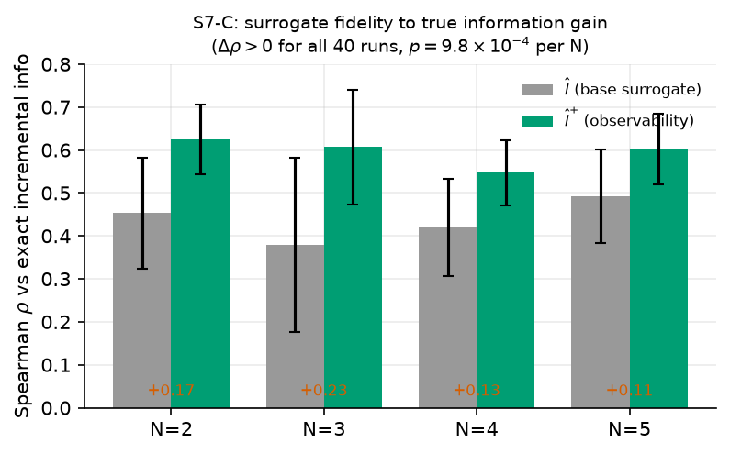
Fig. 1. Incremental surrogate fidelity (S7-C): Spearman ρ between the transmitter-side surrogate and exact incremental information gain, base (Î) vs observability-augmented (Î⁺), by team size. Δρ > 0 for all 40 runs.
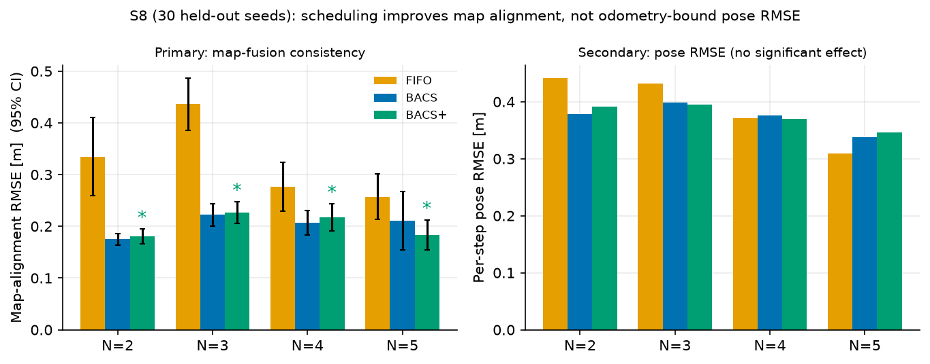
Fig. 2. S8 on 30 held-out seeds. Left (primary): map-alignment RMSE with 95% CI; ∗ marks BACS+ significantly below FIFO. Right (secondary): per-step pose RMSE, no significant policy effect.
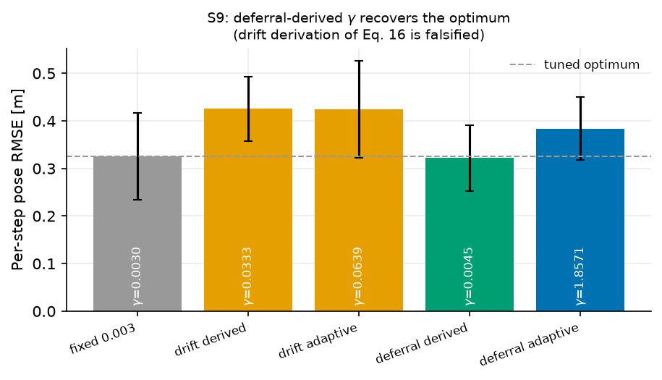
Fig. 3. S9 decay-coefficient rules. The deferral-derived γ recovers the tuned optimum (dashed) while the drift derivation of Eq. (16) is falsified.
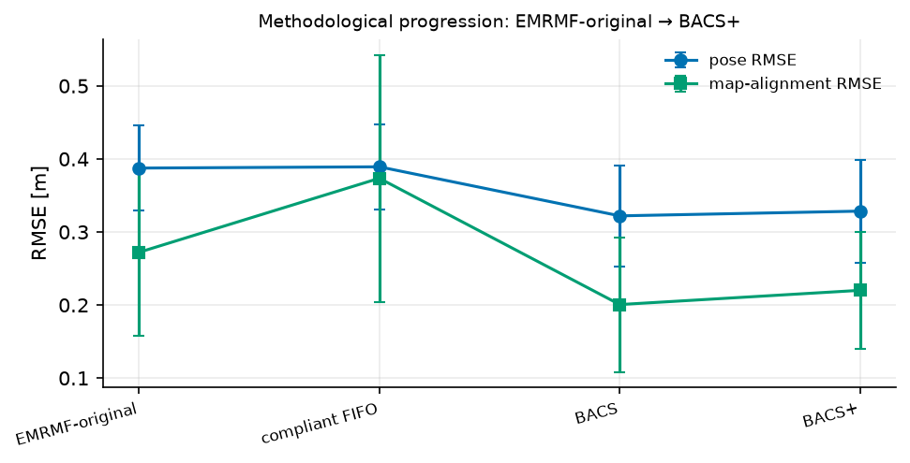
Fig. 4. Methodological progression EMRMF-original → BACS+ on both pose and map-alignment RMSE.

7. Discussion and Threats to Validity
Information-optimal ≠ RMSE-optimal, but = alignment-optimal. The central lesson is that better information-ranking (S7-C) does not translate into lower per-step pose RMSE, because RMSE is odometry-bound; it translates into lower map-alignment error, which is precisely what inter-robot constraints govern. A scheduler for trajectory accuracy would need a term tied to each robot’s own estimation geometry, not only to inter-robot information.
Scope of the observability claim. BACS+ is justified by a robust, unanimous improvement in surrogate fidelity (S7-C) and by a uniquely significant N = 5 alignment advantage; it is not claimed to beat plain BACS in a direct paired alignment test (differences there are not significant at 30 seeds). We state this plainly.
Overfitting. The observability weights were screened on the same synthetic world used for evaluation; the S7-C validation mitigates this by showing the term tracks exact information rather than a generator artifact, but hardware validation (Section 8) remains necessary.
Simulation fidelity. The pose-graph back-end stands in for g2o/GTSAM; the LoRa model is closed-form. bacs_sim/model.py is a separate communication-layer reference and is not on the path that produces any reported metric.

8. Conclusion and Future Work
Under duty-cycle regulation, the decision that governs collaborative map quality is which constraints to transmit, not how to weight them on arrival. BACS moves that decision to the transmitter; observability-aware BACS corrects the information objective so it accounts for pairwise graph structure. We report a corrected decay calibration that recovers the optimum from first principles, a corrected surrogate validation showing the observability term improves fidelity to exact information for every held-out run, and an end-to-end study showing the benefit is a large, significant reduction in map-alignment error rather than in odometry-bound pose RMSE. A reference ROS 2 node (ros2_ws/src/bacs_scheduler) wraps the identical decision functions for deployment; the hardware protocol in hardware/ specifies the physical validation — a motion-capture-referenced, ≥ 20-session comparison over a real RYLR998 link — that would confirm these findings outside simulation.

Reproducibility
All results derive from the bacs_sim package and the frozen CSVs in paper_results/:
Result | Script | Output
Progression (Table 1, Fig. 4) | experiments.progression | progression.csv
γ rules (Table 2, Fig. 3) | experiments.s9_deferral_gamma | s9_deferral_gamma.csv
Surrogate fidelity (Table 3, Fig. 1) | experiments.s7c_paired | s7c_paired.csv
S8 alignment/pose (Tables 4–5, Fig. 2) | scripts/run_s8_30seed.py | s8_30seed_{raw,summary,tests}.csv
Figures | scripts/make_figures.py | paper_figures/*.png
Pre-registered hypotheses and their outcomes are stated in Section 5; the two falsified hypotheses (H1, H3) are retained deliberately.

