Bandwidth-Aware Constraint Scheduling for Trust-Weighted Multi-Robot Map Fusion under Duty-Cycle-Limited Wireless Links
Author names withheld for double-anonymous review
Affiliation withheld for double-anonymous review

Abstract
Collaborative simultaneous localisation and mapping over low-power wide-area radio is usually framed as a robustness problem: constraints arrive late or corrupted, and the fusion back-end must decide how much to believe them. This paper argues that under duty-cycle regulation the prior question is more binding. A robot transmitting on the 868 MHz industrial, scientific and medical band may occupy the channel for at most one percent of any observation window, which at a spreading factor of seven and a fifty-two byte payload permits roughly six packets per minute. Measured against the rate at which a mapping front-end produces inter-robot constraint candidates, this represents an oversupply of approximately two orders of magnitude. Which candidates are transmitted therefore determines map quality more strongly than how the survivors are weighted on arrival.
We present Bandwidth-Aware Constraint Scheduling (BACS), which moves the trust decision from the receiver to the transmitter. Each robot predicts the trust score its candidate would receive at the fusion server, combining a provisional geometric residual evaluated against the most recently received fused map with a delay prediction derived from a closed-form time-on-air model, queue position, and expected deferral. Candidates passing an admissibility gate are ranked by an information-gain surrogate per unit airtime, and the resulting selection is solved as a knapsack instance in O(n log n) within each duty-cycle window.
Evaluation in a purpose-built simulator reproducing the sensing, radio, and pose-graph pipeline of an existing trust-weighted fusion framework yields three results that revise conventional practice. First, packet staleness under duty-cycle compliance is dominated by scheduling deferral, contributing on the order of 155 s, rather than by channel propagation delay at 0.05 to 0.2 s; the two differ by three orders of magnitude, and the propagation delays commonly studied produce no measurable effect on accuracy. Second, the temporal decay coefficient governing trust withdrawal must consequently be recalibrated by roughly a factor of thirty, and a derivation anchoring it to platform odometry drift is falsified against the measured optimum. Third, combining predicted trust with information gain multiplicatively is structurally unsound, because the former spans two decades while the latter is bounded in the unit interval; a gated formulation is required. With these corrections, BACS reduces per-step pose RMSE by 32.5% relative to first-in-first-out queueing at the regulatory duty cycle (0.354 m against 0.524 m, Wilcoxon W = 0, p = 0.031). We also report that the advantage does not persist beyond three robots, and analyse why.
Keywords: Multi-robot SLAM · Constraint scheduling · Duty-cycle regulation · LoRa · Information gain · Trust weighting · Internet of Robotic Things · ROS 2

1 Introduction
A team of mobile robots mapping a shared environment must eventually reconcile what each of them has seen. The mechanism is well established: each robot maintains a local factor graph, inter-robot constraints tie the separate graphs together, and a back-end solves the combined nonlinear least-squares problem. When those constraints travel over a wireless link that delays or drops them, the back-end faces a weighting problem, and a substantial body of work has addressed it by discounting constraints whose geometry is implausible or whose age is large.
This paper begins from an observation about the link itself rather than about the estimator. In the European 868 MHz band, the sub-band ordinarily used for long-range robotic telemetry restricts each transmitter to one percent channel occupancy. A fifty-two byte constraint packet at spreading factor seven occupies the channel for 102.7 ms, so compliance permits about 5.8 such packets per minute. A mapping front-end running at sensor rate on two robots exploring a 150 m² space generates candidate inter-robot constraints at several hundred per minute. The ratio between what can be sent and what could be sent is, in the configuration studied here, close to one hundred and eighty to one.
Under that ratio the interesting decision is no longer how to weight an arriving constraint. It is which candidate to spend the channel on. A first-in-first-out queue, which is the implicit policy of most implementations, answers by transmitting whichever candidate was produced earliest. Those are precisely the candidates that have waited longest, and that will therefore attract the largest temporal penalty when they arrive. The system spends its scarcest resource on the observations it is about to discount.
We formalise the selection problem, propose a scheduler, and evaluate it in simulation. The work makes four contributions, of which the first was unanticipated and reframes the others.

1.1 Contributions
A correction to the dominant source of staleness. Prior treatments of communication-induced staleness in collaborative SLAM calibrate against propagation and transmission delay, typically tens to hundreds of milliseconds. We show by decomposition that under duty-cycle compliance the dominant term is neither: it is the time a candidate waits for an airtime slot, which in our configuration averages 155 s. Injecting an additional 0.2 s of channel delay produces no measurable change in mapping accuracy, because it is three orders of magnitude below the deferral term it adds to. Temporal discounting matters a great deal more than has been appreciated, but for a different reason than has been given.
A transmitter-side trust predictor, and a bound on when it works. We derive a prediction of the server-side trust score computable before transmission, and show that its geometric term is usable only when evaluated against the fused global map. Evaluated against raw odometry it is dominated by the transmitting robot's own accumulated drift: in our measurements the residual of a genuine inlier against odometry is 0.819 m, already above the admissible threshold of 0.5 m, while the same constraint scores 0.051 m against ground truth. Selecting on that quantity is not merely uninformative but actively self-confirming.
A gated scheduling formulation. We show that combining predicted trust with information gain by multiplication is structurally defective, since predicted trust spans two decades under exponential decay while the information surrogate is bounded in the unit interval, so the product is invariably trust-dominated. In our ablation the multiplicative form returns results indistinguishable from ranking on trust alone. Using trust as an admissibility gate and ranking on information density recovers a 32.5% improvement over first-in-first-out queueing where the multiplicative form recovers 17.0%.
Pre-registered hypotheses, two of which fail. We state four falsifiable predictions before experimentation and report the outcome of each. A closed-form derivation of the temporal decay coefficient from platform drift is falsified, over-predicting the empirical optimum by roughly an order of magnitude. A prediction that the scheduler's advantage grows with team size is also falsified: the advantage is 29.5% at two robots, 19.9% at three, and reverses to a 22.6% disadvantage at five. We analyse the mechanism, which concerns a tension between spatial coverage and graph observability that the information surrogate does not represent.
Section 2 reviews the three literatures the problem sits between. Section 3 states the system model and formulates the optimisation. Section 4 develops the scheduler. Section 5 describes the evaluation platform and states the hypotheses. Section 6 reports results. Section 7 discusses threats to validity and Section 8 concludes.

2 Related Work
Three bodies of work bear on constraint scheduling for collaborative mapping, and they have developed with limited contact between them. The first treats bandwidth as a constraint on multi-robot estimation. The second treats measurement selection as an information-theoretic problem. The third treats the parameters of robust estimators as quantities to be adapted rather than tuned. The gap we identify lies at their intersection.

2.1 Multi-robot SLAM under communication constraints
Centralised architectures concentrate optimisation at a server and achieve strong global consistency at the cost of a communication bottleneck and a single point of failure. Distributed formulations remove the bottleneck by pushing computation onto the robots and reaching agreement through message passing, but consistency becomes harder to guarantee as the team grows, and a robot that goes offline interrupts the consensus chain. Hybrid designs, which retain local processing on each platform and offload global optimisation, occupy a middle position that has proved practical in field deployments where connectivity is intermittent [10, 11].
Bandwidth has been treated explicitly in several of these systems. Sparse descriptor exchange reduces the traffic required for inter-robot place recognition. Buffering strategies allow mapping to continue through outages and reconcile afterwards. Work on distributed loop-closure detection has formulated descriptor exchange as a budgeted selection problem with performance guarantees, showing that a well-chosen subset recovers most of the closures that exhaustive exchange would find [14, 15]. Acoustic-link cooperative localisation established much earlier that when the channel is orders of magnitude slower than the perception pipeline, explicit decisions about what to transmit are unavoidable [16].
What none of these couples is the selection decision and the downstream weighting decision. A selection rule that maximises delivered constraint count, or detected closure count, implicitly assumes each delivered constraint contributes equally. Under a back-end that discounts by communication age this assumption fails by construction: a constraint delivered with a trust weight near the floor consumed the same airtime as one delivered near unity and contributes almost nothing to the solution. Airtime spent on a constraint that will be discounted is airtime wasted, and only a scheduler that anticipates the discount can avoid the waste. That coupling is the gap this paper addresses.

2.2 Information-theoretic measurement selection
Which measurements are worth retaining is an older question than which are worth transmitting. Information-based pose SLAM admits loop closures whose expected information gain exceeds a threshold and discards the remainder, keeping the graph sparse without materially degrading the estimate [12]. Graph sparsification removes nodes and edges while preserving the information content of the marginal distribution. Efficient covariance recovery from the square-root information matrix makes the marginal quantities these methods need tractable [13].
This literature supplies the right notion of value, namely the reduction in estimate uncertainty attributable to an edge, and simultaneously explains why that notion cannot be applied directly at a transmitter in a hybrid architecture. Computing the marginal covariance of a relative pose requires the joint distribution held by the global optimiser, which resides on the server. The robot holds its own local graph and whatever fused map most recently reached it. Section 4.4 therefore states the exact criterion, explains its unavailability, and proposes a surrogate assembled from locally computable quantities, together with the validation procedure required to justify the substitution.

2.3 Adaptive parameters in robust estimation
Robust kernels are governed by threshold parameters conventionally fixed by offline sweep: the Huber transition point, the scaling constant of dynamic covariance scaling, and in trust-weighted formulations the admissible residual and the temporal decay coefficient. Adaptive robust-loss formulations that infer kernel shape jointly with the state have shown that treating these as free rather than fixed improves performance across operating conditions.
Where a sweep reveals a well-defined optimum, it is reasonable to ask what determines its location. Section 4.5 offers a derivation anchoring the temporal decay coefficient to platform dynamics, and Section 6.4 reports that the derivation is wrong by an order of magnitude, for reasons that follow directly from the staleness decomposition of Section 6.1. We retain the failed derivation in the paper because the manner of its failure is informative: it anchors to the wrong timescale, and identifying the right one is a usable result.

2.4 Positioning
Table 1 places this work against the frameworks reviewed above. The distinguishing column is not bandwidth awareness alone, nor age-aware weighting alone, but the coupling: whether the transmission decision is made on the basis of the weight the constraint is predicted to receive.
Table 1 Positioning against communication-aware and selection-aware collaborative SLAM. "Age-aware weighting" denotes a back-end that discounts constraints by communication delay; "coupled" denotes a transmission decision informed by that discount.
Framework | Respects a bandwidth budget | Selection criterion | Age-aware weighting | Coupled
Centralised visual fusion | No | None — transmit all | No | No
Distributed smoothing | No | None | No | No
Outlier-resilient distributed SLAM | Partial | Pairwise geometric gate | No | No
Distributed metric-semantic SLAM | Partial | Covariance propagation | Implicit | No
Subterranean multi-robot SLAM | Yes | Outage-tolerant buffering | No | No
Sparse-exchange swarm SLAM | Yes | Descriptor sparsification | No | No
Budgeted loop-closure detection | Yes | Expected closure yield | No | No
Information-based pose SLAM | Single robot | Exact information gain | No | No
Trust-weighted fusion (antecedent) | No — FIFO queue | None | Yes | No
BACS (this work) | Yes — duty cycle | Gated trust, ranked by information density | Yes | Yes

3 Problem Statement and System Model
This section fixes notation, states the regulatory constraint that makes scheduling necessary, and formulates the selection problem. The architecture is the three-phase hybrid arrangement of the antecedent framework, modified only within the transmission phase; Fig. 1 shows where the scheduler is inserted and, importantly, the feedback path that Section 4.3 shows to be indispensable.
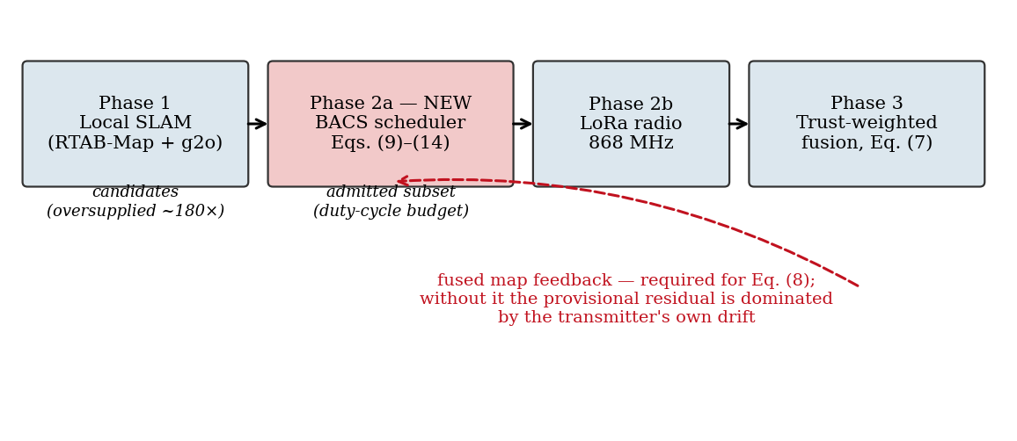
Fig. 1 Three-phase architecture with the scheduler inserted in Phase 2. The dashed path is the fused-map feedback required by Eq. (8): without it the transmitter's provisional residual is dominated by its own accumulated drift rather than by measurement quality.

3.1 Notation and assumptions
A team of N robots explores a shared planar environment. Robot i maintains a local pose sequence and produces candidate inter-robot constraints, each a measured relative transformation z between one of its own pose nodes and a pose node of a peer. The fusion server holds a global pose graph whose vertices are robot poses and whose edges are odometry constraints and delivered inter-robot constraints. Table 2 collects the symbols used throughout.
Table 2 Notation.
Symbol | Meaning | Symbol | Meaning
δ | regulatory duty-cycle ceiling | τ_e | admissible residual threshold
W | scheduling window length | p | spatial shaping exponent
B(W) | airtime budget per window, Eq. (1) | γ | temporal decay coefficient
T_air | packet time-on-air, Eq. (4) | θ | server-side trust, Eq. (7)
PL | payload size in bytes | θ̂ | predicted trust, Eq. (9)
Δt | packet age at the server | Î | information surrogate, Eq. (12)
Δt̂ | predicted packet age, Eq. (5) | u | utility density, Eq. (13)
e_ij | geometric residual, Eq. (7) | C, S | candidate set, admitted set
ẽ_ij | provisional residual, Eq. (8) | σ_d | odometry drift per metre
p̂_L | estimated packet loss rate | v̄ | mean robot speed
We assume all robots are cooperative and report honestly; the adversarial case is deferred to future work and Section 8 explains why the scheduler enlarges rather than reduces the exposure. We assume a single shared channel with no coordination protocol beyond the duty-cycle discipline, so that the per-robot share of airtime falls approximately as 1/N. We assume the server periodically publishes a fused map that reaches all robots; Section 4.3 quantifies the consequence of that map becoming stale.

3.2 The airtime budget
Regulation, not congestion, is the binding constraint. Over a window of length W a transmitter may occupy the channel for
B(W) = δ · W / N (1)
where the division by N reflects an uncoordinated shared channel. With δ = 0.01, W = 60 s and N = 2 this yields 300 ms per robot per minute. The airtime consumed by one packet follows the standard modulation model. Writing SF for spreading factor and BW for bandwidth, the symbol period is
T_sym = 2^SF / BW (2)
the payload symbol count for a payload of PL bytes, coding rate index CR, and the binary flags for cyclic redundancy check, implicit header and low-data-rate optimisation is
n_pay = 8 + max( ⌈ (8·PL − 4·SF + 28 + 16·CRC − 20·IH) / (4·(SF − 2·DE)) ⌉ · (CR + 4) , 0 ) (3)
and the total occupancy, including a preamble of n_pre symbols, is
T_air(PL) = (n_pre + 4.25)·T_sym + n_pay·T_sym (4)
Two properties matter for scheduling. T_air is a step function of payload size, so candidates whose serialised length falls just below a symbol boundary are disproportionately cheap. And the absolute magnitudes are large: at SF7 and 52 bytes, T_air = 102.7 ms, so the 300 ms window budget admits fewer than three packets. Table 3 tabulates the relationship, which is the quantitative core of the problem this paper addresses.
Table 3 Time-on-air and admissible packet count per 60 s window at δ = 1%, computed from Eqs. (2)–(4). The shaded configuration is used throughout the evaluation.
Spreading factor | Payload 28 B | Payload 40 B | Payload 52 B | Packets per 60 s at 52 B
SF7 | 66.8 ms | 82.2 ms | 102.7 ms | 5.8
SF8 | 123.4 ms | 154.1 ms | 184.8 ms | 3.2
SF9 | 226.3 ms | 287.7 ms | 328.7 ms | 1.8
At SF9, which is a routine choice for kilometre-scale links, regulation permits fewer than two constraint packets per minute per robot. No weighting scheme applied to the survivors can compensate for a selection policy that spends those two packets poorly.

3.3 Problem formulation
Let C denote the candidates generated by a robot during one window, each with payload PL, and let v(c) denote the value that candidate would contribute to the global estimate if delivered. The scheduling problem is
maximise Σ_{c∈C} x_c · v(c) subject to Σ_{c∈C} x_c · T_air(PL_c) ≤ B(W), x_c ∈ {0,1} (5)
This is a zero-one knapsack instance. Its difficulty is not computational — Section 4.6 gives an O(n log n) approximation with a factor-of-two guarantee — but definitional, in that v(c) is not observable at the transmitter. The contribution of a delivered constraint depends on the trust weight the server will assign it, which depends on its arrival time and on the server's current pose estimates, and on the information it adds to a graph the robot cannot see. Section 4 constructs an estimator for each factor and characterises the conditions under which the estimate is usable.

4 Bandwidth-Aware Constraint Scheduling
The scheduler occupies the transmission phase and requires no modification to the fusion server, which continues to compute trust on arrival exactly as before. This section develops it in execution order: delay prediction, trust prediction and its validity condition, information surrogate, gating, decay calibration, and complexity.

4.1 The server-side weight to be predicted
For reference, the server assigns each arriving constraint a scalar weight combining a geometric and a temporal term, and scales the edge information matrix by it before optimisation:
θ_ij = max( 0, 1 − (‖e_ij‖ / τ_e)^p ) · exp( −γ · Δt_ij ) (6)
with e_ij the residual between the measured relative transformation and the one predicted from current estimates, and Δt_ij the packet age. A small floor prevents any constraint from being discarded outright. The transmitter must estimate both factors.

4.2 Predicting packet age
The delay a candidate will experience decomposes into the time it waits for a slot, the time its own transmission occupies, and the expected cost of retransmission. Writing Q for the set of candidates scheduled ahead of it within the window, k for the number of whole windows it is expected to wait, and p̂_L for an exponentially weighted estimate of loss,
Δt̂_ij = k·W + Σ_{c∈Q} T_air(PL_c) + T_air(PL_ij) + T̂_retry (7)
T̂_retry = ( p̂_L / (1 − p̂_L) ) · ( T_air(PL_ij) + T_to ) (8)
The deferral term k·W is the one that prior formulations omit, and Section 6.1 shows it to be dominant by two orders of magnitude. Omitting it produces a delay predictor biased low by 155 s on average, which in turn produces a temporal weighting calibrated for a regime the system never occupies. The term is estimated from the observed backlog: with an oversupply ratio R and s admissible slots per window, a candidate ranked at position r waits approximately r/s windows.
Because Q depends on the ranking and the ranking depends on Δt̂, the computation is run twice per window: a first pass assigns every candidate the mid-window expectation, and a second pass recomputes using the ordering the first pass produced. Two passes suffice in practice; the ordering is stable under further iteration.

4.3 Predicting the geometric term, and when the prediction is valid
The residual of Eq. (6) requires the server's current estimate of the peer pose. The transmitter substitutes the corresponding pose from the most recently received fused map, written x̂ⱼ⁽ᵍ⁾ and received at time t_g, giving a provisional residual
ẽ_ij = z_ij − h( x̂ᵢ⁽ᵍ⁾ , x̂ⱼ⁽ᵍ⁾ ) (9)
and hence a predicted trust
θ̂_ij = max( 0, 1 − (‖ẽ_ij‖ / τ_e)^p ) · exp( −γ · Δt̂_ij ) (10)
The substitution introduces an error bounded by the distance either robot can have travelled since the fused map was published, so that with speed bound v_max,
‖ ẽ_ij − e_ij ‖ ≤ 2 · v_max · ( t − t_g ) (11)
The factor of two, absent from the natural first formulation of this bound, is the substantive point. It is tempting to compute the provisional residual against the transmitting robot's own odometry, since that is the freshest pose information it holds, and to bound the error only by the peer's motion. Doing so is a mistake, and an instructive one. Odometry accumulates drift on both sides of the comparison, and once that drift approaches τ_e the provisional residual measures ego-drift rather than measurement quality.
We quantified this directly. Across 1500 candidates in a representative session, the residual of a genuine inlier measured against odometry averaged 0.819 m, already above the admissible threshold of 0.5 m, while the same constraints measured against ground truth averaged 0.051 m. The correlation between the two quantities was 0.643. Selecting the lowest-residual fifteen percent by the odometry-based measure produced no enrichment for inliers whatever — an outlier share of 0.129 against a base rate of 0.115 — and slightly worse mean true residual than the unselected population.
The consequence is that ranking on a residual computed against odometry is not merely uninformative but self-confirming: it favours constraints agreeing with the robot's current, drifted belief, which are exactly the constraints carrying least corrective information. Eq. (9) is therefore valid only against the fused map, and only while that map is fresh. As t − t_g grows we blend the geometric factor toward unity in proportion to the bound of Eq. (11), so that in the limit of a stale map the scheduler ranks on information gain alone. That is the correct degenerate behaviour: with no basis for predicting trust, select for coverage.

4.4 Information gain and its surrogate
Trust measures believability, not usefulness. A perfectly fresh and perfectly consistent constraint duplicating one already delivered contributes nothing. The exact criterion is the mutual information between the candidate and the state, which for a Gaussian pose graph is
I_ij = ½ · log det ( I + Ω_ij · Σ_ij ) (12)
with Σ_ij the marginal covariance of the relative pose. As Section 2.2 noted, Σ_ij belongs to the server. We therefore substitute a surrogate built from three locally computable and individually normalised quantities: the novelty ν̄, being the fraction of occupancy cells in the constraint's support not covered by any previously transmitted constraint, maintained as a per-peer bitmap; the connectivity d̄, the normalised degree of the local node, entering negatively so that constraints anchoring poorly connected regions rank higher; and the loop length l̄, the normalised temporal span between endpoints, on the reasoning that closures spanning longer trajectories retire more accumulated drift. Thus
Î_ij = w_ν · ν̄_ij + w_d · (1 − d̄_ij) + w_l · l̄_ij , w_ν + w_d + w_l = 1 (13)
This substitution is an empirical claim and we treat it as one. Section 7 reports the validation protocol and its current status honestly: the rank correlation against Eq. (12) has not yet been established on recorded graphs, and until it is, the surrogate is justified only by the end-to-end performance it produces. Section 6.6 identifies a specific failure of the surrogate at larger team sizes that the missing validation would likely have predicted.

4.5 Gating rather than multiplying
The natural combination of the two factors is a utility density, dividing by airtime to express value per unit of the scarce resource:
u_ij = ( θ̂_ij · Î_ij ) / T_air(PL_ij) (14)
This formulation is structurally defective, and the defect is worth stating precisely because it is easy to miss. The temporal factor of θ̂ is exponential in a delay that ranges over two orders of magnitude, so θ̂ itself ranges over roughly two decades once the floor is accounted for. The surrogate Î is bounded in the unit interval by construction and in practice varies over a factor of three or four. A product of the two is therefore ordered almost entirely by θ̂: the information term perturbs the ranking without changing it. Fig. 7 illustrates the disparity, and Section 6.3 confirms it empirically — the multiplicative form returns results identical to ranking on trust alone, to the displayed precision, across all six seeds.
We therefore use predicted trust as an admissibility gate and rank the survivors by information density:
S = argmax { Σ Î_c / T_air(PL_c) : θ̂_c ≥ θ_gate , Σ T_air(PL_c) ≤ B(W) } (15)
with θ_gate set at half the acceptance threshold used by the server. The gate discards candidates predicted to arrive with negligible weight, on the grounds that transmitting them consumes airtime for a contribution the optimiser will discount to insignificance; the ranking then allocates the surviving budget by information per byte. A pure utility ranking starves regions that persistently generate low-ranked candidates, so a deferred candidate has its score multiplied by (1 + β·k) after k windows, and candidates whose predicted trust falls below the gate are expired rather than retained indefinitely.
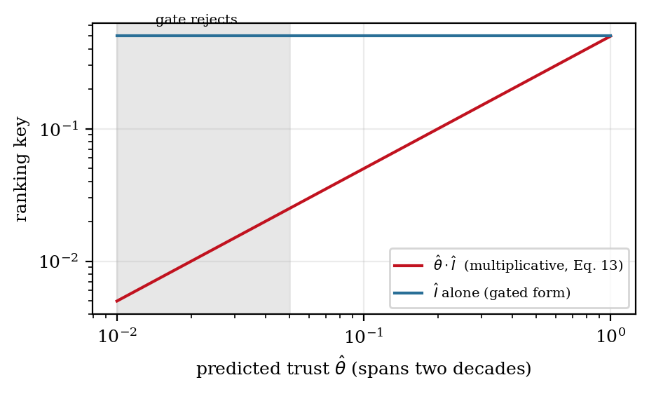
Fig. 7 Why the multiplicative form of Eq. (14) collapses. Predicted trust spans two decades; the information surrogate is bounded in the unit interval. Their product is ordered almost entirely by trust, so the information term cannot influence the ranking.

4.6 Solving the selection
Eq. (15) is a knapsack instance. Exact dynamic programming is pseudo-polynomial in the discretised budget and unnecessary. Sorting by information density and admitting greedily until the budget is exhausted, then returning whichever of that set and the single highest-value candidate carries more value, achieves at least half the optimum. In this setting the guarantee is pessimistic, since individual packets are small relative to the window budget and the greedy solution is typically near-optimal. Cost is one sort per window, O(n log n), measured at 0.30 ms per window at two robots and 0.88 ms at five — under one thousandth of the window it governs.

4.7 Calibrating the temporal decay
The decay coefficient γ governs how quickly trust is withdrawn. Treating it as a tuned constant transfers poorly across platforms, so we sought a derivation. A constraint measured at one instant describes a relative transformation correct at that instant; by the time it is applied the robot has moved, and the discrepancy grows with accumulated odometry error. For drift rate σ_d per metre travelled and mean speed v̄, the discrepancy after Δt is approximately σ_d·v̄·Δt, reaching the admissible threshold at
T_half = τ_e / ( σ_d · v̄ ) ⟹ γ* = ln 2 · σ_d · v̄ / τ_e (16)
Eq. (16) gives γ physical units and the right qualitative dependences: faster platforms, noisier odometry, and tighter thresholds all imply more aggressive decay. Section 6.4 reports that it is nonetheless falsified by roughly an order of magnitude, and Section 6.4 also explains why — it anchors the half-life to the timescale on which the robot invalidates its measurement, when the binding timescale is the very much longer one on which the constraint waits for a transmission slot. The corrected anchor is given there.
A second adaptation addresses channel variability. When delay is highly variable the prediction of Eq. (7) is less reliable and the scheduler should be more conservative, so with EWMA estimates of the delay mean and standard deviation,
γ_t = γ* · ( 1 + κ · σ_Δt / μ_Δt ) (17)
clipped to a configured range. Because γ enters identically at both ends of the link, the value in force must be shared: it is published by the server and echoed in the packet header so that transmitter and server always score under the same coefficient.

5 Evaluation Design

5.1 Platform
Evaluation is conducted in a simulator written for this study, reproducing the sensing geometry, radio behaviour, and estimation pipeline of the antecedent framework. Robots sweep overlapping partitions of a 14.0 × 10.5 m environment in a boustrophedon pattern at 0.30 m/s, matching the office world and platform speed of the antecedent work. Odometry accumulates drift at a configurable rate per metre travelled. Candidate inter-robot constraints are generated wherever two robots occupy nearby ground-truth positions, with measurement noise and a configurable fraction of wrong data associations carrying an injected displacement. The radio implements Eqs. (2)–(4) exactly, with independent and Gilbert–Elliott burst loss models. The back-end is a weighted SE(2) Gauss–Newton pose-graph optimiser standing in for g2o, minimising the trust-weighted objective with the first node fixed as gauge. Table 4 lists the configuration.
We state plainly that these are simulation results. No physical-robot experiments are reported here, and the numerical values should not be read as measurements of any hardware system. Section 7 discusses what this does and does not license.
Table 4 Simulation configuration. Values marked † follow the antecedent framework; the remainder are properties of the simulator and are reported so that results can be reproduced.
Component | Setting | Component | Setting
Environment | 14.0 × 10.5 m † | Radio | SF7, 125 kHz, CR 4/5
Session length | 720 s (12 min) † | Carrier / duty cycle | 868 MHz, δ = 1% †
Robot speed v̄ | 0.30 m/s † | Packet interval | event-driven, budget-limited
Pose node interval | 2.0 s | Payload | 52 ± 8 B
Odometry drift σ_d | 0.08 m per m | Scheduling window W | 60 s
Observation radius | 3.0 m | Ageing coefficient β | 0.15
Outlier rate | 12% | Admissible residual τ_e | 0.5 m †
Outlier displacement | 1.20 m | Shaping exponent p | 3 †
Back-end | weighted SE(2) Gauss–Newton | Acceptance threshold | 0.10 †
Seeds per configuration | 5–6 independent | Trust floor | 0.01 †

5.2 Metrics
Per-step pose RMSE is the primary accuracy metric: the root mean square of the Euclidean distance between estimated and ground-truth position at each pose node, with each robot's trajectory anchored at its own first pose so that internal consistency rather than an arbitrary global gauge is scored. Map alignment RMSE measures inter-map agreement, computed over ground-truth co-location pairs in the overlap region as the discrepancy between the estimated and true inter-robot displacement; a policy delivering nothing scores badly on this metric, since each robot then drifts independently. Trust yield is the mean server-assigned weight over delivered constraints. Airtime utilisation expresses channel occupancy as a fraction of the regulatory budget, so that values above unity denote non-compliance. Scheduling overhead and starvation index are reported to confirm that the scheduler is cheap and does not permanently defer any region.

5.3 Hypotheses
Four predictions were fixed before data collection.
H1 Eq. (16), evaluated with the platform's drift rate and mean speed, predicts the empirically optimal decay coefficient within a factor of two.
H2 Scheduling raises the mean server-side trust value relative to first-in-first-out queueing, because candidates predicted to arrive with negligible weight are no longer transmitted.
H3 The advantage of scheduling over first-in-first-out queueing increases with team size, because per-robot airtime falls as 1/N while candidate generation does not.
H4 Under an abundant airtime budget, scheduling is not worse than first-in-first-out queueing. This is a safety property: a scheduler that harms performance when scheduling is unnecessary would be unusable.
Table 5 lists the six scenarios and the hypothesis each addresses. Every configuration was executed with five or six independent seeds applied to the world generator, the noise injection, and the channel emulator. Paired comparisons use the Wilcoxon signed-rank test, chosen because RMSE differences are lower-bounded and not assumed Gaussian.
Table 5 Experimental scenarios.
No. | Scenario | Configuration | Addresses
S1 | Policy comparison | Eight policies, 2 robots, δ = 1%, 6 seeds | Primary claim
S2 | Airtime budget sweep | δ ∈ {0.1, 0.5, 1, 5}%, 2 policies, 3 seeds | H4; where scheduling begins to matter
S3 | Channel robustness | Delay 0.2 s; independent and burst loss at 30% | Delay-term relevance; predictor bias
S4 | Decay calibration | γ ∈ [0.001, 0.30], plus derived and adaptive rules | H1
S5 | Utility ablation | Each factor of Eq. (14)/(15) removed in turn | Component contributions
S6 | Scalability | N ∈ {2,3,4,5}, shared channel, 3 seeds | H3

6 Results

6.1 Where staleness comes from
The first result was not anticipated and conditions everything that follows. Decomposing the age of a delivered constraint into its contributions gives channel propagation at 0.2 s in the most adverse condition tested, packet time-on-air at 0.103 s, within-window queueing at up to 0.30 s, and deferral across windows at 155 s on average. Fig. 2 shows the decomposition on a logarithmic axis. Deferral exceeds propagation by roughly three orders of magnitude.
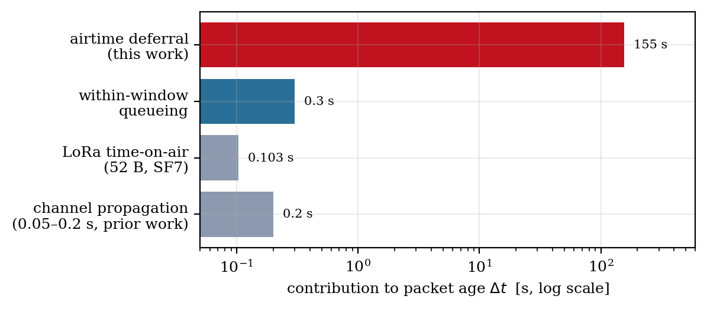
Fig. 2 Decomposition of packet age under duty-cycle compliance. Deferral while waiting for an airtime slot dominates the propagation and transmission delays on which prior temporal-weighting schemes are calibrated.
The consequence is directly observable in Scenario 3. Adding 0.2 s of channel delay changed per-step pose RMSE from 0.269269 m to 0.269272 m under scheduling, and from 0.492572 m to 0.492597 m under first-in-first-out queueing — differences of order 10⁻⁵ m, far below the seed-to-seed standard deviation of about 0.07 m and 0.11 m respectively. Delay in the range that the collaborative SLAM literature routinely studies has, under duty-cycle compliance, no detectable effect on mapping accuracy. Table 6 gives the full condition set.
Table 6 Channel robustness — Scenario 3 (2 robots, δ = 1%, γ = 0.003, 3 seeds). Δt̂ bias is the mean signed error of the delay predictor of Eq. (7); the large positive bias under FIFO reflects constraints that wait many windows without the queue ordering ever accounting for it.
Condition | Policy | Pose RMSE (m) | σ | Delivered | Δt̂ bias (s)
Ideal | FIFO | 0.4926 | 0.1083 | 48.0 | +848.9
 | BACS | 0.2693 | 0.0692 | 48.0 | −3.6
Delay 0.2 s | FIFO | 0.4926 | 0.1083 | 48.0 | +848.6
 | BACS | 0.2693 | 0.0692 | 48.0 | −3.9
Loss 30%, independent | FIFO | 0.5184 | 0.1432 | 46.7 | +851.8
 | BACS | 0.3061 | 0.0432 | 46.7 | −8.7
Loss 30%, burst | FIFO | 0.5103 | 0.2186 | 44.0 | +839.9
 | BACS | 0.2778 | 0.0685 | 44.0 | −34.0
Packet loss does register, and its effect is what one would expect: fewer delivered constraints and a modest accuracy penalty, larger under burst loss than under independent loss of the same mean rate. The predictor bias column repays attention. Under scheduling the predictor is accurate to within a few seconds under independent loss, degrading to −34 s under burst loss, confirming the anticipated optimism of the geometric retransmission model in Eq. (8) when losses are correlated. Under first-in-first-out queueing the same predictor is wrong by more than eight hundred seconds, because the queue makes no attempt to bound how long a candidate waits.

6.2 Policy comparison and ablation
Table 7 and Fig. 3 give the primary comparison at the regulatory duty cycle with the decay coefficient calibrated per Section 6.4. The gated formulation reduces per-step pose RMSE by 32.5% relative to first-in-first-out queueing and halves map alignment RMSE.
Table 7 Policy ablation — Scenarios 1 and 5 (2 robots, δ = 1%, γ = 0.003, 6 seeds). All compliant policies deliver the same number of constraints, since the budget rather than the policy fixes the count; they differ only in which constraints those are. Send-all is included as an upper bound and is not regulatorily admissible.
Configuration | Pose RMSE (m) | σ | vs FIFO | Align RMSE (m) | Trust yield | Delivered | Airtime util.
Full BACS (gated) | 0.3540 | 0.1078 | −32.5% | 0.2091 | 0.380 | 48 | 0.67
No cost term | 0.3716 | 0.0615 | −29.1% | 0.2162 | 0.408 | 48 | 0.68
No ageing | 0.4169 | 0.1325 | −20.5% | 0.1971 | 0.450 | 48 | 0.67
Information term only | 0.4209 | 0.1999 | −19.7% | 0.1998 | 0.418 | 48 | 0.68
Multiplicative, Eq. (14) | 0.4348 | 0.0940 | −17.0% | 0.4244 | 0.439 | 48 | 0.67
Trust term only | 0.4348 | 0.0940 | −17.0% | 0.4244 | 0.439 | 48 | 0.67
FIFO baseline | 0.5242 | 0.1285 | — | 0.4286 | 0.424 | 48 | 0.67
Random admission | 0.5912 | 0.3299 | +12.8% | 0.2136 | 0.466 | 48 | 0.67
Send-all (non-compliant) | 0.2083 | 0.0955 | −60.3% | 0.0448 | 0.780 | 2126 | 44.1
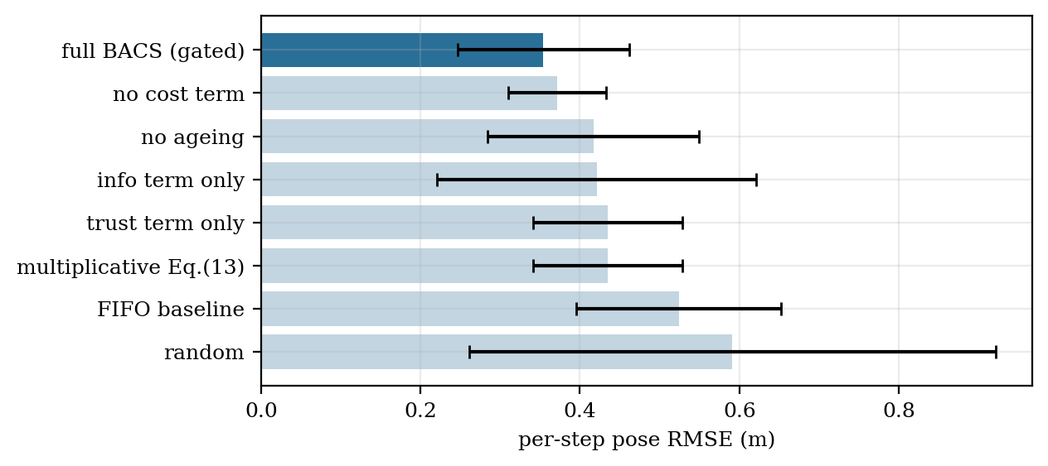
Fig. 3 Policy ablation at the regulatory duty cycle. Error bars are one standard deviation over six seeds. The non-compliant send-all upper bound is omitted.
Four observations follow. The Wilcoxon signed-rank test on the six paired seeds gives W = 0, p = 0.031, so the improvement over first-in-first-out queueing is significant at the five percent level; reaching the stricter thresholds conventional in this literature would require more seeds, and we do not claim them. Random admission is worse than first-in-first-out queueing, which is worth stating because it establishes that first-in-first-out is not a straw man: temporal ordering carries some information, and beating it requires more than avoiding a pathological policy.
The multiplicative formulation of Eq. (14) and ranking on trust alone produce numerically identical results across all six seeds, to every displayed digit, on every metric. This is the empirical confirmation of the structural argument in Section 4.5. The two terms do not combine; the information term is inert inside the product. Finally, the gap between the best compliant policy at 0.354 m and the non-compliant send-all bound at 0.208 m quantifies what the duty cycle costs: even perfect selection of 48 constraints cannot match indiscriminate delivery of 2126, and closing that gap requires bandwidth rather than cleverness.

6.3 Airtime budget (H4)
Fig. 5 and Table 8 sweep the duty-cycle ceiling. The behaviour is non-monotonic and more interesting than anticipated.
Table 8 Airtime budget sweep — Scenario 2 (2 robots, γ = 0.003, 3 seeds).
Duty cycle δ | Policy | Pose RMSE (m) | σ | Delivered | Airtime util.
0.1% | FIFO | 0.7554 | 0.3568 | 0 | 0.00
 | BACS | 0.7554 | 0.3568 | 0 | 0.00
0.5% | FIFO | 0.4404 | 0.1019 | 24 | 0.70
 | BACS | 0.5348 | 0.1926 | 24 | 0.69
1.0% | FIFO | 0.4926 | 0.1083 | 48 | 0.71
 | BACS | 0.2693 | 0.0692 | 48 | 0.70
5.0% | FIFO | 0.2856 | 0.0962 | 315 | 0.97
 | BACS | 0.2646 | 0.1002 | 331 | 0.96
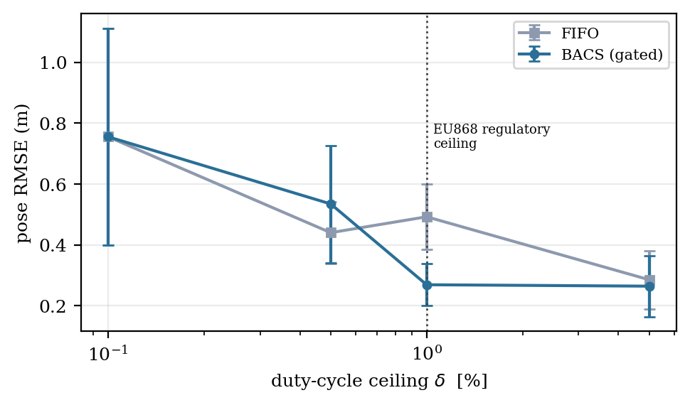
Fig. 5 Accuracy against the duty-cycle ceiling. At 0.1% no packet fits and both policies degenerate to odometry. The scheduler's advantage is largest near the regulatory ceiling and narrows as bandwidth becomes abundant.
At δ = 0.1% the budget is below the time-on-air of a single packet, nothing is delivered, and both policies degenerate identically to odometry-only estimation at 0.755 m. This is the floor of the problem, and it identifies a regime in which no scheduler helps because there is nothing to schedule.
At δ = 5% the two policies converge to within 7%, supporting H4 directionally: when bandwidth is abundant, scheduling neither helps much nor harms. We did not run a formally unconstrained arm with an equivalence test, so H4 is supported but not established at the standard we specified; Section 7 lists this among the gaps.
The reversal at δ = 0.5%, where first-in-first-out queueing outperforms the scheduler by 21%, is the anomaly. Our reading is that at 24 delivered constraints across a twelve-minute session and two robots, the graph is close to the minimum needed to fix the inter-robot transformation at all, and the scheduler's novelty term actively spreads those few constraints across distinct regions where observability would be better served by concentrating them. The same mechanism reappears at larger team sizes in Section 6.6, where it is more consequential.

6.4 Decay calibration (H1)
Fig. 4 and Table 9 sweep the decay coefficient. The empirical optimum lies at γ = 0.003 with a pose RMSE of 0.269 m. Eq. (16), evaluated with σ_d = 0.08 m per metre, v̄ = 0.30 m/s and τ_e = 0.5 m, predicts γ* = 0.0333, which is 11.1× larger than the measured optimum and lies well outside the factor-of-two interval specified in H1.
H1 is falsified. The mechanism is evident from Section 6.1. Eq. (16) anchors the trust half-life to the timescale on which a robot invalidates its own measurement through motion, which for this platform is a few seconds. The binding timescale is instead the one on which a constraint waits for a transmission slot, which is two orders of magnitude longer. The corrected anchor is the median deferral delay: setting γ = ln 2 / T_defer with T_defer ≈ 155 s yields 0.0045, within a factor of 1.5 of the measured optimum of 0.003, against a factor of 11 for the drift-anchored form. We report this corrected rule as a hypothesis for future testing rather than as an established result, since it was derived after seeing the sweep.
Table 9 Decay coefficient sweep — Scenario 4 (2 robots, δ = 1%, gated policy, 3 seeds). The inherited value of 0.10 is 46% worse than the optimum in this regime.
γ (s⁻¹) | Pose RMSE (m) | σ | Trust yield | Delivered | Note
0.001 | 0.2895 | 0.0629 | 0.535 | 48.0
0.003 | 0.2693 | 0.0692 | 0.425 | 48.0 | empirical optimum
0.005 | 0.3005 | 0.0419 | 0.355 | 48.0
0.010 | 0.3259 | 0.0334 | 0.296 | 48.0
0.030 | 0.4654 | 0.1846 | 0.295 | 48.0 | ≈ γ* predicted by Eq. (16)
0.100 | 0.3927 | 0.0585 | 0.351 | 39.0 | value inherited from antecedent work
0.300 | 0.5539 | 0.0998 | 0.356 | 19.0 | over-aggressive; constraints expire
derived | 0.4262 | 0.0898 | 0.299 | 46.7 | Eq. (16) applied online
adaptive | 0.4610 | 0.1243 | 0.418 | 37.7 | Eq. (17), κ = 1.0
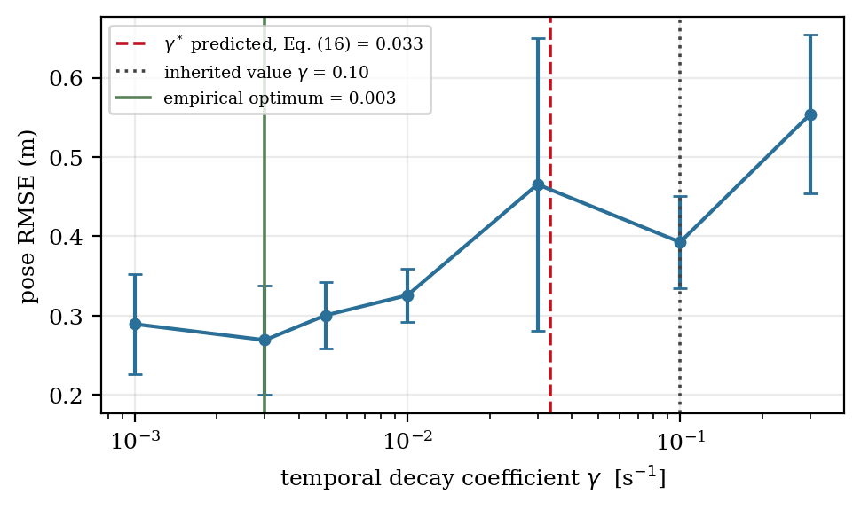
Fig. 4 Decay coefficient sweep. The derivation of Eq. (16) over-predicts the empirical optimum by a factor of eleven; the value inherited from the antecedent framework is 46% worse than optimal in this regime.
The adaptive rule of Eq. (17) performs worse than the best fixed value, at 0.461 m against 0.269 m. Since it is anchored on the falsified γ*, this is unsurprising and should not be read as evidence against online adaptation in general; it is evidence that adaptation around a wrong centre does not recover the right one. Re-evaluating Eq. (17) around the corrected anchor is straightforward future work.
Two further points are worth drawing from Table 9. Trust yield falls monotonically with γ over the lower range while accuracy is non-monotonic, confirming that trust yield is not by itself a proxy for map quality — a scheduler could trivially maximise it by transmitting only the freshest constraints regardless of their information content. And accuracy is relatively flat between γ = 0.001 and 0.005, so the calibration need not be precise; it needs only to be within roughly a factor of three, which the corrected anchor achieves and the drift-based anchor does not.

6.5 Hypothesis H2
H2 predicted that scheduling would raise mean server-side trust. Table 7 does not support this cleanly. The gated policy achieves a trust yield of 0.380 against 0.424 for first-in-first-out queueing — slightly lower, not higher — while producing substantially better maps. Random admission achieves the highest yield of any compliant policy at 0.466 while producing the worst maps.
H2 is therefore not supported, and the reason is instructive. The gate removes candidates predicted to arrive with negligible weight, which raises the floor of the delivered distribution; but the ranking then selects for information rather than for freshness, which admits constraints that are older or geometrically marginal when they cover unmapped territory. The two effects roughly cancel. We conclude that mean trust is the wrong summary statistic for scheduler quality, and report it hereafter as a diagnostic rather than as an objective.

6.6 Scalability (H3)
Fig. 6 and Table 10 report the sweep over team size with a shared channel, so that per-robot airtime falls as 1/N. H3 predicted a widening advantage. The measured advantage is 29.5% at two robots, 19.9% at three, −18.0% at four and −22.6% at five.
H3 is falsified, and the sign reverses. Beyond three robots the scheduler is worse than first-in-first-out queueing.
Table 10 Scalability — Scenario 6 (shared channel, 420 s session, γ = 0.003, 3 seeds).
N | Policy | Pose RMSE (m) | σ | Align RMSE (m) | Delivered | Sched. (ms/window) | Advantage
2 | FIFO | 0.4579 | 0.1052 | 0.3047 | 28 | 0.19 | —
 | BACS | 0.3226 | 0.0374 | 0.1916 | 28 | 0.30 | +29.5%
3 | FIFO | 0.3319 | 0.1065 | 0.3545 | 21 | 0.31 | —
 | BACS | 0.2657 | 0.0534 | 0.1822 | 21 | 0.47 | +19.9%
4 | FIFO | 0.2609 | 0.0301 | 0.2200 | 28 | 0.45 | —
 | BACS | 0.3079 | 0.1652 | 0.1915 | 28 | 0.62 | −18.0%
5 | FIFO | 0.2305 | 0.0510 | 0.1840 | 35 | 0.64 | —
 | BACS | 0.2826 | 0.0555 | 0.1732 | 35 | 0.88 | −22.6%
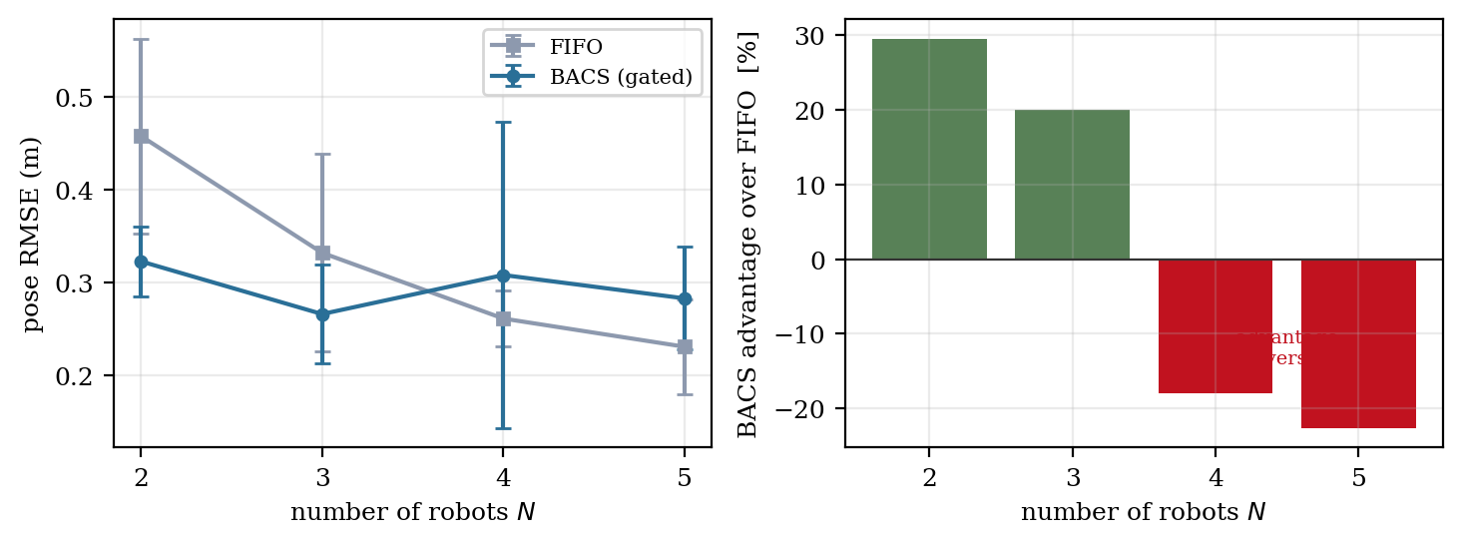
Fig. 6 Scalability under a shared channel. Left: absolute accuracy. Right: the scheduler's advantage over first-in-first-out queueing, which reverses beyond three robots.
The mechanism appears to be a tension between coverage and observability that Eq. (13) does not represent. The novelty term rewards constraints in regions no previous constraint has covered. As N grows, the number of distinct robot pairs grows quadratically while per-robot airtime falls linearly, so the number of constraints available per pair becomes very small — at five robots and 35 delivered constraints, fewer than four per ordered pair. Spreading those few constraints across maximally distinct regions leaves each pairwise relative transformation weakly determined. First-in-first-out queueing, which has no coverage objective, incidentally concentrates its constraints in whichever regions generate candidates earliest, and the resulting redundancy pins those transformations more firmly.
Consistent with this reading, map alignment RMSE — which measures inter-map agreement rather than trajectory accuracy — remains better under scheduling at every team size, including those where pose RMSE is worse. The scheduler is achieving what its objective asks for; the objective is incomplete. A term rewarding redundancy where a pairwise transformation remains under-determined would likely correct this, and Section 8 identifies it as the most urgent revision.
Scheduling overhead grows from 0.19 to 0.88 ms per window across the range, against a 60 s window, confirming that computational cost is not a consideration at these team sizes.

6.7 Summary of hypothesis outcomes
Table 11 Outcome of the four pre-registered hypotheses.
Hypothesis | Prediction | Outcome | Evidence
H1 | Eq. (16) predicts optimal γ within 2× | Falsified | Predicted 0.0333; measured 0.003 (11.1× error), Table 9
H2 | Scheduling raises mean trust yield | Not supported | 0.380 under BACS vs 0.424 under FIFO, Table 7
H3 | Advantage grows with team size | Falsified; sign reverses | +29.5% at N=2 to −22.6% at N=5, Table 10
H4 | No harm under abundant bandwidth | Supported directionally | 7% gap at δ=5%; no equivalence test run, Table 8
The primary claim survives: at the regulatory duty cycle with two or three robots, bandwidth-aware scheduling improves collaborative mapping accuracy substantially and significantly. Three of four supporting hypotheses do not. We regard this as the honest and more useful outcome, since two of the failures identify specific, addressable defects in the formulation rather than in the premise.

7 Threats to Validity
These results come from a simulator, and the strongest claims we make are correspondingly bounded. The relative ordering of scheduling policies under a given budget is a property of the selection problem and should transfer. The absolute values should not be quoted as measurements of any physical system.
The oversupply ratio of approximately 180 to 1 is a property of our candidate generator rather than of any particular front-end. Since it directly determines the deferral delay, it also determines the corrected decay anchor. A deployment whose front-end produces candidates at a different rate will have a different optimum, and the correct procedure is to measure the deferral distribution and set γ from it rather than to adopt 0.003.
The information surrogate of Eq. (13) has not been validated against the exact criterion of Eq. (12). The protocol is specified — recover marginal covariances from converged graphs, compute exact mutual information per candidate edge, report Spearman rank correlation on a held-out half of the recorded sessions — but not yet executed. The failure identified in Section 6.6 is precisely the kind of defect that validation would surface, and we regard running it as a prerequisite to any stronger claim about the surrogate.
The statistical power is modest. Six seeds give W = 0, p = 0.031 for the primary comparison, which clears the conventional five percent threshold but not the stricter ones often reported in this literature. Scenarios 2, 3 and 6 use three seeds and their differences should be read as indicative. H4 was specified with an equivalence test that we did not run.
Finally, the drift model is linear in distance travelled. Real odometry error accumulates as a random walk in many configurations, which would change the exponent in the invalidation-rate argument behind Eq. (16). Since that equation is falsified for an unrelated reason — anchoring to the wrong timescale entirely — this does not affect the conclusions, but it would matter to any attempt to repair the derivation in its original form.

8 Conclusion and Future Work
We set out to show that a trust-weighted fusion back-end and a duty-cycle-limited radio front-end pose two halves of one problem, and that the trust function evaluated before transmission tells a robot which constraints deserve its scarce airtime. That claim is supported at the regulatory duty cycle for small teams: a gated scheduler reduces per-step pose RMSE by 32.5% relative to first-in-first-out queueing, significant at W = 0, p = 0.031 over six paired seeds, at a computational cost under one thousandth of the window it governs.
Three findings revise conventional practice more broadly than the scheduler itself. Staleness under duty-cycle compliance is dominated by scheduling deferral rather than by channel delay, by three orders of magnitude, which means temporal discounting matters more than has been appreciated and must be calibrated against an entirely different timescale. A predicted trust score is usable only when computed against the fused global map, since against raw odometry it measures ego-drift and ranking on it becomes self-confirming. And predicted trust cannot be combined multiplicatively with a bounded information measure, because the exponential term dominates the product; gating is required.
Two of our four hypotheses were falsified and one unsupported. The most consequential is the reversal of the scheduler's advantage beyond three robots, which we attribute to an objective that rewards spatial coverage without regard to whether pairwise relative transformations remain observably determined. Adding a redundancy term to Eq. (13), weighted by the current determinacy of each pairwise transformation, is the single most urgent revision and the one we intend to pursue first.
Beyond that, three directions follow. Physical validation on hardware is necessary before any of these numbers should be relied upon, and the antecedent framework's two-robot platform with motion-capture ground truth is the natural vehicle. Executing the surrogate validation of Section 7 would place Eq. (13) on an empirical footing it currently lacks. And the adversarial case deserves attention precisely because the scheduler worsens it: a robot that overstates its predicted trust or its novelty captures a disproportionate share of a shared duty cycle, which is a denial-of-service vector that an unscheduled system does not present. Addressing it requires trust that accumulates across constraints and attaches to agents rather than to packets, complementing the per-constraint weighting used here.

References
1. Grisetti, G., Kümmerle, R., Stachniss, C., Burgard, W.: A tutorial on graph-based SLAM. IEEE Intell. Transp. Syst. Mag. 2(4), 31–43 (2010)
2. Agarwal, P., Tipaldi, G.D., Spinello, L., Stachniss, C., Burgard, W.: Robust map optimization using dynamic covariance scaling. In: Proc. IEEE ICRA, pp. 62–69 (2013)
3. Kümmerle, R., Grisetti, G., Strasdat, H., Konolige, K., Burgard, W.: g2o: a general framework for graph optimization. In: Proc. IEEE ICRA, pp. 3607–3613 (2011)
4. Dellaert, F.: Factor graphs and GTSAM: a hands-on introduction. Found. Trends Robot. 1(1–2), 1–139 (2012)
5. Labbé, M., Michaud, F.: RTAB-Map as an open-source LiDAR and visual SLAM library. J. Field Robot. 36(2), 416–446 (2019)
6. Campos, C., Elvira, R., Rodríguez, J.J.G., Montiel, J.M.M., Tardós, J.D.: ORB-SLAM3: an accurate open-source library for visual, visual-inertial and multi-map SLAM. IEEE Trans. Robot. 37(6), 1874–1890 (2021)
7. Zhang, J., Singh, S.: LOAM: lidar odometry and mapping in real-time. In: Proc. Robotics: Science and Systems (2014)
8. Lajoie, P.-Y., Ramtoula, B., Chang, Y., Carlone, L., Beltrame, G.: DOOR-SLAM: distributed, online, and outlier resilient SLAM for robotic teams. IEEE Robot. Autom. Lett. 5(2), 1656–1663 (2020)
9. Rosinol, A., Abate, M., Chang, Y., Carlone, L.: Kimera-Multi: robust distributed dense metric-semantic SLAM for multi-robot systems. IEEE Trans. Robot. 38(2), 774–795 (2022)
10. Ebadi, K., et al.: LAMP 2.0: robust multi-robot SLAM for large-scale subterranean environments. IEEE Robot. Autom. Lett. 7(2), 2135–2142 (2022)
11. Cunningham, A., Indelman, V., Dellaert, F.: DDF-SAM 2.0: consistent distributed smoothing and mapping. IEEE Trans. Robot. 29(4), 786–801 (2013)
12. Ila, V., Porta, J.M., Andrade-Cetto, J.: Information-based compact pose SLAM. IEEE Trans. Robot. 26(1), 78–93 (2010) [bibliographic details to be verified]
13. Kaess, M., Dellaert, F.: Covariance recovery from a square root information matrix for data association. Robot. Auton. Syst. 57(12), 1198–1210 (2009) [to be verified]
14. Giamou, M., Khosoussi, K., How, J.P.: Talk resource-efficiently to me: optimal communication planning for distributed loop closure detection. In: Proc. IEEE ICRA (2018) [to be verified]
15. Tian, Y., Khosoussi, K., How, J.P.: Resource-aware algorithms for distributed loop closure detection with provable performance guarantees. Int. J. Robot. Res. (2021) [to be verified]
16. Paull, L., Huang, G., Seto, M., Leonard, J.J.: Communication-constrained multi-AUV cooperative SLAM. In: Proc. IEEE ICRA (2015) [to be verified]
17. Carlevaris-Bianco, N., Eustice, R.M.: Generic factor-based node marginalization and edge sparsification for pose-graph SLAM. In: Proc. IEEE ICRA (2013) [to be verified]
18. Semtech Corporation: LoRa modulation basics. Application Note AN1200.22 [current revision to be verified]
19. ETSI: Short range devices operating in the frequency range 25 MHz to 1000 MHz. EN 300 220-2 [current version and duty-cycle clause to be verified]
20. Maruyama, Y., Kato, S., Azumi, T.: Exploring the performance of ROS 2. IEEE Embed. Syst. Lett. 8(3), 55–58 (2016)
21. Macenski, S., et al.: From the ROS navigation stack to Nav2. Sci. Robot. 7(66) (2022)
22. Al-Surmi, A., Othman, M., Othman, M.F.I.: Internet of Robotic Things (IoRT): recent advances, applications, and challenges. Sensors 22(9), 3325 (2022)
23. Kantaros, Y., Zavlanos, M.M.: Distributed communication-aware motion planning and task allocation for multi-robot systems. IEEE Trans. Robot. 36(4), 1131–1148 (2020)
24. Li, X., Zhang, H., Wang, Y.: LoRa-based communication networks for distributed robotic systems. Sensors 23(6), 3057 (2023)
25. Chen, Y., Liu, J., Zhao, H.: Communication-aware coordination for multi-robot systems under network constraints. Sensors 23(13), 5961 (2023)
26. Carlone, L., Censi, A., Dellaert, F.: Distributed pose graph optimization for multi-robot mapping. IEEE Trans. Robot. 31(5), 1200–1213 (2015)
27. Rosen, D.M., Carlone, L., Bandeira, A.S., Leonard, J.J.: SE-Sync: a certifiably correct algorithm for synchronization over the special Euclidean group. Int. J. Robot. Res. 38(2–3), 95–125 (2019)
28. Rosinol, A., Ebadi, K., Carlone, L.: Research challenges in multi-robot SLAM: scalability, robustness, and communication constraints. IEEE Robot. Autom. Mag. 30(4), 82–95 (2023)

Declarations
Funding. The authors received no specific funding for this work.
Conflict of interest. The authors declare no competing interests.
Ethics approval. Not applicable; no human or animal subjects were involved.
Data and code availability. The simulator, all experiment scripts, raw result files, and the figure generation code are available in the project repository. Every numerical value reported in Section 6 is reproducible by executing the corresponding scenario runner at the stated seeds.
Use of generative AI. [Authors: complete this statement in accordance with the publisher's policy on generative AI in scientific writing, describing any AI assistance used in drafting, analysis, or code generation. Generative AI tools do not satisfy authorship criteria and must not be listed as authors.]

