AGENTICOS v0.1 ALPHA
TARGET PRODUCT ARCHITECTURE + DAILY EMPLOYEE EXECUTION PLAN
Development: 27 September–13 October 2026 | Final Testing: 14 October | Launch: 15 October 2026

1. Purpose of This Document
This is the master execution document for the new AgenticOS team. The architecture shown below is the TARGET PRODUCT ARCHITECTURE. The team's job from 27 September to 13 October is to implement the layers, integrate them vertically, prove them with tests, and reach a release candidate that matches the architecture. 14 October is reserved for full-system testing and release blocking fixes; 15 October is the final launch.

2. Target Architecture — Product Definition
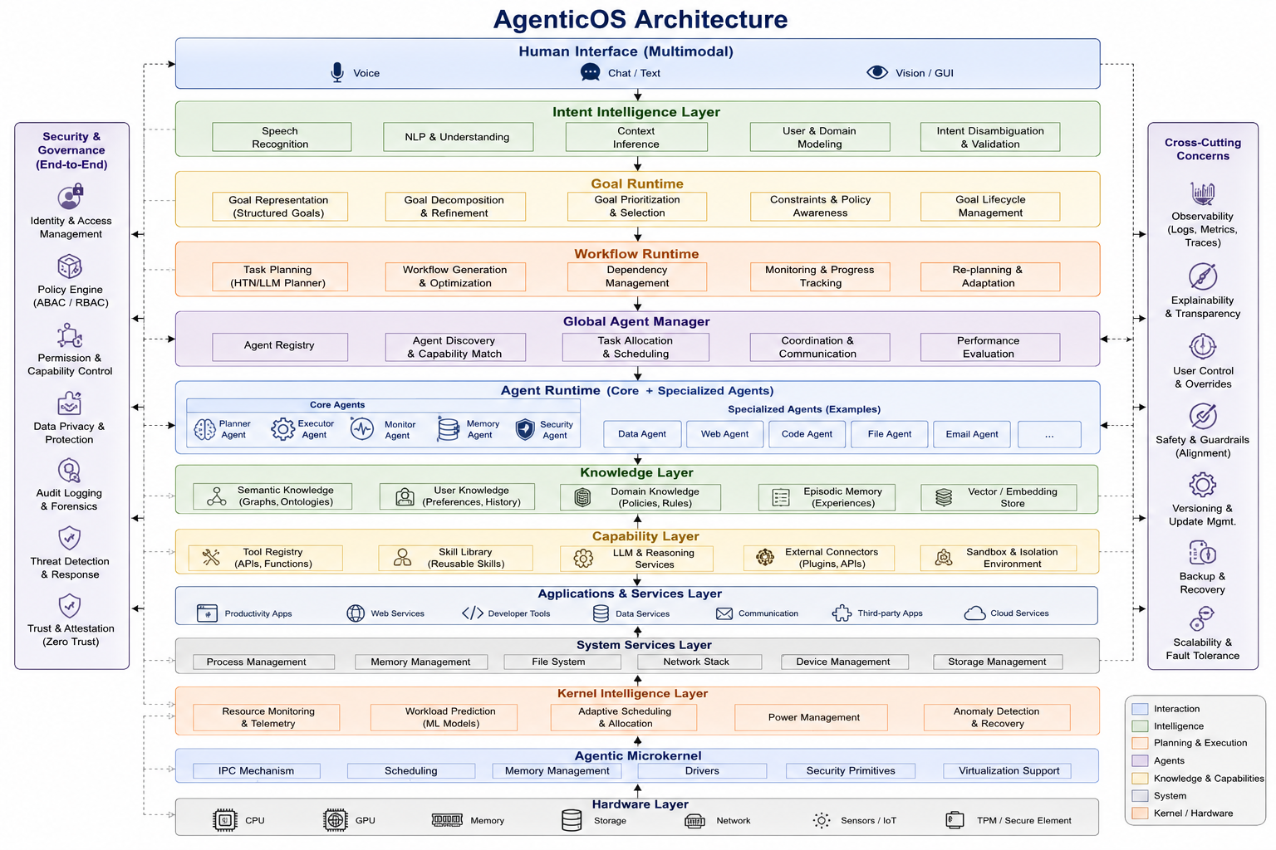
Figure 1 — AgenticOS target architecture supplied by the product team

3. Important Architecture Interpretation
AgenticOS is built on Linux. The architecture's 'Agentic Microkernel' should be implemented in v0.1 as the AgenticOS kernel-integration/control layer above the Linux kernel unless the engineering team explicitly changes the OS kernel architecture. It must not be presented as replacing Linux's kernel scheduler, memory manager or drivers. Linux remains responsible for core kernel primitives; AgenticOS adds intelligence, policy, orchestration and controlled interfaces around them.

4. Architecture Layers That Must Exist by Launch
Layer | Architecture component | What must be implemented | Owner(s) | Launch expectation
1 | Human Interface (Multimodal) | Voice, Chat/Text, Vision/GUI, prompt UI | Lishanth + Vishnu | Working prompt experience; optional voice/vision adapters can be staged.
2 | Intent Intelligence Layer | Speech recognition adapter, NLP/LLM understanding, context inference, user/domain modeling, intent validation | Vishnu | Natural-language goal becomes validated structured intent.
3 | Goal Runtime | Structured goals, decomposition/refinement, priority, constraints/policy awareness, lifecycle | Vivek + Vishnu | Goal object and lifecycle implemented.
4 | Workflow Runtime | Task planning, workflow generation, dependencies, progress/tracing, re-planning | Vivek + Krithikesh | Multi-step task execution state works.
5 | Global Agent Manager | Registry, capability matching, allocation/scheduling, communication, evaluation | Vivek | Discovers and coordinates agents.
6 | Agent Runtime | Core agents + specialized agents: Planner, Executor, Monitor, Memory, Security, Data/Web/Code/File/Email etc. | Krithikesh | Core agents + minimum useful specialized agents integrated.
7 | Knowledge Layer | Semantic knowledge, user knowledge, domain knowledge, episodic memory, vector/embedding store | Krithikesh + Vishnu | Scoped memory and retrieval available.
8 | Capability Layer | Tool registry, skill library, LLM/reasoning services, connectors/APIs, sandbox/isolation | Krithikesh + Lishanth | Controlled tools/skills can be registered and invoked.
9 | Applications & Services | Productivity, web, developer, data, communication, third-party/cloud services | Magesh + Krithikesh | At least selected local applications and service adapters work.
10 | System Services | Process, memory, filesystem, network, device, storage management | Magesh | AgenticOS adapters safely interact with Linux user space.
11 | Kernel Intelligence Layer | Telemetry, workload prediction, adaptive scheduling/policy, power management, anomaly/recovery | Vidhyuth | System intelligence operates above/alongside Linux controls.
12 | Agentic Microkernel / Linux Integration | IPC, scheduling interface, memory interface, drivers, security primitives, virtualization support | Magesh + Vidhyuth + Vivek | Controlled integration boundary to Linux kernel; no unsafe direct AI kernel mutation.
13 | Hardware | CPU, GPU, memory, storage, network, sensors/IoT, TPM/secure element | Magesh + Vidhyuth | Hardware detected and measurable; security hardware awareness where available.
Cross-cutting | Security & Governance | Identity, policy, permissions, privacy, audit, threat detection, trust | Lishanth | Security controls apply across every layer.
Cross-cutting | Observability & Reliability | Logs, metrics, traces, explainability, overrides, guardrails, versioning, backup/recovery, scalability | Lishanth + Vivek | Every critical workflow is observable and recoverable.

5. Employee Ownership Model
Employee | Role | Primary layers | Success definition
Vivek | Architecture/integration lead | Goal Runtime, Workflow Runtime, Global Agent Manager, system integration, release gates | Makes all layers connect into one executable product.
Vishnu | AI intelligence lead | Human language → Intent Intelligence → Goal input; LLM/reasoning/context | Makes natural-language interaction reliable and structured.
Krithikesh | Agent platform lead | Agent Runtime, Agent Bus/communication, Knowledge/Capability integration, specialized agents | Makes agents discoverable, callable, coordinated and testable.
Magesh | Linux/OS lead | Ubuntu/Linux base, ISO, desktop, Applications/Services, System Services, kernel integration | Makes the product bootable, installable and operational on Linux.
Vidhyuth | System intelligence lead | Resource monitoring, workload prediction, adaptive policy, anomaly/recovery, kernel intelligence | Makes the OS observe and optimize resources safely.
Lishanth | Security/UI/QA lead | Human Interface, security/governance, observability, test automation, release evidence | Makes the product safe, usable, observable and releasable.

6. Development Strategy — Build Bottom + Top, Integrate Middle
- Do not build the architecture as isolated demos. Every layer must expose a documented interface.
- OS foundation starts immediately so the AI team has a real target environment.
- AI/agent components are developed in parallel using mocks, then connected to real Linux services.
- Every 2–3 days must produce a vertical slice: User → AI → Goal → Workflow → Agent → System → Result.
- Cross-cutting security and observability are added from the first working service, not at the end.
- By 8 October the first complete RC architecture should exist; 9–13 October are for hardening, performance, E2E workflows and release.

7. Daily Execution Plan — 27 September to 13 October
Date | Architecture milestone | Work allocation — Vivek | Vishnu | Krithikesh | Magesh | Vidhyuth | Lishanth | Daily output | Pass gate
27 Sep | Architecture freeze & environment | Vivek: freeze layer interfaces and data contracts. Vishnu: define intent/goal schemas. Krithikesh: agent protocol/capability schema. Magesh: Ubuntu build + kernel source environment. Vidhyuth: telemetry/kernel metrics specification. Lishanth: threat model + QA matrix + UI requirements. | Architecture spec v1, repo skeleton, API schemas, build environment, test matrix. | Architecture review PASS; all members build/run baseline; no undefined critical interface.
28 Sep | Linux foundation + interface skeleton | Vivek: Agentic Core skeleton. Vishnu: LLM adapter + intent parser skeleton. Krithikesh: Agent Runtime/Bus skeleton. Magesh: first branded bootable ISO + systemd services. Vidhyuth: /proc,/sys telemetry collector. Lishanth: prompt UI shell + security boundary. | Bootable AgenticOS ISO + service skeleton + telemetry + UI shell. | Clean ISO boots; core services start; telemetry returns valid data.
29 Sep | Human Interface + Intent Intelligence | Vivek: request lifecycle. Vishnu: speech/text input adapters, NLP/LLM, context inference and intent validation. Krithikesh: message routing. Magesh: desktop integration. Vidhyuth: process/load metrics. Lishanth: prompt UX, error/confirmation states. | Prompt → validated structured intent in running AgenticOS. | Valid, invalid and ambiguous prompts handled safely.
30 Sep | Goal Runtime | Vivek: goal representation, decomposition, prioritization, constraints and lifecycle. Vishnu: intent→goal conversion/context. Krithikesh: goal messages through agents. Magesh: service persistence. Vidhyuth: system-state context. Lishanth: policy hooks. | Goal object + lifecycle + first execution plan. | Goal create/update/cancel/replan tests PASS.
1 Oct | Workflow Runtime | Vivek: planner/workflow engine. Vishnu: task decomposition quality. Krithikesh: dependency execution and agent calls. Magesh: app/service adapters. Vidhyuth: progress/resource observation. Lishanth: trace/progress UI. | Multi-step workflow runtime. | Two-step and three-step workflow executes in correct order.
2 Oct | Global Agent Manager | Vivek: registry, capability matching, allocation/scheduling, coordination and evaluation. Vishnu: agent intent requirements. Krithikesh: agent registration/discovery/health. Magesh: service startup. Vidhyuth: agent resource metrics. Lishanth: authorization and audit. | Global Agent Manager with live agents. | Agent discovery, allocation, timeout and health tests PASS.
3 Oct | Core + specialized agents | Vivek: Planner/Executor/Monitor orchestration. Vishnu: intent-facing agent contracts. Krithikesh: Planner, Executor, Monitor, Memory, Security + File/Web/Application agents. Magesh: application launch adapters. Vidhyuth: monitor inputs. Lishanth: agent permissions. | Minimum production demo agent set integrated. | Open app + create/search file + monitor system E2E PASS.
4 Oct | Knowledge Layer | Vivek: knowledge access in workflow. Vishnu: context retrieval and semantic query. Krithikesh: semantic/user/domain/episodic stores + vector/embedding interface. Magesh: persistence/service. Vidhyuth: resource impact. Lishanth: data privacy/access controls. | Knowledge + memory subsystem. | Store/retrieve/scoping/clear/privacy tests PASS.
5 Oct | Capability Layer | Vivek: capability selection. Vishnu: LLM/reasoning service adapter. Krithikesh: Tool Registry, Skill Library, connector interface, sandbox interface. Magesh: local application/system adapters. Vidhyuth: resource limits. Lishanth: tool authorization and sandbox policy. | Controlled tools/skills usable by agents. | Registered tool can execute; unregistered/unauthorized tool cannot.
6 Oct | Applications & System Services | Vivek: end-to-end adapters. Vishnu: app-control intent mapping. Krithikesh: application/file/web service agents. Magesh: process, memory, filesystem, network, device, storage adapters. Vidhyuth: telemetry hooks. Lishanth: UI and permission checks. | AgenticOS can safely operate selected applications and Linux services. | Application/file/system workflows PASS with audit trail.
7 Oct | Kernel Intelligence Layer | Vivek: policy integration. Vishnu: workload-context input. Krithikesh: Scheduler/Monitor agent interfaces. Magesh: Linux cgroups/systemd/kernel interfaces. Vidhyuth: workload prediction, adaptive policy, power/anomaly logic. Lishanth: safety/rollback tests. | Kernel Intelligence Layer v0.1. | Telemetry accurate; policy bounded; rollback PASS; no kernel instability.
8 Oct | Agentic Microkernel / Linux integration + RC1 | Vivek: integration of all layers. Vishnu: model packaging/config. Krithikesh: agent packaging. Magesh: Linux IPC/security/driver boundary + reproducible ISO. Vidhyuth: kernel/system metrics. Lishanth: RC1 QA/security suite. | RC1 matches target architecture from UI to hardware-facing services. | Fresh VM boot/install + vertical E2E + smoke suite PASS.
9 Oct | Cross-cutting security + observability | Vivek: trace propagation and recovery. Vishnu: prompt injection/unsafe intent handling. Krithikesh: agent auth/capabilities. Magesh: least-privilege system services. Vidhyuth: anomaly detection. Lishanth: identity, policy, permissions, privacy, audit, threat tests, logs/metrics/traces. | Security + observability integrated across all layers. | Unauthorized action blocked; complete trace available for E2E request.
10 Oct | Multimodal + UI completion | Vivek: full workflow integration. Vishnu: chat/text plus voice adapter; vision/GUI adapter where feasible. Krithikesh: agent results/progress. Magesh: desktop shell. Vidhyuth: system cards. Lishanth: polished UI, confirmation, overrides, explainability. | Product-grade AgenticOS interaction experience. | Representative prompts produce clear progress/result/error states.
11 Oct | Performance + reliability | Vivek: bottleneck removal. Vishnu: inference latency. Krithikesh: bus/agent latency and retry. Magesh: boot/app launch/restart. Vidhyuth: full benchmark and workload tests. Lishanth: failure injection, recovery and QA regression. | Performance/reliability report + fixes. | Repeated benchmark runs; service/agent failures recover correctly.
12 Oct | Full architecture integration + RC2 | All: integrate every layer. Vivek: architecture compliance review. Vishnu: AI behavior. Krithikesh: agent/knowledge/capability. Magesh: ISO/deployment. Vidhyuth: kernel intelligence. Lishanth: security/QA/release evidence. | RC2 architecture-complete build. | Every target layer has implementation or documented v0.1 scope; no critical broken dependency.
13 Oct | Code freeze + release candidate | Vivek: final integration/sign-off. Vishnu: model/prompt freeze. Krithikesh: agent freeze. Magesh: final ISO. Vidhyuth: final benchmarks. Lishanth: final QA/security and evidence package. | Final ISO candidate, checksum, architecture map, docs, test evidence. | Zero open P0/P1 blockers; release gates ready for 14 Oct.

8. 14 October — Architecture Acceptance Testing
ID | Architecture area | Acceptance test | Owner
A01 | Human Interface | Text prompt works; voice/vision adapters behave according to v0.1 scope. | Lishanth/Vishnu
A02 | Intent Intelligence | Prompt becomes valid structured intent; ambiguity triggers clarification. | Vishnu
A03 | Goal Runtime | Goal can be created, decomposed, prioritized, constrained, cancelled/replanned. | Vivek
A04 | Workflow Runtime | Dependencies and task order are respected; progress is visible. | Vivek/Krithikesh
A05 | Global Agent Manager | Agents are discovered by capability and allocated correctly. | Vivek/Krithikesh
A06 | Agent Runtime | Planner/Executor/Monitor/Memory/Security and selected specialized agents execute correctly. | Krithikesh
A07 | Knowledge Layer | Context/memory retrieval is scoped and persistent as designed. | Vishnu/Krithikesh
A08 | Capability Layer | Only registered/authorized tools and connectors execute. | Krithikesh/Lishanth
A09 | Applications | Selected application workflows work from natural language. | Magesh/Krithikesh
A10 | System Services | Process/filesystem/network/device/storage adapters behave correctly. | Magesh
A11 | Kernel Intelligence | Telemetry, workload prediction and policy controls work without destabilizing Linux. | Vidhyuth/Magesh
A12 | Kernel boundary | AgenticOS cannot bypass kernel/security boundaries through unsafe AI execution. | Lishanth/Magesh
A13 | Security & Governance | Identity, policy, permissions, privacy, audit, threat and trust tests pass. | Lishanth
A14 | Observability | Logs, metrics and traces correlate one request end-to-end. | Lishanth/Vivek
A15 | Recovery | Agent/service failure produces detection, recovery or safe user-visible failure. | All
A16 | Hardware | CPU/GPU/RAM/storage/network/device detection works on target hardware/VM. | Magesh/Vidhyuth
A17 | Vertical E2E | User goal → intent → goal → workflow → agent → tool → system → verification → result. | All
A18 | Release | ISO boot/install, checksum, documentation and reproducible demo pass. | Vivek/Magesh/Lishanth

9. Mandatory End-to-End Demo Scenarios
Demo | User goal | Required architecture path
DEMO-01 | “Open the browser.” | Intent → Application Agent → desktop → verification.
DEMO-02 | “Create a folder Project in Documents.” | Intent → File Agent → filesystem → verification.
DEMO-03 | “Create a file inside Project and write this text.” | Goal decomposition → File Agent → verification.
DEMO-04 | “Show my CPU and memory usage.” | Intent → Monitor Agent → Resource Monitor → result.
DEMO-05 | “The system is under high CPU load; analyze it.” | Monitor → Knowledge/Policy → diagnosis → explanation.
DEMO-06 | “Optimize this workload.” | Workload prediction → Adaptive Resource Policy → bounded policy → verification.
DEMO-07 | Sensitive/destructive request | Security Agent → policy → confirmation/block → audit.
DEMO-08 | Multi-step goal | Goal Runtime → Workflow Runtime → multiple agents → final verification.
DEMO-09 | Agent failure | Timeout/failure → detection → retry/replan or safe failure.
DEMO-10 | Restart a service | System Service adapter → permission check → restart → health verification.

10. Final Architecture Definition of Done
- Every major layer in Figure 1 has an implemented v0.1 component, documented interface, or explicitly documented staged scope.
- Every vertical dependency is integrated; no layer is only a PowerPoint concept.
- User → Human Interface → Intent → Goal → Workflow → Global Agent Manager → Agent Runtime → Knowledge/Capability → Application/System Service → Linux/kernel/hardware path is demonstrable.
- Security & Governance applies across the entire path.
- Observability provides logs, metrics and traces across the entire path.
- Failures result in retry, re-planning, rollback or safe user-visible failure.
- AgenticOS does not give the LLM unrestricted root access.
- Kernel Intelligence controls are bounded and reversible.
- ISO is reproducible, boots, installs and runs the complete integrated prototype.
- All mandatory acceptance tests pass on 14 October before launch.

11. Final Product to Be Achieved on 15 October
The launch product is AgenticOS v0.1 Alpha: a Linux-based AI-native operating system prototype in which the architecture is operational from human interaction down to Linux system services and hardware-facing controls. The key product property is not merely a chatbot. It is a controlled execution architecture: the system understands a goal, manages goals and workflows, coordinates agents, retrieves knowledge, invokes authorized capabilities, interacts with applications and system services, observes system state, applies bounded system policies, verifies outcomes, and records what happened.

12. Final Release Package
- AgenticOS-v0.1-Alpha.iso
- SHA-256 checksum
- Architecture diagram + layer-to-code mapping
- Product document
- Installation and deployment guide
- Agent/API/IPC documentation
- Security and governance report
- Knowledge/memory design
- Kernel intelligence and resource-policy report
- Final test matrix and signed acceptance report
- Performance benchmark report
- Known limitations and v0.2 roadmap
- Demo script/video
- Source repository tagged release

13. One-Line Mission for the Team
“By 15 October, turn the architecture diagram into a working, bootable, testable AgenticOS product—not just separate modules.”

