Quoridor
Game Implementation

CSE472S: ARTIFICIAL INTELLIGENCE



Team Members

NAME | CODE
Mahmoud Mostafa Mahmoud | 2100403
Khaled Mohamed Mohamed Ali | 2100689
Mohamed Abdelbaky Tony Abdelbaky | 2101710
Rana Ayman Hamdy | 2100830
Farah Amr Mohamed | 2101034

Project Description
Quoridor is a strategic two-player board game implemented in Python with a modern graphical interface. The game features an AI opponent with multiple difficulty levels, allowing players to compete against the computer or another human player.

Game Rules
- Each player starts on opposite ends of a 9×9 board
- Players take turns either moving their pawn or placing a wall
- Pawns can move one cell horizontally or vertically (or jump over opponent)
- Each player has 10 walls to block the opponent's path
- Walls cannot completely block a player's path to their goal
- The first player to reach the opposite side wins

Project Structure
quoridor_game/
│
├── main.py # Application entry point
├── requirements.txt # Python dependencies
├── README.md # Project documentation
└── src/ # Source code modules
├── __init__.py # Package initializer
├── constants.py # Game constants and configuration
├── game_logic.py # Core game rules and mechanics
├── ai.py # AI opponent implementation
├── board_renderer.py # Board visualization
├── ui_components.py # Reusable UI widgets
├── screens.py # Menu and overlay screens
└── gui.py # Main GUI controller

Algorithms Used
1. Minimax Algorithm with Alpha-Beta Pruning
Location: src/ai.py
Purpose: Used for AI decision-making to determine the best move for the computer opponent.
Why Used:
- Optimal for two-player games: Minimax is the standard algorithm for adversarial games where two players take turns
- Guaranteed optimal play: Finds the best possible move assuming the opponent also plays optimally
- Alpha-Beta Pruning optimization: Reduces the number of nodes evaluated in the game tree by eliminating branches that cannot influence the final decision
- Configurable difficulty: By adjusting the search depth, we can create Easy (depth 1), Medium (depth 2), and Hard (depth 3) AI opponents

How It Works:
function minimax(state, depth, alpha, beta, maximizingPlayer):
if depth = 0 or game over:
return evaluate(state)

if maximizingPlayer:
maxEval = -infinity
for each move in valid_moves:
eval = minimax(apply(move), depth-1, alpha, beta, false)
maxEval = max(maxEval, eval)
alpha = max(alpha, eval)
if beta <= alpha:
break # Beta cutoff
return maxEval
else:
minEval = +infinity
for each move in valid_moves:
eval = minimax(apply(move), depth-1, alpha, beta, true)
minEval = min(minEval, eval)
beta = min(beta, eval)
if beta <= alpha:
break # Alpha cutoff
return minEval
Complexity:
- Without pruning: O(b^d) where b = branching factor, d = depth
- With Alpha-Beta: O(b^(d/2)) in best case

1I. Breadth-First Search (BFS)
Location: src/game_logic.py
Purpose: Used for pathfinding and path validation.
Why Used:
- Shortest path guarantee: BFS always finds the shortest path in an unweighted graph
- Complete algorithm: Will always find a path if one exists
- Path validation: Essential for checking if a wall placement is legal (must not block all paths to goal)
- Move calculation: Used to determine valid moves including special jump moves

How It Works:
function bfs_has_path(start, goal_row):
queue = [start]
visited = {start}

while queue not empty:
current = queue.pop_front()
if current.row == goal_row:
return True

for neighbor in get_valid_neighbors(current):
if neighbor not in visited:
visited.add(neighbor)
queue.append(neighbor)

return False

Use Cases in Project:
- Wall validation: Before placing a wall, check that both players still have a path to their goal
- AI evaluation: Calculate distance to goal for position evaluation
- Valid moves: Determine which cells a player can move to
Complexity
O(V + E) where V = vertices (81 cells), E = edges

III. Heuristic Evaluation Function
Location: src/ai.py
Purpose: Evaluates board positions for the Minimax algorithm.
Why Used:
- Position scoring: Converts game state into a numerical value
- Strategic factors: Considers multiple aspects of the game
- Performance: Fast computation allows deeper search

Evaluation Factors:
Factor | Weight | Description
Distance to goal | High | Fewer steps = better position
Walls remaining | Medium | More walls = more options
Opponent's distance | Medium | Farther opponent = advantage
Path options | Low | Multiple paths = flexibility

Code Overview by Module
- main.py - Entry point that initializes and runs the game.
- src/constants.py - Contains all game configuration: Screen dimensions and colors, Board sizes and cell dimensions, Animation speeds and UI settings.
- src/game_logic.py - Core game mechanics: QuoridorGame class - Main game state management, GameState dataclass - Stores current game state, Move validation and execution, Wall placement logic with BFS validation, Win condition checking.
- src/ai.py - AI opponent implementation: QuoridorAI class - AI player, Minimax with Alpha-Beta pruning, Three difficulty levels, Strategic move generation.
- src/board_renderer.py - Visual board representation: Cell and wall rendering, Pawn animations, Valid move indicators, Hover effects.
- src/ui_components.py - Reusable UI elements: ModernButton - Animated buttons, GlassPanel - Glassmorphism panels, ProgressBar - Wall count display, Tooltip - Help text.
- src/screens.py - Screen management: MenuScreen - Main menu with animated title, GameOverOverlay - Victory screen, ScreenManager - Screen transitions.
- src/gui.py - Main GUI controller: Event handling, Game loop, Screen coordination, Fullscreen support.

Links
Resource | Link
GitHub Repository | https://github.com/MahMoudMostaAfa/AI-Quoridor-Game
Demo Video | https://drive.google.com/drive/folders/1sNrzOPxb1PpBLQ9oGdKHJZDytU5FwSwx?usp=sharing

Game Controls
Control | Action
Left Click | Move pawn to highlighted cell
W Key | Toggle wall placement mode
Right Click | Rotate wall orientation
ESC | Cancel wall placement / Exit fullscreen
F11 | Toggle fullscreen mode

Screenshots
1. Main Menu
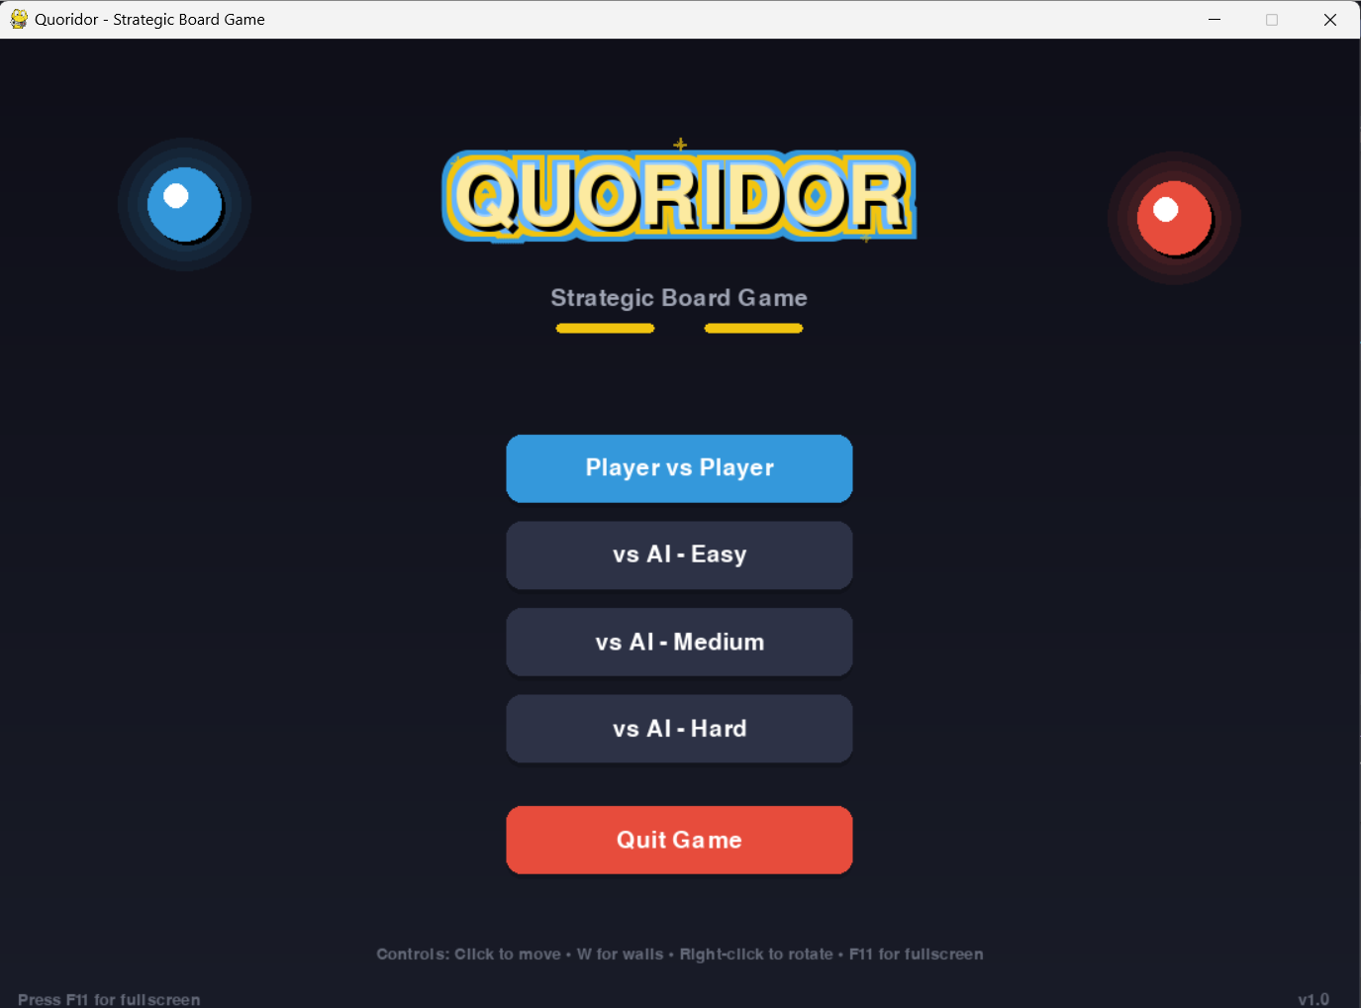
Description: The main menu featuring the animated "QUORIDOR" title with sparkle effects, game mode selection buttons (PvP and AI difficulties), and control instructions.
2. Game Board - Player vs Player
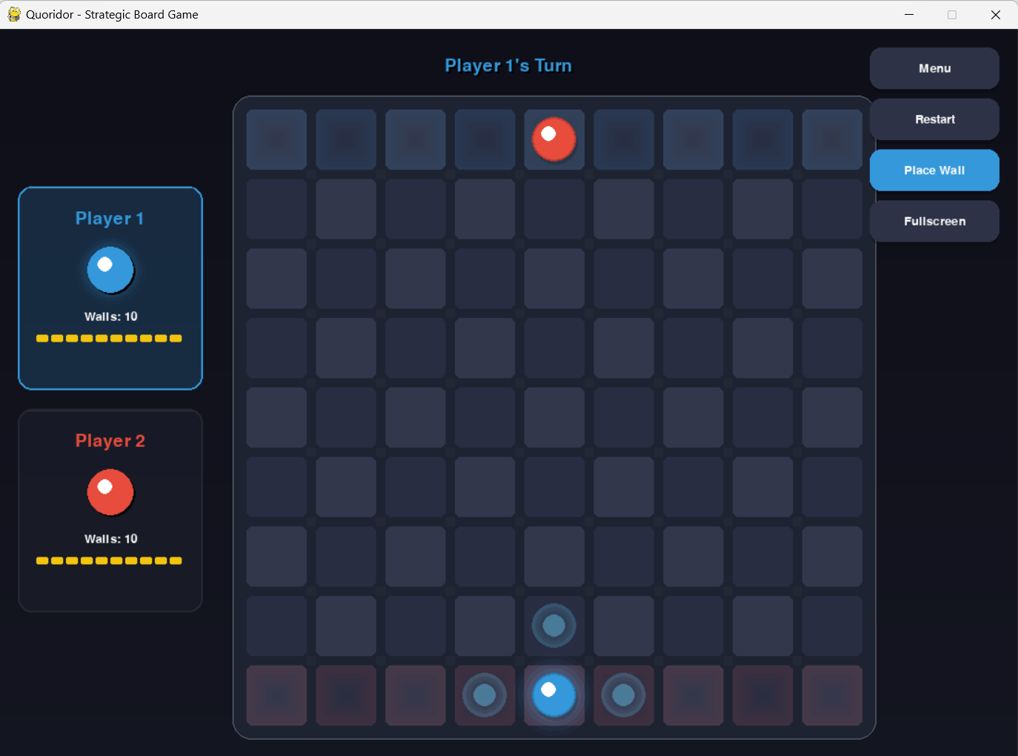
Description: Two-player gameplay showing the 9×9 board with both pawns, placed walls, and player information panels on the left side.

3. Valid Moves Indicator
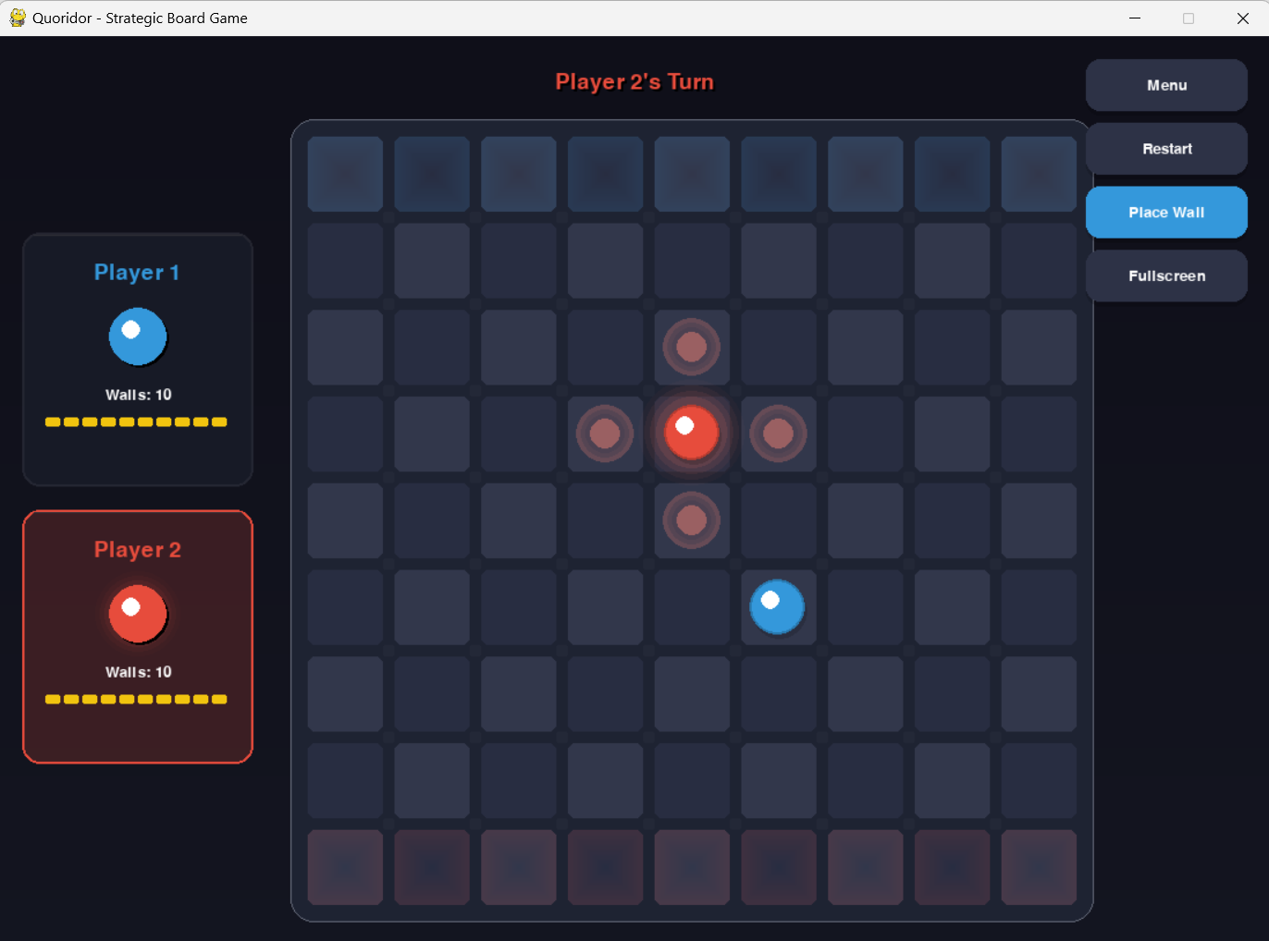
Description: Player's available moves highlighted with their color (cyan for Player 1, coral for Player 2) with pulsing animation effect.

4. Wall Placement Mode
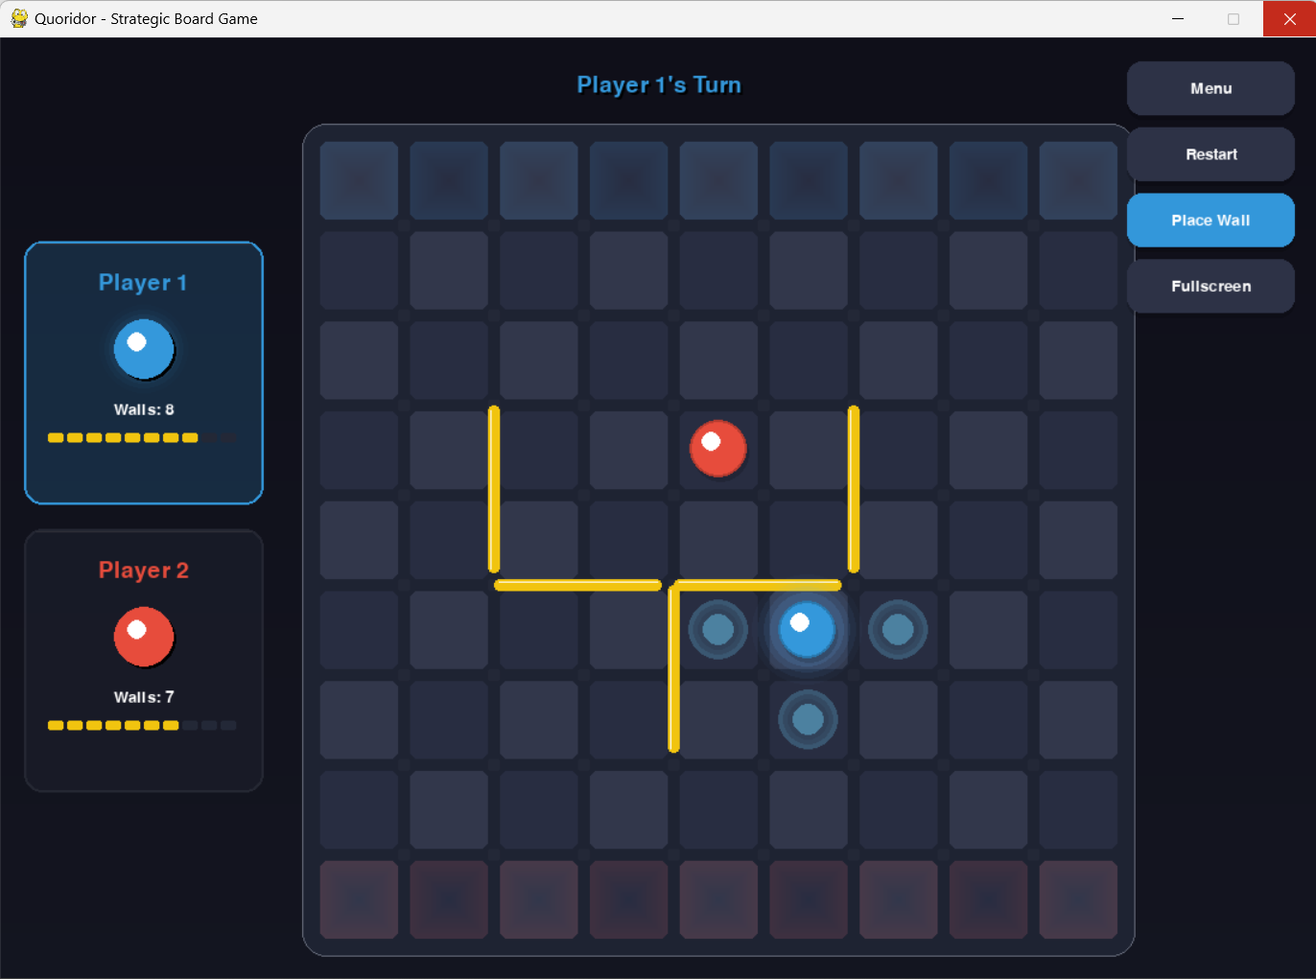
Description: Wall placement preview showing where the wall will be placed, with green indicator for valid placement and red for invalid.

5. AI Opponent Gameplay
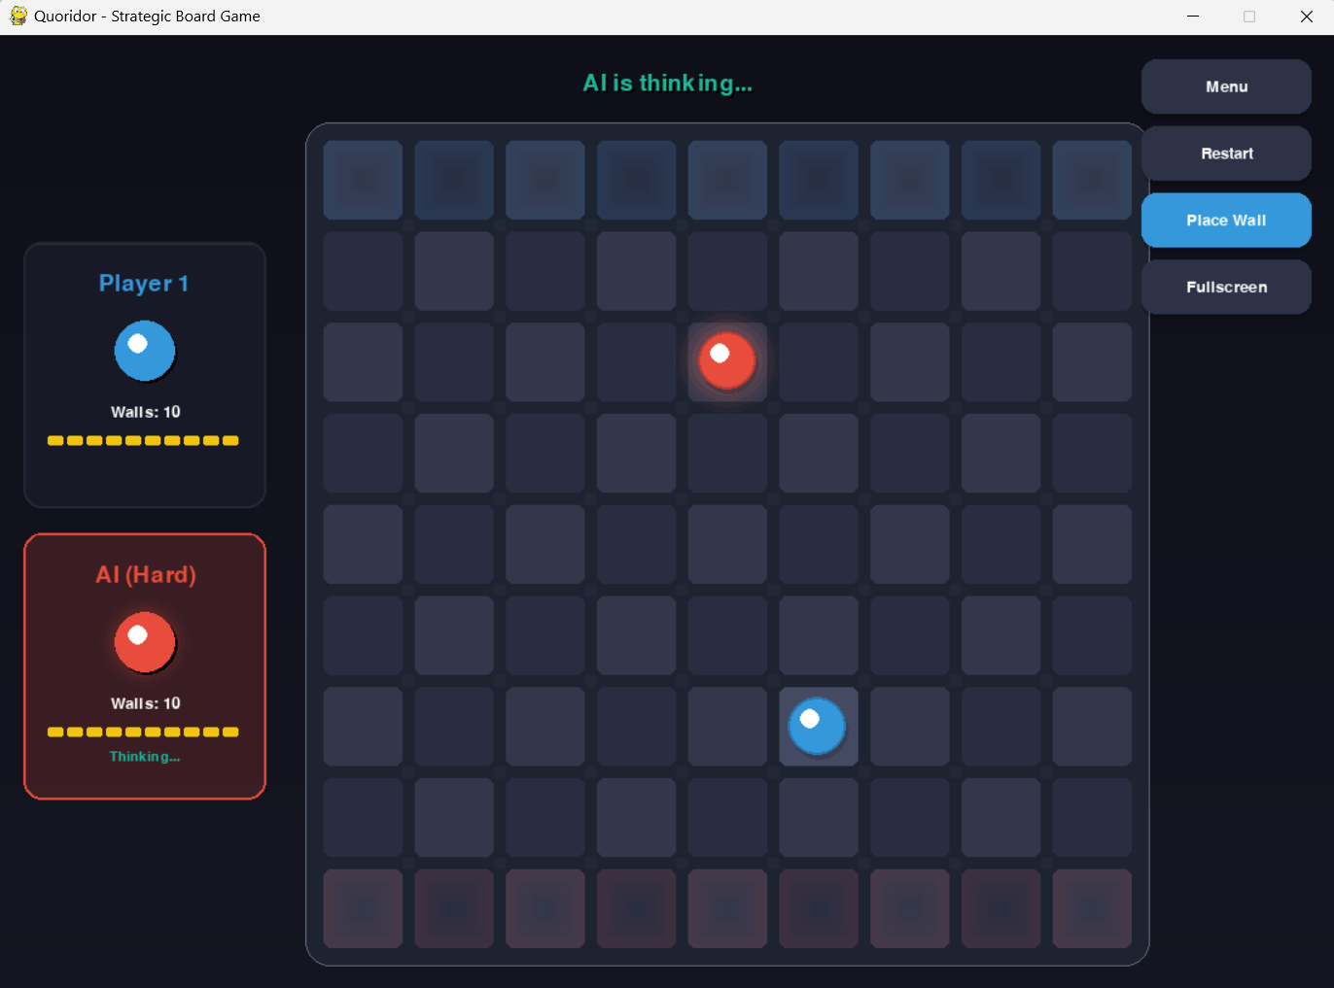
Description: Playing against the AI opponent, showing the "AI is thinking..." indicator and difficulty level display.

6. Game Over Screen
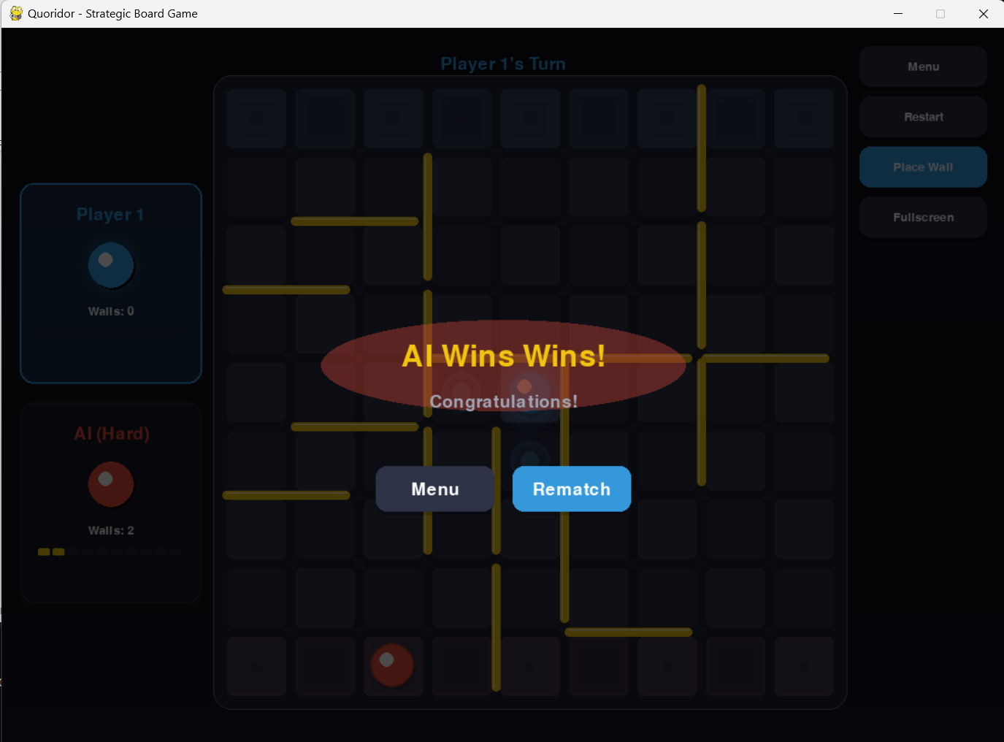
Description: The victory overlay showing the winner announcement with celebratory effects and options to rematch or return to menu

References
1. Minimax Algorithm - Russell, S., & Norvig, P. (2020). Artificial Intelligence: A Modern Approach
2. Alpha-Beta Pruning - Knuth, D. E., & Moore, R. W. (1975). An analysis of alpha-beta pruning
3. Pygame Documentation - https://www.pygame.org/docs/
4. Quoridor Official Rules - Gigamic Games

