University of Wollongong in Dubai
MAAI901 – Deep Learning for Visual Data
Applied Vision Transformer Report (Individual, 20%)

Smart Waste Classification Using Vision Transformers
Evaluating Hazardous Waste Detection and Classification Reliability

Student Name: Shaikh Maha
Student ID: 1560980
Instructor: Dr. Milan Dordevic
Submission: Technical Report, Code (GitHub) and Visualisations
Date: 27 October 2026

Table of Contents
Table of Contents 2
Abstract 3
1. Introduction and problem statement 3
2. Aim, objectives and research question 3
3. Related work 4
4. Dataset selection and limitations 4
5. Data pre-processing and augmentation 7
6. Vision Transformer architecture and configuration 8
7. Training and fine-tuning methodology 8
8. Evaluation metrics 9
9. Results 10
10. Discussion and error analysis 12
11. Hazardous-waste detection analysis 13
12. Bias, limitations and ethical implications 13
13. Environmental and societal relevance 14
14. Conclusion and future improvements 14
References 15
Appendix A – Implementation details 16

Abstract
Sorting the waste correctly matters, and it matters most important for hazardous items like batteries, e-waste, paints and pesticides. If these go into the wrong bin, they can start fires or pollute soil and water. In this project I took a pretrained Vision Transformer (ViT-B/16) and fine-tuned it to sort waste photos into four groups: Hazardous, Non-Recyclable, Organic and Recyclable. I used the public huaweilin/waste-classification dataset. Beyond overall accuracy, I asked how often the model misses a hazardous item and what happens when photos are blurry, dark or compressed. After cleaning the data and splitting it 70/15/15, the model reached 92.6 % accuracy on the test set and a macro F1 of 0.925. Hazardous recall was 0.898, which means 6 out of 59 hazardous test items were missed. Blurring, darkening and compressing the test images reduced accuracy by at most 2.2 points, and heavy JPEG compression caused one more hazardous miss. A fine-tuned ViT works well on clean photos, but because it still misses some hazardous items it should help a human rather than replace one.

1. Introduction and problem statement
Recycling plants separate mixed waste on fast conveyor belts, and image classification can help. But not every mistake is equally bad. If a cardboard box ends up in the plastics bin, that is a small loss. If a lithium battery ends up in organic waste, it can catch fire inside a truck. If a leaking pesticide bottle ends up in compost, it can poison the soil. So, I treat waste sorting as a safety problem: not only "how often is the model right?" but "what happens when it is wrong about a hazardous item?". In this report I fine-tune a pretrained Vision Transformer on a public waste dataset, measure how often it misses hazardous items, and check whether blur, poor lighting or compression make those misses more likely. The sections follow the order of the work: dataset, pre-processing, model, training, results, and finally bias and ethics.

2. Aim, objectives and research question
Aim: to fine-tune a Vision Transformer for four-class waste classification and evaluate it with special attention to hazardous-waste mistakes and image quality.
Objectives: (1) pick a public waste-image dataset and write down its weaknesses; (2) clean it, remove duplicates and split it without leakage; (3) fine-tune google/vit-base-patch16-224; (4) test it on a held-out set using accuracy, precision, recall, macro F1 and a confusion matrix; (5) look closely at hazardous recall and which hazardous items were missed; (6) test the same images after blur, darkening and JPEG compression; (7) discuss bias, limits and ethics.
Research question: How reliably can a Vision Transformer classify waste images into different waste categories, and what types of errors could create risks when identifying hazardous waste?

3. Related work
Dosovitskiy et al. (2021) showed that the Transformer built for text by Vaswani et al. (2017) also works for images if the image is cut into patches treated like words. A ViT pretrained on a huge dataset matches good CNNs, but trained from scratch on small data it does worse, which is why I fine-tuned a pretrained one.
For waste, TrashNet (Yang and Thung, 2016) is the best-known small dataset (about 2,500 photos, six classes), and many papers reach over 90 % on it with CNNs. Shrivastava and Gandhi (2023) used a ViT with a blur-based training trick and got 90.6 % on a two-class waste dataset compared with 88.7 % for a normal ViT, which shows that blur is a known problem for waste classifiers. Hendrycks and Dietterich (2019) showed with ImageNet-C that models with high clean accuracy can lose a lot under blur, brightness change or JPEG compression. Geirhos et al. (2020) describe "shortcut learning", where a model learns easy clues like background or colour instead of the real object. Both ideas are behind my robustness test and my bias discussion.
Most waste papers report one accuracy number for all classes. Few treat the hazardous class as a separate safety question or combine it with an image-quality test; I do not claim to be the first, but it is a less common angle.

4. Dataset selection and limitations
I used huaweilin/waste-classification from Hugging Face. It is a cleaned-up copy of the Kaggle "Waste Classification" dataset by PhenomSG (MIT License). I picked it because it has a real Hazardous class (batteries, e-waste, paints, pesticides), which most other datasets lack, and it is small enough for a free Colab GPU. Each image has a class (four values) and a subclass (18 values, Table 1). It comes as one block, so I made the splits myself.
Table 1 – Classes and subclasses
Class | Subclasses
Hazardous | batteries, e-waste, paints, pesticides
Non-Recyclable | ceramic_product, diapers, plastic bags/wrappers, sanitary_napkin, styrofoam_product
Organic | coffee_tea_bags, egg_shells, food_scraps, kitchen_waste, yard_trimmings
Recyclable | cans_all_type, glass_containers, paper_products, plastic_bottles

Before cleaning there were 1,976 images: 581 Hazardous, 371 Non-Recyclable, 487 Organic and 537 Recyclable (Figure 1). I removed 188 exact duplicates, which left 1,788. Figure 2 shows that the subclasses are very uneven: e-waste (359) and cans (225) are large, while sanitary napkins (41) and kitchen waste (42) are tiny. Inside Hazardous, e-waste is about 62 %; batteries (68), pesticides (71) and paints (83) are much rarer. Figure 3 shows sample images.
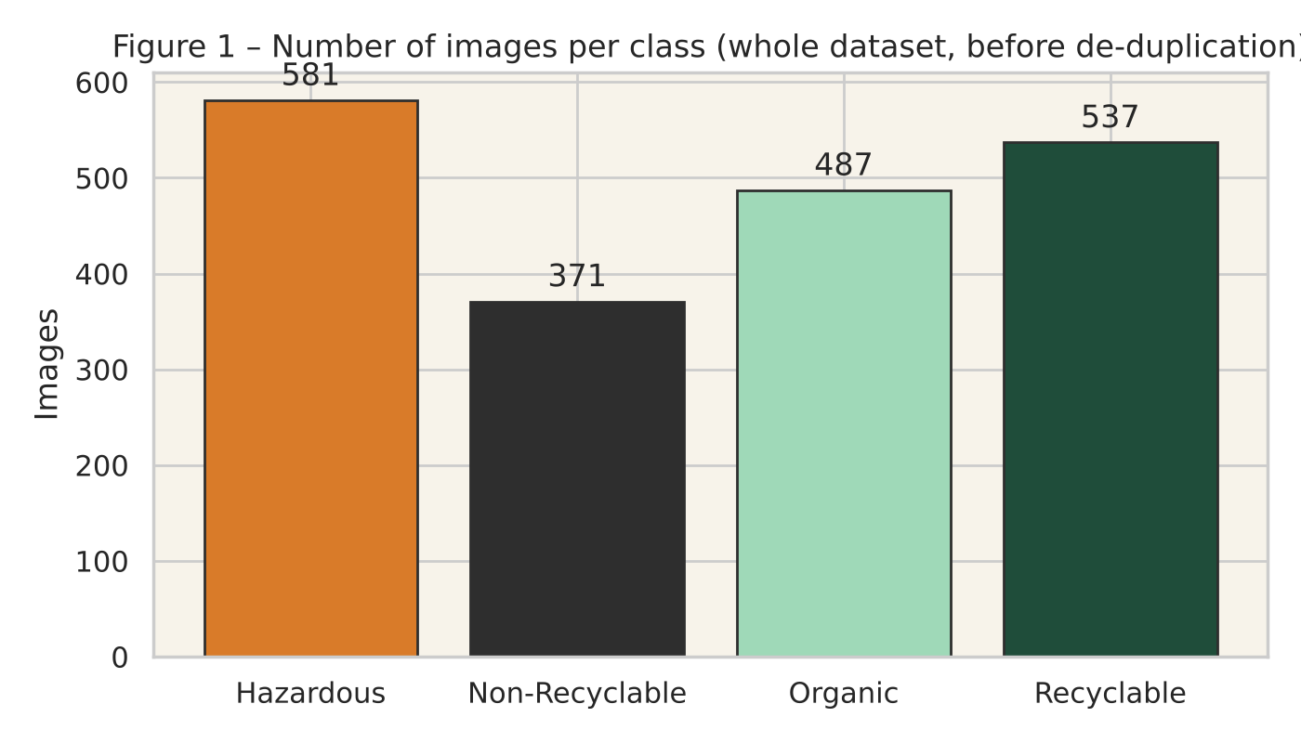
Figure 1. Number of images per class in the raw dataset.
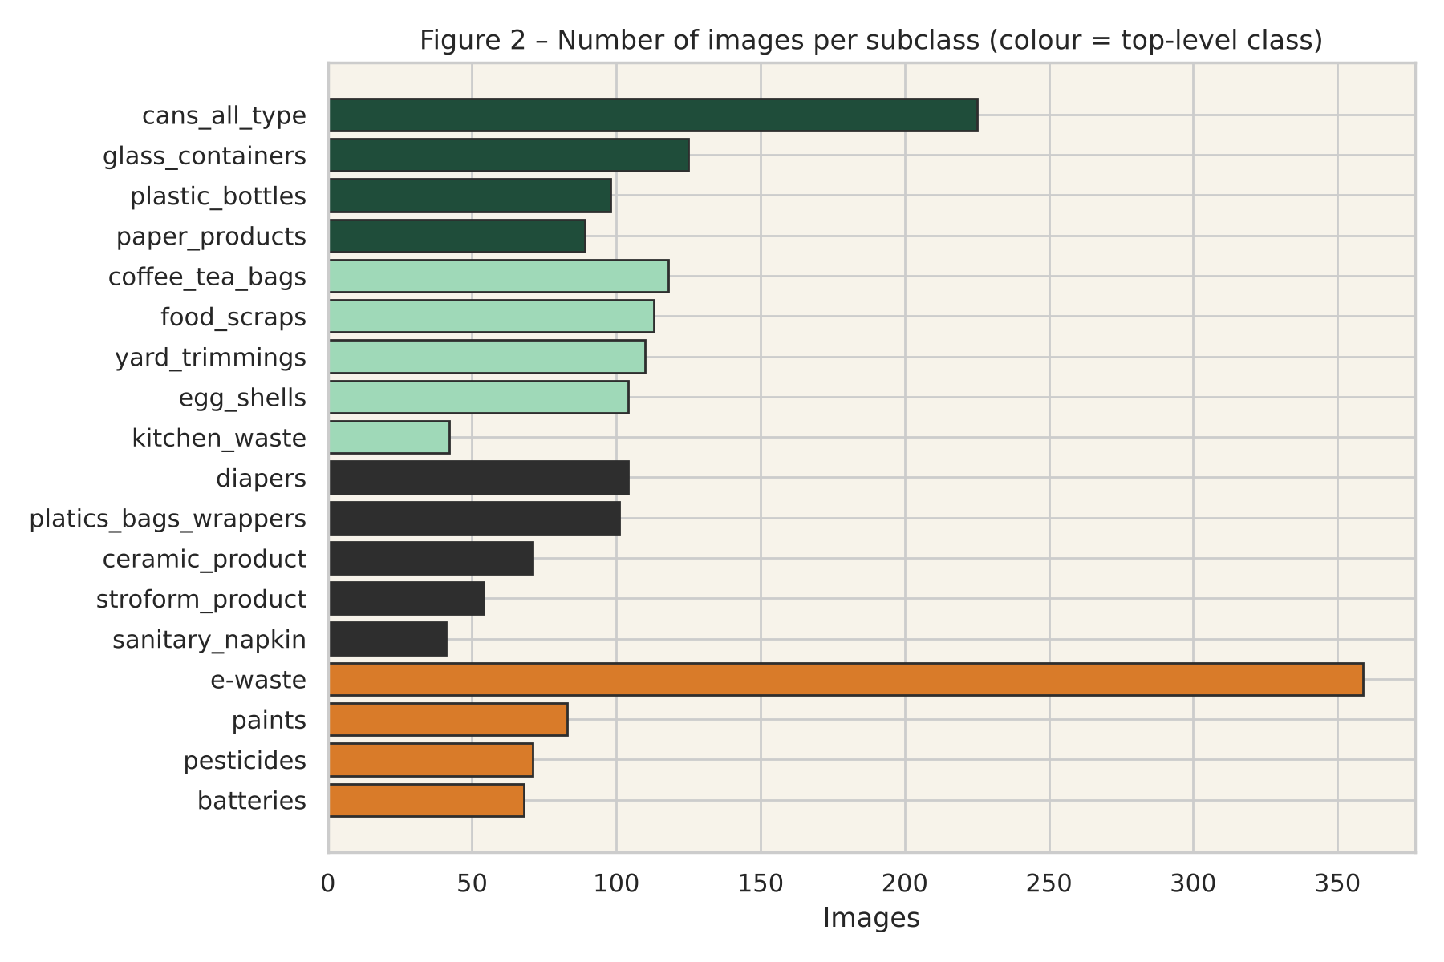
Figure 2. Number of images per subclass (colour = top-level class).
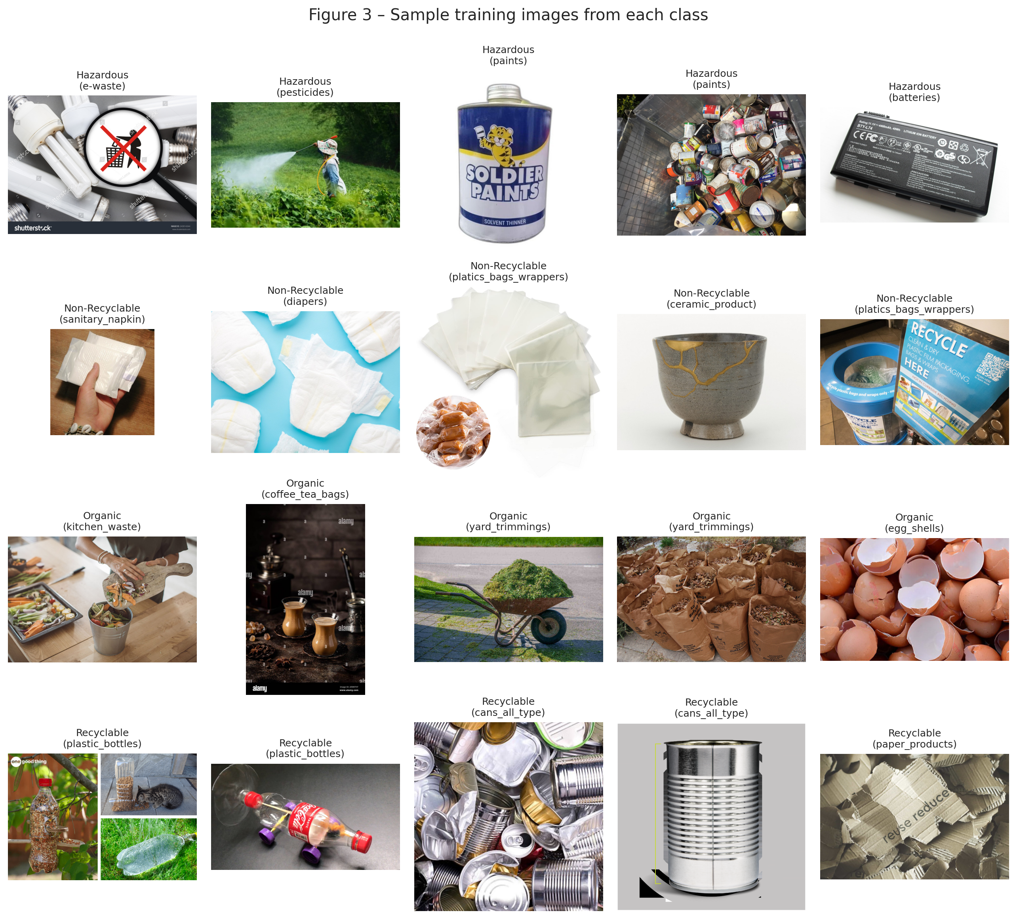
Figure 3. Sample training images from each class.
Limitations. The dataset is small and uneven. The clean product-style photos may teach the model to rely on backgrounds, and they do not look like real bin contents. Hazardous covers only four item types; medicines, syringes and chemicals are missing. The photos' origin is unknown, so I cannot check for regional bias. I kept the dataset anyway, because a hazardous class with real photos was more useful for my question than a larger but hazard-free dataset.

5. Data pre-processing and augmentation
Cleaning. I opened every image and converted it to RGB. Duplicates were found by hashing a 64×64 grey thumbnail of each image and removed before splitting, so the same photo could never be in both training and test sets.
Splitting. I split the data 70 / 15 / 15 (seed 42), stratified by subclass so every subclass is in every split in the same proportion. That gave 1,251 training, 268 validation and 269 test images. Validation was used only to pick the best epoch; the test set was used once, at the end.
Pre-processing and augmentation. All images were resized to 224×224 and normalised with mean 0.5 and standard deviation 0.5, as the checkpoint expects. Only the training images got augmentation: a random crop (70–100 % of the area), a random horizontal flip and small colour changes (±15 % brightness and contrast, ±10 % saturation). Validation and test images were not changed.

6. Vision Transformer architecture and configuration
A ViT reads an image in four steps. (1) Patching: the 224×224 image is cut into 196 patches of 16×16 pixels, each flattened into a list of numbers. (2) Embedding: a linear layer turns each patch into a 768-number vector, and a [CLS] token is added whose final value gives the prediction. (3) Position: a learnable position vector is added so the model knows where each patch came from. (4) Self-attention: twelve encoder layers follow; in each, every patch "looks at" every other patch through 12 attention heads, then passes through a small feed-forward network. So a ViT can connect far-apart parts of the image from the first layer, which a CNN cannot.
I used the checkpoint google/vit-base-patch16-224 (86 M parameters), pretrained on ImageNet-21k and fine-tuned on ImageNet-1k. I replaced its 1,000-class output layer with a new 4-class layer and fine-tuned the whole network.

7. Training and fine-tuning methodology
I trained with the Hugging Face Trainer on a Colab Tesla T4 GPU (Table 2). The small learning rate and warm-up protect the pretrained weights. I chose the best epoch by validation macro F1 because it treats all four classes equally. I chose five epochs because the training set is small and the model is already pretrained, so a few passes are enough and more would only increase over-fitting.
Table 2 – Training configuration
Setting | Value
Epochs / batch size | 5 / 32 (40 steps per epoch)
Learning rate | 5 × 10⁻⁵, 20 warm-up steps, cosine decay
Optimiser | AdamW, weight decay 0.01, fp16
Model selection | best validation macro F1 · seed 42

Training took 5.2 minutes. In Figure 4, validation accuracy went from 84.3 % after epoch 1 to 91.8 % after epoch 3 while loss fell from 0.55 to 0.26; in epochs 4–5 loss rose slightly and accuracy dropped to 90.3 %, a sign of mild over-fitting. So I kept the epoch-3 model (validation macro F1 0.915).
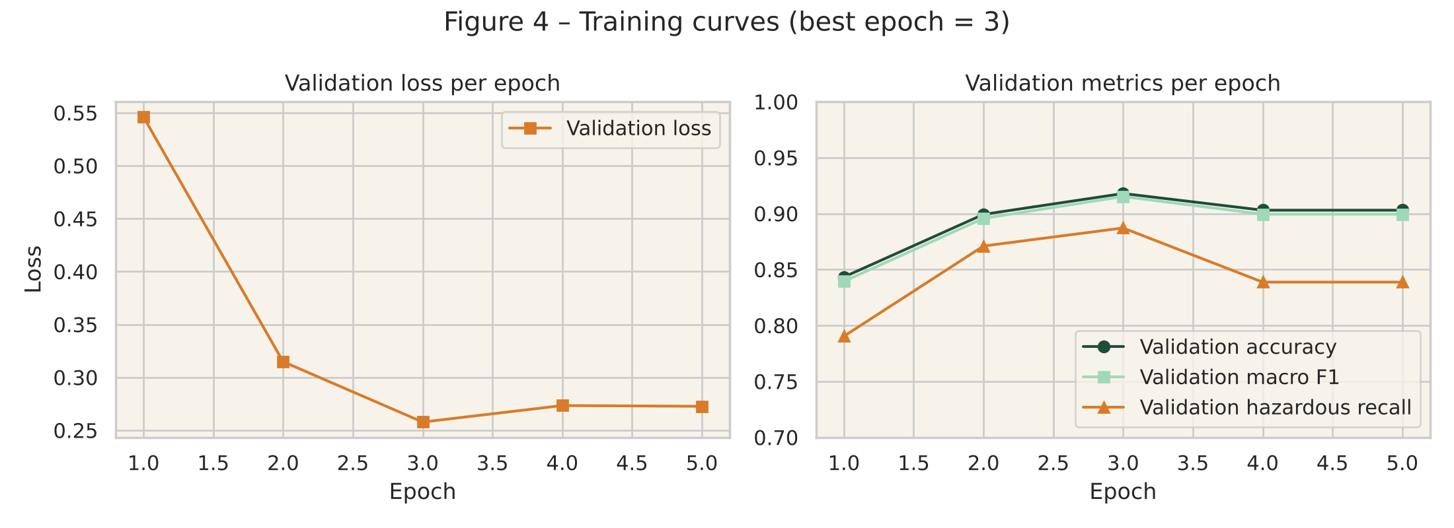
Figure 4. Validation loss and metrics per epoch; the epoch-3 checkpoint was selected.

8. Evaluation metrics
All metrics are on the held-out test set. Accuracy is the share of images the model got right. Precision for a class is: of the items the model called that class, how many really were. Recall is: of the items that are that class, how many it found. F1 combines the two, and macro F1 averages it over the four classes equally. The confusion matrix shows every mistake, and the hazardous false-negative rate (1 − hazardous recall) is the share of hazardous items sent to a non-hazardous class.
Simply put: a hazardous false negative is a battery the model calls "Recyclable" it goes to the wrong bin and can cause harm. A false positive is a drink can called "Hazardous" extra handling, but safe. False negatives are the dangerous mistake, so I report hazardous recall separately.

9. Results
On the 269 test images the model got 249 right (92.6 % accuracy), with macro precision 0.929, macro recall 0.922 and macro F1 0.925 (Table 3).
Table 3 – Per-class results on the test set
Class | Precision | Recall | F1 | Support
Hazardous | 0.964 | 0.898 | 0.930 | 59
Non-Recyclable | 0.925 | 0.891 | 0.907 | 55
Organic | 0.910 | 0.959 | 0.934 | 74
Recyclable | 0.916 | 0.938 | 0.927 | 81
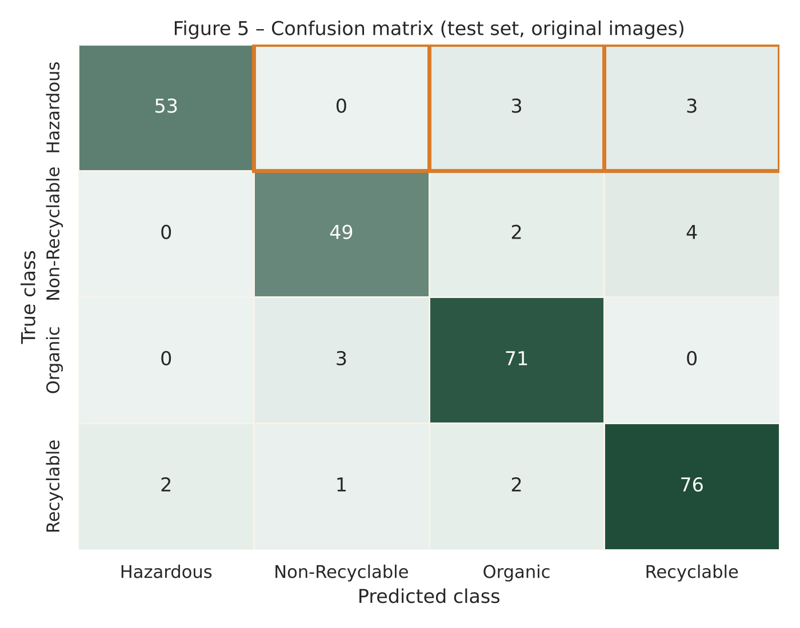
Confusion matrix. In Figure 5 the most common mix-up is Non-Recyclable predicted as Recyclable (4 images), which makes sense because plastic bags look like plastic bottles. Hazardous has the best precision of all classes (0.964, only 2 false alarms) but a lower recall, and that is exactly the pattern that matters for safety. The orange boxes mark the hazardous false negatives.

Figure 5. Confusion matrix on the 269 test images; orange boxes mark hazardous false negatives.
Robustness. Figure 7 shows one image under each type of damage; Table 4 and Figure 8 compare the same test images in all four conditions.
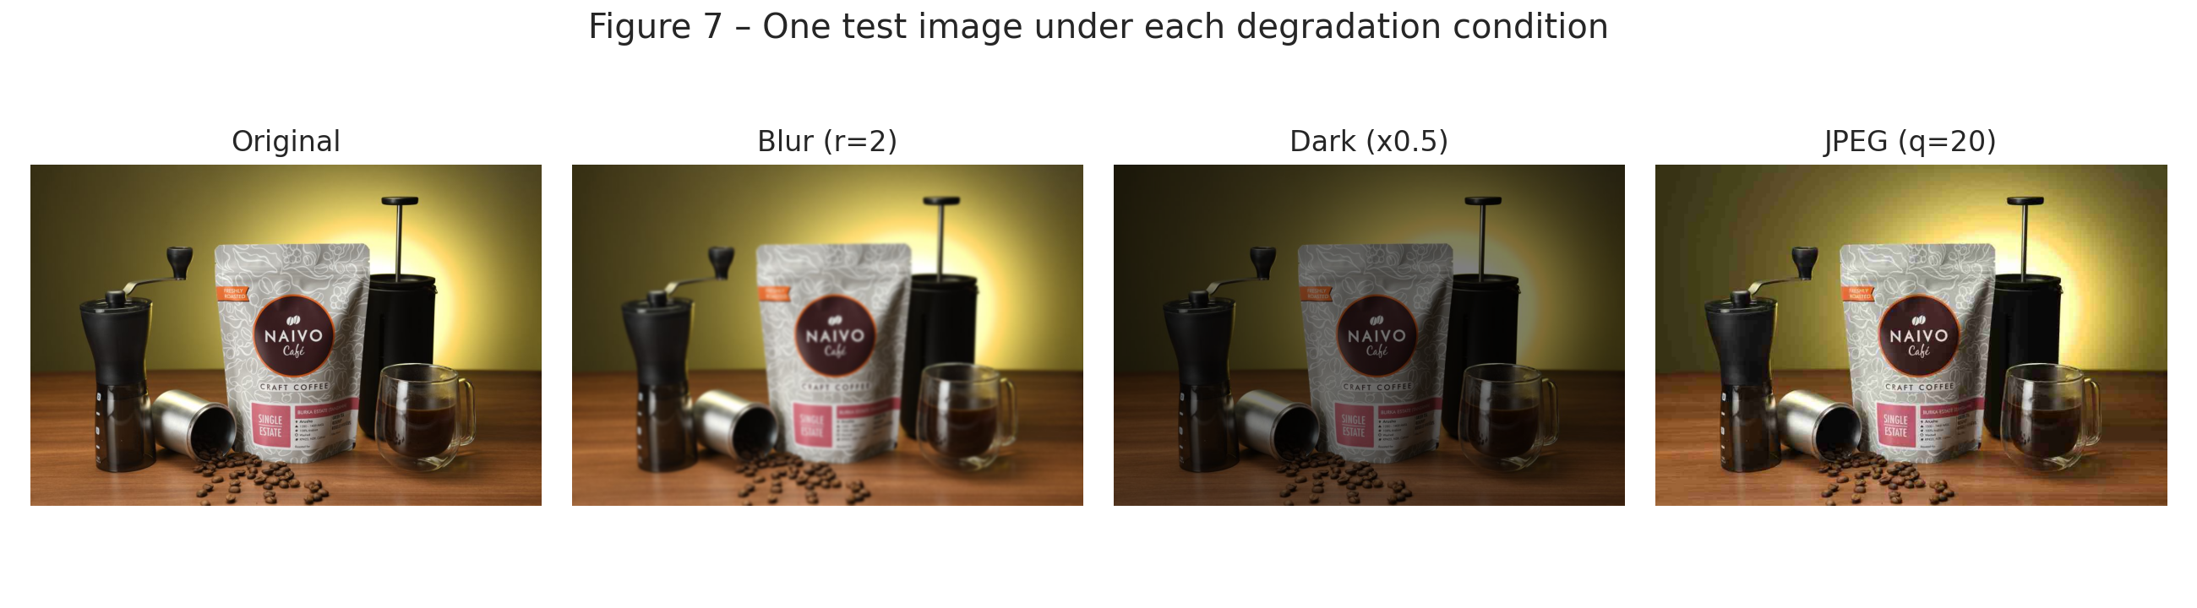
Figure 7. One test image under each degradation condition.
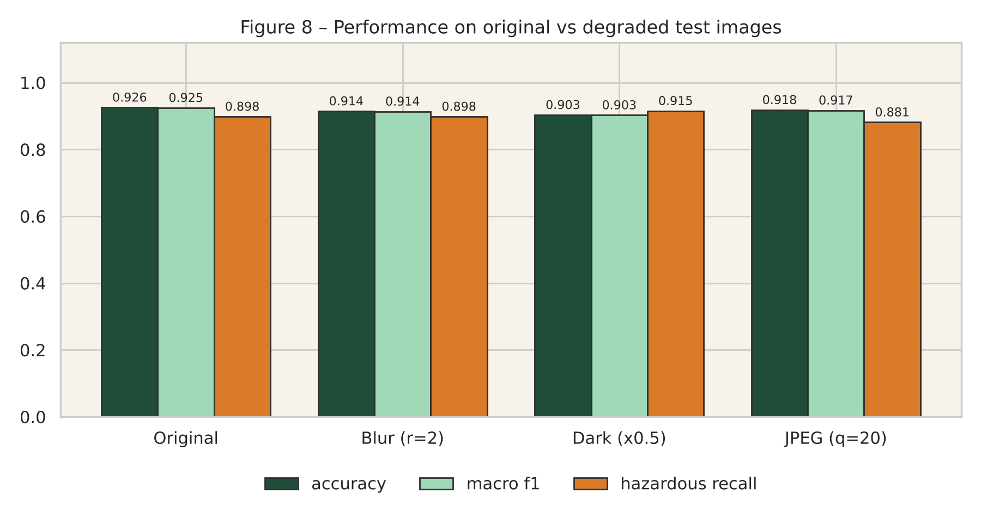
Figure 8. Accuracy, macro F1 and hazardous recall on original vs degraded test images.
Table 4 – Original vs degraded test images
Condition | Accuracy | Macro F1 | Hazardous recall | Hazardous FN / FP
Original | 0.926 | 0.925 | 0.898 | 6 / 2
Blur (radius 2) | 0.914 | 0.914 | 0.898 | 6 / 6
Dark (×0.5) | 0.903 | 0.903 | 0.915 | 5 / 6
JPEG (quality 20) | 0.918 | 0.917 | 0.881 | 7 / 2

Darkening hurt most (−2.2 points), blur cost 1.1 and JPEG 0.7. The hazardous class reacted differently to each. With blur and darkening recall did not fall, but false positives went from 2 to 6 the model called ordinary items hazardous when the photo was unclear, the safer kind of mistake. With heavy JPEG the opposite happened: one more hazardous item was missed (recall 0.881), the dangerous kind. Figures 9–11 show correct and incorrect examples and the prediction demo.

10. Discussion and error analysis
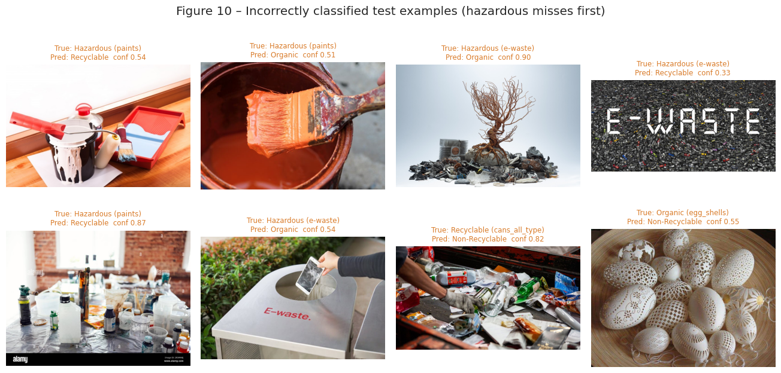
The accuracy is similar to other papers on small waste datasets, so ImageNet pretraining transfers well even with 1,250 training images. The mistakes are not random: all six hazardous misses went to Organic or Recyclable, never to Non-Recyclable. Figure 10 suggests three reasons.
Figure 10. Incorrectly classified test examples (hazardous misses first).
- Look-alike materials. Only paints (3 of 12) and e-waste (3 of 27) were missed; batteries and pesticides were all caught. A paint tin looks like a food can and a paint bottle looks like a plastic bottle, so a model that learned "bottle shape → Recyclable" gets fooled.
- Background. Several misses show the item small in the frame or on a messy surface, suggesting the model partly uses the background.
- Confidence. Four of the six hazardous misses had low confidence (0.33, 0.51, 0.54, 0.54), so a simple rule like "if the top probability is under 0.6, send it to a human" would have caught them. The other two were missed with high confidence (0.87, 0.90), and both false positives were also confident (0.97, 0.98), so a confidence rule alone is not enough; the hazardous threshold itself should be lowered too.
The robustness results broadly agree with Hendrycks and Dietterich (2019). In practice, a bin camera must be well lit and in focus, or the model must be trained with such damage. My tests are artificial; dirt, crushed items and several objects in one photo would make things worse. It would also be worth checking whether the two confident misses share something visible, such as a wooden table or a kitchen-style background, because that would point to a shortcut rather than a difficult image.

11. Hazardous-waste detection analysis
Out of 59 hazardous test images the model found 53 (recall 0.898, false-negative rate 0.102) and raised 2 false alarms. Figure 6 shows recall by subclass: batteries 1.00 (10/10), pesticides 1.00 (10/10), e-waste 0.89 (24/27) and paints 0.75 (9/12). The six misses were two e-waste items predicted as Organic, one e-waste item predicted as Recyclable, one paint container predicted as Organic and two predicted as Recyclable.
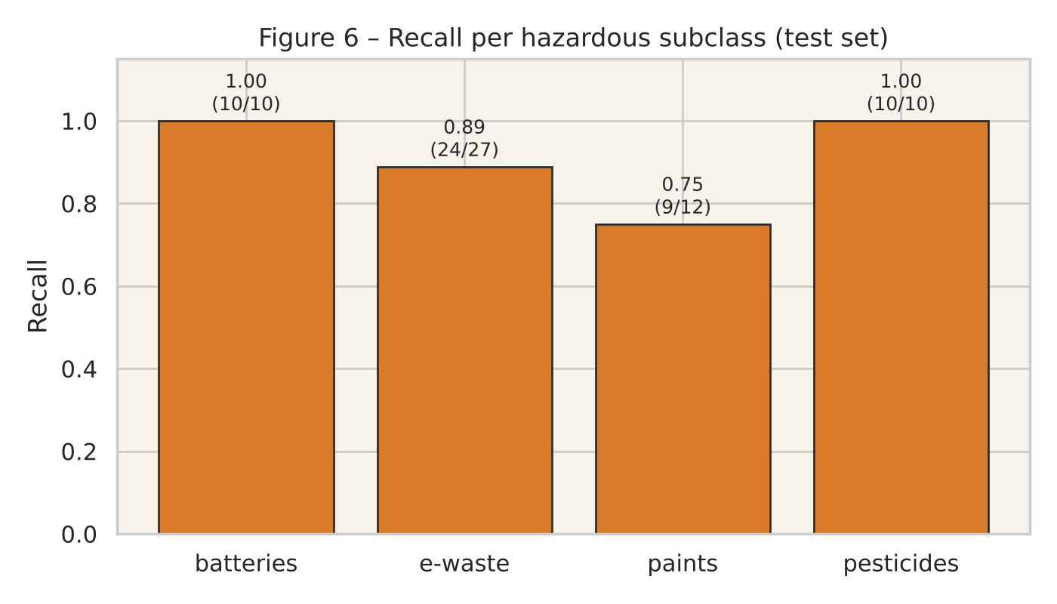
Figure 6. Recall per hazardous subclass on the test set.
Paints, the weakest subclass, look most like normal packaging. Pesticides scored perfectly, but with only 10 test images that is fragile; a pesticide bottle is a plastic bottle, and its label covers only a few of the 196 patches. Reading label text (OCR) or warning symbols would probably help more than a better image classifier alone.
Even a 10 % miss rate matters at scale: in a plant handling thousands of items a day, it means hundreds of hazardous items reaching the wrong stream every week. A real system should lower the hazardous threshold (accept more false alarms) and send unsure cases to a person.

12. Bias, limitations and ethical implications
Dataset bias. The photos are clean product shots; real waste is dirty, crushed and mixed, so the model looks better here than it would in a facility. Rare subclasses (Figure 2) are harder to learn and their test numbers less reliable. The photos' origin is unknown, and packaging and recycling rules differ between countries, so the model may not transfer to another region.
Shortcut learning. As Geirhos et al. (2020) describe, the model may rely on background or colour; attention maps would be needed to confirm this.
Misuse and over-trust. This model must not replace professional hazardous-waste advice. Someone who trusts an app that says "Recyclable" for a leaking battery could start a fire. Real use needs a cautious rule (when in doubt, treat it as hazardous), a visible confidence score and human review.
What I did not do. No regional fairness check was possible (no such data); I did not run a CNN baseline; and all results come from one run, so small differences may be noise.

13. Environmental and societal relevance
Better sorting makes recycled material purer and reduces landfill and burning. Keeping hazardous items in the right stream prevents lithium-battery fires in trucks and plants, a growing problem, and keeps paints and pesticides out of compost and water. But the benefit depends on reliability: a system right nine times out of ten but quietly wrong about the dangerous tenth item could do more harm than none. That is why this report cares more about hazardous recall than headline accuracy. A camera on a sorting line or a phone app at home could both use a model like this, but only if its mistakes are understood first, and that understanding is what this project tries to provide.

14. Conclusion and future improvements
I fine-tuned a pretrained ViT-B/16 on a four-class waste dataset and evaluated it with a focus on hazardous mistakes and image quality. On clean test images it reached 92.6 % accuracy and 0.925 macro F1 with hazardous recall of 0.898; six hazardous items (paints and e-waste) were missed, and heavy JPEG compression added one more. Looking back, the most useful finding was not the accuracy number but the pattern of the mistakes: all hazardous misses went to Organic or Recyclable, and most of them had low confidence. My answer to the research question is: reliable enough to help a person on good-quality photos, but not reliable enough to decide on its own about hazardous waste.
Future work: (1) lower the hazardous decision threshold or use cost-sensitive training; (2) train with blur, low light and compression; (3) use attention maps to check what the model looks at; (4) add OCR or warning-symbol detection; (5) collect bigger, documented, real-world data; (6) add a CNN baseline and run several seeds.

References
Deng, J., Dong, W., Socher, R., Li, L.-J., Li, K. and Fei-Fei, L. (2009) 'ImageNet: A large-scale hierarchical image database', IEEE Conference on Computer Vision and Pattern Recognition (CVPR), pp. 248–255.
Dosovitskiy, A., Beyer, L., Kolesnikov, A., Weissenborn, D., Zhai, X., Unterthiner, T., Dehghani, M., Minderer, M., Heigold, G., Gelly, S., Uszkoreit, J. and Houlsby, N. (2021) 'An image is worth 16×16 words: Transformers for image recognition at scale', International Conference on Learning Representations (ICLR). arXiv:2010.11929.
Geirhos, R., Jacobsen, J.-H., Michaelis, C., Zemel, R., Brendel, W., Bethge, M. and Wichmann, F. A. (2020) 'Shortcut learning in deep neural networks', Nature Machine Intelligence, 2, pp. 665–673.
Hendrycks, D. and Dietterich, T. (2019) 'Benchmarking neural network robustness to common corruptions and perturbations', International Conference on Learning Representations (ICLR). arXiv:1903.12261.
Hugging Face (n.d.) google/vit-base-patch16-224 model card. Available at: https://huggingface.co/google/vit-base-patch16-224 (Accessed: 24 October 2026).
huaweilin (n.d.) waste-classification dataset card. Available at: https://huggingface.co/datasets/huaweilin/waste-classification (Accessed: 24 October 2026). Repackaged from PhenomSG, Waste Classification, Kaggle (MIT License): https://www.kaggle.com/datasets/phenomsg/waste-classification.
Shrivastava, A. K. and Gandhi, T. K. (2023) 'Integrating human vision perception in Vision Transformers for classifying waste items', arXiv:2312.12143.
Vaswani, A., Shazeer, N., Parmar, N., Uszkoreit, J., Jones, L., Gomez, A. N., Kaiser, Ł. and Polosukhin, I. (2017) 'Attention is all you need', Advances in Neural Information Processing Systems (NeurIPS), 30.
Wolf, T. et al. (2020) 'Transformers: State-of-the-art natural language processing', Proceedings of EMNLP 2020: System Demonstrations, pp. 38–45.
Yang, M. and Thung, G. (2016) Classification of trash for recyclability status. CS229 project report, Stanford University.

Appendix A – Implementation details
- Code: notebooks/smart_waste_vit.ipynb (self-contained) and src/ scripts
- Repository: https://github.com/Maha-Shaikh1/smart-waste-vit
- Environment: Google Colab, Tesla T4 GPU, transformers 5.20.2, torch 2.11.0 (CUDA 13.0); training time 5.2 min.
- Degradation settings: Gaussian blur radius 2 px; brightness factor 0.5; JPEG quality 20 (Pillow). Applied to test images only, before resizing.
- Duplicate check: MD5 of 64×64 grayscale thumbnail. All seeds fixed to 42; single run.

