# Bar Chart:-

* Visualizes total sales for each branch
* Branch B leads in sales performance
* Branch A has the lowest sales

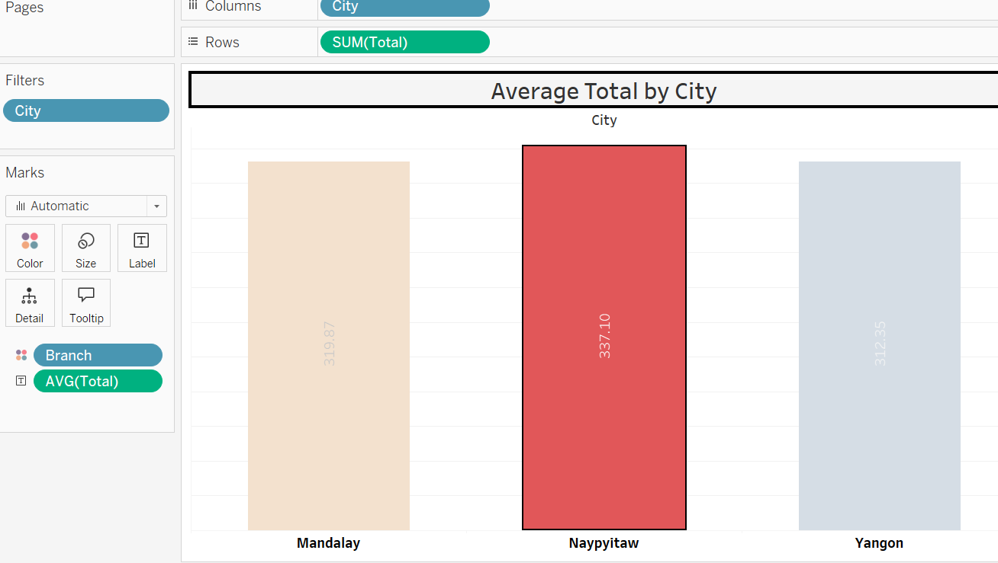

## Pie chart:-

* Shows sales shares between male and female customers
* Female customers contribute slightly more
* Sales distribution is almost equal

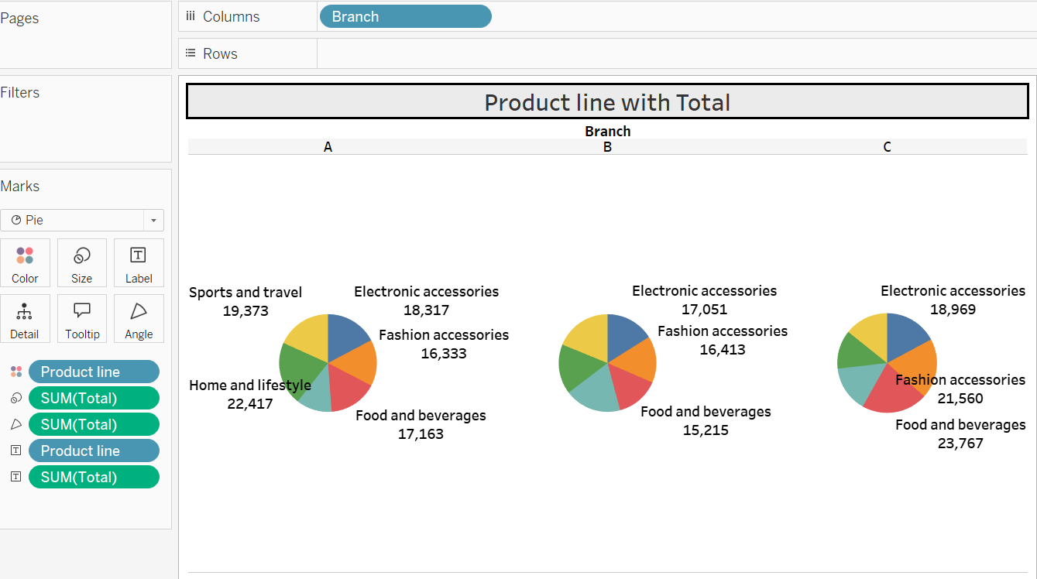

## 3. Stacked Bar Chart:-

* Breaks down product line sales by branch
* Highlights which products perform best per branch
* Useful for comparing category trends across branches

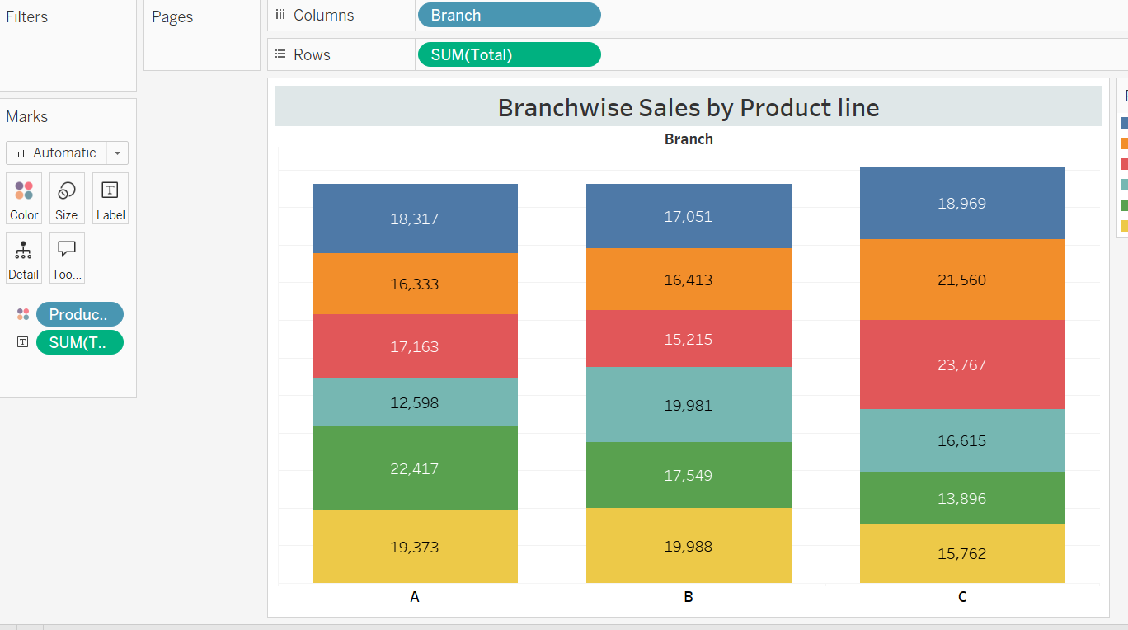

# 4. line chart:-

* Tracks total sales from Jan to Mar 2019
* Reveals ups and downs in monthly performance
* Helps understand sales trend over time

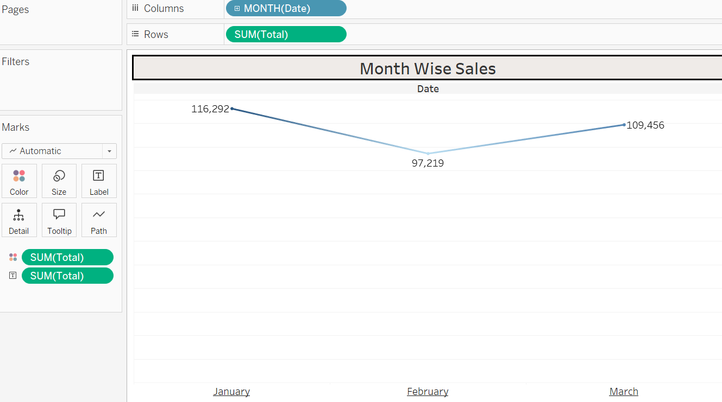

# 5. Bubble Chart:-

* Each bubble represents a product line
* Bubble size shows total revenue
* Food and Beverage has the highest sales

