Assignment-2

## 1. Donut Chart:-

* Shows profit distribution across Branch A,B and C
* Helps compare which branch earned the highest profit
* Quick view of branch-wise contribution to total profit

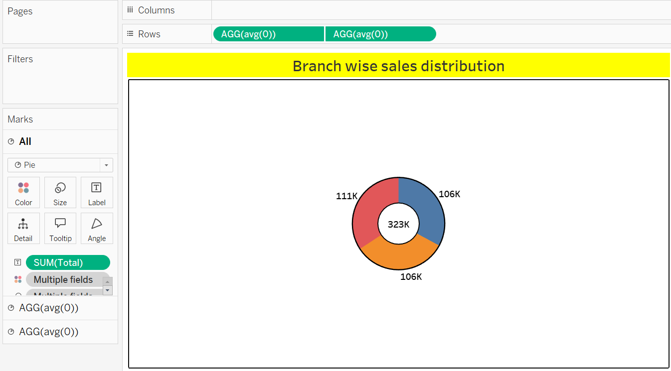

## 2. Area Chart:-

* Displays the profit trend from January to March 2019.
* Helps understand how profit increased or decreased over time.
* Useful for identifying peak or low-performing months.

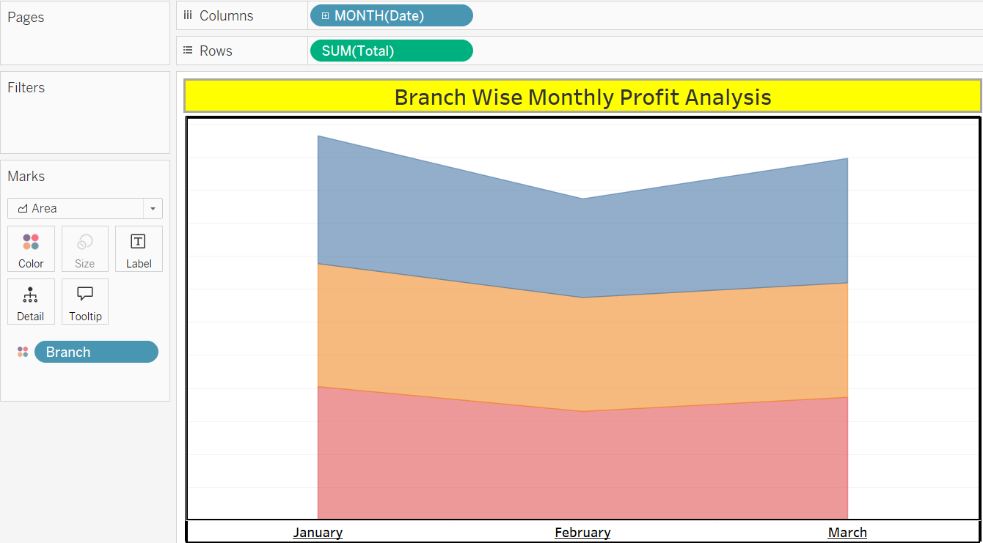

**Assignment-2**

## 3.Text table:-

* Shows exact profit values for each branch and product line month-wise.
* Easy to read detailed numerical data.
* Useful for accurate reporting and analysis.

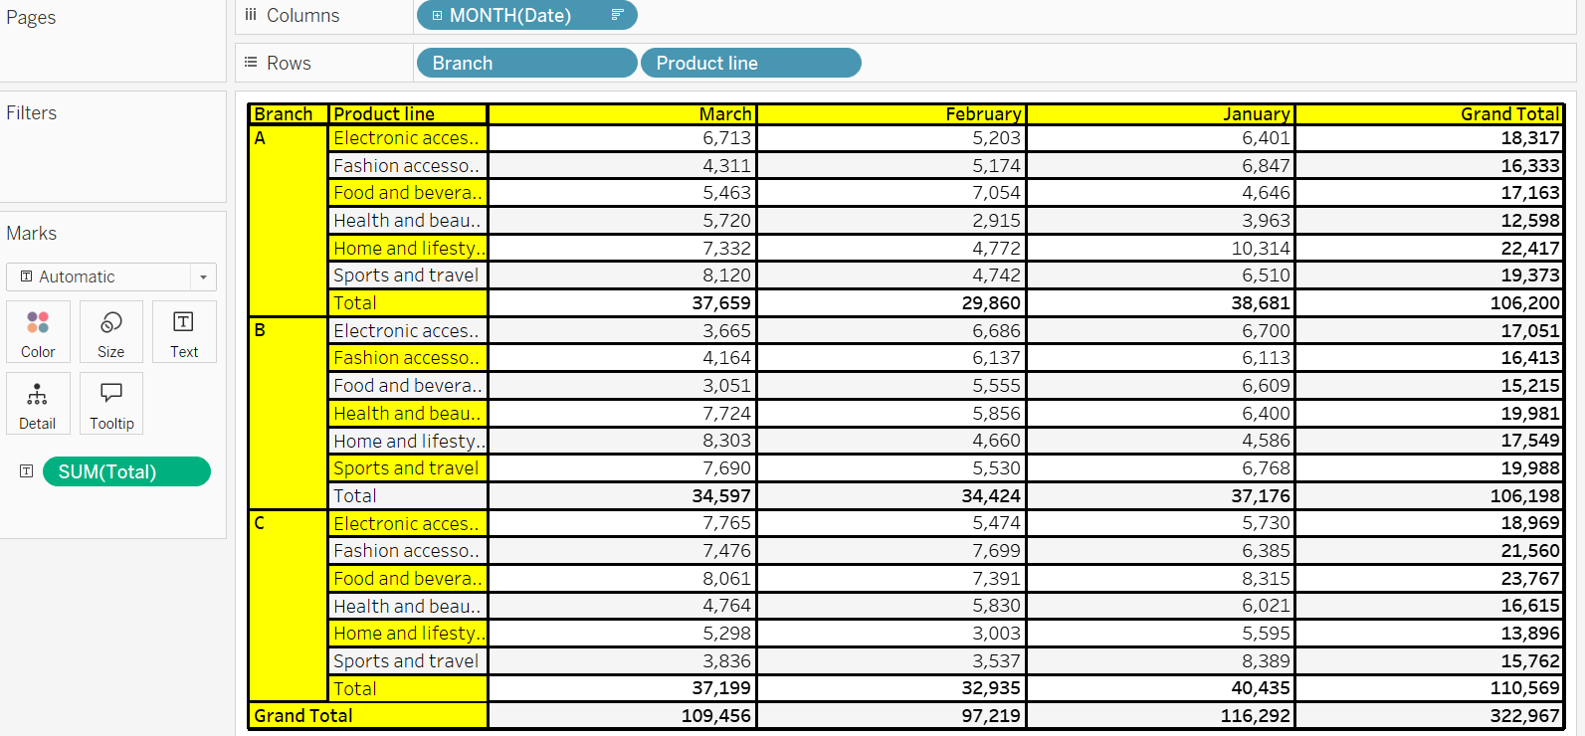

## 4. Highlighted Table :-

* Uses color shading to show high and low profits.
* Quickly identifies which product line performed better each month.
* Combines text with visual emphasis for better understanding.

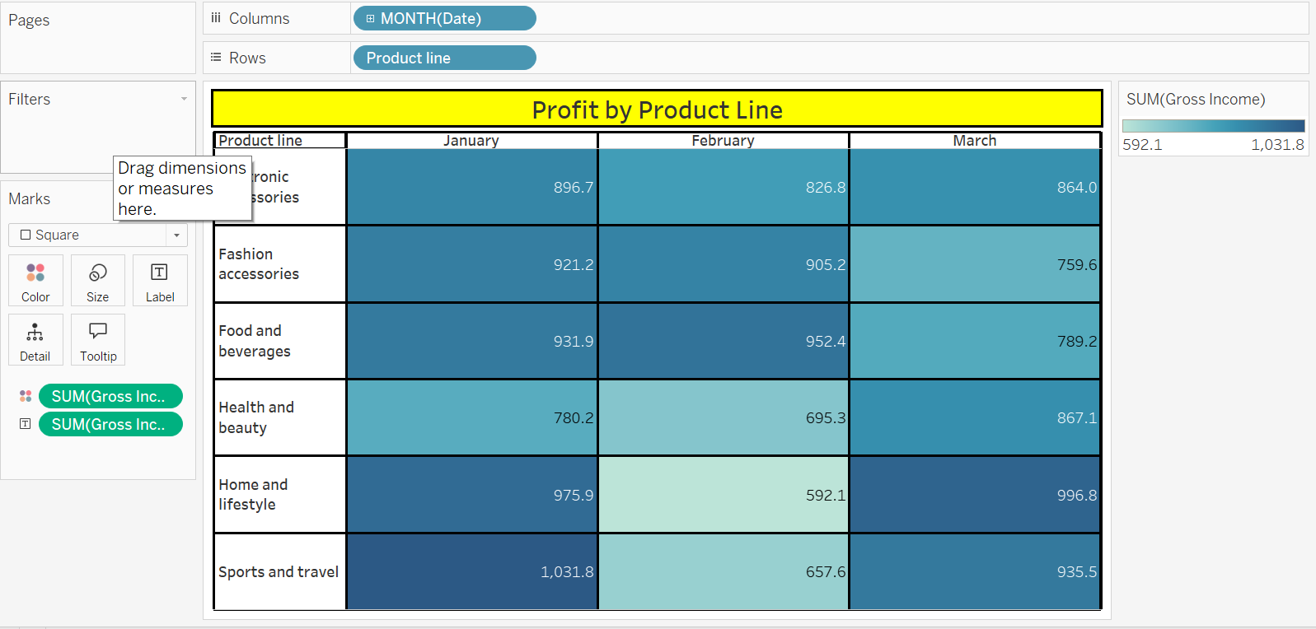

**Assignment-2**

## 5.word cloud:-

* Represents profit by product line- bigger words mean higher profit.
* Visualizes which product line is most profitable.
* Simple way to spot top-performing categories.

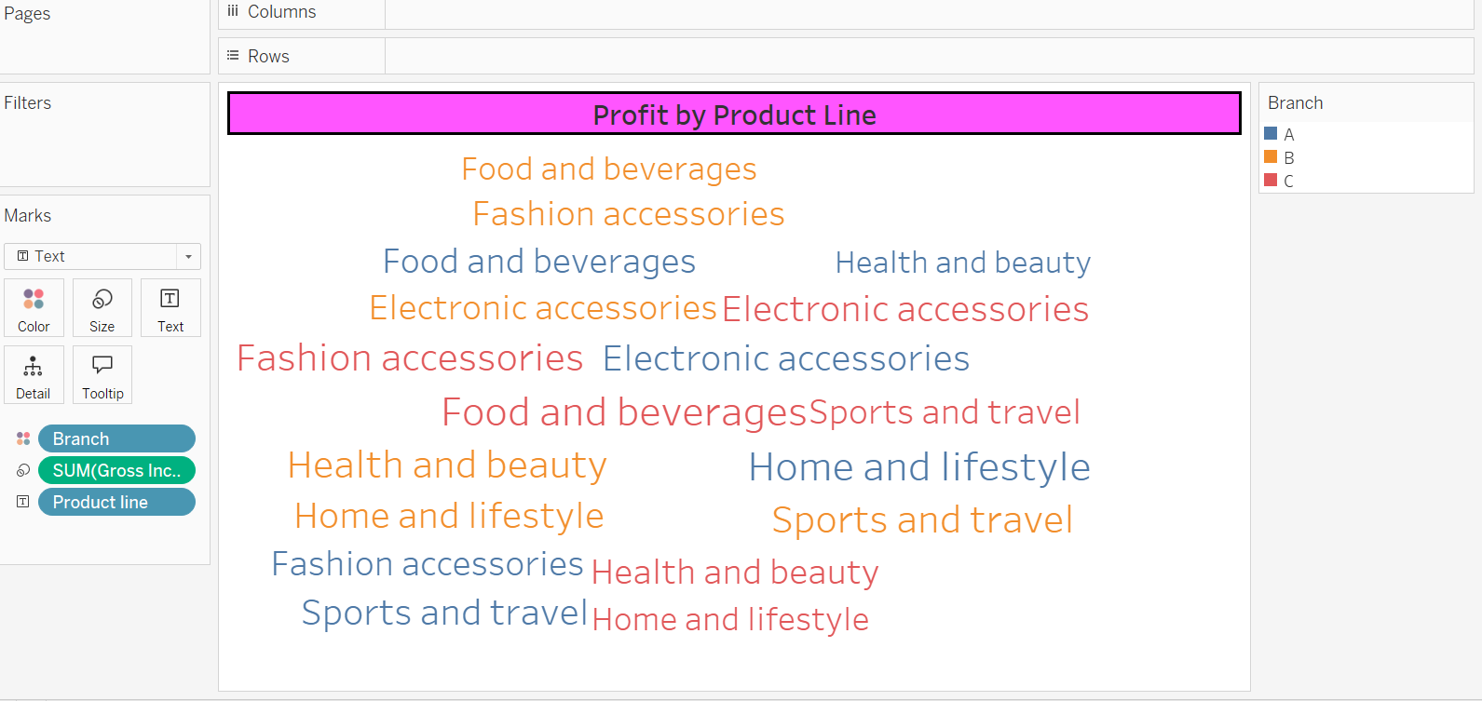

## 6. Funnel chart:-

* Shows profit from product lines in descending order.
* Wide at the top for highest profit, narrow at the bottom for lowest.
* Helps visualize contribution comparison among product lines.

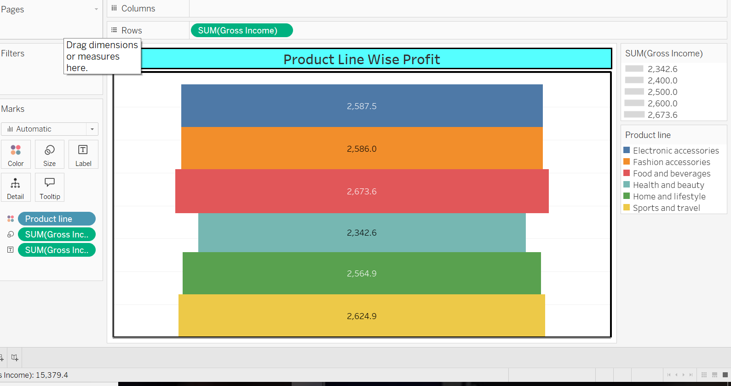

**Assignment-2**

## 7. waterfall Chart:-

* Displays how each product line adds up to total profit step by step.
* Helps understand cumulative growth in profit.
* Useful to track profit flow across different product lines.

