**Test Plan for Password Hashing Application**

**Table of Contents**

1. Introduction 1

2. Test Plan for Manual Testing 1

3. Test Approach for Automation Testing 1

4. Test Conclusion 2

## Introduction

This document covers **Functional Testing of Password Hashing Application of JumpCloud** and **Test Approach for Automation Testing**

## Test Plan for Manual Testing

Functional Testing covers following Modules/endpoints.

* + POST Endpoint (Test case 3 till 6)
  + GET Endpoint -using Job Identifier (Test case 7 till 10)
  + GET Endpoint (for Stats) (Test case 1,2 & 11,12)
  + Shutdown the application (Test Case 13 till 17)

(For actual testcases refer attached Excelsheet)

## Test Approach for Automation Testing

Once the identified bugs are eliminated and the application is stable, we can perform Automation testing whenever regression is required.

Automation can be employed for the following 2 scenarios:

1. Verify if all endpoints are working fine.

To do this, we can create a Batch file, and list all the commands to verify configured endpoints of the application and execute it in a single run

Refer to the below snippet on automation

1. Create a BATCH file and include commands (refer sample below):

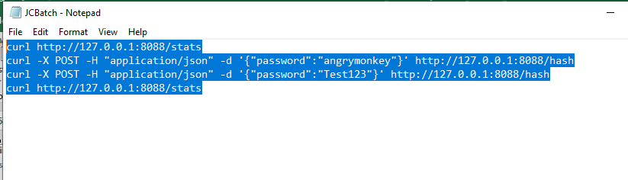

1. Run the batch file as shown below:

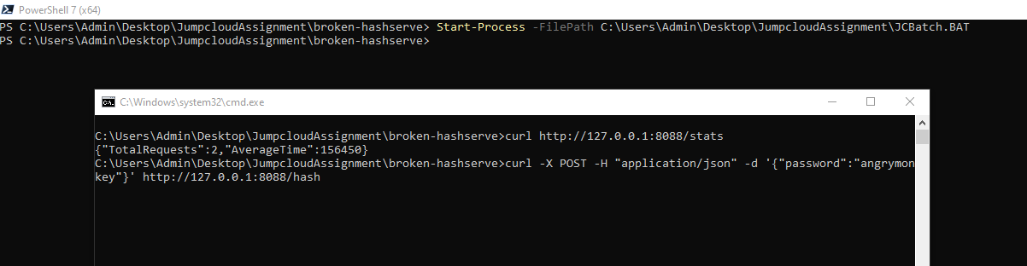

1. Perform test using JMETER to verify Parallel connections to test “Graceful Shutdown” Functionality.

## Test Conclusion

Functional Testing cannot be completed due to Identified bug(Bug1).

PFB test execution report

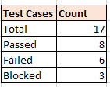

Bugs:

1. Bug1: For valid input for POST Endpoint, getting an error message as "Malformed Input"
2. Bug2: Though application shuts down, output is not getting displayed