**Comparison between Insertion and Selection Sort for**

**Ordered, Random Ordered, Partially Ordered and Reverse Ordered Arrays**

The actual time for insertion and selection sorts are K * N and K * N2 respectively, where K is the system constant,

To find constant K, K = c (1/f)

where c = constant and f is the frequency of operation

Frequency of clock in the system ~ 2.5 Ghz

Thus, K =c * 0.4 nanoseconds

Using trial and run method, the value of c varies between 0.1 -0.5

Hence, approximating, the value of c to be mean of 0.1 & 0.5 which is 2.5

Therefore, K =2.5 * 04 ns = 1 ns

using the trial and run method

1. For Ordered Arrays i.e, the elements are already in sorted ascending order

Here, order of insertion sort is O(N)

and for selection sort is O(N2)

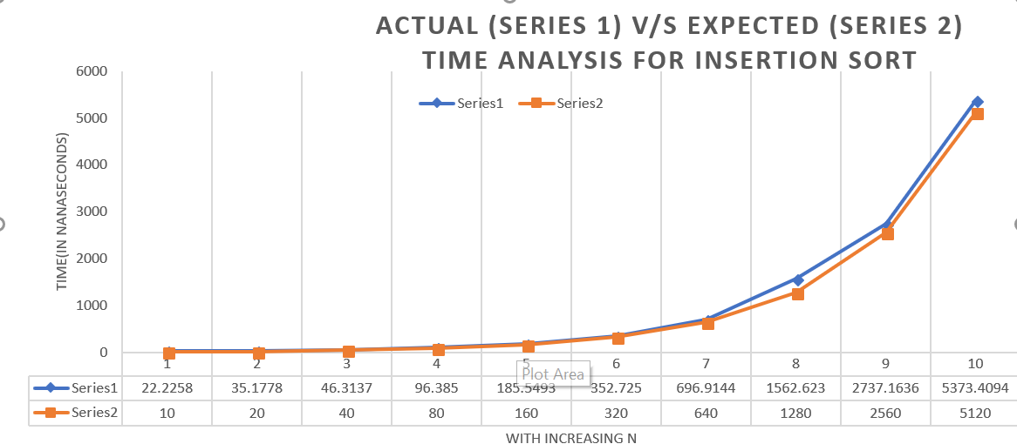

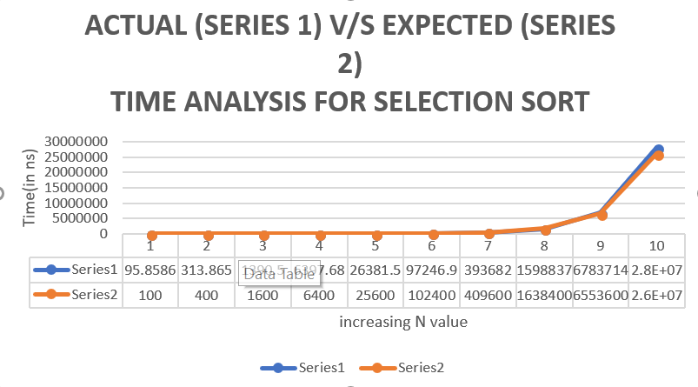

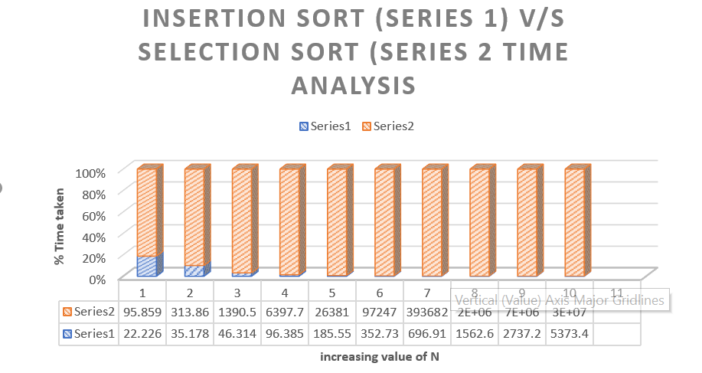

Thus, for ordered arrays, insertion sort takes negligible time compared to selection sort.

1. For Partially Ordered arrays,

Here, order of insertion sort is O(N)

and for selection sort is O(N2)

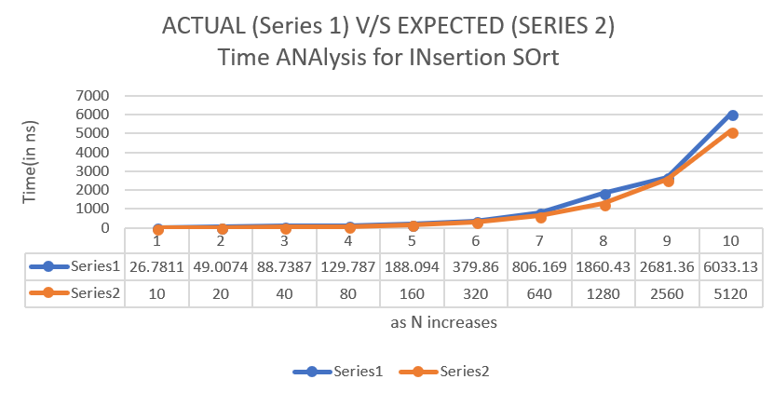

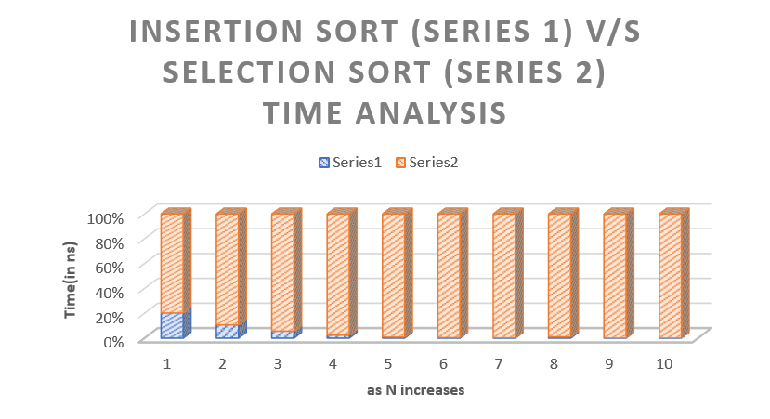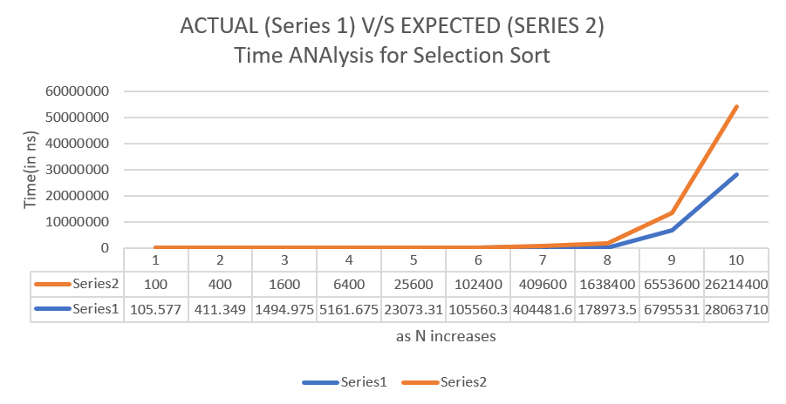

Hence, for partially ordered arrays, insertion sort performs better than selection sort.

1. For Random Ordered arrays

Here, order of insertion sort is O(N)- O(N2)

and for selection sort is O(N2)

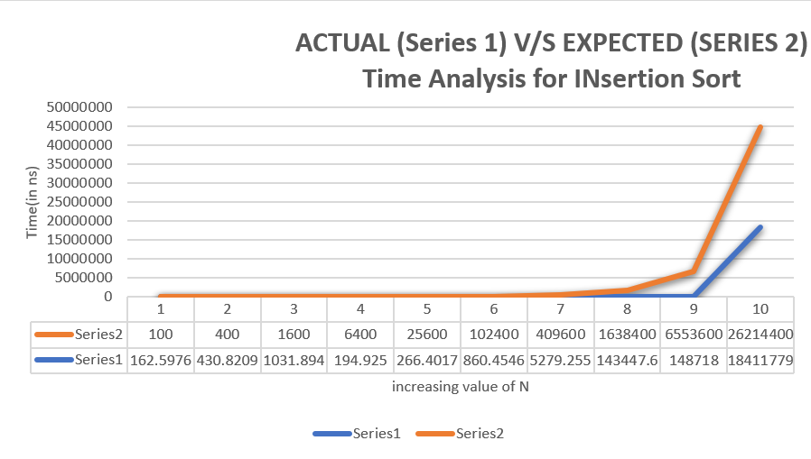

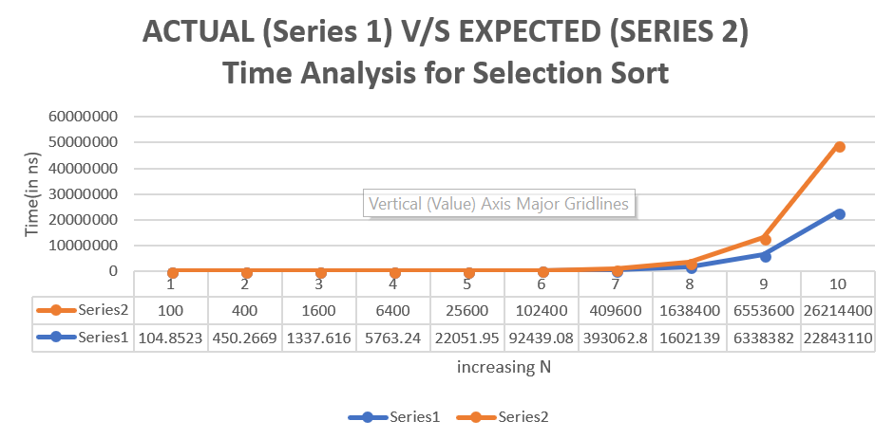

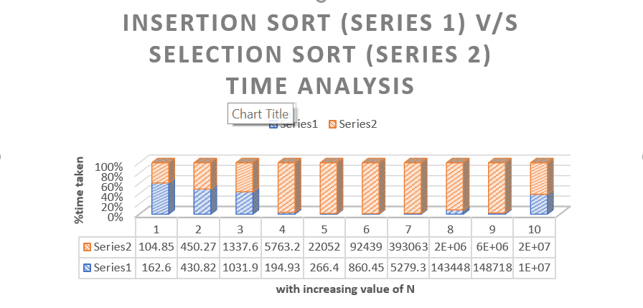

Hence, for random ordered arrays, insertion sort takes more time than when ordered or partially ordered and but still less time in comparison with selection sort time.

1. For reverse Order array

Here, order of insertion sort is O(N2)

and for selection sort is O(N2)

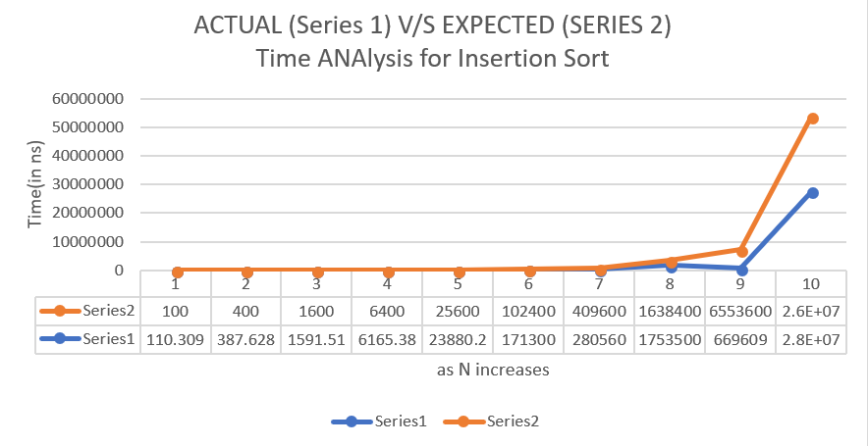

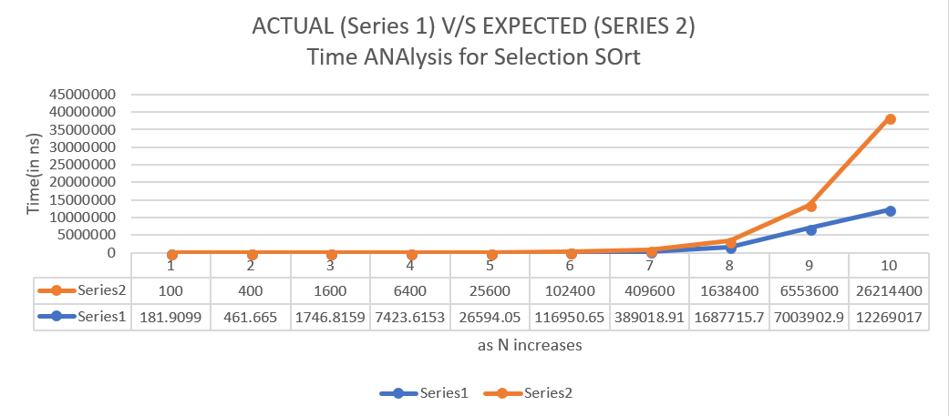

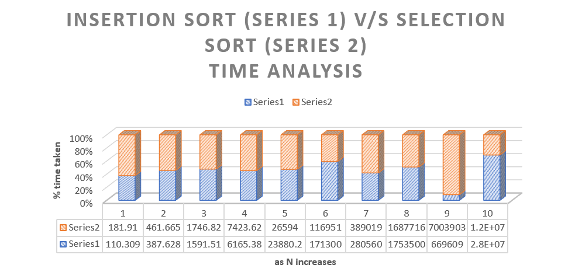

Hence, for reverse ordered arrays, insertion sort behaves same as selection sort.

**Conclusion:**

It is seen that time taken by Insertion sort is very less than time taken for sorting ordered or partially sorted array. Also, randomly allocated array takes less time than selection sort but more time than when the array is sorted. It can be observed that time of execution is increasing quadratically for insertion sort and selection except if the input is reverse sorted array