Critical Path Method (**CPM**)

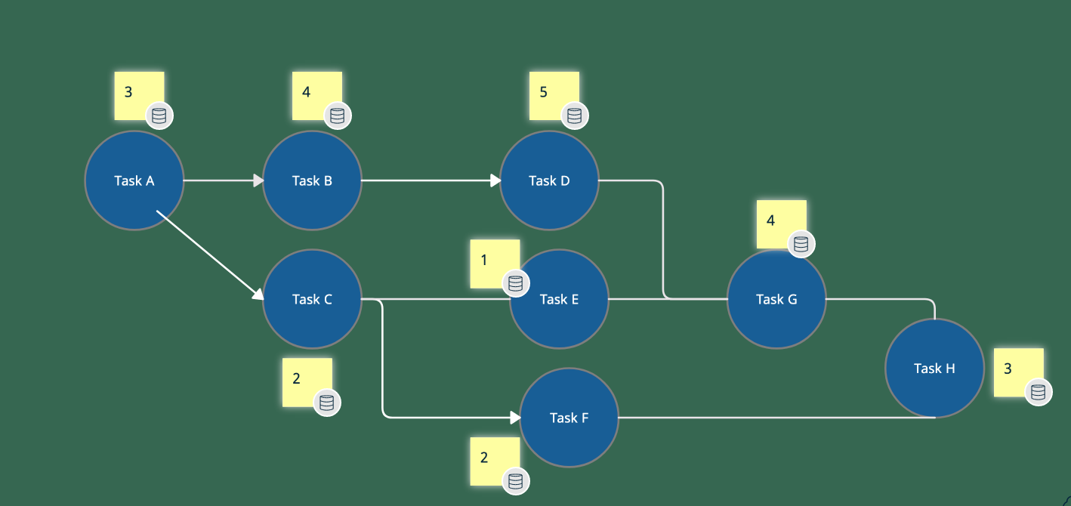

What is the delivery date? In **24 days**

Which tasks could be delayed without delaying the schedule?

Tasks **C**, **E**, **F**

2+1+4+2 = **9 days**