**Comp 421 A**

**Assignment 1**

**SQL Injection Attack Steps**

1. First we have to go to the bricks website.
2. Next go to login page.
3. Then click on the first login page.
4. Afterwards give any random username and password on the login page and then press enter.
5. Next an error message will be received notifying that wrong password and username was entered and a query was displayed showing what exactly was happening and accordingly how database is communicating with the browser.
6. Next we will replace the username with any random username and any statement should be written in password to make it run. Any sql statement should be written to make it run.
7. Next we have to copy, paste the payload in username and password fields of login page.
8. The login will be successful.
9. With the help of Burp Suite on the same login page the request will be intercepted by giving any password and username parameters.

**Screenshots**

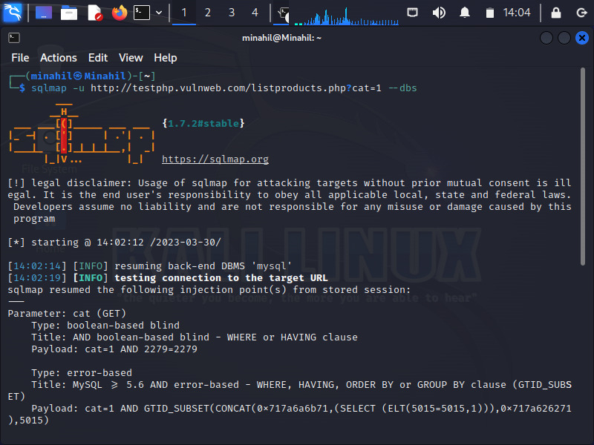

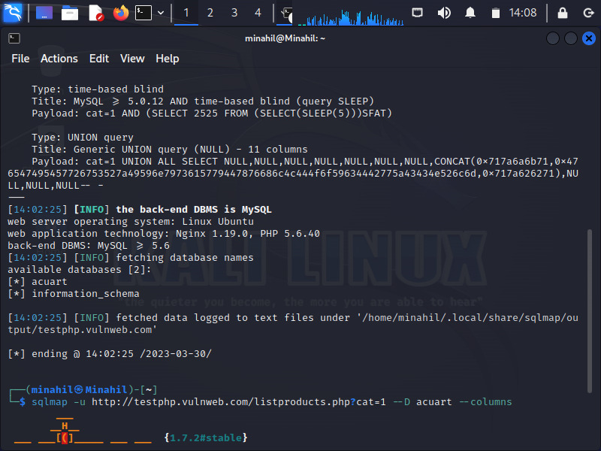

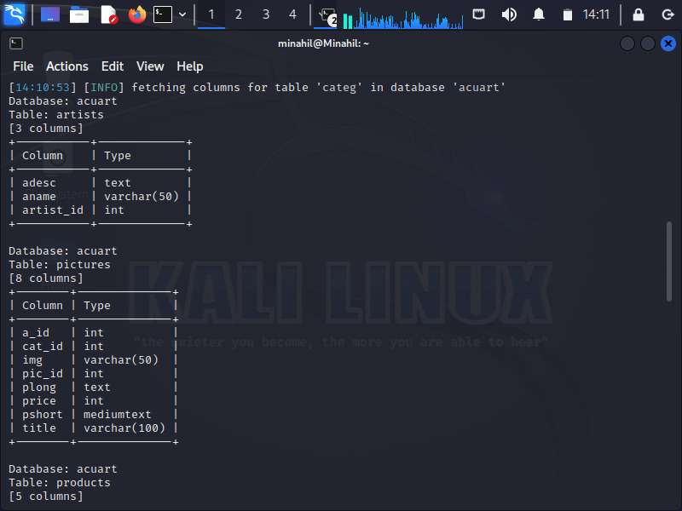

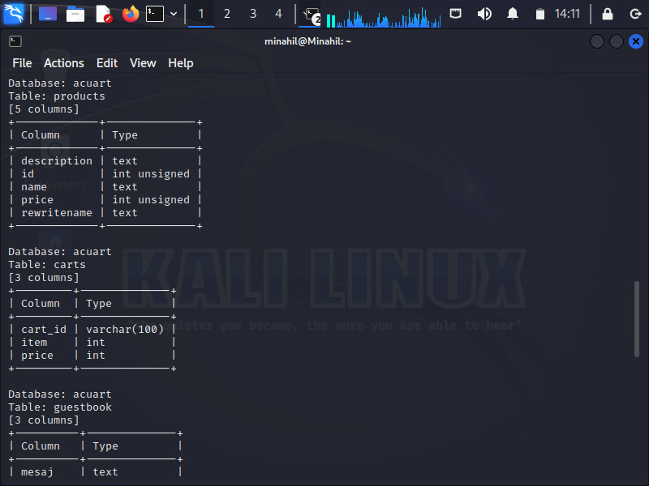

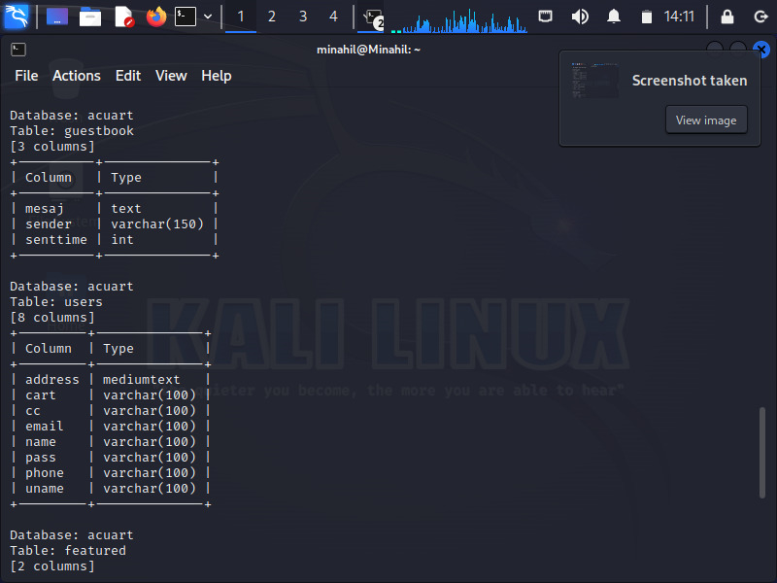

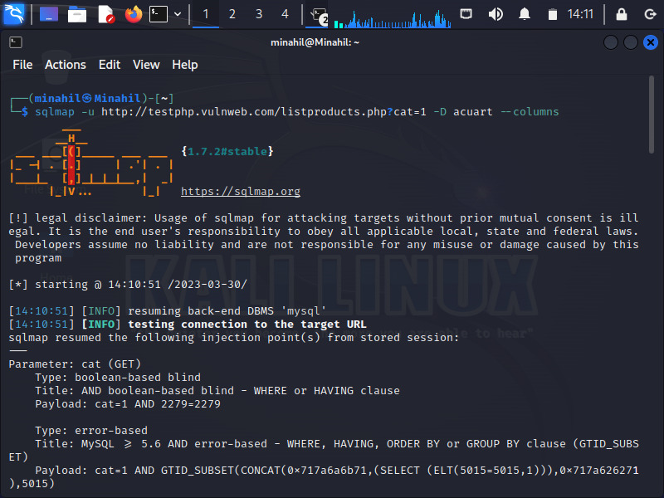

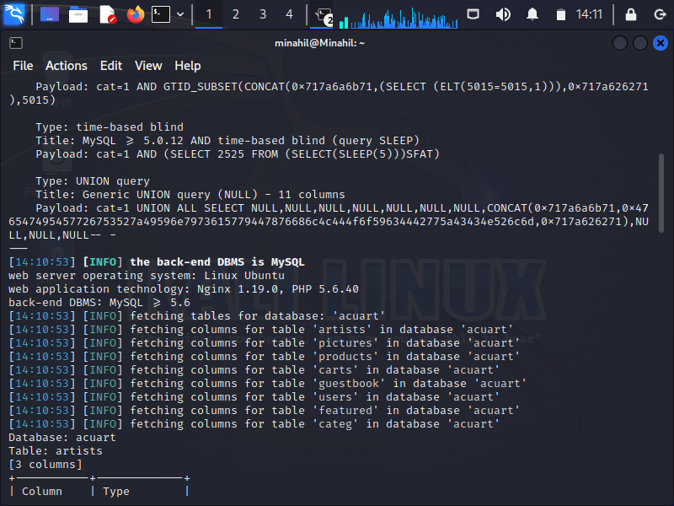

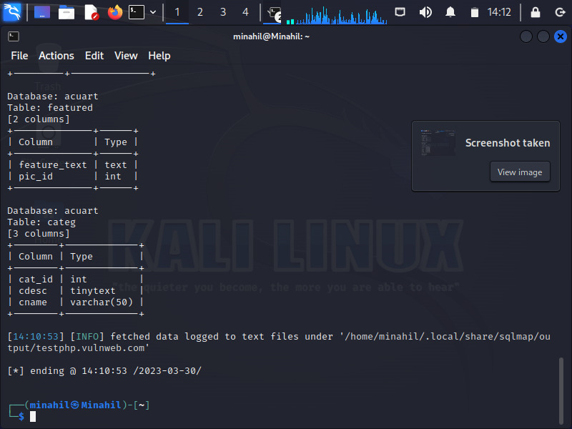

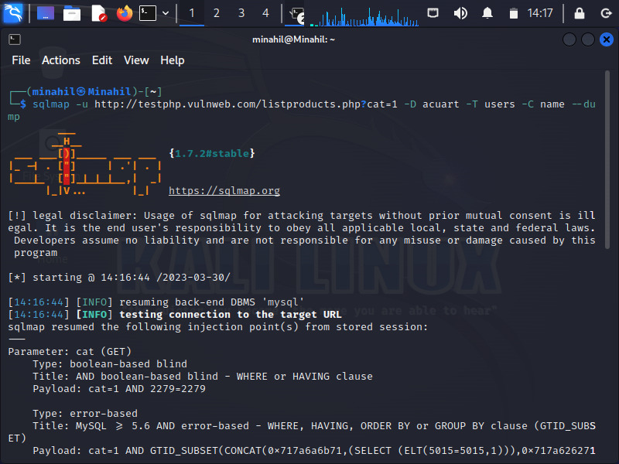

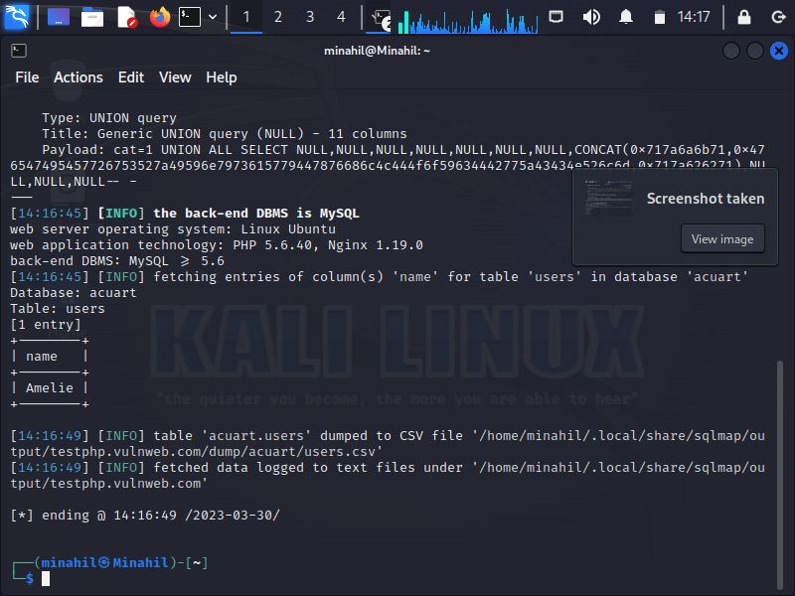

**Commands**

Commands written in the screenshots attached above.

**Dump**

name

amelie