

National Textile University
Department of Computer Science
Subject: Mobile application development

Submitted to: Sir Rehan

Submitted by: Maha

Reg. number: 23-NTU-CS-1170
Lab 6
Semester:6th

Lab Plan Week – 6 Mobile Application Development
- Create an application that has Icon button with toggle Icon that changes the theme of your application as dark or light theme. Create the button on the App bar. Hint: Use ternary Operator

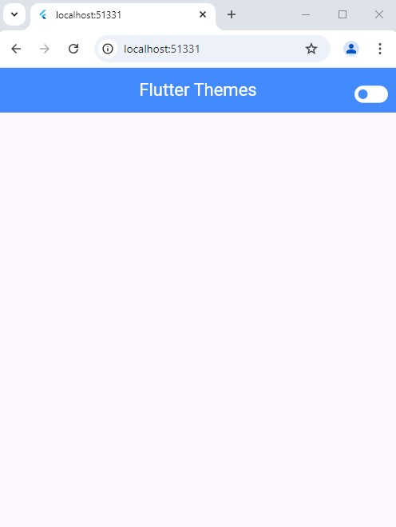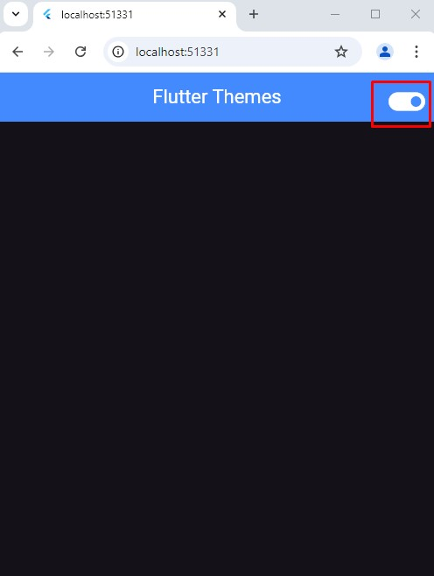

- Add some paragraphs of text on the screen and use the theme data class to implement the textTheme properties like font style, font size, and colors on the text.

- Apply Themes on cards, buttons and App bar.

Code:
import 'package:flutter/material.dart';

void main() {
runApp(MyApp());
}

class MyApp extends StatefulWidget {
@override
State<MyApp> createState() => _MyAppState();
}

class _MyAppState extends State<MyApp> {
bool isDark = false;

@override
Widget build(BuildContext context) {
return MaterialApp(
debugShowCheckedModeBanner: false,

// 🔹 Theme switching
theme: isDark ? darkTheme : lightTheme,

home: Scaffold(
appBar: AppBar(
title: Text("Flutter Themes"),

actions: [
IconButton(
icon: Icon(isDark ? Icons.light_mode : Icons.dark_mode),
onPressed: () {
setState(() {
isDark = !isDark;
});
},
),
],
),

body: Center(
child: Column(
mainAxisAlignment: MainAxisAlignment.center,
children: [
// 🔹 Text
Text(
"Hello Flutter!",
style: Theme.of(context).textTheme.headlineMedium,
),

SizedBox(height: 20),

// 🔹 Button
ElevatedButton(onPressed: () {}, child: Text("Click Me")),

SizedBox(height: 20),

// 🔹 Card
Card(
elevation: 5,
child: Padding(
padding: EdgeInsets.all(16),
child: Text(
"This is a card",
style: Theme.of(context).textTheme.bodyLarge,
),
),
),
],
),
),
),
);
}
}

//
// 🔹 LIGHT THEME
//
final ThemeData lightTheme = ThemeData(
brightness: Brightness.light,
primarySwatch: Colors.blue,

scaffoldBackgroundColor: Colors.white,

// 🔹 AppBar style
appBarTheme: AppBarTheme(
backgroundColor: Colors.blue,
foregroundColor: Colors.white,
),

// 🔹 Text styles
textTheme: TextTheme(
headlineMedium: TextStyle(
fontSize: 24,
fontWeight: FontWeight.bold,
color: Colors.black,
),
bodyLarge: TextStyle(fontSize: 18, color: Colors.black),
),

// 🔹 Button style
elevatedButtonTheme: ElevatedButtonThemeData(
style: ElevatedButton.styleFrom(
backgroundColor: Colors.blue,
foregroundColor: Colors.white,
),
),

cardTheme: CardThemeData(color: Colors.white),
);

//
// 🔹 DARK THEME
//
final ThemeData darkTheme = ThemeData(
brightness: Brightness.dark,

scaffoldBackgroundColor: Colors.black,

// 🔹 AppBar style
appBarTheme: AppBarTheme(
backgroundColor: Colors.grey,
foregroundColor: Colors.white,
),

// 🔹 Text styles
textTheme: TextTheme(
headlineMedium: TextStyle(
fontSize: 24,
fontWeight: FontWeight.bold,
color: Colors.white,
),
bodyLarge: TextStyle(fontSize: 18, color: Colors.white),
),

// 🔹 Button style
elevatedButtonTheme: ElevatedButtonThemeData(
style: ElevatedButton.styleFrom(
backgroundColor: Colors.grey,
foregroundColor: Colors.white,
),
),
cardTheme: CardThemeData(color: Colors.grey),
);

Terminal:
