

National Textile University
Department of Computer Science
Subject: Mobile Application

Submitted to: Sir rehan

Submitted by: Maha

Reg. number: 23-NTU-CS-1170
Lab 5
Semester:6th

Lab Plan – 5

Create an App “Xylophone”,
- The app provides a graphical representation of a xylophone, usually with colorful bars or keys that resemble those of a real xylophone.
- Users can tap on the virtual xylophone bars to produce sounds.
Package: import 'package:audioplayers/audioplayers.dart';
Flutter Dependency: audioplayers: ^0.20.1
Code:
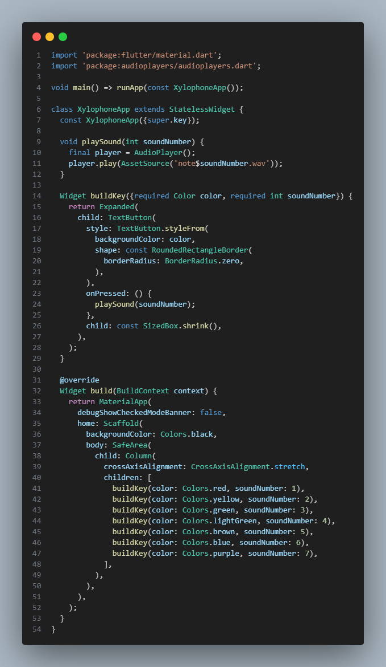
Terminal:
