

National Textile University
Department of Computer Science
Subject: Mobile Application & Development

Submitted to: Sir Rehan

Submitted by: Maha

Reg. number: 23-NTU-CS-1170
Lab 7
Semester:6th

Lab Plan 7: Interactive Flutter UIs (Gestures & Sliders)
Course: Mobile Application Development
Duration: 3 Hours (180 Minutes)

Phase 1: GestureDetector
- Task 1.1: Create a Container (200x200) with a unique background color.
- Task 1.2: Wrap the container in a GestureDetector.
- Task 1.3: Logic Implementation:
  - onTap: Change the container's color to a random Colors value. o onDoubleTap: Toggle the borderRadius between 0 and 100 (Square to Circle).
  - onLongPress: Show a SnackBar saying "Resetting..." and return the box to its original state.
Code:
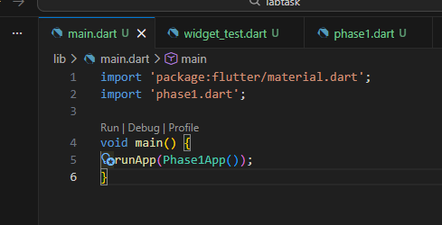
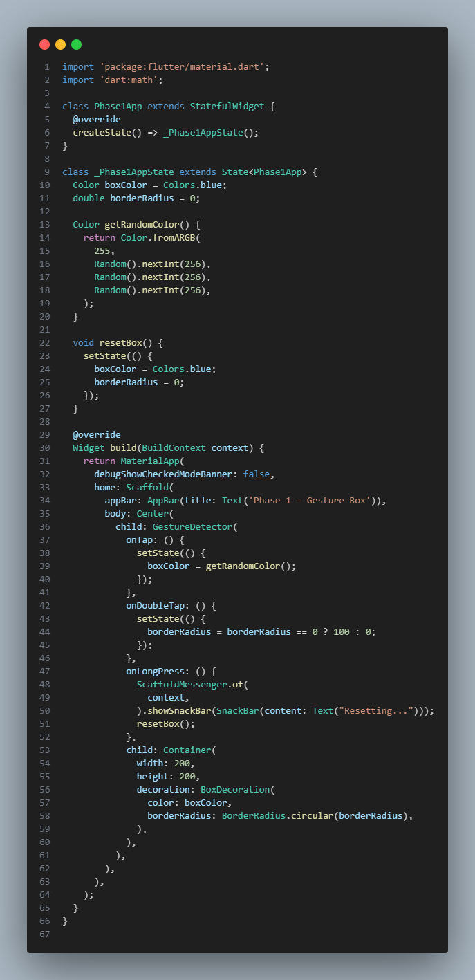

Terminal:
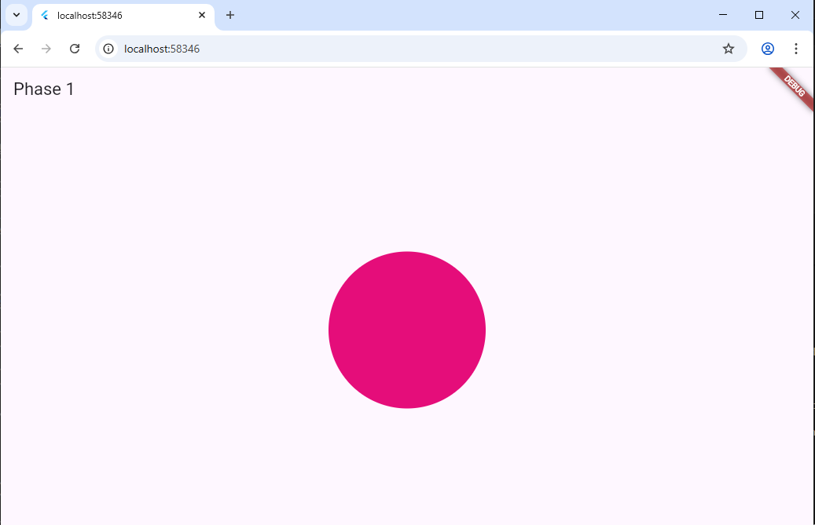
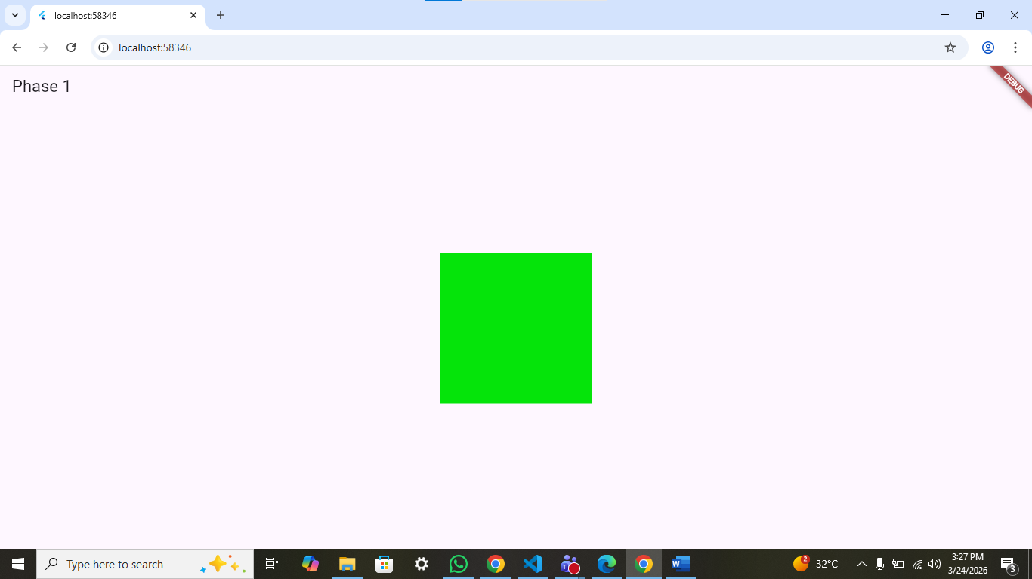
Phase 2: Sliders
- Task 2.1: Create a vertical Column containing a Text widget displaying a "Value" variable.
- Task 2.2: Add a Slider widget:
  - Set min to 0.0 and max to 100.0.
  - Set divisions to 10 to create discrete steps.
  - Update the "Value" text in real-time within onChanged.
- Task 2.3: Implement a CupertinoSlider below the Material one to observe the difference in native "look and feel."
Code:
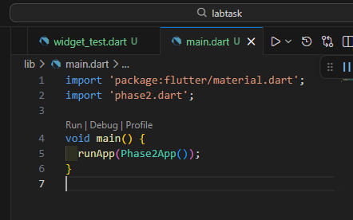
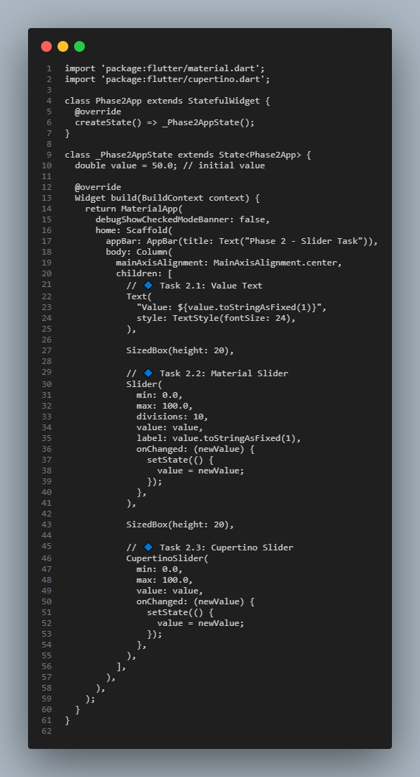
Terminal:
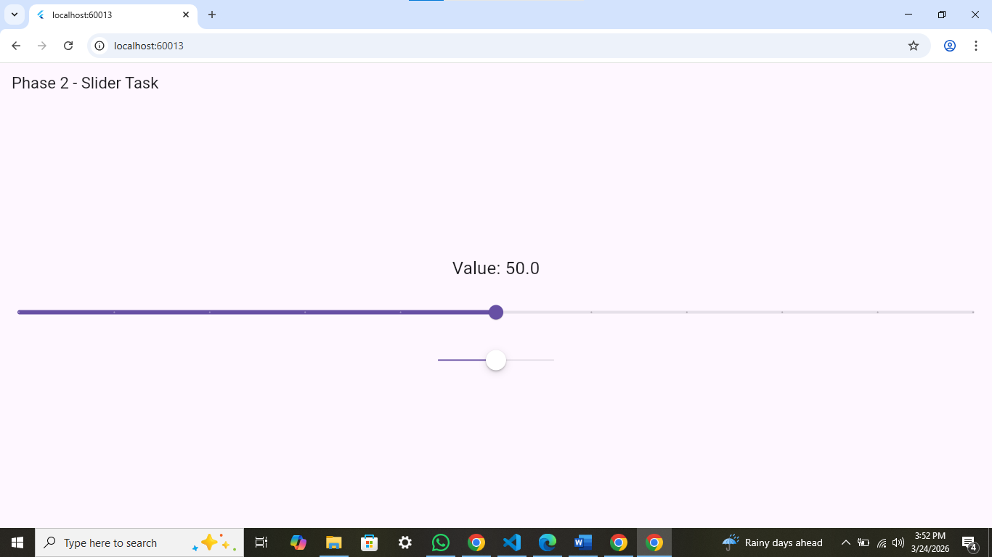
Phase 3: The "Mood & Color" Mixer
The Challenge: Build a mini-app on a single screen where:
- Three Sliders control the Red, Green, and Blue channels of a preview box.
- A GestureDetector on the preview box allows the user to Long Press to "Copy" the Hex code to the console.
- Horizontal Drag (onHorizontalDragUpdate): Should scale the size of the preview box up or down.
Code:
import 'package:flutter/material.dart';

class Phase3App extends StatefulWidget {
@override
createState() => _Phase3AppState();
}

class _Phase3AppState extends State<Phase3App> {
double red = 0;
double green = 0;
double blue = 0;

double boxSize = 150; // initial size

// Convert RGB to HEX
String getHexColor() {
int r = red.toInt();
int g = green.toInt();
int b = blue.toInt();
return "#${r.toRadixString(16).padLeft(2, '0')}"
"${g.toRadixString(16).padLeft(2, '0')}"
"${b.toRadixString(16).padLeft(2, '0')}"
.toUpperCase();
}

@override
Widget build(BuildContext context) {
Color currentColor = Color.fromRGBO(
red.toInt(),
green.toInt(),
blue.toInt(),
1,
);

return MaterialApp(
debugShowCheckedModeBanner: false,
home: Scaffold(
appBar: AppBar(title: Text("Phase 3 - Mood & Color Mixer")),
body: Column(
mainAxisAlignment: MainAxisAlignment.center,
children: [
// 🎨 Preview Box with GestureDetector
GestureDetector(
onLongPress: () {
print("Copied HEX: ${getHexColor()}");
},
onHorizontalDragUpdate: (details) {
setState(() {
boxSize += details.delta.dx;

// limit size
if (boxSize < 50) boxSize = 50;
if (boxSize > 300) boxSize = 300;
});
},
child: Container(
width: boxSize,
height: boxSize,
color: currentColor,
),
),

SizedBox(height: 20),

// 🔴 Red Slider
Text("Red: ${red.toInt()}"),
Slider(
min: 0,
max: 255,
value: red,
activeColor: Colors.red,
onChanged: (value) {
setState(() {
red = value;
});
},
),

// 🟢 Green Slider
Text("Green: ${green.toInt()}"),
Slider(
min: 0,
max: 255,
value: green,
activeColor: Colors.green,
onChanged: (value) {
setState(() {
green = value;
});
},
),

// 🔵 Blue Slider
Text("Blue: ${blue.toInt()}"),
Slider(
min: 0,
max: 255,
value: blue,
activeColor: Colors.blue,
onChanged: (value) {
setState(() {
blue = value;
});
},
),

SizedBox(height: 10),

// HEX display
Text(
"HEX: ${getHexColor()}",
style: TextStyle(fontSize: 18, fontWeight: FontWeight.bold),
),
],
),
),
);
}
}

Terminal:
