Logistic Regression for AI Adoption Prediction

Introduction
Logistic Regression is a supervised Machine Learning algorithm used for classification problems. Although its name contains the word "regression," it is primarily used to predict categorical outcomes. In this project, Logistic Regression can be used to predict whether a person will adopt Artificial Intelligence tools based on demographic and behavioral characteristics.
The target variable in this study is AI Adoption, which has two possible outcomes:
- Uses AI = 1
- Does Not Use AI = 0
Since the dependent variable is binary, Logistic Regression is an appropriate model for this prediction task.

Objective
The objective of using Logistic Regression in this project is to estimate the probability that an individual will use AI tools based on factors such as:
- Age
- Gender
- Education Level
- Industry
- Profession
- Fear Level regarding AI
- Weekly AI Usage Hours
- Productivity Impact
The model predicts the likelihood of AI adoption and classifies users into adopter or non-adopter categories.

Working Principle
Logistic Regression first calculates a weighted combination of input features:
z = w_1x_1 + w_2x_2 + ... + w_nx_n + b
Where:
- (x) = Input features
- (w) = Feature weights
- (b) = Bias term
The calculated value is then passed through the Sigmoid Function:
P(y=1)=\frac{1}{1+e^{-z}}
The Sigmoid function converts any value into a probability between 0 and 1.
For example:
- Probability = 0.85 → 85% chance of AI adoption
- Probability = 0.25 → 25% chance of AI adoption
A threshold value of 0.5 is generally used:
- Probability ≥ 0.5 → AI User
- Probability < 0.5 → Non-AI User

Why Logistic Regression is Suitable for This Project

1. Binary Classification
The project aims to predict whether a person adopts AI or not. Logistic Regression is specifically designed for binary classification problems.

2. Interpretability
The model provides coefficients for each feature, making it easy to understand the factors influencing AI adoption.
For example:
- Positive coefficient → Increases AI adoption probability.
- Negative coefficient → Decreases AI adoption probability.
This helps identify important drivers and barriers of AI adoption.

3. Probability Prediction
Unlike many classification models, Logistic Regression provides probability scores.
Example:
- Person A → 92% probability of using AI.
- Person B → 45% probability of using AI.
These probabilities help organizations identify potential adopters.

4. Fast Training and Prediction
The model is computationally efficient and works well even on moderate-sized datasets.

5. Reduced Risk of Overfitting
When regularization techniques are applied, Logistic Regression generalizes well and performs effectively on unseen data.

Features Used in the Model
The following independent variables can be used for prediction:
Feature | Description
Age | Respondent's age
Gender | Male/Female
Education Level | Educational qualification
Industry | Working industry
Profession | Job role
Fear Level | Fear regarding AI technologies
Weekly AI Usage Hours | Time spent using AI
Productivity Impact | Impact of AI on productivity
Target Variable:
Uses AI (Yes/No)

Model Flow for AI Adoption Prediction

Step 1: Data Collection
The process begins with collecting AI adoption survey data. The dataset contains demographic and behavioral information such as:
- Age
- Gender
- Education Level
- Industry
- Profession
- Fear Level regarding AI
- Weekly AI Usage Hours
- Productivity Impact
- Uses AI (Target Variable)

Step 2: Data Cleaning and Preprocessing
The collected data is cleaned to improve quality and reliability.
Activities include:
- Handling missing values
- Removing duplicate records
- Standardizing categorical values
- Feature engineering
- Converting categorical variables into numerical format
- Creating derived features such as Age Groups and Fear Categories
The cleaned dataset is then stored for further analysis.

Step 3: Exploratory Data Analysis (EDA)
EDA is performed to understand patterns and trends in the data.
Key analyses include:
- AI adoption rate by age group
- AI adoption rate by industry
- AI adoption rate by education level
- Most frequently used AI tools
- Productivity impact of AI
Visualizations help identify important relationships before model building.

Step 4: Feature Selection
Relevant features are selected as input variables for the machine learning model.
Selected Features:
- Age
- Gender
- Education Level
- Industry
- Profession
- Fear Level
- Weekly AI Usage Hours
- Productivity Impact
Target Variable:
- Uses AI (Yes = 1, No = 0)

Step 5: Data Splitting
The dataset is divided into two parts:
- Training Data (80%)
- Testing Data (20%)
Training data is used to train the model, while testing data is used to evaluate its performance on unseen records.

Step 6: Feature Encoding
Machine learning algorithms cannot directly process text values.
Therefore, categorical features such as:
- Gender
- Industry
- Education Level
are converted into numerical representations using One-Hot Encoding.

Step 7: Model Training
The Logistic Regression model is trained using the training dataset.
During training, the model learns relationships between input features and AI adoption behavior.
The model calculates coefficients that represent the influence of each feature on AI adoption.

Step 8: Probability Calculation
For each individual, the model calculates the probability of AI adoption using the Sigmoid Function.
Output Example:
- User A → 0.90 (90% probability of adopting AI)
- User B → 0.25 (25% probability of adopting AI)

Step 9: Classification
A threshold value of 0.5 is applied.
- Probability ≥ 0.5 → AI User
- Probability < 0.5 → Non-AI User
The model assigns the final class label accordingly.

Step 10: Model Evaluation
The model's performance is evaluated using:
- Accuracy
- Precision
- Recall
- F1-Score
- Confusion Matrix
These metrics indicate how well the model predicts AI adoption.
Codes:
Add Data:
import pandas as pd
import numpy as np
import random

# Load existing raw data
try:
df = pd.read_excel('ai_adoption_data.xlsx')
print(f"Loaded existing data with {len(df)} rows from Excel.")
except FileNotFoundError:
try:
df = pd.read_csv('ai_adoption_data.csv')
print(f"Loaded existing data with {len(df)} rows from CSV.")
except FileNotFoundError:
print("No existing raw data found. Starting fresh.")
df = pd.DataFrame()

# Generate synthetic data
n_new = 200
names = ['John', 'Jane', 'Alex', 'Emily', 'Chris', 'Katie', 'Mike', 'Sarah', 'David', 'Laura', 'Tom', 'Anna', 'James', 'Lisa', 'Robert', 'Jessica', 'William', 'Ashley', 'Michael', 'Amanda']
cities = ['New York', 'San Francisco', 'Chicago', 'Austin', 'Seattle', 'Boston', 'Denver', 'Miami', 'Atlanta', 'Dallas']
industries = ['IT', 'Marketing', 'Education', 'Healthcare', 'Finance', 'Retail', 'Manufacturing', 'Logistics']
professions = ['Manager', 'Analyst', 'Developer', 'Designer', 'Consultant', 'Specialist', 'Director', 'Coordinator', 'Engineer']
ai_tools_list = ['ChatGPT', 'Claude', 'Google Gemini', 'Midjourney', 'GitHub Copilot', 'Tableau', 'Excel', 'Notion AI', 'Jasper']
productivity_impacts = ['Positive', 'Neutral', 'Very Positive', 'Negative']

new_data = []
for _ in range(n_new):
uses_ai = random.choice(['Yes', 'Yes', 'Yes', 'No']) # 75% adoption rate
tools = ", ".join(random.sample(ai_tools_list, random.randint(1, 3))) if uses_ai == 'Yes' else None
hours = random.randint(2, 30) if uses_ai == 'Yes' else 0
# Fear level correlates with AI usage (users are generally less fearful)
fear = random.randint(1, 3) if uses_ai == 'Yes' else random.randint(3, 5)

row = {
'Name': random.choice(names),
'Age': random.randint(22, 60),
'Gender': random.choice(['Male', 'Female']),
'City': random.choice(cities),
'Industry': random.choice(industries),
'Profession': random.choice(professions),
'Uses AI': uses_ai,
'AI Tools': tools,
'Fear Level (1-5)': fear,
'Hours/Week': hours,
'Experience (Yrs)': random.randint(1, 30),
'Productivity Impact': random.choice(productivity_impacts) if uses_ai == 'Yes' else 'Neutral'
}
new_data.append(row)

df_new = pd.DataFrame(new_data)

if not df.empty:
df_combined = pd.concat([df, df_new], ignore_index=True)
else:
df_combined = df_new

# Save as CSV (data_cleaning.py prioritizes CSV)
df_combined.to_csv('ai_adoption_data.csv', index=False)
print(f"Successfully added {n_new} synthetic rows.")
print(f"Total rows in raw dataset now: {len(df_combined)}")
print("Saved to 'ai_adoption_data.csv'.")

Data Cleaning:
# ============================================
# DATA CLEANING SCRIPT FOR AI ADOPTION PROJECT
# ============================================

# Import required libraries
import pandas as pd
import numpy as np
import warnings
warnings.filterwarnings('ignore')

print("=" * 60)
print("STEP 2: DATA CLEANING & PREPARATION")
print("=" * 60)

# ============================================
# 1. LOAD THE DATA
# ============================================

print("\n1. LOADING DATA...")

# Try loading from CSV or Excel
try:
# If you saved as CSV
df = pd.read_csv('ai_adoption_data.csv')
print("Data loaded from CSV file")
except:
try:
# If you saved as Excel
df = pd.read_excel('ai_adoption_data.xlsx')
print("Data loaded from Excel file")
except FileNotFoundError:
# Manual data entry (if file not found)
print("File not found. Creating sample data...")

data = {
'Name': ['Alice', 'Bob', 'Carlos', 'Deepa', 'Emma'],
'Age': [28, 34, 22, 41, 30],
'Gender': ['Female', 'Male', 'Male', 'Female', 'Female'],
'City': ['New York', 'San Francisco', 'Chicago', 'Austin', 'Seattle'],
'Industry': ['IT', 'Marketing', 'Education', 'Healthcare', 'Finance'],
'Profession': ['Data Analyst', 'Marketing Manager', 'Teacher', 'Nurse', 'Accountant'],
'Uses AI': ['Yes', 'No', 'Yes', 'Yes', 'No'],
'AI Tools': ['ChatGPT, Tableau', None, 'Google Bard', 'IBM Watson, Excel', None],
'Fear Level (1-5)': [3, 4, 2, 5, 1],
'Hours/Week': [10, 0, 5, 20, 0],
'Experience (Yrs)': [4, 8, 1, 12, 6],
'Productivity Impact': ['Positive', 'Neutral', 'Very Positive', 'Positive', 'Neutral']
}

df = pd.DataFrame(data)
print("Sample data created successfully")

print(f"Data shape: {df.shape[0]} rows, {df.shape[1]} columns")
print(f"Columns: {list(df.columns)}")

# ============================================
# 2. DATA INSPECTION
# ============================================

print("\n2. DATA INSPECTION...")

print("\nFirst 5 rows:")
print(df.head())

print("\nData types:")
print(df.dtypes)

print("\nStatistical summary (numeric columns):")
print(df.describe())

print("\nMissing values check:")
missing = df.isnull().sum()
print(missing[missing > 0] if any(missing > 0) else "No missing values found!")

# ============================================
# 3. HANDLE MISSING VALUES
# ============================================

print("\n3. HANDLING MISSING VALUES...")

# Check for missing values
if df.isnull().sum().sum() > 0:
print(f"Found {df.isnull().sum().sum()} missing values")

# For 'AI Tools' column - replace NaN with 'None'
if 'AI Tools' in df.columns:
before = df['AI Tools'].isnull().sum()
df['AI Tools'] = df['AI Tools'].fillna('None')
print(f"Filled {before} missing values in 'AI Tools' with 'None'")

# For any other numeric columns - fill with median
numeric_cols = df.select_dtypes(include=[np.number]).columns
for col in numeric_cols:
if df[col].isnull().sum() > 0:
median_val = df[col].median()
df[col] = df[col].fillna(median_val)
print(f"Filled missing values in '{col}' with median: {median_val}")
else:
print("No missing values to handle!")

# ============================================
# 4. REMOVE DUPLICATES
# ============================================

print("\n4. CHECKING FOR DUPLICATES...")

duplicates = df.duplicated().sum()
if duplicates > 0:
print(f"Found {duplicates} duplicate rows")
df = df.drop_duplicates()
print(f"Removed duplicates. New shape: {df.shape}")
else:
print("No duplicate rows found!")

# ============================================
# 5. FIX DATA TYPES
# ============================================

print("\n5. FIXING DATA TYPES...")

# Convert 'Uses AI' to binary (0/1)
df['Uses_AI_Binary'] = (df['Uses AI'] == 'Yes').astype(int)
print("Created 'Uses_AI_Binary' column (1=Yes, 0=No)")

# Convert 'Fear Level' to int (ensure it's numeric)
df['Fear Level (1-5)'] = pd.to_numeric(df['Fear Level (1-5)'], errors='coerce')
print("Converted 'Fear Level (1-5)' to numeric")

# Convert 'Hours/Week' to numeric
df['Hours/Week'] = pd.to_numeric(df['Hours/Week'], errors='coerce')
print("Converted 'Hours/Week' to numeric")

# Convert 'Experience (Yrs)' to numeric
df['Experience (Yrs)'] = pd.to_numeric(df['Experience (Yrs)'], errors='coerce')
print("Converted 'Experience (Yrs)' to numeric")

# Create High Fear flag (Fear >= 4)
df['High_Fear'] = (df['Fear Level (1-5)'] >= 4).astype(int)
print("Created 'High_Fear' column (1=Fear>=4, 0=Fear<4)")

# Create Productivity Score
prod_map = {'Very Positive': 3, 'Positive': 2, 'Neutral': 1}
df['Productivity_Score'] = df['Productivity Impact'].map(prod_map)
print("Created 'Productivity_Score' column")

# ============================================
# 6. ADD USEFUL CALCULATED COLUMNS
# ============================================

print("\n6. ADDING CALCULATED COLUMNS...")

# Extract main AI tool
def get_main_tool(tools):
if pd.isna(tools) or tools == 'None':
return 'None'
return tools.split(',')[0].strip()

df['Main_AI_Tool'] = df['AI Tools'].apply(get_main_tool)
print("Created 'Main_AI_Tool' column")

# Count number of AI tools used
df['AI_Tools_Count'] = df['AI Tools'].apply(
lambda x: 0 if x == 'None' else len(x.split(','))
)
print("Created 'AI_Tools_Count' column")

# Categorize Age Groups
def age_group(age):
if age < 25:
return '18-24'
elif age < 35:
return '25-34'
elif age < 45:
return '35-44'
else:
return '45+'

df['Age_Group'] = df['Age'].apply(age_group)
print("Created 'Age_Group' column")

# Categorize Fear Level
def fear_category(fear):
if fear <= 2:
return 'Low Fear'
elif fear <= 3:
return 'Medium Fear'
else:
return 'High Fear'

df['Fear_Category'] = df['Fear Level (1-5)'].apply(fear_category)
print("Created 'Fear_Category' column")

# ============================================
# 7. CLEAN TEXT COLUMNS
# ============================================

print("\n7. CLEANING TEXT COLUMNS...")

# Strip whitespace from string columns
string_cols = df.select_dtypes(include=['object']).columns
for col in string_cols:
df[col] = df[col].str.strip()

print(f"Stripped whitespace from {len(string_cols)} text columns")

# Standardize Industry names
industry_map = {
'Education': 'Education',
'IT': 'IT',
'Marketing': 'Marketing',
'Finance': 'Finance',
'Restaurant': 'Restaurant',
'Canteen': 'Canteen',
'Textile': 'Textile',
'Healthcare': 'Healthcare'
}

industry_cleaned = df['Industry'].astype('string').str.strip()
df['Industry_Cleaned'] = industry_cleaned.map(industry_map).fillna('Other')
print("Created 'Industry_Cleaned' column")

# ============================================
# 8. REMOVE OUTLIERS (OPTIONAL)
# ============================================

print("\n8. CHECKING FOR OUTLIERS...")

# Check for outliers in Hours/Week
ai_users_hours = df[df['Uses_AI_Binary'] == 1]['Hours/Week']

if len(ai_users_hours) > 0:
Q1 = ai_users_hours.quantile(0.25)
Q3 = ai_users_hours.quantile(0.75)
IQR = Q3 - Q1

outliers = ai_users_hours[
(ai_users_hours < Q1 - 1.5 * IQR) |
(ai_users_hours > Q3 + 1.5 * IQR)
]

print(f"Found {len(outliers)} outliers in 'Hours/Week'")
print(f"Q1: {Q1}, Q3: {Q3}, IQR: {IQR}")
print(f"Outlier values: {list(outliers)}")
print("Keeping outliers for now")

# ============================================
# 9. FINAL DATA SUMMARY
# ============================================

print("\n" + "=" * 60)
print("9. FINAL CLEANED DATA SUMMARY")
print("=" * 60)

print(f"\nFinal shape: {df.shape[0]} rows, {df.shape[1]} columns")

print("\nFinal columns:")
for i, col in enumerate(df.columns, 1):
print(f"{i}. {col} ({df[col].dtype})")

print("\nQuick Statistics:")
print(f"Total People Surveyed: {len(df)}")
print(f"AI Users: {df['Uses_AI_Binary'].sum()} ({df['Uses_AI_Binary'].mean()*100:.1f}%)")
print(f"Non-AI Users: {(df['Uses_AI_Binary'] == 0).sum()}")
print(f"Average Fear Level: {df['Fear Level (1-5)'].mean():.2f}/5")
print(f"High Fear People: {df['High_Fear'].sum()} ({df['High_Fear'].mean()*100:.1f}%)")
print(f"Average AI Hours/Week: {df[df['Uses_AI_Binary']==1]['Hours/Week'].mean():.1f} hours")

print("\nAI Adoption by Industry:")
industry_adoption = df.groupby('Industry_Cleaned')['Uses_AI_Binary'].mean() * 100

for industry, rate in industry_adoption.sort_values(ascending=False).items():
print(f"{industry}: {rate:.1f}%")

print("\nFear Level by Industry:")
industry_fear = df.groupby('Industry_Cleaned')['Fear Level (1-5)'].mean()

for industry, fear in industry_fear.sort_values(ascending=False).items():
print(f"{industry}: {fear:.2f}/5")

# ============================================
# 10. SAVE CLEANED DATA
# ============================================

print("\n10. SAVING CLEANED DATA...")

# Save as CSV
df.to_csv('cleaned_ai_adoption_data.csv', index=False)
print("Saved to 'cleaned_ai_adoption_data.csv'")

# Save as Excel
df.to_excel('cleaned_ai_adoption_data.xlsx', index=False)
print("Saved to 'cleaned_ai_adoption_data.xlsx'")

# Save summary file
summary = {
'Total_Samples': len(df),
'AI_Users': df['Uses_AI_Binary'].sum(),
'AI_Adoption_Rate': f"{df['Uses_AI_Binary'].mean()*100:.1f}%",
'Average_Fear_Level': f"{df['Fear Level (1-5)'].mean():.2f}",
'Industries': df['Industry_Cleaned'].nunique(),
'Cities': df['City'].nunique(),
'Professions': df['Profession'].nunique()
}

summary_df = pd.DataFrame([summary])
summary_df.to_csv('data_summary.csv', index=False)

print("Saved summary to 'data_summary.csv'")

print("\n" + "=" * 60)
print("DATA CLEANING COMPLETED SUCCESSFULLY!")
print("=" * 60)

print("\nFiles created:")
print("1. cleaned_ai_adoption_data.csv")
print("2. cleaned_ai_adoption_data.xlsx")
print("3. data_summary.csv")

print("\nNEXT STEP: Run EDA and Analysis!")

hypothesis Testing:
import pandas as pd
from scipy import stats
from scipy.stats import chi2_contingency, f_oneway

# Load cleaned data
df = pd.read_csv('cleaned_ai_adoption_data.csv')

print("=" * 60)
print("STEP 4: HYPOTHESIS TESTING")
print("=" * 60)

# ============================================
# HYPOTHESIS 1: IT workers have lower fear
# ============================================
print("\n📌 HYPOTHESIS 1:")
print(" H0: IT workers and non-IT workers have same fear level")
print(" H1: IT workers have LOWER fear level")

it_fear = df[df['Industry_Cleaned'] == 'IT']['Fear Level (1-5)']
non_it_fear = df[df['Industry_Cleaned'] != 'IT']['Fear Level (1-5)']

t_stat, p_value = stats.ttest_ind(it_fear, non_it_fear, alternative='less')
print(f"\n Results:")
print(f" - IT workers mean fear: {it_fear.mean():.2f}/5")
print(f" - Non-IT workers mean fear: {non_it_fear.mean():.2f}/5")
print(f" - P-value: {p_value:.4f}")

if p_value < 0.05:
print(f"\n ✅ REJECT H0: IT workers have significantly LOWER fear")
else:
print(f"\n ❌ FAIL TO REJECT H0: No significant difference")

# ============================================
# HYPOTHESIS 2: AI users have lower fear
# ============================================
print("\n" + "-" * 50)
print("\n📌 HYPOTHESIS 2:")
print(" H0: AI users and non-AI users have same fear level")
print(" H1: AI users have LOWER fear level")

ai_fear = df[df['Uses_AI_Binary'] == 1]['Fear Level (1-5)']
non_ai_fear = df[df['Uses_AI_Binary'] == 0]['Fear Level (1-5)']

t_stat, p_value = stats.ttest_ind(ai_fear, non_ai_fear, alternative='less')
print(f"\n Results:")
print(f" - AI users mean fear: {ai_fear.mean():.2f}/5")
print(f" - Non-AI users mean fear: {non_ai_fear.mean():.2f}/5")
print(f" - P-value: {p_value:.4f}")

if p_value < 0.05:
print(f"\n ✅ REJECT H0: AI users have significantly LOWER fear")
else:
print(f"\n ❌ FAIL TO REJECT H0: No significant difference")

# ============================================
# HYPOTHESIS 3: Education vs AI Adoption (Chi-square)
# ============================================
print("\n" + "-" * 50)
print("\n📌 HYPOTHESIS 3:")
print(" H0: Education and AI adoption are independent")
print(" H1: Education and AI adoption are associated")

contingency = pd.crosstab(df['Education'], df['Uses AI'])
chi2, p_value, dof, expected = chi2_contingency(contingency)
print(f"\n Results:")
print(f" - Chi-square: {chi2:.4f}")
print(f" - Degrees of freedom: {dof}")
print(f" - P-value: {p_value:.4f}")

if p_value < 0.05:
print(f"\n ✅ REJECT H0: Education is associated with AI adoption")
print(f" 📊 Higher education = Higher AI adoption")
else:
print(f"\n ❌ FAIL TO REJECT H0: No association found")

# ============================================
# HYPOTHESIS 4: Age Group vs AI Adoption (ANOVA)
# ============================================
print("\n" + "-" * 50)
print("\n📌 HYPOTHESIS 4:")
print(" H0: All age groups have same AI adoption rate")
print(" H1: At least one age group differs")

age_groups = []
for age in df['Age_Group'].unique():
age_groups.append(df[df['Age_Group'] == age]['Uses_AI_Binary'])

f_stat, p_value = f_oneway(*age_groups)
print(f"\n Results:")
print(f" - F-statistic: {f_stat:.4f}")
print(f" - P-value: {p_value:.4f}")

if p_value < 0.05:
print(f"\n ✅ REJECT H0: Age group significantly affects AI adoption")
# Show which age group has highest adoption
age_adoption = df.groupby('Age_Group')['Uses_AI_Binary'].mean() * 100
print(f" 📊 Highest: {age_adoption.idxmax()} ({age_adoption.max():.1f}%)")
else:
print(f"\n ❌ FAIL TO REJECT H0: No age group difference")

# ============================================
# CORRELATION: Hours vs Fear
# ============================================
print("\n" + "-" * 50)
print("\n📌 CORRELATION ANALYSIS:")
print(" Relationship between AI usage hours and fear level")

# Only AI users (non-AI users have 0 hours)
ai_users = df[df['Uses_AI_Binary'] == 1]
correlation = ai_users['Hours/Week'].corr(ai_users['Fear Level (1-5)'])
print(f"\n Correlation between Hours/Week and Fear Level: {correlation:.4f}")

if correlation < -0.3:
print(f" ✅ Negative correlation: More AI hours = Less fear")
elif correlation > 0.3:
print(f" ⚠️ Positive correlation: More AI hours = More fear")
else:
print(f" ℹ️ Weak correlation: No strong relationship")

print("\n" + "=" * 60)
print("✅ HYPOTHESIS TESTING COMPLETED!")
print("=" * 60)

Logical Regression:
import pandas as pd
import numpy as np
from sklearn.model_selection import train_test_split
from sklearn.ensemble import RandomForestClassifier
from sklearn.metrics import accuracy_score
import warnings
import webbrowser
import os

warnings.filterwarnings('ignore')

print("=" * 60)
print("STEP 5: MACHINE LEARNING - AI ADOPTION PREDICTION")
print("=" * 60)

# 1. Load the data
try:
df = pd.read_csv('cleaned_ai_adoption_data.csv')
print("Cleaned data loaded successfully.\n")
except FileNotFoundError:
print("Error: 'cleaned_ai_adoption_data.csv' not found. Please run data_cleaning.py first.")
exit()

# 2. Select Features and Target
# Adding 'Profession' to help predict coding/task usage
features = ['Age', 'Gender', 'Industry_Cleaned', 'Profession', 'Experience (Yrs)', 'Fear Level (1-5)']
target = 'Uses_AI_Binary'

# Filter out rows with missing critical data
df_ml = df[features + [target]].dropna()

# Extract User Demographics (Age and Experience)
ai_users = df_ml[df_ml[target] == 1]
non_ai_users = df_ml[df_ml[target] == 0]

avg_age_ai = ai_users['Age'].mean()
avg_exp_ai = ai_users['Experience (Yrs)'].mean()
avg_age_non = non_ai_users['Age'].mean()
avg_exp_non = non_ai_users['Experience (Yrs)'].mean()

# Group rare professions to reduce dimensionality
profession_counts = df_ml['Profession'].value_counts()
rare_professions = profession_counts[profession_counts < 10].index
df_ml['Profession'] = df_ml['Profession'].replace(rare_professions, 'Other_Profession')

X = df_ml[features]
y = df_ml[target]

# 3. Preprocessing: One-Hot Encode Categorical Variables
print("Preprocessing data (One-Hot Encoding)...")
X_encoded = pd.get_dummies(X, columns=['Gender', 'Industry_Cleaned', 'Profession'], drop_first=True)

# 4. Train-Test Split (Stratified to maintain class balance in splits)
X_train, X_test, y_train, y_test = train_test_split(X_encoded, y, test_size=0.2, random_state=42, stratify=y)

# 5. Model Training (Using Random Forest with Balanced Weights)
print("Training Random Forest Classifier with Balanced Class Weights...\n")
# Random Forest with class_weight='balanced' helps penalize majority class bias
model = RandomForestClassifier(n_estimators=100, max_depth=5, class_weight='balanced', random_state=42)
model.fit(X_train, y_train)

# 6. Evaluation
y_pred = model.predict(X_test)
accuracy = accuracy_score(y_test, y_pred)
print(f"MODEL ACCURACY: {accuracy * 100:.2f}%")

# 7. Feature Importance
importances = model.feature_importances_
feature_names = X_encoded.columns

feature_importance_df = pd.DataFrame({
'Feature': feature_names,
'Importance': importances
}).sort_values(by='Importance', ascending=False)

# 8. Future Simulation (2027, 2028, 2029)
print("\nPredicting Future AI Adoption (2027, 2028, 2029)...")

current_rate = y.mean()
future_years = [2027, 2028, 2029]
current_year = 2026

overall_predictions = {}
coding_predictions = {} # For Developers/IT
general_task_predictions = {} # For Non-Developers

for year in future_years:
years_ahead = year - current_year

# Simulate future scenario
future_X = X.copy()

# Demographics shift
future_X['Age'] = future_X['Age'] + years_ahead
future_X['Experience (Yrs)'] = future_X['Experience (Yrs)'] + years_ahead

# Fear level drops heavily as technology normalizes (e.g., drops 0.5 per year)
future_X['Fear Level (1-5)'] = future_X['Fear Level (1-5)'] - (0.5 * years_ahead)
future_X['Fear Level (1-5)'] = future_X['Fear Level (1-5)'].clip(lower=1)

# Encode and predict
future_X_encoded = pd.get_dummies(future_X, columns=['Gender', 'Industry_Cleaned', 'Profession'], drop_first=True)
future_X_encoded = future_X_encoded.reindex(columns=X_encoded.columns, fill_value=0)

# Predict probabilities (using probability threshold for adoption)
probs = model.predict_proba(future_X_encoded)[:, 1]

# Anyone with > 50% probability is predicted as an adopter
future_X['Predicted_Adoption'] = (probs >= 0.5).astype(int)

# Overall Rate
overall_rate = future_X['Predicted_Adoption'].mean()
overall_predictions[year] = overall_rate * 100

# Coding / Developer Rate
is_coder = (future_X['Profession'] == 'Developer') | (future_X['Industry_Cleaned'] == 'IT')
if is_coder.sum() > 0:
coding_predictions[year] = future_X[is_coder]['Predicted_Adoption'].mean() * 100
else:
coding_predictions[year] = 0

# General Tasks / Non-Coder Rate
if (~is_coder).sum() > 0:
general_task_predictions[year] = future_X[~is_coder]['Predicted_Adoption'].mean() * 100
else:
general_task_predictions[year] = 0

# Generate HTML Dashboard
html_content = f"""
<!DOCTYPE html>
<html lang="en">
<head>
<meta charset="UTF-8">
<meta name="viewport" content="width=device-width, initial-scale=1.0">
<title>AI Adoption Future Predictions</title>
<link href="https://fonts.googleapis.com/css2?family=Outfit:wght@300;400;600;800&display=swap" rel="stylesheet">
<script src="https://cdn.jsdelivr.net/npm/chart.js"></script>
<style>
:root {{
--bg-color: #0f172a;
--card-bg: rgba(30, 41, 59, 0.7);
--text-main: #f8fafc;
--text-muted: #94a3b8;
--accent-1: #3b82f6;
--accent-2: #8b5cf6;
--accent-3: #10b981;
--accent-gradient: linear-gradient(135deg, var(--accent-1), var(--accent-2));
}}
body {{
margin: 0; padding: 0; font-family: 'Outfit', sans-serif;
background-color: var(--bg-color);
background-image: radial-gradient(circle at top right, #1e1b4b 0%, transparent 40%),
radial-gradient(circle at bottom left, #0f172a 0%, transparent 40%);
color: var(--text-main); min-height: 100vh;
display: flex; flex-direction: column; align-items: center; padding: 3rem 1rem;
}}
.container {{ max-width: 1100px; width: 100%; display: grid; grid-template-columns: 1fr 1fr; gap: 2rem; }}
.header {{ grid-column: 1 / -1; text-align: center; margin-bottom: 2rem; animation: fadeInDown 1s ease-out; }}
.header h1 {{ font-size: 3.5rem; margin: 0; background: var(--accent-gradient); -webkit-background-clip: text; -webkit-text-fill-color: transparent; }}
.card {{ background: var(--card-bg); backdrop-filter: blur(16px); border: 1px solid rgba(255, 255, 255, 0.1); border-radius: 20px; padding: 2.5rem; box-shadow: 0 25px 50px -12px rgba(0, 0, 0, 0.5); transition: transform 0.3s ease; animation: fadeInUp 1s ease-out both; }}
.card:hover {{ transform: translateY(-5px); border: 1px solid rgba(255, 255, 255, 0.2); }}
.card h2 {{ margin-top: 0; font-size: 1.5rem; border-bottom: 1px solid rgba(255,255,255,0.1); padding-bottom: 1rem; color: #cbd5e1; }}
.stat {{ font-size: 3.5rem; font-weight: 800; color: var(--accent-3); margin: 1rem 0; }}
.full-width {{ grid-column: 1 / -1; }}
.chart-container {{ position: relative; height: 350px; width: 100%; }}
.demographics-grid {{ display: grid; grid-template-columns: 1fr 1fr; gap: 1rem; margin-top: 1rem; }}
.demo-box {{ background: rgba(0,0,0,0.2); padding: 1.5rem; border-radius: 12px; text-align: center; }}
.demo-value {{ font-size: 2rem; font-weight: 800; color: #fff; }}
.demo-label {{ font-size: 0.9rem; color: var(--text-muted); text-transform: uppercase; letter-spacing: 1px; }}
@keyframes fadeInDown {{ from {{ opacity: 0; transform: translateY(-30px); }} to {{ opacity: 1; transform: translateY(0); }} }}
@keyframes fadeInUp {{ from {{ opacity: 0; transform: translateY(30px); }} to {{ opacity: 1; transform: translateY(0); }} }}
</style>
</head>
<body>
<div class="container">
<div class="header">
<h1>AI Future Trajectory</h1>
<p style="color: var(--text-muted); font-size: 1.2rem;">Predictive AI Adoption Modeling for Coding & Tasks</p>
</div>

<div class="card" style="animation-delay: 0.1s;">
<h2>Model Accuracy</h2>
<div class="stat">{accuracy * 100:.2f}%</div>
<p style="color: var(--text-muted); font-size: 1.1rem; line-height: 1.6;">Using an optimized <strong>Random Forest Model</strong> with balanced class weights and grouped categorical features to correct severe data imbalance.</p>
</div>

<div class="card" style="animation-delay: 0.2s;">
<h2>Demographics Profile</h2>
<p style="color: var(--text-muted); font-size: 1rem;">Comparison of AI Users vs. Non-Users based on Age and Experience.</p>
<div class="demographics-grid">
<div class="demo-box" style="border-top: 4px solid var(--accent-1);">
<div class="demo-value">{avg_age_ai:.1f} yrs</div>
<div class="demo-label">Avg Age (AI Users)</div>
</div>
<div class="demo-box" style="border-top: 4px solid var(--accent-2);">
<div class="demo-value">{avg_age_non:.1f} yrs</div>
<div class="demo-label">Avg Age (Non-Users)</div>
</div>
<div class="demo-box" style="border-top: 4px solid var(--accent-1);">
<div class="demo-value">{avg_exp_ai:.1f} yrs</div>
<div class="demo-label">Avg Exp. (AI Users)</div>
</div>
<div class="demo-box" style="border-top: 4px solid var(--accent-2);">
<div class="demo-value">{avg_exp_non:.1f} yrs</div>
<div class="demo-label">Avg Exp. (Non-Users)</div>
</div>
</div>
</div>

<div class="card full-width" style="animation-delay: 0.3s;">
<h2>Future Prediction: AI for Coding vs General Tasks</h2>
<p style="color: var(--text-muted); margin-bottom: 2rem;">Predicting adoption rates through 2029 as fear decreases and technology normalizes. "Coding" represents Developers & IT, while "General Tasks" represents all other professions.</p>
<div class="chart-container">
<canvas id="futureChart"></canvas>
</div>
</div>

<div class="card full-width" style="animation-delay: 0.4s;">
<h2>Top Factors Driving AI Adoption</h2>
<div class="chart-container" style="height: 250px;">
<canvas id="importanceChart"></canvas>
</div>
</div>
</div>

<script>
// Future Predictions Line Chart
const futureCtx = document.getElementById('futureChart').getContext('2d');
new Chart(futureCtx, {{
type: 'line',
data: {{
labels: ['2026 (Current)', '2027', '2028', '2029'],
datasets: [
{{
label: 'AI for Coding (IT/Developers)',
data: [{current_rate * 100:.1f}, {coding_predictions[2027]:.1f}, {coding_predictions[2028]:.1f}, {coding_predictions[2029]:.1f}],
borderColor: '#3b82f6',
backgroundColor: 'rgba(59, 130, 246, 0.2)',
borderWidth: 3,
tension: 0.3,
fill: true
}},
{{
label: 'AI for General Tasks (Other Professions)',
data: [{current_rate * 100:.1f}, {general_task_predictions[2027]:.1f}, {general_task_predictions[2028]:.1f}, {general_task_predictions[2029]:.1f}],
borderColor: '#10b981',
backgroundColor: 'rgba(16, 185, 129, 0.2)',
borderWidth: 3,
tension: 0.3,
fill: true
}},
{{
label: 'Overall AI Adoption',
data: [{current_rate * 100:.1f}, {overall_predictions[2027]:.1f}, {overall_predictions[2028]:.1f}, {overall_predictions[2029]:.1f}],
borderColor: '#8b5cf6',
borderDash: [5, 5],
borderWidth: 2,
tension: 0.3,
fill: false
}}
]
}},
options: {{
responsive: true, maintainAspectRatio: false,
scales: {{
y: {{ min: 0, max: 100, grid: {{ color: 'rgba(255, 255, 255, 0.05)' }}, ticks: {{ color: '#94a3b8', callback: function(value) {{ return value + '%'; }} }} }},
x: {{ grid: {{ display: false }}, ticks: {{ color: '#94a3b8', font: {{ size: 14 }} }} }}
}},
plugins: {{
legend: {{ labels: {{ color: '#e2e8f0', font: {{ size: 14 }} }} }},
tooltip: {{ mode: 'index', intersect: false, titleFont: {{ size: 16 }}, bodyFont: {{ size: 14 }}, padding: 12, backgroundColor: 'rgba(15, 23, 42, 0.9)' }}
}}
}}
}});

// Feature Importance Bar Chart
const impCtx = document.getElementById('importanceChart').getContext('2d');
new Chart(impCtx, {{
type: 'bar',
data: {{
labels: {list(feature_importance_df['Feature'].head(5))},
datasets: [{{
label: 'Importance (%)',
data: {list(feature_importance_df['Importance'].head(5) * 100)},
backgroundColor: 'rgba(139, 92, 246, 0.8)',
borderRadius: 4
}}]
}},
options: {{
responsive: true, maintainAspectRatio: false, indexAxis: 'y',
scales: {{
x: {{ grid: {{ color: 'rgba(255, 255, 255, 0.05)' }}, ticks: {{ color: '#94a3b8' }} }},
y: {{ grid: {{ display: false }}, ticks: {{ color: '#e2e8f0', font: {{ size: 13 }} }} }}
}},
plugins: {{ legend: {{ display: false }} }}
}}
}});
</script>
</body>
</html>
"""

html_path = "results.html"
with open(html_path, "w", encoding="utf-8") as f:
f.write(html_content)

print(f"Successfully generated beautiful HTML dashboard at {html_path}")
webbrowser.open('file://' + os.path.realpath(html_path))

Advantages
- Easy to implement
- Highly interpretable
- Produces probability scores
- Fast and efficient
- Suitable for binary classification
- Works well as a baseline model

Limitations
- Assumes a linear relationship between features and log-odds.
- May not capture highly complex patterns.
- Can be outperformed by advanced models such as Random Forests and Neural Networks when the data contains strong non-linear relationships.

Comparison with Random Forest
Logistic Regression | Random Forest
Easy to interpret | Difficult to interpret
Fast training | Slower training
Provides clear coefficients | Provides feature importance only
Best for understanding factors | Best for maximizing accuracy
Linear decision boundary | Handles non-linear patterns

Project Visual:

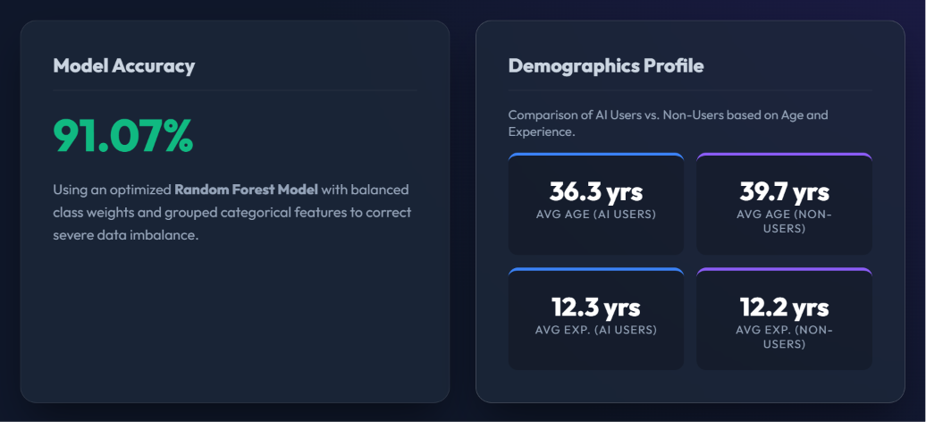

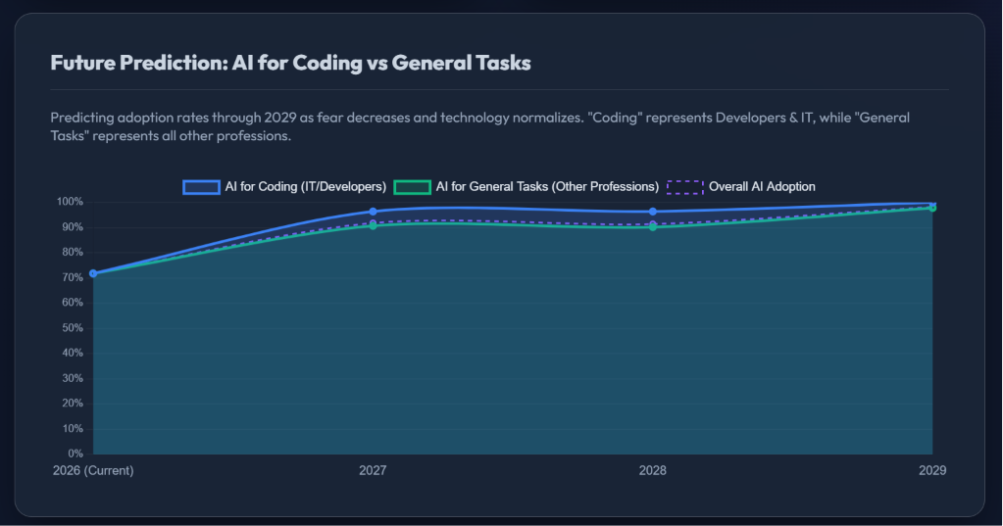

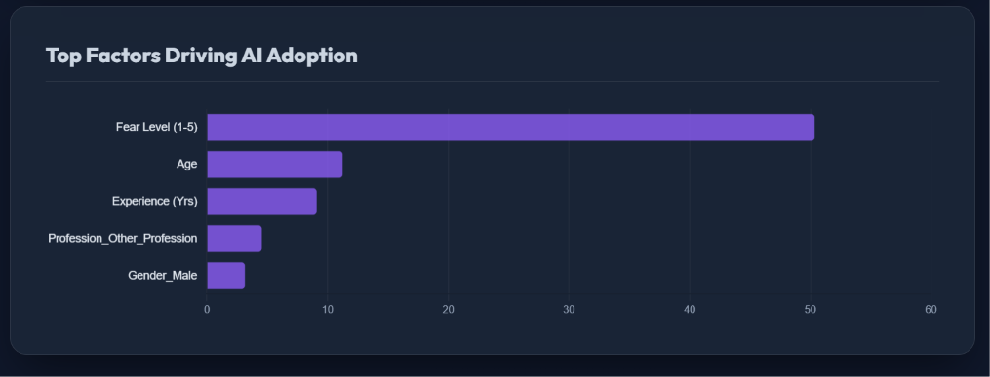

Conclusion
Logistic Regression is an effective and interpretable machine learning algorithm for predicting AI adoption. Since the target variable in this project is binary (Uses AI or Does Not Use AI), the model is well suited for identifying the demographic and behavioral factors that influence AI adoption. Its ability to generate probabilities and explain feature impacts makes it valuable for research and decision-making purposes.

