Tools Required
● Python 3.x
● Jupyter Notebook
● NumPy
● Pandas
● Matplotlib / Seaborn
Step 1: Sample Dataset (Stock Returns)
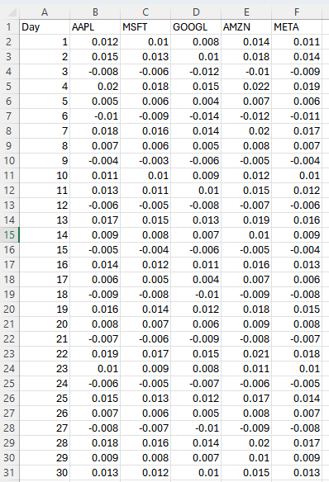

Step 2: Import Libraries
import numpy as np
import pandas as pd
import matplotlib.pyplot as plt

Step 3: Load Data
data = pd.read_excel("Stock data.xlsx")
returns = data.drop(columns=["Day"])
returns

Step 4: Descriptive Statistics
mean_values = returns.mean()
variance_values = returns.var()
mean_values
variance_values

Interpretation
- Mean represents average daily return of each stock
- Variance indicates volatility (risk level)
Step 5: Covariance Matrix
cov_matrix = returns.cov()
cov_matrix
Interpretation
● Positive covariance → stocks move in the same direction
● Higher covariance → higher portfolio risk
● Lower covariance → better diversification
Step 6: Correlation Matrix
corr_matrix = returns.corr()
Corr_matrix

Note
Correlation values range between –1 and +1.

Step 7: Visualization (Optional)
sns.heatmap(corr_matrix, annot=True, cmap="coolwarm")
plt.title("Correlation Matrix – Stock Returns")
plt.show()

Step 8: Interpretation
● Strong positive correlation exists among technology stocks
● Stocks influenced by similar market factors move together
● High correlation increases portfolio risk
Inference
● Diversification reduces unsystematic risk
● Selecting weakly correlated assets improves portfolio stability
● Covariance and correlation help in portfolio construction

OUTPUT:
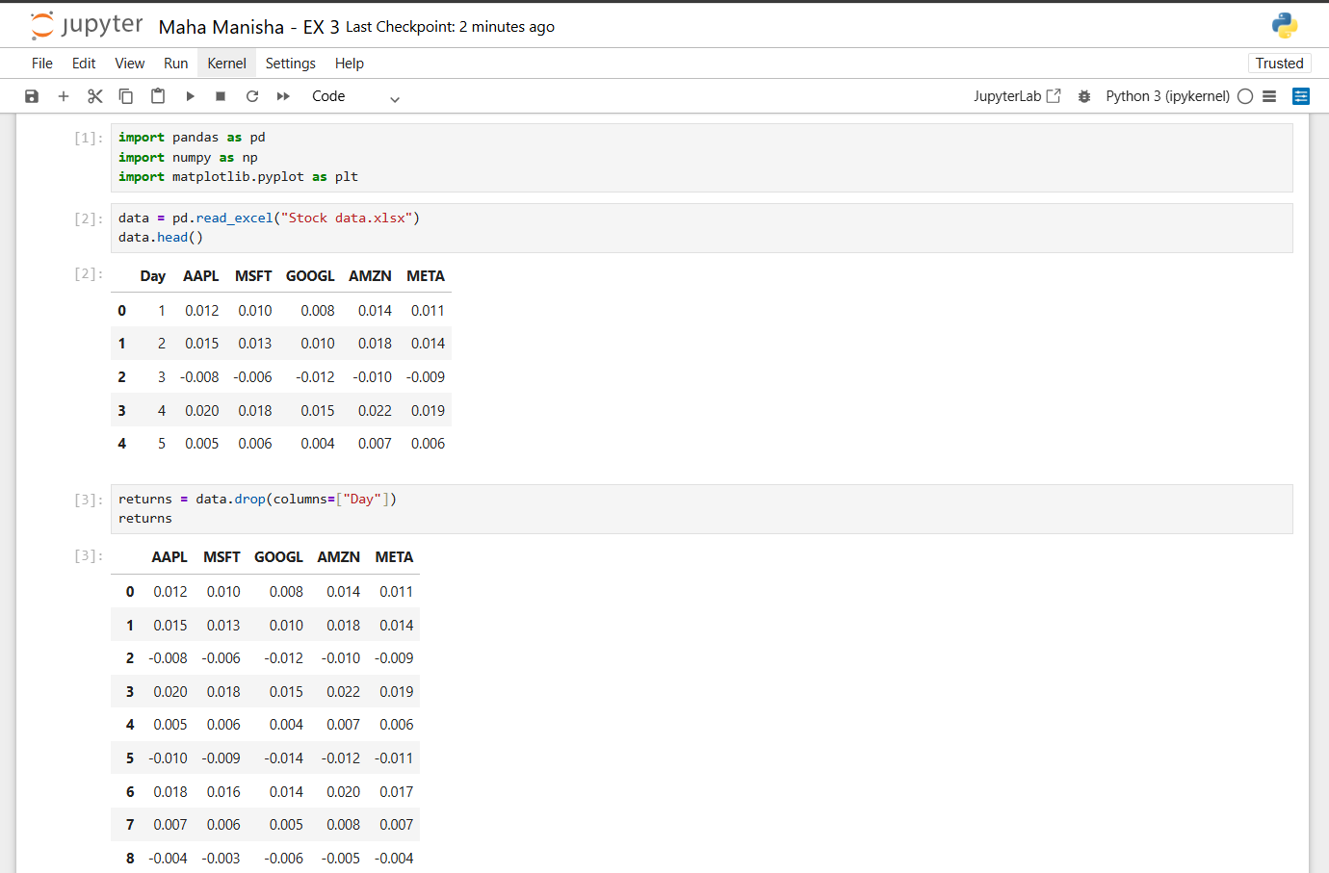
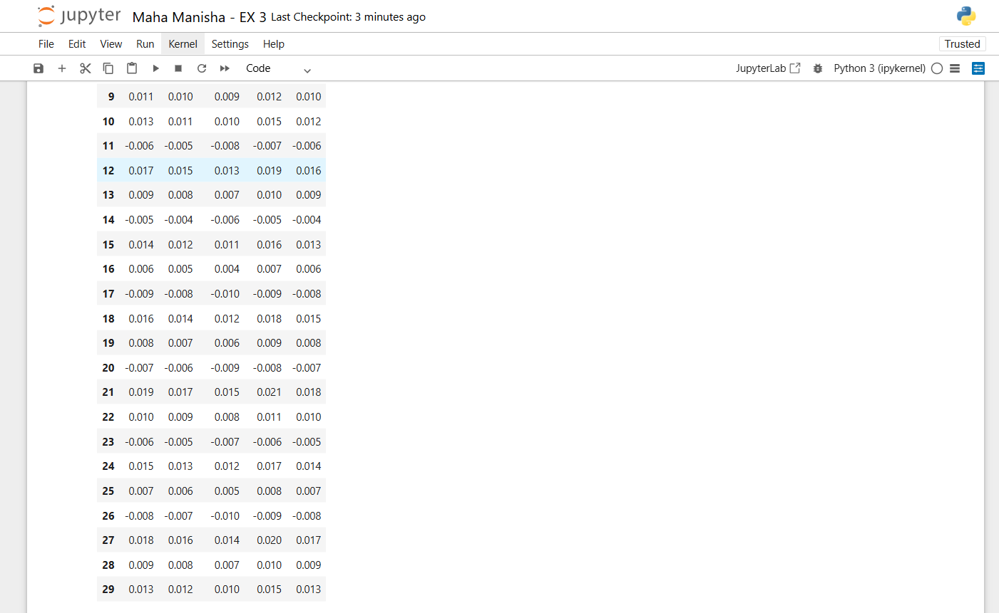

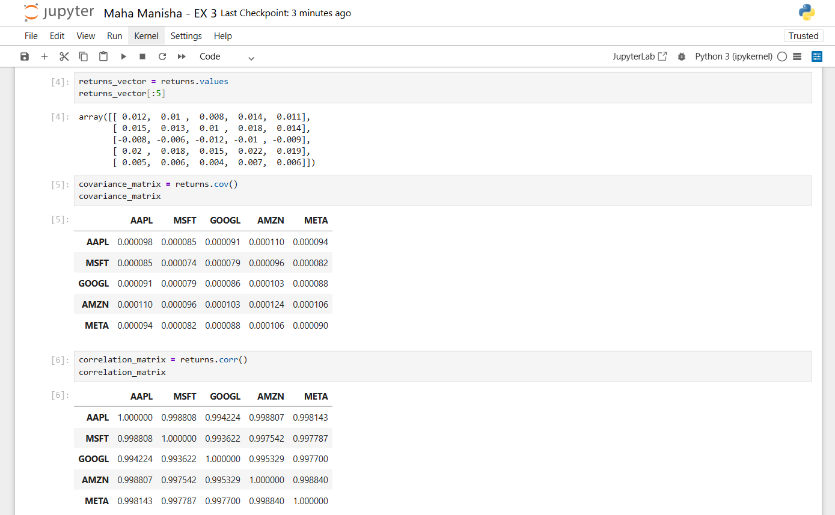

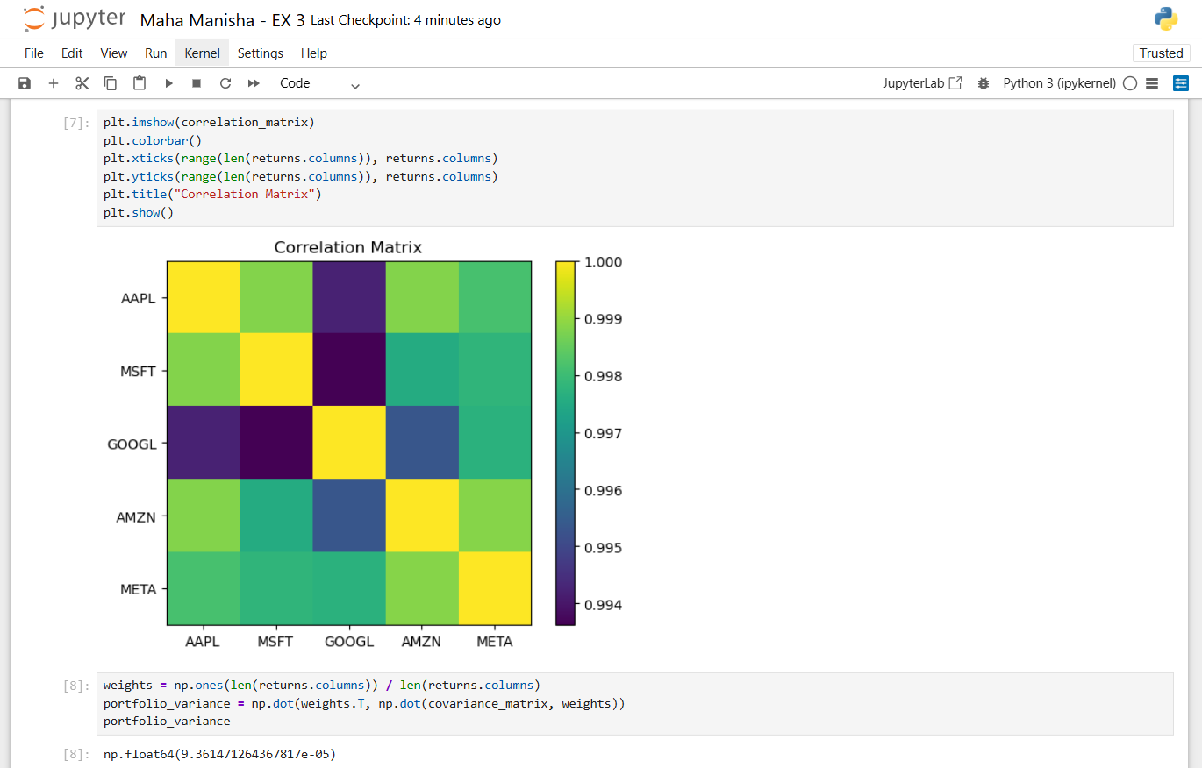

RUBRICS:
Problem Understanding (10) | Design Document (10) | Implementation (15) | Output (5) | Time Management (5) | Viva (5) | Total (50)

RESULT:
Thus, financial asset return data was successfully analyzed using descriptive statistics. Covariance and correlation matrices were computed to study relationships among stocks, helping to understand diversification benefits and portfolio risk exposure.

