**NAME: MAHA REHAN**

**(22SP-018-SE)**

**LAB#4**

**TASK#1**

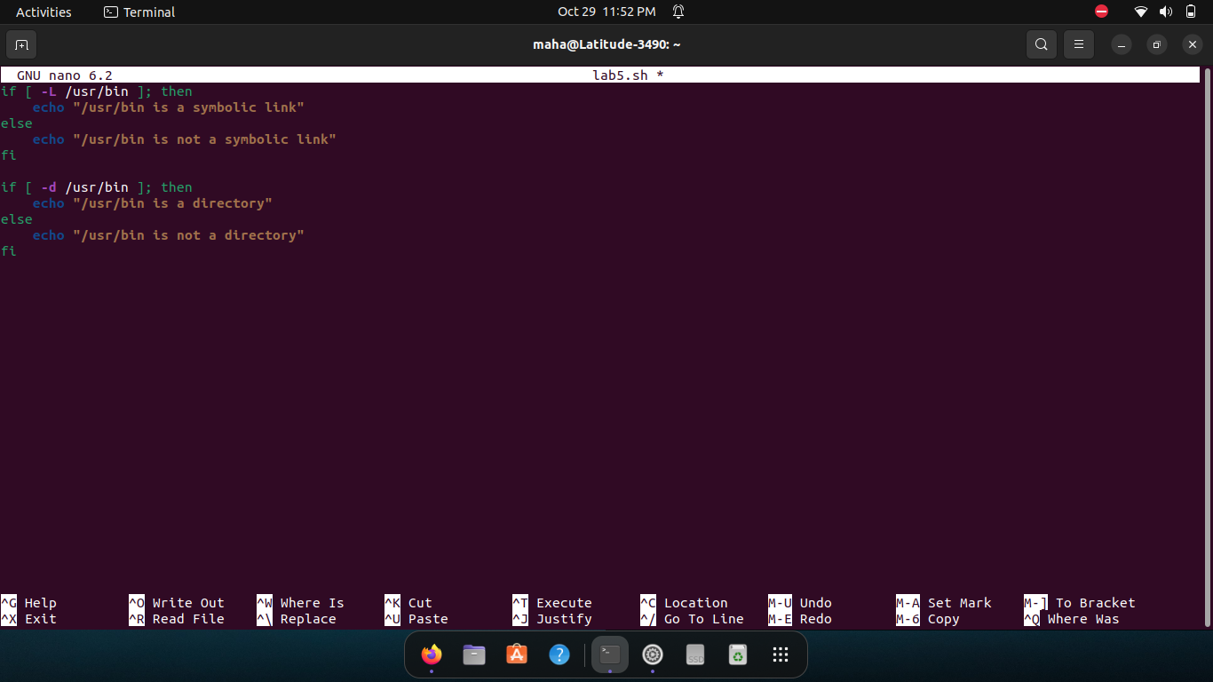

**TASK#2**

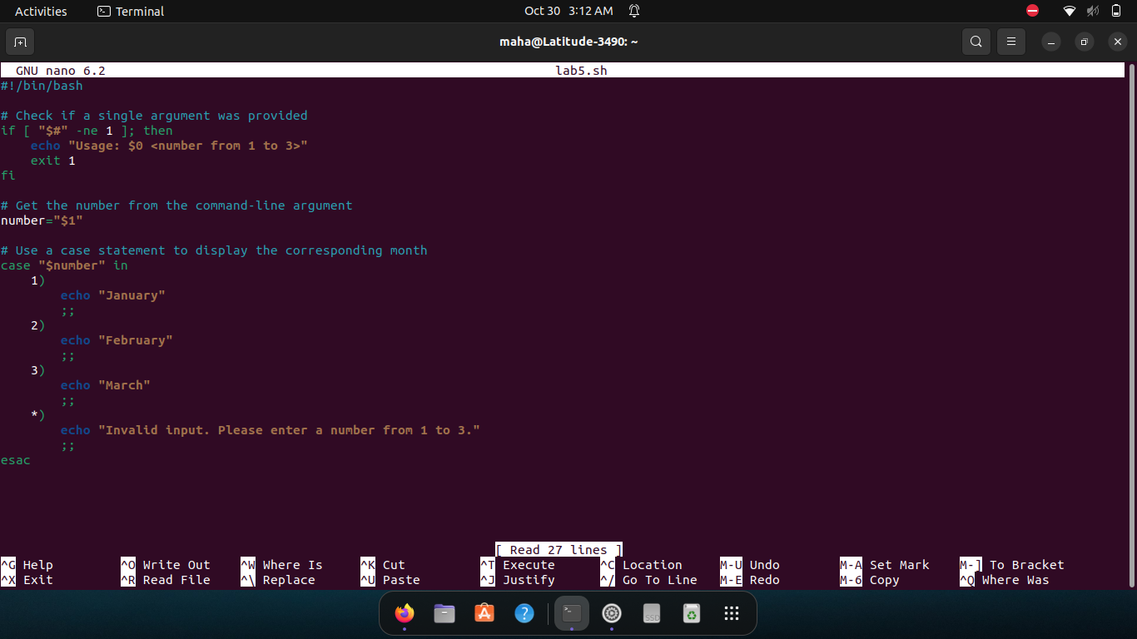

**TASK#3**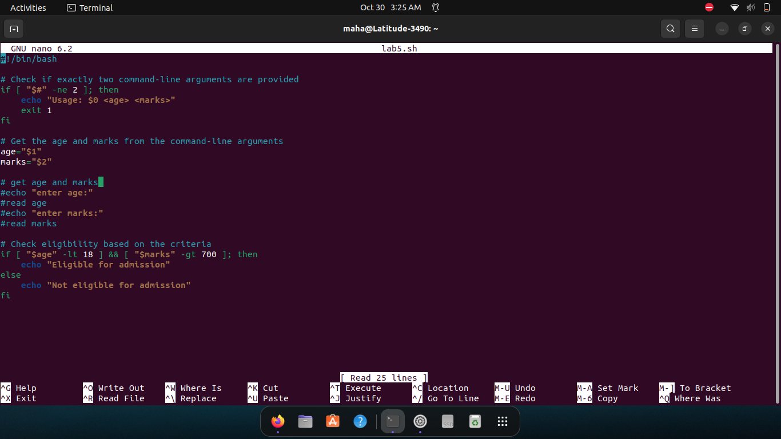

**TASK#4**

