Data Capture Configuration — Proposal
A seamless journey for configuring what Task Mining captures
Prepared by Product Design · Audience: Product & Engineering Management, Lead Value Engineering · 13 Jul 2026

1. Purpose
This document proposes a simpler, safer way for Admins to configure what Task Mining captures. It summarises the pain points and expectations gathered in our research and introduces capture levels — a small set of named choices that let an Admin decide how much to capture for any part of a process, without hand-picking dozens of low-level settings.
Scope & direction: The configuration experience is currently split across two surfaces — a Basic web setup and an Advanced desktop editor — and the Advanced editor runs only on Windows. This proposal focuses on the data-capture journey (what an Admin decides to record) and sits within a broader effort to bring the Basic and Advanced settings into a single, guided configuration surface and remove the Windows-only dependency — so the whole experience becomes one seamless journey rather than two disconnected paths.

2. The problem — configuring capture is where confidence breaks down
From getting into the tool through to fine-tuning what is captured, the same friction recurred across our interviews — including value engineers who set this up daily:
Pain point | What we heard | Why it matters
Fragmented setup | Configuration is split across a Basic (web) surface and an Advanced (desktop) editor; most real setup needs the Advanced editor, and moving between the two is disjointed and file-based. | A steep, disconnected path to a working configuration; longer time-to-value.
OS compatibility | The Advanced configuration editor runs only on Windows, while many Admins — including our own value engineers — work on Mac and must procure or emulate a Windows machine. Raised by every participant. | Setup is blocked or delayed before capture even begins.
Unclear controls | Technical labels (e.g. UIAA) aren’t understood, even by experienced value engineers; little in-product guidance on what a setting does. | Admins pick options they don’t understand, or stall waiting on support.
Events vs. logs split | Separating “events” and “logs” never made intuitive sense; unclear what to turn on. | Cognitive overload; settings get toggled blindly.
Capture noise | Everything is captured by default; many fields (e.g. screenshot width/height) add no clear value. | Hard to tell signal from noise; lower trust in the data.
Redaction is hard | Matches are blanked with asterisks (not analysis-friendly), no tagging, can’t handle names/PHI, and there’s no way to test a rule’s impact. | Sensitive segments (e.g. life sciences) can’t be served; risk of over- or under-redaction.
What users expect instead
- A simple way to say “capture this, not that” for a given part of a process.
- Guidance on what each choice captures and why it matters.
- Keep the depth that makes Task Mining valuable — but make it comprehensible.
- Redact sensitive data reliably, with the ability to check the result.
- Confirm capture is safe before anything is uploaded.
Granularity is a competitive strength, not the problem. The goal is not to capture less, but to make capturing understandable and controllable.

3. The proposal — capture levels
We propose organising data capture around capture levels: a single named choice an Admin makes for any scope (an application, a URL, or everything by default). Instead of assembling capture from many individual toggles, the Admin picks one of three levels:
- Full — captures everything: all events and attributes plus screenshots. For parts of a process you want to analyse in depth.
- Usage-only — captures that an app/screen was used and the element names, but not typed text, selected values or screenshots. For sensitive screens, or an initial discovery pass.
- Deny — captures nothing for that scope. For apps or URLs to exclude entirely.
Every configuration has a default rule — the catch-all that applies to any activity not covered by a more specific rule. Setting the default rule’s capture level establishes the baseline; specific rules refine it. This mirrors how experienced Admins already reason: capture this app fully, keep that one usage-only, exclude another entirely.
Capture levels replace blind toggling with one clear decision, keep full granularity available underneath, and pair with clearer redaction and a validation step before upload — directly addressing the pain points above.

4. Information Architecture
Today the configuration lives in two disconnected places — a Basic web setup and an Advanced desktop editor — and within the Advanced editor the settings are spread across a long list of tabs (Data Connection, Event Processing Rules, Data Redaction, Logging, User Attributes, Extensions, SAP Integration, User Consent). An Admin has to know which tab holds what, and move between the two surfaces to reach a working configuration.
The proposed architecture brings everything into one structure, organised around the things an Admin actually works with rather than around screens. There is no Basic or Advanced mode to choose between — how much gets captured is a decision the Admin makes directly, at the capture level (see Section 3).

4.1 The structure
At the centre is Capture Rules, where an Admin defines what Task Mining records and where. Everything else supports it: Privacy & Consent brings redaction, hashing, and the user-consent notice together in one place; Client Behaviour covers how and when the client records, including the live event monitor and startup mode; and Data Connection handles where captured data is sent. User Attributes and Integrations & Extensions sit below as the sources that can enrich capture when they are relevant.
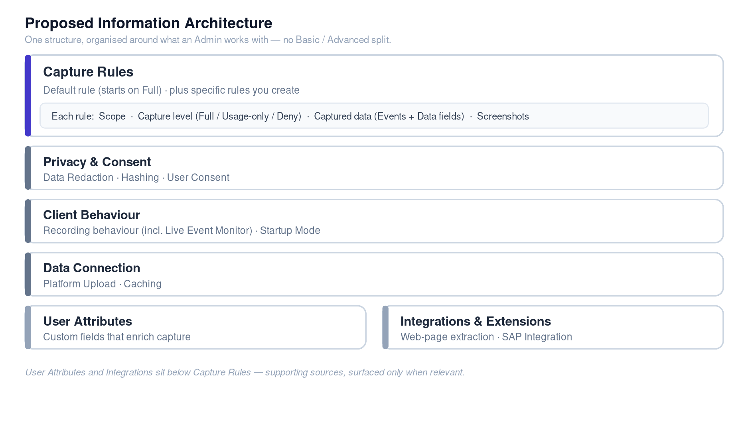

4.2 How a rule is structured
Within a rule, the Admin sets its scope — the applications and URLs it applies to — and, alongside it, the capture level, the captured data, and screenshots. The capture level is the primary control and presets the other two; the detail beneath it, grouped as “Captured data”, reflects the level chosen and can be fine-tuned when needed. The default rule — the catch-all for anything a specific rule does not cover — starts at Full, matching how the client behaves today. When an Admin creates a new rule, no level is preselected: choosing one is a deliberate step.

4.3 No Basic / Advanced split
We are deliberately not carrying forward the Basic-versus-Advanced division. That split asked Admins to guess which mode they needed and created a one-way street between the two. In the new structure there is a single path, and the choice once implied by “Basic” or “Advanced” is now made explicitly and in context — at the capture level, per rule: Full captures everything and is the default, matching today; Usage-only is the leaner, safer option; Deny excludes.

4.4 How the structure adapts
The structure shows an Admin only what is relevant, through two mechanisms:
1. The capture level presets what a rule records — choosing Usage-only, for example, keeps the interaction events but leaves out the content of what was typed or copied.
2. Source-specific fields appear only when their source is switched on — most notably the two dozen or so SAP fields, which surface only when SAP Integration is enabled, so a customer who does not use SAP never has to look at them. The same applies to browser-extension and accessibility (UIAA) fields.

4.5 What changes from today — and why it helps
Most of today’s settings still exist — they are regrouped so related decisions live together, with a few renamed or merged to remove long-standing confusion. The table below maps the current Advanced editor onto the new structure.
Today — Advanced editor | New structure
Event Processing Rules — Event, Condition, Logging, Hashing, Screenshots tabs | Capture Rules → a rule with Scope, Capture level, Captured data, Screenshots (Hashing moves to Privacy)
Logging (global tab) | Client Behaviour → Recording behaviour
Data Redaction | Privacy & Consent → Data Redaction
User Consent | Privacy & Consent → User Consent
Data Connection | Data Connection → Platform Upload · Caching
User Attributes | User Attributes (own area)
Extensions | Integrations & Extensions → Web-page extraction
SAP Integration | Integrations & Extensions → SAP Integration
The most significant shifts: the capture level becomes the primary control (no equivalent today); the rule’s Event and Logging tabs merge into a single “Captured data” step, because separating them never made intuitive sense to Admins; hashing moves out of the rule into the Privacy group alongside redaction and consent; and the global “Logging” tab — which shared a name with per-rule logging — becomes “Recording behaviour” under Client Behaviour.
Together these lower the effort of finding and setting things: one object-based structure instead of scattered tabs, a simple capture-level choice up front that still preserves the underlying granularity value engineers value, privacy decisions grouped in one place, and only relevant fields on show so the data stays trustworthy. Early moderated tree tests support the direction — participants found most settings where they expected them, the main confusion being the wording of the capture levels rather than the structure itself.
This reflects the current working architecture — the direction is settled; the specifics remain open for discussion.

5. How data capture works
Each interaction event is matched to a rule (or falls through to the default rule). The matched rule’s capture level determines how much is recorded; privacy controls then apply, and the Admin validates before anything is uploaded.
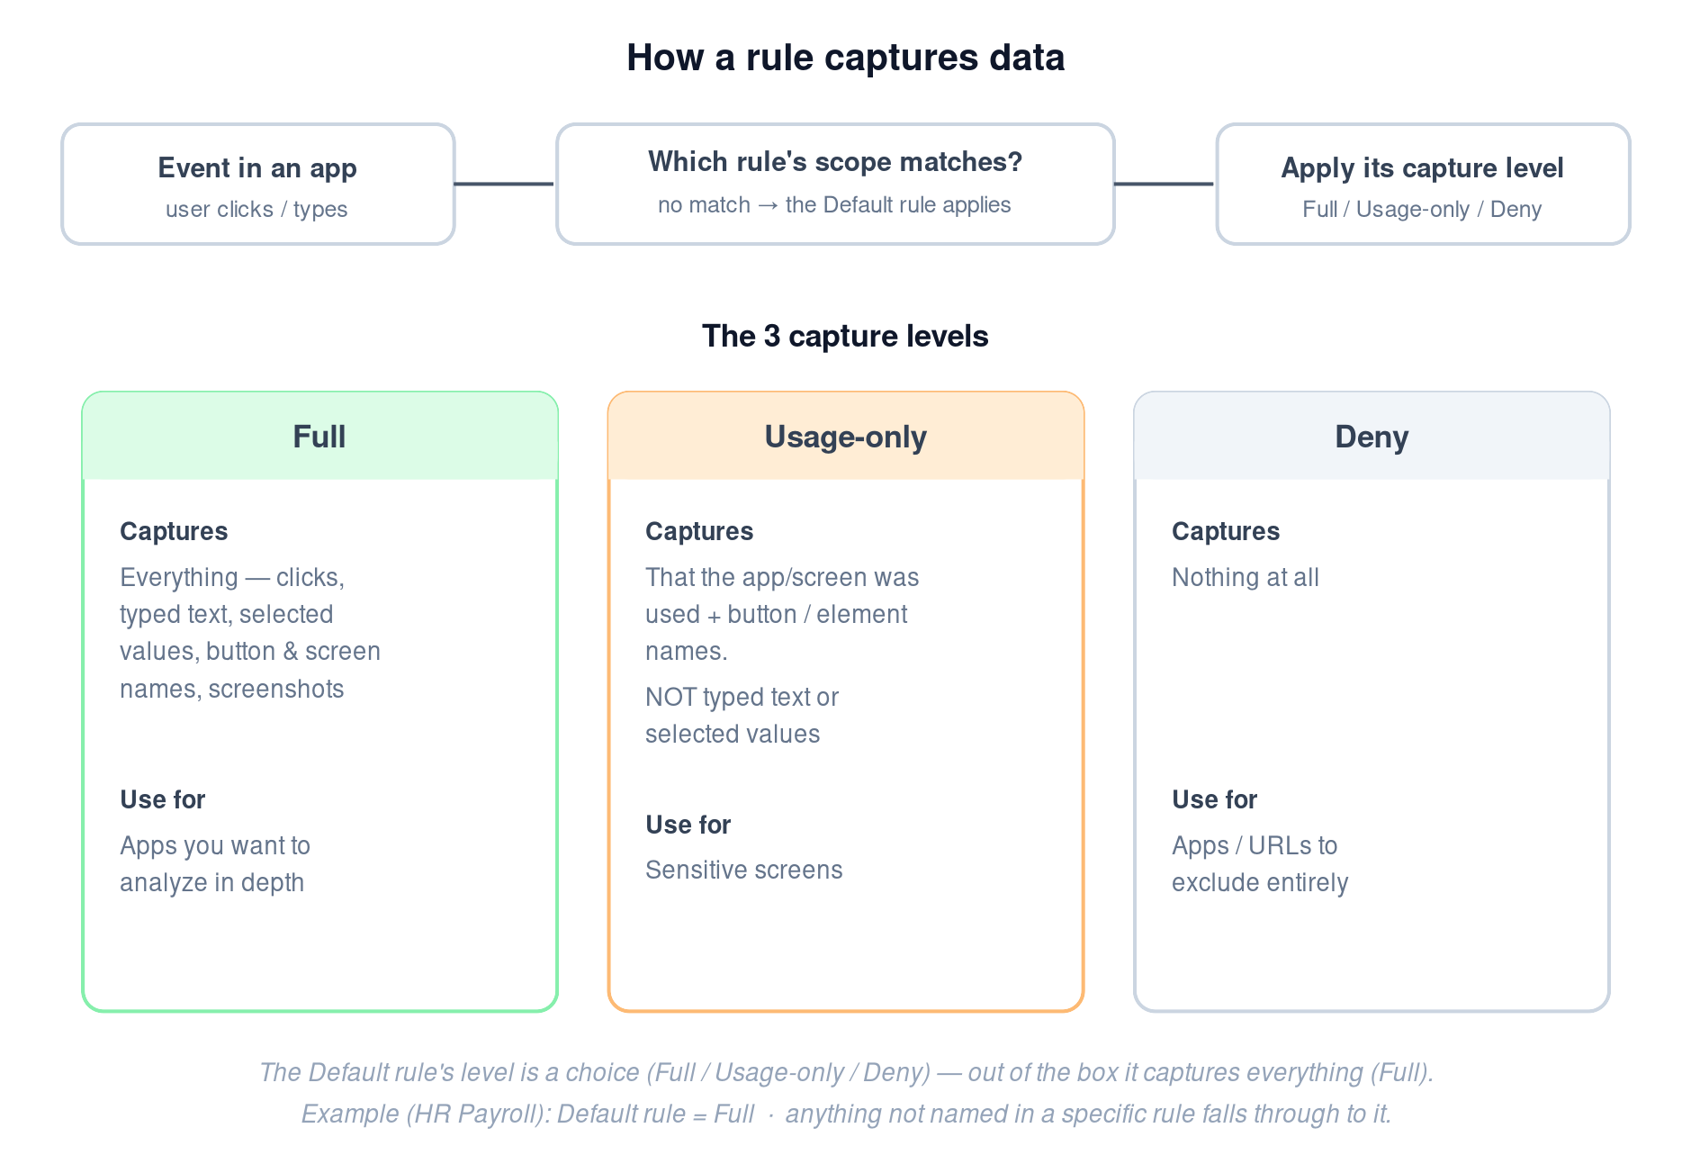

6. Configuring capture — the three capture levels
The flows below show the Admin’s journey for each capture level and what the system does as a result.

6.1 Full
Chosen when the goal is deep process analysis; the system records the complete interaction and relies on the privacy layer to keep it safe.
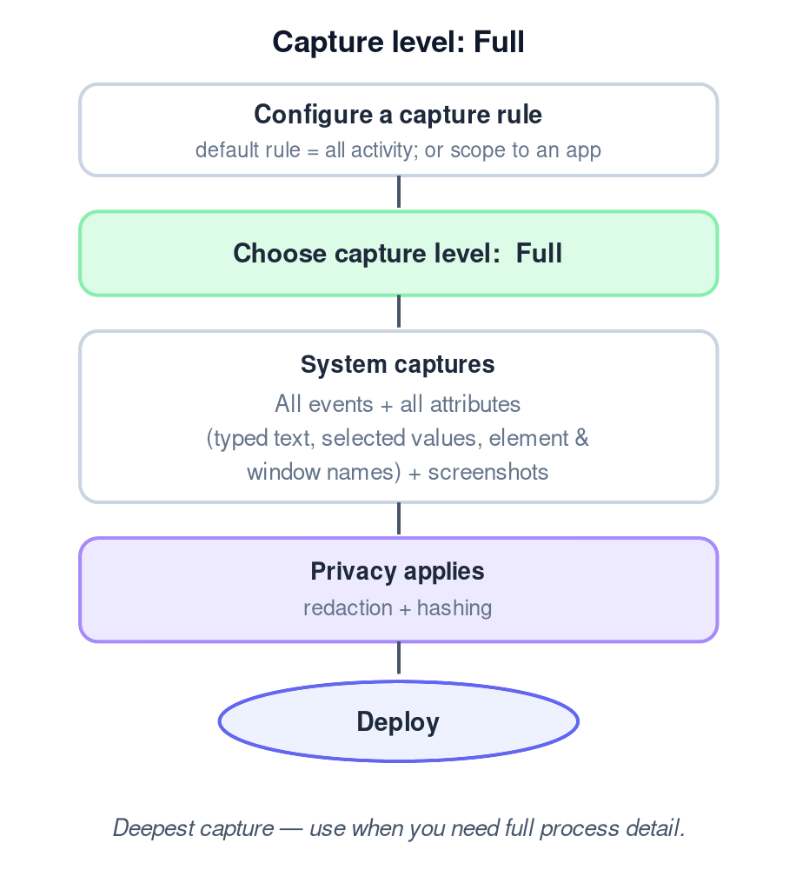

6.2 Usage-only
Chosen for sensitive screens or a first discovery pass; the system records that an app was used and the element names, but not the content typed or selected.
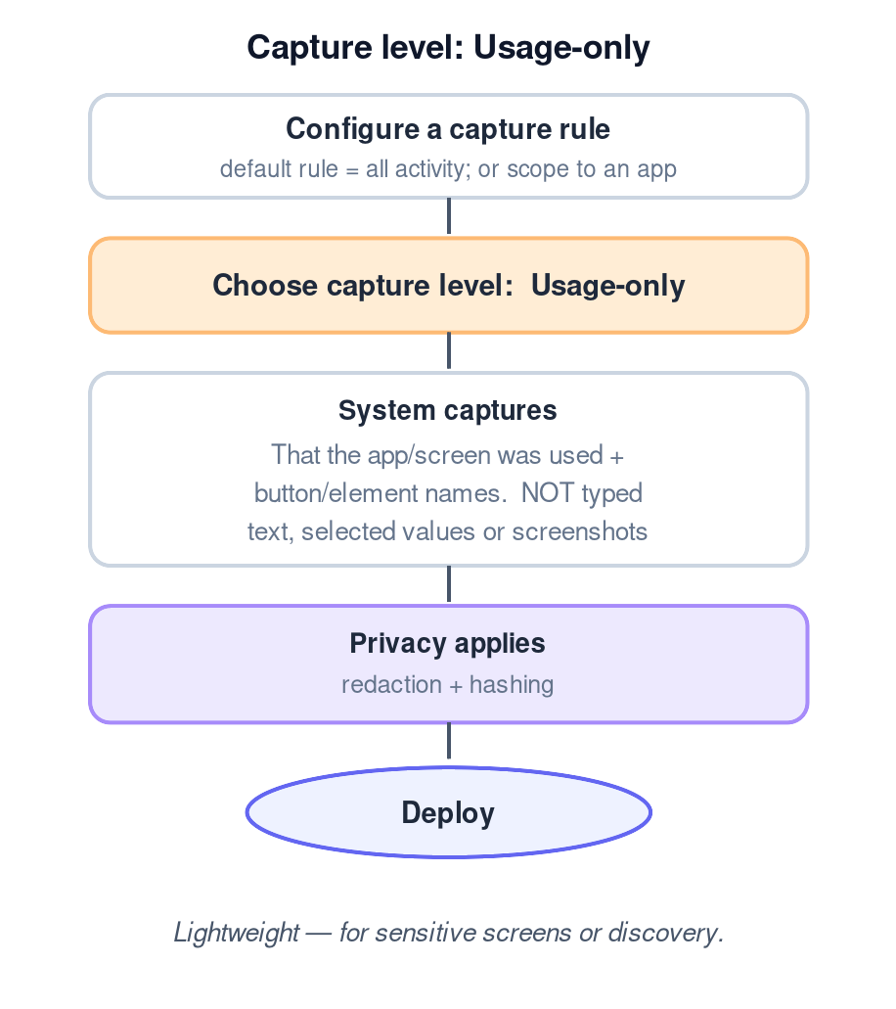

6.3 Deny
Chosen to exclude an app or URL entirely; no data is captured for that scope, so there is nothing to redact or preview.
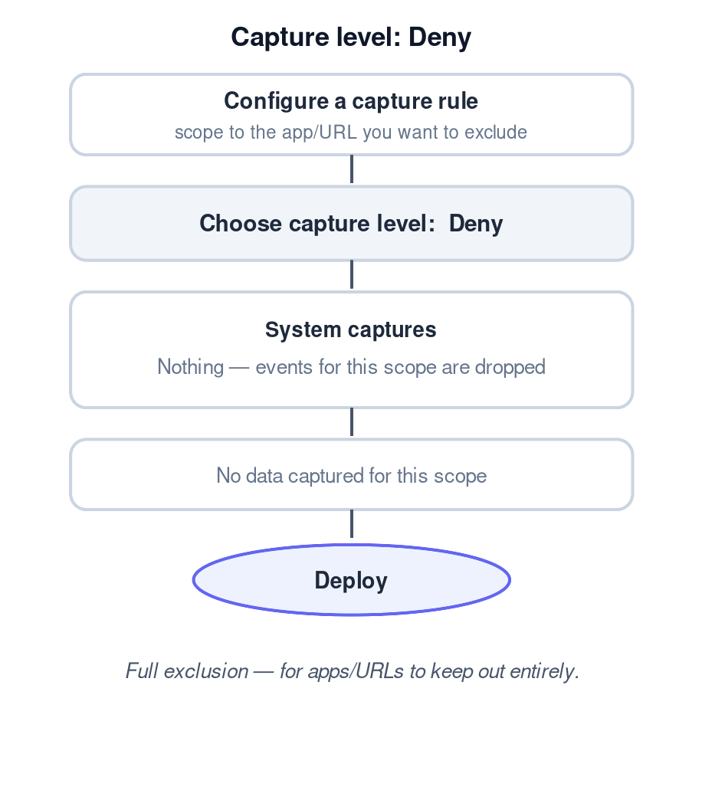

7. Privacy & validation
Because capture and privacy are inseparable for sensitive processes, privacy controls stay together and always available: redaction (with the ability to test the result), hashing of identifiers such as usernames and machine IDs, and user consent.
On validation, our research showed that most value engineers validate reactively — they capture data and check the resulting data table, rather than relying on the Preview or Live Event Monitor features in the configuration. Some scale and enterprise customers do require a check before data is uploaded. The open question is therefore how validation should work once configuration moves to EMS.

8. Expected impact
- Faster, more confident configuration — one clear choice instead of many opaque toggles.
- Less noise, more trustworthy data — capture depth matched to intent.
- Sensitive processes become serviceable — usage-only and reliable redaction.
- Granularity preserved — full control remains available beneath the presets.

9. Open questions & next steps
- Unify the Basic and Advanced settings into a single, guided configuration surface, and remove the Windows-only dependency so setup is not blocked by OS.
- Validate the capture-level model and its labels with Admins (tree test).
- Confirm engine behaviour: rule evaluation order, and how a level maps to underlying events/attributes.
- Data redaction — the team to rethink improvements, including pre-built libraries (e.g. GDPR/HIPAA) and the ability to test redaction against sample data.
- Validation — define how Admins validate captured data in EMS, recognising that today validation happens on the captured-data table rather than through Preview / Live Event Monitor (and Preview runs only in the Windows configuration editor).

