Task Mining Client Configuration — Scope, Phasing & Success Metrics
Draft for alignment — a Product Design strawman for PM / Engineering to confirm and own. Not final.
Prepared by Product Design · 21 Jul 2026

Purpose: this one-pager proposes how the Task Mining configuration redesign could be scoped into phases and how we would measure success — so design, product, and engineering are aiming at the same target. It is a starting point for discussion, meant to be corrected, not a final plan.
Problem it serves: research showed configuration is where Admins lose the most time and confidence — fragmented setup, ambiguous controls, and noisy capture. The redesign consolidates this into one guided structure built around capture levels. Success should therefore be measured against reduced friction, fewer errors, and more trustworthy data.

Phasing
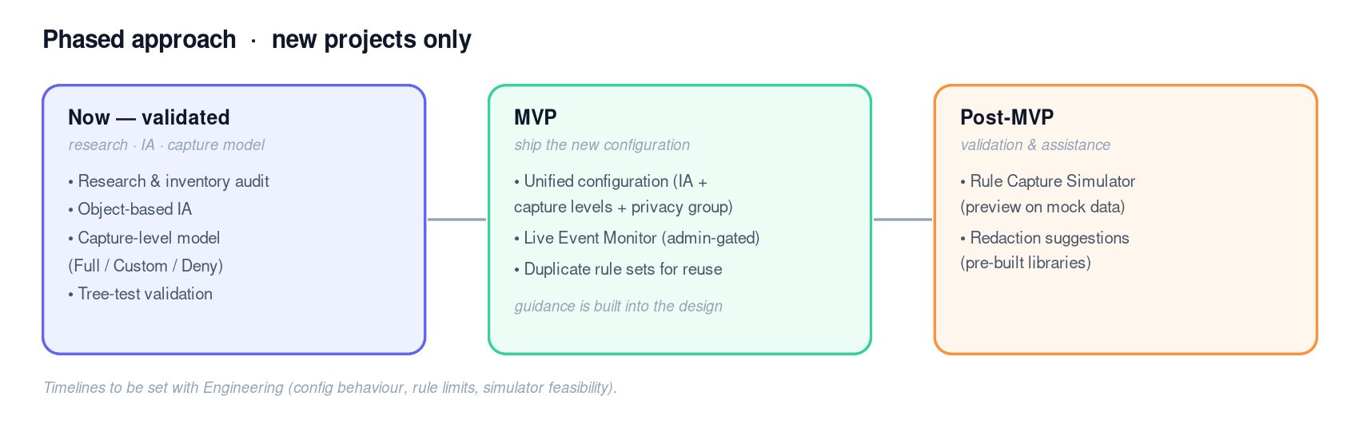
Scope guardrail: the new configuration applies to new projects only — existing projects keep their current setup (no migration). Reuse across new projects is via duplicating rule sets.

Success metrics (proposed)
A small set tied to the problem, split into leading indicators we can read now and lagging ones after launch. Targets (baseline + goal) to be set with PM.
Metric | Type | How we’d measure it
Time-to-first-valid-config | Lagging | Time from starting a config to a validated, deployable rule set (new vs. today’s baseline).
Config errors / rework | Lagging | Misconfigurations, re-uploads, and config-related support tickets.
Task success & comprehension | Leading (now) | Tree/usability test success + directness; can Admins explain the capture levels.
Data quality (signal-to-noise) | Qualitative | VE feedback on the quality/usefulness of data captured under the new config.
Redaction misses / privacy incidents | Lagging | Sensitive values that slip through; compliance escalations.

What I need to align on
- Confirm the MVP vs. Post-MVP split above (and that the capture-level model sits within the MVP’s unified configuration).
- PM to own a short PRD and set a target (baseline + goal) for each success metric.
- Set phase timelines with Engineering — dependent on config behaviour, rule limits, and simulator feasibility (Midhun / Danish).
- Note two interaction details still being validated: the Live Event Monitor admin-access model, and Custom’s default content set.
Once confirmed, this becomes the shared reference for scope and success; ownership sits with Product.

