**Problem Statement – The Doomed Dice Challenge**

**Output Screenshots :**

**Part – A :**

1. **How many total combinations are possible? Show the math along with the code!**

The total number of possible combinations have been displayed

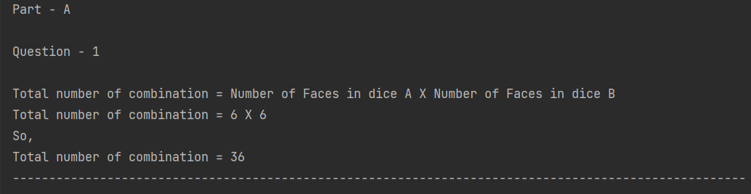

1. **Calculate and display the distribution of all possible combinations that can be obtained when rolling both Die A and Die B together. Show the math along with the code!**

The distribution of all possible combinations have been displayed

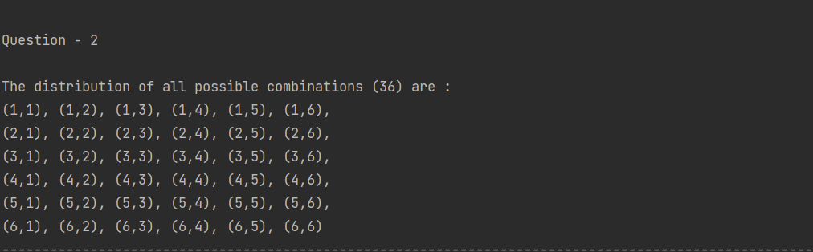

1. **Calculate the Probability of all Possible Sums occurring among the number of combinations from (2).**

The probability of all possible sums occurring among the combinations are shown below

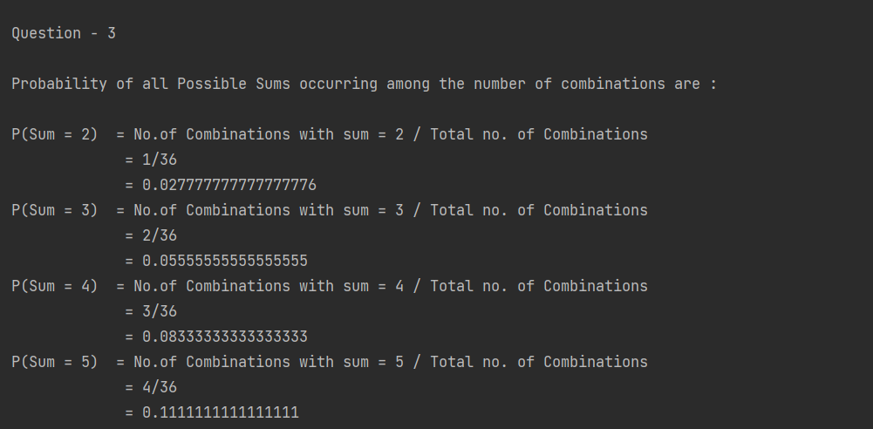

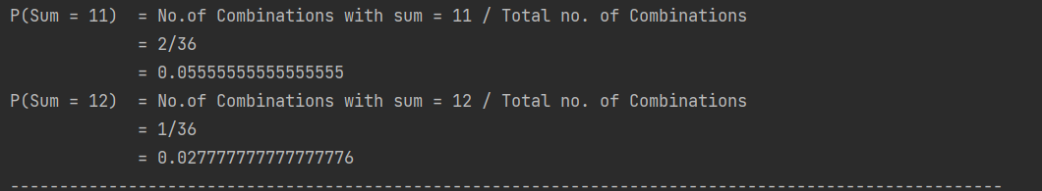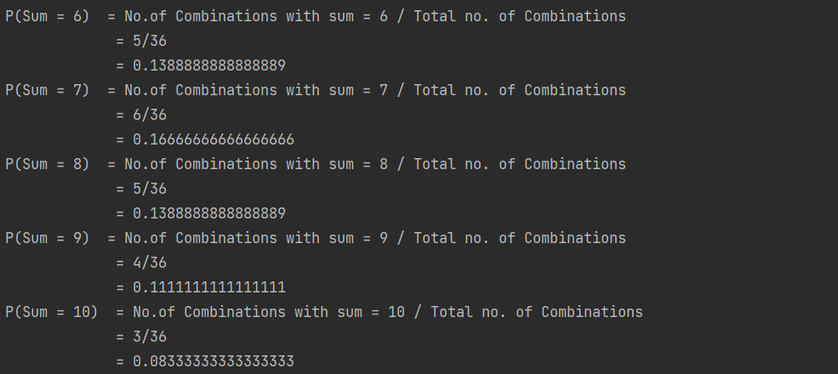

**Part – B :**

**Question :**

**A Transform Function undoom_dice that takes (Die_A, Die_B) as input &outputs**

**New_Die_A = [?, ?, ?, ?, ?, ?],**

**New_Die_B = [?, ?,?, ?, ?, ?]**

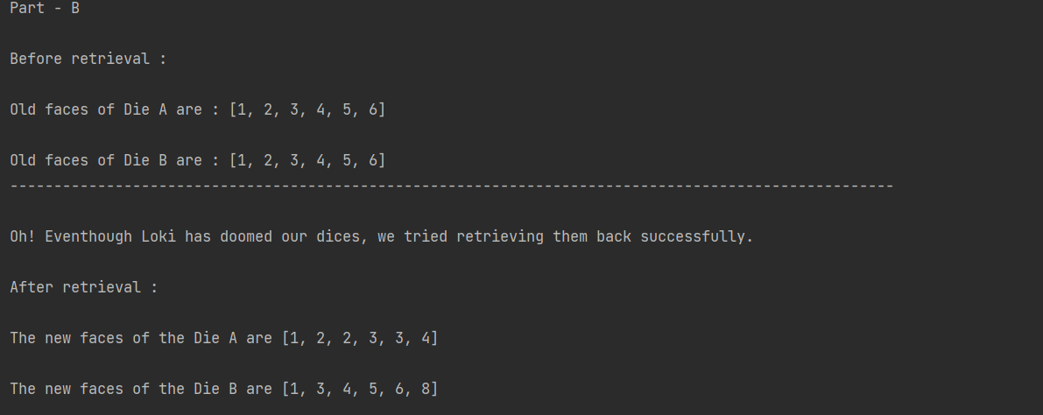The new faces of the die A and die B are displayed below

*The code for the above questions has been attached with a **JAVA file named Main.java** within the folder .