Name: Mahad
Reg No: L1F21BSCS0533
Section: E14

Lab 4 CP 1

#include<stdio.h>
#include<unistd.h>
#include<sys/wait.h>

int main(){
printf("I am before fork()\n");
fork();
printf("I am after fork()\n");
printf("I am having pid %d and parent pid %d.\n", getpid(),getppid());
}
Output:

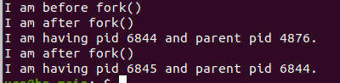

Line 1 works as it is
Line 2 creates as fork()→ a child processes
Fork is created and line 3 runs giving after fork output.
Line 4 gives pid and ppid.
When fork is created duplicates the lines under it as it creates a duplicate process.
- We have different id’s as parent executes before child so when fork executes it gives parent id something else and when fork duplicates the process it gives parent id something else as parent has executed from the memory.

