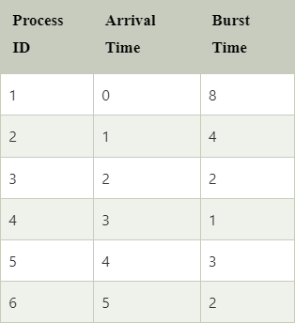

Calculate CT, TAT, WT, RS by applying FCFS and SJF.