Advanced MLOps Exercise
Professional CI Workflow with Pull Requests, Docker & Container Registry
Student: Mahad Malik | Roll No: 23I-0537 | Course: Advanced MLOps
Repository: github.com/Mahad1090/student-ml-api | Registry: ghcr.io/mahad1090/student-ml-api
Date: 10 September 2026
Core principle. Git manages the evolution of source code. Pull Requests control how changes enter main. CI verifies those changes. Docker converts approved source code into a reproducible artifact. The container registry stores and distributes versioned artifacts that can later be delivered consistently to staging and production.

1. Pipeline Overview
Developer
|
feature branch --> commit + push --> Pull Request
|
+-----------------------------+
| GitHub Actions - CI |
| - Unit tests (pytest) | (no image push)
| - Docker build validation |
+-----------------------------+
| green + review
Squash merge --> main
|
Semantic version tag vX.Y.Z
|
+-----------------------------+
| GitHub Actions - Release |
| pytest / GHCR login |
| docker build / derive ver |
| push X.Y.Z / latest / sha |
+-----------------------------+
|
ghcr.io/mahad1090/student-ml-api
|-- 1.0.0 |-- 1.1.0 |-- latest

2. Requirement Completion Matrix
Part | Requirement | Status | Evidence
1 | FastAPI app with /health + /predict | Done | Sec 3, Fig 14
2 | 4+ automated tests, pytest green | Done | Sec 3, Fig 1
3 | Feature-branch workflow, meaningful commits | Done | Sec 4, Fig 3/17
4 | Professional PR description + checklist | Done | Sec 4, Fig 2/18
5 | CI on PR: checkout>python>deps>tests>docker build | Done | Sec 5, Fig 6/19
6 | Deliberate test failure + fix, evidence captured | Done | Sec 6, Fig 5/6/3
7 | Branch protection on main, documented | Done | Sec 7, Fig 7
8 | Merge PR (strategy stated + justified) | Done - Squash | Sec 8, Fig 4
9 | Production Dockerfile + .dockerignore | Done | Sec 9
10 | Local build student-ml-api:1.0.0, run, verify | Done | Sec 10, Fig 12-14
11 | images/ps/logs/inspect/exec; identify IDs | Done | Sec 10, Fig 15
12 | Container registry (GHCR) | Done | Sec 11, Fig 8
13 | Git tag v1.0.0 after merge | Done | Sec 12, Fig 17
14-15 | Tag-triggered release, version derived from tag | Done | Sec 12, Fig 10/11
16 | Registry has 1.0.0, 1.1.0, latest; digest recorded | Done | Sec 11, Fig 8/9/21
17 | Delete local image, pull from registry, run | Done | Sec 13, Fig 16
18-19 | v1.1.0 via full PR workflow, released | Done | Sec 14, Fig 18-20/11
20 | Rollback to 1.0.0 from registry, no rebuild | Done | Sec 15, Fig 21/23
21 | Full traceability chain for 1.1.0 | Done | Sec 16
22 | CI vs Release separation + rationale | Done | Sec 17
23 | OCI labels on image | Done | Sec 17, Fig 15
24 | Commit-SHA image tag | Done | Sec 17, Fig 8
25 | Docker build-cache analysis | Done | Sec 17
26 | 2+ failures reproduced & diagnosed | Done - 3 | Sec 18, Fig 5/25

3. Application & Automated Tests (Parts 1-2)
The service is a FastAPI application (app.py). The prediction "model" simply doubles the input - the exercise targets the MLOps workflow, not model quality.
Endpoint | Request | Response (v1.0.0)
GET /health | - | {"status":"healthy","application":"student-ml-api","version":"1.0.0"}
POST /predict | {"value":10} | {"input":10,"prediction":20}

The application version is read from the VERSION file at runtime, so it is never hard-coded in code. Pydantic StrictInt | StrictFloat validation makes a non-numeric value return HTTP 422 rather than being silently coerced.

Test suite - tests/test_app.py (4 tests)
- test_health_endpoint - status, application name, version
- test_predict_success - {"value":10} -> {"input":10,"prediction":20}
- test_predict_missing_input - empty body -> 422
- test_predict_invalid_input - {"value":"not-a-number"} -> 422
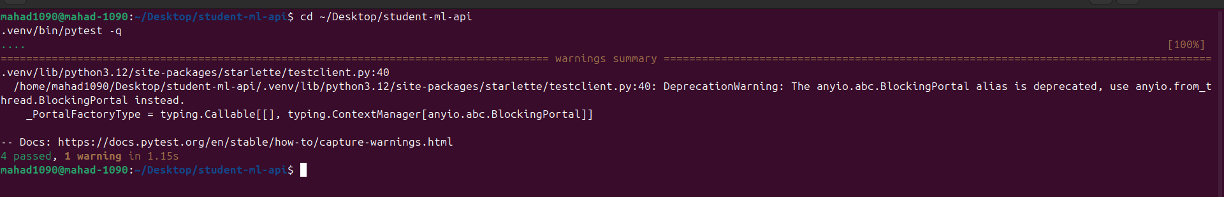
Fig 1 - pytest -q -> 4 passed.

4. Git Workflow & Pull Requests (Parts 3-4)
Direct development on main was never performed. All code reached main through Pull Requests:
PR | Branch | Title | Merge commit
#1 | feature/prediction-api | feat: prediction API with CI pipeline | fa0394b
#2 | feature/model-metadata | feat: report application and model version on /health | 02dc3db
#3 | docs/mlops-workflow-writeup | docs: MLOps workflow write-up, traceability, failure analysis | 4650a2b
#4 | docs/final-report | docs: add final assignment report | 3ab591d

Commits follow Conventional-Commits style: feat:, test:, ci:, fix:, docs:, chore:. Each PR body contains Summary / Changes / Testing Performed / Docker Impact / Checklist (from .github/pull_request_template.md).
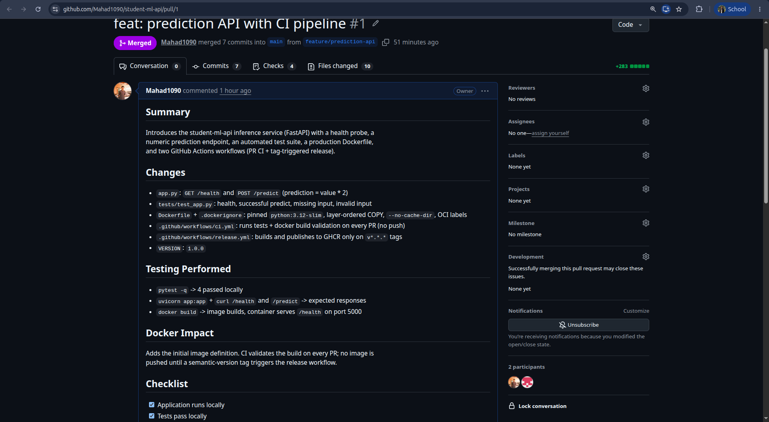
Fig 2 - PR #1 professional description & checklist.
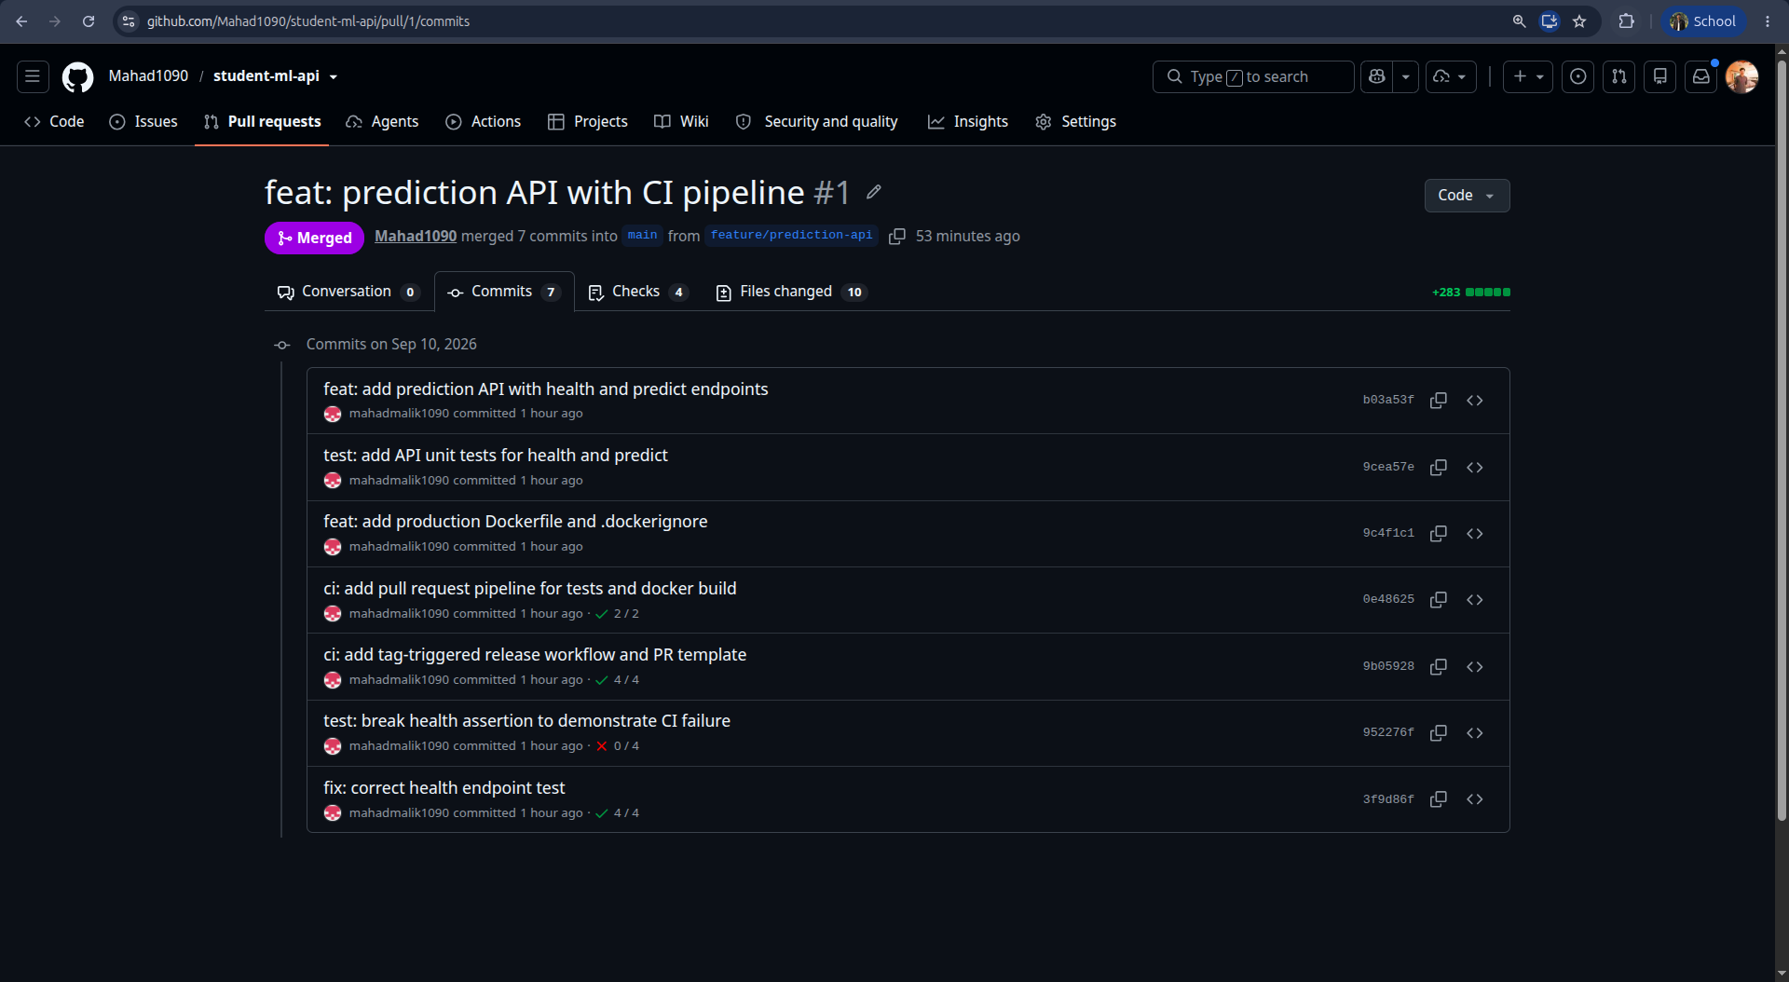
Fig 3 - PR #1 commit history (7 commits incl. the deliberate break X and the fix OK).

5. GitHub Actions CI (Part 5)
ci.yml runs on pull_request -> main and on pushes to feature branches. It publishes NO artifact.
job: test -> checkout -> setup-python 3.12 -> pip install -r requirements.txt -> pytest -q
job: docker-build -> needs: test -> checkout -> docker build (validation only, no push)
Because docker-build declares needs: test, a failing pytest short-circuits the pipeline (the build job is skipped) and the whole run is FAILED. A failing docker build likewise fails the run. Branch protection then makes that a hard merge gate.
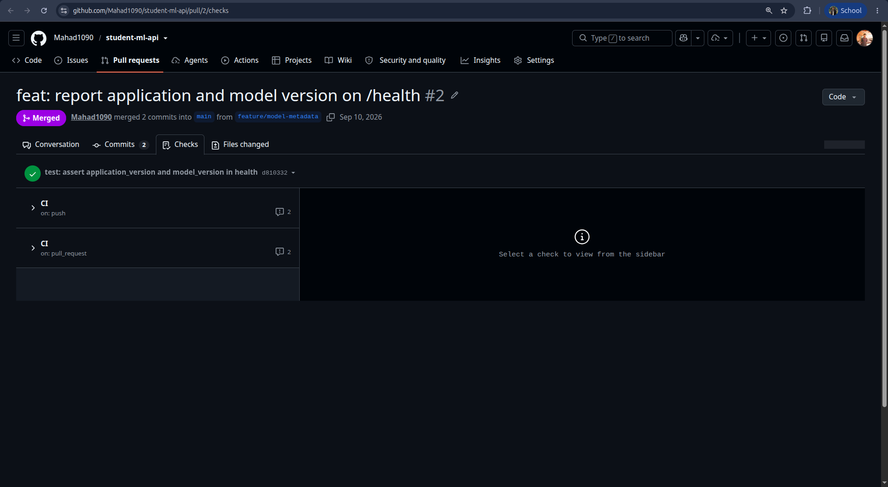
Fig 19 - required checks (Unit tests, Docker build validation) on a PR.

6. Deliberate Failure Demonstration (Part 6)
 | Detail
Symptom | PR #1 CI turned red. Unit tests failed; Docker build validation skipped; PR banner 'Merging is blocked'.
Root cause | Commit 952276f changed test_health_endpoint to assert data['status'] == 'wrong', but the endpoint returns 'healthy'.
Evidence | Actions run 34494638490 - AssertionError: assert 'healthy' == 'wrong' -> FAILED tests/test_app.py::test_health_endpoint (Fig 5).
Correction | Commit 3f9d86f 'fix: correct health endpoint test' restored == 'healthy'. Re-run 34494921761 passed both checks; merge unblocked (Fig 6).

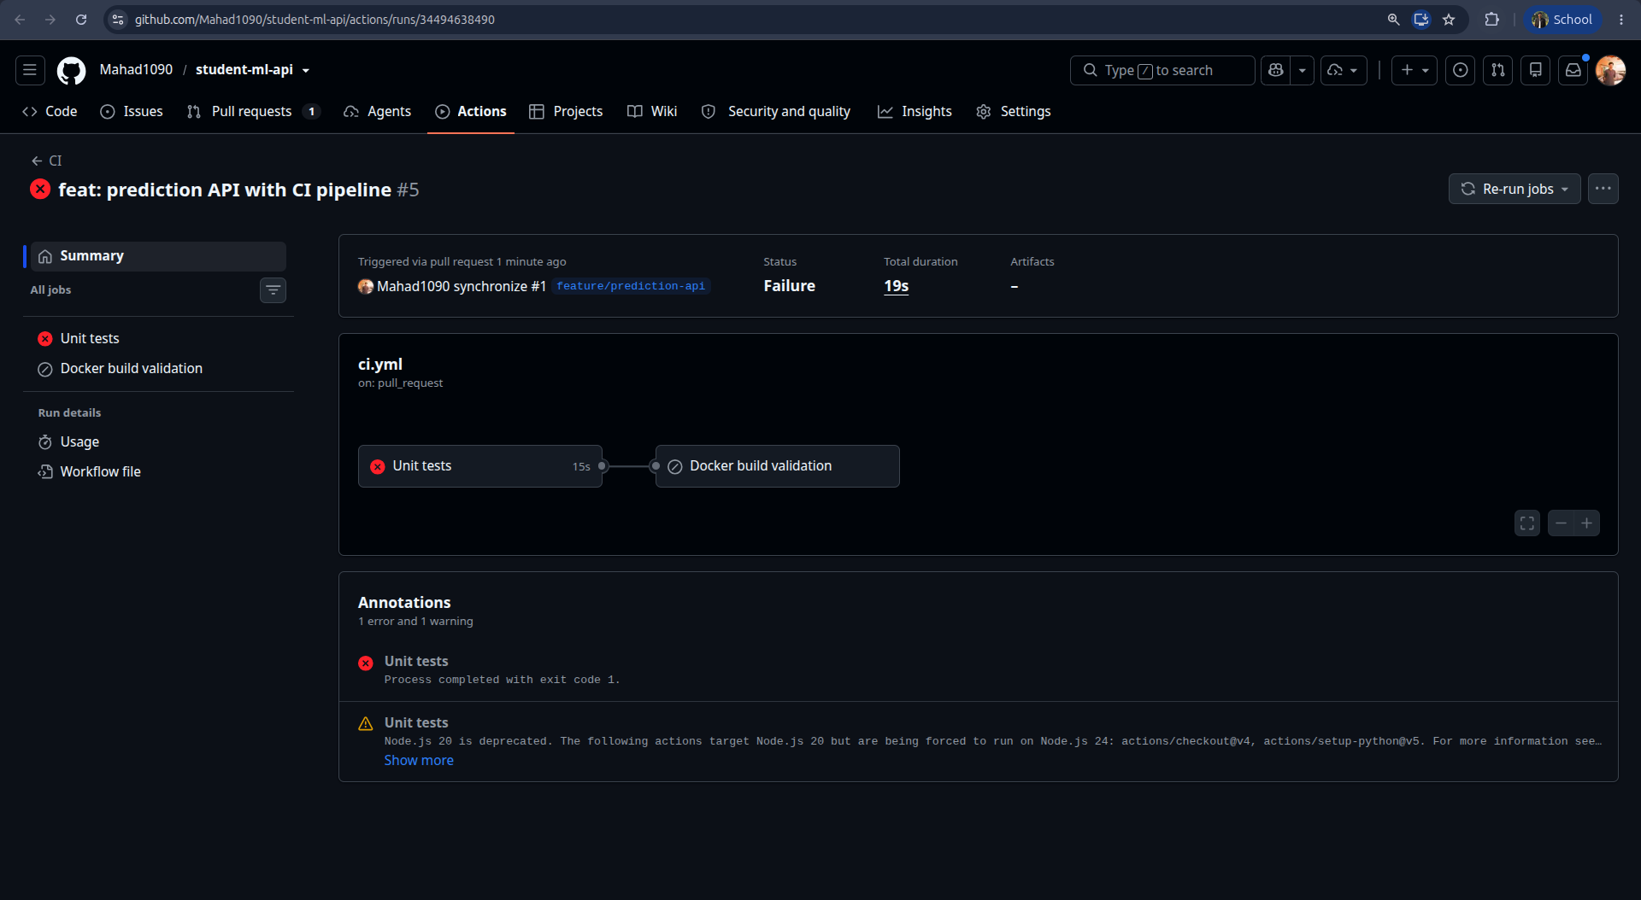
Fig 5 - CI run FAILED after the broken assertion was pushed.
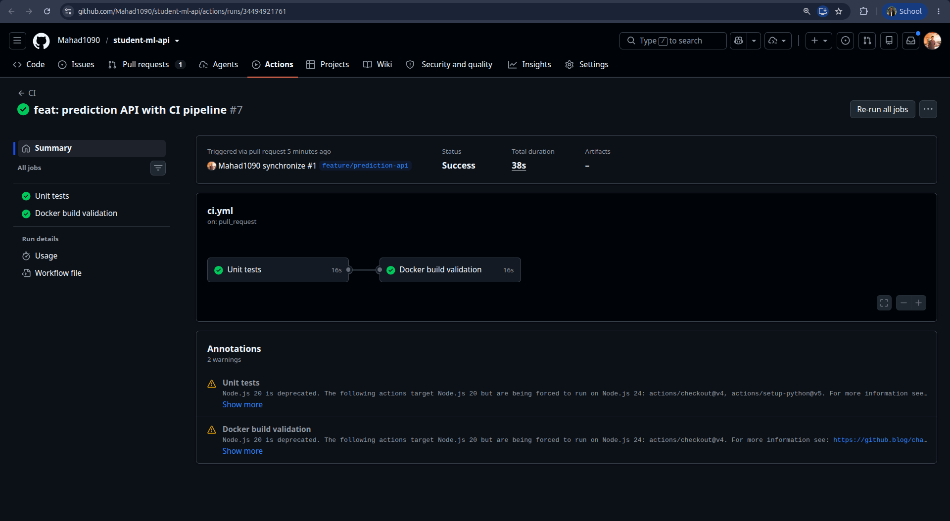
Fig 6 - CI run SUCCESS after the fix commit.

7. Branch Protection (Part 7)
Configured on main. Settings selected and their rationale:
Setting | Value | Why
Require a pull request before merging | On | No direct commits to main; every change reviewed and CI-checked.
Require approvals | 1 | Forces a second reviewer in a team context.
Dismiss stale approvals on new commits | On | An approval must reflect the code that actually merges.
Require status checks to pass | On - Unit tests, Docker build validation | Only a green pipeline can merge.
Require branches up to date before merging | On | Checks run against the real post-merge state.
Require conversation resolution | On | No unresolved review threads slip through.
Allow force pushes / deletions | Off | main history cannot be rewritten or the branch deleted.
Enforce for administrators | Off (solo repo) | GitHub forbids approving one's own PR; in a team this is On and a colleague approves. The PR + passing-CI gate still applies.

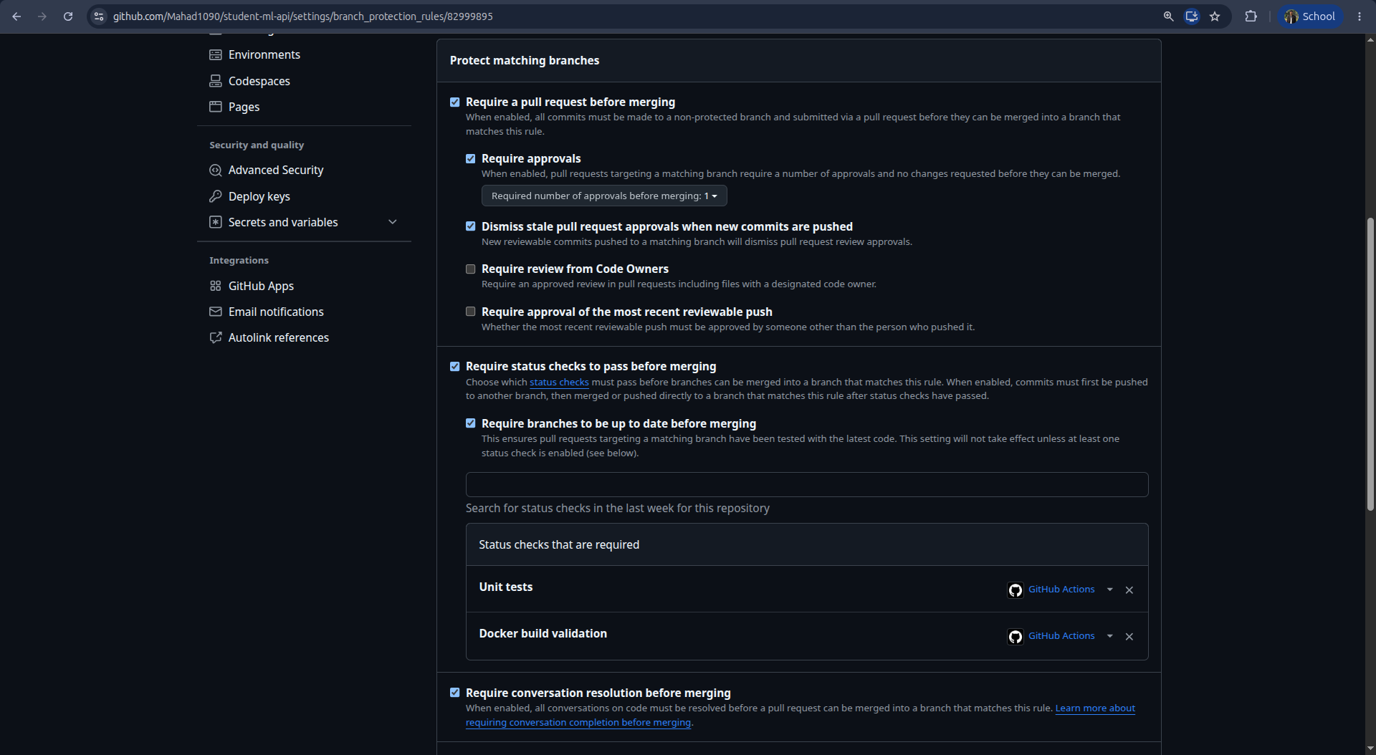
Fig 7 - branch protection rule for main.

8. Merge Strategy (Part 8)
Squash and merge was used for every PR.
- Each feature branch carries several iterative WIP commits (PR #1 even contains the deliberate break + fix). Squashing lands one atomic, reviewed change per feature on main.
- main stays linear and every commit is independently buildable, keeping git bisect meaningful.
- The squash commit references the PR number ((#1), (#2)) - main -> PR is one hop - while the full commit-by-commit history remains on the PR.
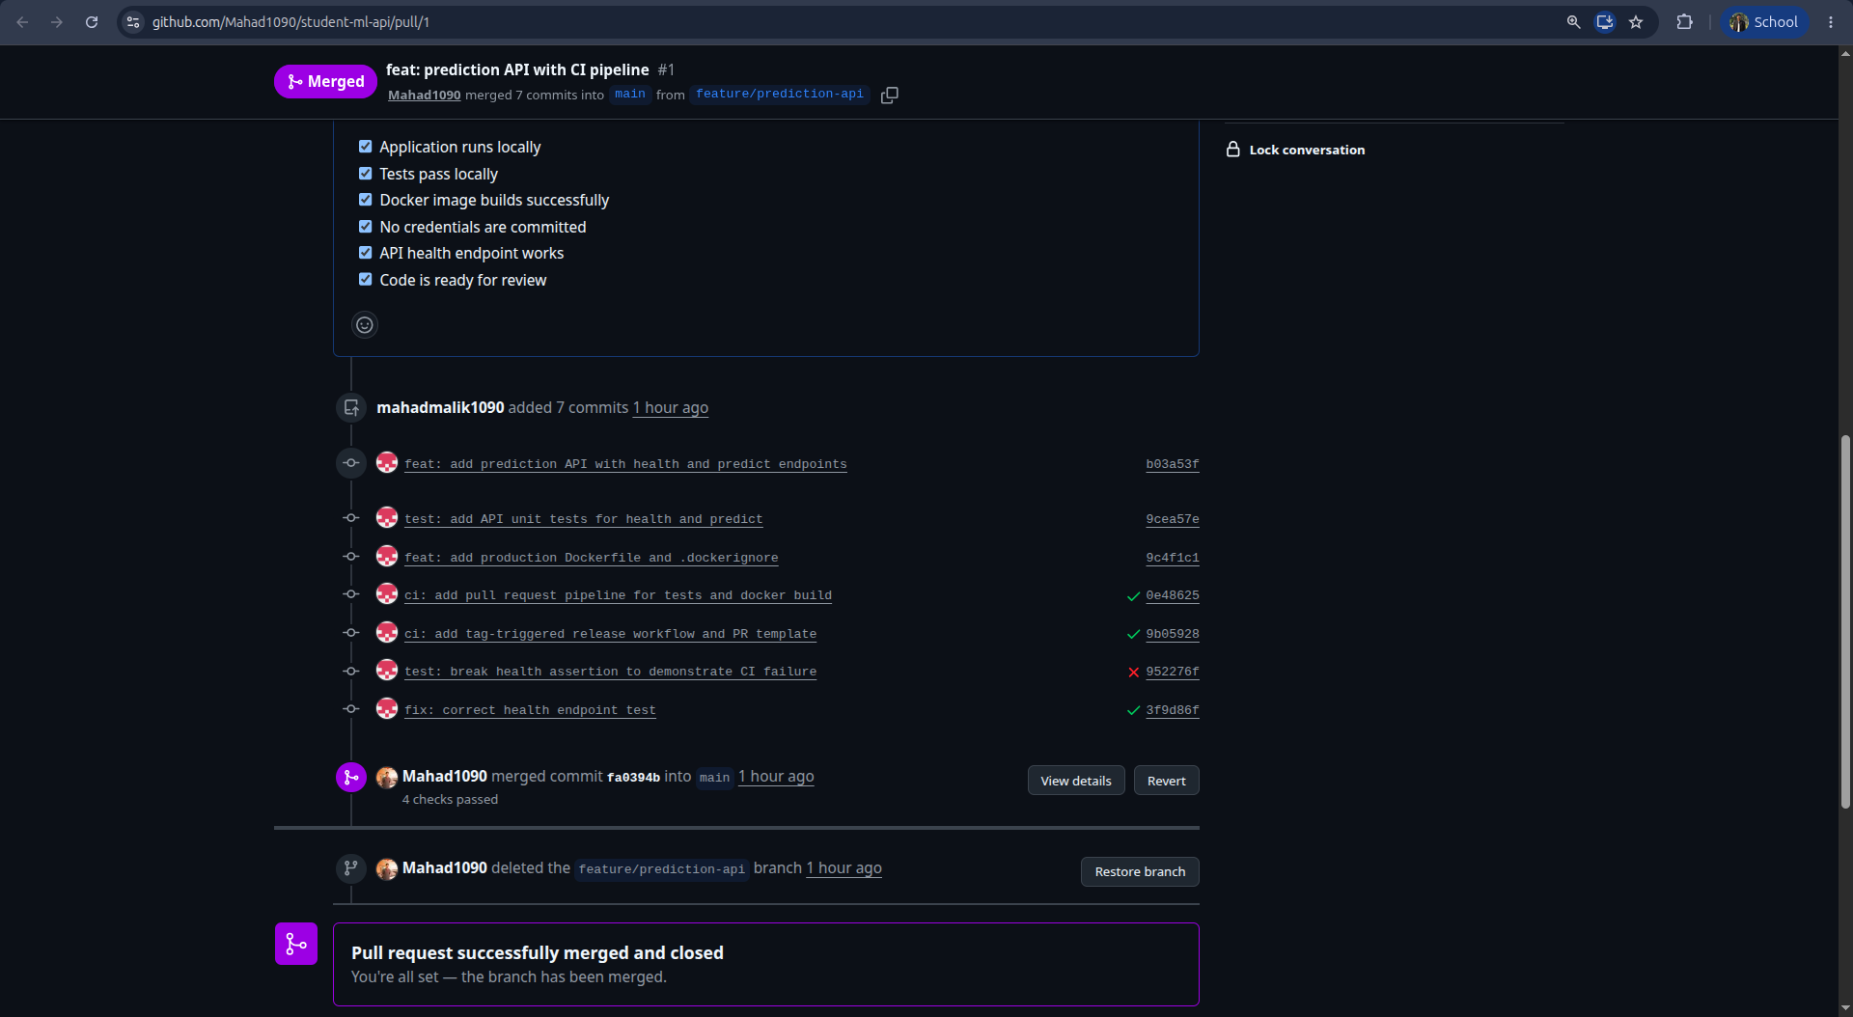
Fig 4 - PR #1 squash-merged as commit fa0394b; checklist complete; branch auto-deleted.

9. Dockerization (Part 9)
FROM python:3.12-slim # pinned - never python:latest
ARG APP_VERSION / GIT_COMMIT / BUILD_DATE
LABEL org.opencontainers.image.* # OCI metadata (Part 23)
WORKDIR /app
COPY requirements.txt . # deps copied first ...
RUN pip install --no-cache-dir -r requirements.txt # ... so this layer caches
COPY app.py VERSION ./ # app code last
EXPOSE 5000
CMD ["uvicorn","app:app","--host","0.0.0.0","--port","5000"]
.dockerignore excludes .git, .github, __pycache__, *.pyc, .venv, .env, tests, *.md, the assignment PDF, etc. Good practices: explicit base-image version, WORKDIR, dependency-before-code COPY ordering, --no-cache-dir, EXPOSE, and an exec-form CMD that binds 0.0.0.0 (not 127.0.0.1) so the port is reachable from the host.

10. Local Build, Run & Inspection (Parts 10-11)
docker build -t student-ml-api:1.0.0 \
--build-arg APP_VERSION=1.0.0 \
--build-arg GIT_COMMIT=$(git rev-parse HEAD) \
--build-arg BUILD_DATE=$(date -u +%Y-%m-%dT%H:%M:%SZ) .
docker run -d --name student-ml-api -p 5005:5000 student-ml-api:1.0.0
curl http://localhost:5005/health -> {"status":"healthy","application":"student-ml-api","version":"1.0.0"}
(Host port 5005 was used locally because ports 5000-5002 were occupied by unrelated containers - see Section 18 Failure 3.)
Identifier (Part 11) | Value
Container ID | cd0c8599377d
Image ID | b9bab104a906 (sha256:b9bab104a906...)
Exposed port | 5000/tcp
Running command | uvicorn app:app --host 0.0.0.0 --port 5000
Application working directory | /app

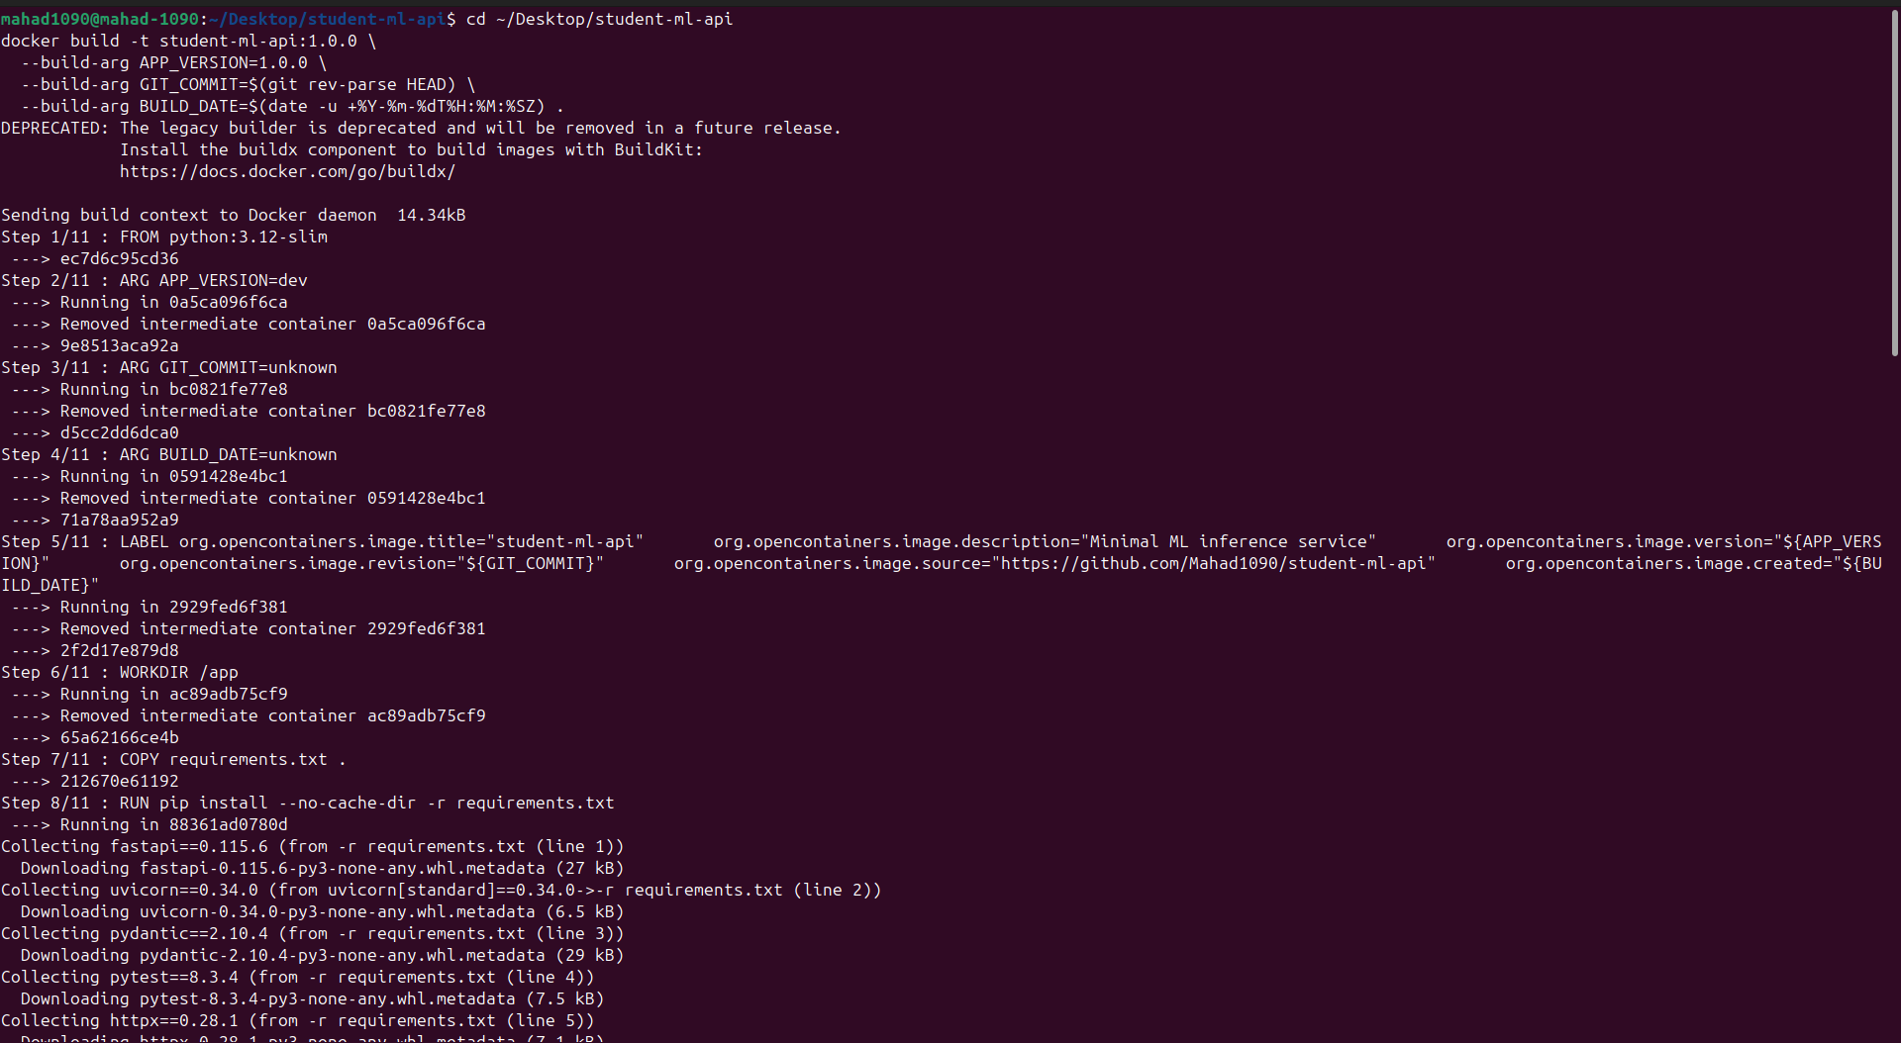
Fig 12 - docker build steps 1-8.
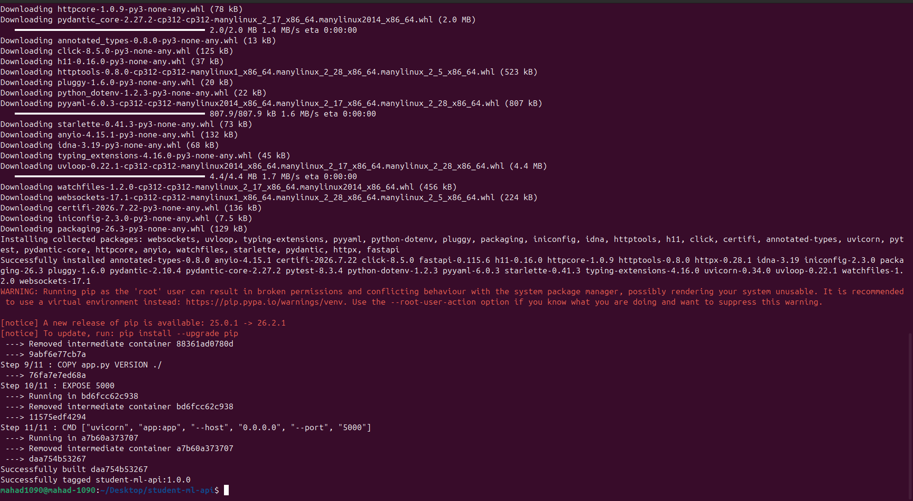
Fig 13 - steps 9-11, Successfully built / tagged.
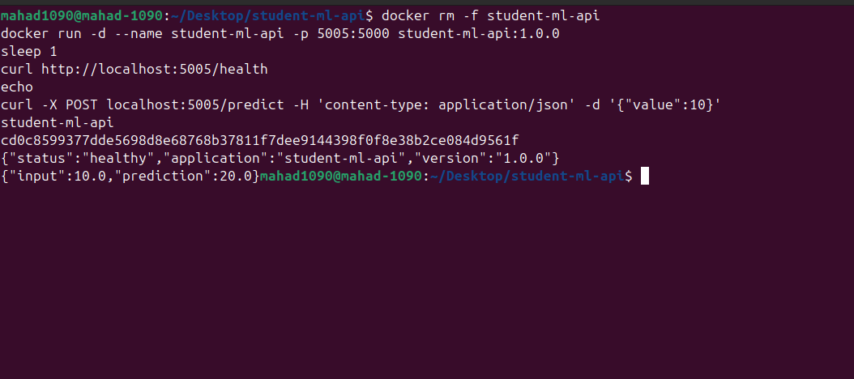
Fig 14 - container running from the local image; /health & /predict verified.
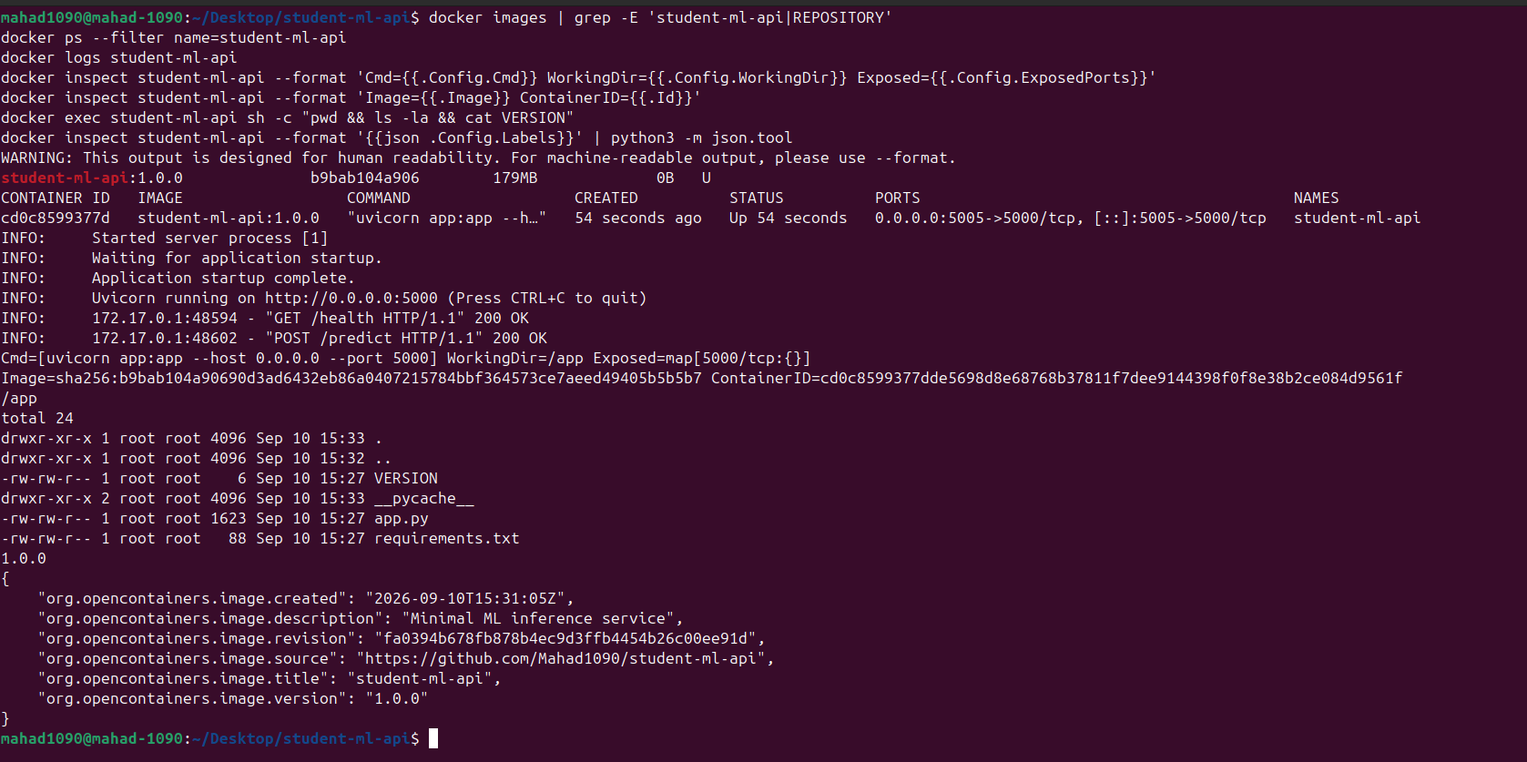
Fig 15 - images/ps/logs/inspect/exec + OCI labels (revision = fa0394b678...).

11. Container Registry (Parts 12, 16)
Registry: GitHub Container Registry (GHCR) - ghcr.io/mahad1090/student-ml-api, package visibility Public, linked to the repository.
Tag | Digest | Points to
1.0.0, fa0394b | sha256:10000c57bd3adc45a796199743b8b52e858b54d996ca34433f208c6b7b778e4c | commit fa0394b
1.1.0, latest, 02dc3db | sha256:2c9ccbd13d38ad9e8fbb4a067825f32b2c39b09082b31e4372f03332baadcaf5 | commit 02dc3db

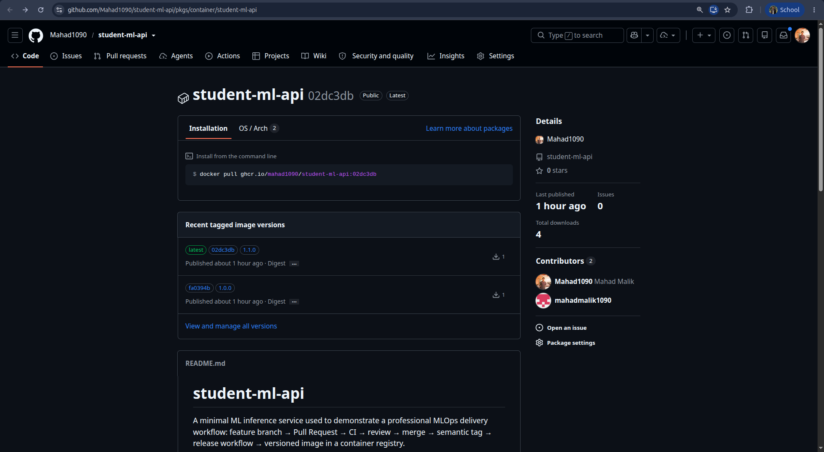
Fig 8 - GHCR package: tags latest, 1.1.0, 1.0.0 + commit-SHA tags.
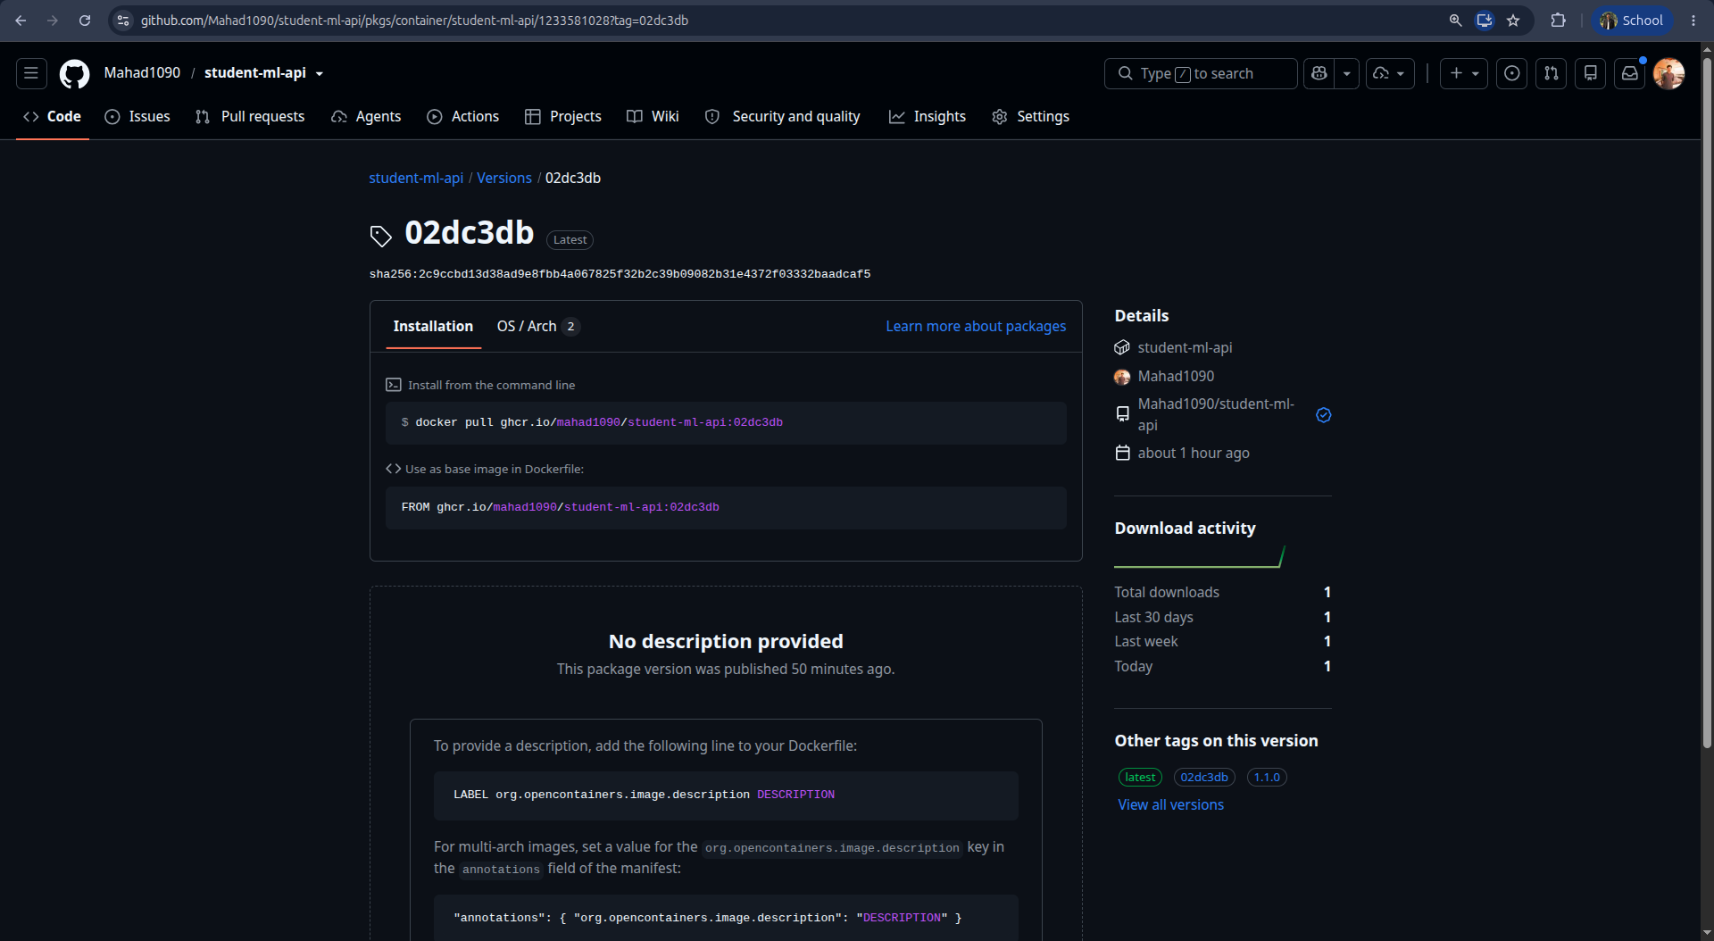
Fig 9 - version 1.1.0 / latest digest sha256:2c9ccbd1...

12. Git Tags & Release Workflow (Parts 13-15)
After each merge: git checkout main && git pull && git tag vX.Y.Z && git push origin vX.Y.Z. Tags present: v1.0.0 -> fa0394b, v1.1.0 -> 02dc3db.
release.yml runs ONLY on push: tags: ['v*.*.*'] and performs:
checkout -> derive version from tag -> run pytest -> GHCR login (GITHUB_TOKEN)
-> docker buildx build -> tag X.Y.Z / latest / <short-sha> -> push
The version is derived automatically - version=${GITHUB_REF_NAME#v} turns v1.1.0 into 1.1.0. Nothing is hard-coded; no password is stored in YAML (the GitHub-managed GITHUB_TOKEN with packages: write is used).
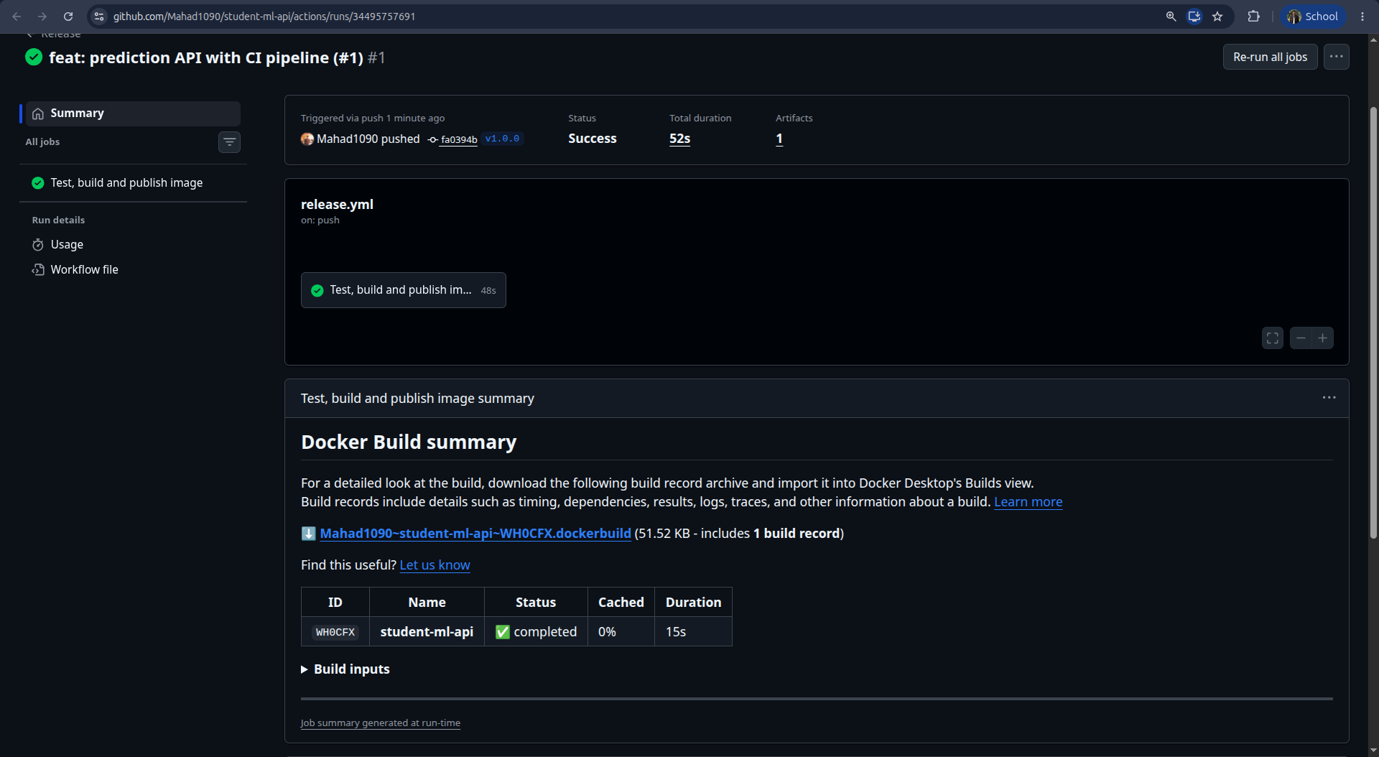
Fig 10 - Release run for v1.0.0 (success).
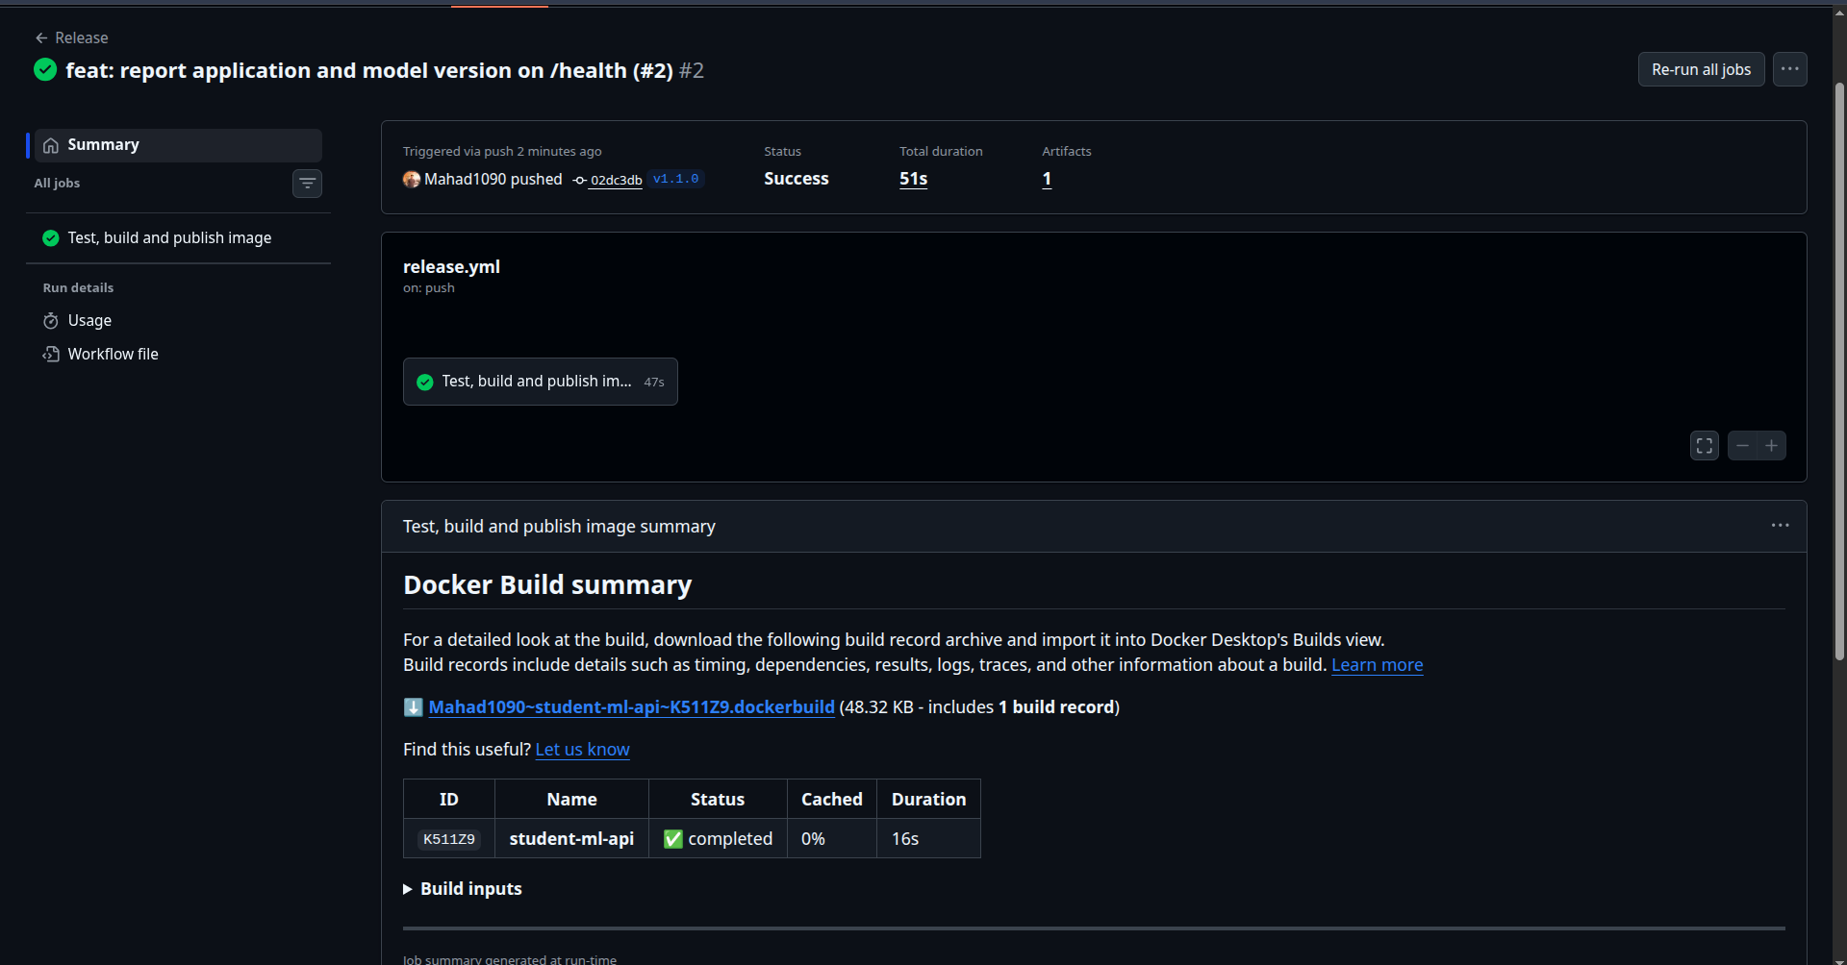
Fig 11 - Release run for v1.1.0 (success).

13. Artifact Reproducibility (Part 17)
docker rmi student-ml-api:1.0.0 # delete local build
docker pull ghcr.io/mahad1090/student-ml-api:1.0.0 # fetch from registry
-> Digest: sha256:10000c57bd3adc45a796199743b8b52e858b54d996ca34433f208c6b7b778e4c
docker run -d --name student-ml-api -p 5005:5000 ghcr.io/mahad1090/student-ml-api:1.0.0
curl localhost:5005/health -> {"status":"healthy",...,"version":"1.0.0"}
The image ran on a different toolchain state without rebuilding - build machine -> registry -> runtime environment.
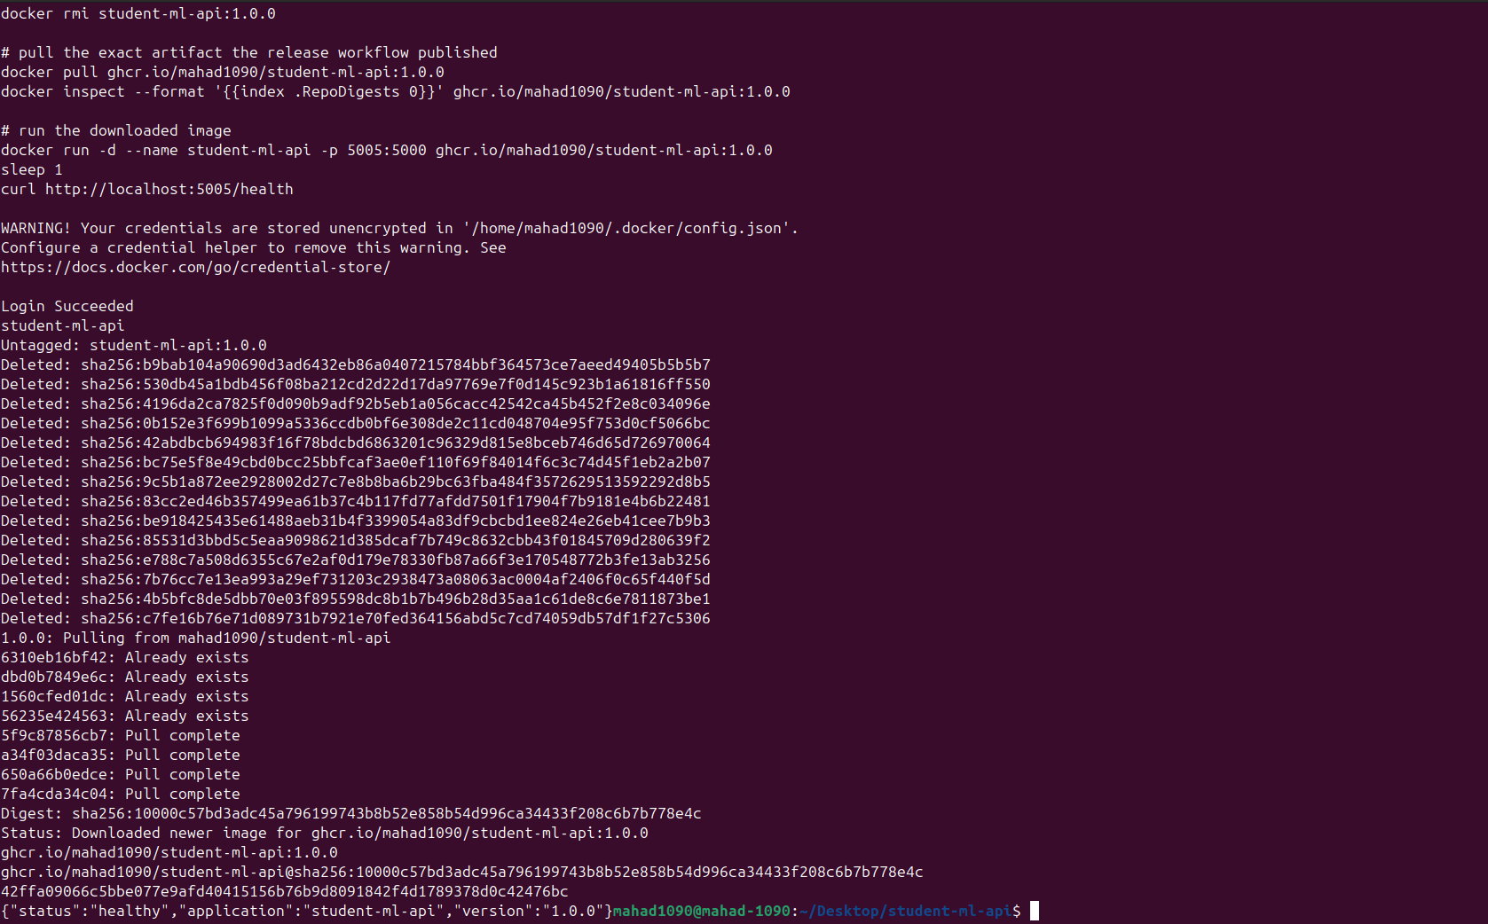
Fig 16 - local image removed, pulled by digest from GHCR, container healthy.

14. Version 1.1.0 (Parts 18-19)
Branch feature/model-metadata. /health was extended to report the application and model versions independently, and VERSION bumped to 1.1.0:
{"status":"healthy","application":"student-ml-api","application_version":"1.1.0","model_version":"model-1"}
Tests updated to assert both new fields. The full workflow was repeated (branch -> commits -> push -> PR #2 -> CI -> merge -> tag v1.1.0 -> release). The PR workflow was not bypassed.
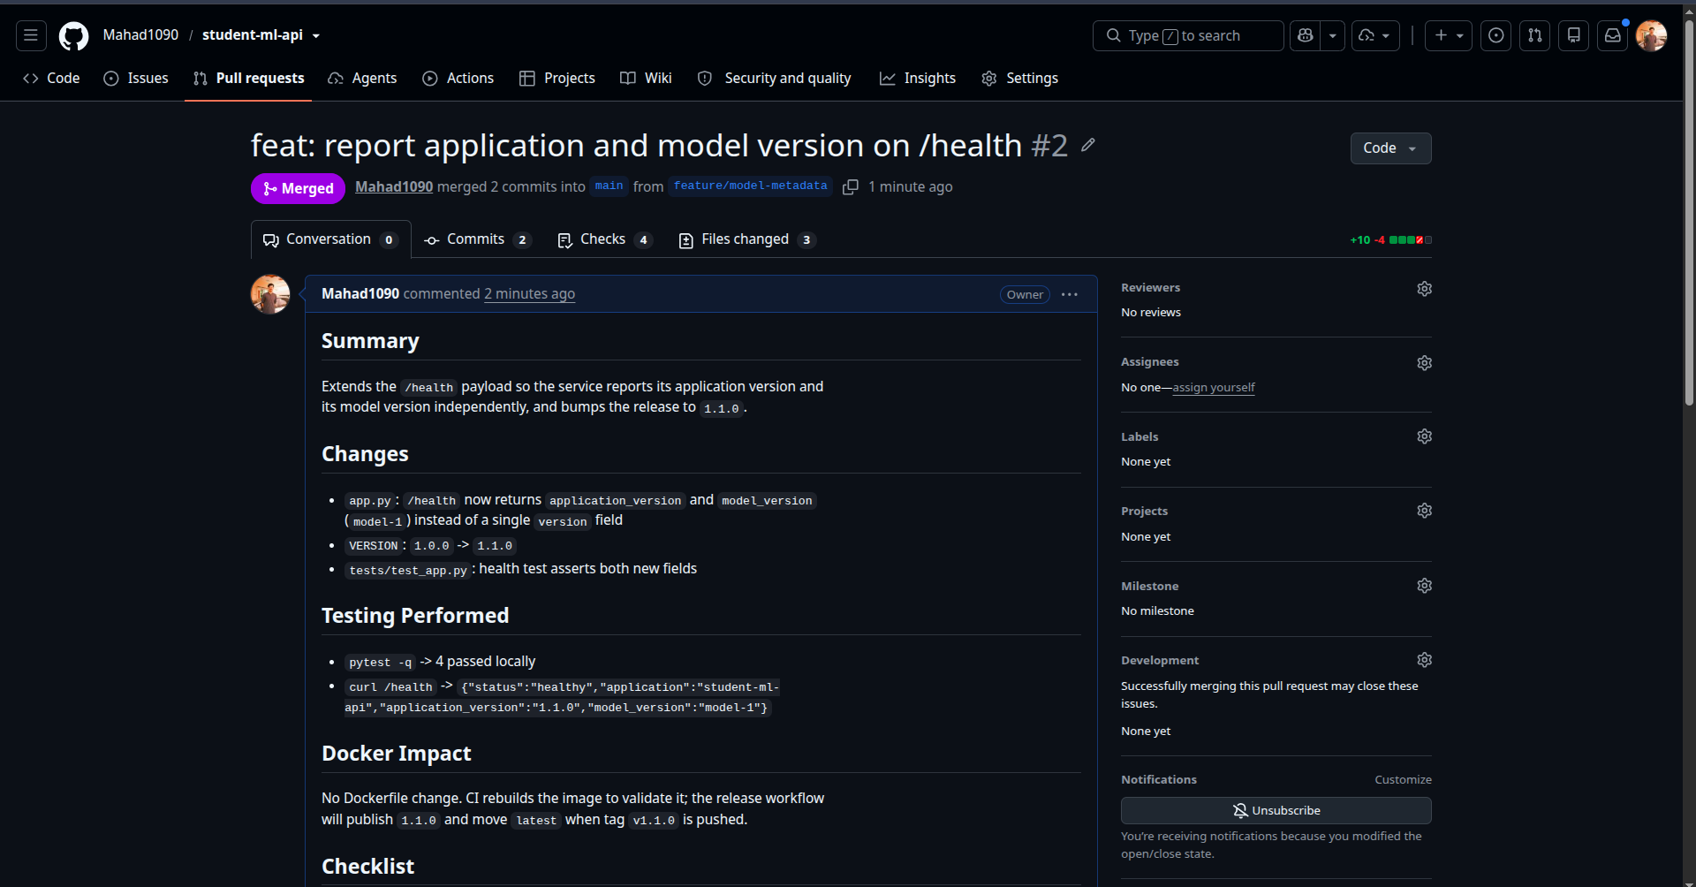
Fig 18 - PR #2 professional description.
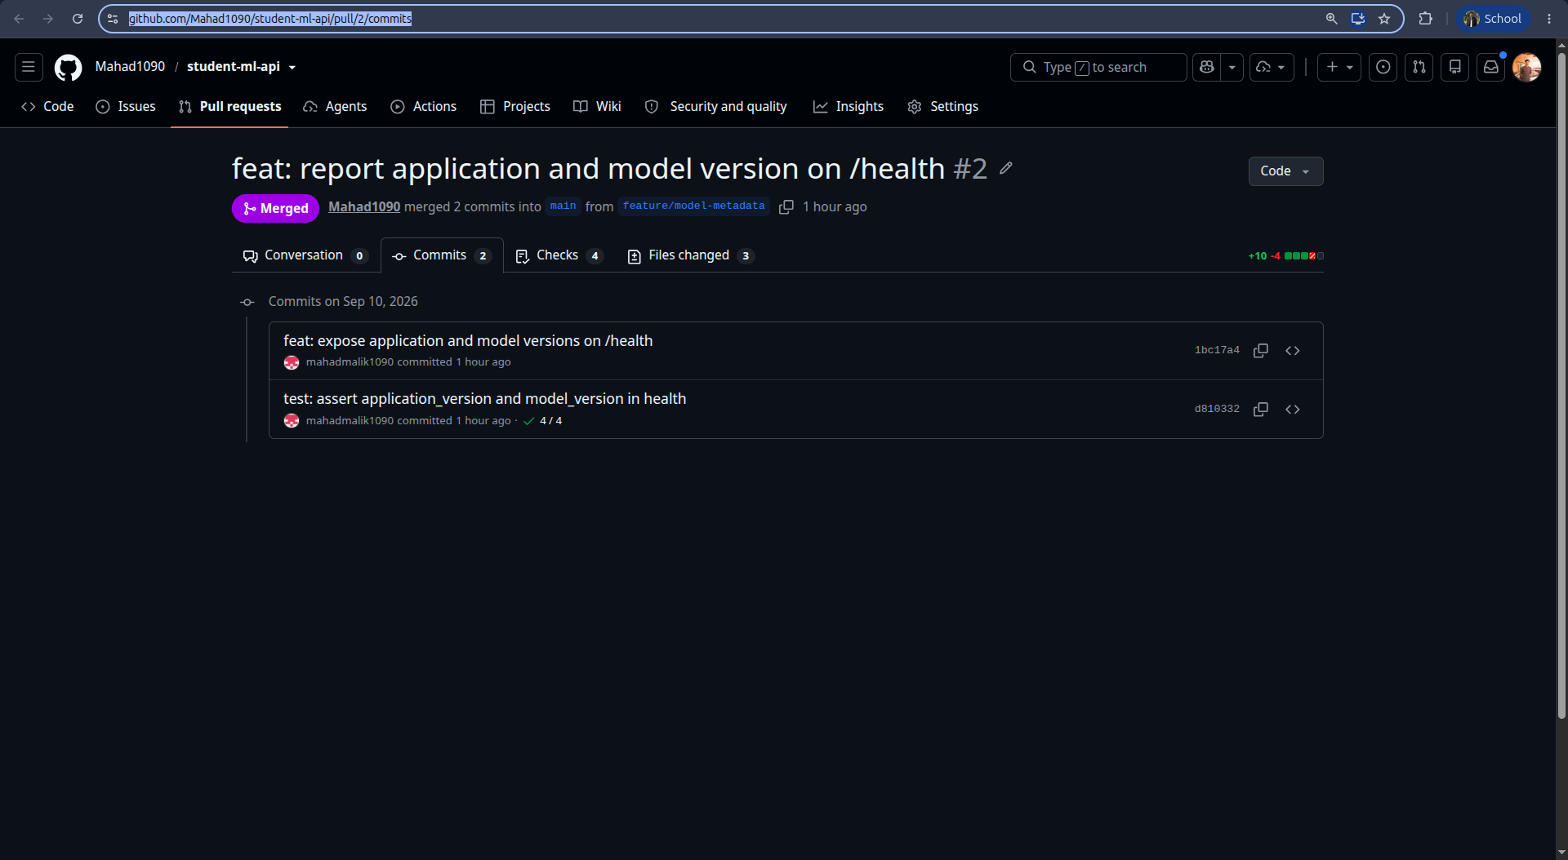
Fig 20 - PR #2 commits (feat + test).
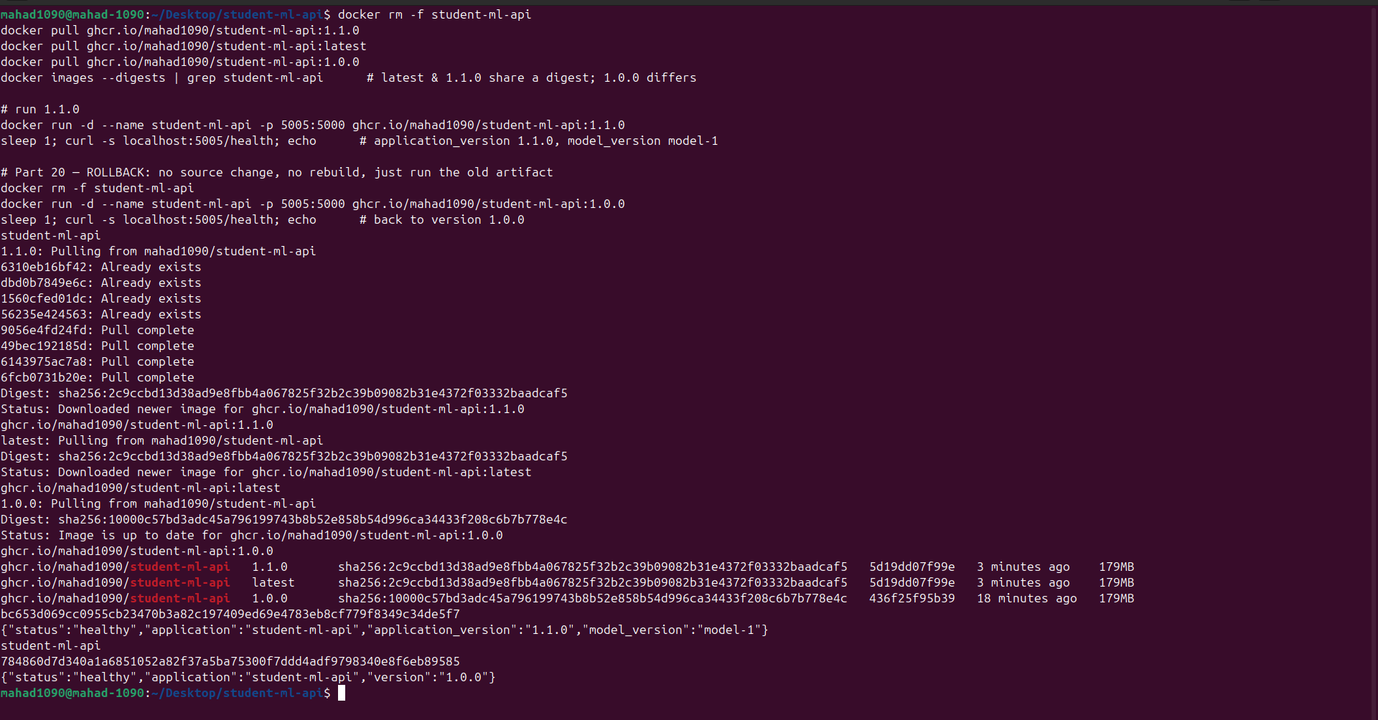
Fig 21 - docker images --digests: latest and 1.1.0 share digest 2c9ccbd1...; 1.0.0 keeps digest 10000c57... and remains available.

15. Rollback Exercise (Part 20)
Assume 1.1.0 has a production issue. Restore 1.0.0 with NO source change and NO rebuild:
docker rm -f student-ml-api
docker run -d --name student-ml-api -p 5005:5000 ghcr.io/mahad1090/student-ml-api:1.0.0
curl localhost:5005/health -> {"status":"healthy","application":"student-ml-api","version":"1.0.0"}
Why this beats git clone -> pip install -> python app.py: the 1.0.0 image is the exact bytes that were tested and previously ran - same OS packages, same pinned Python, same wheels. A fresh pip install can resolve different transitive versions and reintroduce bugs. Rollback is one docker run (seconds, no build toolchain on the host) and is auditable by digest.

16. Traceability Challenge (Part 21)

Version 1.0.0
Pull Request : #1 feat: prediction API with CI pipeline
Merge Commit : fa0394b678fb878b4ec9d3ffb4454b26c00ee91d
Git Tag : v1.0.0
Docker Image : ghcr.io/mahad1090/student-ml-api:1.0.0 (also :fa0394b)
Image Digest : sha256:10000c57bd3adc45a796199743b8b52e858b54d996ca34433f208c6b7b778e4c

Version 1.1.0
Pull Request : #2 feat: report application and model version on /health
Merge Commit : 02dc3db8bf199a185b6f0c9d0c454fb599e25e12
Git Tag : v1.1.0
Docker Image : ghcr.io/mahad1090/student-ml-api:1.1.0 (also :latest, :02dc3db)
Image Digest : sha256:2c9ccbd13d38ad9e8fbb4a067825f32b2c39b09082b31e4372f03332baadcaf5
The image additionally carries the commit as an OCI label (org.opencontainers.image.revision), so a running container can always be traced to its source commit (Fig 15).
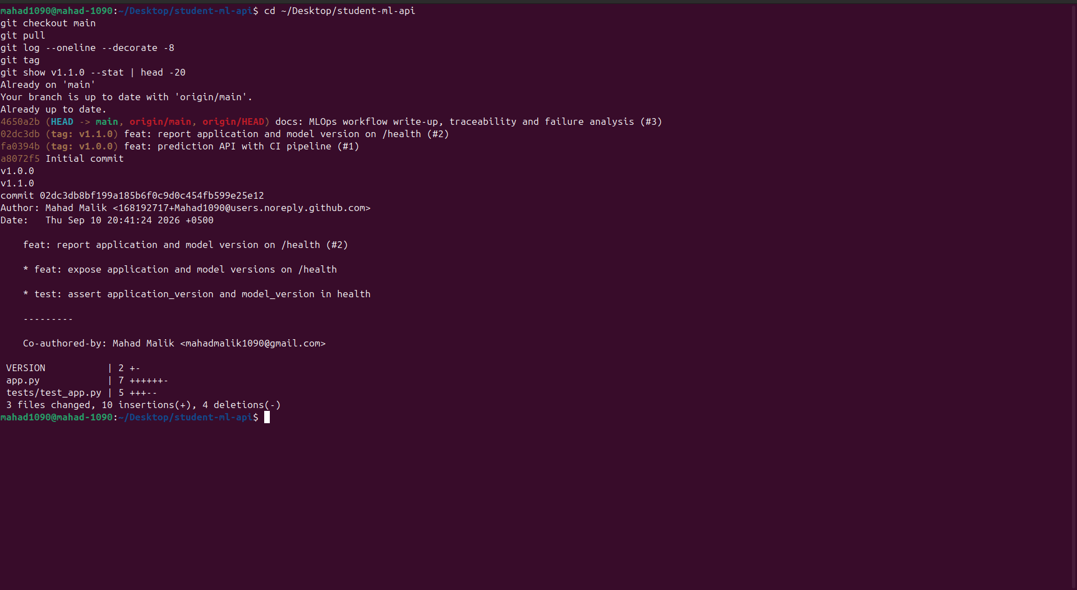
Fig 17 - git log --decorate + git tag: tags on main, PR-merge commits.

17. CI vs Release, Metadata, Commit Tag, Cache (Parts 22-25)

CI workflow vs Release workflow (Part 22)
 | CI - ci.yml | Release - release.yml
Trigger | pull_request -> main, feature-branch push | push tag v*.*.*
Does | test, validate, build-check | test, build, version, publish
Publishes artifact | No | Yes

Why not publish an image from every PR? A PR is unreviewed and possibly unstable (or from a fork); publishing pollutes the registry with throwaway tags and risks deploying an un-merged change. Registry storage/bandwidth cost money and most PR builds are never used. Publishing should be a deliberate, tagged, auditable event - and a push credential is far more dangerous in a PR-triggered job than in a tag-triggered one only maintainers can fire.

Image metadata (Part 23)
org.opencontainers.image.title = student-ml-api
org.opencontainers.image.version = 1.1.0
org.opencontainers.image.revision = 02dc3db8bf199a185b6f0c9d0c454fb599e25e12
org.opencontainers.image.source = https://github.com/Mahad1090/student-ml-api
org.opencontainers.image.created = <build timestamp>
Verified with docker inspect --format '{{json .Config.Labels}}' (Fig 15).

Commit-SHA tag (Part 24)
Alongside 1.1.0 and latest, the release publishes student-ml-api:02dc3db. Benefit: a semantic tag is a human label that could be re-pushed and latest moves constantly; a commit-SHA tag is 1:1 with an immutable point in source history - given a running container you can name the exact commit, and given a commit you can pull exactly that image.

Build cache (Part 25)
With COPY requirements.txt -> RUN pip install -> COPY app.py: editing only app.py reuses the cached dependency layer (---> Using cache) and rebuilds in seconds; editing requirements.txt invalidates that layer and everything after it, so pip install re-runs. COPY . . before pip install is worse because any one-character source change forces a full re-install on every build - wasting CI minutes on every commit.

18. Failure Analysis (Part 26)

Failure 1 - Failed pytest blocks the PR
Symptom | PR #1 CI red; Unit tests failed, Docker build validation skipped; merge blocked.
Root cause | Assertion changed to == 'wrong' while the endpoint returns 'healthy'.
Evidence | Run 34494638490: AssertionError: assert 'healthy' == 'wrong' (Fig 5).
Correction | Restored the assertion; commit 3f9d86f; run 34494921761 green (Fig 6).

Failure 2 - Missing dependency (deliberately reproduced)
Symptom | On branch chore/failure-demo, CI Unit tests failed during collection; Docker build validation skipped.
Root cause | httpx removed from requirements.txt. FastAPI's TestClient wraps httpx, so every test fails to import even though app.py still runs.
Evidence | Run 34498295688: ModuleNotFoundError: No module named 'httpx' / RuntimeError: The starlette.testclient module requires the httpx package (Fig 25).
Correction | Restored httpx==0.28.1; branch discarded (never merged). A runtime-only missing dep (e.g. dropping uvicorn) would instead pass pytest but fail the container's CMD at start - which is why CI also builds the image.

Failure 3 - Wrong / already-allocated container port (observed locally)
Symptom | docker run -p 5000:5000 -> Bind for 0.0.0.0:5000 failed: port is already allocated. curl localhost:5000/health returned a different app's JSON.
Root cause | Three containers from an unrelated exercise already published host ports 5000-5002; the new container could not bind and the port that answered belonged to another service.
Evidence | docker ps showed 0.0.0.0:5000->5000/tcp on competent_rhodes, ...5001 / ...5002 on staging-a/-b; our container stuck in Created.
Correction | Published on a free host port: -p 5005:5000. curl localhost:5005/health then returned the correct student-ml-api payload. The container port (EXPOSE 5000, --port 5000) is fixed by the image; only the host side of -p host:container collided.

Related - binding to 127.0.0.1: if the app bound 127.0.0.1 instead of 0.0.0.0, it would only accept connections from inside the container's namespace, so -p 5005:5000 forwarding from the host would get connection reset. This is why the CMD uses --host 0.0.0.0.
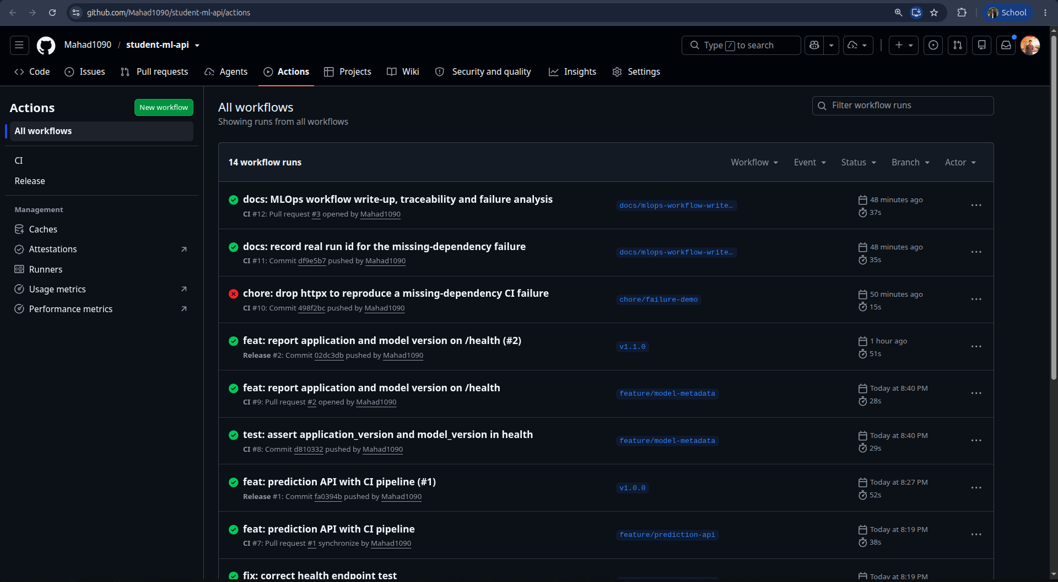
Fig 25 - Actions history: the failed chore/failure-demo and Part-6 runs among the green CI / Release runs.

19. Viva Questions
1. Why avoid pushing directly to main? No review, no CI gate, no audit trail - a bad commit is instantly 'production'. PRs make every change reviewed, tested and revertible as a unit.
2. Purpose of a PR beyond merging? Code review, discussion, a CI checkpoint, a documented rationale, and a durable link between a change and why it was made.
3. Why CI before merge? To keep main always green. A failure caught after merge means everyone pulls broken code and the fix needs its own PR.
4. Image vs container? An image is an immutable, layered filesystem + metadata (a build artifact). A container is a running/stopped instance of an image with its own writable layer, PID, network and lifecycle.
5. Why version images? So a deploy names an exact artifact, rollbacks are possible, and 'what is running?' has a precise answer.
6. Why is latest insufficient? It is a moving pointer - different bytes over time, recorded nowhere; two machines pulling it a day apart can run different code.
7. Why promote the same artifact instead of rebuilding? A rebuild can pull different transitive dependencies / base-image patches and produce an untested image. Promotion ships the tested bits.
8. Purpose of a container registry? A versioned, access-controlled store that distributes immutable image artifacts (by tag and by digest) to any environment.
9. CI vs release workflow? CI validates proposed changes on PRs and publishes nothing. Release runs on a version tag and is the only thing that builds and pushes a published image.
10. Why secrets for registry credentials? Hard-coded credentials live in git history forever, are visible to anyone with read access, and cannot be rotated cleanly. Secrets are injected at runtime, masked in logs, and scoped.
11. How to identify the commit that produced an image? The <short-sha> image tag, or docker inspect -> org.opencontainers.image.revision label.
12. Why does layer ordering affect CI/CD performance? A changed layer invalidates the cache for itself and everything after it - put slow, rarely-changing steps (dependency install) before fast, frequently-changing ones (app code).
13. How to roll back 1.1.0 -> 1.0.0? docker run ghcr.io/mahad1090/student-ml-api:1.0.0 - the old image is still in the registry; no code change, no rebuild.
14. Git tag vs Docker image tag? The Git tag (v1.1.0) marks a commit in source history and triggers the release; the Docker tag (1.1.0) labels the resulting image in the registry. The workflow derives the second from the first.
15. App version vs model version changing independently? Both must be recorded per release (here via application_version + model_version) - the same code with a different model, or the same model behind different code, are different systems. It also multiplies the test matrix and complicates rollback (roll back code, model, or both?).

20. Screenshot Appendix
All evidence images, in order.
Fig 1 - pytest -q: 4 passed.
Fig 2 - PR #1 description & checklist.
Fig 3 - PR #1 commits (break X / fix OK).
Fig 4 - PR #1 squash-merged (fa0394b).
Fig 5 - Part 6: CI FAILED.
Fig 6 - Part 6: CI SUCCESS after fix.
Fig 7 - main branch protection.
Fig 8 - GHCR package tags.
Fig 9 - image digest for 1.1.0/latest.
Fig 10 - Release workflow for v1.0.0.
Fig 11 - Release workflow for v1.1.0.
Fig 12 - docker build (steps 1-8).
Fig 13 - docker build (steps 9-11, tagged).
Fig 14 - container from local image, endpoints verified.
Fig 15 - Part 11 inspection + OCI labels.
Fig 16 - Part 17: rmi -> pull -> run from GHCR.
Fig 17 - git log / git tag on main.
Fig 18 - PR #2 description.
Fig 19 - PR #2 required checks.
Fig 20 - PR #2 commits.
Fig 21 - digests: latest=1.1.0, 1.0.0 still present + rollback curls.
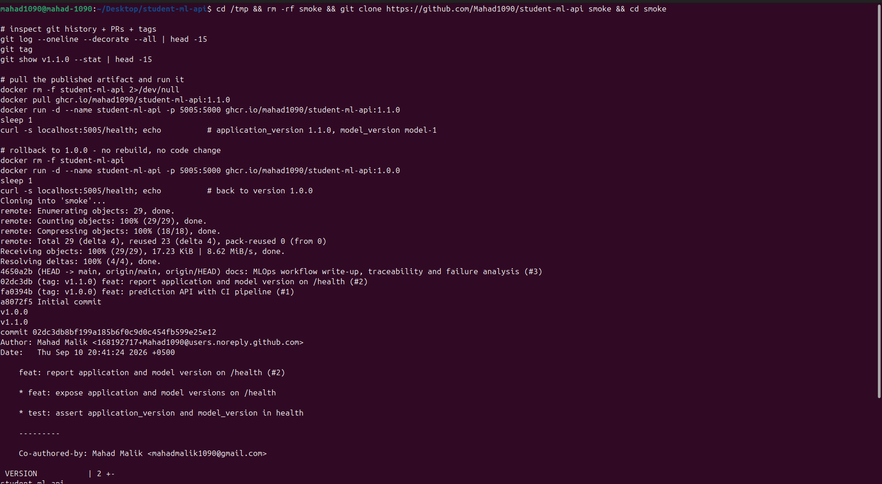
Fig 22 - Demonstration: clone repo, inspect git history/tags.
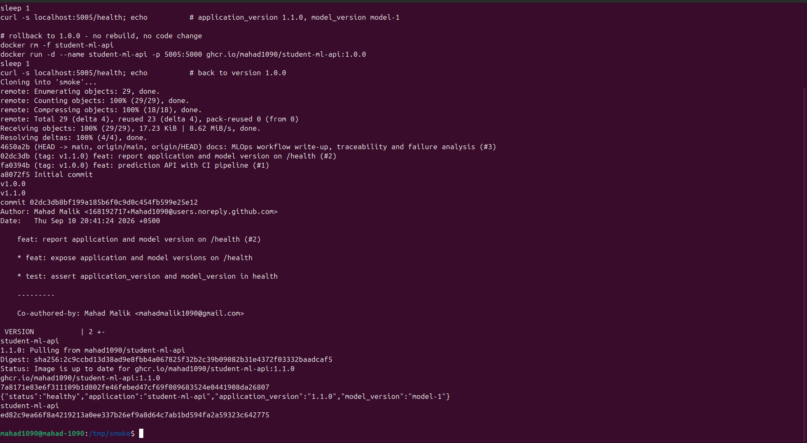
Fig 23 - Demonstration: pull & run 1.1.0, then roll back to 1.0.0.
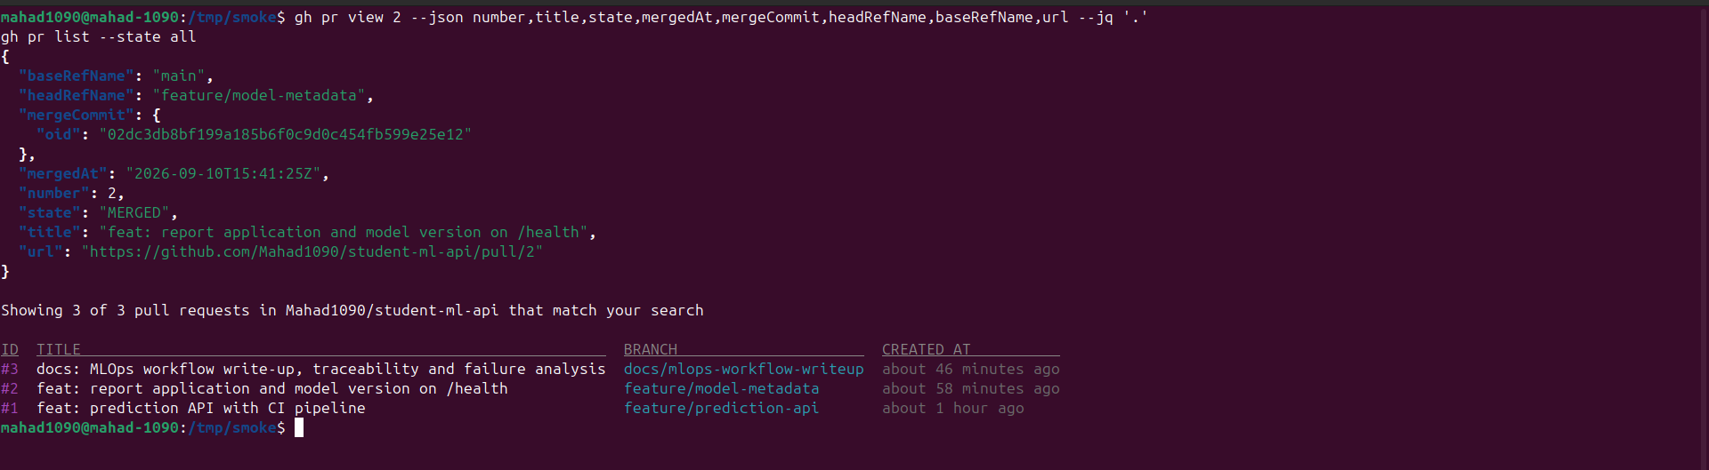
Fig 24 - Demonstration: inspect PR (gh pr view / gh pr list).
Fig 25 - Actions history (top): failed & successful runs.
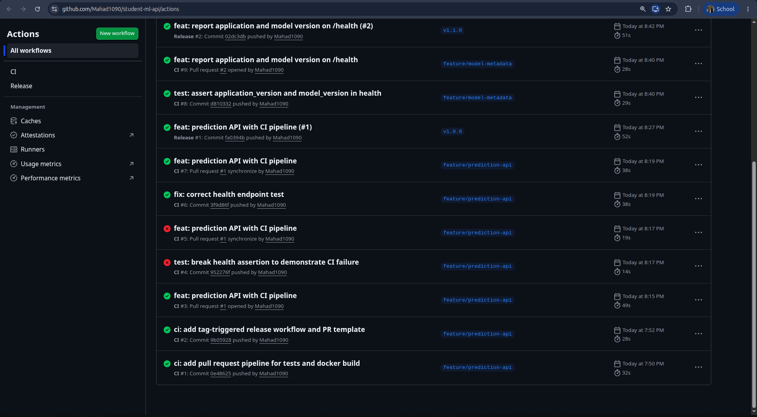
Fig 26 - Actions history (bottom): Part-6 failed run, Release runs.

