

Progress Report 1
Data Leak Prevention using Artificial Intelligence
By
Muhammad Afeef Bari 2023356
Mahad Aqeel 2023286
Yashfa Fatima 2023762
Rubab Ali 2023614

Faculty of Computer Science and Electrical Engineering
Bachelors of Science in Cybersecurity

Abstract
Data leakages pose risks to the confidentiality and integrity of any sensitive information both at individual and organization level. Traditional Data Leak Prevention (DLP) systems have relied on the use of predefined, rule-based detection, which is insensitive to any new data types or contextual differences.
This report gives the initial stage of our project which is a hybrid search based intelligent agent integrating Regular Expressions (Regex) in pattern matching by rule and Linear Regression in scoring by anomaly.
The Regex component helps to extract the direct matches with the predefined sensitive data patterns (e.g. emails, phone numbers,CNICs), whereas the Linear Regression component scores data risks due to the frequency and density of discovered sensitive items. They all constitute a semi-intelligent DLP system that can recognize structured leakages and identify unusual text records that can represent the possibility of data leakage.

Introduction and Motivation
Data leakage remains one of the major threats to cybersecurity particularly in companies that deal with classified customer or corporate information.
The classic DLP systems are based on strict rules that cannot be flexed according to the context, resulting in a high false positive and the low adaptability.
The rationale of such a step is to create a hybrid detection agent that takes the deterministic accuracy of Regex pattern search and integrates with adaptive intelligence of machine learning - in this instance, Linear Regression to rank possible risk levels.
This hybrid system gives the ability to identify both:
- Pattern based (explicitly sensitive) content.
- Trauma, unostentatious, or abnormal records (statistical aberrations).

Problem Definition and Objectives

Problem Statement
There is a lack of adaptation to new dangers or the ability to notice the minor abnormalities of communication patterns therefore causing companies to face difficulty in stopping deliberate or unintentional data leakage.

Objectives
- Use a Regex based agent to detect sensitive patterns in text information.
- Establish a Linear Regression based scoring system to examine the probability of a record being sensitive depending on the density of the pattern.
- Analyze the detection results in the form of logs and visualization.
- Initiate a functional hybrid detection model as a base of future DLP systems based on AI.

Literature Review
Past studies have shown that whereas the Regex-based systems are capable of detecting explicit data like credit card or email formats, they are not flexible to novel or disguised information.
Kim et al. (2021) found that there are too many false positives with the use of static DLP systems. According to Malik et al. (2022), ML has a place in enhancing adaptive detection.
Our solution is based on these findings and combines search-based Regex detection with a simple Linear Regression anomaly model to enhance the accuracy of decisions with a limited computational cost.
System Architecture

Components
- Input Layer: Imports and cleans textual data.
- Regex Detection Engine: Searches for predefined sensitive patterns.
- Feature Extraction Module: Counts detected sensitive items per record.
- Linear Regression Analyzer: Scores records based on sensitivity density.
- Alert and Blocking System: Alerts and blocks detected leaks with severity scores.

Architecture Flow
[Text Data]
↓
[Regex Pattern Detection]
↓
[Feature Extraction → Count Sensitive Matches]
↓
[Linear Regression Risk Scoring]
↓
[Alerts + Logs]

Methodology and Algorithmic Implementation

5.1 Regex Detection Algorithm
The Regex-based agent searches each data record for sensitive patterns using re.findall().
Patterns include:
- Email addresses
- Phone numbers
- CNICs/Credit Card Numbers
Algorithm Steps:
- Input text record
- Apply Regex patterns
- Store number of matches
- Pass feature count to regression model for scoring

5.2 Linear Regression Risk Scoring
After detecting sensitive data, the system applies a Linear Regression model to predict a risk score based on the number of sensitive items found.
This model learns from labeled examples e.g., “Low Risk” (0–1 matches), “Medium Risk” (2–3 matches), “High Risk” (4+ matches).

Implementation Code with Results & Output
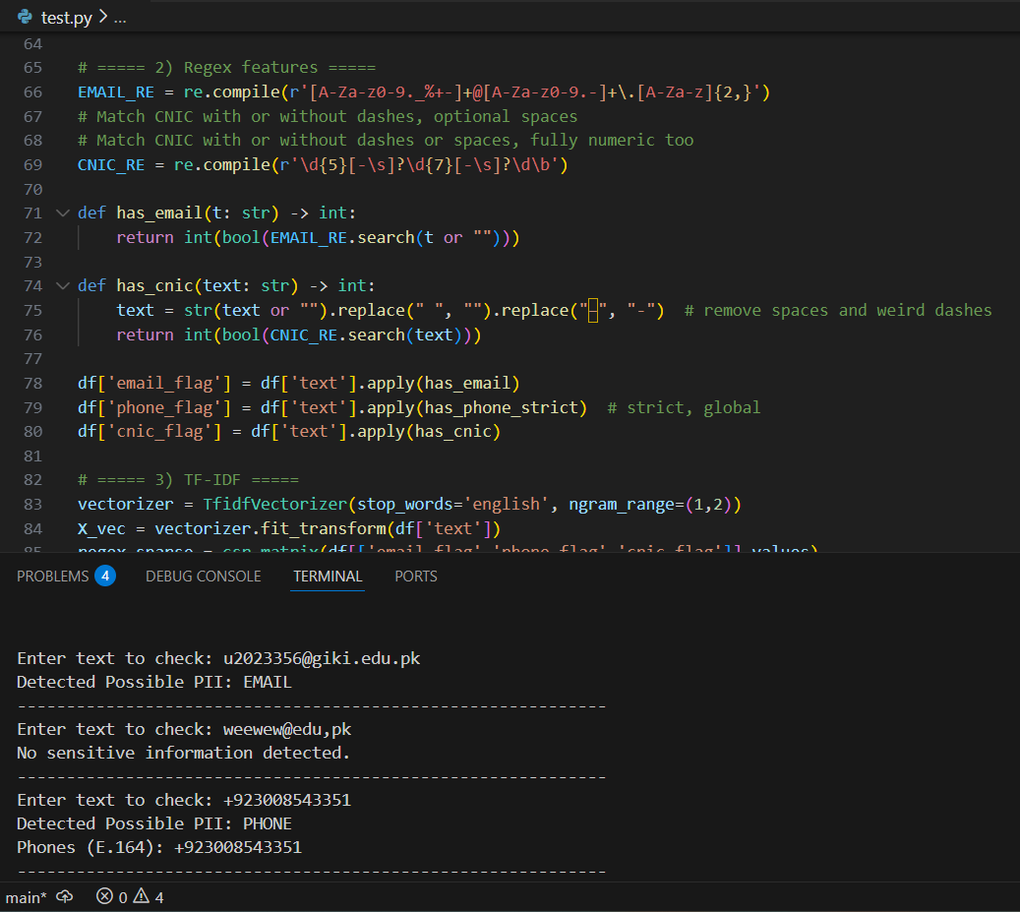
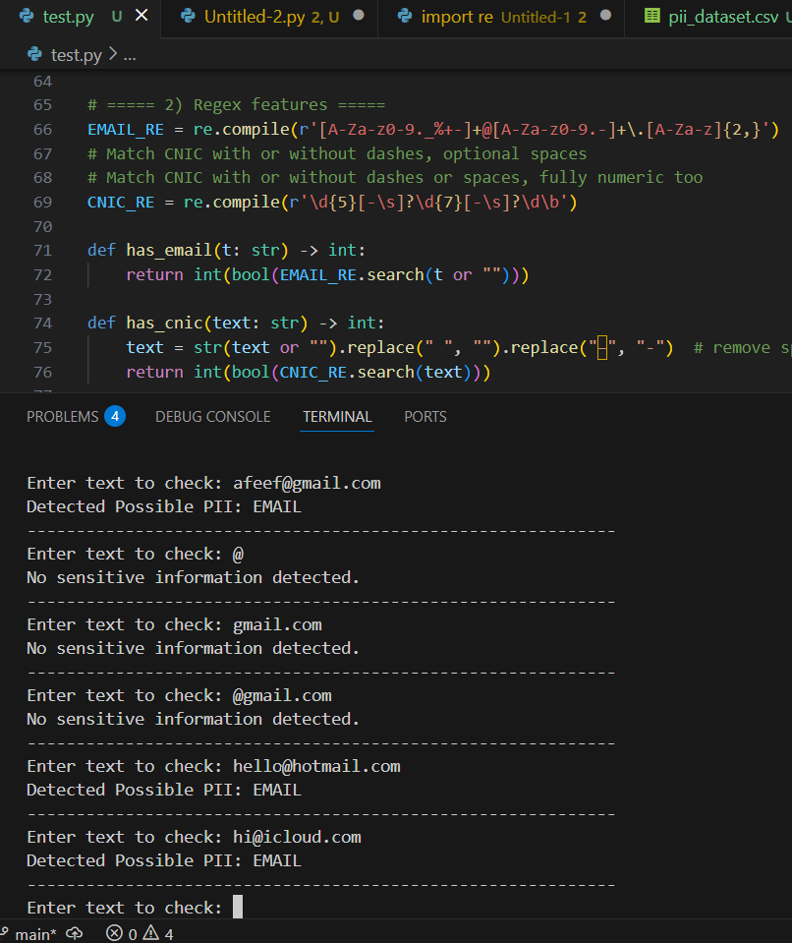
Discussion
The Regex and Linear Regression solution is used together to boost the DLP detection. Regexes are accurate at detecting defined patterns whereas Linear Regression is accurate at giving a numerical sensitivity measure, which can be used to rank alerts. Such approach also preconditions the supervised learning and detection of anomalies in the further stages.
Limitations
Linear Regression can only be applied to simple number relationships; one does not analyze contextual meaning. Small sample size has an implication on model generalization. Accuracy in Risk Scoring is required with diversity of data.
Conclusion
The hybrid search of data leak prevention is successfully implemented. The Regex is used to recognize particular sensitive items and the Linear Regression is used to offer adaptive scoring and statistical insight. The design satisfies the AI agent/search algorithm requirement and bases the context-aware ML-based DLP system.
Future Work
Instead of Linear Regression, use classification models (e.g toward the Naive Bayes model, or the Logistic Regression model). Add semantic context NLP features. Increase the data and incorporate the model into a live monitoring dashboard.

References
- J. Kim, Y. Kim, and J. Kim, “Data Leakage Prevention Techniques: A Review,” IEEE Access, vol. 9, pp. 95784–95799, 2021.
- M. I. Malik, M. A. Khan, R. Ali, and S. A. Madani, “Machine Learning Techniques for Data Leakage Detection in Cloud Computing: A Survey,” IEEE Access, vol. 10, pp. 16017–16042, 2022.
- S. D. Ramapuram and M. Sebastiani, “AI-Driven Insider Threat Detection and Data Loss Prevention Using Behavior Analysis,” IEEE Big Data Conference, 2021.
- N. Hubballi and V. Suryanarayanan, “Layered Approach for Insider Attack Detection Using Machine Learning,” ICISSP, 2017.

