**How to Create and Save a New Document in Microsoft Word**

This guide will show you how to create a new blank document in Microsoft Word and save it on your computer. We'll use screenshots to help you follow along easily.

**1. Open Microsoft Word:**

* Locate the Microsoft Word icon on your computer. It might be on your taskbar, desktop, or Start menu.

[Opens in a new window[https://encrypted-tbn2.gstatic.com/favicon-tbn?q=tbn:ANd9GcRpbYPn4WJFVFQGJrIejHnlYehSYyTXdvPuEgD0mrIq7TI2ggSWmyKQzIgXbKdshoHWUvJF4V5W5eWxPUQ-vWA3U7bBm8eWGZc52goT](https://en.m.wikipedia.org/wiki/File:Microsoft_Office_Word_(2019%E2%80%93present).svg)wikipedia.org](https://en.m.wikipedia.org/wiki/File:Microsoft_Office_Word_(2019%E2%80%93present).svg)

Microsoft Word icon

pen_spark

* Click on the icon to launch the program. A new blank document will usually open by default.

**2. (Optional) Start with a Template (Skip if you want a blank document):**

* If you want a pre-formatted document for specific purposes like a resume, letter, or report, you can use a template.
* Click on the "**Search for online templates**" box at the top of the screen.

[Opens in a new window[https://encrypted-tbn0.gstatic.com/favicon-tbn?q=tbn:ANd9GcR7Bujbu9lWsCT3iltoqvqAsNe14hXhcPt24wGy7v9QD7rE7up94tbY00Qcnl9XBpf9z9pr4D84EtQPIi562Xw8BYkIZAD9OrRGSGf17I9TCA](https://www.thewindowsclub.com/how-to-search-for-online-templates-in-word)www.thewindowsclub.com](https://www.thewindowsclub.com/how-to-search-for-online-templates-in-word)

Search for online templates box in Word

* Type in a keyword for the type of document you need (e.g., "resume") and press Enter.
* Browse the available templates and double-click on the one you want to use.

**3. Create Your Document Content:**

* Once you have a blank document (or opened a template), you can start typing your content.
* The formatting bar at the top allows you to change the font style, size, and color of your text.

[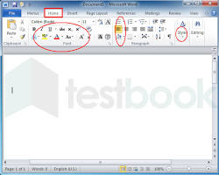Opens in a new window[https://encrypted-tbn0.gstatic.com/favicon-tbn?q=tbn:ANd9GcQ-eM7aDgzdCfhWtfNb9xoIkpoJtb0lIWFZ-yo4NeEaru0TEm23aBsISyzJExEq6Y8yP-8Z3QtxdjzO3LXmkYF0H-GoTBbQ](https://testbook.com/question-answer/just-below-the-toolbar-there-is-a-______-bar--634edf8e5b70495322d37c38)testbook.com](https://testbook.com/question-answer/just-below-the-toolbar-there-is-a-______-bar--634edf8e5b70495322d37c38)

Formatting bar in Word

* You can also insert images, tables, and other elements using the options in the ribbon bar at the top of the screen.

**4. Save Your Document:**

* It's important to save your work regularly to avoid losing it.
* Click on the "**File**" tab in the top left corner of the screen.

[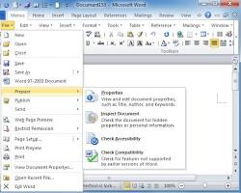Opens in a new window[https://encrypted-tbn1.gstatic.com/favicon-tbn?q=tbn:ANd9GcTuFoLgJ-Q607AGcnMxs84oaz-8knAYQIxzGk-SOSDLDAVv2x26vtHhoisoxWJTVruMx7Y8jTLeHP3GwNBII3NXf-jByO7_dc3e8swk](https://www.addintools.com/documents/office/where-file-menu.html)www.addintools.com](https://www.addintools.com/documents/office/where-file-menu.html)

File tab in Word

* Select "**Save As**" from the menu.
* In the "**Save As**" dialog box, choose a location on your computer where you want to save the document.

[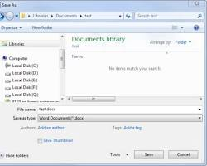Opens in a new window[https://encrypted-tbn3.gstatic.com/favicon-tbn?q=tbn:ANd9GcSfC8aWYyuN6-l4go9ygmtCKzijBWAOctfb4Z3BPXTHhrPyEr6lRJnX9JiPiyFtQDjQWY-t6UTQWZwgahQr00wtWFMk1sjOr6AA4AejPQ](https://learn.microsoft.com/en-us/office/troubleshoot/word/save-as-dialog-box-appears-two-times)learn.microsoft.com](https://learn.microsoft.com/en-us/office/troubleshoot/word/save-as-dialog-box-appears-two-times)

Save As dialog box in Word

* Give your document a descriptive name in the "**File name**" field.
* Click the "**Save**" button.

**Congratulations!** You have now created and saved a new document in Microsoft Word.

**Additional Tips:**

* You can use keyboard shortcuts like "Ctrl+S" (Windows) or "Command+S" (Mac) to save your document quickly.
* It's a good practice to create a folder on your computer to store your Word documents for easy organization.