Name: Muhammad Mahad 21L-6195

Q1. (A)

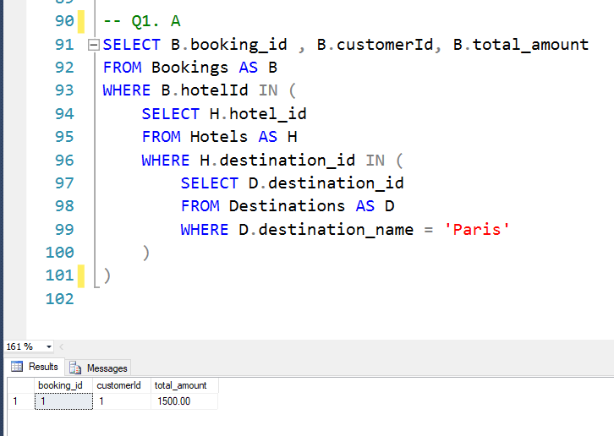

Assuming taking flight is not equal to booking

CODE:

-- Q1. A

SELECT B.booking_id , B.customerId, B.total_amount

FROM Bookings AS B

WHERE B.hotelId IN (

SELECT H.hotel_id

FROM Hotels AS H

WHERE H.destination_id IN (

SELECT D.destination_id

FROM Destinations AS D

WHERE D.destination_name = 'Paris'

)

)

Q1 . B

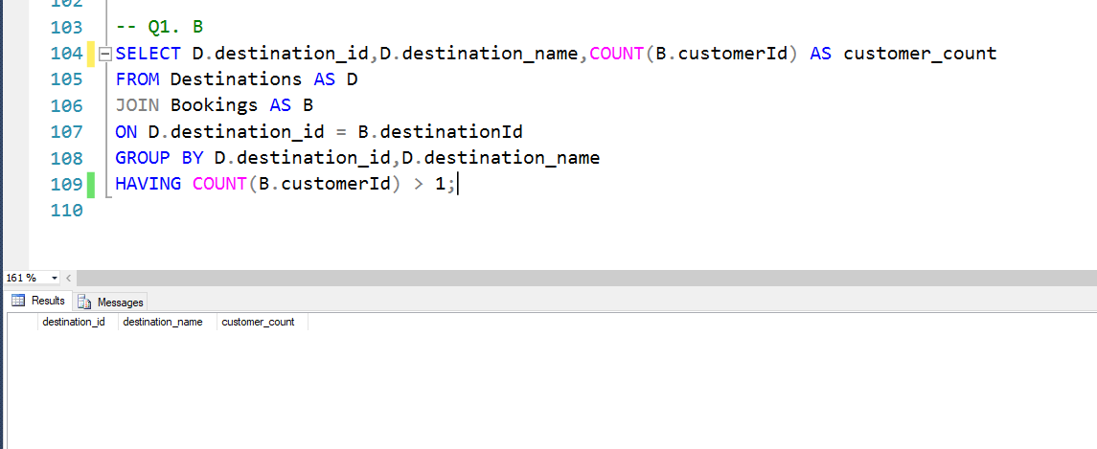

Assuming a customer has unique c_id

CODE:  
SELECT D.destination_id,D.destination_name,COUNT(B.customerId) AS customer_count

FROM Destinations AS D

JOIN Bookings AS B

ON D.destination_id = B.destinationId

GROUP BY D.destination_id,D.destination_name

HAVING COUNT(B.customerId) > 1;

Q2. A.

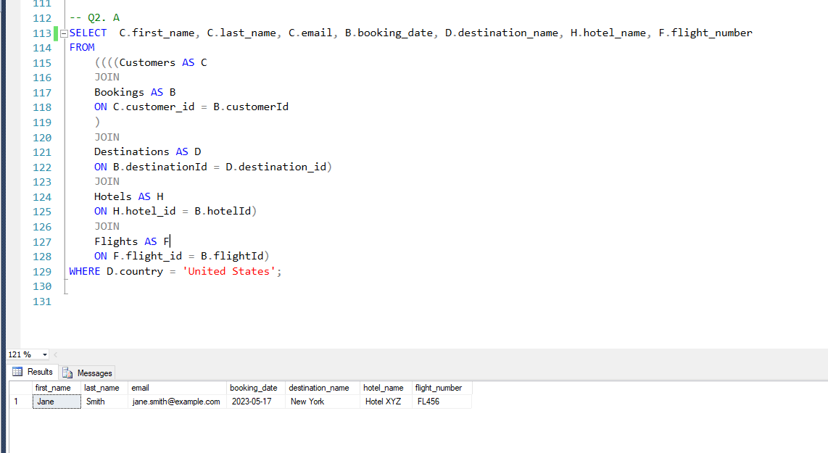

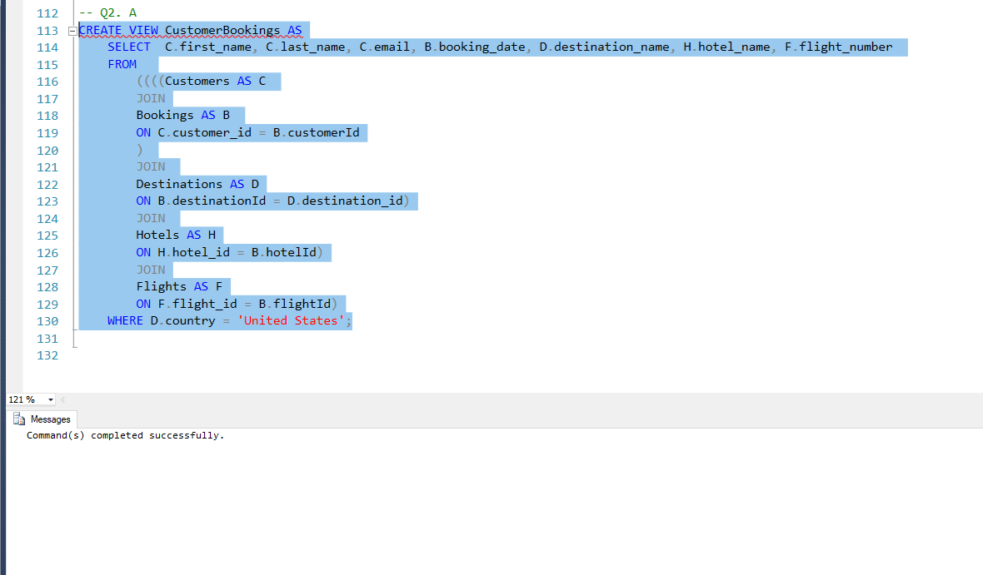

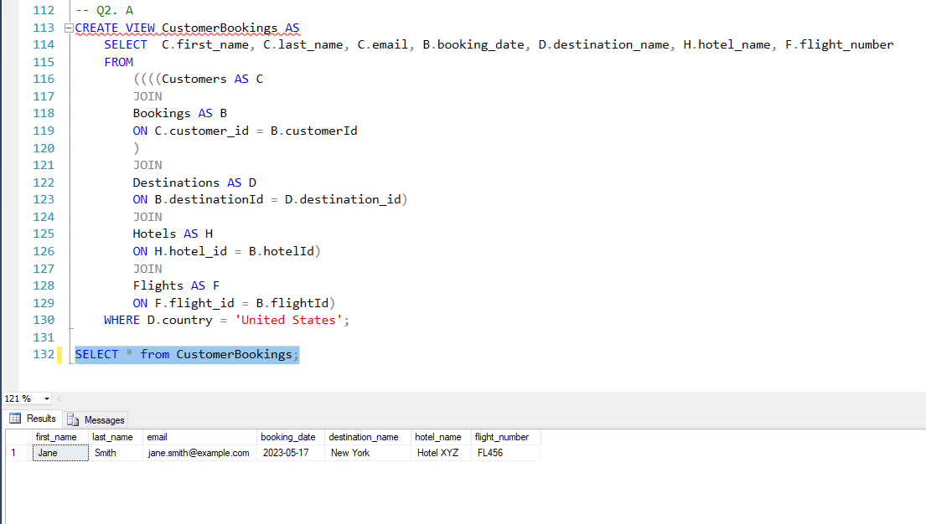

CODE:

-- Q2. A

CREATE VIEW CustomerBookings AS

SELECT C.first_name, C.last_name, C.email, B.booking_date, D.destination_name, H.hotel_name, F.flight_number

FROM

((((Customers AS C

JOIN

Bookings AS B

ON C.customer_id = B.customerId

)

JOIN

Destinations AS D

ON B.destinationId = D.destination_id)

JOIN

Hotels AS H

ON H.hotel_id = B.hotelId)

JOIN

Flights AS F

ON F.flight_id = B.flightId)

WHERE D.country = 'United States';

SELECT * from CustomerBookings;

Q2. B

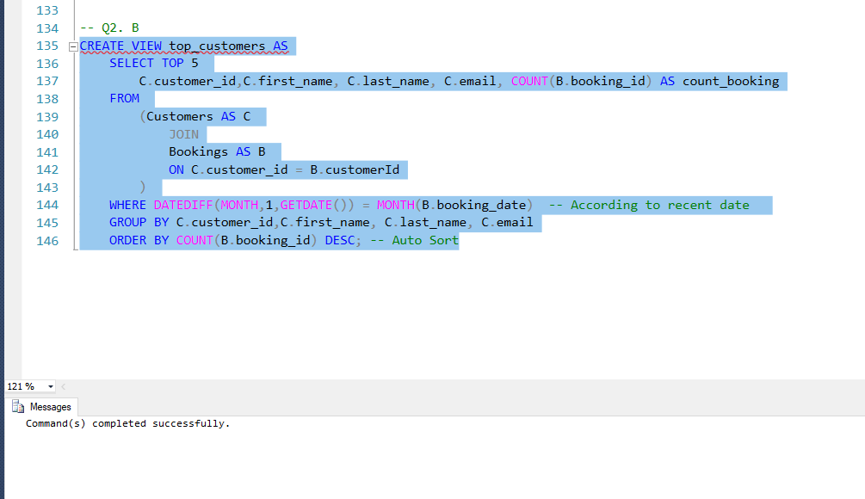

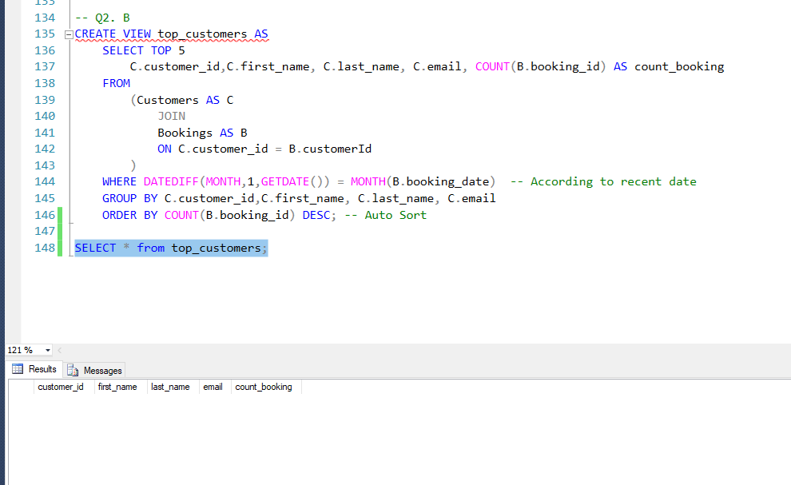

The output is according to current date

CODE:

-- Q2. B

CREATE VIEW top_customers AS

SELECT TOP 5

C.customer_id,C.first_name, C.last_name, C.email, COUNT(B.booking_id) AS count_booking

FROM

(Customers AS C

JOIN

Bookings AS B

ON C.customer_id = B.customerId

)

WHERE DATEDIFF(MONTH,1,GETDATE()) = MONTH(B.booking_date) -- According to recent date

GROUP BY C.customer_id,C.first_name, C.last_name, C.email

ORDER BY COUNT(B.booking_id) DESC; -- Auto Sort

SELECT * from top_customers;

Q3. A

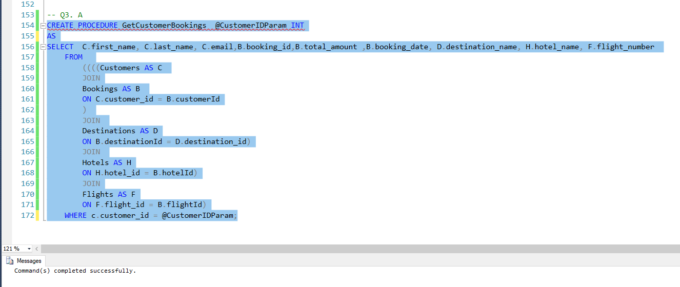

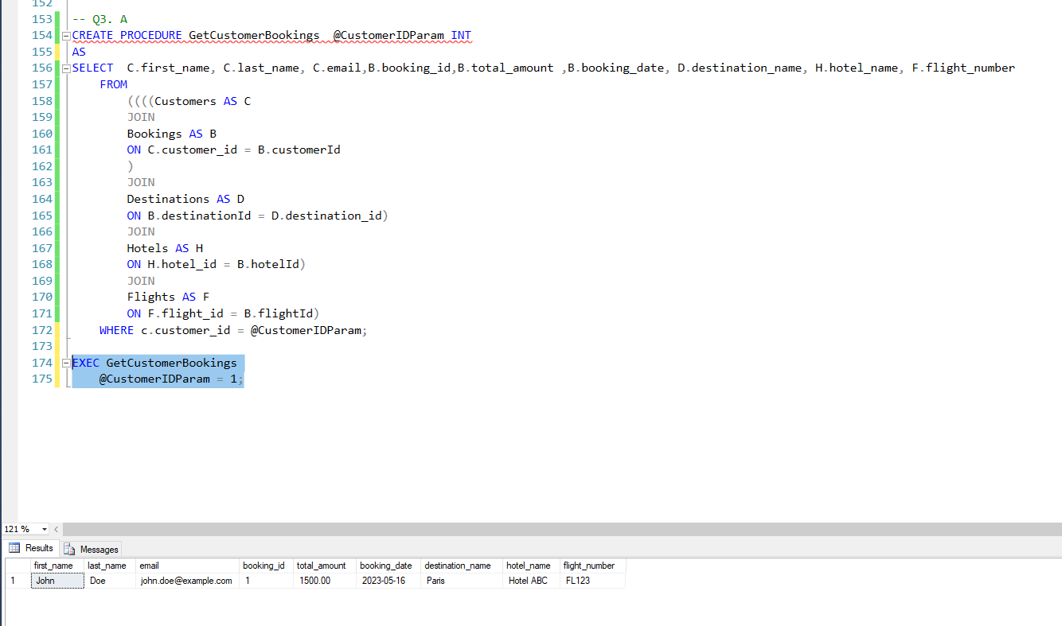

CODE:

-- Q3. A

CREATE PROCEDURE GetCustomerBookings @CustomerIDParam INT

AS

SELECT C.first_name, C.last_name, C.email,B.booking_id,B.total_amount ,B.booking_date, D.destination_name, H.hotel_name, F.flight_number

FROM

((((Customers AS C

JOIN

Bookings AS B

ON C.customer_id = B.customerId

)

JOIN

Destinations AS D

ON B.destinationId = D.destination_id)

JOIN

Hotels AS H

ON H.hotel_id = B.hotelId)

JOIN

Flights AS F

ON F.flight_id = B.flightId)

WHERE c.customer_id = @CustomerIDParam;

EXEC GetCustomerBookings

@CustomerIDParam = 1;

Q3. B

Checking SELECT:  
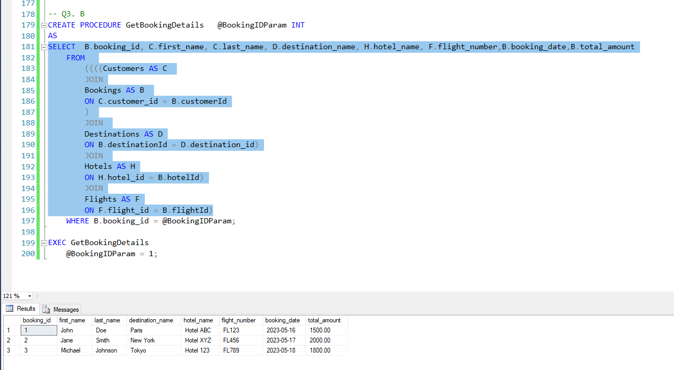

Executing command:

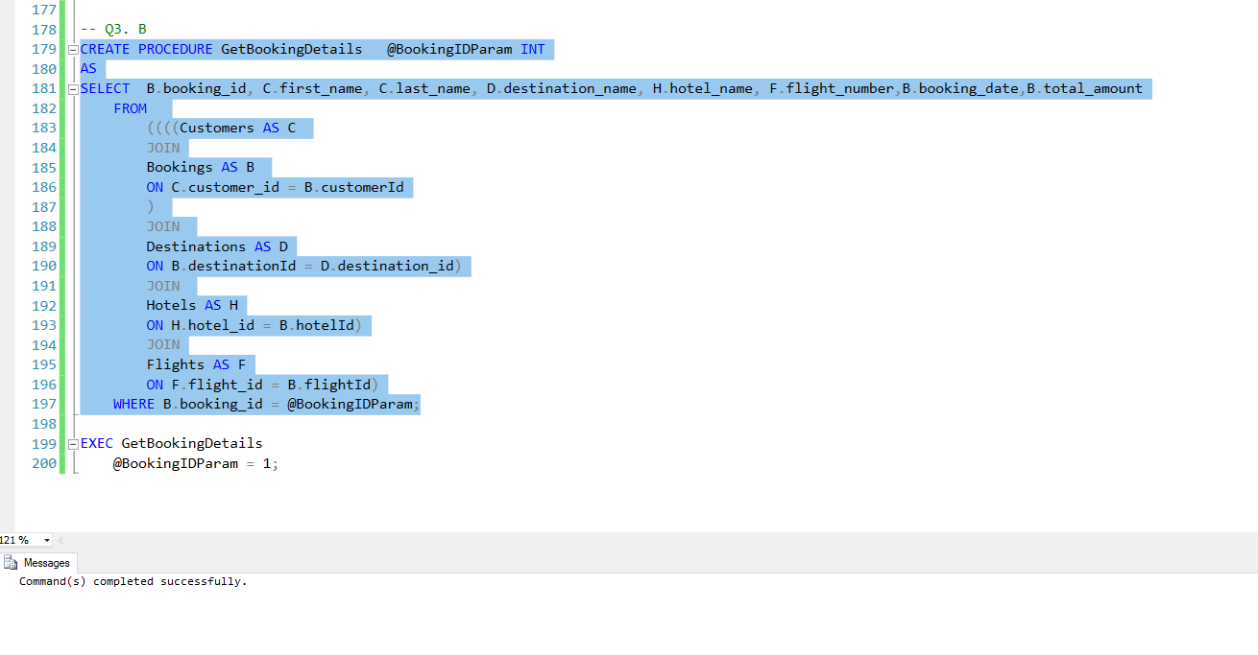

Checking Procedure:

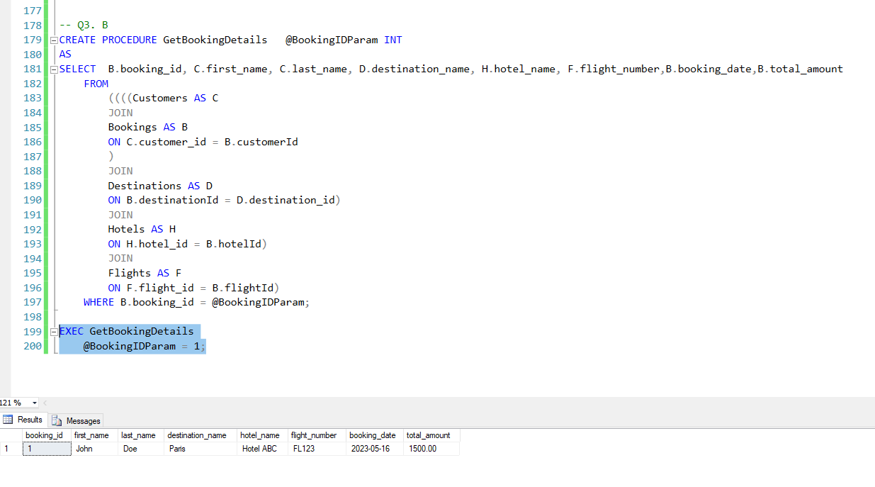

CODE:  
-- Q3. B

CREATE PROCEDURE GetBookingDetails @BookingIDParam INT

AS

SELECT B.booking_id, C.first_name, C.last_name, D.destination_name, H.hotel_name, F.flight_number,B.booking_date,B.total_amount

FROM

((((Customers AS C

JOIN

Bookings AS B

ON C.customer_id = B.customerId

)

JOIN

Destinations AS D

ON B.destinationId = D.destination_id)

JOIN

Hotels AS H

ON H.hotel_id = B.hotelId)

JOIN

Flights AS F

ON F.flight_id = B.flightId)

WHERE B.booking_id = @BookingIDParam;

EXEC GetBookingDetails

@BookingIDParam = 1;

Q4. A

Ali want to maintain a logbook of the changes made of the customer’s email addresses in customer table.

**Solution**:

* For this we create a separate ***log table*** named **customer_email_log**, to keep track of the changes made in the customers email addresses.
* The ***log table*** named **customer_email_log** contains **customer_ID** as **PK**, **date_changes (datetime datatype)**  and **changes_email_address**.
* CREATED TRIGGER:  
  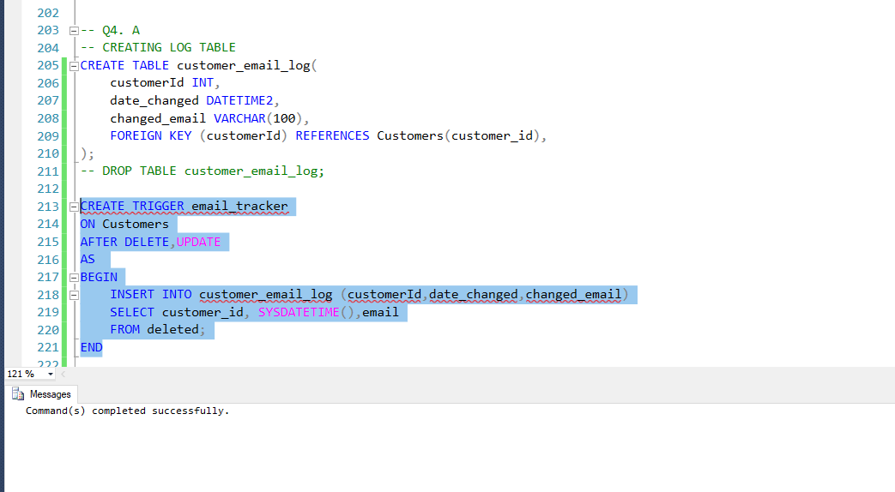

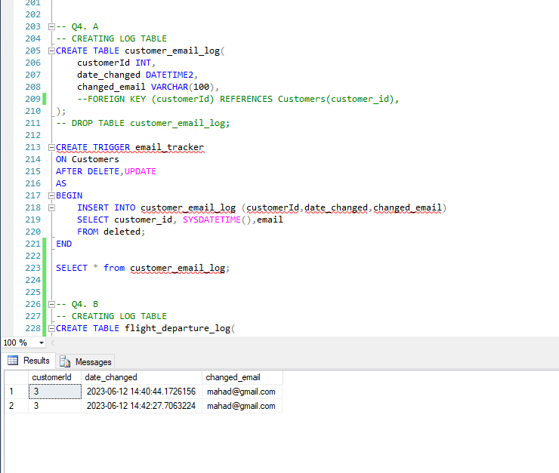

CODE:

-- Q4. A

-- CREATING LOG TABLE

CREATE TABLE customer_email_log(

customerId INT,

date_changed DATETIME2,

changed_email VARCHAR(100),

--FOREIGN KEY (customerId) REFERENCES Customers(customer_id),

);

-- DROP TABLE customer_email_log;

CREATE TRIGGER email_tracker

ON Customers

AFTER DELETE,UPDATE

AS

BEGIN

INSERT INTO customer_email_log (customerId,date_changed,changed_email)

SELECT customer_id, SYSDATETIME(),email

FROM deleted;

END

SELECT * from customer_email_log;

Q.4 B

Same solution as Q1

CREATED TRIGGER:

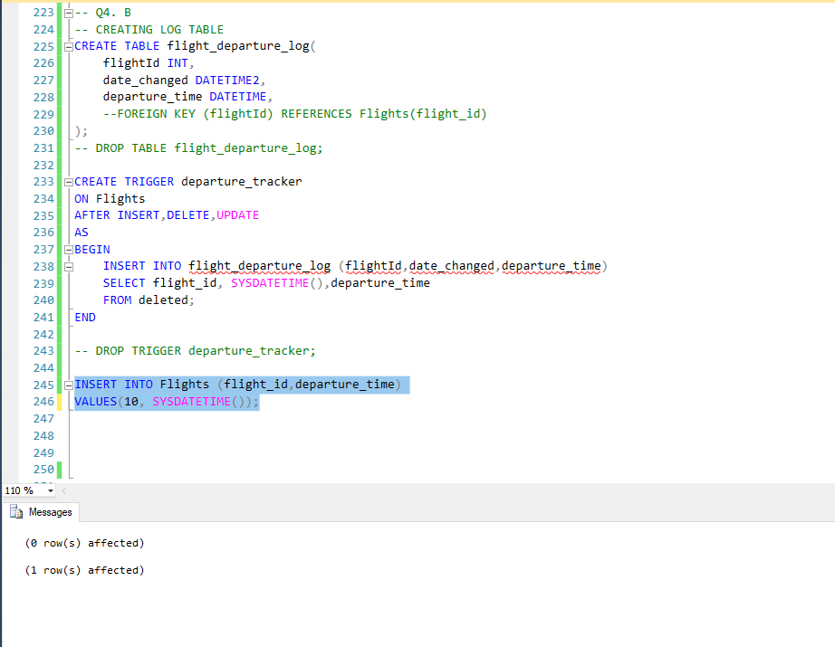

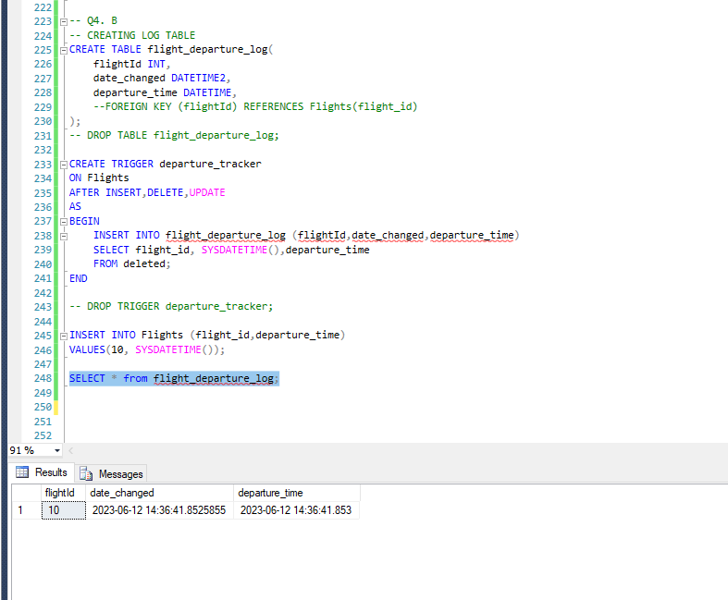

CODE:

-- Q4. B

-- CREATING LOG TABLE

CREATE TABLE flight_departure_log(

flightId INT,

date_changed DATETIME2,

departure_time DATETIME,

--FOREIGN KEY (flightId) REFERENCES Flights(flight_id)

);

-- DROP TABLE flight_departure_log;

CREATE TRIGGER departure_tracker

ON Flights

AFTER INSERT,DELETE,UPDATE

AS

BEGIN

INSERT INTO flight_departure_log (flightId,date_changed,departure_time)

SELECT flight_id, SYSDATETIME(),departure_time

FROM deleted;

END

-- DROP TRIGGER departure_tracker;

INSERT INTO Flights (flight_id,departure_time)

VALUES(10, SYSDATETIME());

SELECT * from flight_departure_log;