**Name:** Muhammad Mahad.

**Roll. No.:** 21L-6195

**Lab:** 2

**Question # 01:**

**A) pwd:**

* Pwd stands for **print working directory.**
* It prints the directory in which we are currently working.

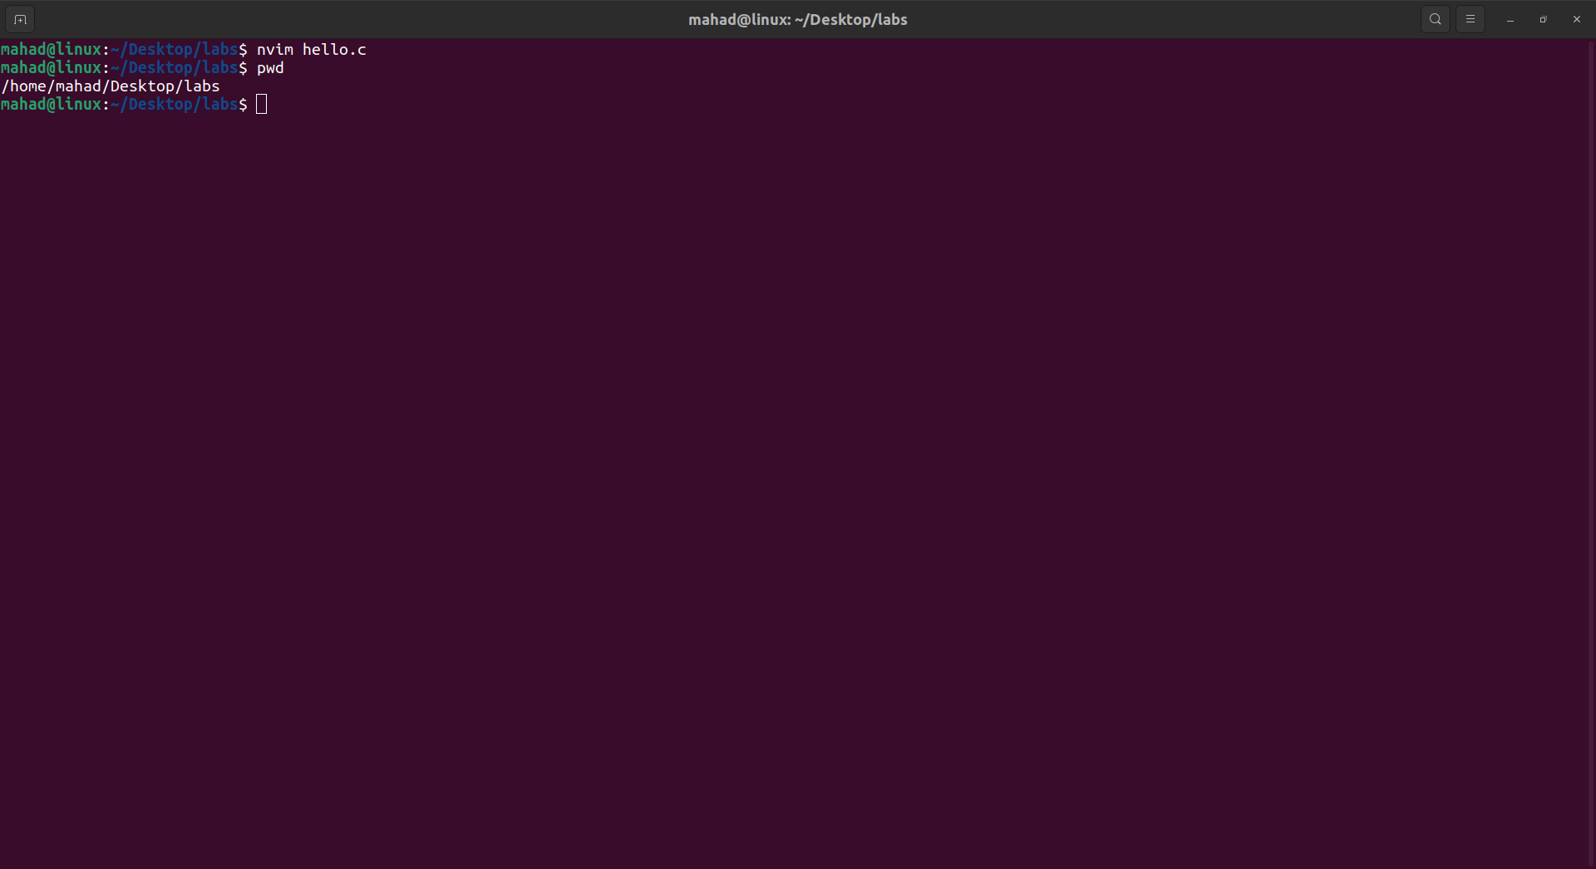

**B) ls:**

* Ls stands for list.

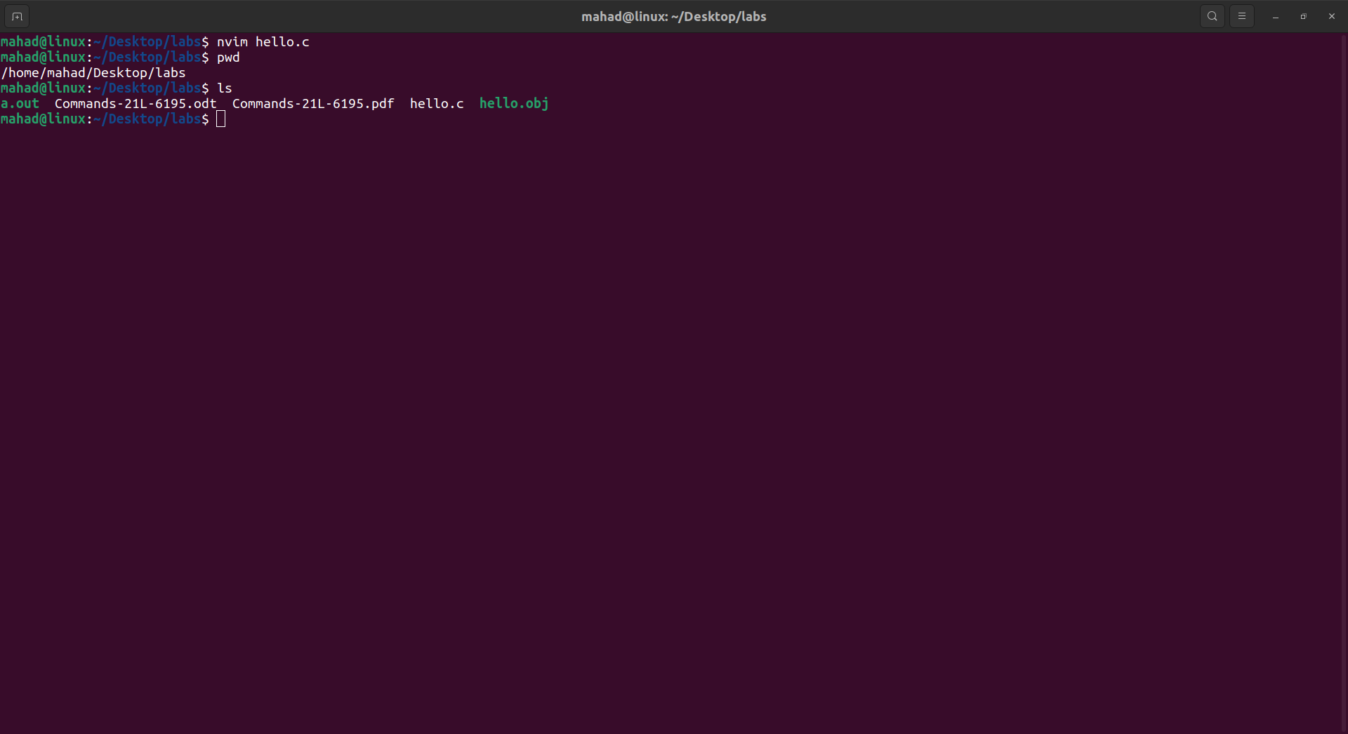

**C) cd:**

* **Cd stands** for change directory.

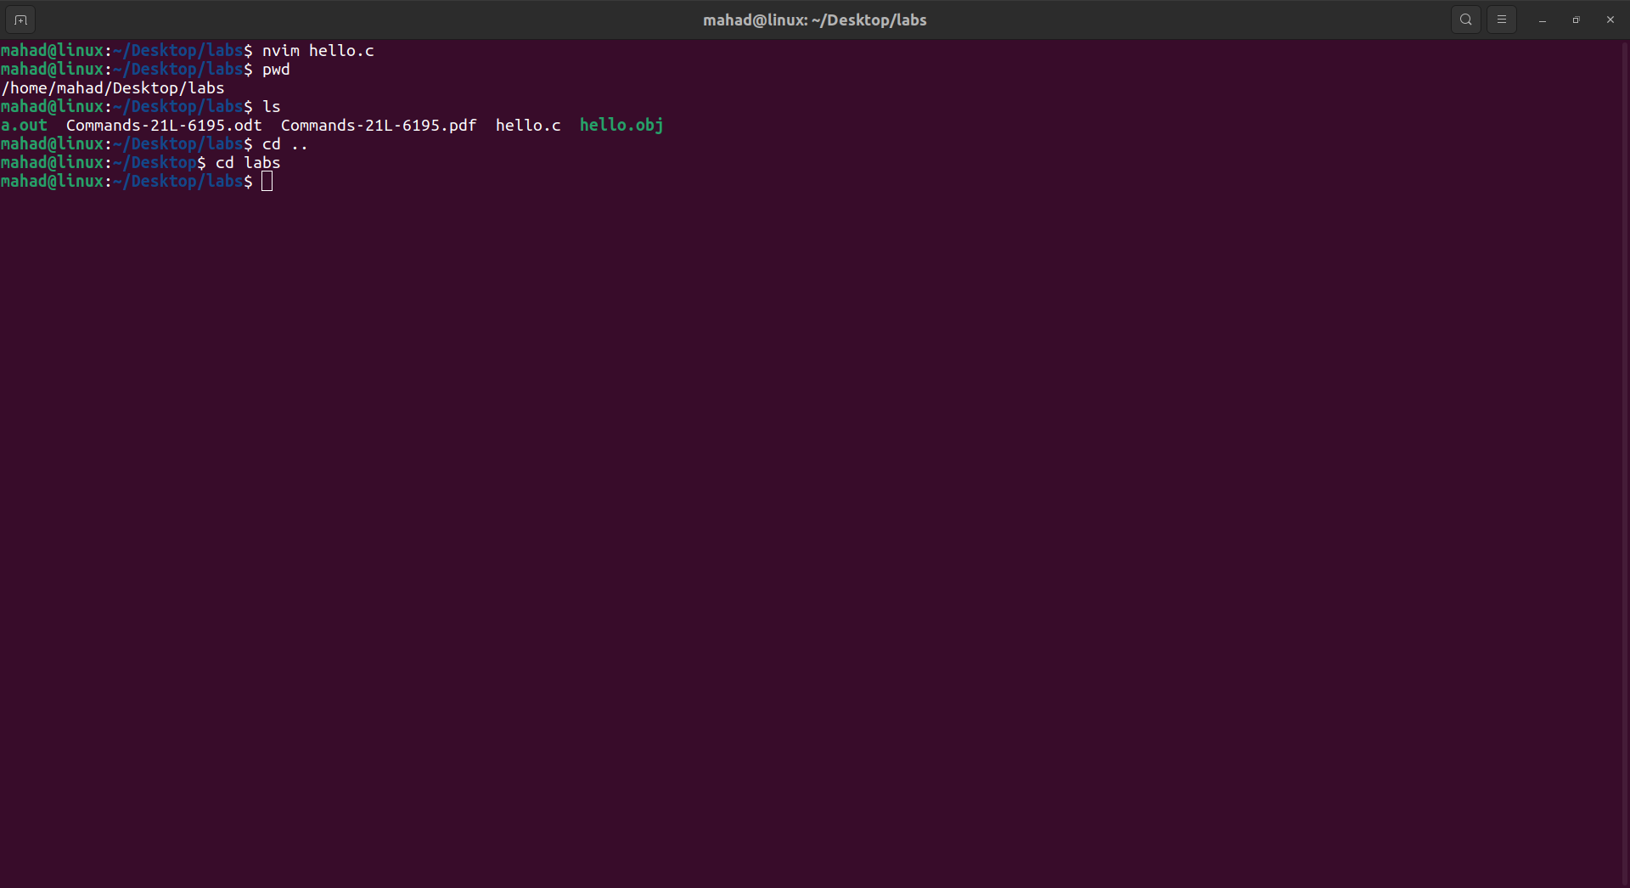

**C) cp:**

* **cp** stands for **copy**.

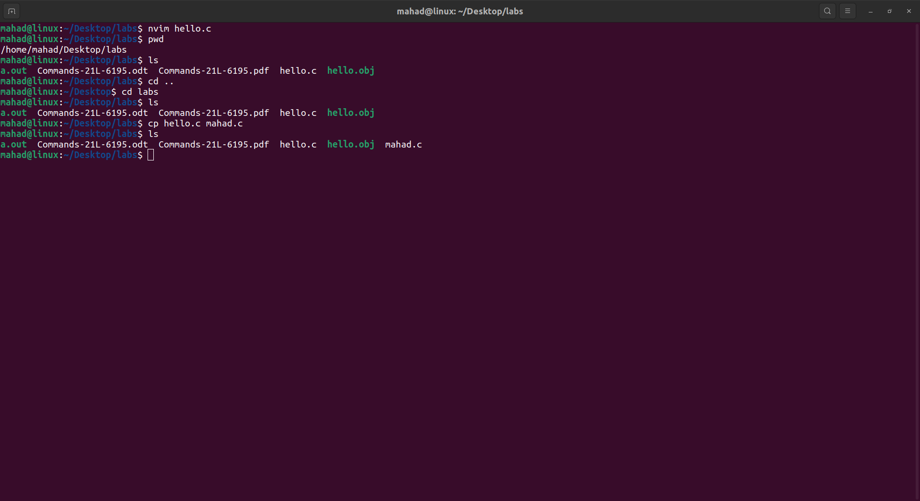

**C) cd:**

* **Cd**  stands for change directory.

**Question # 03:**

**Write a program that takes multiple numbers from the user through command line arguments.**

**CODE:**

