Mortality Projection

Japan

Mahadev Suresh

2024-06-01

Table of Contents

# Pre-processing of data

## Read Data

Exposure data & death has been downloaded from **Human Mortality Database** <https://mortality.org/>.

exposure <- fread(paste0(path, "Mortality Data - Japan/", "Exposures_1x1.txt"))  
death <- fread(paste0(path, "Mortality Data - Japan/", "Deaths_1x1.txt")) %>%   
 mutate(Female = as.integer(Female), Male = as.integer(Male)) %>%  
 as.data.table()  
  
kableExtra::kable(head(exposure))

| Year | Age | Female | Male | Total |
| --- | --- | --- | --- | --- |
| 1947 | 0 | 1122695.6 | 1170640.0 | 2293336 |
| 1947 | 1 | 777087.8 | 800958.6 | 1578046 |
| 1947 | 2 | 850243.1 | 869133.1 | 1719376 |
| 1947 | 3 | 985176.3 | 1006140.7 | 1991317 |
| 1947 | 4 | 953958.8 | 976684.0 | 1930643 |
| 1947 | 5 | 995604.1 | 1020042.5 | 2015647 |

kableExtra::kable(head(death))

| Year | Age | Female | Male | Total |
| --- | --- | --- | --- | --- |
| 1947 | 0 | 93923 | 111818 | 205741.71 |
| 1947 | 1 | 27719 | 29671 | 57391.07 |
| 1947 | 2 | 14696 | 14962 | 29658.70 |
| 1947 | 3 | 11068 | 11408 | 22477.48 |
| 1947 | 4 | 6704 | 7299 | 14003.90 |
| 1947 | 5 | 4812 | 5216 | 10028.53 |

## Reshaping Data

Converting Data in wide format to long format.

## Warning in melt.data.table(setDT(death), id.vars = c("Age", "Year"),  
## variable.name = "Gender", : 'measure.vars' [Female, Male, Total, ...] are not  
## all of the same type. By order of hierarchy, the molten data value column will  
## be of type 'double'. All measure variables not of type 'double' will be coerced  
## too. Check DETAILS in ?melt.data.table for more on coercion.

## Warning: There was 1 warning in `mutate()`.  
## ℹ In argument: `Age1 = if_else(Age == "110+", 110, as.double(Age))`.  
## Caused by warning in `if_else()`:  
## ! NAs introduced by coercion

| Age | Year | Gender | Exposure |
| --- | --- | --- | --- |
| 0 | 1947 | Female | 1122695.6 |
| 1 | 1947 | Female | 777087.8 |
| 2 | 1947 | Female | 850243.1 |
| 3 | 1947 | Female | 985176.3 |
| 4 | 1947 | Female | 953958.8 |
| 5 | 1947 | Female | 995604.1 |

| Age | Year | Gender | Death |
| --- | --- | --- | --- |
| 0 | 1947 | Female | 93923 |
| 1 | 1947 | Female | 27719 |
| 2 | 1947 | Female | 14696 |
| 3 | 1947 | Female | 11068 |
| 4 | 1947 | Female | 6704 |
| 5 | 1947 | Female | 4812 |

| Age | Year | Gender | Exposure | Death | mx |
| --- | --- | --- | --- | --- | --- |
| 0 | 1947 | Female | 1122695.6 | 93923 | 0.0836585 |
| 1 | 1947 | Female | 777087.8 | 27719 | 0.0356704 |
| 2 | 1947 | Female | 850243.1 | 14696 | 0.0172845 |
| 3 | 1947 | Female | 985176.3 | 11068 | 0.0112345 |
| 4 | 1947 | Female | 953958.8 | 6704 | 0.0070276 |
| 5 | 1947 | Female | 995604.1 | 4812 | 0.0048332 |

## `summarise()` has grouped output by 'AgeBand', 'Gender'. You can override using  
## the `.groups` argument.

## Visulaizing the pre-COVID mortality

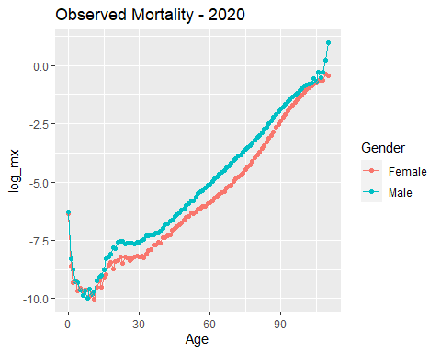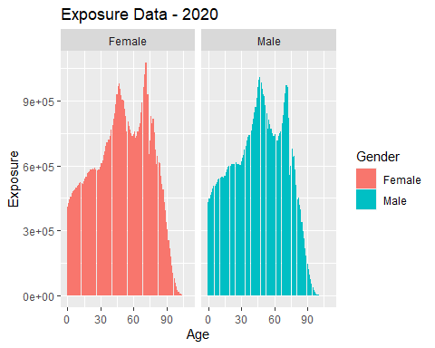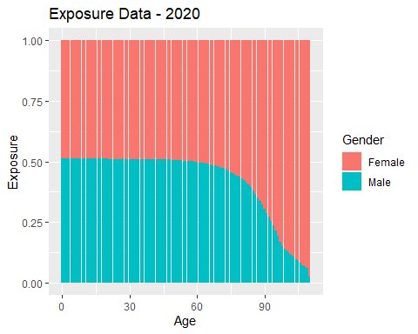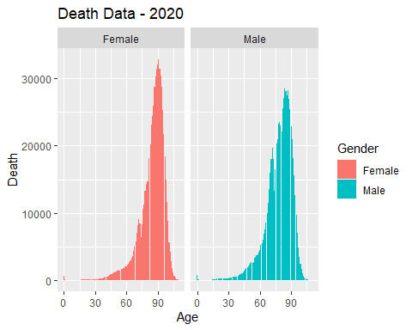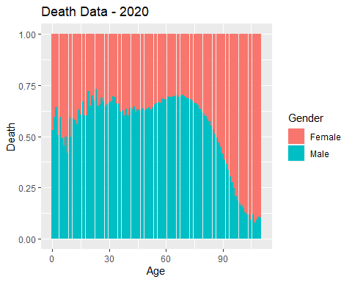

## Mortality Curve over the years.

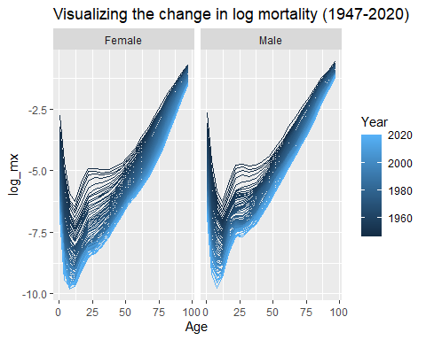

## Data Reshaping for Modelling

male_mortality <- combined %>%   
 filter(Gender == "Male", Year >= 1980) %>%  
 pivot_wider(names_from = Year, values_from = mx, id_cols = Age) %>%   
 select(-Age) %>%   
 as.matrix()  
  
female_mortality <- combined %>%   
 filter(Gender == "Female", Year >= 1980) %>%  
 pivot_wider(names_from = Year, values_from = mx, id_cols = Age) %>%   
 select(-Age) %>%   
 as.matrix()  
  
male_exposure <- combined %>%   
 filter(Gender == "Male", Year >= 1980) %>%  
 pivot_wider(names_from = Year, values_from = Exposure, id_cols = Age) %>%   
 select(-Age) %>%   
 as.matrix()  
  
female_exposure <- combined %>%   
 filter(Gender == "Female", Year >= 1980) %>%  
 pivot_wider(names_from = Year, values_from = Exposure, id_cols = Age) %>%   
 select(-Age) %>%   
 as.matrix()  
  
rows <- unique(combined$Age)  
cols <- as.numeric(colnames(male_mortality))  
male_demog <- demography::demogdata(male_mortality, male_exposure, years = cols, ages = rows, name = "male", "Japan - HMD", type = "mortality")

## Warning in .recacheSubclasses(def@className, def, env): undefined subclass  
## "ndiMatrix" of class "replValueSp"; definition not updated

## Registered S3 methods overwritten by 'demography':  
## method from   
## print.lca e1071  
## summary.lca e1071

female_demog <- demography::demogdata(female_mortality, female_exposure, years = cols, ages = rows, name = "female", "Japan - HMD", type = "mortality")  
male_demog_stomomo <- StMoMoData(male_demog)  
female_demog_stomomo <- StMoMoData(female_demog)

# Lee Carter Model

## Model Fitting

LC_log <- lc(link = "log")  
   
LCfit_male <- fit(LC_log, data = male_demog_stomomo)

## Warning in fit.StMoMo(LC_log, data = male_demog_stomomo): StMoMo: 11 data points have   
## non-positive exposures and have been zero weighted

## Warning in fit.StMoMo(LC_log, data = male_demog_stomomo): StMoMo: 11 missing values which have been zero weighted

## StMoMo: Start fitting with gnm  
## Initialising  
## Running start-up iterations..  
## Running main iterations......  
## Done  
## StMoMo: Finish fitting with gnm

LCfit_female <- fit(LC_log, data = female_demog_stomomo)

## Warning in fit.StMoMo(LC_log, data = female_demog_stomomo): StMoMo: 2 data points have   
## non-positive exposures and have been zero weighted

## Warning in fit.StMoMo(LC_log, data = female_demog_stomomo): StMoMo: 2 missing values which have been zero weighted

## StMoMo: The following cohorts have been zero weigthed: 1870   
## StMoMo: Start fitting with gnm  
## Initialising  
## Running start-up iterations..  
## Running main iterations......  
## Done  
## StMoMo: Finish fitting with gnm

#ax is similar to the mortality rates observed in the past.   
#bx is smooth for most part except for 10-14, the improvement for 20-40 is as low as people in 80s. Interpolation maybe required.   
#kt seems alright, but I suspect the forecast will overstate the improvements.   
plot(LCfit_male, type = "point")

## Warning in plot.xy(xy, type, ...): plot type 'point' will be truncated to first  
## character

## Warning in plot.xy(xy, type, ...): plot type 'point' will be truncated to first  
## character  
  
## Warning in plot.xy(xy, type, ...): plot type 'point' will be truncated to first  
## character

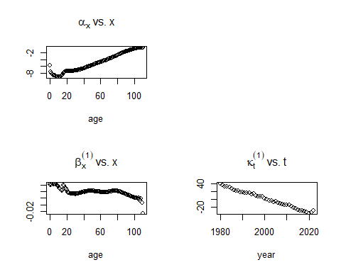

plot(LCfit_female, type = "point")

## Warning in plot.xy(xy, type, ...): plot type 'point' will be truncated to first  
## character  
  
## Warning in plot.xy(xy, type, ...): plot type 'point' will be truncated to first  
## character  
  
## Warning in plot.xy(xy, type, ...): plot type 'point' will be truncated to first  
## character

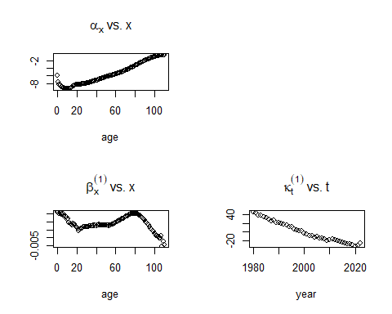

## Goodness of fit

LCres_male <- residuals(LCfit_male)  
LCres_female <- residuals(LCfit_female)  
plot(LCres_male, type = "colourmap", reslim = c(-3.5, 3.5), main = "Male - Residuals")

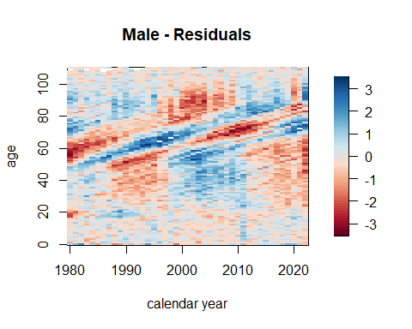

# The fit overestimates mortality for ages around 60.   
plot(LCres_male, type = "scatter", reslim = c(-3.5, 3.5), main = "Male - Residuals")

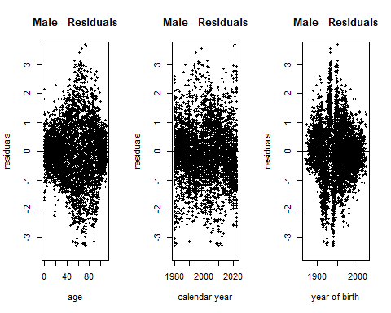

# Deviation observed for ages between 60-70.   
  
plot(LCres_female, type = "colourmap", reslim = c(-3.5, 3.5), main = "Female - Residuals")

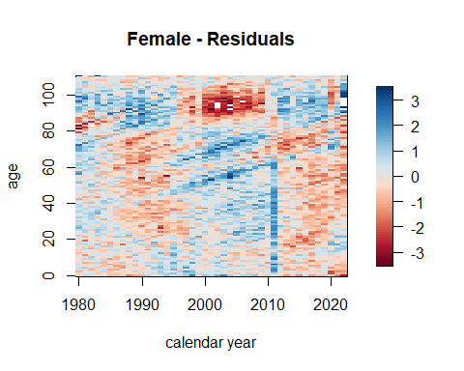

plot(LCres_female, type = "scatter", reslim = c(-3.5, 3.5), main = "Female - Residuals")

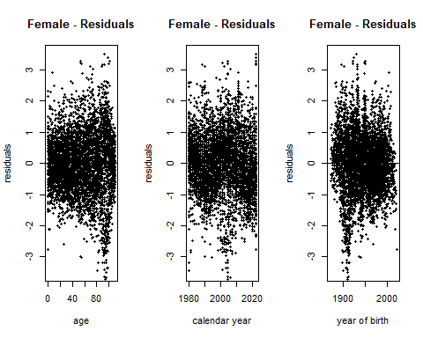

# Female residuals are better (closer to zero, lower deviations) on average compared to the males. LC model fit better for females.   
# Cohort effect is visible for both, but for males its seems to be higher.

## Forecast mortality

# Plot the forecast kt.   
LCfor_male <- forecast(LCfit_male, h = 40)  
plot(LCfor_male, only.kt = TRUE)

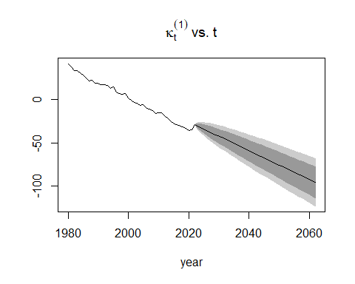

LCfor_female <- forecast(LCfit_female, h = 40)  
plot(LCfor_female, only.kt = TRUE)

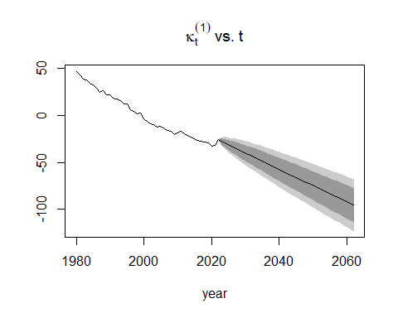

LCforArima_male <- forecast(LCfit_male, h = 40, kt.method = "iarima", kt.order = c(1, 1, 1))  
plot(LCforArima_male, only.kt = TRUE)

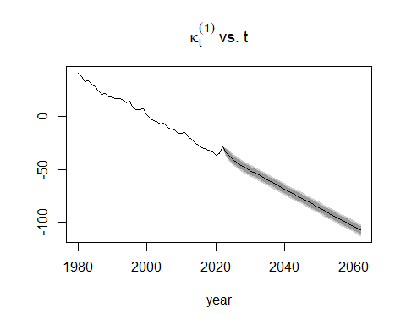

LCforArima_female <- forecast(LCfit_female, h = 40, kt.method = "iarima", kt.order = c(1, 1, 1))  
plot(LCforArima_female, only.kt = TRUE)

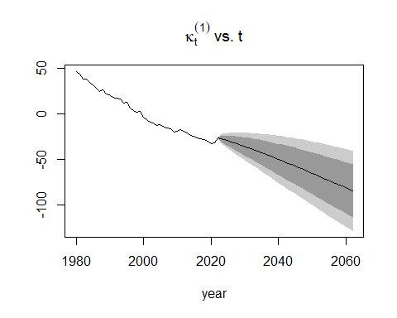

## Visualizing the projections - Lee Carter

forcast_male <- LCfor_male$rates %>%   
 as.data.table() %>%   
 mutate(age = rownames(LCfor_male$rates), gender = "Male") %>%   
 pivot_longer(cols = colnames(LCfor_male$rates), values_to = "rates", names_to = "year")  
  
forcast_female <- LCfor_female$rates %>%   
 as.data.table() %>%   
 mutate(age = rownames(LCfor_male$rates), gender = "Female") %>%   
 pivot_longer(cols = colnames(LCfor_male$rates), values_to = "rates", names_to = "year")  
  
forcast_arima_male <- LCforArima_male$rates %>%   
 as.data.table() %>%   
 mutate(age = as.integer(rownames(LCforArima_male$rates)), gender = "Male") %>%   
 pivot_longer(cols = colnames(LCforArima_male$rates), values_to = "rates", names_to = "year") %>%   
 mutate(log_rate = log(rates)) %>%   
 arrange(year, age)  
  
forcast_arima_female <- LCforArima_female$rates %>%   
 as.data.table() %>%   
 mutate(age = as.integer(rownames(LCforArima_female$rates)), gender = "Female") %>%   
 pivot_longer(cols = colnames(LCforArima_female$rates), values_to = "rates", names_to = "year") %>%  
 mutate(log_rate = log(rates)) %>%   
 arrange(year, age)   
  
ggplot(forcast_arima_male, aes(age, log_rate, color = year, group = year)) +   
 geom_line() +  
 ggtitle("Projected Male Mortality - Male")

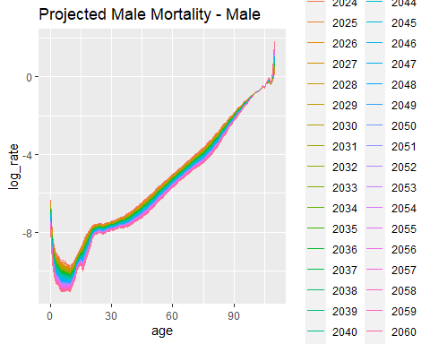

ggplot(forcast_arima_female, aes(age, log_rate, color = year, group = year)) +   
 geom_line() +   
 ggtitle("Projected Male Mortality - Female")

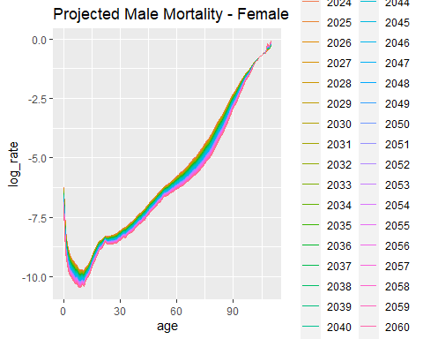

## Simulation

LCsim_male <- simulate(LCfit_male, nsim = 500, h = 50)  
  
plot(LCfit_male$years, LCfit_male$kt[1, ], xlim = range(LCfit_male$years, LCsim_male$years),   
 ylim = range(LCfit_male$kt, LCsim_male$kt.s$sim[1, , 1:20]),   
 type = "l", xlab = "year", ylab = "kt", main = "Period index, Male")  
  
matlines(LCsim_male$kt.s$years, LCsim_male$kt.s$sim[1, , 1:20], type = "l", lty = 1)

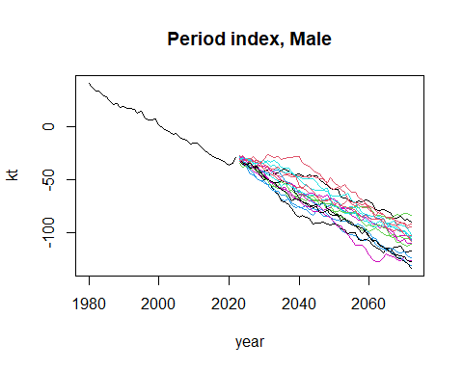

LCsim_female <- simulate(LCfit_female, nsim = 500, h = 50)  
  
plot(LCfit_female$years, LCfit_female$kt[1, ], xlim = range(LCfit_female$years, LCsim_female$years),   
 ylim = range(LCfit_female$kt, LCsim_female$kt.s$sim[1, , 1:20]),   
 type = "l", xlab = "year", ylab = "kt", main = "Period index, Female")  
  
matlines(LCsim_female$kt.s$years, LCsim_female$kt.s$sim[1, , 1:20], type = "l", lty = 1)

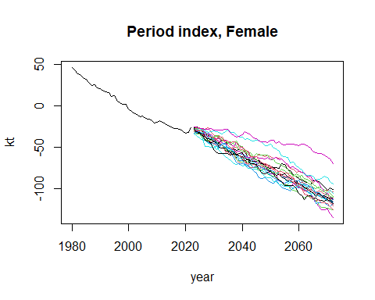

# Age-Period-Cohort

## Fitting APC Model

### Key difference is no b_x instead we have an additive cohort factor.

wxt_male <- genWeightMat(male_demog_stomomo$ages, male_demog_stomomo$years,   
 clip = 3)  
wxt_female <- genWeightMat(female_demog_stomomo$ages, female_demog_stomomo$years,  
 clip = 3)  
  
male_demog_stomomo_init <- central2initial(male_demog_stomomo)  
  
APCfit_male <- fit(apc(link = "log"), data = male_demog_stomomo, wxt = wxt_male)

## Warning in fit.StMoMo(apc(link = "log"), data = male_demog_stomomo, wxt = wxt_male): StMoMo: 11 data points have   
## non-positive exposures and have been zero weighted

## Warning in fit.StMoMo(apc(link = "log"), data = male_demog_stomomo, wxt = wxt_male): StMoMo: 11 missing values which have been zero weighted

## StMoMo: The following cohorts have been zero weigthed: 1870 1871 1872 2020 2021 2022   
## StMoMo: Start fitting with gnm  
## StMoMo: Finish fitting with gnm

APCfit_female <- fit(apc(link = "log"), data = female_demog_stomomo, wxt = wxt_female)

## Warning in fit.StMoMo(apc(link = "log"), data = female_demog_stomomo, wxt = wxt_female): StMoMo: 2 data points have   
## non-positive exposures and have been zero weighted

## Warning in fit.StMoMo(apc(link = "log"), data = female_demog_stomomo, wxt = wxt_female): StMoMo: 2 missing values which have been zero weighted

## StMoMo: The following cohorts have been zero weigthed: 1870 1871 1872 2020 2021 2022   
## StMoMo: Start fitting with gnm  
## StMoMo: Finish fitting with gnm

plot(APCfit_male)

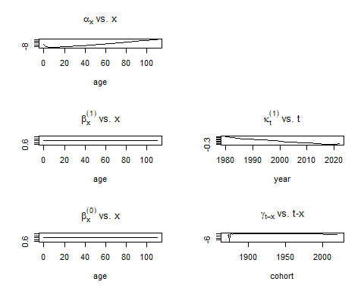

plot(APCfit_female)

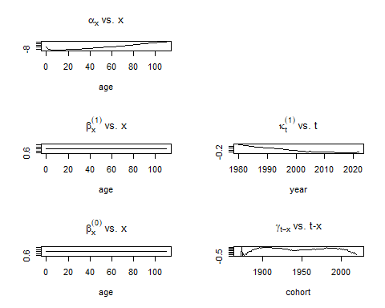

## Analysis of Goodness of Fit

APCres_male <- residuals(APCfit_male)  
APCres_female <- residuals(APCfit_female)  
  
plot(APCres_male, type = "colourmap", reslim = c(-3.5, 3.5), main = "Male - Residuals")

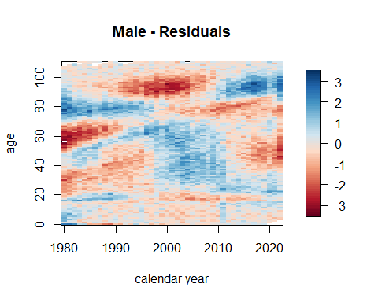

# The fit overestimates mortality for ages around 60.   
plot(APCres_male, type = "scatter", reslim = c(-3.5, 3.5), main = "Male - Residuals")

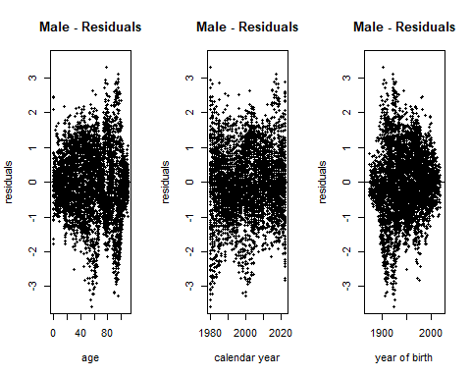

plot(APCres_female, type = "colourmap", reslim = c(-3.5, 3.5), main = "Female - Residuals")

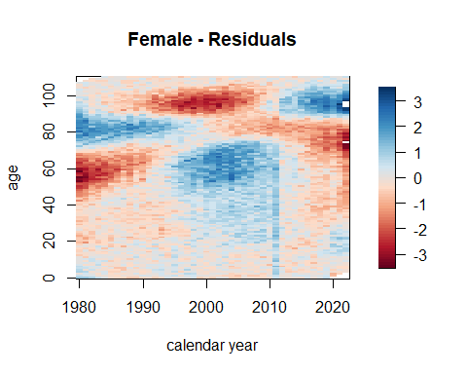

# The fit overestimates mortality for ages around 60.   
plot(APCres_female, type = "scatter", reslim = c(-3.5, 3.5), main = "Female - Residuals")

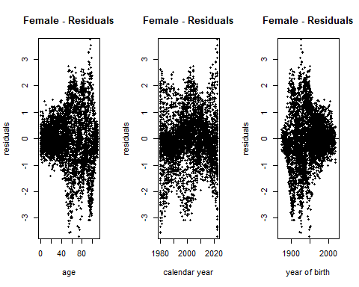

# Much poorer fit than Lee-Carter for Males & Females

## Forecast mortality - APC

# Plot the forecast kt.   
APCfor_male <- forecast(APCfit_male, h = 40)  
plot(APCfor_male)

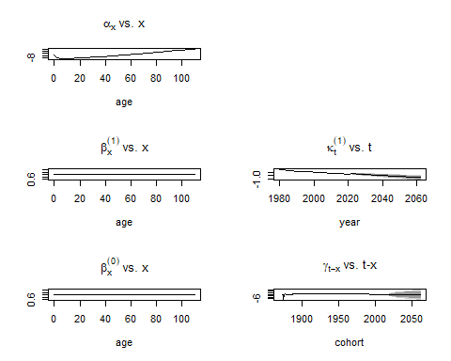

APCfor_female <- forecast(APCfit_female, h = 40)  
plot(APCfor_female)

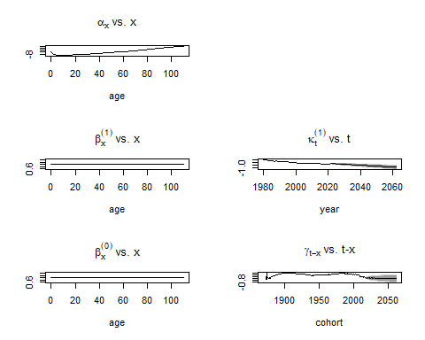

APCforArima_male <- forecast(APCfit_male, h = 40, kt.method = "iarima", kt.order = c(1, 1, 1))  
plot(APCforArima_male)

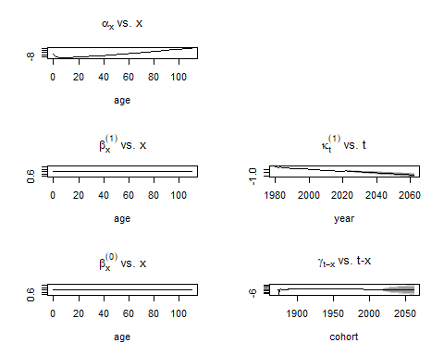

APCforArima_female <- forecast(APCfit_female, h = 40, kt.method = "iarima", kt.order = c(1, 1, 1))  
plot(APCfit_male)



## Visualizing the projections - APC

forcast_male <- APCfor_male$rates %>%   
 as.data.table() %>%   
 mutate(age = as.integer(rownames(APCfor_male$rates)), gender = "Male") %>%   
 pivot_longer(cols = colnames(APCfor_male$rates), values_to = "rates", names_to = "year") %>%   
 mutate(log_rate = log(rates)) %>%   
 arrange(year, age)   
  
forcast_female <- APCfor_female$rates %>%   
 as.data.table() %>%   
 mutate(age = as.integer(rownames(APCfor_female$rates)), gender = "Female") %>%   
 pivot_longer(cols = colnames(APCfor_female$rates), values_to = "rates", names_to = "year") %>%   
 mutate(log_rate = log(rates)) %>%   
 arrange(year, age)   
  
ggplot(forcast_male, aes(age, log_rate, color = year, group = year)) +   
 geom_line() +  
 ggtitle("Projected Male Mortality - Male")

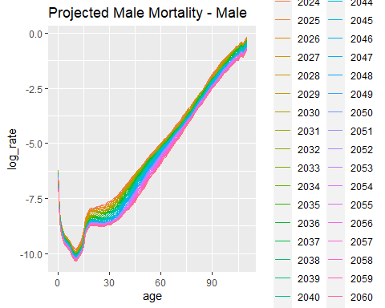

ggplot(forcast_female, aes(age, log_rate, color = year, group = year)) +   
 geom_line() +   
 ggtitle("Projected Male Mortality - Female")

