Name: | Mahadev Balla
UID: | 2023300010
Experiment No. | 1

AIM:
Program 1
PROBLEM STATEMENT : | Write a program which contains a class called Rectangle with data members length and breadth. Define methods perimeter and area. Create a Tester class which creates objects of Rectangle classs in the main() method and calls the methods of rectangle class.
PROGRAM: | import java.util.Scanner;  class Rectangle{  double area(double l, double b){  return l * b;  }  double perimeter(double l, double b){  return 2*(l + b);  }  }  class rectangle{  public static void main(String []arr){  Scanner sc = new Scanner(System.in);  System.out.print("Enter length : ");  double x= sc.nextDouble();  System.out.print("Enter breadth : ");  double y= sc.nextDouble();  Rectangle r = new Rectangle();  double a = r.area(x,y);  double p = r.perimeter(x,y);  System.out.println("Area of rectangle is : " + a);  System.out.println("Area of rectangle is : " + p);  }  }
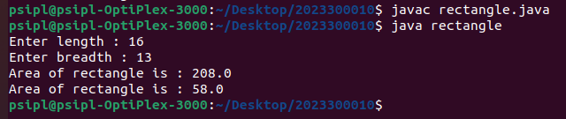
RESULT:
Program 2
PROBLEM STATEMENT : | Write a Java program to Generate marksheet for a student  Data members: Name, Rollno, Subje1 marks, Subj2 Marks, Total, Grade  Assign grade:  Total: <40---F  40 To 60----B grade  61 To 75----A grade  75>---O grade  Display the marksheet of the student
PROGRAM:
RESULT:
CONCLUSION:

