Python
A Command Line Interface (CLI) is a text-based interface that allows users to interact with a computer program or operating system by typing commands into a console or terminal.

✅ Key Features of CLI
- Text-based interaction: Users type commands instead of using graphical elements like buttons or menus.
- Direct control: Provides powerful and precise control over the system or application.
- Lightweight: Requires fewer resources compared to a GUI (Graphical User Interface).

✅ Examples of CLI
- Windows Command Prompt (cmd)
- Linux/Unix Shells (e.g., bash, zsh)
- PowerShell (Windows)
- Git CLI for version control

Data Types:
Primitive data types:
- String “ ”
‘’’
Multi Line
‘’’
- Integer 1,2,3…
- Float 1.0,1.1,1.2
- Complex 2+5j, 2-6j…
- None None

Non Primitive data types:
- List [1, None, “Madhan”, True] different data types can store in one list and its changeable
- Tuple (1, None, “Madhan”, True) Same as list but Tuple can’t be changeable.
- Set Same as list but Set its unordered collection (Index concept is not worked out) and it’s also changeable.
- Dict Example. Amount: 5 (Key and value pair) and it’s also changeable.
- Range t = range (0,10) it means 0 to 9.
Mutable Objects:
- It can be changed after creation.
Immutable Objects:
- It can’t be changed after creation.
List:
Lists are used to store multiple items in a single variable.
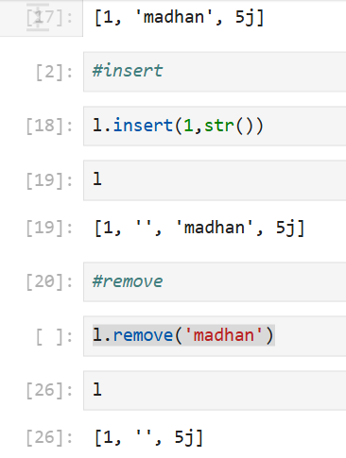
Lists are created using square brackets:
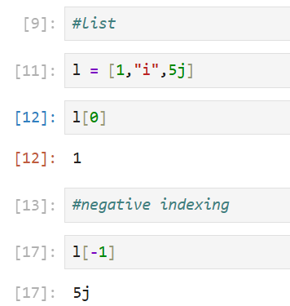

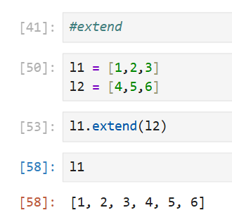
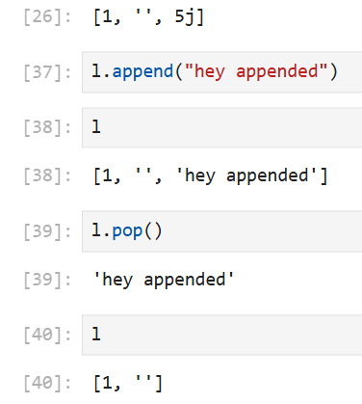
Tuple:
A tuple in Python is an immutable, ordered collection of elements. Here are the key points:
✅ Characteristics of a Tuple:
- Ordered: Elements maintain their position.
- Immutable: Once created, you cannot change, add, or remove elements.
- Allows duplicates: Same value can appear multiple times.
- Can store mixed data types: e.g., integers, strings, lists, etc.
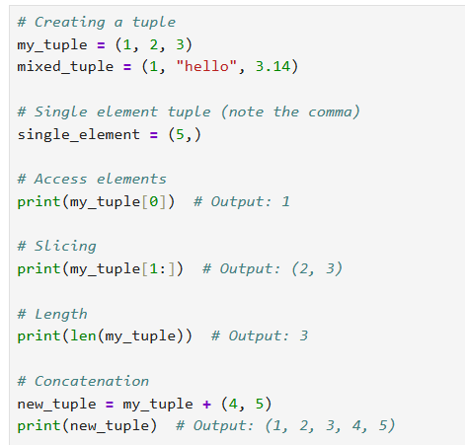

Dict:
Dictionaries are used to store data values in key & value pairs.
Dictionaries are written with curly brackets, and have keys and values
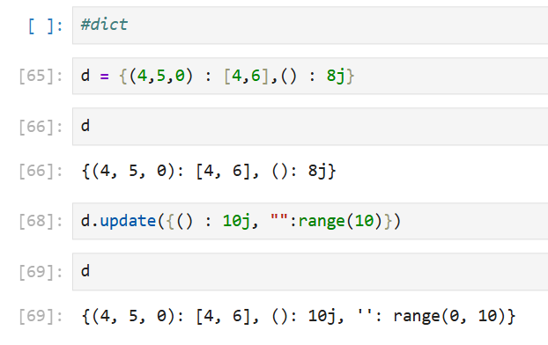

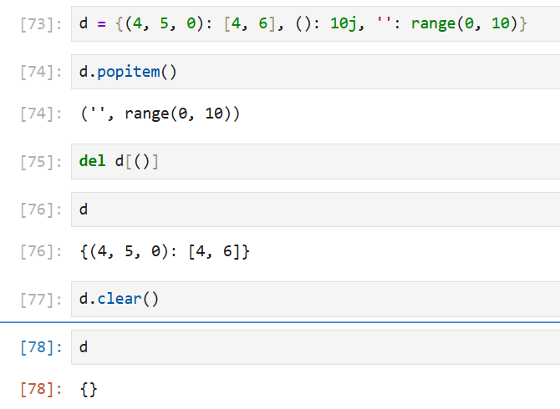
Set:
- Sets are used to store multiple items in a single variable.
- A set is a collection which is unordered, unchangeable, and unindexed.
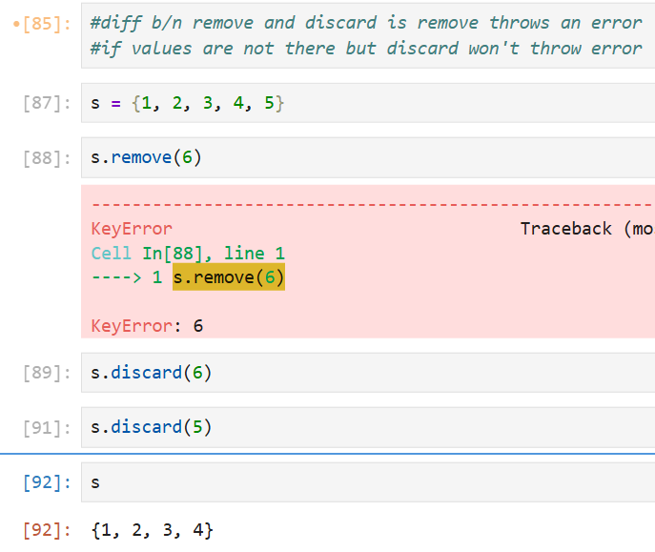
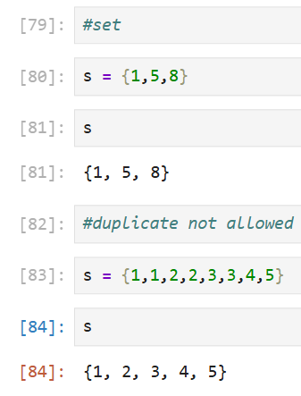
- Sets cannot have two items of the same value

Enumerate:
It is a built-in Python function that lets you iterate over an iterable (like a list, tuple, string) while also getting an automatic counter (index) for each item.
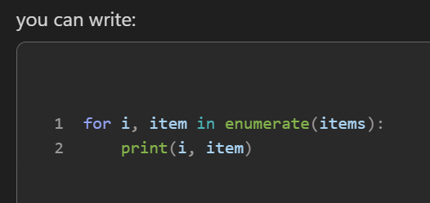
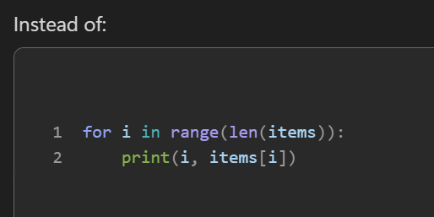
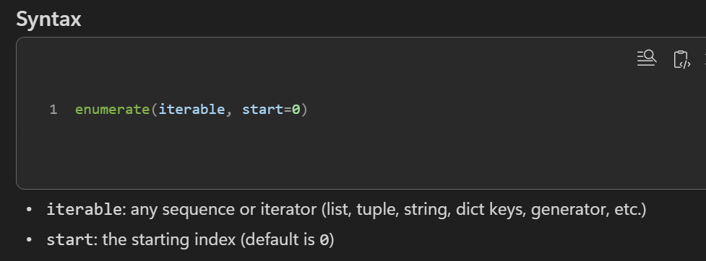
Operators
Arithmetic operators are used with numeric values to perform common mathematical operations:
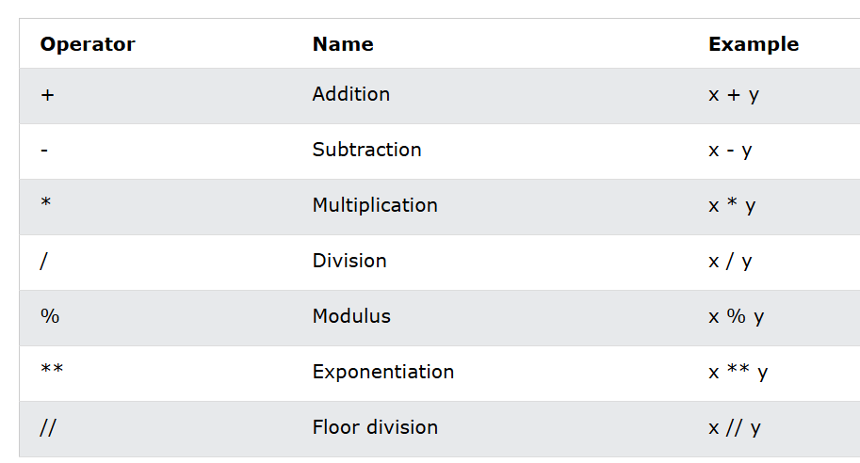
Assignment operators are used to assign values to variables:
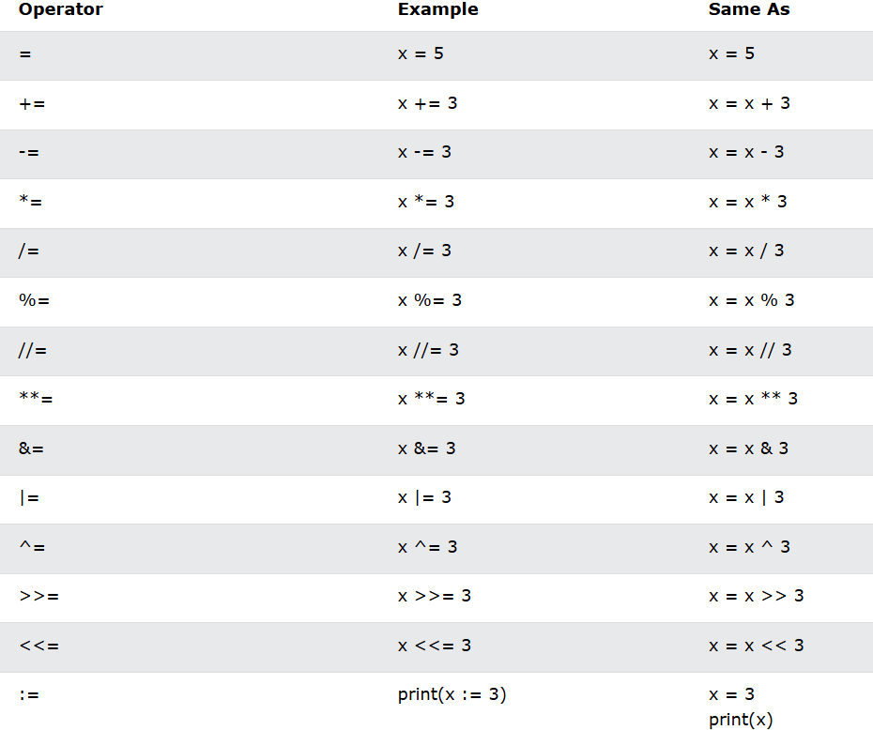

Comparison operators are used to compare two values:
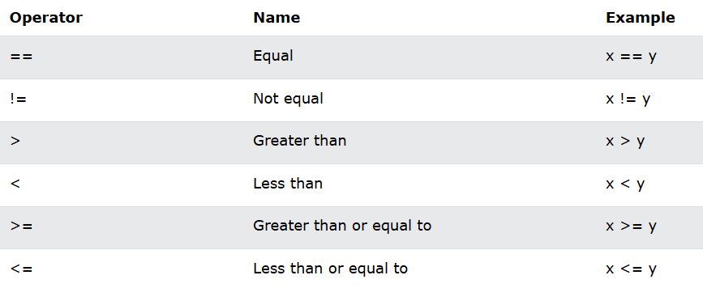

Logical operators are used to combine conditional statements:
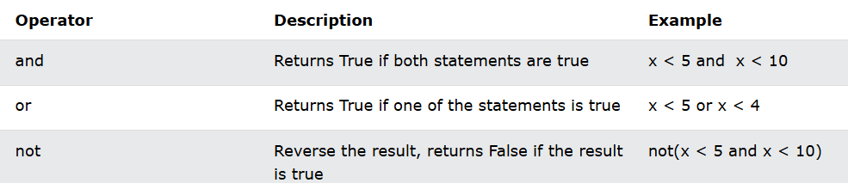

Identity operators are used to compare the objects, not if they are equal, but if they are actually the same object, with the same memory location:
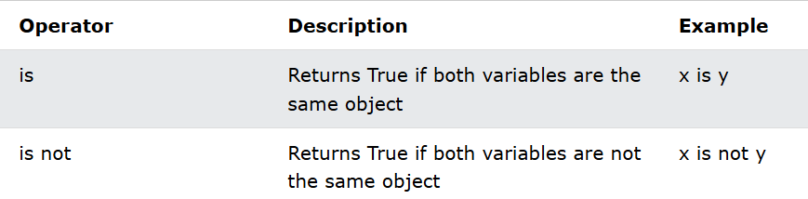

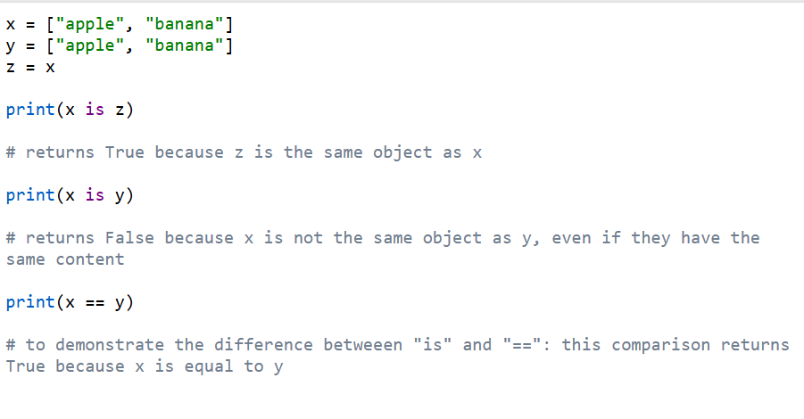

Membership operators are used to test if a sequence is presented in an object:
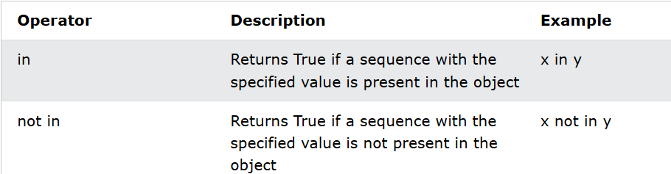
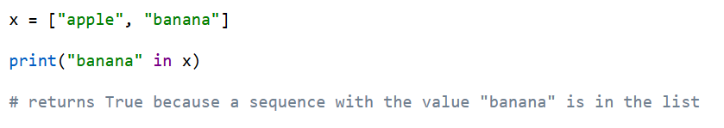

Bitwise operators are used to compare (binary) numbers:
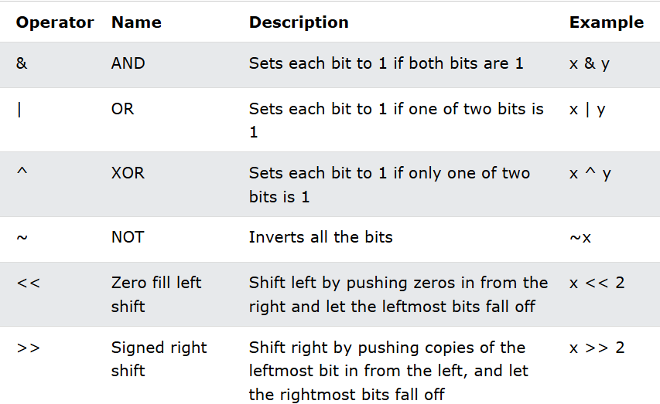
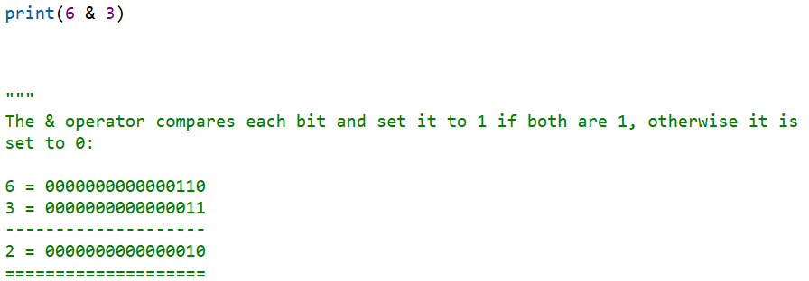

input() Function
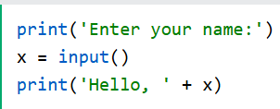

Conditional Statements:
Python supports the usual logical conditions from Mathematics.
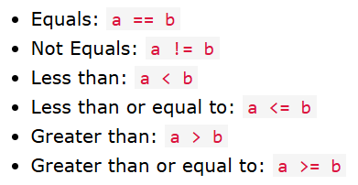
If Statement:
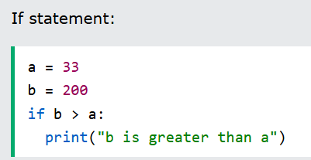

Elif:
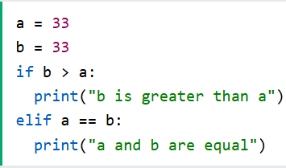
Else:
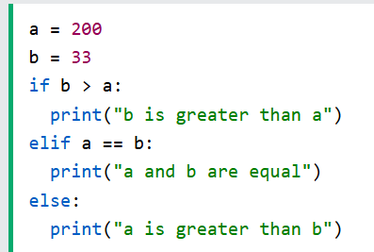
For Loops:
A for loop is used for iterating over a sequence (that is either a list, a tuple, a dictionary, a set, or a string).
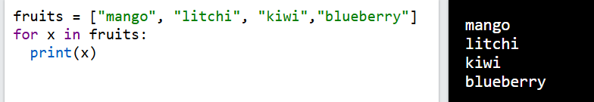

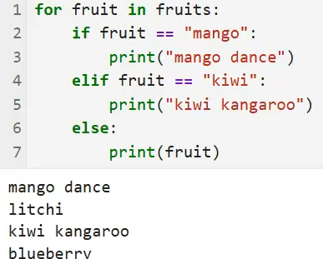

Break Statement:
With the break statement we can stop the loop before it has looped through all the items:
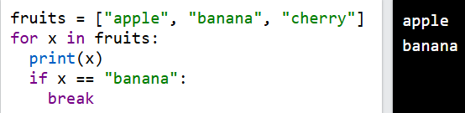

Continue Statement:
With the continue statement we can stop the current iteration of the loop, and continue with the next:
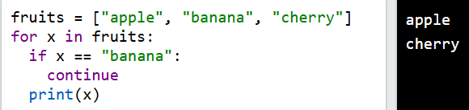

Pass Statement:
It is used when a statement is syntactically required but you do not want to execute any code. Essentially, it does nothing but allows you to maintain the structure of your program.
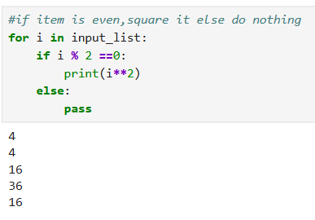
While Loop:
With the while loop we can execute a set of statements as long as a condition is true.
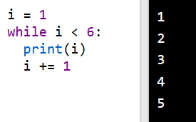

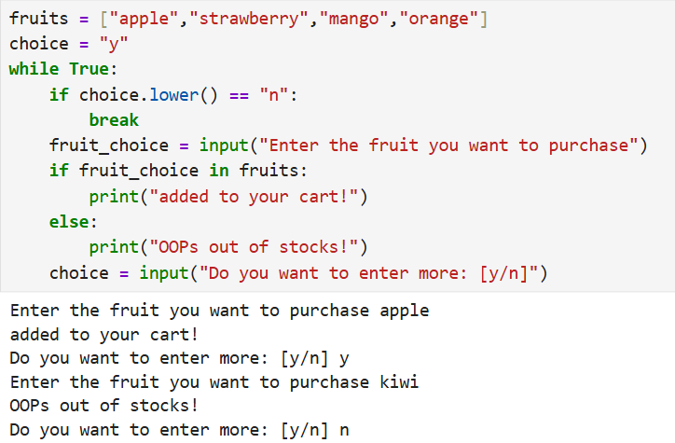

Function

  - CREATING A function:
In Python a function is defined using the def keyword:
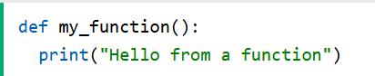

Calling a Function:
To call a function, use the function name followed by parenthesis:
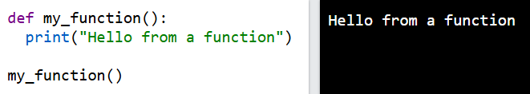

String Formatting:
F-Strings
F-string allows you to format selected parts of a string.
To specify a string as an f-string, simply put an f in front of the string literal, like this:
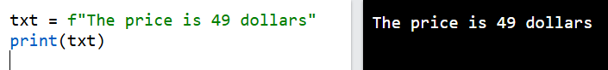
Arbitrary Arguments
If you do not know how many arguments will be _{pass}ed into your function, add a * before the parameter name in the function definition.
This way the function will receive a tuple of arguments, and can access the items accordingly:
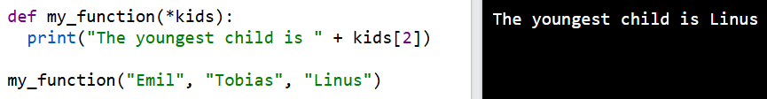

Lambda Function:
- A lambda function is a small anonymous function.
- A lambda function can take any number of arguments, but can only have one expression

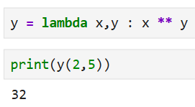
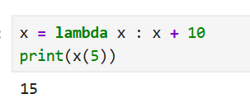
MAP() function:
The map() function in Python is a built-in function used to apply a given function to all items in an iterable (like a list, tuple, etc.) and return a map object (an iterator). It is particularly useful for transforming data in a concise and readable way.
Syntax
map(function, iterable, ...)
function: The function to apply to each element of the iterable.
iterable: One or more iterable whose elements will be passed to the function.
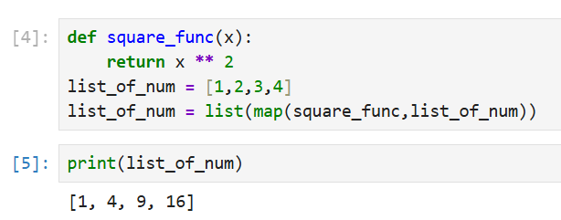
Filter() function:
The filter() function in Python is used to filter elements from an iterable (like a list, tuple, or string) based on a condition defined by a function. It returns an iterator containing only the elements for which the function returns True.
Syntax
filter(function, iterable…)
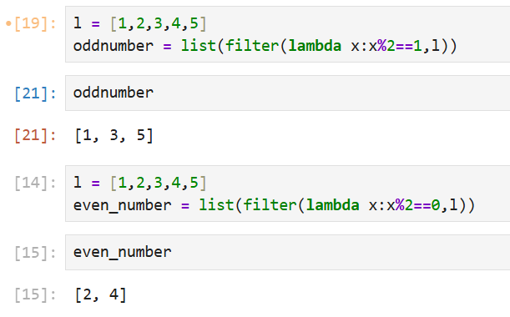
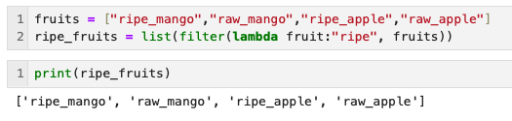

reduce() function:
The reduce() function in Python is a powerful tool for applying a function cumulatively to the items of an iterable, reducing it to a single value. It is part of the functools module and is commonly used in functional programming.
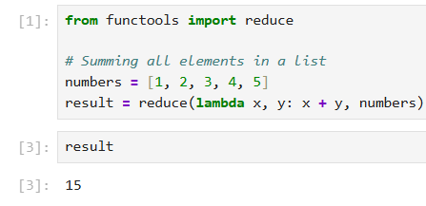
return:
It is a statement used inside a function to send a value back to the caller and terminate the function’s execution.
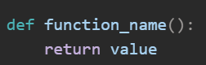
✅ Key Points about return:
- Ends the function:
  - When Python encounters return, it immediately exits the function.
- Returns a value:
  - The value after return is sent back to the caller.
- Optional:
  - If no return is specified, the function returns None by default.

Zip
The zip() function returns a zip object, which is an iterator of tuples where the first item in each passed iterator is paired together, and then the second item in each passed iterator are paired together etc.
If the passed iterables have different lengths, the iterable with the least items decides the length of the new iterator.
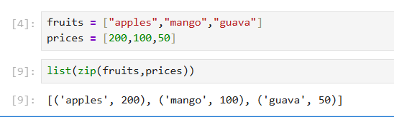
Range
The Python range() function returns a sequence of numbers, in a given range. The most common use of it is to iterate sequences on a sequence of numbers using Python loops.
- start: [ optional ] start value of the sequence
- stop: next value after the end value of the sequence
- step: [ optional ] integer value, denoting the difference between any two numbers in the sequence
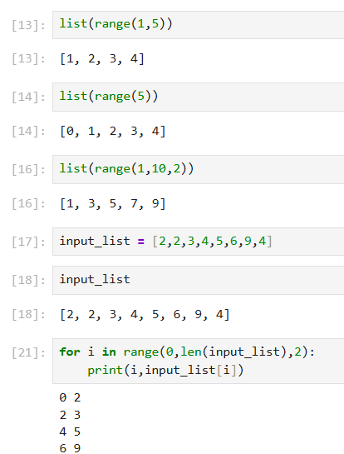
Global Keyword

Global keyword is used inside a function.

To modify a global variable(variable outside all functions).
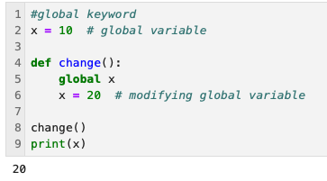
NonLocal Keyword
- It is used inside a nested(inner) function.

To modify a variable from the outer function, not global.
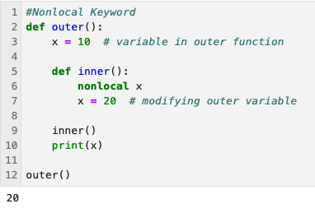
Keyword | Modifies Variable In | Where Variable Must Exist | Used In
global | Global (top-level) scope | Outside all functions | Any function
nonlocal | Outer function scope | Inside an enclosing function | Nested functions only

Keyword | Affects Which Variable | Suitable for Inner Function? | Example Use
global | Top-level program variable | ❌ No (if modifying outer variable) | Change a global counter
nonlocal | Variable in outer function | ✅ Yes | Modify outer function variable
List Comprehension
List comprehension offers a shorter syntax when you want to create a new list based on the values of an existing list.
Traditional Way:
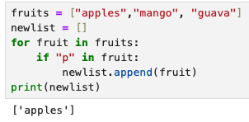
With list comprehension you can do all that with only one line of code:
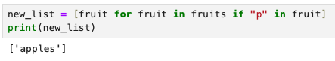
Strings
Strings in python are surrounded by either single quotation marks, or double quotation marks.
'hello' is the same as "hello".
You can display a string literal with the print() function:
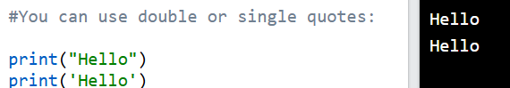

Multiline Strings:
You can assign a multiline string to a variable by using three quotes:
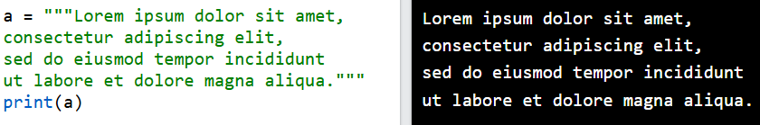
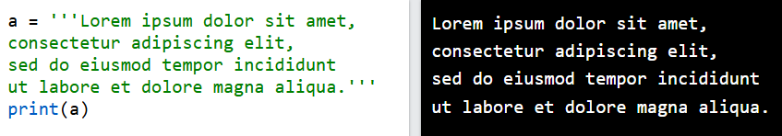
Slicing:
The slice() function returns a slice object.
A slice object is used to specify how to slice a sequence. You can specify where to start the slicing, and where to end. You can also specify the step, which allows you to e.g. slice only every other item.
Syntax
slice(start, end, step)
Parameter Values
Parameter | Description
start | Optional. An integer number specifying at which position to start the slicing. Default is 0
end | An integer number specifying at which position to end the slicing
step | Optional. An integer number specifying the step of the slicing. Default is 1

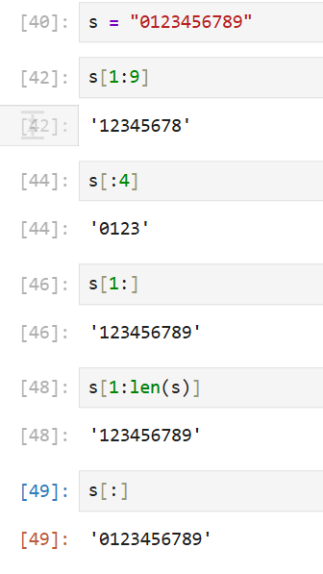
Striding:
String[first_index:last_index_step_value]
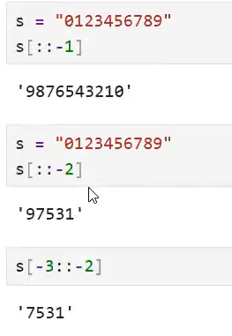
split() Method:
Split a string into a list where each word is a list item.
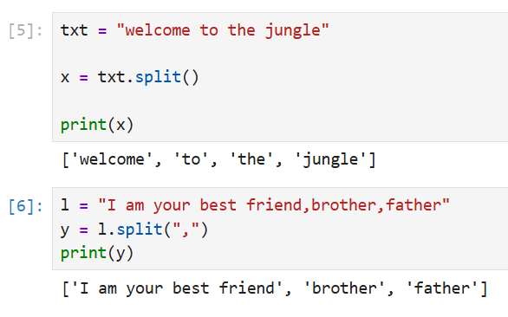

strip() Method:
Remove spaces at the beginning and at the end of the string.
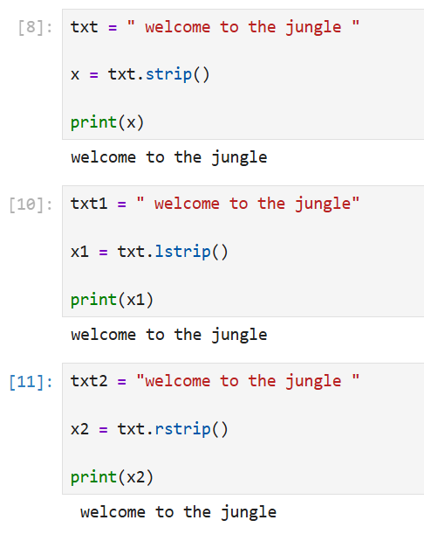

join() Method
Join all items in a tuple into a string, using a some character as separator:
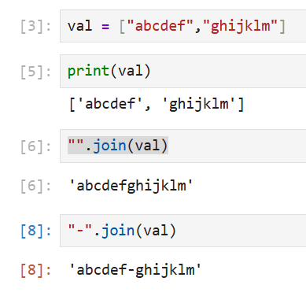

replace() Method
Replace the word
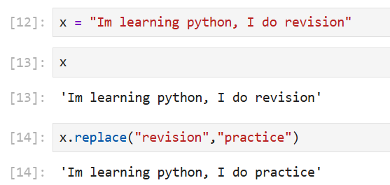

index() Method
The index() method in Python is used to find the first occurrence of a specified value within a string
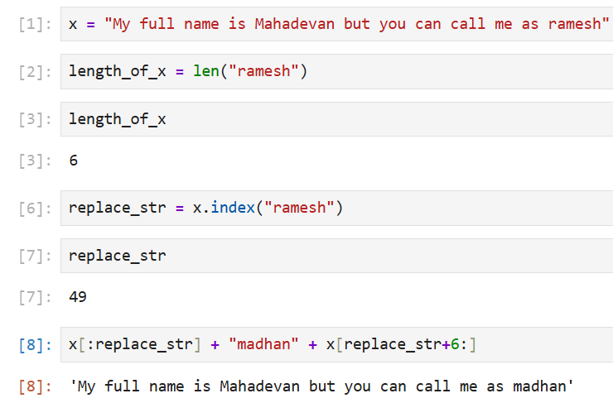
string() Method
Python has a set of built-in methods that you can use on strings.
The center() method will center align the string, using a specified character (space is default) as the fill character.
Syntax: string.center(length, character)
Parameter | Description
length | Required. The length of the returned string
character | Optional. The character to fill the missing space on each side. Default is " " (space)
Example:
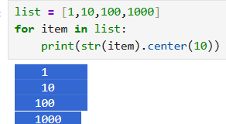
The ljust() method will left align the string, using a specified character (space is default) as the fill character.
Syntax: string.ljust(length, character)
Parameter | Description
length | Required. The length of the returned string
character | Optional. A character to fill the missing space (to the right of the string). Default is " " (space).
Example:
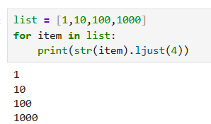
The rjust() method will left align the string, using a specified character (space is default) as the fill character.
Syntax: string.rjust(length, character)
Parameter | Description
length | Required. The length of the returned string
character | Optional. A character to fill the missing space (to the left of the string). Default is " " (space).
Example:
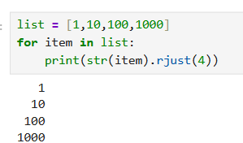

The zfill() method adds zeros (0) at the beginning of the string, until it reaches the specified length.
If the value of the len parameter is less than the length of the string, no filling is done.
Syntax
string.zfill(len)
Parameter | Description
len | Required. A number specifying the desired length of the string

Example:
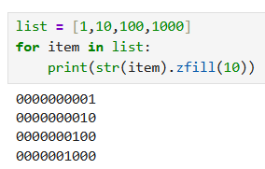

Object Oriented Programming
Classes and Objects
- Python is an object-oriented programming language.
- Almost everything in Python is an object, with its properties and methods.
- A Class is like an object constructor
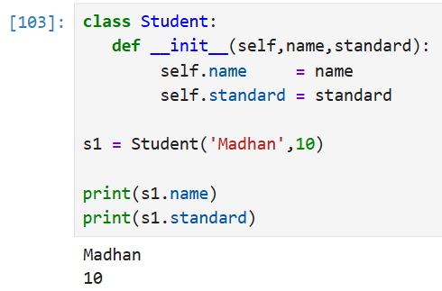
Types of Methods:
Three Types of Methods:
- Instance Method Object Level Methods
- Static Method Local Method
- Class Method Class Level Method
Object or Instance Method:
Objects can also contain methods. Methods in objects are functions that belong to the object.
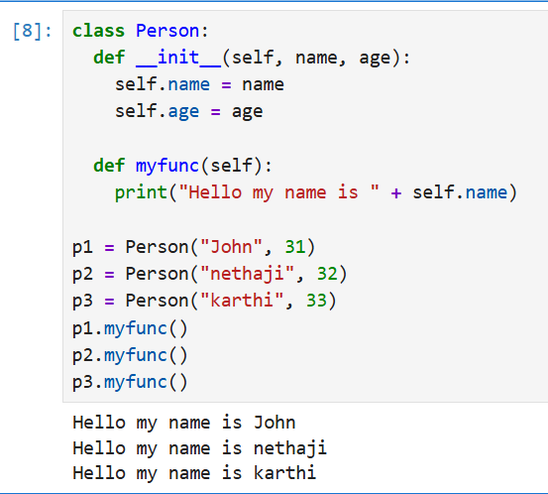
Class Methods:
- Belongs to the class, not to an object (instance)
- Uses the @classmethod decorator
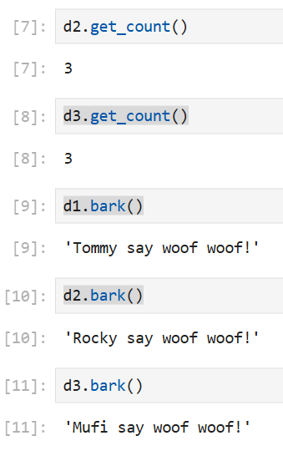
- Takes cls as the first parameter (represents the class)
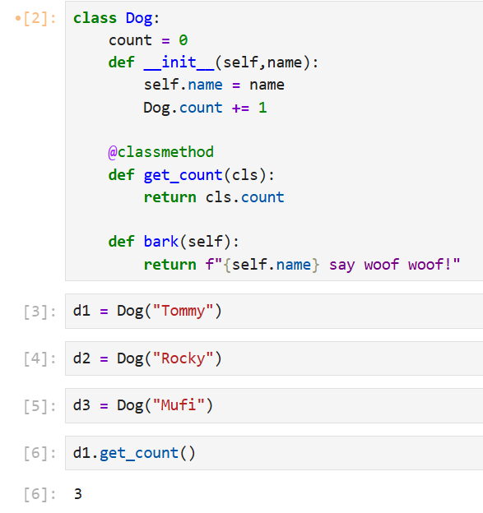
Static Method:
- Static methods in Python are methods that belong to a class rather than an instance of the class.
- They are defined using the @staticmethod decorator and do not require an instance of the class to be called.
- This makes them useful for utility functions that are related to the class but do not need to access or modify the class or instance state.

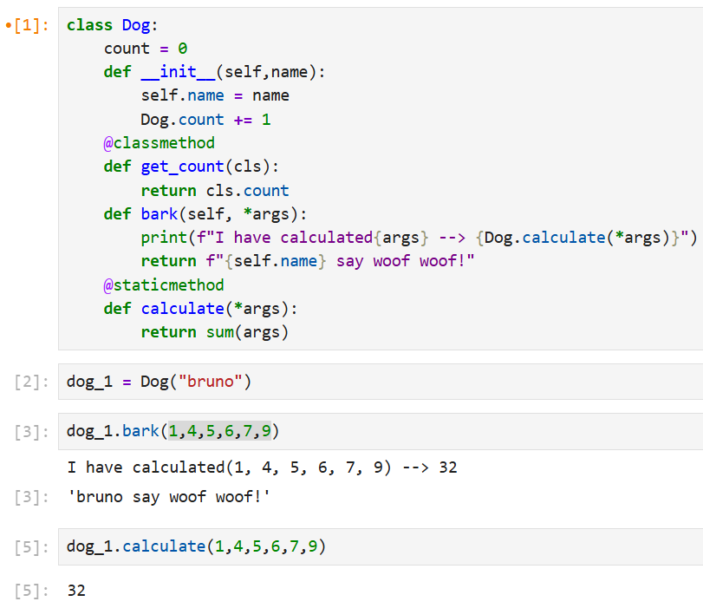
isinstance() is a built-in Python function used to check if an object is an instance of a specific class or a tuple of classes.
Syntax:
isinstance(object, classinfo)
- object → The variable or value you want to check.
- classinfo → A class, type, or a tuple of classes/types.

Returns:
- True if the object is an instance of the specified class (or any class in the tuple).
- False otherwise.

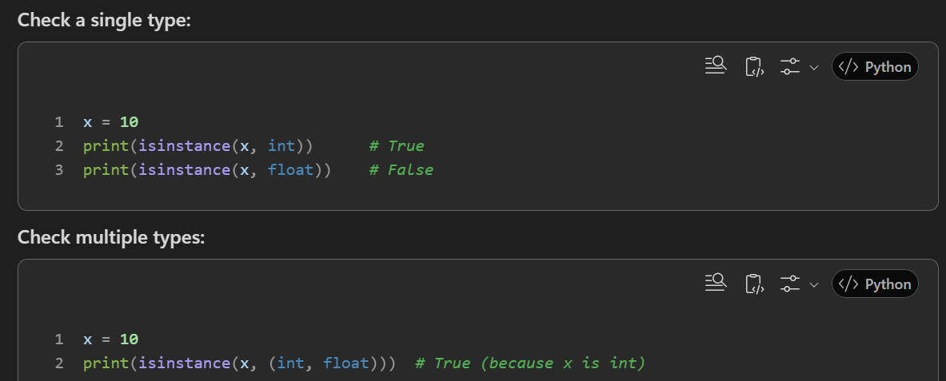

Inheritance
Inheritance allows us to define a class that inherits all the methods and properties from another class.

Parent Class is the class being inherited from, also called base class.
Child Class is the class that inherits from another class, also called derived class.
Types of Inheritance:
- Single Inheritance
A B
- Multilevel Inheritance
A B C
- Multiple Inheritance
(A, B) C
- Hierarchal Inheritance
A (A, B, C)
- Hybrid Inheritance
A (B, C) D
Super () Function:
It inherits all the methods and properties from parent class.
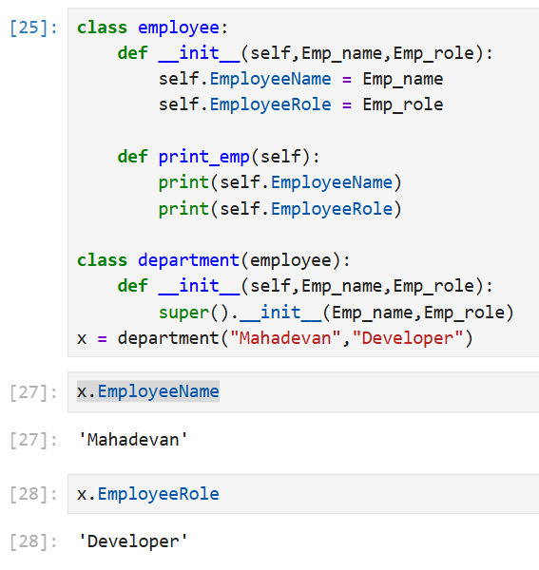

MRO:
In Python, Method Resolution Order (MRO) is the order in which Python looks for a method or attribute in a hierarchy of classes. It is particularly important in the context of multiple inheritance, as it determines the sequence in which base classes are searched when a method is called.
Linearization: Python uses the C3 Linearization Algorithm to determine the MRO. This ensures consistent and predictable order.
Object

Base Class 2

Base Class 1

Derived Class

Single Inheritance:
One Parent class and One Child Class
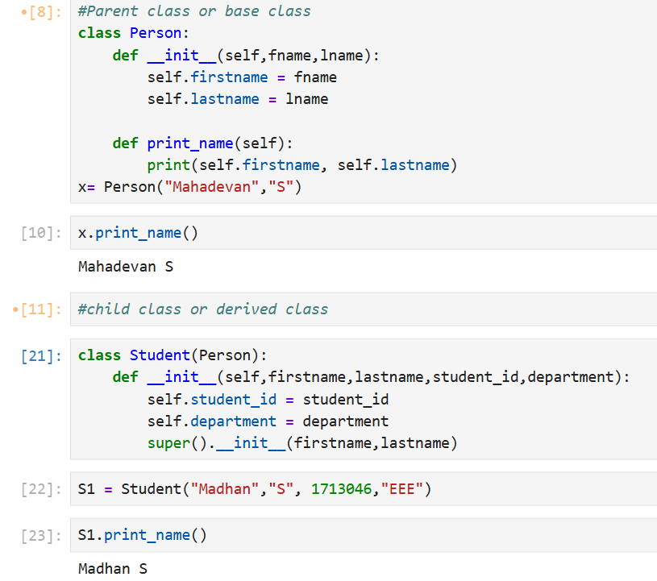

Multilevel Inheritance:
One Parent class and One Intermediatory Class and One Child Class
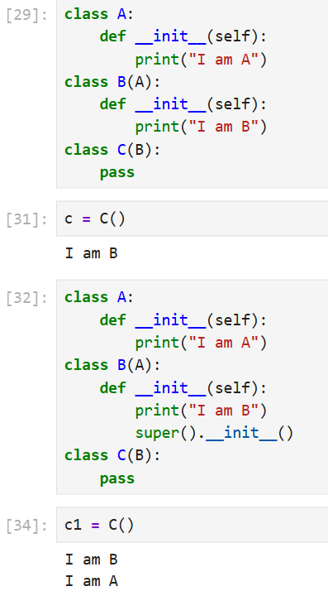
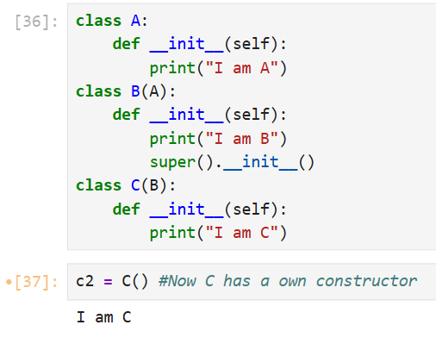
Multiple Inheritance:
Multiple Parent class and One Child Class
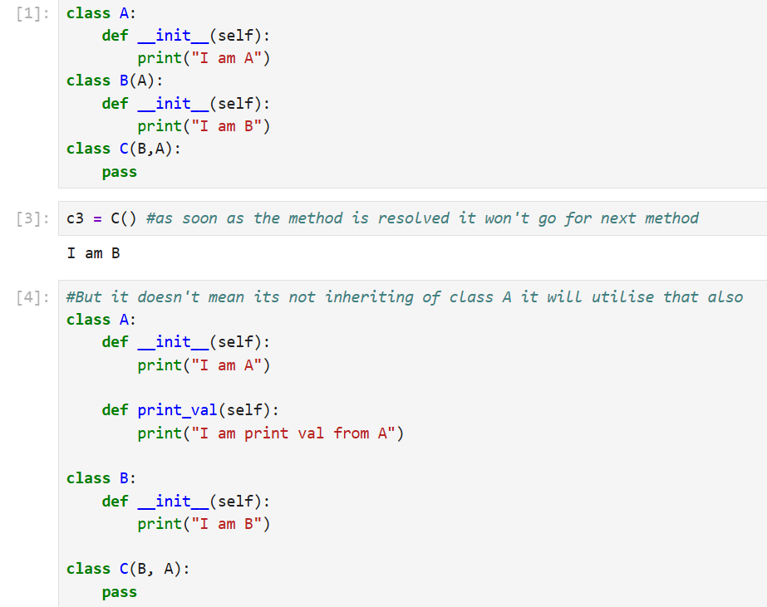
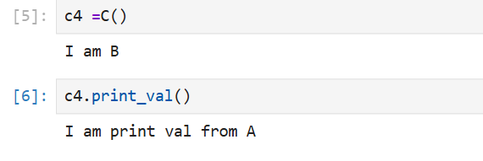

Hierarchical Inheritance:
One Parent class and Multi Child Class
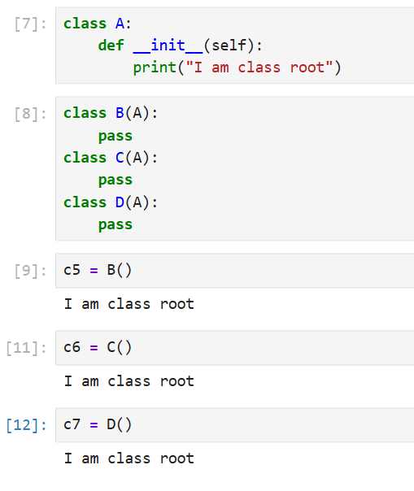

Hybrid Inheritance:
One Parent class and inherits multiple child class and inherits one child class
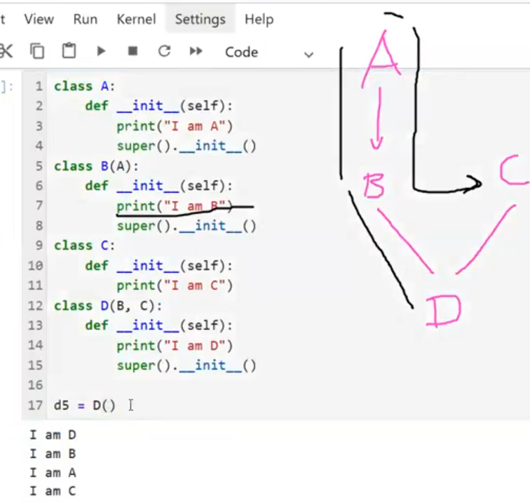

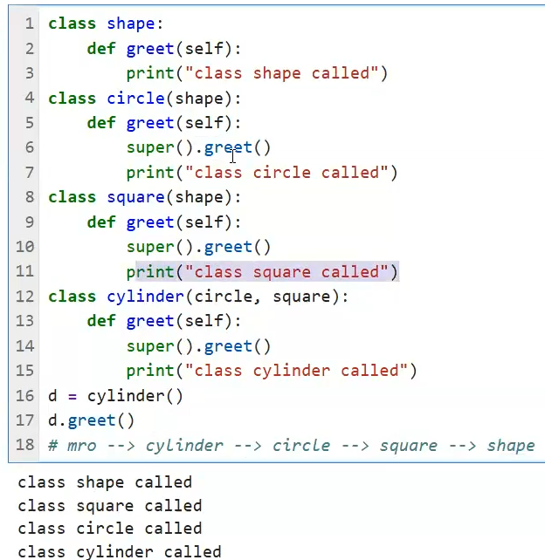

Magic Methods or Dunder Methods:
Magic methods in Python, also known as dunder methods (short for "double underscore"), are special methods that allow you to define the behavior of objects for built-in operations. These methods are surrounded by double underscores (e.g., __init__, __str__) and are automatically invoked by Python in specific situations.
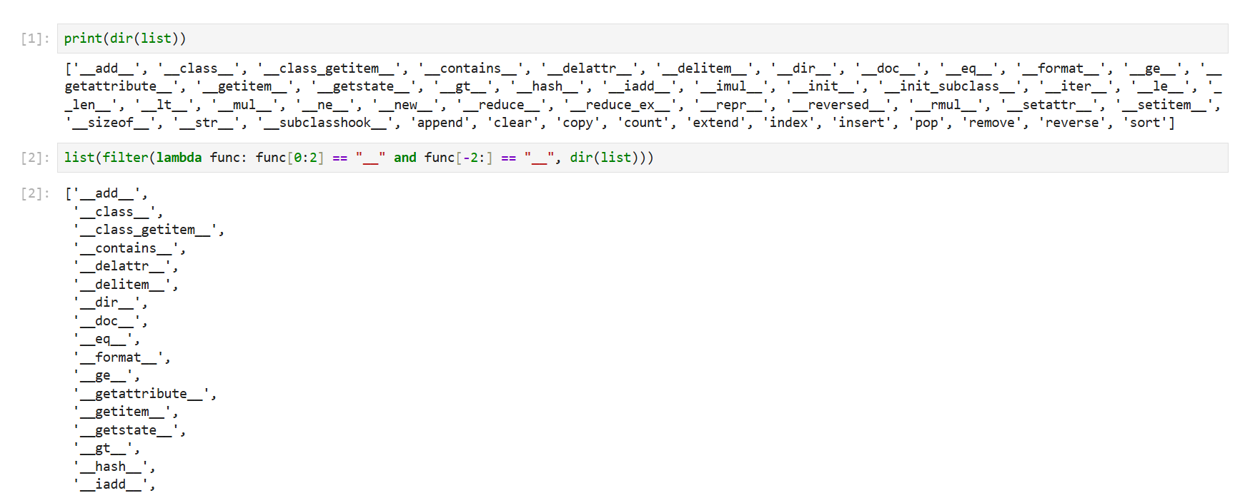
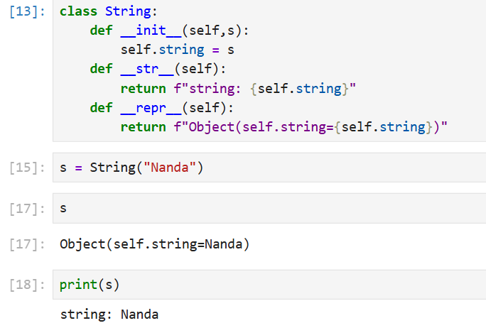
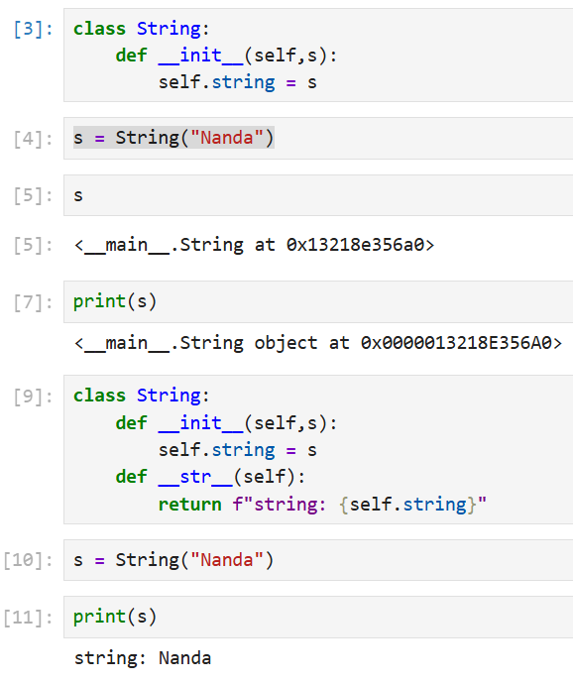
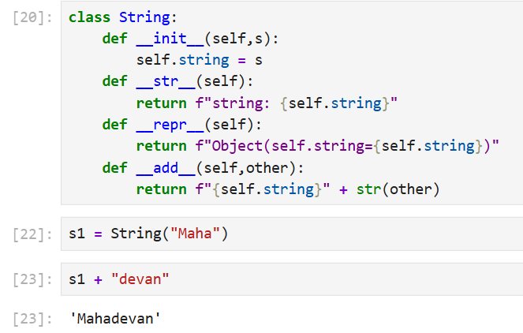
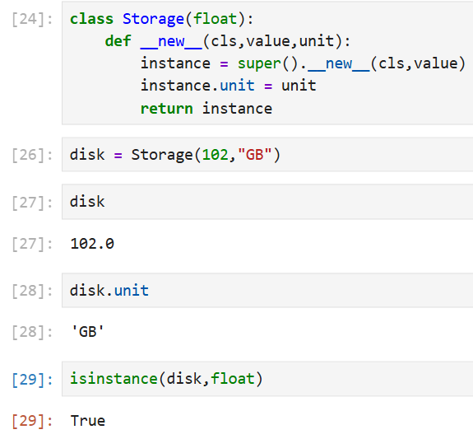

File Handling
- File handling is an important part of any web application.
- Python has several functions for creating, reading, updating, and deleting files.
- The key function for working with files in Python is the open() function.
- The open() function takes two parameters: filename, and mode.
- There are four different methods (modes) for opening a file:

- "r" – Read Only
- "a" - Append
- "w" - Write Only
- "x" - Create
- “r+”, ”w+”, ”a+” (read and write)
Read Mode:
- The file pointer starts from the first place
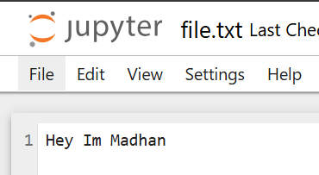
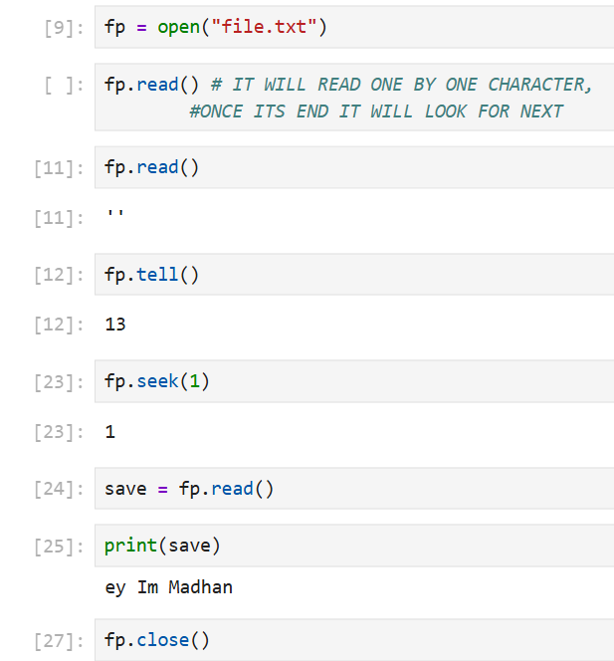

Write Mode:
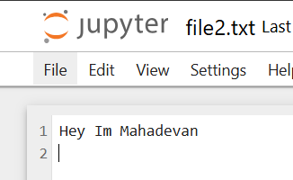
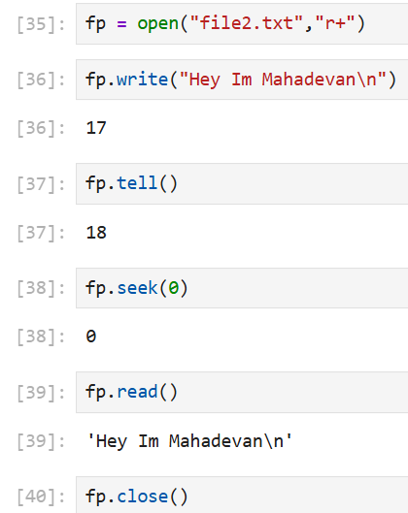
W+ mode:
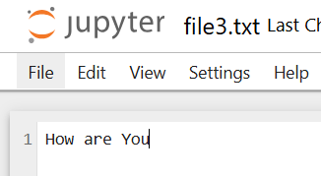
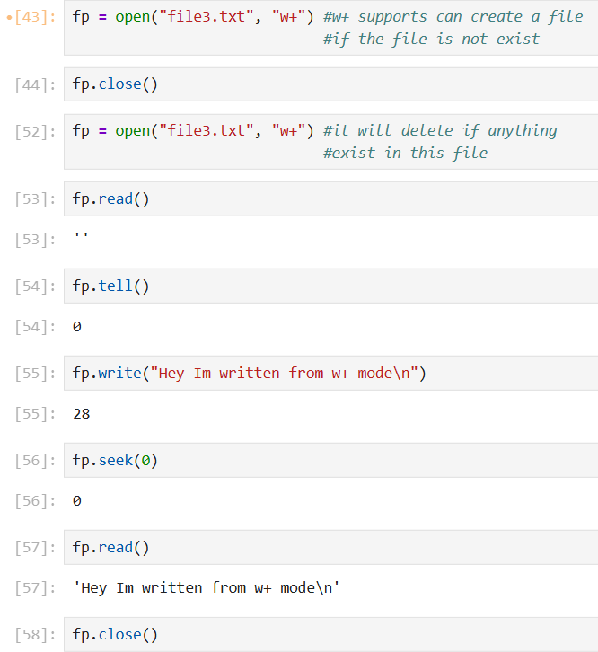
append mode:
- The file pointer starts from the last place
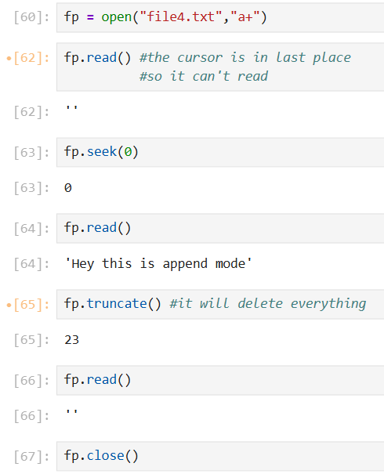
Before
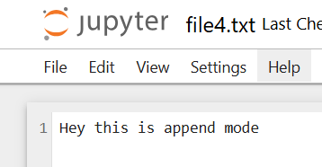
After:
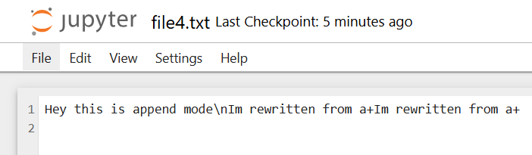
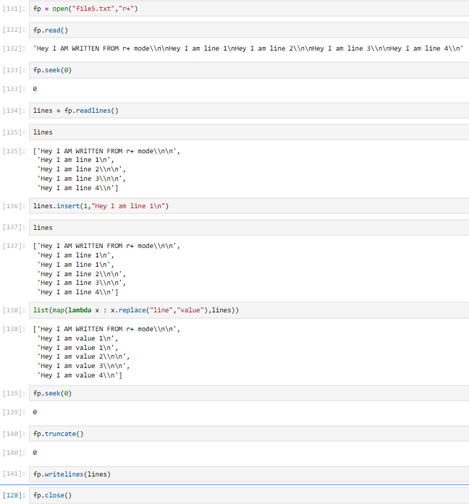

Context Manager:
A context manager is a construct that allows you to manage resources efficiently by ensuring that setup and cleanup actions are performed automatically. The most common use case is with the with statement, which simplifies resource management like file handling, database connections, or locks.
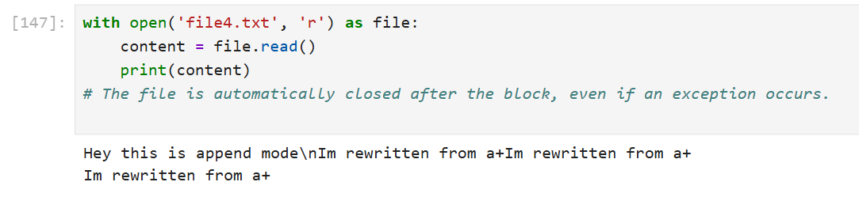
Decorators:
Decorators are a powerful and elegant way to modify or extend the behavior of functions or methods without permanently modifying their code. They are essentially functions that wrap another function, adding functionality before or after the wrapped function is executed.
- Higher-Order Functions: Decorators take a function as input and return a new function.
- Syntax: Decorators are applied using the @decorator_name syntax above the function definition.
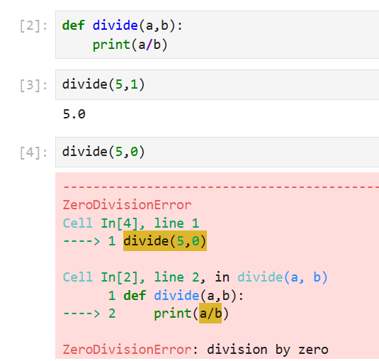
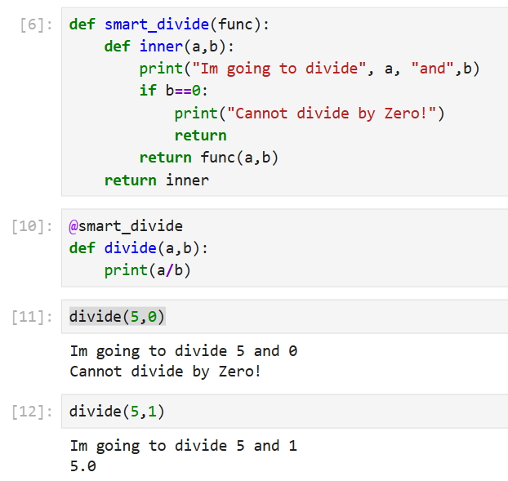
Iterators:
- An iterator is an object that contains a countable number of values.
- An iterator is an object which implements the iterator protocol, which consist of the methods __iter__() and __next__().
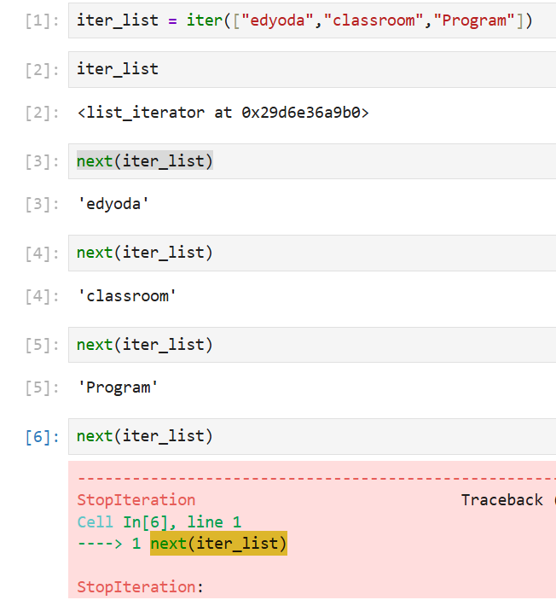
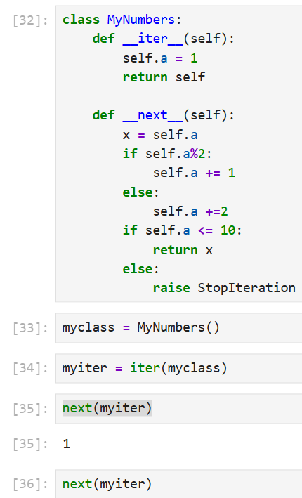
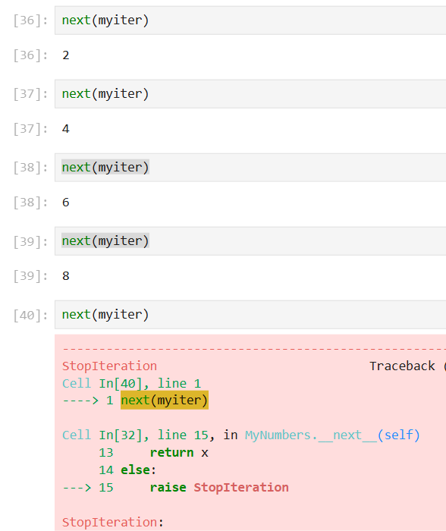

Generators:
Generators in Python are a way to create iterators in a more concise and memory-efficient manner. They allow you to yield values one at a time, rather than creating and storing the entire sequence in memory. Here's a quick overview:
Key Features of Generators
- Memory Efficiency: Generators produce items lazily, meaning they generate values on the fly and don't store the entire sequence in memory.
- Simpler Syntax: Use the yield keyword instead of return in a function to create a generator.
- State Retention: Generators maintain their state between calls, allowing you to resume execution where it left off.
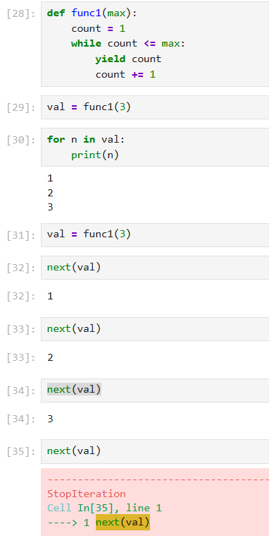
Python Generator Expression:
A Python Generator Expression is a concise way to create a generator, which is an iterator that yields items one at a time and computes them lazily (on demand). It is similar to a list comprehension but uses parentheses () instead of square brackets []. This makes it memory-efficient for large datasets since it doesn't store all items in memory at once.
Syntax:
(expression for item in iterable if condition)
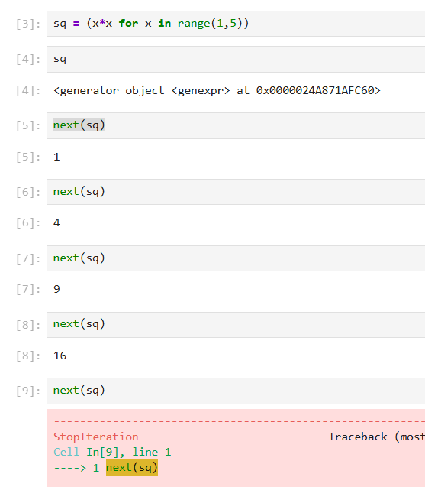
Regular Expression:
A RegEx, or Regular Expression, is a sequence of characters that forms a search pattern.
RegEx can be used to check if a string contains the specified search pattern.
Function | Description
findall | Returns a list containing all matches
search | Returns a Match object if there is a match anywhere in the string
split | Returns a list where the string has been split at each match
sub | Replaces one or many matches with a string

Metacharacters are characters with a special meaning:
Character | Description | Example
[] | A set of characters | "[a-m]"
\ | Signals a special sequence (can also be used to escape special characters) | "\d" digit  “\s” space  “\D” no digit  “\s” no space
. | Any character (except newline character) | "he..o"
^ | Starts with | "^hello"
$ | Ends with | "planet$"
* | Zero or more occurrences | "he.*o"
+ | One or more occurrences | "he.+o"
? | Zero or one occurrence | "he.?o"
{} | Exactly the specified number of occurrences | "he.{2}o"
| | Either or | "falls|stays"
() | Capture and group

Go to this link Python RegEx Meta Characters and try it the above characters
[] A set of characters [a, b], [a-b], [A-Za-z], [A-Za-z0-90]
\ Signals a special sequence "\d" digit, “\s” space, “\D” no digit, “\s” no space
. Any character (except a newline)
* zero or more occurrences
+ One or more occurrences
? Zero or one occurrence
^ Start with specific word (eg: ^f)
$ Ends with specific word (eg: e$)
{} Exactly the specified number of occurrence(eg: a..b(2,5) aabbb,abab,abbb)
Practical example:
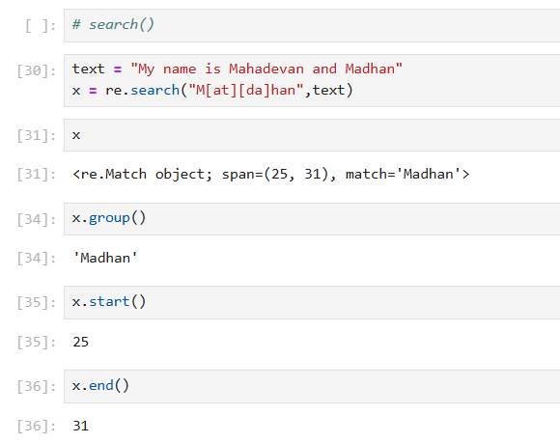
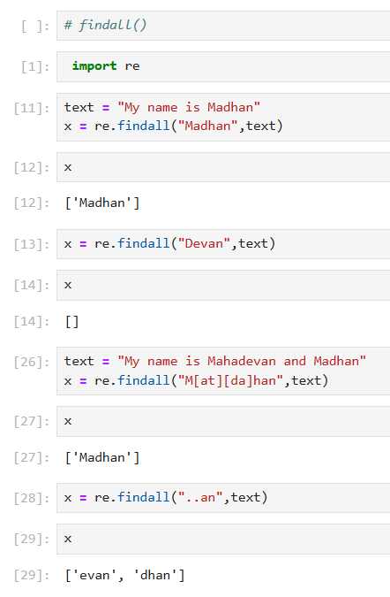

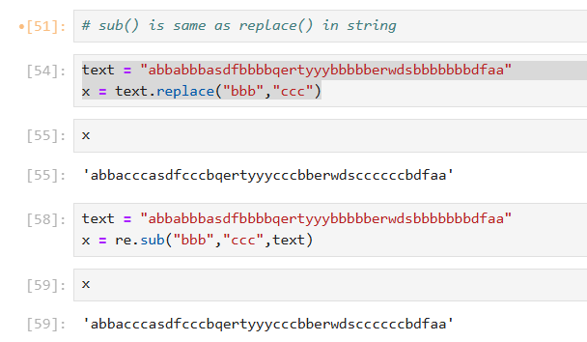
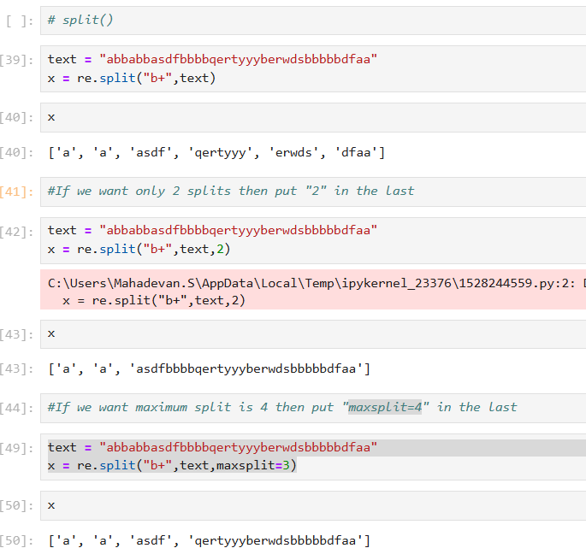

Global Keyword

Global keyword is used inside a function.

To modify a global variable(variable outside all functions).
NonLocal Keyword
- It is used inside a nested(inner) function.

To modify a variable from the outer function, not global.
Keyword | Modifies Variable In | Where Variable Must Exist | Used In
global | Global (top-level) scope | Outside all functions | Any function
nonlocal | Outer function scope | Inside an enclosing function | Nested functions only

Keyword | Affects Which Variable | Suitable for Inner Function? | Example Use
global | Top-level program variable | ❌ No (if modifying outer variable) | Change a global counter
nonlocal | Variable in outer function | ✅ Yes | Modify outer function variable

