ChatBot using OpenAI API in Python

I have Created a simple Python application using OpenAI API & Gradio library that takes an input and generates a desired output.

Software Required

* Any IDE or Code Editor (like: VS Code, PyCharm, Jupiter, Eclipse)
* Python 3.9.10

Steps to create chat GPT API

1. Install the required dependencies-

* Install gpt-engineer
* pip install gpt-engineer
* Install OpenAI module
* pip install openai
* Install Gradio module
* pip install gradio

1. Set the OPENAI_API_KEY that was obtained from <https://openai.com/> by creating OPENAI account.

* openai.api_key = [your secret api key]

1. In this application, simply use create method to query the model

* There are two main parameters to use this method.
* Model- This API supports gpt-3.5-turbo.
* messages- Model inputs are defined by three types of messages corresponding to three roles: system, user, assistant.

The **system** message helps set the behaviour of the assistant.

The **user** messages help instruct the assistant.

The **assistant** messages help store prior responses.



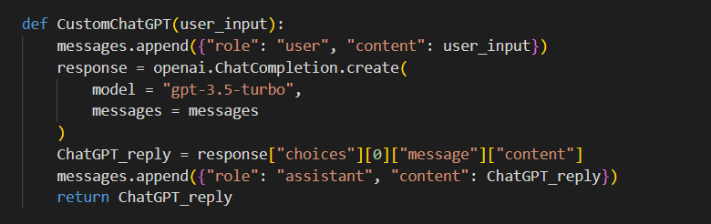

1. Gradio Interface is the main high-level class. The Interface class allows you to create the GUI for your functions and ML models.

Interface class has three required parameters i.e., Interface (fn, inputs, outputs, title). We set inputs, outputs as text type, Fn is the arbitrary function and title is headline of web server.



1. demo.launch(share=True) launches a simple web server that serves the demo and share=True means used to create a public link used by anyone to access the demo from their browser.



1. This application is hosted on : -



Output: -

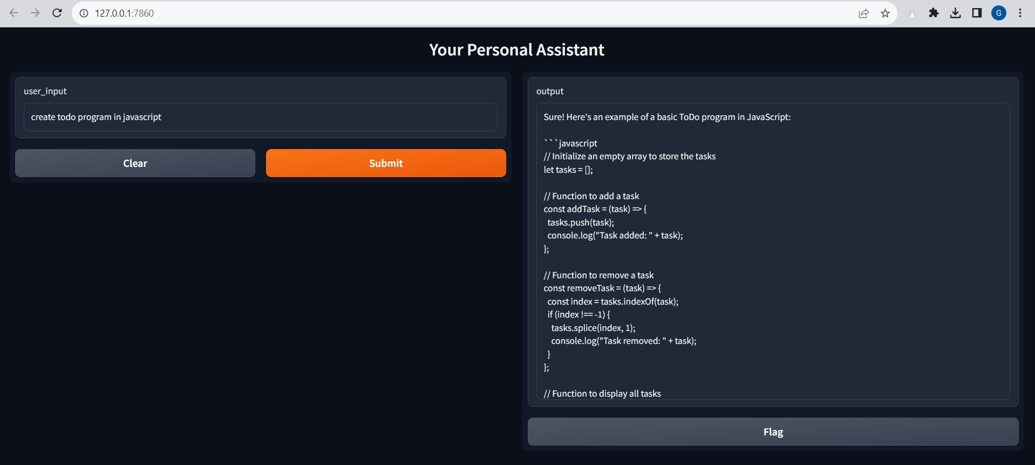

Issue faced while creating app

* Have to create virtual environment in python because in my local setup GPT engineer is not found so I just simply created Virtual Environment using python.
* Command for create Virtual Environment in python
* python -m venv /path/to/new/virtual/environment
* c:\>python -m venv c:\path\to\myenv