Broadcast Traffic Control using Mininet and Open vSwitch
Name: Meha Mahajan
SRN: PES2UG24AM090

1. Objective
To control excessive broadcast traffic in a network by detecting broadcast packets, limiting flooding, applying selective forwarding rules, and evaluating improvement.

2. Tools Used
- Ubuntu (VirtualBox)
- Mininet
- Open vSwitch
- tcpdump

3. Implementation and Results
Mininet Setup
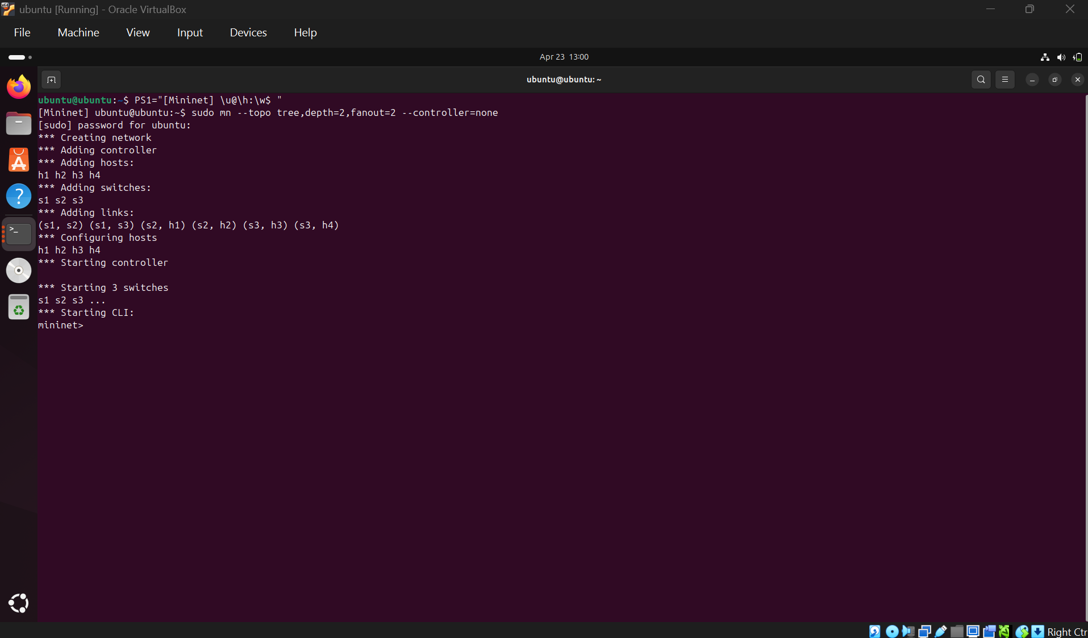

Network Topology
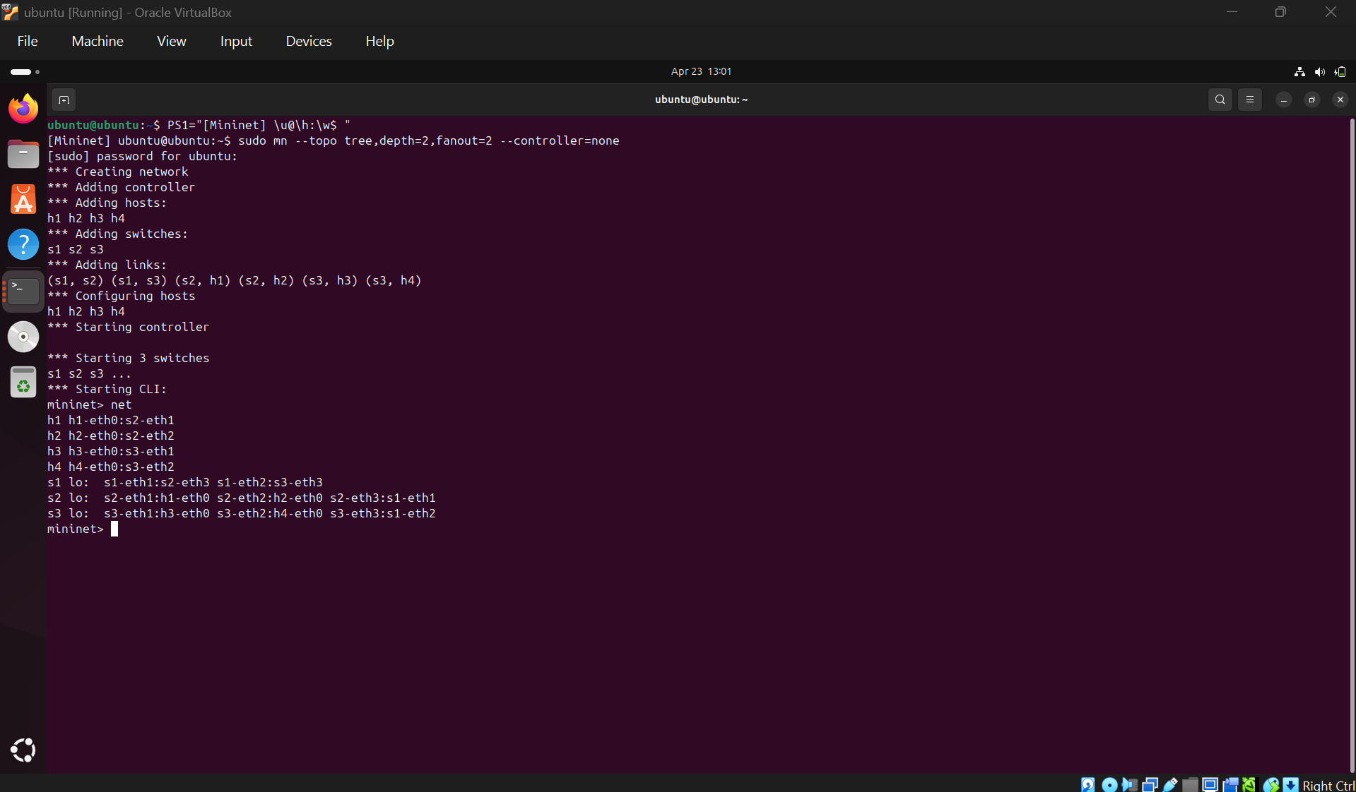

Broadcast Traffic Generation
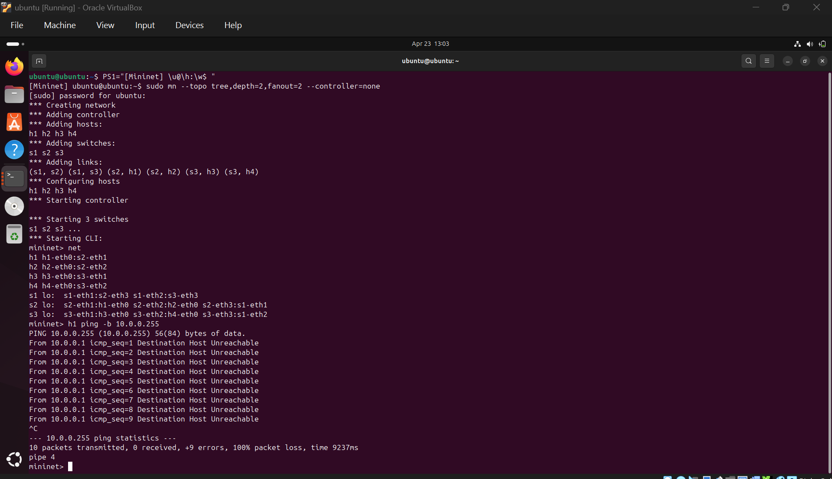

Broadcast Detection using tcpdump
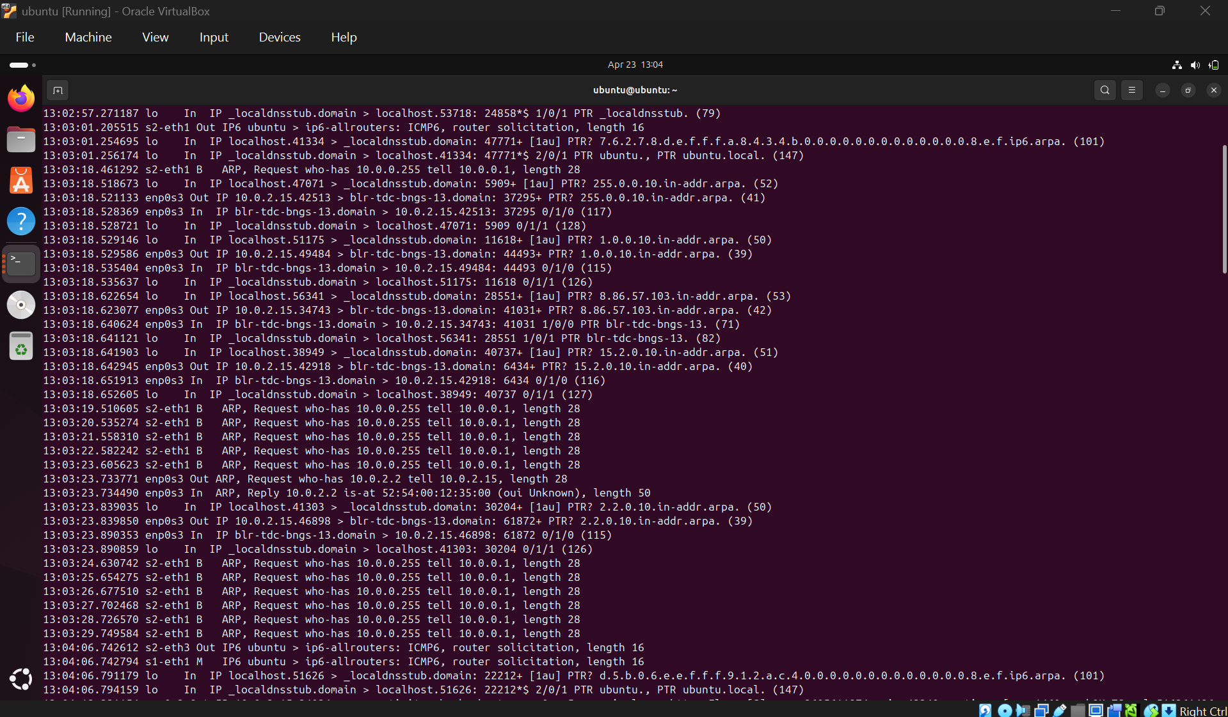

Applying Control Rules
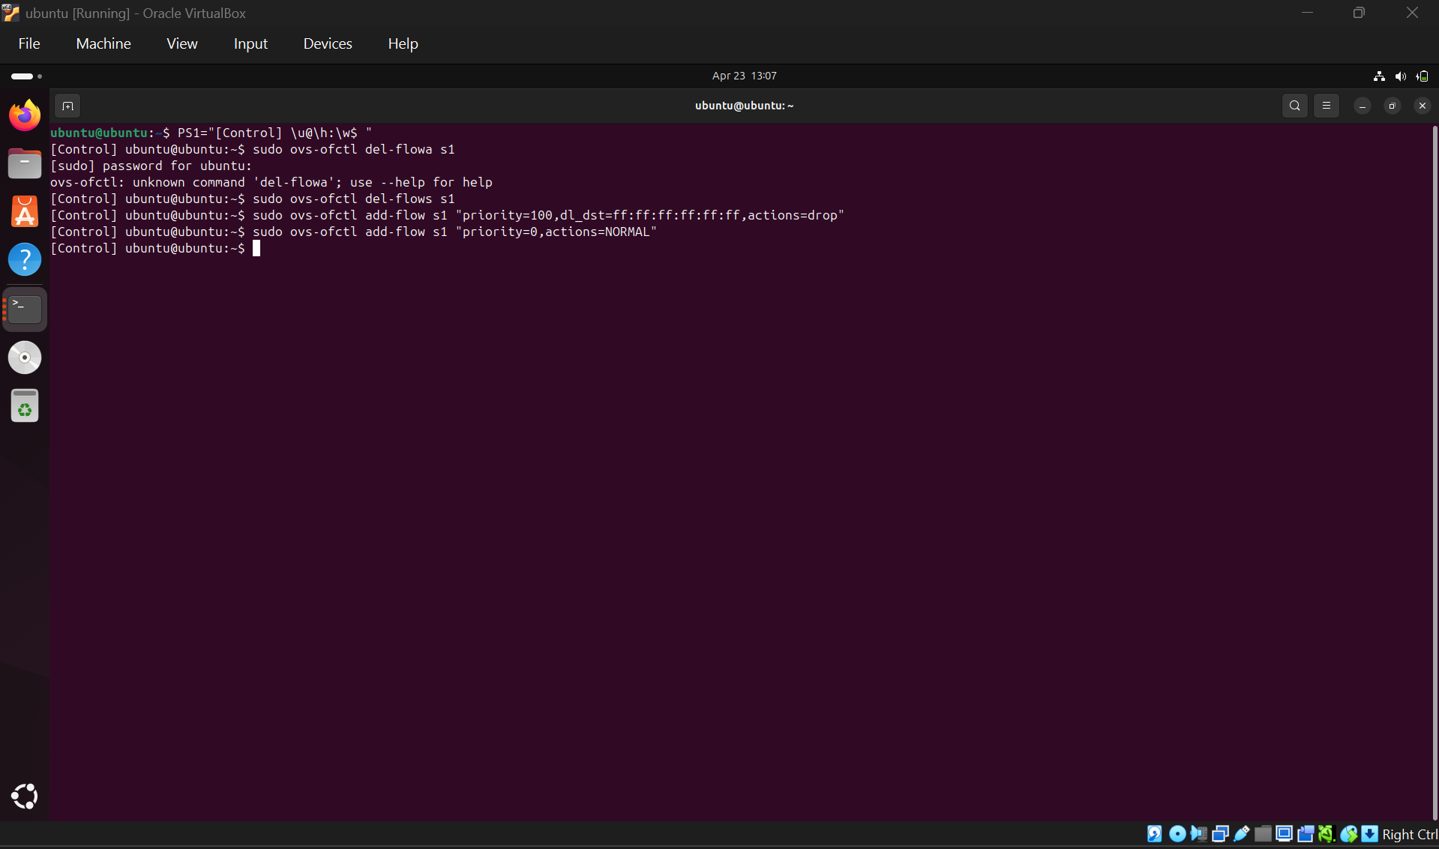

Flow Table Verification
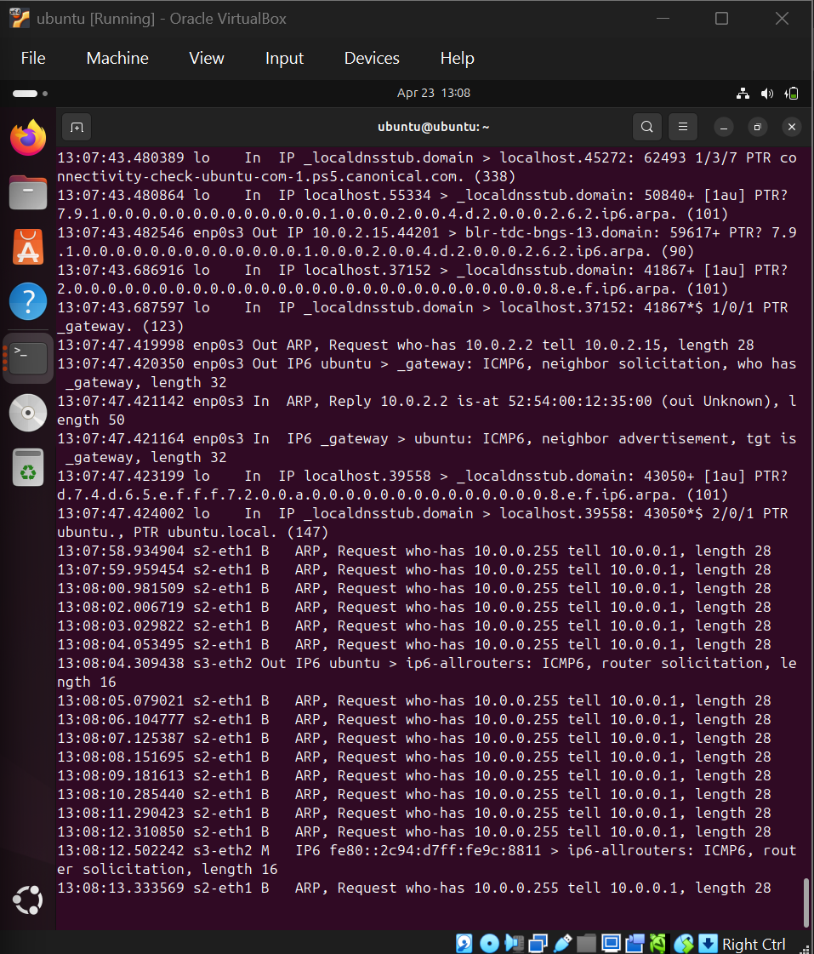

Result after Broadcast Control
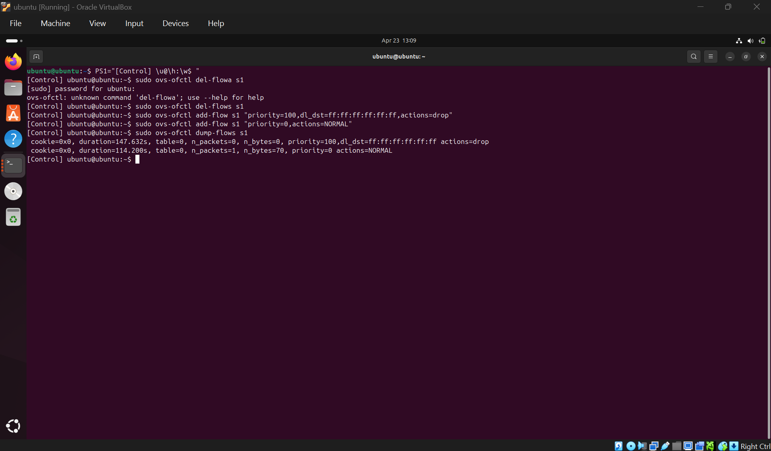

4. Conclusion
Broadcast traffic was successfully detected and controlled using OpenFlow rules, reducing unnecessary flooding and improving network efficiency.

